Iquique, Chile, june 17, 2016.

Edil Torres Rivera, Ph. D.
Editor in Chief, Interamerican Journal of Psychology
The Chicago School of Professional Psychology
Chicago, Illinois, USA

Dear Dr. Torres:

I am sending a submission to Interamerican Journal of Psychology entitled, ‘Work engagement, teaching practices with motivational effects and learning-oriented classroom motivational climate.’ The manuscript is 20 pages long double spaced, 11 pages long single spaced. It includes 2 tables, and is 5,035 words in all. The manuscript was prepared following the instructions for authors of Interamerican Journal of Psychology.

This manuscript is not submitted to any other journal, and has not been submitted previously to Interamerican Journal of Psychology. The research and manuscript were conducted following APA ethical guidelines. Research was partially supported by Government of Chile through GRANT FONDECYT 1110722, and there is no conflict of interest.

I will be serving as the corresponding author for this manuscript. All of the authors have agreed to the byline order and to submission of the manuscript in this form.

Sincerely,

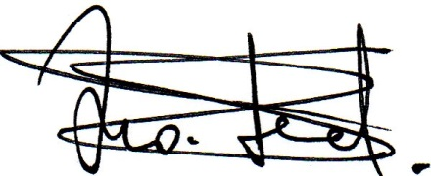
Francisco Leal-Soto
Universidad de Tarapacá
Avda. Luis Emilio Recabarren 2477
Iquique, 1113642, Región de Tarapacá, Chile
56572727250 (office)
56987568719 (personal)
franleso@gmail.com

