APPENDIX 1
DOMAIN: Academics
OUTCOME: Mindset for Intelligence and talent
MEASURE: Revised Implicit Theories of Intelligence and talent (Self-Theory) Scale

The following questions are exploring students’ beliefs about their personal ability to change their intelligence and talent level. There are no right or wrong answers. We are just interested in your views. Using the scale below, please indicate the extent to which you agree or disagree with the following statements.
 | Strongly disagree | Disagree | Mostly disagree | Mostly agree | Agree | Strongly agree
1. I don’t think I personally can do much to increase my intelligence. | □  1 | □  2 | □  3 | □  4 | □  5 | □  6
2. I can learn new things, but I don’t have the ability to change my basic intelligence. | □  1 | □  2 | □  3 | □  4 | □  5 | □  6
3. My intelligence is something about me that I personally can’t change very much. | □  1 | □  2 | □  3 | □  4 | □  5 | □  6
4. To be honest, I don’t think I can really change how intelligent I am. | □  1 | □  2 | □  3 | □  4 | □  5 | □  6
5. With enough time and effort I think I could significantly improve my intelligence level. | □  1 | □  2 | □  3 | □  4 | □  5 | □  6
6. I believe I can always substantially improve on my intelligence. | □  1 | □  2 | □  3 | □  4 | □  5 | □  6
7. Regardless of my current intelligence level, I think I have the capacity to change it quite a bit. | □  1 | □  2 | □  3 | □  4 | □  5 | □  6
8. I believe I have the ability to change my basic intelligence level considerably over time. | □  1 | □  2 | □  3 | □  4 | □  5 | □  6
9. I don’t think I personally can do much to increase my Talent. | □  1 | □  2 | □  3 | □  4 | □  5 | □  6
10. I can learn new things, but I don’t have the ability to change my basic Talent. | □  1 | □  2 | □  3 | □  4 | □  5 | □  6
11. My Talent is something about me that I personally can’t change very much. | □  1 | □  2 | □  3 | □  4 | □  5 | □  6
12. To be honest, I don’t think I can really change how intelligent I am. | □  1 | □  2 | □  3 | □  4 | □  5 | □  6
13. With enough time and effort I think I could significantly improve my Talent level. | □  1 | □  2 | □  3 | □  4 | □  5 | □  6
14. I believe I can always substantially improve on my Talent. | □  1 | □  2 | □  3 | □  4 | □  5 | □  6
15. Regardless of my current Talent level, I think I have the capacity to change it quite a bit. | □  1 | □  2 | □  3 | □  4 | □  5 | □  6
16.. I believe I have the ability to change my basic Talent level considerably over time. | □  1 | □  2 | □  3 | □  4 | □  5 | □  6

APPENDIX.2
TEACHING SKILLS OF UNIVERSITY FACULTY
The intention behind this scale is for you to assess the teaching skills that university
professors should have. We will use your opinion to build an evaluation model that is
coherent with the new requirements of the European Higher Education Area. Likewise,
the information obtained in this scale will be processed anonymously, so we ask that you
answer with complete honesty.
THANK YOU FOR YOUR COOPERATION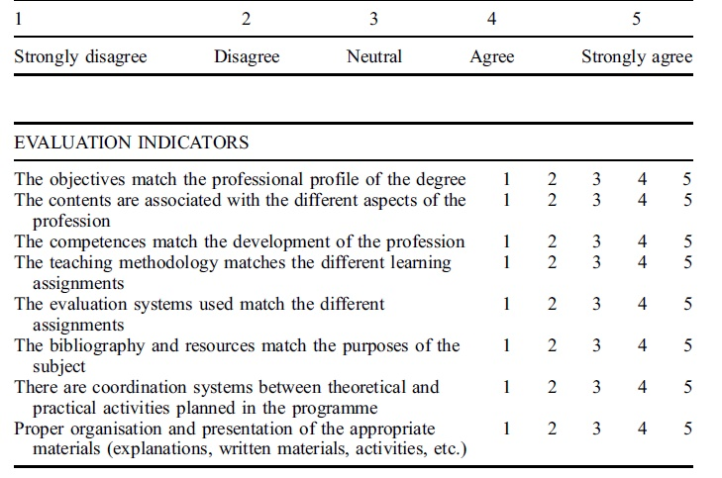
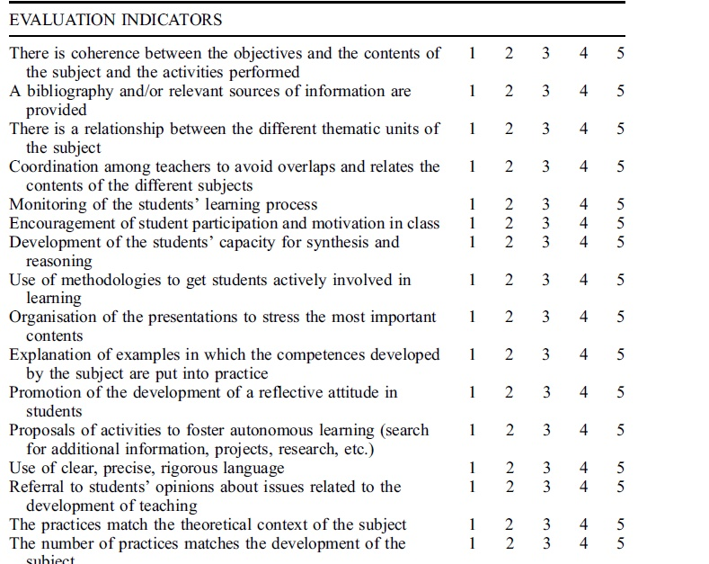
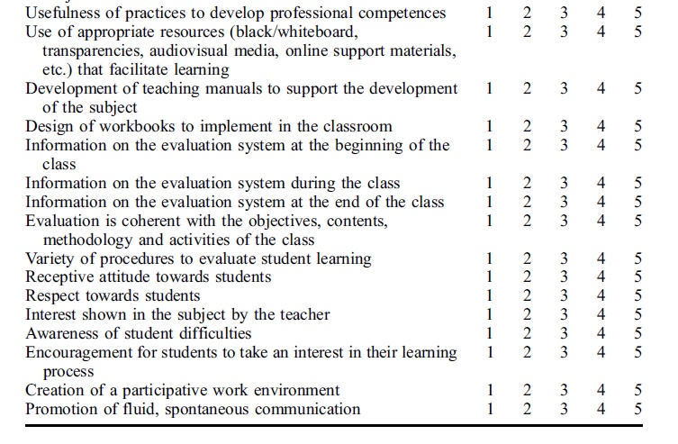
APPENDIX3
- Class-Related Emotions
Attending classes at university can induce different feelings. This part of the questionnaire refers to emotions you may experience when being in class at university. Before answering the questions on the following pages, please recall some typical situations of being in class which you have experienced during the course of your studies. Read each item carefully and RESPOND USING THE SCALE PROVIDED. Record your answers on the BUBBLE SHEET, using the appropriate number, 1 THROUGH 80.

The following questions pertain to feelings you may experience. Please indicate how you feel, typically, before you go to class.

1  Strongly  Disagree | 2 | 3 | 4 | 5  Strongly  Agree

1.
I get excited about going to class.
2.
It’s pointless to prepare for class since I don’t understand the material anyway.
3.
Even before class, I worry whether I will be able to understand the material.
4.
Being confident that I will understand the material motivates me.
5.
I am looking forward to learning a lot in this class.
6.
Because I’m so nervous I would rather skip the class.
7.
I am confident when I go to class.
8.
I wish I didn’t have to attend class because it makes me angry.
9.
I am full of hope.
10.
Even before class, I am resigned to the fact that I won’t understand the material.
11.
I am motivated to go to this class because it’s exciting.
12.
I worry whether I’m sufficiently prepared for the lesson.
13.
My confidence motivates me to prepare for class.
14.
The thought of this class makes me feel hopeless.
15.
I worry whether the demands might be too great.
16.
My hopes that I will be successful motivate me to invest a lot of effort.
17.
Thinking about class makes me feel uneasy.
18.
Because I’ve given up, I don’t have energy to go to class.
19.
When I think about class, I get queasy.
20.
I am optimistic that I will be able to keep up with the material.
21.
I feel scared.
22.
I’d rather not go to class since there is no hope of understanding the material anyway.
23.
I am hopeful that I will make good contributions in class.
DURING CLASS
The following questions pertain to feelings you may experience DURING class. Please indicate how you feel, typically, during class.
24.
I enjoy being in class.
25.
I worry the others will understand more than me.
26.
I’m tempted to walk out of the lecture because it is so boring.
27.
When I say something in class I feel like I turn red.
28.
I feel frustrated in class.
29.
Because the time drags I frequently look at my watch.
30.
I take pride in being able to keep up with the material.
31.
Because I don’t understand the material I look disconnected and resigned.
32.
My enjoyment of this class makes me want to participate.
33.
I get restless because I can’t wait for the class to end.
34.
When I say anything in class I feel like I am making a fool of myself.
35.
I get tense in class.
36.
I get bored.
37.
I am confident because I understand the material.
38.
After I have said something in class I wish I could crawl into a hole and hide.
39.
I feel anger welling up in me.
40.
I am proud that I do better than the others in this course.
41.
It’s so exciting that I could sit in class for hours listening to the professor.
42.
I get so bored I have problems staying alert.
43.
I get embarrassed.
44.
Thinking about the poor quality of the course makes me angry.
45.
I start yawning in class because I’m so bored.
46.
When I make good contributions in class, I get even more motivated.
47.
I’m embarrassed that I can’t express myself well.
48.
I feel hopeless.
49.
I enjoy participating so much that I get energized.
50.
I feel nervous in class.
51.
The lecture bores me.
52.
Because I get embarrassed, I become tense and inhibited.
53.
I am proud of the contributions I have made in class.
54.
Because I’m angry I get restless in class.
55.
I have lost all hope in understanding this class.
56.
I get scared that I might say something wrong, so I’d rather not say anything.
57.
During class I feel like I could sink into my chair.
58.
I am ashamed.
59.
Thinking about all the useless things I have to learn makes me irritated.
60.
When I do well in class, my heart throbs with pride.
61.
Because I get bored my mind begins to wander.
62.
When I talk in class I start stuttering.
63.
I find this class fairly dull.
64.
If the others knew that I don’t understand the material I would be embarrassed.
65.
When I don’t understand something important in class, my heart races.
66.
I think about what else I might be doing rather than sitting in this boring class.
67.
After class I start looking forward to the next class.
68.
I am ashamed because others understood more of the lecture than I did.
69.
I wish I could tell the teachers off.
70.
I am proud of myself.
71.
I am happy that I understood the material.
72.
I’d rather not tell anyone when I don’t understand something in class.
73.
I am angry.
74.
I think that I can be proud of what I know about this subject.
75.
I feel so hopeless all my energy is depleted.
76.
I am glad that it paid off to go to class.
77.
Because I take pride in my accomplishments in this course, I am motivated to continue.
78.
When I think of the time I waste in class I get aggravated.
79.
I feel hopeless continuing in this program of studies.
80.
I would like to tell my friends about how well I did in this course.

APPENDIX.4

1. Taking exams
2. Presentations of work in class
3. Intervening in class (e.g., asking questions, participating in debates)
4. Dealing with the teacher outside of class (e.g., in homeroom, office visits)
5. Academic overload (having too many exams and tasks to do)
6. Lack of time to fulfill all the activities we are asked to do
7. Competitiveness among classmates
8. Doing tasks that involve looking for information and writing
9. The task of studying (e.g., meeting established schedules, level of effort)
10. Working with classmates on tasks in class
11. Problems or conflicts with teachers
12. Problems or conflicts with classmates
13. Being able to attend all the classes
14. Too much responsibility to fulfill my obligations
15. Obtaining high grades in different subjects
16. Future academic and professional perspectives
17. Choosing subjects in the coming courses
18. Getting or keeping a grant to study
19. Finishing 10th grade (or 12th grade or Vocational Education) in the stipulated time periods
20. Family pressure to obtain good grades
21. Lack of support from my teachers
22. Keeping up with the academic activities and tasks
23. My relationships with my classmates
24. Doing things well in all the subjects in the course
25. Family discussions and conflicts caused by my studies
26. Making leisure time and academic work compatible
27. Teachers’ pressure about my work and behavior
28. The fact that my parents are always on top of me (e.g., whether I do my homework and activities, my grades, …)
29. Doing poorly on an exam.
30. The fact that my classmates think I’m not a good student.

