Abstract
The present study suggests that the amplitude of the error-related negativity (Ne/ERN) potential can be modified by over-learning and by correct/incorrect response feedback. 32 female Mexican college students, ages between 18 and 24, were recruited to participate. Previously to the electroencephalographic (EEG) recordings, participants were divided for training into 4 groups and were exposed to a) over-learning and correct response feedback learning; b) over-learning and incorrect response feedback learning; c) correct response feedback learning without over-learning and d) incorrect response feedback learning without over-learning. During EEG recording, participants were asked to press the key that matched a previously presented stimulus (“X”/“+”). Greater negativity in Ne/ERN amplitude was found during over-learning conditions compared to conditions without over-learning. Similar results were found in the over-learning/correct response feedback phase as opposed to the incorrect response without over-learning condition.

Keywords: Ne; ERN; feedback; over-learning; Loreta.

Resumen
El presente estudio sugiere que la amplitud de la negatividad relacionada con el error (Ne/ERN) puede ser modificada por el sobre-aprendizaje y por la retroalimentación de respuesta correcta/incorrecta. Para evaluar lo anterior, se seleccionaron cómo participantes a 32 mujeres universitarias mexicanas, de entre 18 y 24 años. Previo al registro del electroencefalográfico (EEG), las participantes se dividieron para el entrenamiento en cuatro grupos y para ser expuesta a alguna de las siguientes condiciones: a) sobre-aprendizaje y aprendizaje de retroalimentación de respuesta correcta; b) sobre-aprendizaje y aprendizaje de retroalimentación de respuesta incorrecta; c) aprendizaje de retroalimentación de respuesta correcta sin sobre-aprendizaje y d) aprendizaje de retroalimentación de respuesta incorrecta sin sobre-aprendizaje. Durante la grabación del EEG, se pidió a las participantes que presionaran la tecla que coincidiera con un estímulo previamente presentado ("X"/"+"). Se encontró una mayor negatividad en la amplitud de Ne/ERN durante las condiciones de sobre-aprendizaje en comparación con las condiciones sin sobre-aprendizaje. Se encontraron resultados similares en la fase de sobre-aprendizaje/retroalimentación de respuesta correcta, en oposición a la condición retroalimentación de respuesta incorrecta sin sobre-aprendizaje.
Palabras clave: Ne; ERN; retroalimentación; sobre-aprendizaje; Loreta.

Effects of overlearning and correct-incorrect response feedback on Ne/ERN amplitude

Permanent changes in behavior due to the learning process (Domjan, 2018) are inherent to changes in neural mechanisms (Penagos-Corzo, Bonilla, Rodríguez, Flores, & Negrete, 2015) and can be studied from different approaches, including fMRI and event related potentials (ERPs) paradigm (Sun, Sun, & Fu, 2019). ERPs can be related to a variety of processes that are invoked by the psychological demands of a given situation (Luck, 2014), for instance, learning tasks.
There are a vast variety of studies on the relation between ERPs and cognitive tasks, but there seems to be a lack of information on the Ne or ERN potential and the over-learning experience. This event-related potential (ERP) known as negativity error (Ne) (Falkenstein, Hohnsbein, Hoorman, & Blanke, 1990; 1991) or error-related negativity (ERN) (Gehring, Coles, Meyer, & Donchin, 1990), was originally described by Falkenstein, Hohnsbein, Hoorman and Blanke (1989), and conceived as an error monitoring system that, in the event of a mistake, would allow the necessary adjustments to correct or avoid them in the future (Gehring, Goss, Coles, Meyer, & Donchin, 1993). Subsequent studies have pointed out that this potential is a manifestation of error processing (Scheffers, Coles, Bernstein, Gehring, & Donchin, 1996), which reflects a general error-detection mechanism, not limited to the identification of certain types of errors in particular tasks (Miltner, Braun, & Coles, 1997). Thus, the previously mentioned potential, is an index of unfavorable results in general (Holroyd & Coles, 2002). The Ne/ERN is a negative deflection that shows on EEG recordings after having made a mistake and extends to approximately 100 ms (Hoogeveen, Schjoedt, & van Elk, 2018). Its amplitude varies from 2 to 10 μV and it is bilaterally symmetrical, having a maximal distribution around the scalp in the central and frontal regions (Grützmann, Endrass, Klawohn, & Kathmann, 2014; Riesel, Weinberg, Endrass, Meyer, & Hajcak, 2013). The origin of this component has been located in some brain structures, i. e. the anterior cingulate cortex (ACC), related to attention, executive functions, error detection and emotional processing (Holroyd & Coles, 2002; Luu, Tucker, Derryberry, Reed, & Poulsen, 2003; Van Veen & Carter, 2002); also in the dopaminergic pathways (Boksem, Meijman, & Lorist, 2006; de Bruijn, Hulstijn, Verkes, Ruigt, & Sabbe, 2004; Ridderinkhof et al. 2002; Tieges, Ridderinkhof, Snel, & Kok, 2004). Holroyd and Coles (2002) propose a model where they mentioned that ERN amplitude is linked to the mesencephalic dopamine system. They suggest that the presence of reward or punishment situations has an impact in dopaminergic activity and thus, in the studied component.
In reward-learning processes, the mesencephalic dopamine system encodes certain hedonic aspects of the reward (Ferdinand, Mecklinger, & Kray, 2008; Schultz, 2002; Schultz, Dayan, & Montague, 1997). This system acts as an error signal, in order to adjust the power of association between the stimulus and the responses. In this sense, when an event turns out better than expected, a positive dopaminergic signal is triggered. When the event turns out to be worse, the signal is negative (Schultz, 2002). Similar information encoded by dopaminergic neural activity –related to reward-learning and error prediction– is processed in the prefrontal cortex and the ACC. The latter has different neural populations, which encode separately positive and negative error predictions; this structure’s activity is particularly linked to the action to undertake than to the stimulus itself (Rushworth & Behrens, 2008).
On the other hand, as Ne/ERN is an electroencephalographic component related to error detection, is highly probable that it might be modified by the precision level of a task, which can be obtained and evaluated by the means of over-learning. Over-learning is the ongoing performance of a task immediately after its initial mastery, an error-free performance or when an improvement has plateaued (Driskell, Willis, & Copper, 1992; Rohrer & Pashler, 2007; Shibata, 2017). In general, over-learning is an inefficient strategy in long-term learning (Rohrer, Taylor, Pashler, Wixted, & Cepeda, 2005) and has an effect on the error rate. For example, it has been found that perseverative errors are higher in over-learning conditions, although in such conditions there is better performance in a reversal learning task (Dhawan, Tait, & Brown, 2019). Scheffers and Coles (2000) found that Ne/ERN varies with the perception of an imprecise behavior. The relationship between speed/precision and Ne/ERN suggests that this process is influenced by the importance given to errors by the participants: the greater the importance given, the stronger the Ne/ERN manifestation (Gehring Goss, Coles, Meyer, & Donchin, 2018). In this sense, there is evidence to suggest that motivational influences on monitoring performance have effects on Ne/ERN (Unger, Greulich, & Kray, 2014) Thus, in the present study, we hypothesize that over-learning and Correct-Response Feedback, increase Ne/ERN amplitude.

Method
Participants
Thirty-two female participants were recruited from a Mexican university subject pool, ages between 18 and 24. The mean of age of the group was 22. None of the participants reported having any neurological disorder or condition. None of them were currently taking any prescription medications, alcohol or drugs. All participants had normal or corrected-to-normal vision. Ethical criteria were conducted in accordance with the Declaration of Helsinki (World Medical Association, 2013), including informed consent of the participants. The research protocol was approved by the Research Board of the Department of Psychology.

Materials and Procedure
First phase: Training. Previous to ERP evaluation, participants were randomly divided into four groups and were exposed to four different experimental conditions: a) over-learning and correct response feedback learning (N = 8); b) over-learning and incorrect response feedback learning (N = 7); c) correct response feedback learning without over-learning (N = 7) and d) incorrect response feedback learning without over-learning (N = 10). Feedback on correct or incorrect responses was presented in the form of a visual and auditory reward or punishment. In this phase, participants were exposed to a visual discrimination task, presented on SuperLab v. 4.08 (Cedrus, 2009). Subjects were presented with an asterisk on the screen as a warning cue. Random stimuli were presented in the forms of crosses (+) and exes (x), for 1000 ms, in 260 pt. Helvetic, on a 21” screen, with 1680 x 1050 pixel resolution. Participants were instructed to press the key that matched the stimulus as fast as possible on a Cedrus RB-830answer keyboard. The task was the same throughout all four experimental conditions (and during EEG recording).
During over-learning, participants reached the correct/incorrect feedback phase only after achieving 60 correct responses plus 30 correct practice trials in a row. If participants were correct during the correct answer feedback phase, they were rewarded with a bell-like success sound accompanied by the word “bien” (good, in English). During the incorrect response feedback condition, when participants made a mistake, a “wrong answer” buzzer indicated failure and the word “mal” (bad, in English) appeared on screen. Feedback was absent when subjects answered correctly. In conditions without over-learning and with correct/incorrect response feedback, aversive and rewarding sounds were present, without considering the 60 correct responses plus the 30 correct practice trials criteria. Under these conditions, only 10 trials were performed prior to electroencephalographic recording.
Second phase: Recording task. During the Ne/ERN recording task, participants were presented with four blocks of 50 random stimuli each, with a one-minute pause between blocks. 20 percent of stimuli were targets. Stimuli were presented according to the oddball paradigm standard (see figure 1). The stimuli were presented in a similar way to the one used in the previous phase on a 17” LCD screen with 1024 x 768 pixels resolution, using E-Prime v. 2.0 program (Psychology Software Tools, Inc., 2008).

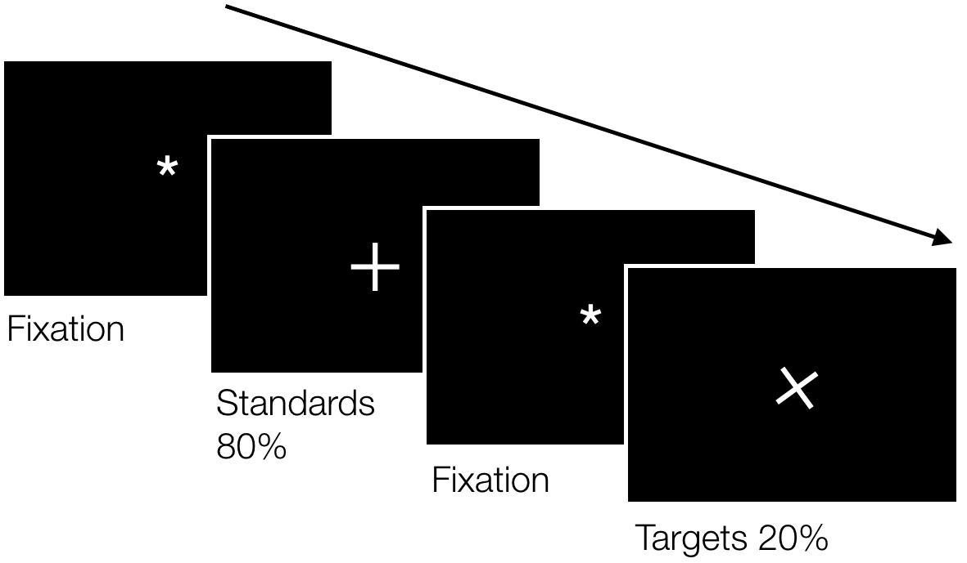
Figure 1. Paradigm for ERN.
EEG recording and analysis. EEG was recorded from 256 Hydrocel Geodesic Sensor scalp sites using the Geodesic EEG System 300, with an EEG Dense Array system (Electrical Geodesics [EGI], 2010), with a HydroCel GSN 256 1.0 montage (EGI, 2001). All electrode impedances were kept below 50 kΩ at the beginning of the recording. All channels were referenced to Cz and collected using 0.3-100 Hz bandpass. Afterwards, all channels were referenced to polar average reference effect (PARE) correction (EGI, 2006) and baseline corrected using 100 ms baseline period relative to segment start. The EEG data were filtered allowing frequencies between 0.01-30 Hz. Segments with artifacts due to 10 or more channels with data with fast average amplitude >200µV or differential amplitude >100µV, eye movement and blinking (>70µV) were eliminated from the recording. For the recording segmentation we took the subject’s response as a starting point of the segment, extending it as far as 200 ms, interval in which Ne/ERN event related potential appears according to literature (Gehring et al. 1990). For the statistical treatment only the recordings that surpassed 95.7% of correct channels or without significant artifacts were used. Spherical Spline Interpolation was used to recalculate bad-channel recordings. For the numerical data we only considered those errors made by mistake, not the ones made by omission. For the statistical treatment of Ne/ERN data was defined as the highest negative peak exhibited in a -100 ms-to-100 ms window relative to incorrect response for each participant. Segments baseline were corrected as mentioned before.
Finally, following Falkenstein et al. (1991) and Gehring et al. (1990), studies in which Ne/ERN appears in frontal-central and central areas, respectively, two different montages were created: frontal-central layout including 26 electrode positions and central layout with 15 electrodes (see figure 2).
A B
Figure 2. A) Central montage, B) Frontal-central montage.

Statistical analysis. Final data for the statistical analysis were a) Adaptive mean of Ne/ERN amplitude – redefined mean from a new interval, after calculating the mean of Ne/ERN original amplitude (EGI, 2006)–; b) Minimal Ne/ERN amplitude -the highest negative value in the defined interval-. A multivariate analysis was performed with two-way ANOVA, for comparisons between all conditions. For comparisons between two conditions, Mann Whitney's U was used.

Results
Behavior performance
The behavioral performance of the participants shows increased reaction time for correct responses in all conditions ( = 4 05.25) than for incorrect responses ( = 345.21). These differences are significant (t = 4.84, df = 31, p < .001). No statistically significant differences were found either in reaction times, or the number of errors between the different conditions.
The incorrect and correct responses data for each condition are showed in figure 3. The responses occurred in invalid epochs were not considered. For example, segments with artifacts, as noted before. These responses were analyzed for both, errors and hits, under all conditions. Only differences in error or incorrect responses were found in the OL vs WOL comparison, through a two-way ANOVA (F (1,28) = 5.745, p < .05)

Figure 3. Behavioral performance during recording task

ERN Analysis
When comparing maximum negativity amplitudes, significant differences were found in Ne/ERN minimum amplitude, in OL/WOL conditions (see figure 4) for central montage F (1, 28) = 4.680, p = .039, but not in other comparisons (p > .05). The higher mean was found in the OL condition (M = -6.01, DE= 2.58, N = 15), and a lower mean in the WOL condition (M = -4.54, DE = 1.95, N = 17), d = -.643.

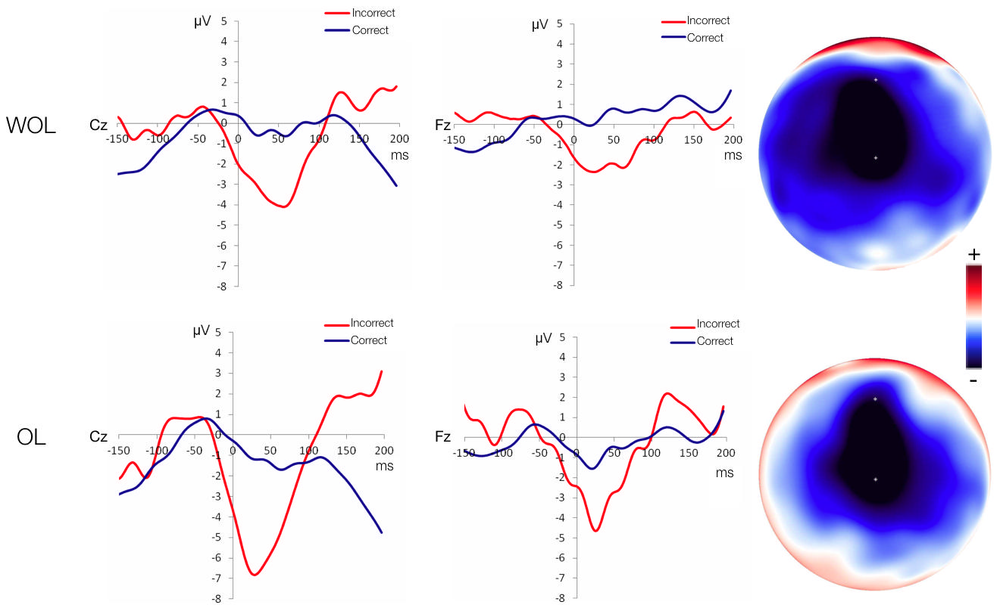
Figure 4. Grand-average Ne/ERN potential voltages comparison between OL vs. WOL conditions in Cz, Fz electrodes, and voltage maps.

The highest negative voltage was found on the Cz electrode, in which the OL condition has a greater-negative peak amplitude (-6.8 µV) than the one in the WOL condition (-4.1 µV) (t (290) = 1.968 p < .001) (see figure 4). A similar situation is observed for the Fz electrode (electrode No. 15), where the negative peak for the OL condition has a greater amplitude (-4.7 µV) than the one in the WOL condition (-2.4 µV) (t (254) = 1.969 p < .001) (see figure 4).
When comparing Over-learning with Correct Response Feedback vs. Incorrect Response Feedback conditions, significant differences (U = 8, p = .039) were found for the adaptive mean of the Ne/ERN amplitude with a central montage. In this comparison, the adaptive mean of the Ne/ERN amplitude for the OL/CRF condition, is greater (M = -4.67, SD = 2.58, N = 8) than the one for the IRF condition (M = -1.95, SD = 1.88, N = 6), d = -1.205. The areas with the highest negative voltages are located in the central (-7.5 µV for the OL/CRF condition) and frontal-central areas (-4.3 µV for the IRF condition) (see figure 5).
The highest negative voltage was found (see figure 5) around the Cz electrode, in which the OL/CRF has a greater-negative voltage (-7.5 µV) than the one in the OL/IRF condition (-2.7 µV) (t(279) = 1.968, p < .001) (see figure 4). In the Fz electrode a smaller amplitude negative voltage is found (-4.1 µV) for the OL/CRF condition than for the OL/IRF condition (-4.3 µV) (t(293) = 1.968, p < .001). This shows that there is primarily frontal activity in the latter condition (see figure 5).
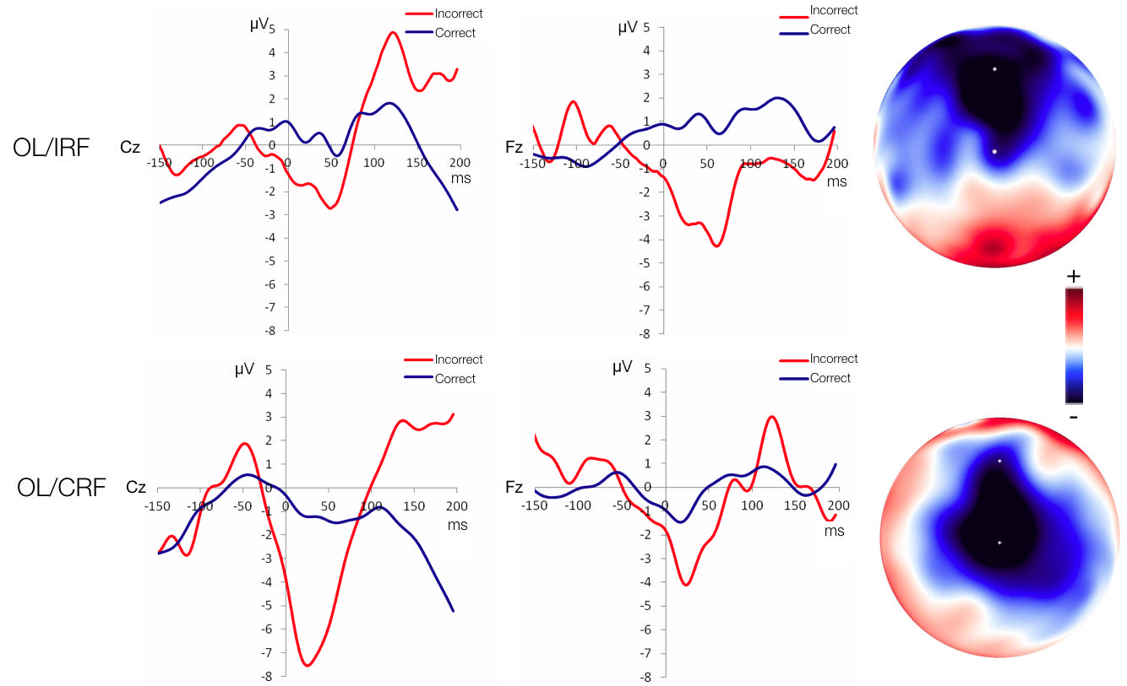
Figure 5. Grand-average Ne/ERN potential voltages comparison between OL/CRF vs. OL/IRF conditions in Cz, Fz electrodes, and voltage maps.

The intracerebral current density underlying the ERN was estimated using LORETA (Pascual-Marqui, 1991), executed with GeoSource v. 2.0 (EGI, 2011) Within a 50 to 100 ms window following error responses, this algorithm registered the mean peak latency of the ERN at FCz and Cz (73 ms) in the rostral and ventral regions of the ACC (see figure 6).

A
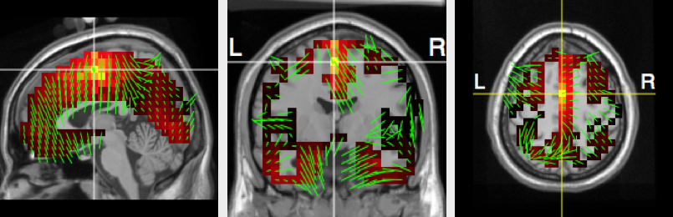
B
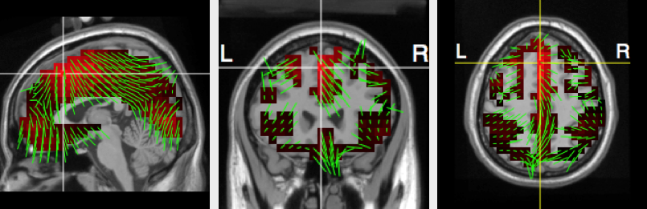
Figure 6. Source analysis with Loreta algorithm shows in A, activity for the OL/CRF condition, and in B, activity for OL/IRF.

Discussion
As stated in the present study, the participants who were exposed to over-learning conditions showed greater Ne/ERN amplitude, compared to other conditions. Even if there is evidence that points to a relationship between the precision level of a particular behavior and Ne/ERN (Gehring et al. 1990; Gehring et al.1993; Scheffers & Coles, 2000; Wessel, 2012), there seems to be no evidence on the effects that over-learning has on Ne/ERN amplitude. This study shows that over-learning is a precision measure and therefore affects Ne/ERN, thus supporting our initial statement.
The results presented here do not allow us to determine, due to the low number of incorrect responses, in what way the type of feedback affects the Ne/ERN wave amplitude, without over-learning. Nevertheless, the over-learning/feedback interactions show that the wave amplitude is greater in the over-learning/correct response feedback condition than in the without over-learning/incorrect response feedback condition. It is important to point out that, when comparing each of the other combinations (i.e. over-learning/correct response feedback vs. over-learning/Incorrect response feedback), no significant differences were found. Due to the fact that feedback was given in the form of either reward or punishment, is possible to suggest that over-learning acts as an amplifier of the reward vs. punishment effect. Even though the conditions where rewards were present did not modify the Ne/ERN amplitude, it was only during over-learning/reward interactions that effects were found. However, punitive stimulation through incorrect response feedback may not have been enough in quantity and/or intensity. This can be explained by the habituation effect, which refers to a decrease in a response to a stimulus after repeated exposure to that stimulus (Domjan, 2017). In the present study, participants exposed to punitive stimulation were only given feedback after giving an incorrect response, which may have caused a loss of interest in giving a correct answer.
It has been reported, although in participants who showed extremely low socialization scores that during avoidance-learning, low-SO participants found errors to be less salient; monitored their errant responses less closely; and were less concerned about the consequences of having made an error than during reward learning (Dikman & Allen, 2000). This suggests that the importance given to an incorrect response has to do with its emotional evaluation. This is consistent with the findings of Tucker et al. (2003) in the sense that Ne/ERN can also reflect a monitoring process of the conflict or an emotional evaluation of the actions. It is also important to note that participants showed significantly fewer errors in the overlearning condition. It is known that the error rate is related to the amplitude of Ne/ERN (Niessen, Fink, Hoffmann,Weiss, & Stahl, 2017). Therefore, it is also likely that the higher Ne/ERN in the overlearning condition was the result of low error rates.
The more frontal activity identified in the OL/IRF condition is consistent with the assumption of Tucker and Luu (2007). They suggest that, when the reward expectation is violated, the subject experiments distress and because of this, more activity in the ventral regions of the ACC is registered.
The behavioral performance of the participants is related with Scheffers et al. (1996) findings. These authors found that there was a greater latency to respond after given incorrect responses in which Ne/ERN amplitude was greater. They also observed that errors due to premature responses are related to a greater Ne/ERN, whereas errors due to lack of information (error related insecurity) were related to lower Ne/ERNs. On the other hand, Ne/ERN occurrence may or may not be accompanied by the awareness of having made a mistake (Shalgi, Barkan, & Deouell, 2009) without changing Ne/ERN magnitude (Nieuwenhuis, Ridderinkhof, Blom, Band, & Kok, 2001). Even though there are contradictory reports about the above (Di Gregorio, Steinhauser, & Maier, 2015; Wessel, 2012). However, there is a component referred to as error-positivity (Pe), which is related to the awareness of having made a mistake, as well as coping strategies, and with a subjective emotional evaluation of errors (Falkenstein et al., 1991; Falkenstein, Hoormann, Christ, & Hohnsbein, 2000). This component is a positive slow wave that occurs in parietal regions between 200 and 500 ms after making an error (Shalgi et al., 2009). Although its occurrence has also been reported in centro-parietal sites 150–400 ms after erroneous responses (Kim, Jang, & Kim, 2015). It was not in the purposes of the present study to analyze Pe, but future studies could investigate it in relation to the variables studied here.

Limitations
In the present study, participants were given feedback prior to Ne/ERN registry in one of the conditions. In this sense, Falkenstein (2005) found that Ne/ERN appearance can be controlled with feedback during its recording, having greater amplitude when feedback was related to error. As from these findings, it would be interesting to conduct a study in which Ne/ERN amplitude is analyzed when participants receive incongruent feedback during the recordings.
The small amount of errors committed by the participants in this study may have been caused by the simplicity of the visual discrimination cognitive task. Although a reduced number of errors is acceptable to analyze the amplitude of Ne/ERN (Fischer, Klein, & Ullsperger, 2017), we suggest working with a medium-to-high difficulty task in order to obtain a greater number of incorrect responses. For instance, a Stroop task could be used (Bailey et al., 2019; Larson, Kaufman, Kellison, Schmalfuss, & Perlstein, 2009; Luu, Tucker, & Collins (2000).
Within the limitations of this study is the reduced sample size. Therefore, it is important to confirm our findings with larger samples. At the same time, our explanations must be considered in light off the sample. Another limitation was the absence of a physiological record of the participant's error awareness. In future studies an electromyographic marker (Elkins, Saunders, & Inzlich, 2016) could be used, accompanied by some instruction to the participant to indicate the execution of an erroneous response.
Despite these limitations, the present study sheds light on the relationship between over-learning processes, brain feedback and brain electrical activity, specifically changes in Ne/ERN.

References
Bailey, N. W., Raj, K., Freedman, G., Fitzgibbon, B. M., Rogasch, N. C., Van Dam, N. T., & Fitzgerald, P. B. (2019). Mindfulness meditators do not show differences in electrophysiological measures of error processing. Mindfulness, 10(7), 1360–1380. doi:10.1007/s12671-019-1096-3
Boksem, M., Meijman, T., & Lorist, M. (2006). Mental fatigue, motivation and action monitoring. Biological Psychology, 72(2), 123-132. doi:10.1016/j.biopsycho.2005.08.007
Cedrus Corporation. (2009). SuperLab (V 4.0.8) [Software]. San Pedro, CA, EE. UU.: Author.
Dhawan, S. S., Tait, D. S., & Brown, V. J. (2019). More rapid reversal learning following overtraining in the rat is evidence that behavioural and cognitive flexibility are dissociable. Behavioural Brain Research, 363, 45–52. doi:10.1016/j.bbr.2019.01.055
De Bruijn, E., Hulstijn, W., Verkes, R., Ruigt, G., & Sabbe, B. (2004). Drug-induced stimulation and suppression of action monitoring in healthy volunteers. Psychopharmacology, 177(1-2), 151-160. doi:10.1007/s00213-004-1915-6
Di Gregorio, F., Steinhauser, M., & Maier, M. E. (2016). Error-related brain activity and error awareness in an error classification paradigm. NeuroImage, 139, 202–210. doi:10.1016/j.neuroimage.2016.05.074
Dikman, Z. V., & Allen, J. J. B. (2000). Error monitoring during reward and avoidance learning in high- and low-socialized individuals. Psychophysiology, 37(1), 43-54. doi:10.1017/S0048577200980983
Domjan, M. (2018). Habituation and sensitization. In M. Domjan (Ed), The essentials of conditioning and learning (pp. 27-41). Washington, D. C.: American Psychological Association. doi:10.1037/0000057-003
Donchin, E., Ritter, W., & McCallum, W. C. (1978). Cognitive psychophysiology: the endogenous components of the ERP. In K. A. Kooi, E. Callaway, P. Tueting & S. H. Koslow (Eds.), Event-related brain potentials in man (pp. 349-411). New York, EE. UU.: Academic Press.
Driskell, J. E., Willis, R. P., & Copper, C. (1992). Effect of Overlearning on Retention. Journal of Applied Psychology, 77(5), 615-622. doi:10.1037/0021-9010.77.5.615
Electrical Geodesics, Inc. (2006). Net Station Waveform Tools Technical Manual. Eugene, OR, EE. UU.: Author.
Electrical Geodesics, Inc. (2010). Net Station (V 4.4.1) [Software]. Eugene, OR, EE. UU.: Author.
Electrical Geodesics, Inc. (2011). GeoSource 2.0 [Software]. Eugene, OR, EE. UU.: Author.
Elkins, B. N., Saunders, B., & Inzlicht, M. (2016). Error-related electromyographic activity over the corrugator supercilii is associated with neural performance monitoring. Psychophysiology, 53(2), 159–170. doi: 10.1111/psyp.12556
Fabiani, M., Gratton, G., & Coles, M. G. H. (2005) Event-Related Brain Potentials. In J. T. Cacioppo, L. G. Tassinary, & G. G. Berntson (Eds.), Handbook of Psychophisiology (pp. 53-84). New York, EE. UU.: Cambridge University Press.
Falkenstein, M. (2005). Electrophysiology of response monitoring and control. Journal of Psychophysiology, 19(4), 241–243. doi:10.1027/0269-8803.19.4.241
Falkenstein, M., Hohnsbein, J., Hoormann, J., & Blanke, L. (1990). Effects of errors in choice reaction tasks on the ERP under focused and divided. In C. H. M. Brunia, A. W. K. Gaillard & A. Kok (Eds.), Psychophysiological Brain Research (Vol. 1, pp. 192 – 195). Tilburg, Netherlands: Tilburg University Press.
Falkenstein, M., Hohnsbein, J., Hoormann, J., & Blanke, L. (1991). Effects of crossmodal divided attention on late ERP components: II. Error processing in choice reaction tasks. Electroencephalography and Clinical Neurophysiology, 78(6), 447-455. doi:10.1016/0013-4694(91)90062-9
Falkenstein, M., Hoormann, J., Christ, S., & Hohnsbein, J. (2000). ERP components on reaction errors and their functional significance: a tutorial. Biological Psychology, 51(2-3), 87-107. doi:10.1016/S0301-0511(99)00031-9
Ferdinand, N. K., Mecklinger, A., & Kray, J. (2008). Error and deviance processing in implicit and explicit sequence learning. Journal of Cognitive Neuroscience, 20(4), 629-642. doi:10.1162/jocn.2008.20046
Fischer, A. G., Klein, T. A., & Ullsperger, M. (2017). Comparing the error-related negativity across groups: The impact of error- and trial-number differences. Psychophysiology, 54(7), 998–1009. doi: 10.1111/psyp.12863
Gehring, W. J., Coles, M. G. H., Meyer, D. E., & Donchin, E. (1990). The error-related negativity: an event-related brain potential accompanying errors. Supplement to Psychophysiology, 27(4A), S34.
Gehring, W. J., Goss, B., Coles, M. G. H., Meyer, D. E., & Donchin, E. (1993). A neural system for error detection and compensation. Psychological Science, 4(6), 385-390. doi:10.1111/j.1467-9280.1993.tb00586.x
Gehring, W. J., Goss, B., Coles, M. G. H., Meyer, D. E., & Donchin, E. (2018). The Error-Related Negativity. Perspectives on Psychological Science, 13(2), 200–204. doi:10.1177/1745691617715310
Grützmann, R., Endrass, T., Klawohn, J., & Kathmann, N. (2014). Response accuracy rating modulates ERN and Pe amplitudes. Biological Psychology, 961-7. doi:10.1016/j.biopsycho.2013.10.007
Gruzelier, J. H., Galderisi, S., & Strik, W. (2002). Neurophysological research in Psychiatry. In J. J. López-Ibor, W. Gaebel, M. Maj & N. Sartorius (Eds.), Psychiatry as a Neuroscience (pp. 125-180). Chichester, West Sussex, UK: Wiley.
Holroyd, C., & Coles, M. (2002). The neural basis of human error processing: Reinforcement learning, dopamine, and the error-related negativity. Psychological Review, 109(4), 679-709. doi:10.1037/0033-295X.109.4.679
Hoogeveen, S., Schjoedt, U., & van Elk, M. (2018). Did I do that? Expectancy effects of brain stimulation on error-related negativity and sense of agency. Journal of Cognitive Neuroscience, 30(11), 1720–1733. doi:10.1162/jocn_a_01297
Kim, S.-H., Jang, K.-M., & Kim, M.-S. (2015). Deficits in Error-Monitoring by College Students with Schizotypal Traits: An Event-Related Potential Study. PLoS ONE, 10(3), 1–14. doi:10.1371/journal.pone.0122861
Larson, M. J., Kaufman, D. A. S., Kellison, I. L., Schmalfuss, I. M., & Perlstein, W. (2009). Double Jeopardy! The Additive Consequences of Negative Affect on Performance-Monitoring Decrements Following Traumatic Brain Injury. Neuropsychology, 23(4), 433-444. doi:10.1037/a0015723
Luck, S. (2014). An introduction to the event-related potential technique. Boston: Massachusetts Institute of Technology.
Luu, P., Tucker, D. M., & Collins, P. (2000). Mood, personality, and self monitoring: negative affect and emotionality in relation to frontal lobe mechanism of error monitoring. Journal of Experimental Psychology, 129(1), 43-60. doi:10.1037/0096-3445.129.1.43
Luu, P., Tucker, D. M., Derryberry, D., Reed, M., & Poulsen, C. (2003). Electrophysiological responses to errors and Feedback in the process of action regulation. Psychological Science, 14(1), 47-53. doi:10.1111/1467-9280.01417
Martínez, A. M. (2002). Potenciales Evocados Auditivos de larga latencia (Peall) relacionados con el procesamiento de la información. Universitas Psychologica, 1(1), 67-80.
Miltner, W. H. R., Braun, C. H., & Coles, M. G. H. (1997). Event related brain potentials following incorrect feedback in a time-estimation task: evidence for a “generic” neural system for error detection. Journal of Cognitive Neuroscience, 9(6), 788-798. doi:10.1162/jocn.1997.9.6.788
Niessen, E., Fink, G. R., Hoffmann, H. E. M., Weiss, P. H., & Stahl, J. (2017). Error detection across the adult lifespan: Electrophysiological evidence for age-related deficits. NeuroImage, 152, 517–529. doi:10.1016/j.neuroimage.2017.03.015
Nieuwenhuis, S., Ridderinkhof, K. R., Blom, J., Band, G. P., & Kok, A. (2001). Error-related brain potentials are differentially related to awareness of response errors: evidence from an antisaccade task. Psychophysiology, 38(5), 752–760. doi:10.1017/S0048577201001111
Pascual-Marqui, R. D. (1991). Review of methods for solving the EEG inverse problem. International Journal of Bioelectromagnetism, 1, 75– 86.
Penagos-Corzo. J. C., Bonilla, A., Rodríguez, M. A., Flores, G., & Negrete, D. J. V. (2015). Conditional self‐discrimination enhances dendritic spine number and dendritic length at prefrontal cortex and hippocampal neurons of rats. Synapse, 69(11), 543–552. doi:10.1002/syn.21847
Psychology Software Tools, Inc. (2008). E-Prime Professional (V 2.0) [Software]. Pittsburgh, PA, EE. UU.: Author.
Rains, D. G. (2004). Principios de Neuropsicología Humana. México, D. F., México: McGraw-Hill.
Ridderinkhof, K. R., de Vlugt, Y., Bramlage, A., Spaan, M., Elton, M., Snel, J., et al. (2002). Alcohol consumption impairs detection of performance errors in mediofrontal cortex. Science, 298(5601), 2209-2211. doi:10.1126/science.1076929
Riesel, A., Weinberg, A., Endrass, T., Meyer, A., & Hajcak, G. (2013). The ERN is the ERN is the ERN? Convergent validity of error-related brain activity across different tasks. Biological Psychology, 93(3), 377-385. doi:10.1016/j.biopsycho.2013.04.007
Rohrer, D., & Pashler, H. (2007). Increasing retention without increasing study time. Current Directions in Psychological Science, 16(4), 183-186. doi:10.1111/j.1467-8721.2007.00500.x
Rohrer, D., Taylor, K., Pashler, H., Wixted, J. T., & Cepeda, N. J. (2005). The effect of overlearning on long- term retention. Applied Cognitive Psychology, 19(3), 361-374. doi:10.1002/acp.1083
Rushworth, M. F. S., & Behrens, T. E. J. (2008). Choice, uncertainty and value in prefrontal and cingulated. Nature Neuroscience, 11(4), 389-397. doi: 10.1038/nn2066
Scheffers, M. K., & Coles, M. G. H. (2000). Performance monitoring in a confusing world: error-related brain activity, judgments of response accuracy, and types of errors. Journal of Experimental Psychology, 26(1), 141-151. doi:10.1037/0096-1523.26.1.141
Scheffers, M., Coles, M., Bernstein, P., Gehring, W., & Donchin, E. (1996). Event-related brain potentials and error-related processing: an analysis of incorrect responses to go and no-go stimuli. Psychophysiology, 33(1), 42-53. doi:10.1111/j.1469-8986.1996.tb02107.x
Schultz, W. (2002). Getting formal with dopamine and reward. Neuron, 36(2), 241-263. doi: 10.1016/S0896-6273(02)00967-4
Schultz, W., Dayan, P., & Montague, P. R. (1997). A neural substrate of prediction and reward (cover story). Science, 275(5306), 1593–1599. doi:10.1126/science.275.5306.1593
Shalgi, S., Barkan, I., & Deouell, L. (2009). On the positive side of error processing: error-awareness positivity revisited. The European Journal of Neuroscience, 29(7), 1522-1532. doi:10.1111/j.1460-9568.2009.06690.x
Sun, X. W., Sun, Y., & Fu, Q. F. (2019). Cross-modal Learning and Its Cognitive and Neural Mechanisms. Progress in biochemistry and biophysics, 46(6), 565-577. doi: 10.16476/j.pibb.2018.0321
Tieges, Z., Ridderinkhof, K. R., Snel, J., & Kok, A. (2004). Caffeine strengthens action monitoring: evidence from the error-related negativity. Brain Research. Cognitive Brain Research, 21(1), 87-93. doi:10.1016/j.cogbrainres.2004.06.001
Tops, M., Boksem, M. S., Wester, A. E., Lorist, M. M., & Meijman, T. F. (2006). Task engagement and the relationships between the error-related negativity, agreeableness, behavioral shame proneness and cortisol. Psychoneuroendocrinology, 31(7), 847-858. doi: 10.1016/j.psyneuen.2006.04.001
Tucker, D. M. & Luu, P. (2007). Neurophysiology of motivated learning: adaptive mechanisms underlying cognitive bias in depression. Cognitive Therapy & Research, 31(2), 189-209. doi: 10.1007/s10608-006-9115-9
Tucker, D. M., Luu, P., Frishkoff, G., Quiring, J., & Poulsen, C. (2003). Frontolimbic response to negative feedback in clinical depression. Journal of Abnormal Psychology, 112(4), 667-678. doi:10.1037/0021-843X.112.4.667
Unger, K., Greulich, B., & Kray, J. (2014). “Trick or treat”: the influence of incentives on developmental changes in feedback-based learning. Frontiers In Psychology, 5, 968. doi:10.3389/fpsyg.2014.00968
Van Veen, V., & Carter, C. S. (2002). The timing of action –monitoring processes in the Anterior Cingulate Cortex. Journal of Cognitive Neuroscience, 14(4), 593-602. doi:10.1162/08989290260045837
Wessel, J. R. (2012). Error awareness and the error-related negativity: Evaluating the first decade of evidence. Frontiers in Human Neuroscience, 6. doi:10.3389/fnhum.2012.00088
World Medical Association. (2013). Declaration of Helsinki. Ethical Principles for Medical Research Involving Human Subjects. Retrieved from: https://www.wma.net/policies-post/wma-declaration-of- helsinki- ethical- principles- for- medical- research- involving- human- subjects/.

