Values and eudaimonic wellbeing: conclusions from the European Social Survey analysis

Abstract:
The present study analyses the influence of personal values on eudaimonic WB perception – on a sample of 33.123 respondents of the European Social Survey (2016) aged 15 and over. We use the six components of Ryff model (Autonomy, Environmental Mastery, Personal Growth, Self-Acceptance, Positive Relationships and Purpose in life) as a criteria for analyzing how personal values affect eudaimonic WB perception of individuals. In the second part an Exploratory Factorial Analysis has been applied to data related to personal values, and four different patterns have been proposed (Curious, Ambitious, Altruistic, and Polite). Finally, there have been examined variables related to education, income, health, and social relationship to analyze their influence on each profile.

Resumen:
El presente estudio analiza la influencia de los valores personales en la percepción eudaimónica del bienestar en una muestra de 33.123 encuestados de la Encuesta Social Europea (2016) de 15 años o más. Utilizamos los seis componentes del modelo Ryff (Autonomía, dominio del entorno, Crecimiento Personal, Autoaceptación, Relaciones Positivas y Propósito en la vida) como criterios para analizar cómo los valores personales afectan la percepción del bienestar eudaimónico en los individuos. En la segunda parte se ha aplicado un Análisis Factorial Exploratorio a los datos relacionados con los valores personales, y se han propuesto cuatro patrones diferentes (Curioso, Ambicioso, Altruista y Cortés). Finalmente, se han examinado variables relacionadas con la educación, los ingresos, la salud y las relaciones sociales para analizar su influencia en cada perfil.

Keywords: values, wellbeing, life satisfaction, measurement, European Social Survey.

Introduction

Well-being (WB) is a multidimensional concept that involves lots of perspectives, sense, and affections (Vittersø et al. 2010; Huppert & So, 2009). Also, it could be considered as an active and dynamic process that gives individuals a sense of how their lives are going through the interaction between their circumstances, environments, activities, and psychological resources or mental capital.
WB refers to both objective and subjective evaluations of human life (Lane, 2000). The objective component assesses observable characteristics evaluated within a defined scale, such as economic development, among others. The subjective element relates to a person’s experience of the quality of his/her life and emotional responses, satisfaction with different aspects of life and global satisfaction. Within this subjective component, values can provide predictive and explanatory power in the analysis of attitudes, opinions, and actions of individuals.
Personal values influence behavior and WB because they held motivations as striving towards goals underlying individuals (Schwartz, 2012; Schwartz & Sortheix, 2018; Huppert, 2009). They are considered subjective because they reflect what people think and state about themselves, and can envisage a broad range of attitudes, inclinations, and specific behaviors. Researchers have determined the usefulness of values in influencing action, because, understanding personal values mean understanding human behavior, and understanding human behavior approximates to understand WB fulfillment (Sagiv and Schwartz, 2000; Bobowik et al., 2011) (Sagiv et al. 2017). Moreover, researches demonstrated that focusing on improving one´s values and virtuous life is more effective in achieving eudaimonic happiness than focusing on hedonic subjective wellbeing (Braaten et al., 2019; Moore and Diener, 2019; Sheldon, Corcoran and Prentice, 2019) and that Positive Psychology program enhances emotional long term perception of wellbeing (Pintado, Castillo and Penagos-Corzo, 2018).
The aim of this article is to understand the relationship between values and eudaimonic WB perception among 33.123 respondents of the European Social Survey (2016) from different European countries. We are going to start with a brief presentation of value theory and empirical studies developed by Schwartz and colleagues; and the Ryff model of WB. These two conceptual models have been taken as reference frameworks for our research. Secondly, we explain the methodology that we follow to try to identify the relationship between values and WB perception. Based on the analysis of the empirical results we propose four different profiles attending predominant behaviors of individuals (curious, ambitious, altruistic and polite). Finally, we analyze the correlation between these four profiles with education/age, education/life satisfaction, and net income/life satisfaction.
- Values and wellbeing: a complex relationship
Values can be defined from two main perspectives: philosophical and psychological ones. From a philosophical perspective, value is a quality that we can attribute to objects, people, and relations (Schroeder, 2016). Values are qualities that human capacity discovers in the outer world and are essential for organizing it and for making decisions; they are based on the human capacity to axiological relationship with the external world (Ortega & Gasset, 1923). What is relevant from the philosophical perspective is that values are: inevitable (human always are making evaluations), they are generated in a social context and have an intersubjective dimension; and they constitute our personality and mediate our world vision (Weltsanschaung) (Cortina et al. 2008).
The psychological perspective –that take into consideration also sociological assessments– is the most relevant for our article and highlight some aspects of the previous philosophical definition. Schwartz and Sortheix state that: “﻿Most theorists agree in defining basic values as desirable, trans-situational goals, varying in importance, that serve as guiding principles in people’s lives” (Schwartz & Sortheix, 2018:1). This conception of values have six essential traits: 1) values are beliefs with a strong emotional dimension; 2) values refer to desired goals that motivate actions; 3) values transcend specific situations and tend to be relevant for different contexts; 4) values serve as evaluation criteria (many times unawareness); 5) values are ordered by importance and stablish hierarchies; and 6) their importance is established in relation to others values (Schwartz, 2012).
The relationship between values and eudaimonic Wellbeing has been studied intensively, and three main interpretations are presented (Russo-Netzer, 2018; Schwartz, S. H. and Sortheix, 2018; Sheldon, Corcoran and Prentice, 2019). 1) Values have a direct impact on Wellbeing (healthy values increase autonomy and unhealthy values undermine Wellbeing and cause stress and anxiety); 2) when personal and environmental values are congruent, the level of Wellbeing increases; 3) the level of Wellbeing depends on the attainment of desired goals.
The key question about the relationship between values and wellbeing is how can we measure both concepts: values and subjective wellbeing. One well stablished proposal of values measurement is the International Value Survey developed by Ronald Inglehart and Christian Denzel, which starting from Maslow basic need´s theory develop a theory of value change from material to postmaterialist values (Inglehart & Dezel, 2005). This theory do not face directly the connection between values and subjective wellbeing but we can conclude that the evolution to post-materialist societies is correlated with an Easterlin's conception of wellbeing (Easterlin 2002, 2003; Easterlin et al., 2010; Delhey, 2010). One confirmation of that correlation between wellbeing and material needs it the research developed by Noda, who conclude that the work-life balance has a positive effect on life satisfaction in the OECD countries (Noda, 2019).
Even though Inglehart and Denzel's proposal is very interesting, we are going to follow the scale for measuring values proposed by Schwartz and collaborators (Sagiv & Schwartz, 2000; Schwartz, 2012; Skimina et al., 2019). The reason is that this scale is currently the most widely used by social and cross-cultural psychologists for studying individual differences in values, where the Inglehart and Denzel scale focus on societal and cultural changes.
The Schwartz scale considers ten different motivational types of values that allow the measure of personal goals: 1) Universalism- that denotes understanding, tolerance, equality, and protection for the welfare of all and the environment and nature. 2) Benevolence – that relates to preservation and enhancement of the welfare of people with whom one is in frequent personal contact. 3) Tradition- that refers to respect, acceptance, and follow of the customs and ideas that traditional culture or religion provide the self, and be humble. 4) Conformity- that denotes the limitation of actions that could trouble others, violate social expectations or norms, and thus obey rules. 5) Security- that refers to safety against threats, harmony, and stability of society, relationships, and of the self. 6) Power – that relates to social status and prestige and control or dominance over people and resources, and wealth. 7) Achievement- that refers to personal success and demonstration of competence and abilities according to social standards.8) Self Direction refers to independent and freedom of thought and action-choosing, creating, exploring. 9) Stimulation- that relates to excitement, variety, novelty, and challenge in life. And 10) Hedonism – that refers to importance of fun, good time, pleasure, and sensuous gratification for oneself.
Looking specifically a wellbeing measurement, Carol Ryff, one of the most popular researchers studying that concept, defined six components constitute it: Autonomy, Environmental Mastery, Personal Growth, Self-Acceptance, Positive Relationships, Purpose in life (Ryff, 1989, 2014, 2017). Figure II presents Ryff’s model and its foundations and theoretical underpinnings (Ryff, 2017).
Figure II. Core dimensions Ryff Model and foundations
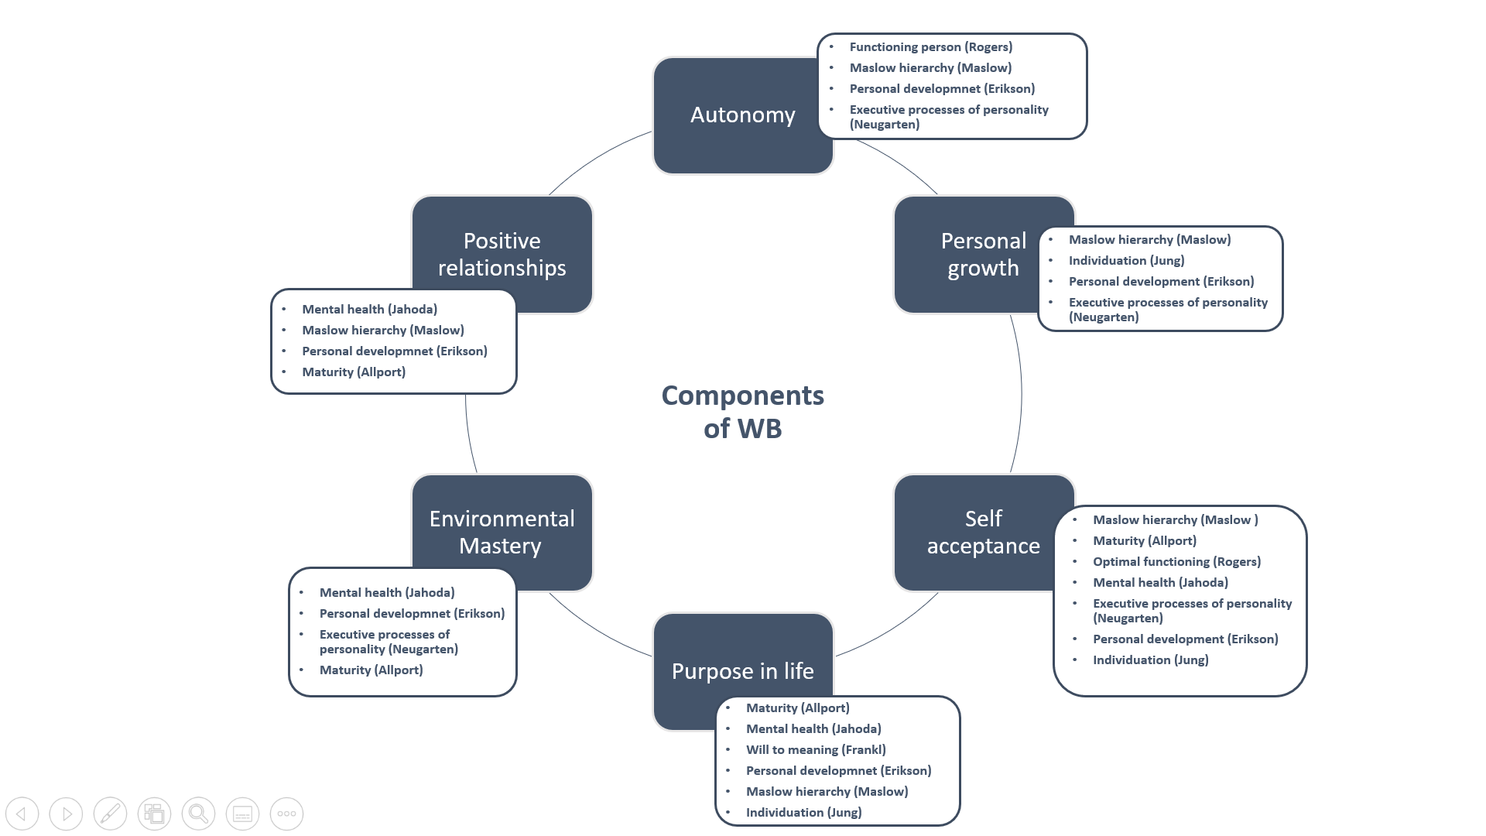
Source: Own elaboration based on Ryff, 2017
The autonomy factor is related to a fully functioning person (Rogers, 1961). It highlights independence and independent functioning and self-actualization, responding to Maslow's hierarchy (Maslow, 1968), personal development, and turning inward in later life (Erikson, 1959) and freedom from the norms and executive processes of personality (Neugarten,1973).
The personal Growth factor is related to self-realization and achieving personal potential related to the Maslow’s hierarchy (Maslow, 1968; Jahoda, 1958), and fully individualization (Jung, 1933). It takes into consideration basic life tendencies and challenges and tasks at different periods of life-related to executive processes of personality and personal development (Erikson, 1959; Bühler, 1935; Neugarten, 1973).
Self-Acceptance factor is related to having positive self-regard related to Maslow’s hierarchy (Maslow, 1968), maturity (Allport, 1961), optimal functioning (Rogers, 1961), and mental health (Jahoda, 1958). It includes the acceptance of one’s past life, including executive processes of personality and personal development or individuation (Erikson, 1959; Neugarten, 1973; Jung, 1933).
The purpose in life factor concerns to directedness and intentionality to life related to maturity and mental health (Allport, 1961; Jahoda, 1958); existential formulations, searching for meaning in adversity situations and will to meaning (Frankl, 1959), and its evolution along life-changing purposes or goals at different life stage concerning personal development, individuation or Maslow hierarchy (Erikson, 1959; Maslow, 1968; Jung, 1933).
Environmental Mastery factor is associated with the capacity to create situations suitable to one’s psychic needs necessary for mental health (Jahoda, 1958). It also relates to the capability to act on and change the close world through psychological and physical actions related to personal development or executive processes of personality (Erikson, 1959; Neugarten, 1973). And to maturity – state to extend the self into spheres of endeavor that goes beyond the person (Allport, 1961).
Positive Relations with Others factor refers to the ability to have feelings of empathy and affection and to love as a central feature of mental health (Jahoda, 1958). It also relates to deep friendship and understanding with others related to Maslow's hierarchy (Maslow, 1968), or intimacy and affection about personal development and maturity (Erikson, 1959; Allport, 1961).
Considering the Schwartz and colleagues' proposal for measuring values and the Ryff model for understanding Wellbeing explained before, the present study analyzes how personal values affect eudaimonic WB perception of individuals included in the European Social Survey 2016.

Research Methodology
For our study, it has been considered data provided by the European Social Survey - Round 8 - 2016 2.0 version. It includes information of 33.123 individuals of 18 countries distributed by: Austria (5,8%); Belgium (5,1%); Switzerland (4,4%); Czech Republic (6,6%); Germany (8,2%); Estonia (5,8%); Finland (5,5%); France (5,9%); United Kingdom (5,6%); Ireland (7,9%); Israel (7,3%); Iceland (7,9%); Netherlands (4,8%); Norway (4,4%); Poland (4,9%); Russian Federation (7,0%); Sweden (4,5%) and Slovenia (3,8%).
Gender participation is balanced, with 51% of female respondents and 47,9% male respondents overall. The age distribution is also well-adjusted. Individuals from 15 to 30 years old represent 20,2% of the sample, those from 31 to 50 the 32% of the sample, those from 51 to 65 the 25,7% of the sample and those from more than 65 years old 21,8%. So, the group of individuals from 31 to 50 years represents more share because it involves 20 years- 5 more than other groups.
ESS survey includes questions regarding WB that refer to general aspects of one´s perception of life, health, happiness, trust in others, social exclusion, religion, perceived discrimination, and national and ethnic identity.
Regarding human values, the ESS survey includes a well-established item measure of human values, which was developed by Prof. Schwartz, based on its own scale (Schwartz, 2012). The 'Human Values Scale' is designed to classify respondents according to their underlying value orientations.
Thus, there have been selected from ESS questions related to WB that refer to:
- General aspects of life satisfaction: All things considered, how satisfied are you with your life as a whole nowadays? – Measured with a scale from 0 to 10 being 0. Extremely bad and 10 Extremely good.
- General aspects of relationships: Using this card, how often do you meet socially with friends, relatives or work colleagues? – Measured with a scale from 1 to 7, being 1. Never; 2. Less than once a month; 3. Once a month; 4. Several times a month; 5. Once a week; 6. Several times a week and 7. Every day.
- General aspects of safety: How safe do you - or would you - feel walking alone in this area after dark? Do - or would - you feel... – measured with a scale from 1 to 4, being 1 very safe, 2 safe, 3 unsafe and 4 very unsafe.
- General aspects of subjective and objective health: How is your health in general? Would you say it is ... – Measured with a scale from Given with a scale from 1 to 5, being 1. Very good; 2. Good; 3. Fair; 4. Bad and 5. Very bad; and, are you hampered in your daily activities in any way by any longstanding illness, or disability, infirmity or mental health problem? If yes, is that a lot or to some extent? ... – Measured with a scale from 1 to 3, being 1. Yes, a lot; 2. Yes to some extent and 3. No.
- General aspects of education: Generated variable: Highest level of education, ES - ISCED: – measured with a scale from 0 to 7, being 0.Not possible to harmonize into ES-ISCED; 1.ES-ISCED I, less than lower secondary; 2. ES-ISCED II, lower secondary; 3.ES-ISCED IIIb, lower tier upper secondary; 4. ES-ISCED IIIa, upper tier upper secondary; 5.ES-ISCED IV, advanced vocational, sub-degree; 6. ES-ISCED V1, lower tertiary education, BA level and 7. ES-ISCED V2, higher tertiary education, >= MA level. And, informal learning: During the last twelve months, have you taken any course or attended any lecture or conference to improve your knowledge or skills for work? – Measured with a scale from 1 to 2, being 1 yes, and 2 no.
- General aspects of objective and subjective income: Household's total net income, all sources – measured on number; and feeling about household's income nowadays – Measured with a scale from 1 to 4, being 1 living comfortably on present income, 2 coping on present income, 3 finding it difficult on present income, 4 finding it very difficult on present income.
- And items defined by Prof. Schwartz associated with human values of respondents: Important to be rich, have money and expensive things, Important that people are treated equally and have equal opportunities, Important to show abilities and be admired; Important to try new and different things in life; Important to understand different people; Important to do what is told and follow rules Important to be humble and modest, not draw attention Important to have a good time Important to make own decisions and be free important to help people and care for others well-being Important to be successful and that people recognize achievements Important to seek adventures and have an exciting life Important to behave properly Important to follow traditions and customs Important to seek fun and things that give pleasure – measured with a scale from 1 to 6, being 1 very much like me, 2 like me; 3 some-what like me; 4 a little like me; 5 not like me and 6 not like me at all.
Once identified selected from ESS questions related to our study, we divide them attending their type of analysis they will follow. On one hand, we identified different values and attitudes that help us to identify several personal profiles; and by another, there are other general aspects of those profiles that could provide wider information about how they influence people’s life satisfaction.
23 selected variables have been related to identified values and attitudes including the type of evaluation process each variable has followed and linked to each Ryff dimension attending a personal consideration based on an equated distribution.
- Autonomy dimension includes the importance to be rich, to follow the rules or to make their own decisions, but also how hampered are individuals for doing in daily activities that include illness or mental problems.
- Environmental mastery refers to the importance of seeking adventures and have an exciting life, to think new ideas and be creative, but also feelings of safety including walking alone in the local area after dark.
- Personal growth relates to trying new and different things in life, but also with the level of education individuals have, or with the importance of improving knowledge and skills and attendance to courses, lectures, or conferences.
- Positive relationships comprise influence to follow traditions and customs, to behave correctly, to be humble, modest, or not draw attention, but also with the frequency of meeting with friends and socialize.
- The purpose in life refers to the importance of seeking fun and things that give pleasure, to have a good time, to understand different people and to treat equally, or help and care for others' wellbeing.
- And self-acceptance relates to importance to show abilities and be admired, to be successful, and people recognize their achievements, but also with subjective general health and feelings about the household’s income.
Variables related to human values (16) will be evaluated with an Exploratory Factor Analysis (AFE), while the others that are measured with another type of scale (7) will be examined separately with later analysis. The reason is that as presented on different possible responses, not all variables were measured on the same scale. Thus, to avoid disparities in measurement influence results and conclusions, it has been analyzed separately the ones that were comparable (because they were asked with the same language and evaluation scale) to the others.
Thus, the AFE analyses human values and relate them with different profiles of individuals. Once characterized different identified patterns, we include other variables and analyze their influence for each profile.

Data Analysis and results
Taking into consideration the 16 variables defined, an AFE has been determined. AFE consistency relies on the method of the main components with VariMax rotation and criterion of auto values higher than 0,9. By this way, on the AFE presented:
- The entire correlation matrix through Bartlett's sphericity contrast provides the statistical probability required for the correlation matrix of the variables to be an identity matrix. It is obtained from the transformation of the Chi-square of the determinant of the correlation matrix. As this statistic is high, being the level of significantly lower than 0.05, it is rejected the null hypothesis that the model is an identity matrix.
- The statistician of Kaiser-Meyer-Olkin (KMO). This index varies between 0 and 1, reaching 1 when each variable is correctly predicted without error by the other variables. If KMO value is 0.8 or higher, the sample suitability measure is outstanding; if it is 0.7 or higher, the measurement is regular; if it is 0.60 or higher, the height is mediocre; 0.50 or above negligible and below 0.50 unacceptable for exploratory analysis. This measure of adequacy or sample sufficiency increases as the sample size increases, the average correlations increase, the number of variables increases, or the number of factors decreases.
The factors of the factorial analysis define each different profile. By factor definition, this is a normal variable with mean 0 and standard deviation 1. Therefore, to establish the patterns have been taken a standard deviation as a measure of differentiation. Low-profile individuals are those persons below-1, middle-profile ones are those that are between-1 and 1, and high-profile ones are those that are above 1. By typical variable definition, the percentage of the sample that remains between minus a standard deviation and more a regular deviation is 68%. So below minus a standard deviation will be 16% of the sample and above more a standard deviation, there will be another 16%, as Figure III displays.

Figure III. Definition profiles of sample
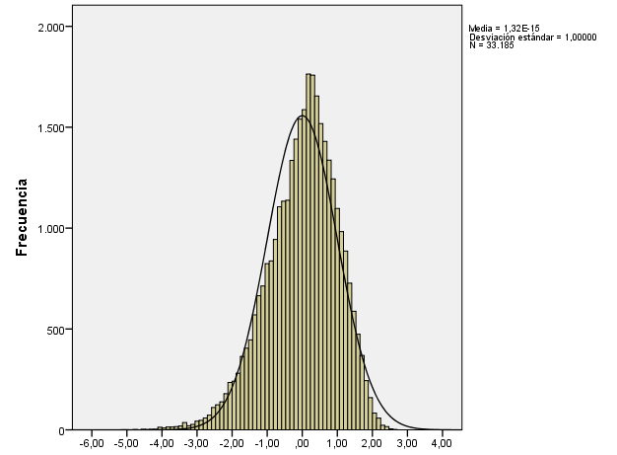

Low profile
<µ-α
16% sample
High profile
>µ+α
16% sample
Medium profile
µ± α
68% sample

Source: Own aboration

As high-profile defines a person that has a dominant prevalence of this profile, there will be 16% of people with each one of the patterns. Consequently, when displayed graphically, the balls' charts of each profile will have the same size for all of them.
After defined profiles, the other seven variables will be incorporated to make a broader descriptive of each pattern. Table I resume variables and type of analysis each will follow. As we can observe, some concepts have been evaluated twice, with different measures, once more objectively and other more subjectively. For instance, education has been assessed with the highest education level, but also with the improvement of knowledge on 12 last months. Income has also been measured with net income and feeling about that income. And health has been evaluated with hampered or illness and subjective general health.
Table I. Ryff dimension and evaluation process for each selected variable
Ryff dimension | N | Variable | Evaluation process
Autonomy | 1 | Importance to be rich, have money and expensive things | AFE
Autonomy | 2 | Importance to do what is told and follow rules | AFE
Autonomy | 3 | Importance to make own decisions and be free | AFE
Autonomy | 4 | Hampered in daily activities by illness/disability/infirmity/mental problem | Posterior analysis
Environmental mastery | 5 | Importance to seek adventures and have an exciting life | AFE
Environmental mastery | 6 | Importance to think new ideas and being creative | AFE
Environmental mastery | 7 | The feeling of safety of walking alone in local area after dark | Posterior analysis
Personal growth | 8 | Highest level of education | Posterior analysis
Personal growth | 9 | Importance to try new and different things in life | AFE
Personal growth | 10 | Improve knowledge/skills: course/lecture/conference, last 12 months | Posterior analysis
Positive relationships | 11 | Importance to follow traditions and customs | AFE
Positive relationships | 12 | Importance to behave properly | AFE
Positive relationships | 13 | Importance to be humble and modest, not draw attention | AFE
Positive relationships | 14 | Frequency of meeting with friends | Posterior analysis
Purpose in life | 15 | Importance to seek fun and things that give pleasure | AFE
Purpose in life | 16 | Importance to have a good time | AFE
Purpose in life | 17 | The importance that people are treated equally and have equal opportunities | AFE
Purpose in life | 18 | Importance to understand different people | AFE
Purpose in life | 19 | Importance to help people and care for others well-being | AFE
Self-acceptance | 20 | Importance to show abilities and be admired | AFE
Self-acceptance | 21 | Feeling about the household's income nowadays | Posterior analysis
Self-acceptance | 22 | Subjective general health | Posterior analysis
Self-acceptance | 23 | Importance to be successful and that people recognize achievements | AFE
Source: Own elaboration
As Table II presents, 14 of the 16 variables included in the AFE were significative, while two variables (3. Importance to make own decisions and be free, and 6. Importance to think new ideas and being creative) have been rejected because they do not correlate with any other item, and their level of significance is lower than 0,5.
Furthermore, as the KMO test is higher than 0,7 and Chi² is significative, AFE defined with 14 variables is adequate. Additionally, the four resulting factors explain more than 50% of the variance, so the presented model seems to be respectable. Thus, with those variables and identified four components, we have created the following four different individual profiles.
Table II. Component Matrix rotated profile
 | Component
 | 1 |  | 2 | 3 | 4
15. Importance to seek fun and things that give pleasure | ,800
16. Importance to have a good time | ,724
5. Importance to seek adventures and have an exciting life | ,684
9. Importance to try new and different things in life | ,646
23. Importance to be successful and that people recognize achievements |  |  | ,793
20. Importance to show abilities and be admired |  |  | ,762
- Importance to be rich, have money and expensive things |  |  | ,683
17. The importance that people are treated equally and have equal opportunities |  |  |  | ,761
18. Importance to understand different people |  |  |  | ,736
19. Importance to help people and care for others well-being |  |  |  | ,676
12. Importance to behave properly |  |  |  |  | ,727
2. Importance to do what is told and follow rules |  |  |  |  | ,695
- Importance to follow traditions and customs |  |  |  |  | ,692
13. Importance to be humble and modest, not draw attention |  |  |  |  | ,506
3. Importance to make own decisions and be free | - |  | - | - | -
6. Importance to think new ideas and being creative | - |  | - | - | -
Barlett test:  Chi²=92260  sig. 0,000 |  | KMO test = 0.793%  Variance explained by the factors of each AFE  (with self-values >0.9) = 56,89%
Source: Own elaboration

- Personal values and eudaimonic wellbeing: a four profiles proposal
Taking into consideration delivered results in Table II, we created and named four different profiles attending predominant behaviors and values individuals report, and component majority fit. For instance, questions 15, 16, 5 and 9 have been related to component 1; items 23, 20 and 1 to component 2; 17, 18 and 19 to component 3; and 12, 2, 10 and 13 to component 4. Questions 3 and 6 are been rejected. And with that information, and considering meaning of items grouped by each element, we named different profiles.
Component 1 groups individuals that seek fun, adventures, exiting life, have a good time and try new things in life, so we named it curious profile, and we define it as an extroverted, adventurer, animated and curious individual. Component 2 units people that desire be admired and recognized for achievements, and to be rich; they aspire for social or professional recognition and material success; so we called it an ambitious profile. Component 3 relates persons that look for help and care, other people, try to understand different and defend equality, so we defined as an altruist and solidarity person and named it altruistic profile. At last, component 4 groups individuals that behave correctly, like follow traditions, rules, be humble, and we imagine them as polite or correctness people, so we named this profile polite.
Once defined different patterns, we associated them with the dimensions of the Ryff Model, to examine engagement each profile with aspect it majority fills. Thus, most of the profiles have a mix of dimensions, for instance: the Curious or Adventurer pattern enhances the importance of seeking fun, pleasure, and enjoyable time, which refers to Purpose in Life dimension of Ryff. But it also highlights to explore adventures (Environmental Mastery) or to try new things in life (Personal Growth). Ambitious profile enhances the self (Self-acceptance) and money (Autonomy). While Altruistic profile emphasizes the others (Purpose in Life), and Polite pattern enhances the correctness (Positive relationship).
As Figure IV displays, except the Altruistic profile that focuses 100% accurately on Purpose in life, the other ones have a mix of different dimensions. Polite pattern enhances positive relationships mixed with autonomy dimension, while Ambitious profile remarks self-acceptance and autonomy dimension.
Figure IV. Relationship individual profiles with Ryff dimensions

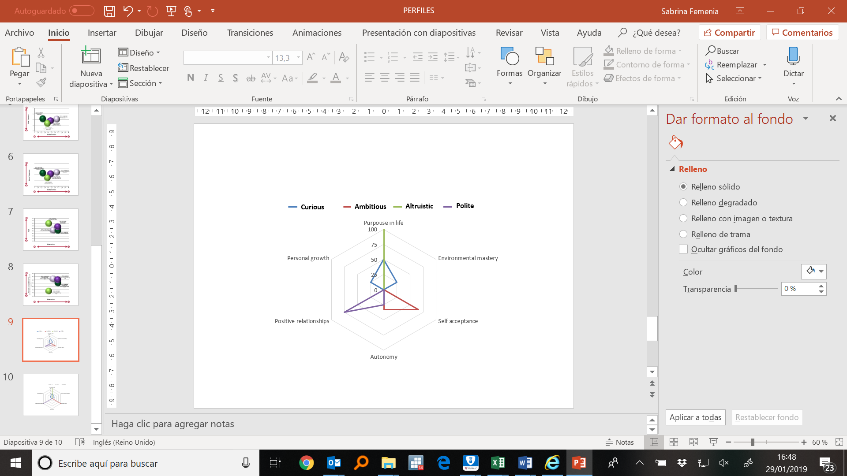
Source: Own elaboration
Therefore, our analysis anticipate that there could be significative differences among profiles; however, we include different variables identified before to contrast those differences persist together with broader information, and if they influence eudaimonic WB perception. Our results are coherent with recent Braaten and colleagues studies, wich conclude that: “(…) students will derive well-being from their studies in the broadest and most diverse way when they pursue them for personal growth, authenticity, and excellence (…)” (Braaten et al., 2019: 192).
Regarding age and formal education, Curious and Ambitious profiles are the youngest groups of individuals, both have similar age, although an Ambitious group is higher educated than the curious one. The Altruistic group is similarity trained as the Ambitious one, even if a bit older, while the Polite group refers to the oldest and lowest educated people. Nevertheless, as formal education refers only a part of individuals education, it also has been considered interesting using the information of attendance to a course, conference, or lecture to improve skills in the last 12 months, when they are available. Therefore, the relationship between that actualization, that could be assimilated to a part of non-formal education, for each profile and formal education level have been analyzed.
As Figure V displays, Polite individuals are the ones that less worried are about improving their knowledge, although their education level is the lowest. It could make sense when considering they are the oldest group, at latterly working age or retired. Curious individuals and Altruistic ones are the most active collective; they attend courses, lectures, and conferences with regular frequency to improve their skills. The Curious group, as young, middle educated, and restless individuals is proactive in developing their skills in specific areas. While Altruistic one, a bit older and better educated, does it for ongoing improving knowledge. By contrast, the Ambitious group- although looks forward to recognizing- does not take excessive care of improving their skills.
Figure V. Non-formal education and formal education at different profiles
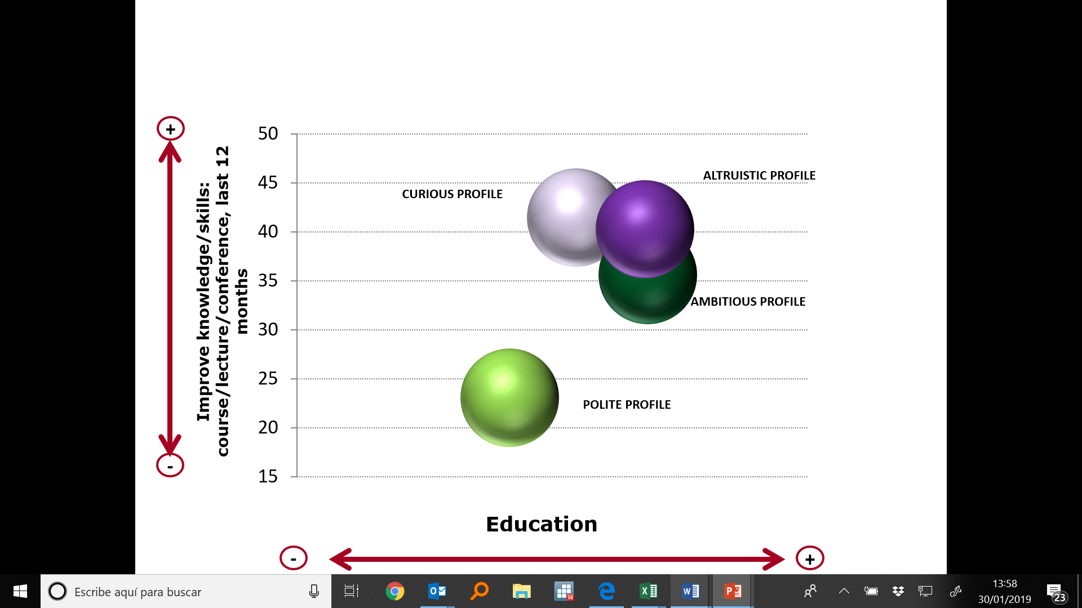
Source: Own elaboration
Regarding life satisfaction, we carried on several complementary analyses to each profile group that includes formal education, age, frequency of meeting with friends, feelings of safety, income, and subjective health.
Figure VI shows the relationship between the level of education of individuals (that we can assimilate to formal education) and life satisfaction. As figure remarks, although Ambitious and Altruistic individuals have a similar level of training, the life satisfaction of the Ambitious ones are lower than the Altruistic ones. The reason for this difference could be Altruistic individuals are older and focused on a search a purpose in life, enhancing others (understand, help, take care, treat equally different people) while Ambitious individuals are centered on themselves. The Curious group is the most satisfying collective; it represents young middle educated individuals. And Polite group is the middle-low satisfied collective that represents the oldest and lowest educated individuals.
Figure VI. Formal education and life satisfaction at different profiles
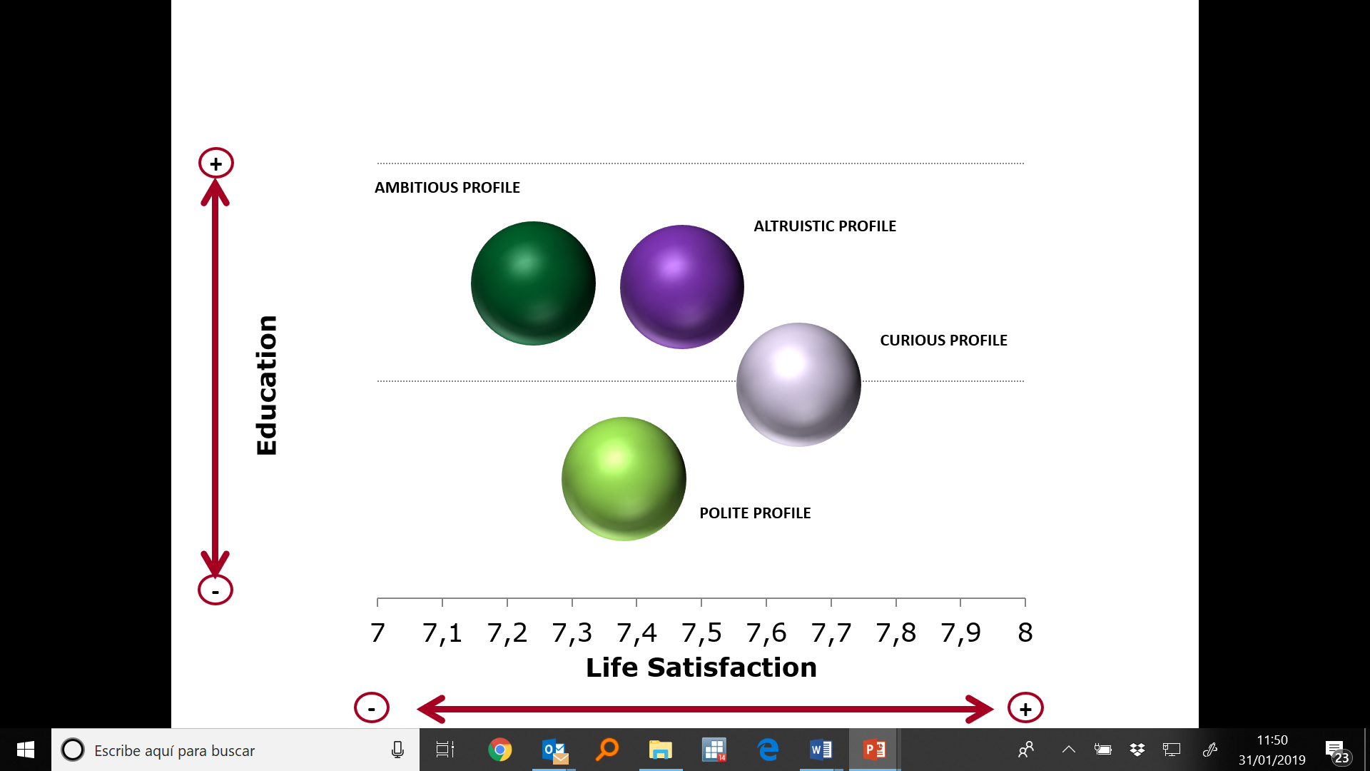
Source: Own elaboration

Examining social relationships with the frequency of meeting with friends, our results agree with previous researchers (Coleman, 1988; Putnam, 2000), being the more frequency of meeting with friends the higher life satisfaction individuals report. It is also interesting to note that positive relationship has a multiplier effect. As Moore and Diener show for partners´ relationship: “Thus, not only is SWB associated with good outcomes for participants but for their partners as well” (Moore and Diener, 2019:116) .As Figure VII displays, the Ambitious group that is more focused on the self, reports the lowest satisfaction, while the Curious group that is more opened collective report the highest satisfaction.

Figure VII. The frequency of meeting friends and life satisfaction at different profiles
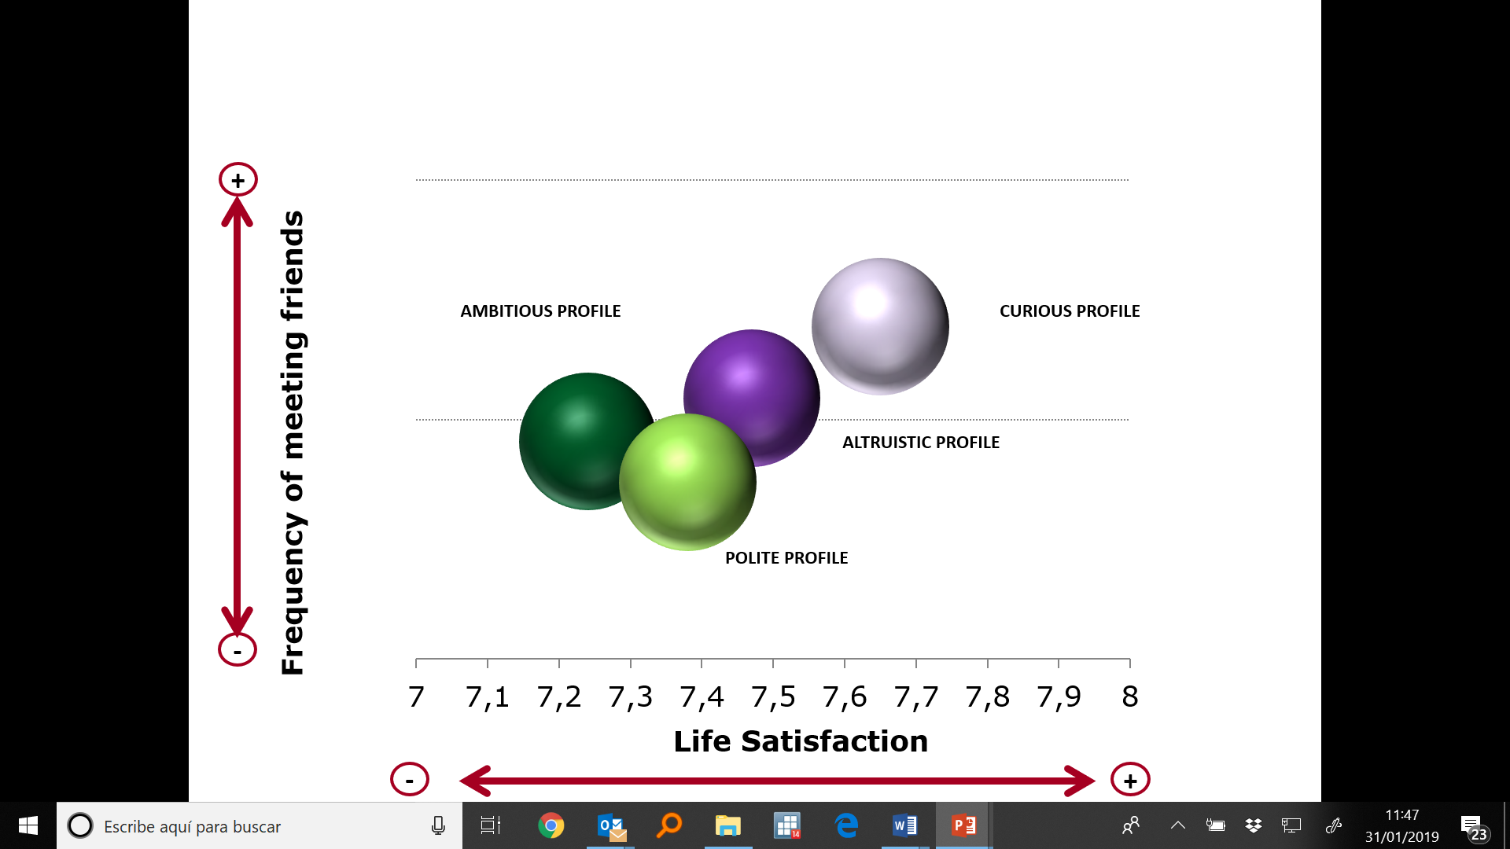

Source: Own elaboration

Regarding Income issues, it is a fact that income influence WB perception (Deaton, 2008; Diener & Diener, 1995; Pavot & Diener, 1993; 2013; Hudson et al. 2016; Easterlin, 2010; Easterlin et al. 2012), but research do not find a strong, positive correlation between GDP per capita and life satisfaction (Noda, 2019).
Deepen on Income data, it has been considered interesting to distinguish among net income that responds to an objectivated numeric value, and comfort feeling related to household income. Thus, two different analysis have been elaborated.
Figure VIII displays how Net income influences WB perception at different profiles. The Ambitious collective - although it presents the highest net income group- has the lowest satisfaction. By contrast, Curious collective -with slightly lower income- shows the highest satisfaction rate. That is because, for Ambitious individuals, money and materialistic issues play an essential role in their life, so they rarely will have enough. Furthermore, the Altruistic group, at a similar income level than the Curious group, present lower life satisfaction.

Figure VIII. Net income and life satisfaction at different profiles
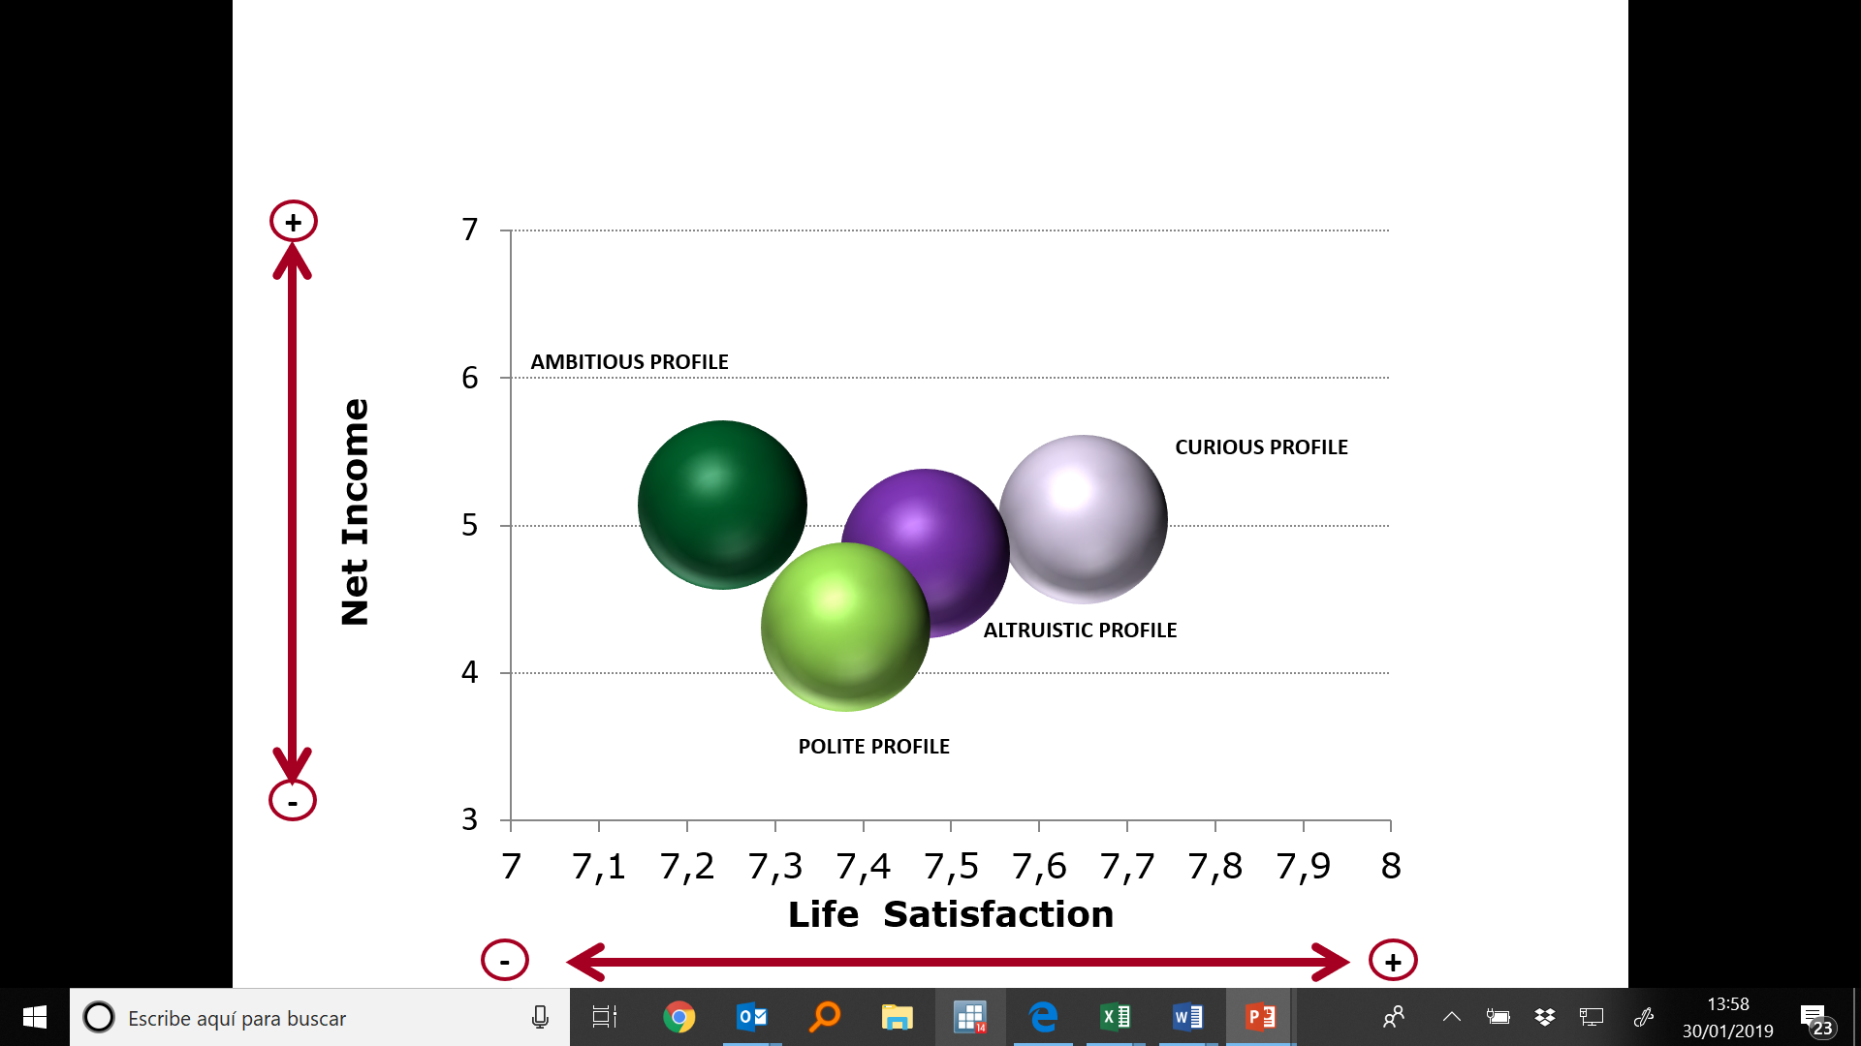
Source: Own elaboration

Finally, individuals' perception of their general health has been examined. It has been evaluated as a subjective evaluation provided by individuals' perception, but also introducing an objectivated aspect that refers to how hampered in daily activities by illness/disability/infirmity or mental problem they have.
As Figure IX displays, the Ambitious and the Curious collectives are rarely hampered (both are young individuals), and they offer different evaluations. It seems the Ambitious group does not take into consideration this healthy aspect of their assessment, because they present lower satisfaction rates. The Polite group represents the oldest group, and by the end, the most disabled one, although it neither seems to influence extending their satisfaction.

Figure IX. Feeling hampered in daily activities and life satisfaction at different profiles
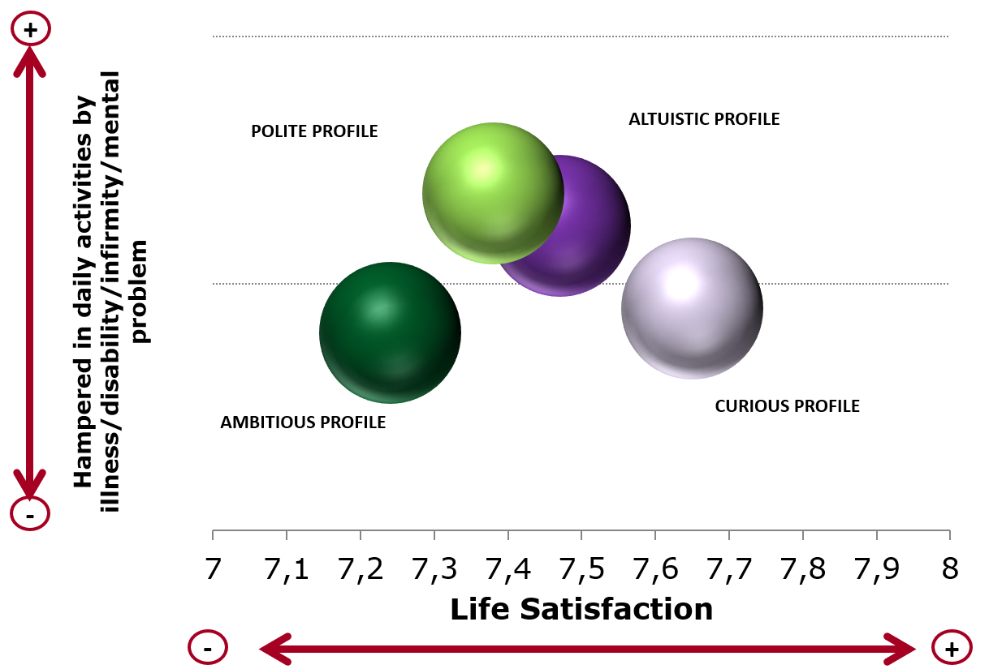

Source: Own elaboration
The same occurs in Figure X, and similar conclusions could be extracted. Better subjective general health groups (Ambitious and Curious) represent both extremes of satisfaction evaluations, depending on how each one takes into consideration their health and autonomy it provides.
Figure X. Subjective general health and life satisfaction at different profiles
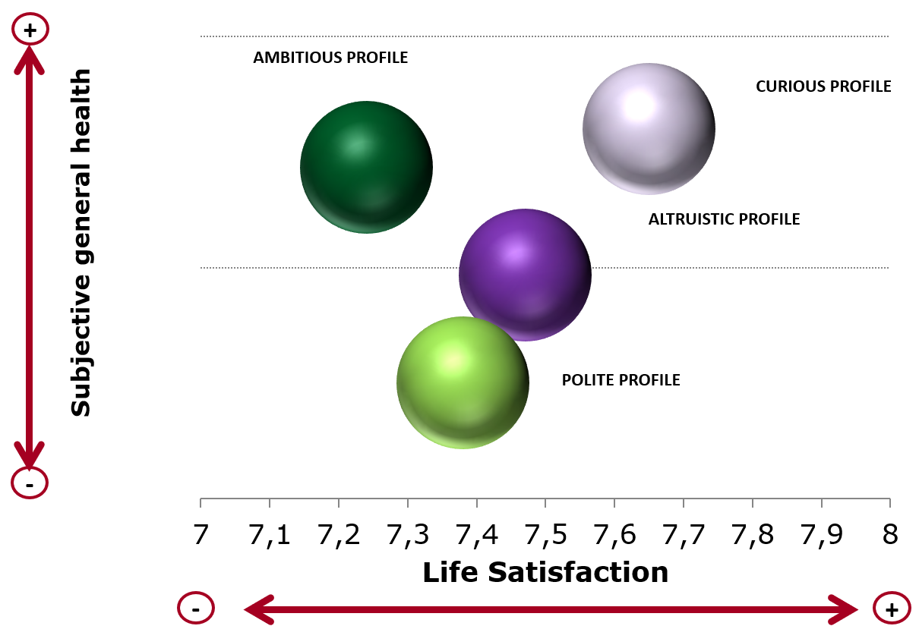
Source: Own elaboration

Conclusions
Several research demonstrate that education (OECD 2016, 2018, Boarini, et al. 2012; OECD 2013a), Personal safety (OECD 2011), income (Pavot & Diener, 1993; Myers, 2000; Diener & Biswas-Diener, 2002), health (Delaruelle, et al. 2016; OECD 2016) or social relationships (Coleman, 1988; Putnam, 2000, Helliwell & Putnam, 2004; DeNeve, et al. 2013), influence WB perception.
Our study, based on the European Social Survey, demonstrates that individuals’ profiles and values, also play an essential role in this influence. After applying an exploratory factor analysis and identifying distinct predominant patterns, we construct four different profiles based on: a) variables included in the European Social Survey that relate to defined components of WB and individuals' values; b) behaviors defined by Schwartz, and c) the six Ryff dimensions of wellbeing. We consider that values and perspectives are complementary and taking altogether information provided by both we can offer a more a comprehensive behavior explanation.
Education presents different effects depending on each profile. Polite individuals perform a lower education level and lower interest in improving knowledge. Thus, it influences al lower level of their WB. Curious individuals that enhance their personal growth and environmental mastery, although they present medium formal level of education, they are aware of improving knowledge and skills frequently, influencing at a major extent their WB.
Social relationships, by contrast, influence at all profiles in a similar way. As more frequency of meeting with friends, more life satisfaction and WB individuals report.
Personal safety influence is nearly inexistent for Altruistic individuals, those who have a predominant purpose in life dimension. It could explain the behavior of missioners or other humanitarian aiders that expose their life to helping others. By contrast, for Curious and Polite people, it influences their life satisfaction positively, while for Ambitious individuals, it seems not to have influence.
Income also impacts on the different way depending on profiles. It influences a greater extend to Ambitious individuals that enhance autonomy and self-acceptance components, that although they tend to have medium-high level income, they do not feel comfortable with it. By contrast, Polite individuals- those who domain positive relationships and autonomy, although they present lower income rates and feel uncomfortable about it, they do not influence at high extend their life satisfaction. Curious and Altruistic profiles present are more conformity; they accept and feel comfortable their wages and incomes; thus, it barely influences their WB.
General health influences positively WB for all profiles. Ambitious collective, although report good general health, (subjective and objective- the absence of illness) do not appreciate it. Curious individuals, by contrast, are medium hampered, and they report being good subjective general health. It would be interesting to deep on this collective to analyses why.
Further research should consider and contrast conclusions analyzing each specific aspect in the other way. It would say, for instance, through the exam of a hampered collective, it would be interesting to classify individuals attending their values and predominant behaviour, and measure also its WB perception. So, it could be contrasted reported conclusions and the strength of that relationship.

Literature

Allport, G. W. (1961). Pattern and growth in personality. New York: Holt, Rinehart & Winston.
Boarini, R. et al. (2012), “What Makes for a Better Life?: The Determinants of Subjective Well-Being in OECD Countries – Evidence from the Gallup World Poll”, OECD Statistics Working Papers, 2012/03, OECD Publishing.
Bobowik, M. et al. (2011) ‘Personal Values and Well-Being among Europeans, Spanish Natives and Immigrants to Spain: Does the Culture Matter?’, Journal of Happiness Studies, 12(3), pp. 401–419. doi: 10.1007/s10902-010-9202-1
Braaten, A. et al. (2019) ‘Hedonic and eudaimonic motives toward university studies : How they relate to each other and to well-being derived from school’, Journal of Positive Psychology & Wellbeing, x(June), pp. 1–17.
Bühler, C. (1935). The curve of life as studied in biographies. Journal of applied psychology, 19(4), 405. DOI: 10.1037/h0054778
Coleman, J. S. (1988). Social capital in the creation of human capital. American journal of sociology, 94, S95-S120.
Cortina, A. Conill, J. García-Marzá, D. (eds) (2008) Public Reason and Applied Ethics: The Ways of Practical Reason in a Pluralist Society. Hampshire: Ashgate Publishing.
De Neve, J. E., Diener, E., Tay, L., & Xuereb, C. (2013). The Objective Benefits of Subjective Well-Being. In Helliwell, J., Layard, R., & Sachs, J., eds. World Happiness Report 2013. Social Science Research Network.
Delaruelle, K., Buffel, V., & Bracke, P. (2016). The reversed gender gap and the education gradient in health: A cohort perspective. In 16th biennal congress of the European Society for Health and Medical Sociology.
Delhey, J. (2010) ‘From materialist to post-materialist happiness? National affluence and determinants of life satisfaction in cross-national perspective’, Social Indicators Research, 97(1), pp. 65–84. doi: 10.1007/s11205-009-9558-y.
Diener, E., & Biswas-Diener, R. (2002). Will money increase subjective well-being?. Social indicators research, 57(2), 119-169. https://doi.org/10.1007/978-90-481-2350-6_6
Diener, E., Tay, L., & Oishi, S. (2013). Rising income and the subjective well-being of nations. Journal of personality and social psychology, 104(2), 267. https://doi.org/10.1037/a0030487
Easterlin, R. A. (2002) Diminishing marginal utility of income? Caveat emptor. Social Indicators Research, 70(3), 243-255.
Easterlin, R. A. (2003) Building a better theory of well-being (pp. 29-64). Economics and Happiness. Framing the Analysis. Oxford: Oxford University Press. doi: 10.1080/13604813.2015.1024073.
Easterlin, R. A. (2010). Happiness, growth and the life cycle. Europe Journal of Psychology, 7(2), 395-398.
Easterlin, R. A. et al. (2010) ‘The happiness-income paradox revisited’, Proceedings of the National Academy of Sciences, 107(52), pp. 22463–22468. doi: 10.1073/pnas.1015962107.
Easterlin, R. A., McVey, L. A., Switek, M., Sawangfa, O., & Zweig, J. S. (2010). The happiness–income paradox revisited. Proceedings of the National Academy of Sciences, 107(52), 22463-22468. https://doi.org/10.1073/pnas.1015962107
Erikson, E. H. (1959). Identity and the life cycle: Selected papers. Psychological Issues, 1, 1-171
Frankl, V. E. (1985). Man's search for meaning. New York, Simon and Schuster.
Helliwell, J. F., & Putnam, R. D. (2004). The social context of well–being. Philosophical Transactions of the Royal Society of London. Series B: Biological Sciences, 359(1449), 1435-1446. https://doi.org/10.1098/rstb.2004.1522
Ho, L. S. (2012). Principles of public policy practice. Springer Science & Business Media.
Hudson, N. W., Lucas, R. E., Donnellan, M. B., & Kushlev, K. (2016). Income reliably predicts daily sadness, but not happiness: A replication and extension of Kushlev, Dunn, and Lucas (2015). Social psychological and personality science, 7(8), 828-836. https://doi.org/10.1177/1948550616657599
Huppert, F. A. (2009). Psychological well‐being: Evidence regarding its causes and consequences. Applied Psychology: Health and Well‐Being, 1(2), 137-164. https://doi.org/10.1111/j.1758-0854.2009.01008.x
Huppert, F. A., & So, T. (2009, July). What percentage of people in Europe are flourishing and what characterises them. In IX ISQOLS Conference (pp. 1-7).
Inglehart, R., & Welzel, C. (2005). Modernization, cultural change, and democracy: The human development sequence. Cambridge University Press.
Jahoda, M. (1958). Joint commission on mental health and illness monograph series: Vol. 1. Current concepts of positive mental health. New York, NY, US: Basic Books.
Jung, C. G. (2014). Modern man in search of a soul. London, Routledge 2014.
Lane, R. E. (2000). The loss of happiness in market democracies. Yale, Yale University Press.
Maslow, AH. (1968). Towards a psychology of being. 2nd. Van Nostrand; New York.
Moore, S. and Diener, E. (2019) ‘Types of Subjective Well-Being and Their Associations with Relationship Outcomes’, Journal of Positive Psychology and Well-being, x(x), pp. 1–15. Available at: http://journalppw.com/index.php/JPPW/article/view/118.
Neugarten, B. L. (1973). Personality change in late life: A developmental perspective. In C. Eisdorfer & M. P. Lawton (Eds.), The psychology of adult development and aging (pp. 311-335). Washington, DC, US: American Psychological Association.
Noda, H. (2019) ‘Work–Life Balance and Life Satisfaction in OECD Countries: A Cross-Sectional Analysis’, Journal of Happiness Studies. Springer Netherlands, (0123456789). doi: 10.1007/s10902-019-00131-9.
OECD- Organisation for Economic Co-operation and Development (2016). Skills Matter: Further Results from the Survey of Adult Skills, OECD Skills Studies, OECD Publishing, Paris. https://read.oecd-ilibrary.org/education/skills-matter_9789264258051-en#page1 https://doi.org/10.1787/9789264258051-en
OECD- Organisation for Economic Co-operation and Development (2016). Society at glance. https://www.slideshare.net/linoagudelo/society-at-a-glance-2016-oecd-social-indicators https://doi.org/10.1787/soc_glance-2016-5-en
OECD- Organisation for Economic Co-operation and Development (2011), How’s Life? Measuring well-being, OECD Publishing, Paris, https://doi.org/10.1787/9789264121164-1-en
OECD- Organisation for Economic Co-operation and Development (2017). Key Issues for Digital transformation in the G20. https://www.oecd.org/g20/key-issues-for-digital-transformation-in-the-g20.pdf
Ortega y Gasset, J. (1923) Introducción a una estimativa. ¿Qué son los valores? Madrid: Ediciones Encuentro.
Pavot, W., & Diener, E. (1993). The affective and cognitive context of self-reported measures of subjective well-being. Social Indicators Research, 28(1), 1-20. https://doi.org/10.1007/bf01086714
Pintado, S., Castillo, M. and Penagos-Corzo, J. C. (2018) ‘Comparing cognitive-behavior therapy and positive psychology to enhance emotional well-being’, Interamerican Journal of Psychology, 52(2), pp. 171–182. doi: 10.30849/rip/ijp.v52i2.338.
Putnam, R. D. (2000). Bowling alone: America’s declining social capital. In Culture and politics (pp. 223-234). Palgrave Macmillan, New York. https://doi.org/10.1007/978-1-349-62397-6_12
Rogers, C. R. (1961). On becoming a person. Boston: Hourghton Mifflin.
Russo-Netzer, P. (2018) ‘Prioritizing Meaning as a Pathway to Meaning in Life and Well-Being’, Journal of Happiness Studies. Springer Netherlands, 20(6), pp. 1863–1891. doi: 10.1007/s10902-018-0031-y.
Ryff, C. D. (1989). Happiness is everything, or is it? Explorations on the meaning of psychological well-being. Journal of personality and social psychology, 57(6), 1069. https://doi.org/10.1037//0022-3514.57.6.1069
Ryff, C. D. (2014). Psychological well-being revisited: Advances in the science and practice of eudaimonia. Psychotherapy and psychosomatics, 83(1), 10-28. https://doi.org/10.1159/000353263
Ryff, C. D. (2017). Eudaimonic well-being, inequality, and health: Recent findings and future directions. International review of economics, 64(2), 159-178. https://doi.org/10.1007/s12232-017-0277-4
Sagiv, L. and Schwartz, S. H. (2000) ‘Value priorities and subjective well-being: Direct relations and congruity effects’, European Journal of Social Psychology, 30(2), pp. 177–198. doi: 10.1002/(SICI)1099-0992(200003/04)30:2<177::AID-EJSP982>3.0.CO;2-Z.
Sagiv, L., Roccas, S., Cieciuch, J., & Schwartz, S. H. (2017). Personal values in human life. Nature Human Behaviour, 1(9), 630. https://doi.org/10.1038/s41562-017-0185-3
Schroeder, M. (2016) ‘Value Theory’, The Stanford Encyclopedia of Philosophy (Fall 2016 Edition).
Schwartz, S. H. (2012) ‘An Overview of the Schwartz Theory of Basic Values’, Online Readings in Psychology and Culture, 2(1). doi: 10.9707/2307-0919.1116.
Schwartz, S. H. and Sortheix, F. M. (2018) ‘Values and Subjective Well-Being What Values Are and How They Are Structured’, Handbook of Well-being, pp. 1–16.
Sheldon, K. M., Corcoran, M. and Prentice, M. (2019) ‘Pursuing Eudaimonic Functioning Versus Pursuing Hedonic Well-Being: The First Goal Succeeds in Its Aim, Whereas the Second Does Not’, Journal of Happiness Studies. Springer Netherlands, 20(3), pp. 919–933. doi: 10.1007/s10902-018-9980-4.
Skimina, E. et al. (2019) ‘Behavioral signatures of values in everyday behavior in retrospective and real-time self-reports’, Frontiers in Psychology, 10(FEB). doi: 10.3389/fpsyg.2019.00281.
Vittersø, J., Søholt, Y., Hetland, A., Thoresen, I. A., & Røysamb, E. (2010). Was Hercules happy? Some answers from a functional model of human well-being. Social Indicators Research, 95(1), 1. https://doi.org/10.1007/s11205-009-9447-4
Weehuizen, R. M. (2008). Mental capital: The economic significance of mental health (Doctoral dissertation, Maastricht University).

