A Visual Way to Represent Content Validity and Item Properties.

Abstract
The purpose of this instrumental study was to show how to conduct an R studio process to obtain a content validity visual representation through the alluvial function of the ggplot2 package to Condom Use Self-Efficacy Scale (CUSES). This paper explains the stages to analyse content validity using a visual representation of an interrater agreement and item – factor belonging and focused mainly in qualitative aspects to evaluated the judge’s behaviour and items weight. Furthermore, the paper discusses about classical criteria to obtain content validity and its representation. The visual representation used shows high relevance to present the qualitative data associated with the content validity analysis, since it allows to visualize in a differential way the weight of the dimensions in each item, the content validity coefficient in the set of dimensions and the behavior of the judges in the overall evaluation of the scale.

Keywords: CUSES, Content validity, R studio, Alluvial plot

Resumen

El propósito de este estudio instrumental fue mostrar cómo llevar a cabo un análisis a través de la plataforma R studio para obtener una representación visual de validez de contenido usando la función aluvial del paquete ggplot2 para la escala Condom use self efficacy (CUSES). Este artículo explica las etapas para analizar la validez de contenido utilizando una representación visual del acuerdo entre evaluadores y la pertenencia de cada ítem enfocado principalmente en aspectos cualitativos que permiten a la vez evaluar el comportamiento del juez e identificar el peso otorgado a los ítems. Además, el documento discute acerca de los criterios clásicos para obtener la validez de contenido y su representación. La representación visual utilizada muestra gran relevancia para presentar los datos cualitativos asociados al análisis de validez de contenido, ya que permite visualizar de manera diferencial el peso de las dimensiones en cada ítem, el coeficiente de validez de contenido en el conjunto de dimensiones y el comportamiento de los jueces en la evaluación general de la escala.

Palabras clave: CUSES, validez de contenido, R studio, Alluvial plot

Sexual intercourse is one of the main pathways of transmission for HIV and is the main cause of infection among young in Colombia (Instituto Nacional de Salud, 2019), several strategies are developed to recognize condom use as the only effective rate against both STIs, and pregnancy (UNFPA, 2015).
Attitudes towards condom are a psychosexual variable with greatest prediction about use (Fergunson, 2011; Albarracin, Johnson, Fishbein & Muellerleile, 2001; Diez, Juárez, Nebot, Cerda & Villalbi, 2000; Sheeran, Abrahan & Orbell, 1999). Other psychosocial key variables are knowledge about HIV and other ITS´s, (Vallejo-Medina et al., 2018; Yi, Te, Pengpid, & Peltzer, 2018), subjective norms or beliefs (Vincent, Gordon, Campbell, Ward, Albritton & Kershaw, 2016; Ellis, Homish, Parks, Collins & Kiviniemi, 2015) intention to use (Morales, Espada & Orgilés, 2019; Visser, 2017; Farrington, Bell & DiBacco, 2016; Widman et al, 2019), communication about condom (Cassar , 2019; Gause, Brown, Welge, & Northern, 2018; Caouette, Hudson, Bryan, Ewing, & Feldstein Ewing, 2018; Horan & Cafferty, 2017) and condom use self-efficacy (Brien, Thombs, Mahoney, & Wallnau, 1994; Forsyth, Carey, & Fuqua, 1997; Barkley, & Burns, 2000; Asante, & Doku, 2010; Shaweno, & Tekletsadik, 2013). Intentions to use condom or subjective norms or beliefs are usually measured with single questions, while others are assessed trough standardized scales. In Colombia, some versions are adapted to measure such variables (Plaza-Vidal, Ibagón-Parra & Vallejo-Medina, 2020; Morales, Espada, & Orgilés 2019; Morales et al 2018; Vallejo, 2017; Vallejo et al, 2016; Soler et al, 2016) but not to measure condom use self-efficacy.
Despite the importance of assessing the content validity, most psychometric studies skip this step (Vallejo-Medina, Ramírez, Saavedra-Roa, Gómez-Lugo, & Pérez-Durán, 2019; Mansouri, Nadrian, Allahverdipour, & Hejazi Bazargan, 2019; Gil-Llario, Morell-Mengual, Ruiz-Palomino, & Ballester-Arnal, 2019) in fact, most psychometric works just give Cronbach's alpha and an Exploratory Factor Analysis - with main components - (Gil-Llario, Ruiz-Palomino, Morell-Mengual, Giménez-García, & Ballester-Arnal, 2019; Golub, & Gamarel, 2017). Content validity is usually obtained through the inter-judge agreement, frequently three expert judges are needed (appointment) although this number of judges is not an agreement (Cronbach, 1971; Carmines & Zeller, 1979; Haynes, Richard, & Kubany, 1995; Polit & Beck, 2006; Carretero-Dios, & Pérez, 2007; LeBreton, & Senter, 2008). In any case, it does not seem a difficult requirement to reach for a researcher. Some of the most popular estimators calculate consensus among judges are: a) the kappa statistic used to test interrater reliability, to represent the extent to which the data collected are correct representations of the variables measured, taking into account the possibility that two raters on categorical (or ordinal) data actually guess on at least some variables due to uncertainty (Cohen, 1960) is easily calculated through statistical programs like SAS, SPSS or STATA; b) iota coefficient, used when a variety of targets are rated by different set of judges, is an index of interrater agreement of quantitative or nominal multivariate observation (Janson & Olson, 2001); c) Kendall's coefficient of concordance, used as an index of interrater reliability of ordinal data (McGraw & Wong, 1996) and, d) Coefficient of content validity (Aiken’s V), applied to summarize the ratings of expert judges through estimates of content validity by means of coefficients (Aiken, 1985).
At the mathematical or technical level, they do not seem difficult indicators to obtain either. So, why do so many researchers skip this step that minimizes the problems of construct validity so much? A possible explanation may be related to the cost in words of the article, for example, an evaluation on a table of specifications that measures five attributes of 20 items by five judges, assumes at least 500 words for a table. It is possible to save words by highlighting trends, but much relevant information would be lost.
To achieve the aim, the authors made an interrater agreement using alluvial visual representation in R, a tool that shows a lot of relevant information about items marking and agreement between judges.

Method
Participants
On one hand, the sample was two translators, five researchers with adequate expertise in sexuality and three bilingual psychologists, whom translate and carried out linguistic adaptation to the CUSES (see procedure). On the other hand, twelve professionals (three sexual health specialists, four psychometrics, one public health PhD and three sexologists) were asked to evaluate the translation and cultural adaptation of the CUSES in four attributes and assess the content validity and some item properties through a specification table.

Instruments
Condom Use Self-Efficacy Scale (CUSES, Brien, Thombs, Mahoney & Wallnau, 1994) evaluate a person's feelings of confidence about the possibility of buying condoms, putting them on, taking them off, and negotiating their use with a new sexual partner. The CUSES, in its first version, had 28 items with five Likert-scale response alternatives ranging from "Strongly disagree" = 0, to "Strongly agree" = 4. It also had seven items coded in reverse. These 28 items grouped in the initial application into 15 factors. Cronbach's alpha was .91 and test re-test correlation after two weeks .81 (Brafford, & Beck, 1991). Later studies propose changes in the factorial structure of the scale, reducing both, items and factors (Brien, Thombs, Mahoney, & Wallnau, 1994; Forsyth, Carey, & Fuqua, 1997; Barkley Jr., & Burns, 2000; Asante, & Doku, 2010; Shaweno, & Tekletsadik, 2013,) with Cronbach's alpha between .66 and .92 in all new versions.
Abbreviated version has 15 items with five response alternatives in Likert scale ranging from Strongly disagree = 0, to Strongly agree = 4, seven items coded in reverse. It has four factors, Mechanics (e.g., “I feel confident in my ability to put a condom on myself or my partner”; Cronbach´s alpha = .79), Partner's disapproval (e.g., “I would not feel confident suggesting using condoms with a new partner because I would be afraid he or she would think I have a sexually transmitted disease”; Cronbach´s alpha = .71), Assertive (e.g., “I feel confident in my ability to suggest using a condom with a new partner”; Cronbach´s alpha = .73) and Intoxicants (e.g., “I feel confident that I would remember to use a condom even if I were high”; Cronbach´s alpha = .82).
Adapted version of the scale can be consulted in supplemental materials.

Procedure
In the first part of the study a team of psychologist and translators, translated and carried out linguistic adaptation to the CUSES for use with Colombian Spanish speaking participants. Translators used intercultural adaptation guidelines for psychological measurement instruments based on Muñiz, Elosua, & Hambleton (2013), as well as AERA, APA, and NCME (2014) standards.
Twelve professionals were asked to evaluate content validity and some item properties through the following criteria: a) representativeness, item’s representative degree of the self-efficacy variable in condom use; b) comprehensiveness, assessment of whether the item is properly understood; c) interpretability, number of item’s interpretations; d) clarity, item’s conciseness / direct; and e) belonging, construct’s component to which the item belongs. Four construct’s component were the options: Appropriation (confidence to acquire and use condom in a sexual intercourse), Partner’s disapproval (confidence to deal with the possible rejection of a sexual partner), Assertiveness (individual's perceived ability to be assertive about the use of condoms) or Intoxication – “Self-control” in the Spanish version- (confidence to use a condom under the effect of substances that alter consciousness or sexual excitement). These evaluations enabled a final version of the scale to be reached.
Data analyses. This study was conducted with R (R Core Team, 2017) under RStudio interface (RStudio Team, 2016) content validity and other items properties were plotted using “ggplot2” package, “a system for declaratively creating graphics using the grammar of graphics” (Wickham et al, 2019. p. 1), an alluvial diagram, with “ggalluvial” function as a categorical data visualization technique generated its graphical representation, consist of axes, strata, alluvial flows and lodes (Brunson, 2019). This function visualizes categorical data with accurately convey proportions to viewers from tabular (or array) form, popular for storing data with multiple categorical dimensions. Raw data and syntaxes can be consulted in: https://github.com/CUSES/CUSES-Validation.

Results
Figure 1, shows the observations of the expert judges and the coefficient of content validity for inter-observer reliability analysis. Visual representation illustrates the behavior of each judge in the evaluation process as well as the evaluation of each judge against each criterion by item. For instance, we can observe how judges 1, 2, 4 and 6 had an acquiescent trend to value items as “perfect”. While judges 8 and 11 had a more critical view of the items content. Furthermore, item 2 and 5 -despite Aiken V value is the same for comprehensiveness and interpretability (item 2) and, representativeness and clarity (item 5)- but labels of the characteristic representing those values with different weight.

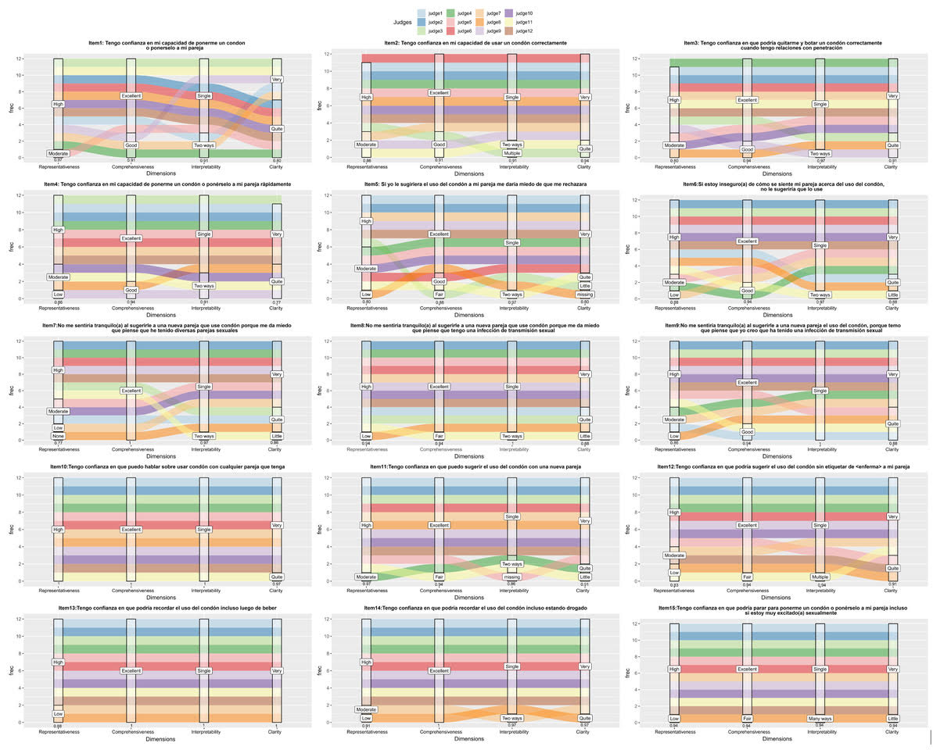
Figure 1. Judges agreement visual representation with ggalluvial.
Figure 2, shows the percentage of agreement between judges against the factor to which each one belongs. An additional benefit of using this visualization is that is easier to observe items codominance in two dimensions, opposite to a classical numerical presentation. Thus, items 1, 2, 3 and 4 have mixed qualitative weights within appropriation and assertiveness, and item 15 with appropriation and self-control. Implications for FA will be discussed.

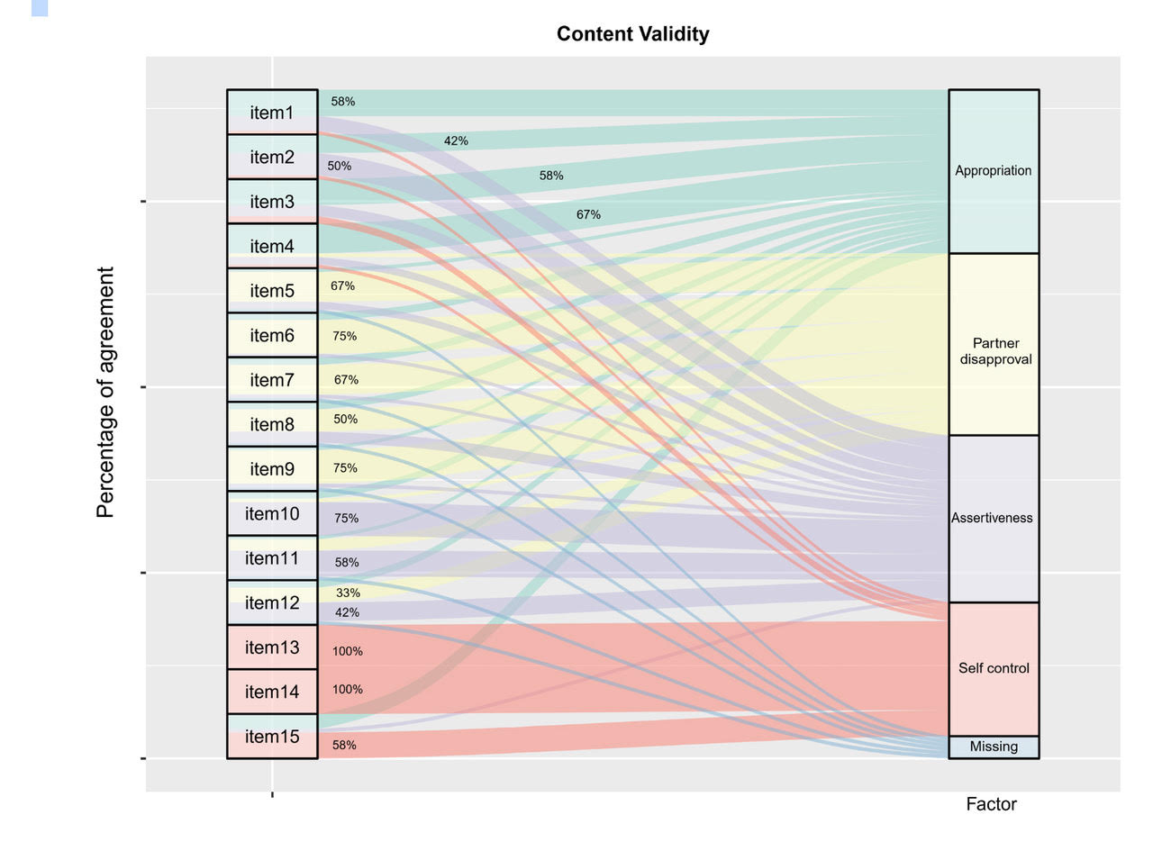
Figure 2. Content validity visual representation with ggalluvial.

Discussion
The objective of the present study was to show a visual representation about some items properties –content validity included- trough R studio. For those purpose, after translate and carried out linguistic adaptation to the CUSES, twelve professionals were asked to evaluate its translation and cultural adaptation in four attributes and four factors. Semantic definition of the construct to be measured facilitates its syntactic definition and decreases the likelihood of ambiguities in the adaptation process; also state that its presentation through a specification table facilitates the evaluation that judges do, although it is common to ignore it (Carretero-Dios & Pérez, 2005). Present study graphic representation provides helpful information about the distribution of the weights in each criteria evaluated by judges. It also displays trends of each judge evaluation and contrast the value of coefficient of content validity according to criteria. As could be seen here, three judges may not be a good number. Presence of missing data, acquiescence of some experts in the “best label”, or an extreme criticism may determine the final agreement. Thus, we suggest using a higher number of experts. Additionally, the presentation of the test specifications is usually carried out through a table that summarizes the general data of the judge’s evaluation. Perhaps limited by the manuscript words limitation, this prevents describing in depth the behavior of the item in relation to the global scale and of each judge in relation to the set of judges. This feature is fixed with the use of the alluvial plot, since this allows identifying differentially the values ​​attributed to each dimension and the relevance of each one in relation to the set of the items.
It is known that from a clear semantic definition of the construct it is possible to have better indicators of content validity, which in turn is related to the construct validity (Carretero-Dios & Pérez, 2007). Thus, with the results proposed here it is easy to see the possible overlap of some items in several factors. Despite, as happened with the versions by Brien, Thombs, Mahoney & Wallnau (1994), Asante & Doku (2010) and Shaweno & Tekletsadik (2013), four factors seems to set the scale (Appropriation, Partner´s disapproval, Assertiveness and Self-control), although this is different from results obtained in Thomas, Barkley Jr., & Burns (2000) with three factors. Visually is noted that some items may have relationships with two factors. In advance we could anticipate the using of Exploratory Structural Equation Modeling (ESEM) or by using rotations that force the positioning of an item on one of the factors. If item content is related to two dimensions, a rewording may help to clarify its factor. So that items with high scores are obtained even if judges do not agree about the attribute judged, or items with low scores can be obtained, although the judges are agreeing with item's attribute
This study suggests the use of a graphic representation to show the agreement between the judges, however the numerical indicators used here were inserted afterwards. Thus, we still do not have an R package that matches the graphical display with the numerical descriptor, something that could be addressed in the future.

References
Aiken, L.R. (1985). Three coefficients for analyzing the reliability and validity of ratings. Educational and Psychological Measurement, 45, 131–142. doi: 10.1177/0013164485451012
Albarracin, D., Johnson, B., Fishbein, M., & Muellerleile, P. (2001). Theories of reasoned action and planned behavior as models of condom use: a meta-analysis. Psychological Bulletin, 127, 142-161. doi: 10.1037/0033-2909.127.1.142
AERA, APA, & NCME. (2014). AERA, APA, and NCME. Standards for educational and psychological testing. Washington, DC: American Educational Research Association.
Asante, K., & Doku, P. (2010). Cultural adaptation of the Condom Use Self-Efficacy Scale (CUSES) in Ghana. BMC Public Health. 10:227. doi:10.1186/1471-2458-10-227
Barkley, W.Jr,. & Burns, J. (2000). Factor analysis of the condom use self-efficacy scale among multicultural college students. Health Education Research. 15, 489-499. doi: 10.1093/her/15.4.485
Brafford, L.J., & Beck, K.H. (1991). Development and validation of a condom self-efficacy scale for college students. Journal of American College Health, 39, 219-225. doi: 10.1080/07448481.1991.9936238
Brien, T., Thombs, D., Mahoney, C., & Wallnau, L. (1994) Dimensions of Self-Efficacy among three distinct groups of condom users. Journal of American College Health, 42, 167-174. doi: 10.1080/07448481.1994.9939665
Brunson, J.C. (2019). Package ggalluvial. Retrieved from https://cran.r-project.org/web/packages/ggalluvial/ggalluvial.pdf
Caouette, J.D., Hudson, K.A., Bryan, A.D., & Feldstein Ewing, S.W. (2018). Featured article: Adolescent condom use and connectivity in the social–planful brain. Journal of Pediatric Psychology, 43, 821-830. doi: 10.1093/jpepsy/jsy025
Carmines, E.G., & Zeller, R.A. (1979). Quantitative Applications in the Social Sciences: Reliability and validity assessment. Thousand Oaks, CA: SAGE Publications, Inc. doi: 10.4135/9781412985642
Carretero-Dios, H., & Pérez, C. (2005). Normas para el desarrollo y revisión de estudios instrumentales. International Journal of Clinical and Health Psychology, 5, 521-555.
Carretero-Dios, H., & Pérez, C. (2007). Standards for the development and review of instrumental studies: Considerations about test selection in psychological research. International Journal of Clinical and Health Psychology, 7, 863-882.
Cassar, J. (2019). There is condom-less sex but there are glow-in-the-dark condoms too: girls debating safe sex. Sexuality & Culture, 23, 1072–1088. doi:10.1007/s12119-019-09605-7
Cohen, J. (1960). A coefficient of agreement for nominal scales. Educational and Psychological Measurement, 20, 37–46. doi:10.1177/001316446002000104
Cronbach, L.J. (1971). Test validity. In R. L. Thorndike, (Ed). Educational measurement. (pp.443-507). Washington D.C: American Counsil on Education.
Diez, E., Juárez, O., Nebot, M., Cerda, N., & Villalbi, J. (2000). Effects on attitudes, knowledge, intentions and behaviour of an AIDS prevention programme targeting secondary school adolescents. Promotion & Education, 7, 17-22. doi:10.1177/102538230000700307
Ellis, E.M., Homish, G.G., Parks, K.A., Collins, R.L., & Kiviniemi, M.T. (2015). Increasing condom use by changing people’s feelings about them: An experimental study. Health Psychology, 34, 941-950. doi:010.1037/hea0000205
Ellis, E.M., Rajagopal, R., & Kiviniemi, M.T. (2017). The interplay between feelings and beliefs about condoms as predictors of their use. Psychology & Health, 33, 176–192. doi:10.1080/08870446.2017.1320797
Farrington, E., Bell, D., & DiBacco, A. (2016). Reasons people give for using (or not using) condoms. AIDS & Behavior, 20, 2850–2862. doi:10.1007/s10461-016-1352-7
Forsyth, A.D., Carey, M.P., & Fuqua, R.W. (1997). Evaluation of the validity of the Condom Use Self-Efficacy Scale (CUSES) in young men using two behavioral simulations. Health Psychology, 16, 175-178. doi: 10.1037/0278-6133.16.2.175
Gause, N.K., Brown, J.L., Welge, J., & Northern, N. (2018). Meta-analyses of HIV prevention interventions targeting improved partner communication: effects on partner communication and condom use frequency outcomes. Journal of Behavioral Medicine, 41, 423–440. doi:10.1007/s10865-018-9916-9
Gil-Llario, M.D., Ruiz-Palomino, E., Morell-Mengual, V., Giménez-García, C., & Ballester-Arnal, R. (2019). Validation of the AIDS prevention questionnaire: A brief self-report instrument to assess risk of HIV infection and guide behavioral change. AIDS & Behavior, 23, 272–282. doi:10.1007/s10461-018-2224-0
Gil-Llario, M.D., Morell-Mengual, V., Ruiz-Palomino, E., & Ballester-Arnal, R. (2019). Factorial structure and psychometric properties of a brief scale of the condom use self-efficacy for Spanish-speaking people. Health Education & Behavior, 46, 295–303. doi:10.1177/1090198118806964
Golub, S., & Gamarel, K. (2017). Psychometric evaluation of the condom carriers and motivations scale (CBMS). Journal of Behavioral Medicine, 40, 494–505. doi:10.1007/s10865-016-9815-x
Haynes, S.N., Richard, D., & Kubany, E.S. (1995). Content validity in psychological assessment: A functional approach to concepts and methods. Psychological Assessment, 7, 238-247. doi:10.1037/1040-3590.7.3.238
Horan, S.M., & Cafferty, L.A. (2017). Condom communication: Reports of sexually active young adults’ recent messages with new partners. Journal of Health Communication, 22, 763-771. doi: 10.1080/10810730.2017.1355420
Instituto Nacional de Salud. (2019). Informe de Evento. VIH/SIDA. Colombia 2018. Retrieved from https://www.ins.gov.co/buscador-eventos/Informesdeevento/VIH-SIDA%20SEMESTRE%20I%202019.pdf
Janson, H., & Olsson, U. (2001). A measure of agreement for interval or nominal multivariate observations. Educational and Psychological Measurement, 61, 277–289. doi:10.1177/00131640121971239
LeBreton, J.M., & Senter, J.L. (2008). Answers to 20 questions about interrater reliability and interrater agreement. Organizational Research Methods, 11, 815–852. doi:10.1177/1094428106296642
Mansouri, P., Nadrian, H., Allahverdipour, H., & Hejazi Bazargan, S. (2019). Condom use attitude and self-efficacy, and STIs risk perception among Iranian female sex workers: A psychometric study. Health Care for Women International, 40, 527-538. doi: 10.1080/07399332.2018.1526288
McGraw, K.O., & Wong, S.P. (1996). Forming inferences about some intraclass correlations coefficients. Psychological Methods, 1, 30-46. doi:10.1037/1082-989X.1.1.30
Morales, A., Espada, J.P., & Orgilés, M. (2019). Mediation of an efficacious HIV risk reduction intervention for adolescents: A cluster-randomised controlled trial. Journal of Health Psychology, 24, 1884–1896. doi:10.1177/1359105317707256
Morales, A., Vallejo-Medina, P., Abello-Luque, D., Saavedra-Roa, A., García-Roncallo, P., Gomez-Lugo, M., García-Montaño, E., … & Espada, J.P. (2018). Sexual risk among Colombian adolescents: knowledge, attitudes, normative beliefs, perceived control, intention, and sexual behaviour. BMC Public Helath. 18:1377. doi:10.1186/s12889-018-6311-y
Muñiz, J., Elosua, P., & Hambleton, R. (2013). Directrices para la traducción y adaptación de los test: segunda edición. Psicothema, 25, 151-157. doi: 10.7334/psicothema2013.24
Plaza-Vidal, R., Ibagón-Parra, M. & Vallejo-Medina, P. (2020) Translation, adaptation and validation of the Spanish version of the multidimensional condom attitudes scale for Colombian young. Manuscript under review.
Polit, D.F., & Beck, C.T. (2006). The content validity index: are you sure you know what's being reported? Critique and recommendations. Research in Nursing & Health, 29, 489-497. doi:10.1002/nur.20147
Shaweno, D., & Tekletsadik, E. (2013). Validation of the condom use self-efficacy scale in Ethiopia. BMC International Health and Human Rights, 13, 22. doi: 10.1186/1472-698X-13-22
Sheeran, P., Abraham, C., & Orbell, S. (1999). Psychosocial correlates of heterosexual condom use: A meta-analysis. Psychological Bulletin, 125, 90-132. doi: 10.1037/0033-2909.125.1.90
Soler, F., Gómez-Lugo, M., Espada, J.P., Morales, A., Sierra, J.C., Marchal-Bertrand, L., & Vallejo-Medina, P. (2016). Adaptation and validation of the brief sexuality scale in Colombian and Spanish populations. International Journal of Psychology and Psychological Therapy, 16, 343-356.
Vallejo-Medina, P., Ramírez, C., Saavedra-Roa, D, Gómez-Lugo, M. & Pérez-Durán, C. (2019). Spanish validation of Female Condom Attitude Scale and female condom use in Colombian young women. BMC Women’s Health, 19, 128. doi:10.1186/s12905-019-0825-z
Vallejo-Medina, P., Saavedra-Roa, A., Gómez-Lugo, M., Morales, A., Abello-Luque, D., García-Montaño, E., Garavito-Zamudio, C. & Espada, J.P. (2018). Adaptación, fiabilidad y validez de una versión breve de la multicomponent AIDS phobia scale (MAPS) en adolescentes colombianos. Revista Iberoamericana De Psicologia y Salud, 9, 42-57. doi:10.23923/j.rips.2018.01.014
Vincent, W., Gordon, D.M., Campbell, C., Ward, N.L., Albritton, T., & Kershaw, T. (2016). Adherence to traditionally masculine norms and condom-related beliefs: Emphasis on African American and Hispanic men. Psychology of Men & Masculinity, 17, 42-53. doi:10.1037/a0039455
Visser, M. (2017). Rethinking HIV-prevention for school-going young people based on current behaviour patterns. SAHARA-J: Journal of Social Aspects of HIV/AIDS, 14, 64–76. doi:10.1080/17290376.2017.1376704
Wickham, H., Chang, W., Henry, L., Lin Pedersen, T., Takahashi, K., Wilke, C., Woo, K., & Yutani, H (2019). Create Elegant Data Visualisations Using the Grammar of Graphics. Retrieved from https://cran.r-project.org/web/packages/ggplot2/ggplot2.pdf
Widman, L., Kamke, K., Evans, R., Stewart, J. L., Choukas-Bradley, S., & Golin, C. (2019) Feasibility, acceptability, and preliminary efficacy of a brief online sexual health program for adolescents, The Journal of Sex Research, 57, 145-154. doi: 10.1080/00224499.2019.1630800
Yi, S., Te, V., Pengpid, S., & Peltzer, K. (2018). Social and behavioural factors associated with risky sexual behaviours among university students in nine ASEAN countries: a multi-country cross-sectional study. SAHARA-J: Journal of Social Aspects of HIV/AIDS, 15, 71-79. doi:10.1080/17290376.2018.1503967

