MAPPING OF HUMAN VALUES AND LIFE PROJECTS OF YOUNG OFFENDERS IN THE DISTRITO FEDERAL, BRAZIL.

Abstract
Juvenile delinquency is a worldwide social problem. Understanding your motivations can be a path to social integration. This study aimed to map the values and life projects of young offenders in order to develop a pedagogical intervention to promote prosocial values. A sample of 404 adolescents complying with a judicial restraint measure in the Distrito Federal, Brazil answered the survey. The predominant values of the sample were: Self-transcendence (4.61) and Openness to Change (4.63). The Descending Hierarchical Classification of the text segments of answers to open-ended questions suggested that subjects wanted to gain training to have a profession, personal fulfillment and life improvement; and expressed dismay at the achievement of these dreams and projects.

Keywords
Adolescent values; Socio-education; Life Projects; Young offenders in Brazil.

Resumo
A delinquência juvenil é um problema social mundial. Compreender suas motivações pode ser um caminho para a integração social. Este estudo teve como objetivo mapear os valores e projetos de vida de jovens infratores e desenvolver uma intervenção pedagógica para promover valores pró-sociais. Uma amostra de 404 adolescentes que cumpriam medida socioeducativa de internação no Distrito Federal, Brasil, respondeu à pesquisa. Os valores predominantes da amostra foram: Auto-transcendência (4,61) e Abertura à Mudança (4,63). A Classificação Hierárquica Descendente dos segmentos de texto das respostas às perguntas abertas sugeriu que os sujeitos desejavam obter capacitação professional, realização pessoal e melhoria de vida; e expressou consternação pela não realização desses sonhos e projetos.

Palavras-chave
Valores de adolescentes, Socioeducação; Projetos de Vida; Jovem infrator do Brasil.

MAPEAMENTO DOS VALORES HUMANOS E PROJETOS DE VIDA DE JOVENS INFRATORES DO DISTRITO FEDERAL, BRASIL

Juvenile crime is a growing phenomenon. In Brazil, adolescents between 12 and 17 years old who break the law are held legally responsible. Thus, they are guaranteed trial in specialized courts for adolescents, technical defense, right to the adversary and due process of law. However, for these acts, adolescents are not accused as adults, but blamed for gradual socio-educational measures that may even suggest the restriction of freedom in detention facilities for up to three years, depending on the degree of violence of the act by he/she committed.
In case of they receive a restrictive sentence, they are sent to a specific unit to comply with their court judgment. Brazilian Socio-Educational Units should not have the characteristics of a total institution (Goffman, 2010) as a prison or sanatorium, since Brazilian laws understand that these adolescents are in the process of development. Therefore, there must be a pedagogical accountability of them, taking into account their social and psychological needs. For this reason, the socio-educational measure aims to hold the adolescent accountable and not just punish him/her. It is characterized as a set of actions aimed at the formation of autonomy and solidarity, among others, so that individuals can better relate to themselves and others. In addition, it should develop adolescent skills to make decisions related to self-interest and the common good for citizenship formation while ensuring physical integrity, safety, education, medical and sociopsychological support. Unfortunately, the context inside these units does not follow the legal system, resembling a prison, living with the constant lack of funds, staff, overcrowding and feuds (Araújo & Oliveira, 2013; Brasil, 1993, 2006, 2012; Nunes & Bosco, 2016).
A young person on the condition of restricted freedom portrays the failure of educational institutions, civil society, the family and the adolescent himself/herself. Thus, the need arises for differentiated educational approaches to support adolescents who are eager for change and broaden their horizons to new life project options. Knowing, therefore, the motivations and values of these young people can support the development of more effective pedagogical practices in the process of guide their choices and attitudes, alternatives to those that led to the loss of freedom. These pedagogical practices should help them to live and cope with the surrounding contexts, promoting values more compatible with life in society, such as respect for life, norms, others and heritage, taking into account the complexity involved in themselves and others around them.
Values are understood as motivations underlying responses due to universal environmental and social demands of human existence, associated with biological needs, social coordination and interaction, well-being and survival, capable of guiding attitudes of different cultural groups (Schwartz, 1992, 2006b, 2006a, 2012; Schwartz et al., 2012). They are described as implicit analog principles and constructed for judging things, people, actions and activities. They are integrated, stable and predictable structures, the relationship of which establishes the priorities of each type of value. Personal values guide the way people view the world (beliefs) and can be influenced by social interaction (Rohan, 2000).
The importance of building personal values for the human being lies in the direct connection of suggesting adaptive behaviors to changing environments, giving him/her flexibility to know how to deal with situations not yet experienced (Schwartz, 2005). Through value studies, we aim to understand the relationships of the individual and social groups based on their attitudes and behaviors (Schwartz, 2012).
The refined theoretical model of human values typified that there were 19 universal values that would be present in each subject. The theoretical model organized the values into circular structure and dynamic compatibility and conflict, recognizing the variation in intensity between each value, emphasizing the possibility of associating themselves to promote or inhibit other underlying values (Schwartz et al., 2012).
Although recognizing the stability of values, Rokeach (1973) and Schwartz (2005) observed that values could change under circumstances of great social impact, reinforcing their sociocultural influence. They also stressed the possibility of changes and variations of values in an individual dimension. Such changes would be associated with the dispositions of compatibility and incompatibility between the values given by each subject.
Rokeach (1973, 1981) investigated the possibility and scope of value changes when subjects become aware of the values surrounding them, confronting them with themselves. Their research was confirmed and replicated by Ros, Grad and Mantínez-Sánches (1999), who found consistent results. More recent studies have indicated that memory-activated self-confrontation of values can be persuasive as it brings awareness and may activate or alter the hierarchy of values (Bardi & Schwartz, 2003; Maio, 2010; Maio, Olson, Allen, & Bernard, 2001; Maio, Pakizeh, Cheung, & Rees, 2009; Schwartz, 2006b).
In a longitudinal study in different cultures, Bardi et al. (2009) confirmed the hypothesis that values of high school students changed during the school year. For them, such changes came from: (a) changes in life circumstances; (b) differences in life and personality trajectories; (c) remarkable events; (d) events that generated self-confrontation and emotional impact.
Studies have shown that Self-transcendence and Conservation values are more related to prosocial behavior (Benish-Weisman, 2015; Feldman, Chao, Farh, & Bardi, 2015; Parks-Leduc, Feldman, & Bardi, 2015; Pulfrey & Butera, 2013; Uzefovsky, Döring, & Knafo-Noam, 2016). Self-transcendent values are centered on the welfare and interests of others, while Conservation values are associated with motivations for preserving the status quo, security and maintaining relationships, traditions and institutions. The approximation of self-transcending and conservation values is coherent given the adjacency between them, supported by the theoretical model (Schwartz et al., 2012).
Given that the Brazilian socio-educational system aims at the resocialization of these offending adolescents, the study of their values can, thus, provide greater knowledge into their significant motivations. Based on these studies, it will be possible to suggest pedagogical proposals that activate values that can lead to prosocial behaviors and the construction of different life projects of those that led them to commit offenses. Lönnqvist et al. (2013) used the value theory to explain prosocial behaviors of both adults and adolescents. In the same way, other studies with adolescents find in the theoretical model the relationship between prosocial or aggressive values and behaviors (Pulfrey & Butera, 2013; Uzefovsky et al., 2016). In addition, Benish-Weisman (2015) also used the theoretical value model to suggest the need for activation of self-transcending values to guide the choices of adolescents with aggressive behaviors.
For this reason, knowing the values of adolescent offenders may theoretically and methodologically support the proposal of an interventionist project of self-confrontation to activate their prosocial values. It is, therefore, expected to provide empirical support for building a strategy for (re)socializing these young people and contributing to the reduction of recidivism in juvenile delinquency. This study aimed to investigate values, motivations, expectations and fears of adolescents who comply with the measure of judicial restriction of freedom in Distrito Federal (DF), Brazil, based on Schwartz’s (2012) theoretical model.

Method
Sample
The study was conducted with the male population of adolescents arrested to comply with a restrictive measure of freedom in the Distrito Federal (DF), Brazil. Participation was voluntary and offered to all young men incarcerated in socio-educational unities of the DF. Adolescents who were still in the initial grades of elementary school (up to the 5th grade) were removed from the sample, since in these grades, many of the adolescents could still be functional illiterate, with little autonomy to interpret the text of the instrument (Toledo, 2015).
The sample consisted of 404 participants, aged 13 to 20 years old ($\overline{X}$ = 17.26; Sd = 1.25), schooling between the 6th grade of elementary school and high school graduates, from a population of 783 adolescents - 51.6% of the population of adolescents incarcerated in DF, the majority being the 8th grade. The average length of stay declared by the adolescents was 357.9 days (Sd = 271.4 days).

Materials
The values were measured with the Brazilian version of Portrait Values Questionnaire – Refined PVQ-RR 57 (Torres et al. 2016). The questionnaire consists of 57 items describing different people according to what is important to them. Respondents indicated how similar the person described in an item was to themselves, using a 6-point scale (from 1—not like me at all to 6—very much like me).
To characterize the participants, the sociodemographic variables were raised: age, education, repetition and dropout, time that is fulfilling restrictive measure of freedom, family structure, place of residence.
At the end, four open-ended questions about dreams, regrets, advice and life projects were inserted. The questions were: (1) As a child, what were your dreams for when you grew up? And now, what are your dreams? (2) If you could go back in time, say something you did that you regret today and wouldn't do again? (3) What advice would you give someone to never become incarcerated in the social-educational unit? (4) What do you think you can do to improve your life, and the lives of the people who matter to you, when you leave this institution where you are serving a deprivation of liberty measure?

Procedure
The research was approved by the Ethics and Research Committee on Humanities and Social Sciences of the Institute of Social Sciences of the University of Brasilia (Opinion No. 2.712.610, of June 14, 2018, process CAAE 85632018.0.0000.5540). It was also authorized by the government agencies responsible for the socio-educational system in the Distrito Federal: Court of Execution of Socio-Educational Measures (VEMSE) of the Court of Justice of the Distrito Federal and Territories (TJDFT) - responsible for judicial monitoring of the restrictive socio-educational measure of freedom; Distrito Federal Department of Education (SEEDF) - responsible for the DF's educational policy to the adolescent offender; State Secretariat of Policies for Children and Adolescents (SEC) - Responsible for implementing the restrictive measure of freedom (Distrito Federal, 2014).
All the socio-educational units of the Distrito Federal housed detained male offenders. Access to youth occurred after signing the informed consent form by the director of the unit, responsible for state supervision of youth. The research objectives were explained, and ethical principles were assured, such as the possibility of giving up participation at any time and that such participation would not imply progression or prejudice in the execution of the sentence. The questionnaires were voluntarily completed by the adolescents, in groups, in their own arrested units, after reading and signing the Informed Consent Form.

Results
PVQ-RR 57 analysis
The structure of the instrument was found to fit the theoretical model through confirmatory multidimensional scaling (MDS) of the second order Self-Transcendence, Openness to Change, Self-Enhancement and Conservation dimensions of the theoretical model by Schwartz et al. (2012). A Confirmatory Factor Analysis (CFA) was also performed to verify the loads and factor averages of the 19 values of this same model (Pasquali, 2005; Schwartz et al., 2012; Tabachnick & Fidell, 2001; Torres et al., 2016).
To perform the MDS, the adjusted sample after the removal of subjects with missing greater than 5% was N = 333. Subjects with missing of less than 5% had median-imputed launches (Garson, 2015; Hair, Anderson, Tatham, & Black, 2005; Tabachnick & Fidell, 2001; Van Buuren, 2015). Through the MDS, we verified the relationships between the items in the value scale and in which second order dimensions were grouped. Proximity ordinal transformations were used, and the Euclidean distance was used as a measure of dissimilarity by monotonic Z-score data transformation (Bilsky, Janik, & Schwartz, 2011; Schwartz et al., 2012). For better graphical representation, the distance from the center was calculated considering the log₁₀.
The CFA was used to evaluate whether the degree of discrimination of the 19 values of the refined theoretical model developed by Schwartz et al. (2012) and validated for Brazil by Torres, Schwartz and Nascimento (2016) could also be applied to Brazilian adolescent offenders. As well as Torres, Schwartz and Nascimento (2016), the CFA of each of the second order values of the theoretical model was performed separately to obtain the adjustment indices appropriate to a large number of latent factors (Cieciuch & Davidov, 2012). The CFA was performed with the adjusted sample of N = 296, after verification and removal of multivariate outliers by Mahalanobis distance greater than 88.38 (df = 60; χ² = .01). According to Pasquali (2005) and Tabachnick and Fidell (2001) it was sufficient for a CFA because it has a sample five times greater than the number of requirements of the instrument.
The multiple fit indices used to verify the acceptability of the model were: the weighted chi-square (χ2 / df), the fit comparison index (CFI), the root of the mean square approximation error (RMSA), the residual of the standardized quadratic mean value (SRMR) and the estimated residuals of the matrices (GFI).

PVQ-RR 57 results
The MDS confirmed the structure of 19 values in the theoretical model within the second order values: Stress-1 index was .141; the dispersion index (DAF) was .980; Tucker’s congruence of coefficient (TCC) was .990. The ordering of these values, compared to the theoretical model, did not obtain the same ordering, with several inversions (Graph 1), besides the Universalism Nature value being outside the Self-transcendence dimension and within the Conservation dimension.

Graph 1: – Multidimensional Scaling of all 19 values
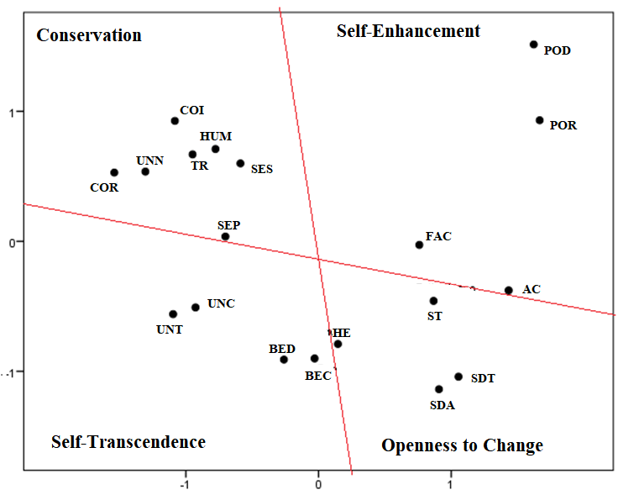
SDT= self-direction: thought; SDA= self-direction: action; ST= stimulation; HE= hedonism; AC= achievement; POR= power: resources; POD= power: dominance; FAC= face; SES= security: societal; SEP= security: personal; COR= conformity: rules; COI= conformity: interpersonal; TR= tradition; HU= humility; BED= benevolence: dependability; BEC= benevolence: caring; UNC= universalism: concern; UNN=universalism: nature; UNT=universalism: tolerance

CFA result
The model was considered satisfactory in almost all indices of the four dimensions of the theoretical model, except for the Conservation dimension in the SRMR index (Table 1). Although not complying all indices, the factor loadings were similar to the data obtained by Torres, Schwartz and Nascimento (2016). Figure 1 and Figure 2 presents the results.

Table 1: CFA indices
SRMR | GFI | RMSA | CFI | χ2 / df | P
Self-Transcendence
.088 | .935 | .057 | .933 | 1.97 | > .001
Openness to Change
.072 | .96 | .045 | .952 | 1.59 | >.005
Self-Enhancement
.13 | .954 | .054 | .932 | 1.86 | > .001
Conservation
.108 | .907 | .063 | .892 | 2.17 | > .001

Figure 1: 2nd order value structure: Self-transcendence and Openness to Change
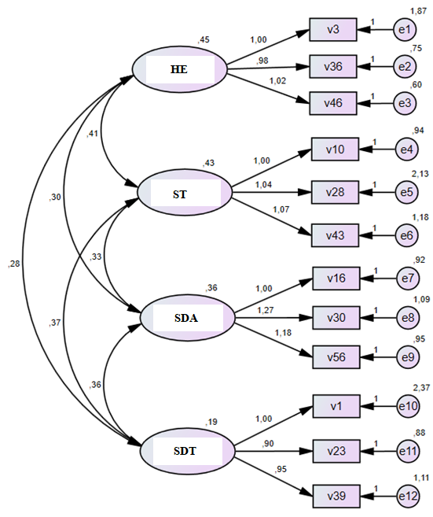  Openness to Change | 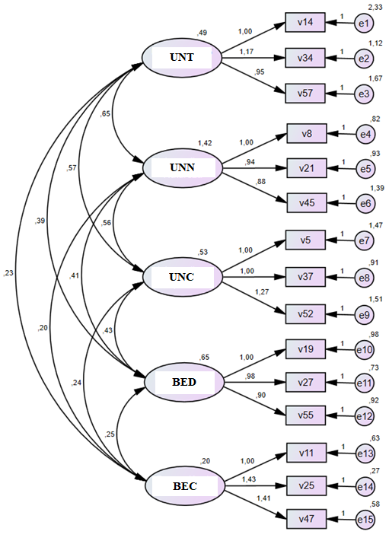  Self-Transcendence

Figure 2 - Second-order value structure: Self-Promotion and Conservation
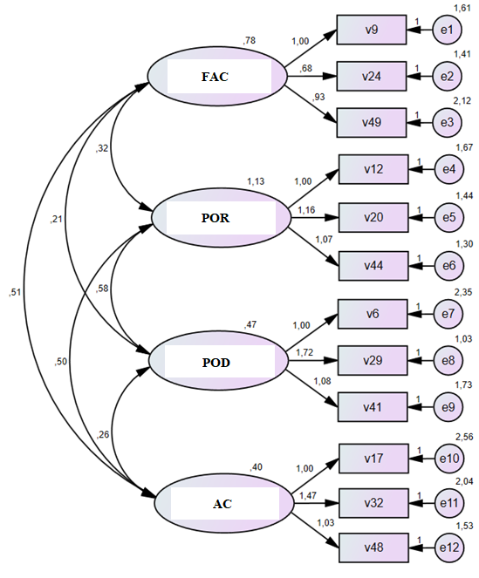  Self-Enhancement | 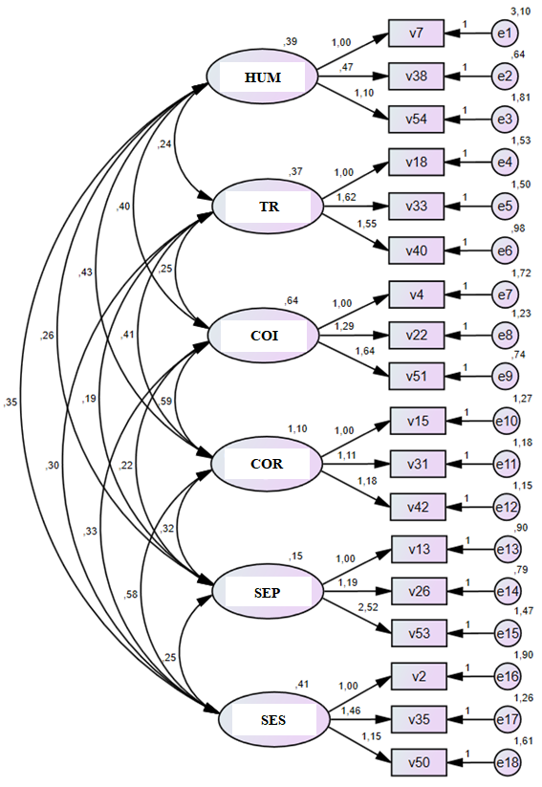  Conservation

Value mapping
The mean of each values and its respective dimensions (Tables 2 and 3) shown that Openness to Change and Self-transcendence were predominant. The highest frequencies were the values Benevolence Care, Benevolence Dependence, Personal Safety and Self-Direction Action, which are respectively associated with the motivations of: devotion and welfare of ingroups; be truthful and reliable with ingroup; personal concern in the most convivial environment; freedom to determine their own choices and actions (Schwartz et al., 2012, p. 669). The scree plot (Graph 2) shows that there is a greater approximation of young people to the values of Self-transcendence and Openness to Change.

Table 2: Descriptive statistics for values and their second order dimensions.
Values |  | $$\overline{X}$$ | σ | C_{v}
Self-Transcendence | Benevolence Caring | 5.37 | .78 | 14.54
Self-Transcendence | Benevolence Dependability | 4.98 | 1.04 | 20.96
Self-Transcendence | Universalism Concern | 4.59 | 1.10 | 23.91
Self-Transcendence | Universalism Tolerance | 4.08 | 1.10 | 26.97
Self-Transcendence | Universalism Nature | 4.05 | 1.30 | 32.02
Self-Transcendence | Geral | 4.61 | 0.79 | 17.14
Openness to Change | Self-direction Action | 4.82 | 0.97 | 20.17
Openness to Change | Hedonism | 4.72 | 1.01 | 21.34
Openness to Change | Self-direction Action Thought | 4.50 | 0.87 | 19.32
Openness to Change | Stimulation | 4.49 | 1.04 | 23.04
Openness to Change | Geral | 4.63 | .75 | 16.29
Self-Enhancement | Face | 4.44 | 1.15 | 25.92
Self-Enhancement | Achievement | 4.27 | 1.13 | 26.56
Self-Enhancement | Power Resource | 3.13 | 1.37 | 43.97
Self-Enhancement | Poder Dominance | 2.82 | 1.20 | 42.56
Self-Enhancement | Geral | 3.66 | .87 | 23.77
Conservation | Security Personal | 4.82 | .90 | 18.71
Conservation | Humility | 4.47 | .99 | 22.26
Conservation | Security Societal | 4.40 | 1.14 | 25.90
Conservation | Conformity Interpersonal | 4.02 | 1.26 | 31.28
Conservation | Tradition | 3.83 | 1.12 | 29.32
Conservation | Conformity Rules | 3.67 | 1.36 | 1.31
Conservation | Geral | 4.20 | .81 | 19.18
C_{v} - Coefficient of Variance

Table 3: Combined Frequencies of Second Order Values
 | Self-Enhancement | Self-Transcendence | Total
Openness to Change | 43 (13.1%) | 185 (56.6%) | 228 (69.7%)
Conservation | 4 (1.2%) | 95 (29.1%) | 99 (30.3%)
Total | 47 (14.4%) | 280 (85.6%) | 327 (100%)
X²=12.317; p<.001

Graph 2 - Second order value scree plot
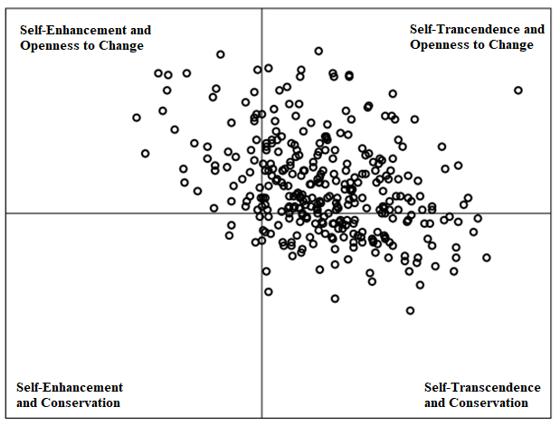
Results of sociodemographic variables
The results of the sociodemographic variables confirmed the data from the National Council of Justice (2012) and the Distrito Federal Planning Company (Distrito Federal, 2013) on school failure and dropout rates in the socio-educational environment (Table 4). The average time that subjects said they had been absent from school was 20.77 months (Sd = 17.3). The mean age of the sample was 17 years (Sd = 1.25). The predominant grade was the 8th grade. The most frequently reported failing grade was grade 6. The mean age / grade distortion was 4.18 (Sd = 1.6) years (due to both dropout time and mean number of repetitions ($\overline{X}$ = 2.41; Sd = 1.3) with two or more years of age-grade distortion was 95.2%.
The families described by the adolescents, mostly, were led by the mothers, composed of an average number of 5.3 people (Sd = 2.3 people), with an average number of 2.5 people (Sd = 1.6 people) responsible for their livelihoods, residents of the poorest regions and worst social indices according to the District Household Sample Survey (Distrito Federal, 2018).

Table 4 - Failures and School Dropouts
Dropout of school | F | %
Yes | 337 | 83.4
No | 62 | 15.3
Did not answer | 5 | 1.8
School Failure
Did not school failure | 24 | 5.94
Once | 65 | 16.09
Twice | 119 | 29.46
Three times | 107 | 26.49
More than three times | 65 | 16.09
Did not answer | 24 | 5.94

Open Question Analytics
Frequencies and correlations of adolescents' dreams with sociodemographic variables were investigated for their responses to their childhood and current dreams. Spearman's correlation index was used to indicate the strength of association between variables (Hair et al., 2005). The content of the open-ended questions and the frequency of the significant words were analyzed by the IRaMuTeQ software (Interface de R pour les Analyses Multidimensionnelles de Textes et de Questionnaires) 0.7 alpha 2. The content analysis of the text segments (TS) was made after statistical verification of the textual corpus and the Descending Hierarchical Classification (DHC). The answers to the questions were grouped into two axes. The composition of these axes is due to the thematic approximation between the TS. The established axes were: Dream and Improve of life; Repentance and Advice.
Questions (1) and (4) made up the Dream and Life Improvement axis for addressing future impressions and life projects. In the first question, we sought to obtain a description of the participants about their childhood dreams, if they had it and if they still remembered them, and what were their current dreams. In the fourth question, the participants answered what they would need to do to change and improve their reality and the people who mattered. Both questions also attempted to identify the presence or absence of projects and life goals.
Questions (2) and (3) formed the Repentance and Advice axis for dealing with past experiences. Based on their answers we sought to describe the regrets about their attitudes and behaviors, as well as to verify the adolescents' understanding about the causes that led them to arrested at a social-educational unit.
For the analysis, age and education were taken into account to verify any correlation with both the questions and the results of the second order values obtained by the PVQ-RR 57 (Schwartz et al., 2012; Torres et al., 2016). According to the theoretical model, second-order values could be grouped and referred to as Self-expanding values or Self-protection values. Self-Expanding values consist of the Self-transcendence and Open to Change dimension values set; Self-protection values consist of the values of the Conservation and Self-promotion dimensions.

Results of open questions
Among the participants, seven adolescents refused to say whether or not they had dreams. Percentages of adolescents' responses to their childhood dreams and current professional dreams were tabulated (Table 5). The results of the CHDs of text segment indicated that there was no significance of the responses regarding variables of age (over 18 years), education (Elementary or Middle), and second order values (Self-Expansion and Self-Protection). These results indicate a homogeneity of responses among the subjects, with no prevalence regarding age, education or even their values.
Significant correlations were found to some variables (Table 6). Spearman's correlations were tested between the following variables: Child's dream x Current dreams; Current dream x Schooling; Child's dream x Schooling; Time of school dropout x current dream; Number of failures x Current dream; Time of school dropout x Child's dream; Current dream x Young provider.

Table 5 - Dreams and Professions (Child and Current)
Child  Dream |  | F | %
Child  Dream | Yes | 343 | 85
Child  Dream | No | 54 | 13
Child  Dream | Did not answer | 7 | 1.7
Current dream | Yes | 222 | 42
Current dream | No | 171 | 55
Current dream | Did not answer | 11 | 2.7

Table 6 - Correlations of variables
Crossings | Spearman Correlations | Significance
 | R | P
Child Dream x Current Dream | .293 | > .001
Child Dream x Schooling | .106 | .017
Dropout time of School x Current Dream | -.168 | .001
Dropout time of School x Child Dream | -.42 | .353
Current dream x Young provider | -.062 | .225

Description of the textual corpus - Dream and Life Improvement Axis
The general textual corpus of the Dream and Life Improvement axis was composed of 404 texts, separated by 404 ST, with 304 ST (75.25%). 5872 occurrences (words, forms or words) emerged, being 582 distinct forms and 275 words with a single occurrence. The number of ST equal to the text number indicated that the participants answers were short.

Graph 3 - ST Class: Dream
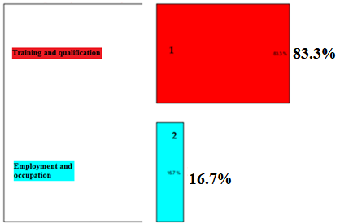

Based on the result of the sum of the absolute chi-square of the ST of the Dream and Life Improvement axis, it was decided to group them and analyze the CHD results separately into two classes: Dream and Life Improvement. The Dream CHD indicated that there were two subclasses of ST (Graph 3): Training and Training; Employment and Profession (Table 7.

Table 7 - Profile of Dream ST
Axis |  | STs profile | Meaningful words (p> 0.05)
Dream | Training and qualification | - “My dream is to get out of this life, give my mother a house, have a child, and graduate as a criminal expert.” | family; life; dream; to help; to form; college; finish studies; leave; have; do
Dream | Employment and occupation | - “Be a lawyer to release the people you need.”  - “Study hard and be a police officer.” | lawyer; firefighter; police officer; military

The CHD of the Improve Life Class suggested five subclasses of ST: Work, Achievement, Effort, Change, and Expectation (Graph 4). The CHD evidenced a relationship of greater similarity between the ST of the performance and effort subclasses, as well as between the ST of the work and change subclasses (Table 8).

Graph 4 - ST Class: Improve Life.

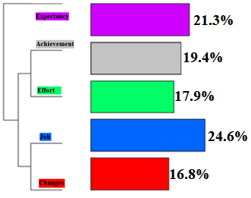

Table 8 - Life Improving ST Profile
Subclass | STs profile | Meaningful words (p> 0.05)
Expectancy | - “Work, finish school, go to college and make a difference in society”. | study; finish; college; attitude; best; do
Achievement | - “I am able to go back to school and make my mother proud”. | proud; to give; to help; mom; family; win; Dream; important; accomplish; able; would you like; God; value; to work; Tue
Effort | - “To lessen my father's suffering, I'm going back to his house and start studying again.” | to study; dad; profession; come back; continue; to work
Job | - “Get a job and listen to the advice that is good for me”. | get a job; honest; take care; get; happy; to listen; power; to be; want
Changes | - “Change your life and stop doing harm to others, doing good and helping people out of life”. | life; leave; to change; friendship; crime; stop; follow; worthy
Description of the textual corpus – Repentance and Council axis
The general textual corpus of the Repentance and Council axis was composed of 404 texts, separated by 810 ST, with 620 STs (76.54%). 6.770 occurrences (words, shapes or words) emerged, of which 523 distinct forms and 240 words with a single occurrence.
The classes of ST resulting from CHD were desirability and discouragement. The class desirability was composed of two subclasses of ST: personal and social. The discouraged class was composed of three subclasses of ST: choices, experienced results, actions (Graph 5). The classifications attributed to the Repentance and Counseling axis were inferred. A social desirability expressed by the participants, probably due to the influence of family members and public agents involved with socio-education, was also taken to account (Table 9).

Graph 5 - ST Class: Regret / Advice
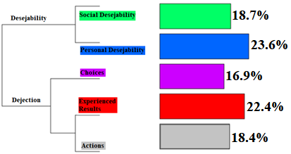
Table 9 - The Profile of Axis ST
Class |  | STs profile | Meaningful words (p> 0.05)
Desirability | Social desirability | - “Continue to study and live an honest life without doing something wrong and being someone in life, stopping to think about your life and your family.” | wrong; thing; to study; anything; stop; hospitalization; dream; friendship; give up; right; do; to work
Desirability | Personal desirability | - “I have committed many infringing acts. Today, I regret it. I do not commit crimes anymore. It is not because I am apprehended, nor am I lying. It's because crime doesn't pay. Only displeases your mother and family”. | to give; family; think; future; want; lose; jail; freedom; church; suffering; consequence; love; compensate; get; to be; way
Dismay | Choices | - “Do not steal, do not kill, do not traffic”. | to steal; kill; used drugs; trafficking; to owe; sad
Dismay | Experienced results | - “I wouldn't leave school and I wouldn't get involved in crime”. | to involve; crime; does not pay; leave home
Dismay | Actions | - “I regret joining the very young crime life and losing my teens”. | regret; log in; life; crime; take off; world; marijuana; lost; Tue

Discussion
The results confirmed the refined theoretical model of values (Schwartz et al., 2012) and showed evidence of validity of PVQ-RR 57 for the target audience. Most indicators have been accepted.
In multidimensional scaling analysis, the Stress-1 indicator was better than found by Schwartz et al. (2012) and Torres et al (2016). The inversion of the order between values and the SRMR index > 0.08 found in the Self-transcendence, Self-Promotion and Conservation values, suggests the need for future adaptation of the instrument to the specificities and profile of the studied population. However, this has not invalidated the use of this instrument.
School repetition was higher in the 6th grade of elementary school, a grade that coincided with the transition from early childhood to adolescence, when students from Brazilian schools now have more subjects and no longer a full teacher. As school dropout also causes failures due to missed classes, it is recognized that school failure and dropout would be overlapping. The distortion between the average age and the grade level above 4 years, where 95.2% of this young people had two or more years of distortion, was very distant from both the Brazilian and local average (Bauer, Vives, Klaus, & Dutra, 2018). This result points to the need for the DF's educational system to revise its pedagogical policy and invest in continuing teacher education. This is especially true in public school because teenage offenders often study there. It is also important to look for articulated actions that promote school success, motivate students to learn, and foster relationships, especially at this stage of adolescent school life.
Comparatively, the results pointed to a negative correlation between time away from school and the presence of current dreams. This could justify the difficulty of these adolescents in planning their life projects. Whether to help adolescents designing their life projects or to include them in a training routine, these data corroborate as justifiable the development of a specific teaching modality for socio-education.
Unsuccessful schooling, difficulties resulting from dropping out, history of failures, and unethical and antisocial practices suggest that the values of these adolescents would be different from other young people who did not commit offensive acts. The results, however, confirmed the predominance of Self-transcendence and Openness values for this sample, consistent with the values of other adolescents (Döring, Daniel, & Knafo-Noam, 2016). These results indicate that the values of adolescents who comply with a restrictive measure of detention in the Distrito Federal are similar to those of other adolescents: eager to break paradigms, discover the world, have new experiences without thinking about the consequences, having greater concern for the welfare of other than themselves.
Self-transcendence is associated with motivations of philanthropy, understanding, appreciation, tolerance, attention to the welfare of others and the environment, and social justice (Daniel, Bilgin, Brezina, Strohmeier, & Vainre, 2015; Schwartz, 2006c; Schwartz et al., 2012; Torres et al., 2016). Even being authors of acts opposed to self-transcending values, when it comes to their family nucleus, the data pointed to Self-transcendence as a dimension of greater importance. Adolescents in prison contexts place great value on the role played by their mothers, who they regard as their "queen." Adolescent responses may be expressing their mothers' desire to want their children to behave in ways associated with honesty, tolerance, and the well-being of others (National Justice Council, 2012; Distrito Federal, 2013; Autor 1, 2014).
The Values of Benevolence Care and Benevolence Dependence suggest motivations for the dedication and well-being of inner group members, specifically to a narrow circle of family and friends, and not to the well-being of others in society at large. On the other hand, the values of benevolence dependence included the motivations for a reliable identity and loyalty to the groups to which they were linked. For the sample of this study, concern for others and their well-being refers to the main reference and belonging groups, the central core of relationship and coexistence, such as family and friends. Taking into account the existing concern of these adolescents with their central relationships, it is possible to promote pedagogical actions that may broaden their concern, suggesting the presence of a latent motivational construct to care for others, especially those they do not know.
Although the MDS results pointed out to the value Universalism Nature outside the Self-transcendence dimension, its proximity to the Conservation dimension was maintained. The adjacency between the Self-transcendence and Conservation dimensions are compatible (Schwartz et al., 2012). The permanence of this value in the Conservation dimension suggests that these adolescents would have a concern for nature due to heteronomy, according to established social rules, and not due to the understanding of the importance of preserving nature for the well-being of all. This data also confirmed the hypothesis of the study conducted with adolescents from Butler, Leshied and Fearon (2007), and found an inverse relationship between antisocial attitudes and environmental attitudes.
The results confirmed the need for activation of Self-transcendence and Conservation values to promote ethical attitudes (Benish-Weisman, 2015; Feldman et al., 2015). According to Rokeach (1981), activation of peripheral values is possible when done through core values. As Conservation values indexes were the lowest in these sample, it is possible, for example, to promote Tradition values (peripheral value associated with the family) by Benevolence Care values (central value, also associated with the family). In this case, activating the values of Tradition can activate the values of the Conservation dimension and, consequently, promote ethical attitudes and the observance of social rules.
In addition, according to the results, it is possible to activate peripheral values, in this case, the Conservation dimension, by activating the Personal Security values. Personal Safety is a value that indicates concern for one's own survival, including also his/her inner group (Schwartz et al., 2012). The Personal Security value may justify the manifestation of 32% of adolescents claiming to be co-responsible for family support and stability, even without being able to provide any financial support to their family because they are arrested.
According to Schwartz et al. (2012) values of Conformity Rules and Tradition would be associated with ethical attitudes. Given the results and the proximity of Safety with Tradition values, an intervention pedagogical project with the development of autobiographical activities, aiming at activating Tradition by Safety values can trigger its activation by memory (Bardi & Schwartz, 2003; Maio, 2010; Maio et al., 2001, 2009; Schwartz, 2006b).
Given that Schwartz et al. (2012) point out to a positive correlation between Commitment Universalism and Nature Universalism, we can also propose pedagogical interventions designed to expand their inner group and promote the interconnection of these adolescents with others, including other living and non-human beings. A possibility of activating Self-transcendence values and broadening adolescents' understanding of the importance of the others can be achieved through pedagogical interventions associated with Environmental Education from the perspective of Human Ecology (Benish-Weisman, 2015; Feldman et al., 2015). Such interventions aim to promote and improve the relationship of individuals with themselves, with others, and with the environments and contexts in which they live interconnectedly (Autor 2, 2014).
Regarding the dimension Openness to Change, two values had higher score: Self-Direction Action and Hedonism. Self-Direction Action is associated with the choice of own goals, independent, self-sufficiency, the pursuit of excitement, novelty and change. The higher average of this value in the sample can support us to understand the possible reasons for immediate and inconsequential choices of their actions, as well as the manifestations of discouragement found in their reports when they expressed their regrets. Thus, the criminal practice of these adolescents of the sample may be the result of an “adventure” to achieve a different reality from the context of poverty in which many of them are embedded. The excitement and access to consumer goods obtained by the first offenses may have reinforced the permanence of infringing practices. On the other hand, Self-Direction Action can be due to their career choices, once their significantly chosen careers dreams were associated with professions linked to high dynamism, excitement, and adventure.
Concerning the Hedonism value, it is associated with motivations aimed to get the organic needs of pleasure, satisfaction and self-indulgence. It is a value that can be associated with violent attitudes (McDonald, Benish-Weisman, O'Brien, & Ungvary, 2015; Seddig & Davidov, 2018), as well as the escape from stress and competition, negatively correlating with aspirations and pursuit of objectives both associated with Achievement value (Schwartz et al., 2012). For this reason, the high score of Hedonism, in this context, may be associated with infraction behaviors as well as the difficulties of these adolescents to pursue their life projects. These conclusions may be supported by expressions of dismay about the chances of success in achieving their dreams, given the employability difficulties for adolescents with infringement records. Empowering the Achievement value based on adolescents' skills and aptitude could be a strategy to facilitate their pursuit of these dreams.
The responses of adolescents, indicating their awareness of the changes that society and their families expect from them, may be a reflection of trying to meet the demands of society, of giving answers based on social desirability. However, their reports also pointed to a personal desire to recover losses from their criminal conduct. This result may indicate that the restriction of freedom imposed by the judicial measure had some impact on the adolescents. Although this, the lack of greater results suggests that there is still a low alignment of activities proposed in the institutional units with the motivations of adolescents to qualify their life projects (Liaudinskien, 2005; Marinho, 2013).
The results from the text segments of the Repentance and Council axis may indicate that adolescents have some clarity about the illusions that accompanied the criminal practice: easy money and a life without obligations and responsibilities. Their statements made it possible to infer that such choices did not produce the expected results. Thus, their expressed discouragement may be evidence of regret and some contrition for their acts, as well as an expression of low objective expectation for planning other life projects. In other words, they would have an idea of what they should do, but at the same time expressed an inability to make them come true.
Taken together, these findings suggest that it is urgent that the Government promotes policies that offer training, professional insertion and present concrete options for the future, with a view to the social reintegration of these young people. In addition to public policies, it is important to develop pedagogical practices aimed at integrating problem solving, the world of work, youth protagonism, aligned to their motivations, in order to provide tools that contribute to transforming the reality that surrounds them.

Conclusions
This study fulfilled its objective. The findings support that an intervention pedagogical project aiming to activate and empowerment values for young people of the infraction environment should be focused on the promotion of prosocial and ethical attitudes. The values that need activation to guide teens' motivations toward these goals should be: Tradition, Universalism Nature, Benevolence Care and Achievement.
This type of intervention project that triggers the activation of values through memory using autobiographical activities can be feasible since educators working with these young people are trained to develop them. In a planned way, these activities can reach all the services offered to these adolescents, individually or in small groups.
Considering the continental dimensions of Brazil and its diversity, it is important that future studies can enlarge the sample and investigate adolescent offenders from other Brazilian regions, in order to confirm our findings. Cross-cultural studies with adolescent offenders from other locations may also contribute to the understanding of the values of these target people and their underlying motivations, making it possible, among others, to compare these adolescents with those who have not committed offenses. Consequently, foster training and resocialization policies for this public and, thus, try to break away from prejudices and discrimination generally directed at adolescent offenders.
In order to improve the value studies for these young people, we recommend the development of an instrument that is better suited to the socio-educational context and educational level of adolescents and able to obtain their values according to the refined theoretical model of Schwartz et al. (2012). This instrument will need to take into account the social reality of the outskirts of large urban centers, the low education level and the difficulty of interpreting texts faced by any teenager, regardless of their educational level.
Given the possibility of gender differences, future studies should not only investigate the values of female offenders to compare them with the values of male offenders, but also investigate similarities and differences between female offending and non-offending adolescents. In general, these studies may reveal central motivations that contribute to better understand these adolescents and, consequently, define the best pedagogical and formative strategies for them.
Finally, in order to avoid acts of infraction of these young people and to embed them into school, the study of values with adolescents should not only take into account the context of restriction on freedom, but also guide the school environment, especially for adolescents with learning difficulties. Understanding their values and bringing pedagogical practice closer to what is important to them can be a way to stop the process of dropping out and retaining school. Since the sixth grade of elementary school is the biggest failure bottleneck and the door to dropout, it would be of great value if studying values with these students was a pedagogical routine to guide programs and actions. Thus, it could help to set them at school and diminish the strength of marginalized groups to capture teenagers into the offensive world.
This research did not receive any specific grant from funding agencies in the public, commercial, or not-for-profit sectors.

References

Araújo, C. M. de, & Oliveira, M. C. S. L. de. (2013, July). Contribuições de Bourdieu ao tema do desenvolvimento adolescente em contexto institucional socioeducativo. Retrieved July 17, 2013, from http://webcache.googleusercontent.com/search?q=cache:nPVlyYmUZjoJ:www.ufsj.edu.br/portal2-repositorio/File/revistalapip/Volume8 n2/PPP 8_2 Art_ 9.doc+&cd=7&hl=pt-BR&ct=clnk&gl=br
Bardi, A., Lee, J. A., Hofmann-Towfigh, N., & Soutar, G. (2009, November). The structure of intraindividual value change. Journal of Personality and Social Psychology, 97(5), 913–929. https://doi.org/10.1037/a0016617
Bardi, A., & Schwartz, S. H. (2003). Values and behavior: strength and structure of relations. Personality and Social Psychology Bulletin, 29(10), 1207–1220. https://doi.org/10.1177/0146167203254602
Bauer, F., Vives, E., Klaus, M., & Dutra, Í. (2018). Panorama da distorção idade-série no Brasil. Retrieved March 21, 2019, from https://static.poder360.com.br/2018/08/panorama_distorcao_idadeserie_brasil.pdf
Benish-Weisman, M. (2015). The interplay between values and aggression in adolescence: a longitudinal study. Developmental Psychology, 51(5), 677–687. https://doi.org/10.1037/dev0000015
Bilsky, W., Janik, M., & Schwartz, S. H. (2011). The Structural Organization of Human Values-Evidence from Three Rounds of the European Social Survey (ESS). Journal of Cross-Cultural Psychology, 42(5), 759–776. https://doi.org/10.1177/0022022110362757
Brasil. Estatuto da Criança e do Adolescente (1993). São Carlos: EdUFSCar/CMDCA.
Brasil. (2006). Sistema Nacional de Atendimento Socioeducativo - SINASE. Brasília: CONANDA.
Brasil. (2012). Sistema Nacional de Atendimento Socioeducativo. Retrieved September 26, 2017, from http://www.planalto.gov.br/ccivil_03/_ato2011-2014/2012/lei/l12594.htm
Butler, S. M., Leschied, A. W., & Fearon, P. (2007). Antisocial Beliefs and Attitudes in Pre-adolescent and Adolescent Youth: the Development of the Antisocial Beliefs and Attitudes Scales (ABAS). Journal of Youth and Adolescence, 36(8), 1058–1071. https://doi.org/10.1007/s10964-007-9178-2
Cieciuch, J., & Davidov, E. (2012, April). A comparison of the invariance properties of the PVQ-40 and the PVQ-21 to measure human values across German and polish samples. Survey Research Methods, 6(1), 37–48. https://doi.org/http://dx.doi.org/10.18148/srm/2012.v6i1.5091
Conselho Nacional de Justiça. (2012). Panorama Nacional: a execução das Medidas Socioeducativas de Internação. Retrieved June 2, 2017, from http://www.cnj.jus.br/images/pesquisas-judiciarias/Publicacoes/panorama_nacional_doj_web.pdf
Daniel, E., Bilgin, A. S., Brezina, I., Strohmeier, C. E., & Vainre, M. (2015). Values and helping behavior: a study in four cultures. International Journal of Psychology, 50(3), 186–192. https://doi.org/10.1002/ijop.12086
Distrito Federal. (2013). Perfil e percepção social dos adolescentes em medida socioeducativa no Distrito Federal. Brasília: CODEPLAN. Retrieved from http://www.tjdft.jus.br/cidadaos/infancia-e-juventude/publicacoes/publicacoes-1/perfil-e-percepcao-social-dos-adolescentes-em-medida-socioeducativa-no-distrito-federal
Distrito Federal. (2014). Portaria Conjunta SEEDF e SECriança n° 03/2014. Retrieved June 1, 2018, from https://www.jusbrasil.com.br/diarios/67969635/dodf-secao-01-24-03-2014-pg-6
Distrito Federal. (2018). Pesquisa Distrital por Amostra de Domicílios – PDAD. Brasília. Retrieved from http://www.codeplan.df.gov.br/pdad/
Döring, A. K., Daniel, E., & Knafo-Noam, A. (2016). Introduction to the special section value development from middle childhood to early adulthood-new insights from longitudinal and genetically informed research. Social Development, 25(3), 471–481. https://doi.org/10.1111/sode.12177
Feldman, G., Chao, M. M., Farh, J.-L., & Bardi, A. (2015). The motivation and inhibition of breaking the rules: Personal values structures predict unethicality. Journal of Research in Personality, 59, 69–80. https://doi.org/10.1016/j.jrp.2015.09.003
Garson, G. D. (2015). Missing values analysis and data imputation. Asheboro (USA): Statistical Associates Publishers.
Goffman, E. (2010). Manicômios, prisões e conventos (7th ed.). São Paulo: Perspectiva.
Hair, J. F., Anderson, R. E., Tatham, R. L., & Black, W. C. (2005). Analise multivariada de dados (5 ed). Porto Alegre: Bookman.
Liaudinskien, G. (2005). Resocialization barriers of juvenile delinquents. Social Sciences, 1(47), 41–53. Retrieved from https://etalpykla.lituanistikadb.lt/object/LT-LDB-0001:J.04~2005~1367184200279/
Lönnqvist, J.-E., Verkasalo, M., Wichardt, P. C., & Walkowitz, G. (2013). Personal values and prosocial behaviour in strategic interactions: Distinguishing value-expressive from value-ambivalent behaviours. European Journal of Social Psychology, 43(6), 554–569. https://doi.org/10.1002/ejsp.1976
Maio, G. R. (2010). Mental representations of social values. In M. P. Zanna (Ed.), Advances in experimental social psychology (Vol. 42, pp. 1–43). Burlington: Academic. https://doi.org/10.1016/S0065-2601(10)42001-8
Maio, G. R., Olson, J. M., Allen, L., & Bernard, M. M. (2001). Addressing discrepancies between values and behavior: the motivating effect of reasons. Journal of Experimental Social Psychology, 37(2), 104–117. https://doi.org/10.1006/jesp.2000.1436
Maio, G. R., Pakizeh, A., Cheung, W.-Y., & Rees, K. J. (2009, October). Changing, priming, and acting on values: effects via motivational relations in a circular model. Journal of Personality and Social Psychology, pp. 699–715. https://doi.org/10.1037/a0016420
Marinho, F. C. (2013). Jovens egressos do sistema socioeducativo: desafios à ressocialização. Universidade de Brasília, Brasília, DF. Retrieved from http://repositorio.unb.br/bitstream/10482/13460/1/2013_FernandaCamposMarinho.pdf
McDonald, K. L., Benish-Weisman, M., O’Brien, C. T., & Ungvary, S. (2015). The Social values of aggressive–prosocial youth. Journal of Youth and Adolescence, 44(12), 2245–2256. https://doi.org/10.1007/s10964-014-0246-0
Nunes, M. C., & Bosco, G. P. (2016). Sistema Nacional de Atendimento Socioeducativo (SINASE): Lei nº 12.594, de 18 de janeiro de 2012. Retrieved April 21, 2017, from https://jus.com.br/artigos/51212/sistema-nacional-de-atendimento-socioeducativo-sinase-lei-n-12-594-de-18-de-janeiro-de-2012
Parks-Leduc, L., Feldman, G., & Bardi, A. (2015, February). Personality traits and personal values: A meta-analysis. Personality and Social Psychology Review, 19(1), 3–29. https://doi.org/10.1177/1088868314538548
Pasquali, L. (2005). Análise fatorial para pesquisadores. Brasília: LabPAM.
Autor 2. (2014).
Pulfrey, C., & Butera, F. (2013). Why neoliberal values of self-enhancement lead to cheating in higher education: a motivational account. Psychological Science, 24(11), 2153–2162. https://doi.org/10.1177/0956797613487221
Autor 1. (2014).
Rohan, M. J. (2000, August). A Rose by Any Name? The Values Construct. Personality and Social Psychology Review, pp. 255–277. https://doi.org/10.1207/S15327957PSPR0403_4
Rokeach, M. (1973). The nature of human values. New York (USA): Free Press.
Rokeach, M. (1981). Crenças, atitudes e valores: uma teoria de organização e mudança. Rio de Janeiro: Editora Interciência.
Ros, M., Grad, H., & Martínez-Sánchez, E. (1999). Una intervención en los valores para la mejora del rendimiento académico. Revista de Psicología Social, 14(2–3), 199–210. https://doi.org/10.1174/021347499760259949
Schwartz, S. H. (1992). Universals in the content and structure of values: theoretical advances and empirical tests in 20 countries. (M. P. Zanna, Ed.), Advances in Experimental Social Psychology, pp. 1–65. https://doi.org/10.1016/S0065-2601(08)60281-6
Schwartz, S. H. (2005). Validade e aplicabilidade da Teoria de Valores. In Á. Tamayo & J. B. Porto (Eds.), Valores e comportamentos nas organizações (pp. 56–95). Petrópolis: Vozes.
Schwartz, S. H. (2006a). A theory of cultural value orientations: explication and applications. Comparative Sociology, 5(2–3), 137–182. https://doi.org/10.1163/156913306778667357
Schwartz, S. H. (2006b). Basic Human Values: Theory, Measurement, and Applications. Revue Française de Sociologie, 47(4), 929–968. https://doi.org/10.1080/026999499377664
Schwartz, S. H. (2006c). Há aspectos universais na estrutura e no conteúdo dos valores humanos? In Maria Ros & V. V. Gouveia (Eds.), Psicologia social dos valores humanos: desenvolvimentos teóricos, metodológicos e aplicados (pp. 55–85). São Paulo: Senac.
Schwartz, S. H. (2012). An Overview of the Schwartz Theory of Basic Values An Overview of the Schwartz Theory of Basic Values. Online Readings in Psychology and Culture, 2, 1–20. https://doi.org/http://dx.doi.org/http://dx.doi.org/10.9707/2307-0919.1116
Schwartz, S. H., Cieciuch, J., Vecchione, M., Davidov, E., Fischer, R., Beierlein, C., … Konty, M. (2012). Refining the theory of basic individual values. Journal of Personality and Social Psychology, 103(4), 663–688. https://doi.org/10.1037/a0029393
Seddig, D., & Davidov, E. (2018). Values, attitudes toward interpersonal violence, and interpersonal violent behavior. Frontiers in Psychology, 9(MAY), 1–13. https://doi.org/10.3389/fpsyg.2018.00604
Tabachnick, B. G., & Fidell, L. S. (2001). Using multivariate statistics (4th ed.). Needham Heights, MA: Prentice Hall.
Toledo, L. S. (2015). Analfabetismo funcional entre adolescentes: um mal-estar na educação contemporânea. Revista Fundamentos, 2(1), 45–61.
Torres, C. V., Schwartz, S. H., & Nascimento, T. G. (2016, May). A Teoria de Valores Refinada: associações com comportamento e evidências de validade discriminante e preditiva. Psicologia USP, pp. 341–356. https://doi.org/10.1177/0022022111403726
Uzefovsky, F., Döring, A. K., & Knafo-Noam, A. (2016). Values in middle childhood: social and genetic contributions. Social Development, 25(3), 482–502. https://doi.org/10.1111/sode.12155
Van Buuren, S. (2015). Flexible imputation of missing data (2 ed.). New York (USA): Chapman and Hall/CRC.

