Ideology and Political Cynicism: Effects of Authoritarianism and Social Dominance on Perceptions about the Political System in 11


Ibero-American Countries

Agustín Espinosa ª , Manuel Pacheco ª, Erika Janos ª, Yorelis Acosta ^{b}, Edilberto Álvarez-Galeano ^{c}, Jaime Berenguer ^{d}, Víctor Jiménez-Benítez ^{e}, Harry Lewis ^{f}, María Lily Maric ^{g}, Julián Martínez ^{h}, Elvira Riba ^{i}, Juan Carlos Romero ^{j}, Salvador Sandoval ^{k}, Juan Valencia-Moya ^{e} & Angela Vera-Ruíz ª

Pontificia Universidad Católica del Perú, Lima, Perú ª; Universidad Central de Venezuela, Caracas, Venezuela ^{b}; Coordinadora de Derechos Humanos del Paraguay, Asunción, Paraguay ^{c}; Universidad Autónoma de Madrid, Madrid, España ^{d}; Pontificia Universidad Católica de Chile, Santiago de Chile, Chile ^{e}; University of Sussex, Brighton, United Kingdom ^{f}; Universidad Mayor de San Andrés, La Paz, Bolivia ^{g}; Universidad de Salamanca, Salamanca, España ^{h}; Universidade de São Paulo, São Paulo, Brasil ^{i}; Universidad de Tarapacá, Arica, Chile ^{j}; Pontifícia Universidade Catôlica de São Paulo, São Paulo, Brasil ^{k}.

Abstract
This study investigates; (1) how Political Cynicism is structured and, (2) how this structure relates to Right-Wing Authoritarianism (RWA) and Social Dominance Orientation (SDO) in 11 Ibero-American countries (N=2388). The results show that the structure of Political Cynicism is composed of four dimensions: (1) Mistrust, (2) Perception of Corruption, (3) Need for Change and, (4) Political Moral Laxity. Furthermore, the study reveals that there is no homogeneous model of relations between the dimensions of Political Cynicism with RWA and SDO by country. However, at a general level it is noted that Mistrust acts as a diffuse indicator of dissatisfaction with the political system that increases Political Moral Laxity, while the Perception of Corruption, functions as a specific indicator of dissatisfaction that is directly associated with the Need for Change and, inversely, to Moral Laxity. Both RWA and SDO increase the negative manifestations of Political Cynicism, but the most interesting result is the stability of the observed relationship between SDO and Moral Laxity in 10 of the 11 countries considered in the study. The results are discussed in terms of the costs that Political Cynicism represents for the consolidation of Democracy, especially in its manifestation of moral laxity.

Keyswords
right-wing authoritarianism, political cynicism, Ibero-America, political moral laxity, social dominance orientation


Resumen
El presente estudio investiga, (1) cómo se estructura el Cinismo Político y, (2) cómo se relaciona esta estructura con el Autoritarismo de Derecha (RWA) y la Orientación a la Dominancia Social (SDO) en 11 países iberoamericanos (N=2388). Los resultados muestran que la estructura del Cinismo Político se compone de cuatro dimensiones: (1) Desconfianza, (2) Percepción de Corrupción, (3) Necesidad de Cambio y, (4) Laxitud Moral Política. Además, el estudio revela que no existe un modelo homogéneo de relaciones entre las dimensiones del Cinismo Político con el RWA y la SDO por país. Sin embargo, a nivel general se observa que la Desconfianza actúa como un indicador difuso de insatisfacción con el sistema político que incrementa la Laxitud Moral Política, mientras que la Percepción de la Corrupción, funciona como un indicador específico de insatisfacción que se asocia directamente a la Necesidad de Cambio e, inversamente, a la Laxitud Moral. Tanto el RWA como la SDO aumentan las manifestaciones negativas del Cinismo Político, pero el resultado más interesante es la estabilidad de la relación observada entre la SDO y la Laxitud Moral en 10 de los 11 países incluidos en el estudio. Los resultados se discuten en términos de los costos que el Cinismo Político, especialmente en su manifestación de Laxitud Moral Política, representa para la consolidación de la Democracia en una sociedad.

Palabras Clave
autoritarismo de derecha, cinismo político, Iberoamérica, laxitud moral política, orientación a la dominancia social

Ideología y Cinismo Político: Efectos del Autoritarismo y la Dominancia Social en las Percepciones sobre el Sistema Político en 11 Países Iberoamericanos

Introduction
Political cynicism is defined as widespread mistrust towards the Political System and the institutions, actors and processes of which it is formed (Capella & Jamieson, 1996; Miller, 1974; Siu-Kai, 1992). Cynicism towards the system is manifested in individuals as a feeling of helplessness or hopelessness about their ability to influence politics, along with a perception that the political system, through the actors, institutions and rules that regulate it, is weak, unfair, corrupt, illegitimate or inefficient (Miller,1974; Siu-Kai, 1992). Moreover, cynicism will increase in contexts where there is a perceived weakness or lack of institutional legitimacy, high levels of corruption and norm transgressions, lack of representation of citizen interests by politicians and perceptions of a lack of distributive and procedural justice among others social problems, thereby creating a vicious cycle (Beramendi, 2014).
Manifestations of political cynicism are considered potentially dangerous for the development of a society, as they erode civic and democratic values and attitudes, reduce citizen participation in the political sphere, and increase a sense of hopelessness and disinterest in public affairs (Chaparro, 2018; Patterson, 2002). Such manifestations also increase citizens’ acceptance of authoritarian or violent measures as a form of opposition to the political system and what it represents (Bélanger & Aarts, 2006). In addition, political cynicism produces in citizens the belief that, as a result of apparent systemic corruption, anyone engaging in political processes will inevitably become corrupted by those processes themselves (Cappella & Jamieson, 1997).
In a cross-cultural study, Gätcher & Schulz (2016) found that citizens within societies where institutions are negatively perceived show a greater tendency to engage in intrinsically dishonest practices. This phenomenon, it is suggested, results from the impoverishment of social capital associated with a high perception of corruption, which in turn results in the normalization of corruption and transgressive behaviors in society at large. As such, the relationship between a negative perception of institutions and feelings of hopelessness and mistrust as a function of political cynicism is an important area of enquiry.
Such findings are corroborated in some countries of Latin America. In Peru, for example, the political, economic and social crises that the country has suffered throughout its history have generally been accompanied by the weakening of institutions and widespread corruption, which has, in turn, led citizens to develop a tolerance towards and acceptance of these problems (Quiroz, 2013). At the political level, Chaparro (2018) highlights how Peru is a society where conventional political action has lost relevance in citizens due to a widespread perception of norm non-compliance and political inefficiency. This increases hopelessness and inaction by causing a general dissatisfaction that, in turn, promotes a vicious cycle where citizens “do what they want". Such willfulness acts as a kind of survival strategy that intensifies and favors corruption in the country as an endemic problem, both at the individual and at the institutional level (Chaparro, 2018; Quiroz, 2013; Schmitz & Espinosa, 2015).
Beramendi (2014) found a similar situation when analysing the problem of normative transgression in Argentina. The author highlights how norm non-compliance and regulatory deviation in important sectors of Argentine society function as adaptations to problems that neither the system nor its institutions can adequately address- a state of affairs which can impair patterns of citizen coexistence (Beramendi, 2014; Beramendi & Zubieta, 2014). Similarly, Girola (2011) analyses the practices of norm transgression and corruption in Mexico as resulting from a weakened and perverse political and institutional structure.
Globally, Latin America is the region where the lowest levels of trust, both political and interpersonal, are observed - a situation which undermines the legitimacy of institutions that look after democracy (Levitt, 2015; Segovia, 2008; Zmerli & Castillo, 2015). For instance, according to the Latinobarómetro, countries such as El Salvador, Nicaragua, Peru and Venezuela systematically and consistently have the lowest citizen ratings of political trust. Furthermore, even those Latin American countries that are at the top of the rankings with higher levels of institutional trust, such as Uruguay, Costa Rica and Chile, still have relatively low trust ratings (Latinobarómetro, 2019). Furthermore, Spain, the only European country considered in this study, but which has important historical and cultural links with Latin American countries, has, in terms of institutional trust, negative indicators compared to the broader European context (Eurobarometer, 2019).
Thus, in Latin America, and to a lesser extent in Spain, there are a range of expressions of adaptation to social contexts in which the political system is delegitimized. Barlach (2013) consistently identifies in Brazil what is described as the jeitinho brasileiro- a cultural trait comprising certain forms of normative transgression which are socially accepted and fulfil a function of adaptation to a scenario where, once again, neither the institutions nor the system that supports them properly function. This is consistent with two types of reaction to corrupt practices perceived in a society. On the one hand, there can be a tendency to accept and tolerate such practices, where narratives about the choice of potentially corrupt candidates is acceptable as long as they "steal, but do work" (Janos, Espinosa & Pacheco, 2018; Schmitz & Espinosa, 2015). Such a position involves a degree of moral laxity within the citizenship and is thus considered a potentially dangerous element of political cynicism. On the other hand, cynicism could also lead to a strong intention to change the system due to the negative and skeptical approach it assumes about politics (Fu, Mou, Miller & Jalette, 2011). These two types of reaction are often based on certain manifestations of conservative ideology in their authoritarian and dominant dimensions. In this sense, ideological conservatism could further aggravate the negative perception of the system, as well as levels of cynicism (Schmitz & Espinosa, 2015). Thus, those with more dominant and/or authoritarian characteristics would have a stronger predisposition towards political cynicism because they tend to question the legitimacy of the system less (Jackson & Gaertner, 2010).
Furthermore, those who endorse such an uncritical and, occasionally, unempathetic view of the political system are typically those most likely to benefit from a maintenance of the status-quo. As such, despite the systemic failings, such individuals have a clear interest in not acting for systemic change, despite the fact that a failure to act has detrimental consequences for many. In this sense, the most ideologically dominant people can morally disconnect from the damage and suffering that their actions and political attitudes can produce, as long as this position continues to confer a benefit (Janos et al., 2018; Monsegur, Espinosa & Beramendi, 2014).
Literature on this topic within the Social Sciences is limited in that it has typically presented political cynicism in a strictly negative way. The present research moves beyond this one-dimensional model by exploring the ways in which political cynicism and mistrust can manifest itself in powerful mobilisations for political change such as those recently witnessed in Bolivia, Chile, Colombia, Ecuador or Haiti in recent years (Manjón et al., 2020).
However, regardless of whether political cynicism is individually manifest through calls for political change, a state of political anomie or a continued endorsement of a particular failed system, all political cynicism will be closely related to motivational elements of authoritarian or dominant conservative ideology (cf. Duckitt & Sibley, 2010). In this sense, the objectives of this study are (1) to analyze the factorial structure of the political cynicism scale (Janos et al., 2018) in 11 Ibero-American countries with the intention of identifying the central components of this perception of political systems and specifying those dimensions that produce more anomia or disposition of change; and (2) to analyze the relationship between conservative ideological measures of social dominance and right-wing authoritarianism with the different dimensions of political cynicism identified previously.

Method

Participants
The sample consisted of 2388 participants from the following Latin-American countries: Bolivia, Brazil, Chile, Colombia, Costa Rica, Ecuador, Mexico, Paraguay, Peru, Venezuela, and the following European country: Spain.
53.6% of participants were women. The ages of the participants fluctuated between 17 and 80 years (M=27.16, SD=10.07). In relation to self-perceptions of socioeconomic level (SEL), most participants self-presented as middle class (54.9%), a second group considered themselves to be upper-middle class (21.1%), and almost the same percentage of participants considered themselves lower middle class (19.8%). The socioeconomic groups with the lowest relative frequencies were lower-class (2.3%) and higher-class groups (1.8%), respectively.
With regard to participants’ level of educational attainment, the largest proportion is made up of those who have an undergraduate education (48.2%). The second largest proportion are those who have completed secondary studies (21.4%), followed by those with postgraduate qualifications (18.5%). The smallest proportions are those with technical education (11.3%) and those who have completed primary studies (0.5%). Sociodemographic information broken down by country of origin is included in Table 1.

Instruments and measures
Political Cynicism Scale. The scale built and validated by János et al. (2018) was used. The scale is composed of 16 items on a Likert scale of 4 points, where 1="Totally Disagree" and 4="Totally Agree". It presented a 5-dimensions structure: (1) "Mistrust in the Political System" is a dimension associated with a negative perception of political actors and politics in general; (2) "Political Moral Laxity" is a dimension consisting of attitudes conducive to maintaining a corrupt and inefficient political system aimed at satisfying the interests of a specific group, regardless of the harm or negative effect it may cause to other groups; (3) "Perception of Corruption in the Political System" is a dimension related to perceived corruption in the political system and its actors; (4) "Perception of Ineffectiveness of the Political System" is a dimension that implies a negative assessment of the functioning of the political system based on the results affecting society; and finally, (5) "Perception of the Need for Change of the Political System" which is an opposite dimension to the previous ones as it focuses on participants’ belief that changes can be made to the system through citizen participation in order to obtain improvements in society.
Social Dominance Orientation Scale (SDO). The version adapted in Chile by Cardenas, Meza, Lagues and Yáñez (2009) of the Social Dominance Orientation Scale (Pratto, Sidanius, Stallworth & Mallé, 1994) was used. This scale consists of 16 statements that refer to hierarchical and asymmetrical relationships between groups inside the society. Response options include a 7-point Likert scale ranging from 1="Totally Disagree" to 7="Totally Agree" with each statement. As a general indicator of social dominance, a higher score on the scale reflects a higher level of dominant ideology. A Cronbach Alpha equal to .90 was obtained for the general sample.
Right-Wing Authoritarianism Scale (RWA). The version adapted and validated in Chile by Cardenas and Parra (2010) of the reduced version of the Right-Wing Authoritarianism scale (Zakrisson, 2005) was used. The answer options for each item are presented on a 7-point Likert scale ranging from 1="Totally Disagree" to 7="Totally Agree" with each statement. Higher scores on the scale suggest higher levels of right-wing authoritarianism in participants. The Cronbach Alpha obtained for the scale in the general sample was .69.
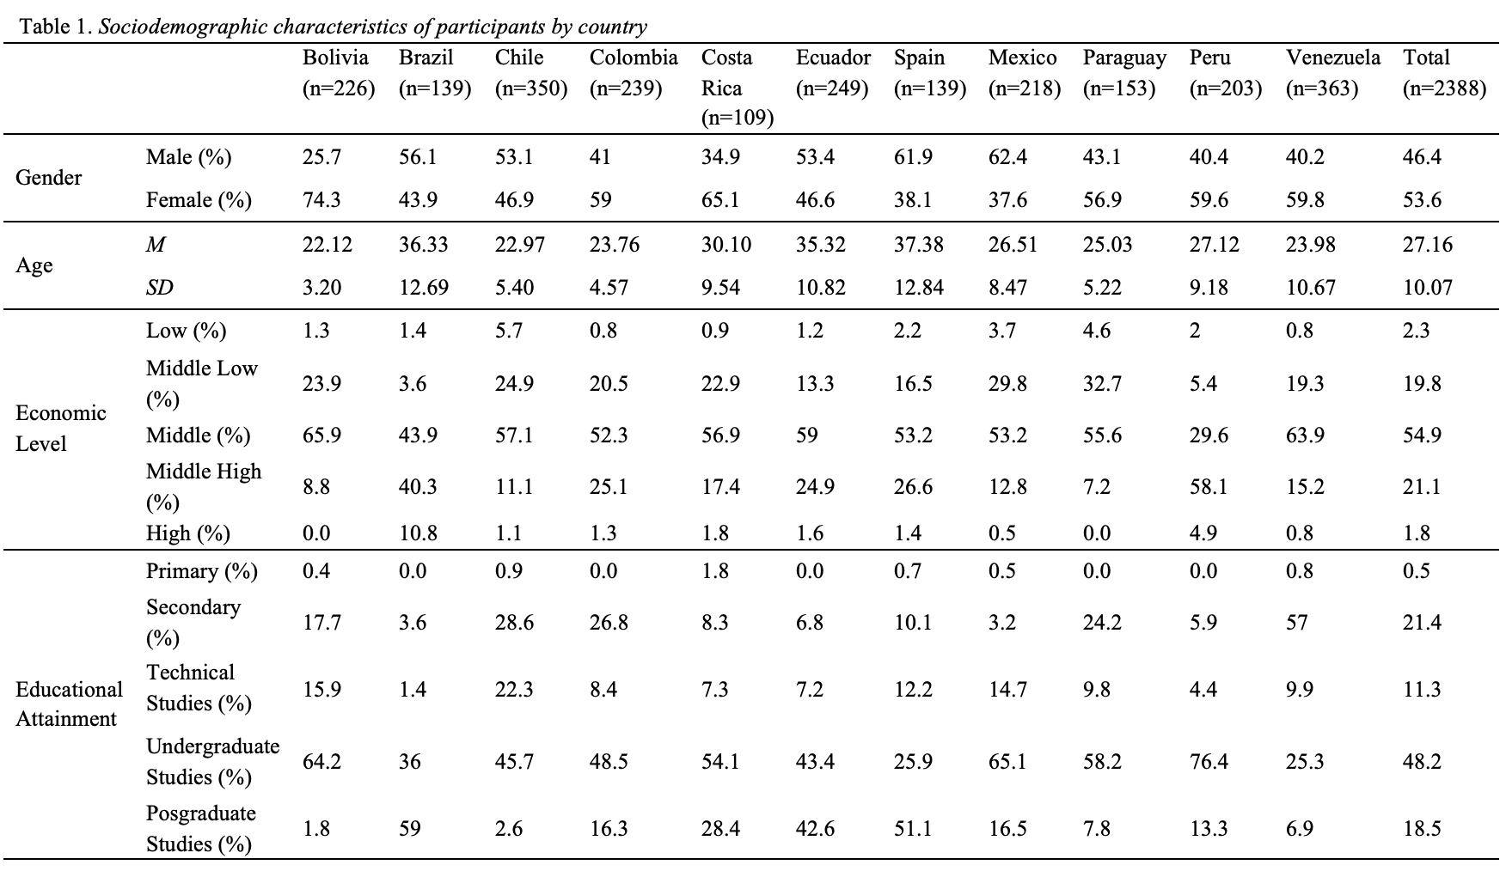

Procedure
First, a questionnaire was developed which took into consideration specific characteristics for each country. Then, a linguistic adaptation was made by region, taking into account the comments and suggestions of several experts from each participant country. Subsequently, the questionnaires were digitized using the Google Forms tool where participants were initially presented with informed consent, indicating the objective of the study, information on the confidentiality of the data provided, and a reminder of the free and voluntary nature of participation in the research. Data gathering started with a virtual call made through various social networks inviting people to participate in the study. The management of the data collection process and subsequent data quality check was carried out in Lima, Peru.

Data analysis
To accomplish the first objective of the study, two Confirmatory Factorial Analyses were conducted with the general sample of the study, in order to analyze the factorial structure and the goodness of fit of the Political Cynicism Scale (Janos et al., 2018). Subsequently, to accomplish the second objective of the study, descriptive analyses of the general sample by country were processed along the dimensions of the political cynicism scale, as well as the ideological dimensions of Social Dominance (SDO) and Authoritarianism (RWA).
Finally, analysis of the relationships between the variables of ideology and political cynicism were processed. The main statistical tools used in order to analyze the data along these lines were correlation analysis and multiple linear regression.

Results

Factorial structure of the political cynicism scale
To accomplish the first objective of this study, two Confirmatory Factorial Analyses (CFA) of the political cynicism scale were carried out. A first CFA was carried out to evaluate the goodness of fit of the 5-factor structure proposed by János et al., (2018) in their study with a Peruvian sample. Following the criteria proposed by Hu & Bentler (1999), the model obtained in this first analysis presents an unacceptable fit for the general sample of the 11 countries, χ2/df = 20.224, CFI=.824, NFI=.817, RMSEA= .090, 90% CI [.086, .093]. For this reason, it was decided to review the structure of the model and the factors originally proposed with some modifications to the scale being made and some items with low factorial loads being removed.
As a result, the "Perception of Ineffectiveness of the Political System" factor was reduced in two of its items and the third that composed it went on to have a higher factorial load in the dimension of "Mistrust in the Political System". These modifications were made taking into consideration both the magnitudes and significance of the factorial loads, and the semantic consistency of the resulting dimension. Thus, the scale of Political Cynicism showed a new structure of 4 factors. The goodness of the fit of the new model is better than that of the previously evaluated version of the scale, χ²/df = 9.967, CFI = .960, NFI = .956, RMSEA = .061, 90% CI [.054, .069].
The new factorial structure, which can be seen in Figure 1, is composed of 9 items and 4 factors. The first factor named "Mistrust in the Political System" (α=.76) has three items; whereas the second factor "Perception of Corruption in the Political System" (α=.74), the third factor "Political Moral Laxity" (α=.69) and the fourth factor "Perception of the Need for Change of the Political System" (α=.52), have two items each. All items load optimally in their respective factor, with the minimum factorial load being .593 and the maximum .866. Correlations between dimensions are small to medium, and reliability is acceptable in three of four dimensions. The fourth factor has the lowest Cronbach’s Alpha score, but taking into account the measured construct, the level of internal consistency obtained is acceptable for statistical inferences according to the criteria of Mezulis, Abramson, Hyde and Hankin (2004).
From the above, it was decided to use the second factorial structure of the Political Cynicism scale in all subsequent analyses and procedures for presenting a semantically clearer structure, being more parsimonious and presenting a better goodness of fit.

Figure 1.
4-Dimensions Factorial structure of the Political Cynicism scale
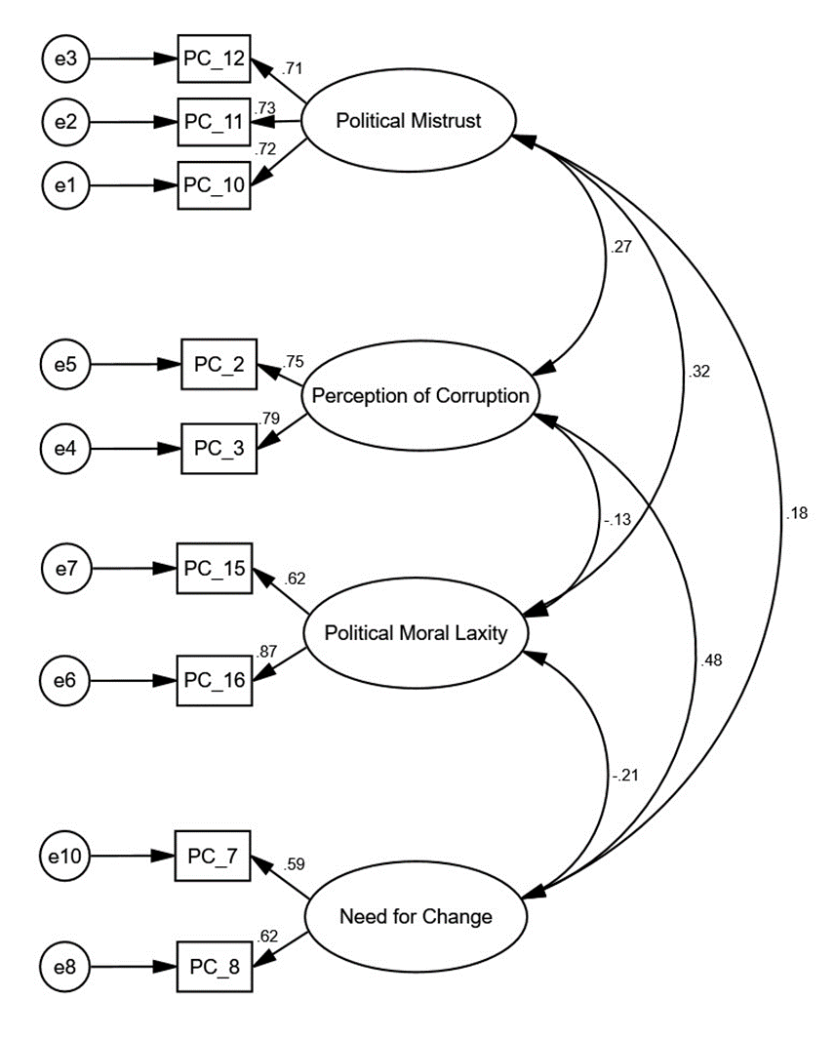

Descriptives of Political Cynicism and Political Ideology
After defining the factorial structure of the Political Cynicism scale, descriptive statistics were calculated for the 4 dimensions of Political Cynicism, as well as for the ideological indicators of Social Dominance Orientation (SDO) and Right-Wing Authoritarianism (RWA). The results can be seen in Table 2.

Table 2.
Descriptives of Political Cynicism, SDO and RWA in the general sample
Variable | n | M | SD | 95%CI
Political Cynicism
Political Mistrust | 2370 | 2.47 | 0.83 | [2.44, 2.51]
Perception of Corruption | 2372 | 3.58 | 0.65 | [3.56, 3.61]
Political Moral Laxity | 2369 | 1.69 | 0.78 | [1.66, 1.72]
Need of Change | 2370 | 3.42 | 0.64 | [3.40, 3.45]
Political Ideology
Social Dominance Orientation (SDO) | 2385 | 2.39 | 1.03 | [2.35, 2.44]
Right-Wing Authoritarianism (RWA) | 2384 | 3.49 | 0.85 | [3.45, 3.52]
With regard to Political Cynicism, the results indicate that, at the general level, participants have a score above the midpoint of the response scale (2.5) in the dimensions of Perception of Corruption and Need for Change. The arithmetic mean for the dimension of Mistrust in the Political System is at the midpoint of the response scale and the mean for the dimension of Political Moral Laxity is below the midpoint of the response scale.
With regard to both SDO and RWA, the indicators of conservative ideology are below the midpoint of the response scale (4 in both cases). Specifically, it is apparent that, at the descriptive level, the general sample is more authoritarian than dominant. In addition, descriptive scores of the dimensions of Political Cynicism, SDO and RWA by country are reported (see Figure 2).

Relationships between Political Cynicism, SDO and RWA.
For the second objective of the study, correlation analyses were carried out in order to explore how the ideological dimensions of SDO and RWA are linked to the different dimensions of Political Cynicism. The results of the relationships for the general sample can be seen in Table 3.
First, at the general level, it can be seen that SDO is directly related with a medium effect-size to Political Moral Laxity. SDO is also inversely related with a small effect-size to the Perception of Need for Change in the Political System.
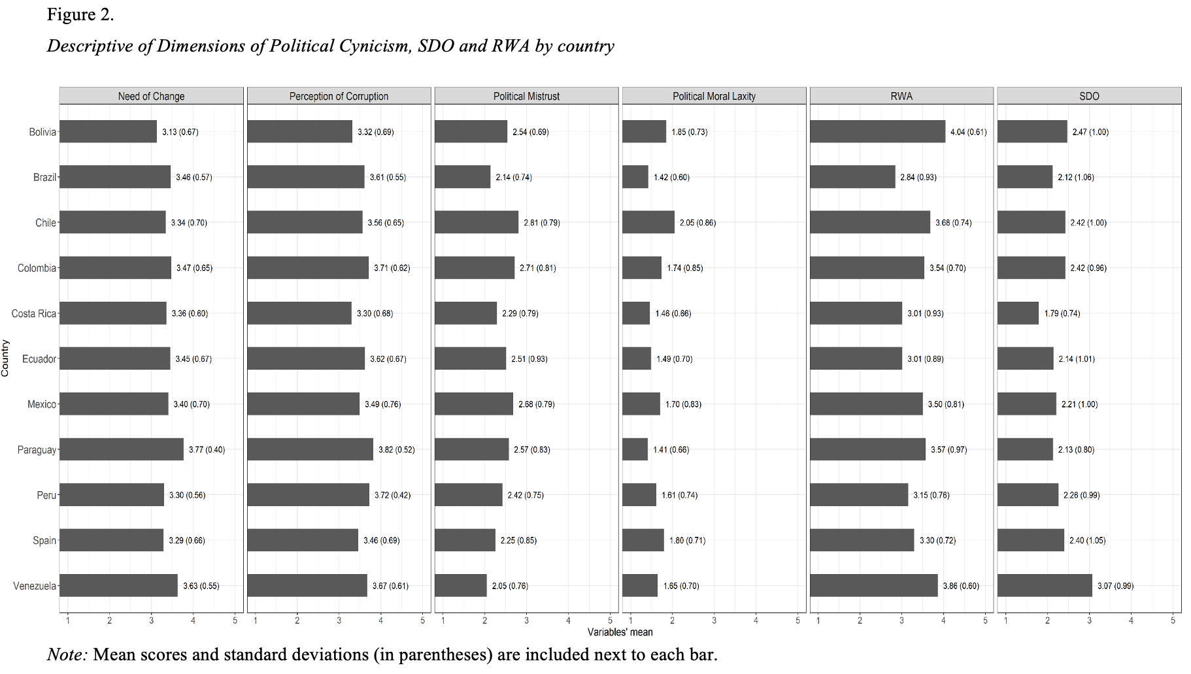
Table 3.
Pearson Correlations between Political Cynicism, SDO and RWA in the general sample
 | 1 | 2 |  | 3 | 4 | 5 | 6
1. Political Mistrust | 1 | .190** | .233** |  | .116** | .036 | .176**
2. Perception of Corruption |  | 1 | -.106** |  | .305** | -.036 | -.013
3. Political  Moral Laxity |  |  | 1 |  | -.123** | .318** | .179**
4. Need of Change |  |  |  |  | 1 | -.061** | -.001
5. SDO |  |  |  |  |  | 1 | .246**
6. RWA |  |  |  |  |  |  | 1
**p < .01 (bilateral)
With regard to RWA, it is noted that this ideological dimension is directly associated with a small effect-size to the Mistrust in the Political System. RWA is also directly associated with a small effect-size to Political Moral Laxity. Relations between RWA or SDO with the Perception of Corruption in the Political System are not observed for the general sample.
In order to investigate these links more closely, correlation analyses by country were performed following the same prior procedure. This analysis found that: (1) Mistrust in the Political System is correlated to RWA in the samples of Chile, Costa Rica, Ecuador, Paraguay and Brazil, and to SDO in Peru; (2) in the samples of Chile and Ecuador, RWA and SDO correlate with Perception of Corruption; however, relations in Chile are inverse and in Ecuador are direct. Something similar to that observed in Chile occurs in Colombia with SDO, which is inversely associated with the Perception of Corruption; (3) Political Moral Laxity is significantly related to SDO in the samples of all countries participating in the study except for Paraguay. In addition, in Chile, Colombia, Costa Rica and Peru, RWA is also related to Moral Laxity, although with smaller effect sizes than observed in relations with dominance; (4) finally, the Perception of Need for Change in the Political System is inversely associated with SDO in samples from Brazil, Chile and Spain. For its part, in Ecuador, RWA is positively associated with the Perception of Need for Change. The Pearson r-values of the relationships described are presented in Table 4 and for a better comparison of their intensity, see Figure 3.

Table 4.
Pearson Correlations between Political Cynicism, SDO and RWA by country
Country |  | Political  Mistrust | Perception of  Corruption | Political  Moral  Laxity | Need of  Change
Bolivia | SDO | -.039 | .104 | .218** | -.039
Bolivia | RWA | .071 | -.064 | .059 | -.013
Brazil | SDO | .290** | -.014 | .220* | -.173*
Brazil | RWA | .350** | -.015 | .074 | .011
Chile | SDO | .082 | -.239** | .370** | -.221**
Chile | RWA | .279** | -.191** | .311** | -.096
Colombia | SDO | .052 | -.248** | .424** | -.040
Colombia | RWA | .119 | -.038 | .186** | -.063
Costa Rica | SDO | .151 | -.178 | .512** | -.039
Costa Rica | RWA | .301** | .162 | .240* | .165
Ecuador | SDO | .056 | .202** | .367** | -.027
Ecuador | RWA | .201** | .127* | .101 | .175**
Mexico | SDO | .129 | -.100 | .364** | -.013
Mexico | RWA | .079 | .036 | .037 | -.013
Paraguay | SDO | .146 | .065 | .105 | -.058
Paraguay | RWA | .396** | .106 | .195* | -.062
Peru | SDO | .166* | -.068 | .401** | -.073
Peru | RWA | .110 | -.014 | .177* | .018
Spain | SDO | .026 | -.015 | .229** | -.247**
Spain | RWA | .151 | .082 | -.057 | -.062
Venezuela | SDO | .056 | -.043 | .257** | -.057
Venezuela | RWA | .057 | -.026 | .030 | -.028
*p < .05, **p < .01

Figure 3.
Comparisons of the intensity of Person’s correlations between the dimensions of Political Cynicism and Political Ideology (SDO and RWA) for each country.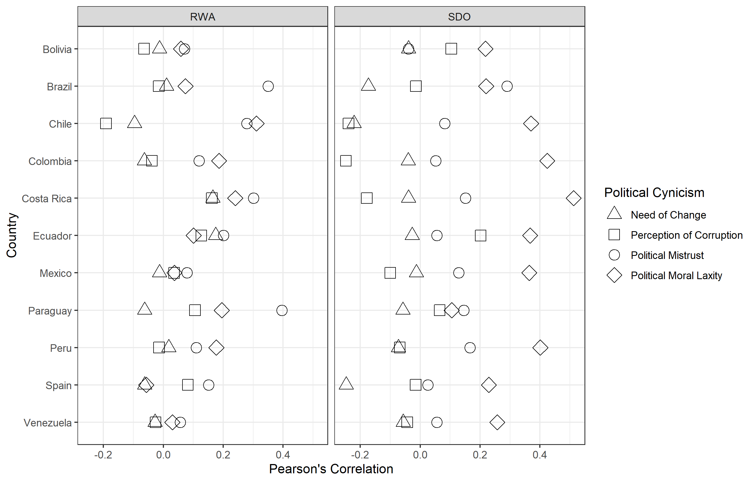

Multiple Regression Analysis of SDO and RWA in Political Cynicism
To further understand the relationships between Political Cynicism and Ideology, several multiple linear regression analyses were conducted by introducing RWA and SDO as predictor variables, and each dimension of the Political Cynicism scale as a criterion variable. The results of these analyses are reported according to each dimension of Political Cynicism.

Mistrust in the Political System
A stepwise multiple linear regression which focused on the influences of RWA and SDO on Mistrust in the Political System found a significant model, at a general level, that explains 3.1% of the variance, F(1, 2366) = 74.98, p < .001. Showing that RWA, b = .172, t = 8.66, p < .01 acts as the only significant predictor for that dimension. When the same analysis was performed for each country, it was found that there are 6 significant models: Brazil, Chile, Costa Rica, Ecuador, Paraguay and Peru.
Specifically, it was found that for 5 of the countries (Brazil, Chile, Costa Rica, Ecuador and Paraguay), RWA is the only dimension of political ideology that predicts Mistrust in the Political System; whereas, in the Peruvian sample it is SDO that best predicts such mistrust (see Table 5).
Table 5.
Regression Analysis of SDO and RWA influences in Mistrust in the Political System by country (significant models only).
Country | Variable | R² | F | B | t | P
Brazil | RWA | .123 | 18.76** | .276 | 4.33 | .000
Chile | RWA | .076 | 28.38** | .291 | 5.32 | .000
Costa Rica | RWA | .091 | 10.45** | .253 | 3.23 | .002
Ecuador | RWA | .041 | 10.27** | .210 | 3.20 | .002
Paraguay | RWA | .157 | 27.71** | .337 | 5.27 | .000
Peru | RWA | .028 | 5.67** | .125 | 2.38 | .018
**p < .01

Perception of Corruption in the Political System
A stepwise multiple linear regression analysis which focused on the influences of RWA and SDO on the Perception of Corruption in the Political System showed that, at a general level, there is not a significant predictive relationship between the measured dimensions of ideology and Perception of Corruption. However, when the same procedure is performed by country, there are significant regression models associated with 3 countries: Chile, Colombia and Ecuador (p < .01).
Specifically, in the case of Colombia and Ecuador it was found that SDO is the only ideological component that influences the Perception of Corruption, although this relationship is positive in Ecuador and negative in Colombia. In Chile, however, it was found that both SDO and RWA inversely predict, the Perception of Corruption (see Table 6).

Political Moral Laxity
A stepwise multiple linear regression analysis of the influences of RWA and SDO on Political Moral Laxity shows, for the general sample, a significant model explaining 11.2% of the variance, F(2, 2365) = 149.69, p < .001. Specifically, it was found that both SDO, b = .220, t = 14.66, p < .01, and the RWA, b = .097, t = 5.31, p < .01 act as general predictors of Political Moral Laxity.
Table 6.
Regression Analysis of SDO and RWA influences in the Perception of Corruption in the Political System by Country (significant models only).
Country | Variable | R² | F | B | T | P
Chile | SDO | .074 | 13.73** | -.132 | -3.67 | .000
Chile | RWA | - | - | -.117 | -2.41 | .016
Colombia | SDO | .061 | 15.51** | -.158 | 5.32 | .000
Ecuador | SDO | .041 | 10.42** | .133 | 3.22 | .001
**p < .01
At the country level, significant models were found in all 11 of the country samples analysed (p < .01). As such, political ideology seems to predict Moral Laxity, with SDO being the most influential ideological dimension, as in 10 of the 11 countries, there was a significant direct relationship between SDO and Moral Laxity. The Paraguay sample is the exception, as in this sample it was found that the ideological dimension of RWA predicted Moral Laxity. In the case of Chile, RWA also plays an important role in the prediction of Political Moral Laxity, but with a smaller intensity than SDO (see Table 7).

Perception of Need of Change in the Political System
With respect to the Perception of Need of Change, a stepwise multiple regression analysis for the general sample yields a significant model explaining 0.4% of the variance, F(1, 2366) = 8.86, p = .003; whereby SDO is the only ideological component which predicts the Perception of Need of Change in the Political System, b = -.038, t = -2.97, p = .003.
In relation individual country results, there are only significant models for samples from Brazil, Chile, Ecuador and Spain (p < .01). In Brazil, Chile and Spain, the SDO is inversely related to the Perception of Need of Change in the Political System, while in Ecuador, the RWA directly predicts this dimension (see Table 8).

Table 7.
Regression Analysis of SDO and RWA influences in the Political Moral Laxity by Country (significant models only).
Country | Variable | R² | F | B | T | P
Bolivia | SDO | .048 | 11.21** | .160 | 3.348 | .001
Brazil | SDO | .048 | 6.785* | .124 | 2.605 | .010
Chile | SDO | .181 | 38.11** | .265 | 6.060 | .000
Chile | RWA | - | - | .242 | 4.102 | .000
Colombia | SDO | .180 | 51.86** | .374 | 7.202 | .000
Costa Rica | SDO | .262 | 37.26** | .457 | 6.104 | .000
Ecuador | SDO | .135 | 37.80** | .253 | 6.148 | .000
Mexico | SDO | .132 | 32.75** | .304 | 5.723 | .000
Paraguay | RWA | .038 | 5.88* | .130 | 2.425 | .017
Peru | SDO | .161 | 38.42** | .301 | 6.198 | .000
Spain | SDO | .052 | 7.44** | .155 | 2.728 | .007
Venezuela | SDO | .066 | 25.25** | .182 | 5.025 | .000
*p < .05, **p < .01
Table 8.
Regression Analysis of SDO and RWA influences in the Perception of Need of Change in the Political System by Country (significant models only).
Country | Variable | R² | F | B | T | P
Brazil | SDO | .030 | 4.12* | -.092 | -2.029 | .044
Chile | SDO | .051 | 18.31** | -.158 | -4.279 | .000
Ecuador | RWA | .031 | 7.69** | .132 | 2.772 | .006
Spain | SDO | .061 | 8.77** | -.156 | -2.962 | .004
*p < .05, **p < .01

Discussion
At the general level, the factorial structure of the Political Cynicism scale employed in this study partially supports the structure described by Janos et al. (2018). Specifically, of the 5 dimensions proposed in the original study with a sample of middle-class Peruvians, 4 dimensions are used in the present work. Of the four dimensions included in the new factorial structure, two remain framed in the classical descriptions of Political Cynicism as a measure of (1) widespread mistrust towards the political system, and (2) a perception of systemic political corruption (Beramendi, 2014; Capella & Jamieson, 1997; Miller, 1974; Siu-Kai, 1992). Dimensions 3 and 4 – Political Moral Laxity and Perception of the Need for Change – are potentially derived from or associated with feelings of mistrust and a perception of widespread corruption as outlined in dimensions 1 and 2. Political Moral Laxity described a conscious tolerance of, and even a support for, the existing political structure despite an awareness of political corruption. This attribute may function as a means for survival in situations where the existing political structure is beneficial for an individual (Beramendi, 2014; Chaparro, 2018; Gächter & Schulz, 2016; Janos et al., 2018). The Perception of the Need for Change, on the other hand, implies a belief in the need for and possibility of social change in response to perceptions of political failings (Fu et al., 2011; Janos et al., 2018). Although this reading seems positive in that, for those high in this measure, it is suggestive of a desire to challenge political malfunction, in societies where democratic values are not clearly consolidated, authoritarian and violent forms can be tolerated as acceptable means for the required social change (Belanger & Arts, 2006).
At a descriptive level, the results show that Political Cynicism in the general sample of the 11 countries is characterized, firstly, by a high Perception of Corruption and secondly by a Perception of Need for Change in the Political System. As established, a Perception of Corruption has significant costs in consolidating a democratic system, as it erodes trust in institutions and increases the risk that corruption and norm transgression will become a systemic problem (Beramendi, 2014). However, the presence of a favourable attitude towards change in the political system reveals a belief in the possibility of systemic improvement and an assumption of civic responsibility in this process - something which may explain the recent social mobilizations calling for substantial political changes in countries of the region such as Bolivia, Ecuador, Chile or Colombia (Manjón et al., 2020; Ramos, 2019).
The level of Mistrust in the Political System is ordinally the third element of Political Cynicism to which participants adhere attitudinally in the study. The moderate level of agreement with this measure suggests that, within the countries of Latin America, levels of trust/mistrust towards different actors and institutions of the system are variable. This is supported by insights from public opinion studies that suggest that, globally, Latin America is the region with the worst levels of institutional trust, while something similar happens with Spain in the European context. However, analysis at an institutional level shows that some are more discredited than others, and that in fact there are a few institutions that enjoy high prestige among citizens (Eurobarómetro Standard 90, 2018; Latinobarómetro, 2018). For this reason, while the result of this indicator is not strictly negative for this study, it is not positive either. This latter finding is worrying, because the more mistrust there is towards a political system and its institutions, the more likely it will lose its legitimacy, and important sectors of citizenship will become more anomic, less agreeable and oriented to normative and regulatory transgression (Beramendi, 2014; Chaparro, 2018; Gächter & Schulz, 2016; Patterson, 2002; Rotenberg, 2020). The fourth dimension analyzed -Political Moral Laxity - refers to an attitude which favors the maintenance of the corrupt and inefficient political system as a function of self- or group-interest, even when the system in question causes damage or harm to other actors or sectors of society (Janos et al., 2018). The results reveal a low adherence to this dimension in the general sample, which shows that morally lax attitudes are recognized, by the participants of this study, as potentially dangerous.
One interesting aspect of the components of political cynicism identified on the scale, is that they appear to act in an integrated and sequential manner, suggesting that the perception of corruption and mistrust tend to produce an endorsement of the need for change in the system, or a legitimization of transgression and corruption through the process of political moral laxity (Janos et al., 2018). More specifically, correlation analyses show, through the magnitudes of relationships, that mistrust in the political system is more intensely associated with political moral laxity, while the perception of corruption is associated with a perception of the need for change in the political system. The first relationship can be explained as a result of people's trust in the system legitimating and empowering political authorities and institutions, while a lack of trust weakens them and leads them to neglect central problems of society (Porter, 2007; Tyler, 2001). In this sense, in societies where authorities and institutions are perceived as weak, corrupt or ineffective, there is a greater tendency in their citizens to show intrinsically dishonest attitudes and behaviours (Gächter & Schulz, 2016).
The second relationship is consistent with the recognition that corruption is a problem that necessitates a need for systemic change (Latinbarómetro, 2019; Quiroz, 2013). It should also be noted that the inverse relationship between the perception of need of change and the political moral laxity is often accompanied by the fact that lax individuals do not perceive in corruption a problem that needs to be solved, but as something which is personally beneficial (Janos et al., 2018; Quiroz, 2013). Also, mistrust is indeed a diffuse component, and in the analyses of this study it appears to have a delegitimizing function of the political system in the terms described above. It is interesting to note that, at the descriptive level, with regard to the order of prioritizations in the dimensions of the Political Cynicism scale and at the correlational level, the relationships tend to exhibit a fairly homogeneous statistical behavior in the samples of the 11 countries considered in the study.
On the other hand, the incorporation of the ideological indicators of SDO and RWA, and their relationship to the dimensions of political cynicism, helps to clarify how ideology is linked to perceptions about the functioning of a political system. In this regard it was found that SDO tends to be positively associated with a moderate effect size, with political moral laxity. This is consistent with the idea that hierarchically inclined individuals tend to hold that “the end justifies the means” with regard to the achievement of personal and group objectives (Janos et al., 2018). Such individuals are typically more tolerant of and likely to engage in behavioral practices ranging from small transgressions of social conventions to outright corruption justified, under a cloak of impunity provided by the situation of relative power and dominance they possess in a given context (Janos et al., 2018; Monsegur et al., 2014).
This relationship between SDO and the dimension of moral laxity is the most stable when analyzing samples from the different countries evaluated in the study. Specifically, in 10 of the 11 samples this trend is reported, with the Paraguayan sample being the only one in which this relationship is not observed. In addition, SDO appears to influence the strengthening of corrupt and ineffective political systems since it mitigates the perception of need for change in such systems. In this case the manifestations of cynicism are not related to people's feelings of helplessness or hopelessness about their ability to influence politics (Miller, 1974; Siu-Kai, 1992), but in their disinterest in improving or changing it. That is, the dominant groups do not express a desire to make changes to the failed political system, as these systems have a positive impact on their individual and collective interests (Jackson & Gaertner, 2010; Janos et al., 2018; Monsegur et al., 2014). This result, although consistent with the idea of maintaining morally lax political systems from adherence to the refusal to change a system, sometimes failed, is subject to variability in samples from different countries; the relationship is only significant for Spain, Chile and Brazil. The influence of SDO on other dimensions of Political Cynicism such as mistrust or a perception of corruption is more limited and is restricted only to samples from a few countries. Specifically, a high SDO increases mistrust in the political system only in Peru, and consistent with a denial of the need for social change, high SDO inversely relates to the perception of corruption in the Colombia, Chile and Brazil samples, and directly in the Ecuador sample.
For its part, at the general level, high levels of RWA increases mistrust and political moral laxity. For the relationship between RWA and mistrust, the effect size is small for the total sample, is significant in the Brazil, Chile, Costa Rica, Ecuador and Paraguay samples. In this regard, existing literature in Political Science has established that mistrust in a political system leads to significant problems in the consolidation of a system with democratic values, with the negative consequences listed previously (Beramendi, 2014; Chaparro, 2018; Gächter & Schulz, 2016; Patterson, 2002; Rotenberg, 2020).
Consistent with the above, authoritarianism as an ideological expression can erode citizen trust in a political system that shows excessive liberalism or practices of procedural and distributive justice that threaten the prevailing status quo in countries that are mostly inegalitarian and conservative. Although authoritarianism is significantly related, with a low effect size, to moral laxity in the general sample; a more detailed analysis by countries show that this relationship is only significant for Chile and Paraguay. This result, although limited by the number of countries where the relationship is present, shows that authoritarianism, although usually marked by an extolling of morality and custom, can also function as a risk factor in the exacerbation of political moral laxity. This is especially the case when there are political elites and certain groups in power who stand to benefit from morally lax practices (Sautu, 2018; Schmitz & Espinosa, 2015). More specifically, it is noted that RWA is inversely related to the perception of corruption in Chile and directly in Ecuador.
In summary, the results show that the structure of Political Cynicism in the studied Ibero-American countries goes beyond descriptions focused on mistrust as a diffuse indicator of adherence to the political system. In this sense, it is important to extend the understanding of cynicism to the perception of corruption as one of the elements that can produce such mistrust. It is also important to include Political Moral Laxity and the Perception of Need of Change in the System in the analysis of the responses that accompany Political Cynicism as a result of tensions within the models of political reality of the countries of Latin America and Spain.
Depending on what is described, the main contribution of this work translates into how conservative political ideology influences political tensions arising from perceptions of a political system. On the one hand, authoritarianism tends to increase a diffuse mistrust and moral laxity, with consequent impacts on democracy and its values. However, the most important result, because of its stability in the studied samples, is that of the relationship between SDO and political moral laxity. Specifically, high SDO has a pernicious effect on the political configuration of a society - a result of the acceptance of normative transgression and corruption alongside a denial of the need for social change, even where such change is necessary.

References
Barlach, L. (2013). O Jeitinho Brasileiro: traço da identidade nacional?. Revista Gestão & Políticas Públicas, 3(2). Retrieved from http://www.revistas.usp.br/rgpp/article/view/98574
Bélanger, E. & Aarts, K. (2006). Explaining the rise of the LPF: Issues, discontent and the 2002 Dutch election. Acta Politica, 41, 4-20. https://doi.org/10.1057/palgrave.ap.5500135
Beramendi, M. & Zubieta, E. (2014). Construcción y validación de la Escala de Percepción del Sistema Normativo. Revista Mexicana de Psicología, 31, 124-137. Retrieved from http://www.redalyc.org/pdf/2430/243033031005.pdf
Beramendi, M. (2014). Percepción del sistema normativo, transgresión y sus correlatos psicosociales en Argentina (Unpublished Doctoral Thesis), Facultad de Psicología, Universidad de Buenos Aires, Argentina.
Cappella, J., & Jamieson, K. (1996). News frames, political cynicism, and media cynicism. The Annals of the American Academy of Political and Social Science, 546(1), 71-84.
Cárdenas, M., & Parra, L. (2010). Adaptación y validación de la Versión Abreviada de la Escala de Autoritarismos de Derechas (RWA) en una muestra chilena. Revista de Psicología, 19(1), 61-79.
Cárdenas, M., Meza, P., Lagues, K., & Yañez, S. (2010). Adaptación y validación de la Escala de Orientación a la Dominancia Social (SDO) en una muestra chilena. Universitas Psychologica, 9(1), 161-168.
Chaparro, H. (2018). Afectos y desafectos. Las diversas subculturas políticas en Lima. Instituto de Estudios Peruanos, Lima, Perú.
Duckitt, J., & Sibley, C. (2010). Personality, ideology, prejudice, and politics: A dual‐process motivational model. Journal of personality, 78(6), 1861-1894.
Eurobarómetro Standard 90 (2018). Opinión Pública en la Unión Europea (Informe Nacional). Retrieved from: https://ec.europa.eu/spain/sites/spain/files/st90_-_report_repes_-_vf110219_limpia_.pdf
Fu, H., Mou, Y., Miller, M. J., & Jalette, G. (2011). Reconsidering political cynicism and political involvement: A test of antecedents. American Communication Journal, 13(2), 44-61.
Gächter, S. & Schulz, J. F. (2016). Intrinsic honesty and the prevalence of rule violations across societies. Nature, 531, 496-499. https://doi.org/10.1038/nature17160
Girola, L. (2011). La cultura de la transgresión. Anomias y cultura del "como si" en la sociedad mexicana. Estudios Sociológicos, 39(85), 99-129.
Jackson, L. E. & Gaertner, L. (2010). Mechanisms of moral disengagement and their differential use by right-wing authoritarianism and social dominance orientation in support of war. Aggressive Behavior, 36, 238-250. https://doi.org/10.1002/ab.20344
Janos, E., Espinosa, A., & Pacheco, M. (2018). Bases Ideológicas de la Percepción del Sistema Normativo y el Cinismo Político en Adultos de Sectores Urbanos del Perú. Psykhe, 27(1), 1-14.
Latinobarómetro (2019). Informe 2018. Corporación Latinobarómetro, Santiago de Chile. Retrieved from: http://www.latinobarometro.org/latContents.jsp
Levitt, B. S. (2015). Discrimination and the distrust of democratic institutions in Latin America. Politics, Groups, and Identities, 3(3), 417-437. http://dx.doi.org/10.1080/21565503.2015.1050410
Manjón, M., Cisneros, A., Otero, J., Goyburu, L., Cruz, F., Tricot, V., & Garrido, M. (2020). América Latina 2019: Vuelta a la inestabilidad. Iberoamericana, 20(73), 205-241.
Mezulis, A. H., Abramson, L. Y., Hyde, J. S., & Hankin, B. L. (2004). Is there a universal positivity bias in attributions? A meta-analytic review of individual, developmental, and cultural differences in the self-serving attributional bias. Psychological bulletin, 130(5), 711.
Miller, A. H. (1974). Political issues and trust in government: 1964-1970. American Political Science Review, 68, 951-972. https://doi.org/10.2307/1959140
Monsegur, S., Espinosa, A. & Beramendi, M. (2014) Identidad nacional y su relación con la dominancia social y la tolerancia a la trangresión en residentes de Buenos Aires (Argentina). Interdisciplinaria, 31, 5-23. https://doi.org/10.16888/interd.2014.31.1.1
Patterson, T. E. (2002) The vanishing voter: Public involvement in an age of uncertainty. Alfred A. Knopf.
Porter, J. (2007). Using structural equation modeling to examine the relationship between political cynicism and right-wing authoritarianism. Sociological Spectrum, 28, 36-54. https://doi.org/10.1080/02732170701675128
Pratto, F., Sidanius, J., Stallworth, L., & Mallé, B. (1994). Social Dominance Orientation: A personality variable predicting social and political attitudes. Journal of Personality and Social Psychology, 67(4), 741-763.
Quiroz, A. W. (2013). Historia de la corrupción en el Perú. Instituto de Estudios Peruanos.
Ramos, J. (8 de noviembre de 2019). El malestar en América Latina. The New York Times. Retrieved from: https://www.nytimes.com/es/2019/11/08/espanol/opinion/protestas-america-latina.html
Rotenberg, K.J. (2020). The Psychology of Interpersonal Trust. Theory and Research. Routledge.
Sautu, R. (2018). La corrupción endémica en un país prebendatario: un intento de construcción teórica. In E. M. Zubieta, J.F. Valencia y G.I. Delfino (Coordinadores). Psicología Social y Política. Procesos Teóricos y Estudios Aplicados (pp.64-83). ECOE & EUDEBA.
Schmitz, M. & Espinosa, A. (2015). Ideología, emocionalidad y crisis de gobernabilidad en Lima Metropolitana: un estudio correlacional sobre el proceso de revocatoria del 2013. Revista Electrónica de Psicología Política, 34, 46-63. Retrieved from http://www.psicopol.unsl.edu.ar/2015-Julio-Art%EDculo03.pdf
Segovia, C. (2008). Political Trust in Latin America (Unpublished Doctoral Thesis). Political Science, University of Michigan, The United States of America.
Siu-kai, L. (1992). Decline of governmental authority, political cynicism and political inefficacy in Hong Kong. Journal of Northeast Asian Studies, 11(2), 3-20. https://doi.org/10.1007/BF03023340
Tyler, T. R. (2001). Public trust and confidence in legal authorities: What do majority and minority group members want from the law and legal institutions? Behavioral Sciences & the Law, 19, 215-235. https://doi.org/10.1002/bsl.438
Zakrisson, I. (2005). Construction of a short version of the Right-Wing Authoritarianism (RWA) scale. Personality and Individual Differences, 39(5), 863-872.
Zmerli, S., & Castillo, J. C. (2015). Income inequality, distributive fairness and political trust in Latin America. Social Science Research, 52, 179-192.
Received: 2020-10-23
Accepted: 2022-08-16

Correspondence about this article should be addressed Agustín Espinosa: agustin.espinosa@pucp.pe
Conflicts of Interest: The authors declare that the research was conducted in the absence of any commercial or financial relationships that could be construed as a potential conflict of interest.

