Supplementary Information
Attitudes toward COVID-19 confinement as a Risk Predictor in Panama

Ericka Matus¹, Lorena Matus² Jay Molino³

1Department of Exact Sciences, Universidad Especializada de las Américas, Paseo Albrook, 00629 Panamá,
Panamá. https://orcid.org/0000-0002-3184-982X.
2Department of Psychology, Universidad Iberoamericana, Santa Fe, Ciudad de México, México. https://orcid.org/0000-0001-7259-1530.
3Department of Engineering, Universidad Especializada de las Américas, Paseo Albrook, 00629 Panamá, Panamá. https://orcid.org/0000-0001-5764-7874.

A survey was carried out through Google forms ©, between April 17 and 30, 2020. The study had 233 participants (78 male and 155 female). The average age for males was 39 years old, and for females, it was 38. Descriptive statistics were employed to characterize the sample: 35% of the participants reported having studied at least a postgraduate degree, 54% the university level, eight percent a technician, and three percent, studied secondary. A T-test was used to determine statistically significant differences in the Attitude of men and women towards confinement. 16 of the 36 items resulted in statistically significant differences between men and women. Furthermore, women are at risk considering that the averages obtained are significantly lower than those of men in question 11. I work from home ($\overline{X}=$ 3.37, d.s. 1.45), 36. I study what I like ($\overline{X}=$ 3.47, d.s. 1.25), 33. I exercise ($\overline{X}=$ 2.96, d.s. 1.34), y 34. I talk with my friends ($\overline{X}=$ 3.51, d.s. 1.17).
For males, the situation is more delicate since items 13. I feel confused ($\overline{X}=$ 1.91, d.s. 1.10), 14. I feel vulnerable ($\overline{X}=$ 2.08, d.s. 1.15), 15. I feel helpless ($\overline{X}=$ 1.86, d.s. 1.08), 17. I feel in danger ($\overline{X}=$ 2.15, d.s. 1.22), 18. I feel scared ($\overline{X}=$ 2.24, d.s. 1.19), 19. I feel upset ($\overline{X}=$ 1.78, d.s. 1.04), 20. I feel isolated ($\overline{X}=$ 2.05, d.s. 1.17), 21. I feel angry ($\overline{X}=$ 1.83, d.s. 1.04), 22. I feel uncertain ($\overline{X}=$ 2.50, d.s. 1.33), 24. I feel worried ($\overline{X}=$ 2.72, d.s. 1.23), 25. I feel imprisoned ($\overline{X}=$ 1.90, d.s. 1.11), 29. I dance ($\overline{X}=$ 2.47, d.s. 1.48), they are significantly less than in women, in addition to the affective factor ($\overline{X}=$ 2.18, d.s. 0.86).

Linear model
Linear regression was calculated from the factors to know the effect that each of them has on attitudes towards confinement, finding a model $y=2.95+0.61x$, with a linear R² = 0.998. This is shown in Graph S1. The relationship between attitude and affective, cognitive, and behavioral factors is shown in Graph S2.

Graph S1. Linear correlation for the predictive model.
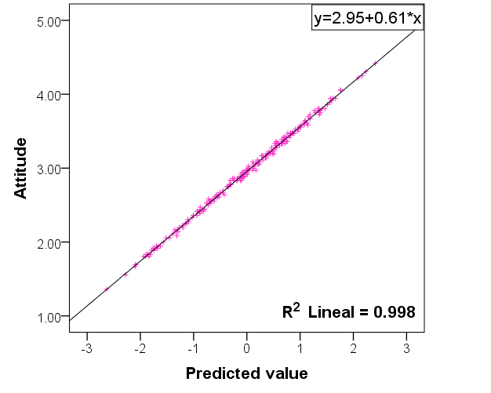

Graphs S2, S3, and S4 show the positive relationship that exists between attitudes and each one of the factors. The relationship between the cognitive factor and the Attitude is direct, positive, and strong, which is evidenced by the value of the linear R2 = 0.623 (Graph S2).
The three factors that make up the attitudes allow us to visualize the dispersion in each of them. The lowest values in the distribution belong to the cognitive factor since the participants knew about the virus. Thus, they were aware of the prevention protocol.
The relationship between the affective factor and the Attitude is direct, positive, and moderate, which is evident in the value of the linear R2 = 0.534. For the affective factor, there is greater dispersion in the responses, possibly due to changes in the way they managed their emotions. This is sumarized in Graph S3.
The relationship between the behavioral factor and Attitude is direct, positive, and weak, which is evidenced by the value of linear R² = 0.379. The greatest dispersion is perceived in the behavioral factor; these values could be related to the autonomy that the population perceives even when the Health Authorities instituted curfews and a full quarantine. The relationship is shown in Graph S4.

Graph S2. Linear correlation for the affective factor v. Attitude.
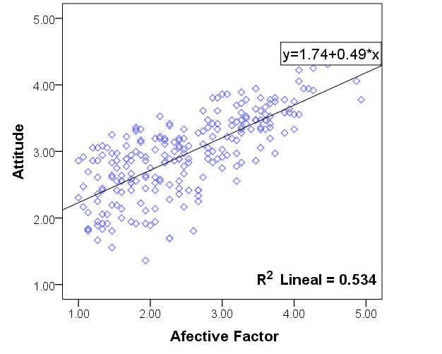

Graph S3. Linear correlation for the cognitive factor v. Attitude. The highest dispersion is observed in this factor.
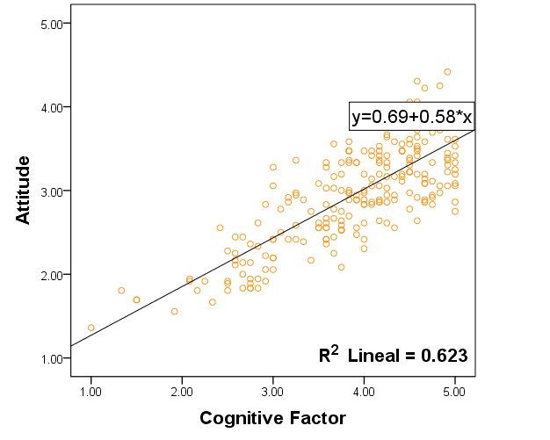

Graph S4. Linear correlation for the behavior factor v. Attitude.
