Knowledge, attitudes, and susceptibility perception towards the COVID-19 pandemic in Latin American regions

ABSTRACT
Latin American countries have been strongly affected by COVID-19. We explore psychosocial elements which may be exerting an influence on the poor compliance with mandatory control measures. We assess knowledge, attitude, and risk perception during the coronavirus outbreak among Latin-American population by collecting data from 600 self-selected participants through a web-based, one-period survey evaluating demographic information on a sample of educated respondents (>70%), aging between 16 to 77 years old, living in any South American countries. Results: Logistic regression showed that knowledge is highly related with age, attitude is related with marital status, perception with education and marital status with occupation (p<0.001**). Although people reported adequate knowledge by identifying expected coronavirus symptoms, there is a significant risk perception to contracting the COVID-19 (57.7%), displaying stigmatized behavior (59.1%), fear of getting sick (70.2%), and distrust toward the current health administration's response (61.57%). Conclusion: public communication-based strategies would serve both to contain psychological reactions, risk perception, as well as to ensure compliance among the population.

KEYWORDS: Attitudes, health knowledge, risk perception, public health, primary prevention, observational study.

RESUMEN
Los países latinoamericanos se han visto fuertemente afectados por el COVID-19. Exploramos los elementos psicosociales que pueden estar ejerciendo una influencia en el escaso cumplimiento de las medidas de control obligatorias. Evaluamos el conocimiento, la actitud y la percepción del riesgo durante el brote de coronavirus entre la población latinoamericana, recogiendo datos de 600 participantes auto-seleccionados a través de una encuesta basada en la web, de un solo período, que evalúa la información demográfica de una muestra de encuestados educados (>70%), con edades comprendidas entre 16 y 77 años, que viven en cualquier país de América del Sur. Resultados: La regresión logística mostró que el conocimiento está altamente relacionado con la edad, la actitud con el estado civil, la percepción con la educación y el estado civil con la ocupación (p<0,001**). Aunque las personas reportaron un conocimiento adecuado al identificar los síntomas esperados del coronavirus, existe una significativa percepción de riesgo a contraer el COVID-19 (57,7%), mostrando un comportamiento estigmatizado (59,1%), miedo a enfermar (70,2%) y desconfianza hacia la respuesta de la administración sanitaria actual (61,57%). Conclusión: las estrategias basadas en la comunicación pública servirían tanto para contener las reacciones psicológicas, la percepción del riesgo, como para asegurar el cumplimiento de la población.

Knowledge, attitudes, and susceptibility perception towards the COVID-19 pandemic in Latin American regions

INTRODUCTION

The emergence of the new coronavirus, nominated as 2019-nCoV by the World Health Organization, had already reached pandemic proportions with 157.9 million confirmed cases worldwide (Sohrabi et al., 2020; Sun et al., 2020). The rapid transmission of this pneumonia cases has urged strict restrictive to mitigate the proliferation of the virus measures disrupted many countries worldwide since late December 2019 (WHO, 2020a).

As previous studies on epidemics have argued, psychological elements play a role in behaviors and attitudes at the level of compliance within the social structure (De Zwart et al., 2009; Smith, 2006). These elements would contribute to explain the ineffectiveness of pandemic mitigation in South America. Theoretical foundations on risk perception highlight the role of the person on addressing the disease. Hence, it is paramount to gain an adequate understanding of the subjective conception of risk, as well as the psychosocial factors associated with compliance with disease control and protection procedures. In this regard, Sander Vann Der Linden's model of socio-psychological determinants (Van der Linden, 2015) proposes cognitive (e.g., people's knowledge and understanding of risk), emotional, experiential elements (e.g., subjective experiences), linked to people socio-cultural conceptions (e.g., social interpretation of risk, culture, and values). This approach unveils subjective differences (e.g., gender, education, ideology), the ones that would allow the elaboration of knowledge, attitudes and perceptions in the face of the current pandemic impacting the population behavior.

In this already complex environment, aimed at curbing the spread of the virus, there is now not only evidence of non-compliance with protective measures, but also of limited governmental capacity to respond to the crisis (Barbisch et al., 2015). While the control standards of Asian countries were indisputable, low-income groups in Latin American countries had greater challenges in complying with such control measures. Social and economic vulnerability, due to poverty, extreme poverty, poor access to social and health systems, insufficient preventive strategies, among others had a direct impact on health outcomes in Latin America. Furthermore, knowledge about virus transmission and management appears to be vital for containing levels of mass spread (Brooks et al., 2020). Hence, understanding people conceptions regarding risk could substantially anticipate response to the existing threat (J. Lau et al., 2003; Joseph Lau et al., 2007; Wang et al., 2020)

It is difficult to ignore people beliefs and attitudes implicit in the pandemic dissemination. Conflicting attitudes arise in response to the limited food access, health complication, loss of the loved ones, on top of long quarantine periods in the population (De Zwart et al., 2009). People attitude is associated with disease knowledge, , the literature states that greater knowledge of COVID-19 promotes better attitude against its proliferation (Zhong et al., 2020). Health-related educational strategies would greatly increase healthy practices by strengthening the adoption of health and safety practices and preventive behaviors (Deblina Roy, Sarvodaya Tripathy, Sujita Kumar Kar, Nivedita Sharma, Sudhir Kumar Verma, 2020; Dryhurst et al., 2020), where cultural values may predict avoidable risk behaviours, both critical to manage public health risk.

High rates of risk perception during pandemics is expected among the population(Dryhurst et al., 2020; Janjua et al., 2007; Van Bavel et al., 2020). The authors examine subjective dimensions that would serve as predictors of risk behavior. This study explores the interaction between knowledge, perception and attitude in the Latin American population in response to COVID-19. We estimate that this study offers an important contribution given the scant number of studies conducted in Latin American contexts.

METHOD
Participants

This cross-sectional, descriptive, web-based survey (Montero & León, 2007) was conducted from March 15 to May 17. An initial sample of 600 individuals was recruited. The mean age was 33.48 ± 11.268, ranged from 16 to 77 years old, mostly females (63.7%).

Instrument: Knowledge, Attitude and perception questionnaire
The survey, that was previously used by Zegarra-Valdivia et al., (Zegarra-Valdivia et al., 2020) were adapted and modified from previously published literature regarding viral epidemics (Abbag et al., 2018; Blendon et al., 2004; Deurenberg-Yap et al., 2005; Di Giuseppe et al., 2008; J. Lau et al., 2003; Wong & Sam, 2011). The test respondents commented that the questions were easily understood, and the average completion time was 10 min. This tool briefly is divided into 6 sections as follows: a) knowledge about coronavirus, b) transmission, c) severity perception, d) perceived susceptibility, e) preventive attitudes, f) behavioral response to COVID-19. All the answers were display as Likert scale, agree, not sure/maybe, and disagree; yes, no, or do not know, or very likely, probable, and unlikely or high, middle, and low. A score of one was assigned to a correct answer and a value of zero to an incorrect answer or “do not know” responses. Total score of a + b is considered the total knowledge score, c + e was the total score of attitude against COVID-19, and d + f was the perception susceptibility. We consider that the cut-off was at least 70% of the total score for Knowledge and Attitude. Regarding perception susceptibility, the cut-off was >30%. We use these cut-off points to divide the sample between less/more knowledge, less/more positive attitude against COVID-19, and less/more frequent perception susceptibility. Their knowledge and attitude were evaluated against facts published by WHO (WHO, 2020b).

The survey original version underwent a pilot study among convenient sample of 256 individuals to ensure validity, interpretation of answers, wording to then be revised item-by-item, and be distributed to the study sample (Zegarra-Valdivia et al., 2020).

Procedure
Ethical Statement

All participants were informed about the aims of this study and gave written informed consent. This study follows ethics guidelines and was approve by the local ethics committee (ref. number N: CEI 003-2020). All data was collected in an anonymous database.

Statistical Analysis
Socio-demographic characteristics were compared with chi2 tests as explanatory variables including: age, gender, marital status, educational level, occupation and region of residency. Other explanatory variables were also considered in the model knowledge, attitudes and risk perception. Reliability was measured by Cronbach alpha. Relation between variables were assesed with Pearson Correlation. One-way ANOVA compared the total score of knowledge, attitude, and perception between sociodemographic variables. Binary logistic regression analyzed the effect of gender, age group, educational level, marital status, occupation, and Latin American region using the total punctuation of the three sections as described above. Statistical analysis was performed through the SPSS software, version 24 (SPSS, Inc., USA) and GraphPad Prism 6 software (San Diego, CA, USA)(George, D. & Mallery, 2003). Statistical significance level was set as a tow-tailed p-value < 0.05.

RESULTS

Background characteristics in Latin American participants (Table 2).
The sample included 600 individuals, the majority of the participants were female (n= 382). We did not find a statistically significant difference between age group (p= 0.565), educational level (p= 0.781), marital status (p= 0.608), occupation (p= 0.067) and Latin American Region (p= 0.958) by gender. The majority of participants were from South America (72.2%), graduated (56.8 %), single (59.5%) and professionals (67.2%) with similar percent distribution between males and females.

Knowledge about symptoms and transmission ways in COVID-19 disease (Table 3)
More than half of the studied sample correctly identified the most frequent symptoms like fever (96.5%), fatigue (65.8%), and dry cough (89.2%) along with others as just as sore throat (78.5 %), joint and muscle pain (57.3%). While some symptoms are described as a manifestation of the disease such as shortness of breath (94.8%); this has not been confirmed as part of the diagnosis (26). The majority of the population (85.3%) knew the incubation period. Furthermore, diarrhea (57.5%), runny nose (57.2%), and nasal congestion (59.7%) were not recognized as part of the disease. Data were significant (p ≤0.001**).

Participants correctly reported means of transmission/ spread of COVID-19 including touching infected objects or surfaces (93.5%), sharing areas/countries infected by COVID-19 (90.5%), shaking hands with infected people (86.7%). In addition, subjects identified situations unrelated to contagion: participating in blood transfusions (56.2%) and by relating to people who were in a hospital or emergency room (53.7%).
Severity of COVID-19 and prevention measures (Table 4)
The majority of respondents (93%) considered COVID-19 as highly contagious, with symptoms similar to flu and influenza (83.8%). Regarding the mortality ratio, they do not assess that it is worse than influenza or tuberculosis (75.2%) or that it causes permanent physical damage to patients (78%). However, when comparing the impact of COVID-19 with influenza or the common cold, more than half indicated greater impact (74.3%), showing distrust in the national/local authorities (61.5%) and preparedness for the disease (73.8%).

Poor understanding of the precautionary measures is evident. Although some form of prevention is recognized such as to wash hands (99.2%), to have special care with people who have symptoms of COVID-19 (97.8%), to avoid crowded places (97.7%), to separate/ isolate patients with coronavirus (97.7%) and personal hygiene (96.5%). Other important measures were not totally considered, such as checking symptoms on websites (p=0.683), despite the fact that the WHO not recommends its use (WHO, 2020a). Furthermore, antibiotics are not recognized as the first line of action against the disease (79.5 %), a sign of the population's knowledge of the treatment.

Perceived susceptibility to COVID-19 (Table 5)
Regarding risk perception, we found stigma about COVID-19 (60.8%); a great proportion responded to preventive measures to avoid the disease (69.3%), 68.7% feels upset about the disease, there may be problems derived from the pandemic (50.5%) with serious consequences in people life (72.3%), compared to people who do not know about it (33.2%), and 50% believe that the situation will not pass quickly. More than half of the respondents reported fear resulting from being in contact with people who have returned from abroad (68.2%), eating out (65%), visiting hospitals (64.8%) and having contact with people with flu symptoms (56.3%).
Concern for medical services personnel is evident (75.2%), followed from people over 60 years of age (66%) and taxi drivers (58.3%) and susceptibility to contract disease (57.7%).
Participants were asked about their perception about getting infected. Countries affected by COVID- 19 (68.4%), public transport (58.3%), family members will get the virus (45.5%) and their own communities are considered as highly likely to experiencing a major outbreak of coronavirus (50.7%); Finally, the perception of treatment efficacy is middle (62.7%); the spread of COVID-19 around the community is relatively high, 50.7%, as well as the concern of family members get sick (45.5%).

Knowledge, Perception, Attitude scores by sociodemographic variables
By comparing regions, post-hoc analyses (Figure 2A). shows North Americans have lower score in perception susceptibility (F: 6.521, p=0.002*) compared to South Americans (p <0.05) and Central Americans (p <0.01). Additionally, marital status reveals differences around the attitude against COVID-19 (F: 3.523, p= 0.007*). Widowers had lower scores compared with single (p <0.05), and married participants (p <0.01*). Analyzing occupation (Figure 2C), we found significant differences in knowledge (F: 3.411, p= 0.034*), attitude (F: 3.447, p=0.032*), and perception (F: 11.682, p <0.001**). Independent workers scored lower in knowledge compared with professionals (p <0.025*). Students scored lower (p <0.043*) compared to professionals and independent workers (p <0.001**). Knowledge (F: 3.864, p= 0.004*) is associated to level of instruction. This is the case of postgraduate, who scored higher compared to secondary instruction level (p <0.042*), and technician (p <0.013*). Finally, to differentiate the perception of susceptibility (F: 3.473, p= 0.008*), postgraduate level displays reduced score compared to high school (p <0.008*). (Figure 2D).

Distribution of sociodemographic factors associated with Knowledge, Attitude, and Perception of susceptibility in Latin Americans (Table 6)
Younger people (21 to 30 years old) evidenced lower COVID-19 symptoms-related knowledge and transmission compared to adults > 51 years old (OR= 0.396; 95% IC: 0.195 – 0.802; p <0.01*). The attitude towards the disease (less vs. more positive attitude) is mediated by occupation (p =0.041*). Both married (OR= 2,779; 95% IC: 1.199 – 6.442, p =0.017*) and singles participants (OR= 2,318; 95% IC: 1.004 – 5.352; p <0.05*) rate higher in positive attitude. Secondary level instruction is related to increased perception susceptibility (OR= 3,004; 95% IC; 1.005 – 8.979; p <0.05), compared to widowers (OR= 0.011; 95% IC: 0.001 – 0.174; p <0.01) and student (OR= 0.184; p <0.01) who scored lower in perception susceptibility.

DISCUSSION

The results of the current study portray a mosaic of opinions towards the COVID-19 pandemic based on a sampling of South American regions. Latin America being a multiethnic region, i.e., with notable socioeconomic and educational differences, culture and traditions maintain certain similarities, particularly linked to corruption, economic informality and access to public health, all of which could explain the knowledge, attitude and perceived susceptibility among Latin American citizens towards COVID-19 disease.

The spread of the virus prompted countries around the world to implement strict public health policies; However, concerns about self-reported behavior still persist given the uneven adherence to government policies. In our study, the majority of respondents were able to identify the common COVID-19-related symptoms (fever, shortness of breath, dry cough and sore throat), incubation period (5 - 14 days) and transmission sources (touching objects, sharing infected areas, shaking hands with infected people, being in touch with people previously diagnosed by COVID-19). However, only nearly half were able to name other coronavirus-related symptoms (diarrhea, stomach discomfort, runny nose), which are potential features of other organ infections reported by the World Health Organization (WHO, 2020a). A significant minority of respondents recognize coughing or sneezing neither being near someone infected as transmission sources. This is consistent with previous research arguing that insufficient knowledge predict people's behavior and non-adherence to protective measures (Janjua et al., 2007).

By analyzing attitudes against the disease, respondents in this study fail to fully understand the unknown nature of the virus. Respondents believe that COVID-19 can be cured, the influenza-like symptoms do not cause permanent physical damage although it is highly contagious with higher mortality rate compared to influenza. Interestingly, considerable amount of people reported negative attitudes toward their health authorities and its procedures. As a result of that, health services, hospitals and their communities are perceived as inadequate for disease control. Comparatively, during the SARS outbreak in Singapore is reported that higher governmental trust allows greater adherence to preventive measures (Deurenberg-Yap et al., 2005). In this same line of investigation, Chinese-based reports describe strong association between optimistic attitudes and adequate health practices during pandemics (Bish & Michie, 2010; Zhong et al., 2020), higher level of information and education is highly likely to be related to positive attitudes toward COVID-19 prevention practices (Wong & Sam, 2011).

Preventive measures are correctly identified (washing hands, taking especial care if a person has symptoms of coronavirus, avoiding crowded places, staying at home if do not feel well); Though, basic practices are not altogether acknowledged (using facemasks, daily temperature monitoring, symptoms checking, avoiding restaurants/shops, having healthy lifestyles). These findings demonstrate that the attitude against COVID-19 is not utterly recognized by the participants. What is noteworthy to find is that more than half of respondents scored higher in perceived susceptibility to contract disease, and average treatment efficacy alongside existing stigma resulting in expected fearful attitude and anxiousness of becoming infected (Asmundson & Taylor, 2020; Deblina Roy, Sarvodaya Tripathy, Sujita Kumar Kar, Nivedita Sharma, Sudhir Kumar Verma, 2020). Limited information or social media exposure may lead people to believe that they can stop the risk of disease infection.

Perceived vulnerability is evident. While the majority of respondents identified most susceptible groups to infection (medical workforce, taxi drivers and people over 60), behavioral response, from the Latin American sampling is not sufficient to fight the disease. Misconceptions and insufficient understanding of the disease could explain unsafe practices. For this reason, several recent researchers consider developing countries most affected by the pandemic. In addition, psychological elements related to health and work such as disease fear and economic pressure would be exerting significant pressure on the population. Thus, limited health compliance may be explained by behavioral responses.

Limitations

The current cross-sectional design restricts the establishment of causal inferences. Moreover, the sample was built on a web-based survey method to avoid possible transmission, which made the sampling of our study voluntary, consequently certain selection bias is reported. Only people who had access to Internet connection were able to participate in the study through computer or mobile phone, this limited the participation of people who did not have such technological devices. In the absence of low-income people, there is limitations in understanding their responses to the pandemic. Sample size is another limitation, as is the current wave of misinformation in social media that may result in poorer responses (Smith, 2006).

Author Contributions
JZV and RAG make substantial contributions to conception and drafting. JZV and BNC work together in the survey. BNC and JZV work in the analysis and interpretation of data. All authors contribute writing, editing, and reviewing the final manuscript.

Funding
None.

Conflict of Interest Statement
The authors declare that the research was conducted in the absence of any commercial or financial relationships that could be construed as a potential conflict of interest.

References
Abbag, H., El-Mekki, A., Al Bshabshe, A., Mahfouz, A., Al-Dosry, A., Mirdad, R., AlKhttabi, N., & Abbag, L. (2018). Knowledge and attitude towards the Middle East respiratory syndrome coronavirus among healthcare personnel in the southern region of Saudi Arabia. Journal of Infection and Public Health, 11(5), 720–722. https://doi.org/10.1016/j.jiph.2018.02.001
Asmundson, G. J. G., & Taylor, S. (2020). Coronaphobia: Fear and the 2019-nCoV outbreak. Journal of Anxiety Disorders, 70(February). https://doi.org/10.1016/j.janxdis.2020.102196
Barbisch, D., Koenig, K. L., & Shih, F. Y. (2015). Is There a Case for Quarantine? Perspectives from SARS to Ebola. Disaster Medicine and Public Health Preparedness, 9(5), 547–553. https://doi.org/10.1017/dmp.2015.38
Bish, A., & Michie, S. (2010). Demographic and attitudinal determinants of protective behaviours during a pandemic: A review. British Journal of Health Psychology, 15(4), 797–824. https://doi.org/10.1348/135910710X485826
Blendon, R. J., Benson, J. M., DesRoches, C. M., Raleigh, E., & Taylor‐Clark, K. (2004). The Public’s Response to Severe Acute Respiratory Syndrome in Toronto and the United States. Clinical Infectious Diseases, 38(7), 925–931. https://doi.org/10.1086/382355
Brooks, S. K., Webster, R. K., Smith, L. E., Woodland, L., Wessely, S., Greenberg, N., & Rubin, G. J. (2020). The psychological impact of quarantine and how to reduce it: rapid review of the evidence. The Lancet, 395(10227), 912–920. https://doi.org/10.1016/S0140-6736(20)30460-8
De Zwart, O., Veldhuijzen, I. K., Elam, G., Aro, A. R., Abraham, T., Bishop, G. D., Voeten, H. A. C. M., Richardus, J. H., & Brug, J. (2009). Perceived threat, risk perception, and efficacy beliefs related to SARS and other (emerging) infectious diseases: Results of an international survey. International Journal of Behavioral Medicine, 16(1), 30–40. https://doi.org/10.1007/s12529-008-9008-2
Deblina Roy, Sarvodaya Tripathy, Sujita Kumar Kar, Nivedita Sharma, Sudhir Kumar Verma, V. K. (2020). Study of knowledge, attitude, anxiety & perceived mental healthcare need in Indian population during COVID-19 pandemic. Journal of the Neurological Sciences, 116544. https://doi.org/https://doi.org/10.1016/j.ajp.2020.102083
Deurenberg-Yap, M., Foo, L. L., Low, Y. Y., Chan, S. P., Vijaya, K., & Lee, M. (2005). The Singaporean response to the SARS outbreak: Knowledge sufficiency versus public trust. Health Promotion International, 20(4), 320–326. https://doi.org/10.1093/heapro/dai010
Di Giuseppe, G., Abbate, R., Albano, L., Marinelli, P., & Angelillo, I. F. (2008). A survey of knowledge, attitudes and practices towards avian influenza in an adult population of Italy. BMC Infectious Diseases, 8(1), 36. https://doi.org/10.1186/1471-2334-8-36
Dryhurst, S., Schneider, C. R., Kerr, J., Freeman, A. L. J., Recchia, G., Bles, A. M. Van Der, Spiegelhalter, D., Dryhurst, S., Schneider, C. R., Kerr, J., Freeman, A. L. J., Recchia, G., Bles, A. M. Van Der, Spiegelhalter, D., & Linden, S. Van Der. (2020). Risk perceptions of COVID-19 around the world. Journal of Risk Research, 0(0), 1–13. https://doi.org/10.1080/13669877.2020.1758193
George, D. & Mallery, M. (2003). Using SPSS for Windows step by step: a simple guide and reference. Allyn & Bacon, Boston, MA.
Janjua, N. Z., Razaq, M., Chandir, S., Rozi, S., & Mahmood, B. (2007). Poor knowledge - Predictor of nonadherence to universal precautions for blood borne pathogens at first level care facilities in Pakistan. BMC Infectious Diseases, 7, 1–11. https://doi.org/10.1186/1471-2334-7-81
Lau, J., Yang, X., Tsui, H., & Kim, J. (2003). Monitoring community responses to the SARS epidemic in Hong Kong: from day 10 to day 62. Journal of Epidemiology & Community Health, 57(11), 864–870. https://doi.org/10.1136/jech.57.11.864
Lau, Joseph, Kim, J. H., Tsui, H. Y., & Griffiths, S. (2007). Anticipated and current preventive behaviors in response to an anticipated human-to-human H5N1 epidemic in the Hong Kong Chinese general population. BMC Infectious Diseases, 7(1), 18. https://doi.org/10.1186/1471-2334-7-18
Montero, I., & León, O. (2007). A guide for naming research studies in Psychology 1. International Journal of Clinical and Health Psychology, 7(3), 847–862. https://doi.org/ISSN 1697-2600
Smith, R. D. (2006). Responding to global infectious disease outbreaks: Lessons from SARS on the role of risk perception, communication and management. Social Science and Medicine, 63(12), 3113–3123. https://doi.org/10.1016/j.socscimed.2006.08.004
Sohrabi, C., Alsafi, Z., O’Neill, N., Khan, M., Kerwan, A., Al-Jabir, A., Iosifidis, C., & Agha, R. (2020). World Health Organization declares global emergency: A review of the 2019 novel coronavirus (COVID-19). International Journal of Surgery, 76, 71–76. https://doi.org/10.1016/j.ijsu.2020.02.034
Sun, P., Lu, X., Xu, C., Sun, W., & Pan, B. (2020). Understanding of COVID-19 based on current evidence. In Journal of Medical Virology. https://doi.org/10.1002/jmv.25722
Van Bavel, J. J., Baicker, K., Boggio, P. S., Capraro, V., Cichocka, A., Cikara, M., Crockett, M. J., Crum, A. J., Douglas, K. M., Druckman, J. N., Drury, J., Dube, O., Ellemers, N., Finkel, E. J., Fowler, J. H., Gelfand, M., Han, S., Haslam, S. A., Jetten, J., … Weeden, K. A. (2020). COVID-19 pandemic response. Nature Human Behaviour, 4(May), 1–12. https://doi.org/10.1038/s41562-020-0884-z
Van der Linden, S. (2015). The social-psychological determinants of climate change risk perceptions: Towards a comprehensive model. Journal of Environmental Psychology, 41, 112–124. https://doi.org/10.1016/j.jenvp.2014.11.012
Wang, C., Pan, R., Wan, X., Tan, Y., Xu, L., Ho, C. S., & Ho, R. C. (2020). Immediate psychological responses and associated factors during the initial stage of the 2019 coronavirus disease (COVID-19) epidemic among the general population in China. International Journal of Environmental Research and Public Health, 17(5). https://doi.org/10.3390/ijerph17051729
WHO. (2020b). Coronavirus Disease 2019 (COVID-19) Situation Reports. 2020. WHO Situation Report. https://covid19.who.int/
Wong, L. P., & Sam, I. C. (2011). Knowledge and attitudes in regard to pandemic influenza A (H1N1) in a multiethnic community of Malaysia. International Journal of Behavioral Medicine, 18(2), 112–121. https://doi.org/10.1007/s12529-010-9114-9
Zegarra-Valdivia, J. A., Chino-Vilca, B. N., & Ames-Guerrero, R. (2020). Knowledge, perception and attitudes in Regard to COVID-19 Pandemic in Peruvian Population. In PsyArXiv. https://osf.io/swmzd/
Zhong, B.-L., Luo, W., Li, H.-M., Zhang, Q.-Q., Liu, X.-G., Li, W.-T., Li, Y., Yi Li, or, & Rd, G. (2020). Knowledge, attitudes, and practices towards COVID-19 among Chinese residents during the rapid rise period of the COVID-19 outbreak: a quick online cross-sectional survey. International Journal of Biological Sciences, 16(10), 1745–1752. https://doi.org/10.7150/ijbs.45221

EXTRA MATERIAL

Table 1. Alpha de Cronbach and correlation between Knowledge, Attitude and Perception scores.

 | Cronbach´s Alpha | N° of elements | 95%  Interval Confidence
 | 0.839 | 94 | 0.82 | 0.857
 | Pearson Correlation | Knowledge (1) | Attitude against  COVID-19 (2) | Perception of susceptibility (3)
1 | Correlation | 1 | .137** | 0.071
 | P value |  | 0.001 | 0.083
2 | Correlation | .137** | 1 | .137**
 | P value | 0.001 |  | 0.001
3 | Correlation | 0.071 | .137** | 1
 | P value | 0.083 | 0.001

Table 2. Sociodemographic characteristics
 |  | Gender
 |  | % Male  (n= 218) | % Female  (n= 382) | % All  (n=600) | X² | P value
Age group
 | 16-20 years | 7.3 | 6.5 | 6.8 | 2.035 | 0.565
 | 21-30 years | 40.4 | 44.8 | 43.2 | 2.035 | 0.565
 | 31-50 years | 41.3 | 40.6 | 40.8 | 2.035 | 0.565
 | >51 years | 11 | 8.1 | 9.2 | 2.035 | 0.565
Educational level
 | Primary school | 0.9 | 1 | 1 | 1.753 | 0.781
 | High school | 10.6 | 11.5 | 11.2 | 1.753 | 0.781
 | technician | 13.3 | 9.9 | 11.2 | 1.753 | 0.781
 | graduate | 55 | 57.9 | 56.8 | 1.753 | 0.781
 | postgraduate | 20.2 | 19.6 | 19.8 | 1.753 | 0.781
Marital Status
 | Single | 61.5 | 58.4 | 59.5 | 2.706 | 0.608
 | Married | 23.9 | 22.8 | 23.2 | 2.706 | 0.608
 | cohavitating | 9.2 | 12.6 | 11.3 | 2.706 | 0.608
 | Widower | 0.5 | 1.3 | 1 | 2.706 | 0.608
 | Divorced | 5 | 5 | 5 | 2.706 | 0.608
Occupation
 | Student | 9.6 | 11.5 | 10.8 | 5.401 | 0.067
 | Professional | 72.9 | 63.9 | 67.2 | 5.401 | 0.067
 | Independent | 17.4 | 24.6 | 22 | 5.401 | 0.067
Latin American region
 | South America | 71.6 | 72.5 | 72.2 | 0.86 | 0.958
 | Central America | 7.3 | 6.8 | 7 | 0.86 | 0.958
 | North America | 21.1 | 20.7 | 20.8 | 0.86 | 0.958
X²: Chi-square test

Table 3. Knowledge about COVID-19 symptoms and transmission ways
What are the most frequent symptoms  of coronavirus (COVID-19)? | Yes | No | I don´t know | X² | P value
1.- Fever | 96.5 | 3.2 | 0.3 | 1078.03 | ≤0.001**
2.- Runny nose | 29.5 | 57.2 | 13.3 | 176.89 | ≤0.001**
3.- Sore throat | 78.5 | 13.5 | 8 | 553.53 | ≤0.001**
4.- Joint and muscle pain | 57.3 | 30.5 | 12.2 | 185.77 | ≤0.001**
5.- Shaking chills | 33.3 | 45.2 | 21.5 | 50.41 | ≤0.001**
6.- Shortness of breath / shortness of breath | 94.8 | 2.7 | 2.5 | 1021.21 | ≤0.001**
7.- Diarrhea | 28.3 | 57.5 | 14.2 | 175.75 | ≤0.001**
8.- Fatigue | 65.8 | 22 | 12.2 | 293.89 | ≤0.001**
9.- Dry cough | 89.2 | 6.3 | 4.5 | 841.99 | ≤0.001**
10.- Nasal congestion | 24.5 | 59.7 | 15.8 | 193.99 | ≤0.001**
11.- Weightloss | 6.2 | 70.5 | 23.3 | 399.49 | ≤0.001**
12.- Stomach discomfort | 13.7 | 66.5 | 19.8 | 300.43 | ≤0.001**
13.- Difficulty to sleep | 15.2 | 61.7 | 23.2 | 222.51 | ≤0.001**
14.- Incubation period is 5–14 days | 85.3 | 7.7 | 7 | 730.12 | ≤0.001**
Which of the following situations are means
of transmission / spread of coronavirus (COVID-19)?
1.- Coughing or sneezing near people infected  with the coronavirus (COVID-19) | 73.3 | 24.3 | 2.3 | 475.56 | ≤0.001**
2.- Go to areas / countries affected by coronavirus (COVID-19) | 90.5 | 8 | 1.5 | 886.17 | ≤0.001**
3.- Touching objects or surfaces that have been  in contact with someone who has the virus | 93.5 | 3.3 | 3.2 | 977.41 | ≤0.001**
4.- Shake hands with someone who has an  active case of coronavirus (COVID-19) | 86.7 | 9 | 4.3 | 769.96 | ≤0.001**
5.- Being on the same plane with someone  with coronavirus (COVID-19) | 68.2 | 23.7 | 8.2 | 349.23 | ≤0.001**
6.- Eating food prepared by someone infected  or exposed to the coronavirus (COVID-19) | 65.8 | 20.7 | 13.5 | 289.81 | ≤0.001**
7.- Participate in blood transfusions | 19.3 | 56.2 | 24.5 | 143.17 | ≤0.001**
8.- By relating to people who were in a  hospital or emergency room | 33 | 53.7 | 13.3 | 146.44 | ≤0.001**
9.- Relating to cases identified by doctors | 78.3 | 14.2 | 7.5 | 550.75 | ≤0.001**
10.- For relating to cases identified during  evaluations at entry points to my country | 72.2 | 16 | 11.8 | 408.73 | ≤0.001**
a: Statistically significant difference (P<0.001** ), X² square test.

Table 4. Severity of COVID-19 and prevention measures
Severity of the coronavirus (COVID-19).  The coronavirus: |  |  |  | Agree | Not sure / Maybe | Disagree | X² | P  value
1.- It can be cured |  |  |  | 69 | ----- | 31 | 86.64 | ≤0.001**
2.- It is highly contagious |  |  |  | 93 | ----- | 7 | 443.76 | ≤0.001**
3.- Coronavirus mortality rate is worse than influenza or tuberculosis |  |  |  | 24.8 | ----- | 75.2 | 152.01 | ≤0.001**
4.- COVID-19 causes permanent physical damage to patients |  |  |  | 22 | ----- | 78 | 188.16 | ≤0.001**
5.- You have symptoms similar to common flu and influenza |  |  |  | 83.8 | ----- | 16.2 | 274.72 | ≤0.001**
6.- My community / country does not have a coronavirus vaccine |  |  |  | 71.8 | ----- | 28.2 | 114.40 | ≤0.001**
7.- My community / country does not have adequate medicine or treatment for the disease |  |  |  | 48.7 | ----- | 51.3 | 0.42 | 0.514
8.- Hospitals in my community / country have not taken adequate infection control measures |  |  |  | 38.7 | ----- | 61.3 | 30.82 | ≤0.001**
9.- Coronavirus impact is worse compared to influenza  or common flu |  |  |  | 74.3 | ----- | 25.7 | 142.10 | ≤0.001**
10.- The authorities of my country are prepared to face the disease |  |  |  | 26.2 | ----- | 73.8 | 136.32 | ≤0.001**
11.- The response of the health authorities of my country / community is effective |  |  |  | 38.3 | 0.2 | 61.5 | 345.31 | ≤0.001**
Knowledge about contagion
prevention / precaution measures
1.- Washing hands vigorously (soap / water)  for 20 seconds helps prevent / transmit disease |  |  |  | 99.2 | ----- | 0.8 | 580.16 | ≤0.001**
2.- Special care should be (COVID-19) in my community. |  |  |  | 97.8 | ----- | 2.2 | 549.12 | ≤0.001**
3.- Personal hygiene |  |  |  | 96.5 | ----- | 3.5 | 518.94 | ≤0.001**
4.- Healthy life style |  |  |  | 82.8 | ----- | 17.2 | 258.72 | ≤0.001**
5.- Daily temperature monitoring |  |  |  | 57.5 | ----- | 42.5 | 13.50 | ≤0.001**
6.- Avoid traveling abroad. |  |  |  | 92.8 | ----- | 7.2 | 440.32 | ≤0.001**
7.-Use of face mask |  |  |  | 58.2 | ----- | 41.8 | 16.01 | ≤0.001**
8.- Clean environment |  |  |  | 91.8 | ----- | 8.2 | 420.01 | ≤0.001**
9.- Stay home if it's not okay |  |  |  | 90.3 | ----- | 9.7 | 390.42 | ≤0.001**
10.- Seek medical attention if not okay |  |  |  | 89.3 | ----- | 10.7 | 371.30 | ≤0.001**
11.- Avoid crowded places |  |  |  | 97.7 | ----- | 2.3 | 545.30 | ≤0.001**
12.- Separation / isolation of patients with coronavirus (COVID-19) |  |  |  | 97.7 | ----- | 2.3 | 545.30 | ≤0.001**
13.- Sending passengers with coronavirus symptoms (COVID-19) to a hospital or referral center for examination |  |  |  | 79.8 | ----- | 20.2 | 213.60 | ≤0.001**
14.- You used a disinfectant at home or at work. |  |  |  | 92.8 | ----- | 7.2 | 440.32 | ≤0.001**
15.- Check symptoms on websites |  |  |  | 49.2 | ----- | 50.8 | 0.16 | 0.683
16.- Wore something to clean objects that may have come in contact with someone with coronavirus (COVID-19) |  |  |  | 81.7 | ----- | 18.3 | 240.66 | ≤0.001**
17.- Avoid restaurants or shops |  |  |  | 47.2 | ----- | 52.8 | 1.92 | 0.165
18.- Cancel appointments in hospitals or doctor's offices |  |  |  | 54.8 | ----- | 45.2 | 5.60 | 0.018*
19.- Avoid public transportation |  |  |  | 85.7 | ----- | 14.3 | 305.30 | ≤0.001**
20.- Antibiotics are the first-line treatment for the management of coronavirus (COVID-19) |  |  |  | 20.5 | ----- | 79.5 | 208.86 | ≤0.001**
21.- Preparation of raw meats and other foods with different knives |  |  |  | 26.3 | ----- | 73.7 | 134.42 | ≤0.001**
a: Statistically significant difference (P<0.001** ), X² square test.

Table 5. Perceived susceptibility to COVID-19
Perception and perceived susceptibility or response | Yes | No | I don´t know | X² | P  value
1.- Do you think there is a stigma related to  the coronavirus (COVID-19) | 60.8 | 23 | 16.2 | 208.39 | ≤0.001**
2.- Thinking that I could become infected with coronavirus (COVID-19) makes me nervous / anxious | 54.8 | 40 | 5.2 | 234.01 | ≤0.001**
3.- Nothing I do can stop the risk of catching me | 16.2 | 69.3 | 14.5 | 350.17 | ≤0.001**
4.- If I contracted the coronavirus (COVID-19), it will have serious consequences for me or my relatives | 72.3 | 18.5 | 9.2 | 418.51 | ≤0.001**
5.- I get upset when I think about the coronavirus (COVID-19) | 24.7 | 68.7 | 6.7 | 366.24 | ≤0.001**
6.- Coronavirus (COVID-19) problems will pass quickly | 16.3 | 50.5 | 33.2 | 105.07 | ≤0.001**
Are you afraid of:
1.- Fear of being in contact with people with flu symptoms (e.g. cough, runny nose, sneezing, fever) | 56.3 | 35.5 | 8.2 | 210.07 | ≤0.001**
2.- Fear of eating out (for example, street vendor centers, food courts) | 65 | 30.2 | 4.8 | 328.51 | ≤0.001**
3.- Fear of being in contact with people who have just returned from abroad | 68.2 | 26 | 5.8 | 364.21 | ≤0.001**
4.- Fear of visiting hospitals | 64.8 | 29.8 | 5.3 | 321.93 | ≤0.001**
Perceived susceptibility to coronavirus infection (COVID-19), Evaluate the possibility of contracting the disease: | Very likely | Probable | Unlikely
1.- Oneself | 16.5 | 57.7 | 25.8 | 167.71 | ≤0.001**
2.- My relatives | 20.5 | 68.7 | 10.8 | 345.49 | ≤0.001**
3.- People over 60 years | 66 | 31.2 | 2.8 | 360.37 | ≤0.001**
4.- Adults | 37.5 | 59.7 | 2.8 | 295.39 | ≤0.001**
5.- Children | 21 | 61 | 18 | 207.48 | ≤0.001**
6.- Medical services personnel | 75.2 | 22.7 | 2.2 | 510.33 | ≤0.001**
7.- Food vendors | 45.7 | 49.3 | 5 | 217.96 | ≤0.001**
8.- Food handlers | 40.7 | 53.2 | 6.2 | 213.33 | ≤0.001**
9.- General public | 40.3 | 57.2 | 2.5 | 282.19 | ≤0.001**
10.- Taxi drivers | 58.3 | 38.7 | 3 | 283.24 | ≤0.001**
Where are people likely to get coronavirus (COVID-19)?
1.- Home | 2.3 | 41.3 | 56.3 | 279.72 | ≤0.001**
2.- Health institutions | 46.7 | 32.8 | 20.5 | 61.69 | ≤0.001**
3.- Public transport | 58.3 | 20.2 | 21.5 | 168.91 | ≤0.001**
4.- Markets or shops | 50 | 33.2 | 16.8 | 99.01 | ≤0.001**
5.- Countries affected by the coronavirus (COVID-19) | 63.2 | 14.2 | 22.7 | 246.81 | ≤0.001**
What do you think the percentage of: | High | Middle | Low
1.- Efficacy of treatments for coronavirus (COVID-19) | 20.8 | 62.7 | 16.5 | 234.01 | ≤0.001**
2.- Likelihood of having a major outbreak of coronavirus (COVID-19) from person to person in my community | 50.7 | 39.7 | 9.7 | 162.12 | ≤0.001**
3.- Concern that you or your family members will get the virus | 45.5 | 42.3 | 12.2 | 121.87 | ≤0.001**
4.- Having effective medications or remedies available | 19.3 | 50.3 | 30.3 | 88.92 | ≤0.001**
a: Statistically significant difference (P<0.001** ), X² square test

Table 6. Distribution of sociodemographic variables associated with Knowledge, Attitude and Perception of susceptibility in Latin Americansa: Statistically significant difference (P<0.001** ), Binary logistic regression

Sociodemographic | Knowledge |  |  |  |  |  | Attitudes |  |  |  |  |  | Perception of susceptibility
Variables |  |  | χ² | OR | 95% CI | p- |  |  | χ² | OR | 95% CI | p- |  |  | χ² |  |  | p-
 | N | % | p-value | OR | 95% CI | value | N | (%) | p-value | OR | 95% CI | value | N | (%) | p-value | OR | 95% CI | value
Gender
Male | 218 | 36.33% | 0.495ª | 1.129 | 0.776 – 1.547 | 0.603 | 225 | 37.5 | 0.514 ª | 1.102 | 0.754 – 1.610 | 0.615 | 197 | 39.4 | 0.502 | 0.823 | 0.521 – 1.301 | 0.405
Female | 382 | 63.67% | 0.27 | 1 |  |  | 375 | 62.5 | 0.261 | 1 |  |  | 403 | 60.6 | 0.27 | 1
Range of Age
16-20 | 22 | 3.67% |  | 0.544 | 0.212 – 1.401 | 0.207 | 11 | 10.3 |  | 1.324 | 0.463 – 3.792 | 0.601 | 8 | 19.5 |  | 0.785 | 0.201 – 3.060 | 0.727
21-30 | 260 | 43.33% | 7.194 | 0.396 | 0.195 – 0.802 | 0.010* | 72 | 27.8 | 0.82 | 1.175 | 0.545 – 2.536 | 0.68 | 48 | 18.5 | 1.272 | 0.751 | 0.255 – 2.211 | 0.603
31-50 | 229 | 38.17% | 0.066 | 0.635 | 0.334 – 1.205 | 0.165 | 76 | 31 | 0.845 | 0.881 | 0.439 – 1.767 | 0.721 | 41 | 16.7 | 0.736 | 0.605 | 0.224 – 1.637 | 0.322
>51 | 89 | 14.83% |  | 1 |  |  | 17 | 30.9 |  | 1 |  |  | 7 | 12.7 |  | 1
Education
Primary | 0 | 0.00% |  | 0.517 | 0.086 – 3.115 | 0.471 | 199 | 33.3 |  | 1.008 | 0.161 – 6.312 | 0.993 | 0 | 0 |  | >33 |  | 0.999
High School | 22 | 3.67% |  | 0.679 | 0.349 – 1.322 | 0.255 | 214 | 35.8 |  | 0.737 | 0.360 – 1.509 | 0.404 | 6 | 9 |  | 3.004 | 1.005 – 8.979 | 0.049*
Technician | 56 | 9.33% | 7.929 | 0.522 | 0.269 – 1.015 | 0.056 | 28 | 32.8 |  | 0.761 | 0.377 – 1.540 | 0.448 | 10 | 14.9 | 6.676 | 1.269 | 0.528 – 3.048 | 0.594
Graduate | 372 | 62.00% | 0.094 | 1.003 | 0.637 – 1.580 | 0.989 | 5 | 28.7 |  | 0.857 | 0.511 – 1.438 | 0.559 | 62 | 18.2 | 0.154 | 1.29 | 0.721 – 2.307 | 0.392
Postgraduate | 150 | 25.00% |  | 1 |  |  | 5 | 25.2 |  | 1 |  |  | 26 | 21.8 |  | 1
Marital status
Single | 303 | 50.50% |  | 1.842 | 0.782 – 4.341 | 0.162 | 97 | 27.2 |  | 2.318 | 1.004 – 5.352 | 0.049* | 68 | 19 |  | 0.165 | 0.021 – 1.311 | 0.088
Married | 171 | 28.50% |  | 1.839 | 0.786 – 4.305 | 0.16 | 35 | 25.2 |  | 2.779 | 1.199 – 6.442 | 0.017* | 22 | 15.8 |  | 0.172 | 0.022 – 1.367 | 0.096
Cohabitating | 103 | 17.17% | 2.456 | 1.938 | 0.753 – 4993 | 0.17 | 27 | 39.7 | 11.076 | 1.443 | 0.574 – 3.626 | 0.436 | 10 | 14.7 | 9.852 | 0.168 | 0.020 – 1.442 | 0.104
Widower | 4 | 0.67% | 0.652 | 1 | 1.37 – 7.278 | 1 | 3 | 50 | 0.026* | 1.178 | 0.185 – 7.519 | 0.862 | 3 | 50 | 0.043* | 0.011 | 0.001 – 0.174 | 0.001**
Divorced | 19 | 3.17% |  | 1 |  |  | 14 | 46.7 |  | 1 |  |  | 1 | 3.3 |  | 1
Occupation
Student | 101 | 16.83% |  | 1.408 | 0.706 – 2.811 | 0.332 | 24 | 36.9 |  | 0.744 | 0.362 – 1.531 | 0.422 | 22 | 33.8 |  | 0.184 | 0.074 – 0.458 | ≤0.001**
Professional | 416 | 69.33% | 3.501 | 1.271 | 0.811 – 1.993 | 0.295 | 105 | 26.1 | 6.402 | 1.385 | 0.863 – 2.222 | 0.178 | 70 | 17.4 | 18.628 | 0.504 | 0.243 – 1.043 | 0.065
Independent | 83 | 13.83% | 0.174 | 1 |  |  | 47 | 35.6 | 0.041* | 1 |  |  | 12 | 9.1 | ≤0.001** | 1
Latin American Region
South America | 506 | 84.33% |  | 1.108 | 0.730 – 1.681 | 0.631 | 127 | 29.3 |  | 1.003 | 0.639 – 1.576 | 0.989 | 71 | 16.4 |  | 1.446 | 0.860 – 2.431 | 0.164
Central America | 22 | 3.67% | 0.355 | 1.264 | 0.611 – 2.613 | 0.528 | 12 | 28.6 | 0.016 | 1.029 | 0.462 – 2.292 | 0.944 | 5 | 11.9 | 3.368 | 1.89 | 0.638 – 5.597 | 0.25
North America | 72 | 12.00% | 0.837 |  |  |  | 37 | 29.6 | 0.992 | 1 |  |  | 28 | 22.4 | 0.186 | 1

Figure 1. Total death (A) and people infected (B) in Latin American countries during days of lockdown. Last actualization date: May 31.

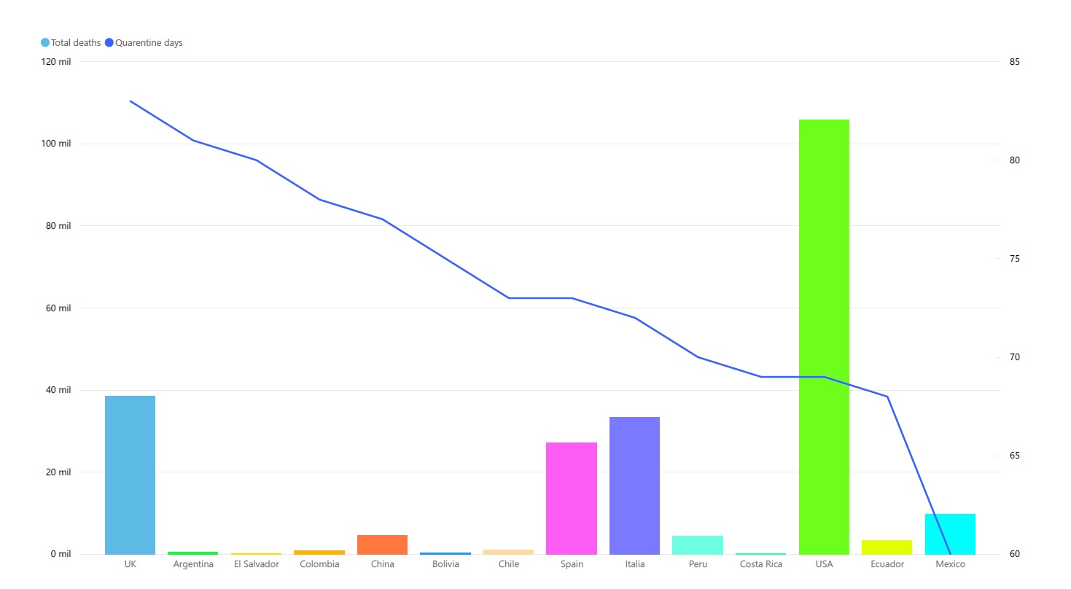
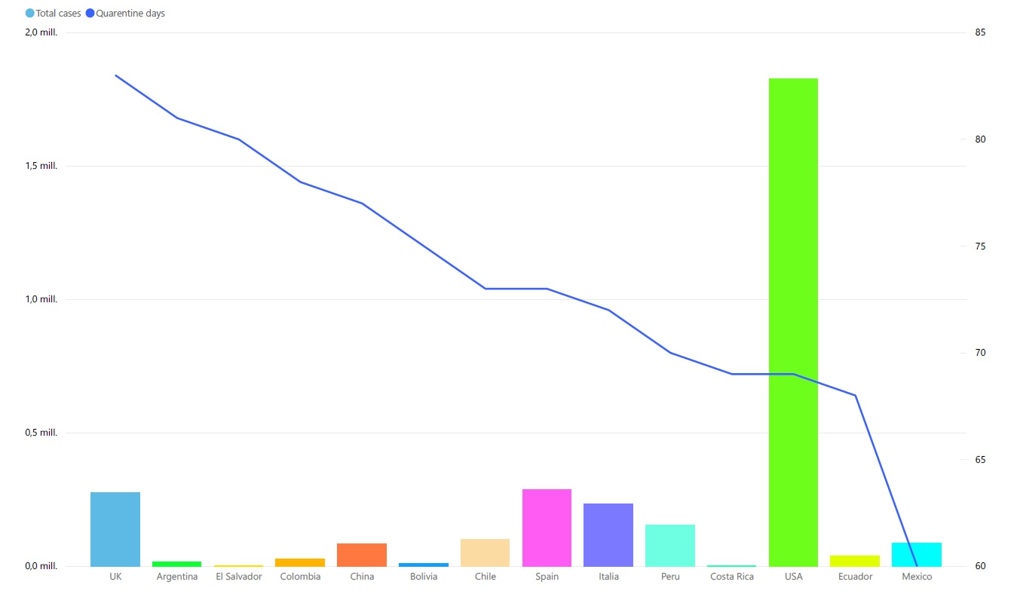
A
B

Figure 2. Comparison between Knowledge, attitude, and risk perception against COVID-19 and sociodemographic variables, by Latin American (A), marital status (B), occupation (C) and educational level (D).
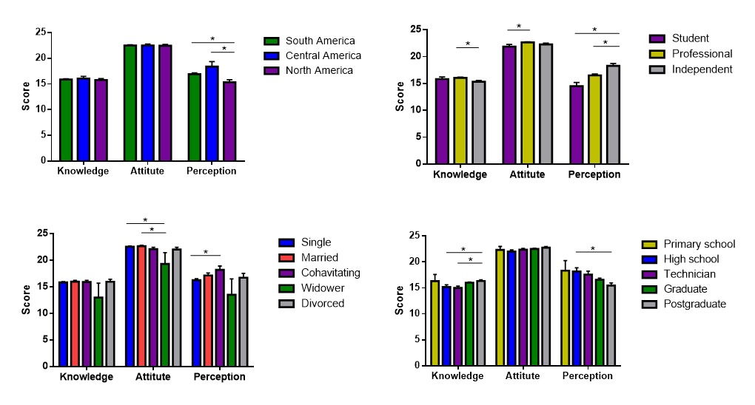
A
B
C
D

