September 20, 2021.

Dr. Fernando Andrés Polanco
Editor
Interamerican Journal of Psychology

Dear Dr. Polanco:

I am pleased to submit the manuscript titled A Global Perspective on Psychologists' and Their Organizations' Response to a World Crisis, coauthored by G. Gutiérrez, O. Barbarin, M. Klicperová-Baker, P. Padakannaya, A. Thompson, S. Crowe, and B. Khoury. It analyzes the contributions that professional organizations of psychology around the globe have made to mitigate the adverse behavioral effects of COVID-19. It shows examples of successful interventions and difficulties experienced in cooperating with other institutions, including governments, NGOs, and other psychology organizations. The paper emphasizes the need for cooperation among national, regional, and international organizations to address the complex combination of effects resulting from crises such as the current pandemic.
We consider that the manuscript fits very well within the Interamerican Journal of Psychology because it discusses how national, regional, and international psychology organizations have addressed the needs for psychological services worldwide during the COVID-19 pandemic. The paper also encourages actions at different levels that align well with the mission of the journal.
The manuscript has not been published elsewhere or submitted to any other academic journal for evaluation.
All the authors have read and followed the Interamerican Journal of Psychology Instructions to Authors. The paper has been reviewed and approved by all authors, and they agree on the order of authorship.
The manuscript extends beyond the limit of pages suggested to authors, but we feel this extension is justified by the scope of the paper and the reach of the topics discussed.
Cordially,
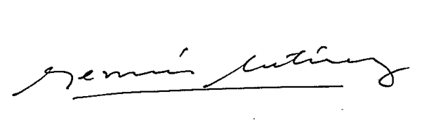
Germán Gutiérrez, Ph.D.
Email: gagutierrezd@unal.edu.co

