Back Home: the effects of the COVID-19 pandemic on the overall life satisfaction of university students

Abstract
We analyzed the effects of social isolation on the overall life satisfaction of university students during the COVID-19 pandemic. A survey was carried out with 2,556 Brazilian university students and the main techniques used were exploratory factor analysis, cluster analysis, and structural equation modeling. The results indicate that most university students perceived losses in overall life satisfaction due to the pandemic. We found that the more the individual identifies the worsening in health during the process of social isolation, the greater their perception of loss of life satisfaction. On the other hand, the greater the feeling that social isolation can protect against COVID-19, the lesser the loss of overall life satisfaction of the individual. The predominant profile in the group with the greatest loss in overall life satisfaction is women, single, childless, and with low income. These results suggest the possibility of an increased demand for psychological care and the need for special care when resuming in-person classes.

Keywords
University Students, Overall Life Satisfaction, Social Isolation, Demographic variables.

Resumo
Este estudo analisa os efeitos do isolamento social na satisfação global de vida de universitários durante a pandemia da COVID-19. Foi realizada uma survey com 2.556 universitários brasileiros e como técnicas principais foram utilizadas a análise fatorial exploratória, a análise de cluster e a modelagem de equações estruturais. Os resultados indicam que a maioria dos universitários perceberam perdas de satisfação global com a vida devido à pandemia. Nós encontramos que quanto mais o indivíduo identifica a piora na saúde durante o processo de isolamento social, maior a sua percepção de perda de satisfação com a vida. Por outro lado, quanto maior é o sentimento de que o isolamento social é capaz de lhe proteger contra a COVID-19, menor será a perda de satisfação global de vida que o indivíduo apresentará. Já o perfil predominante no grupo com maiores perdas de satisfação global de vida é de mulheres, solteiras, sem filhos e de baixa renda. Tais resultados sugerem a possibilidade de aumento de demanda por atendimento psicológico e a necessidade de cuidados especiais na retomada das aulas presenciais.

Palavras-chave
Universitários, Satisfação Global de Vida, Isolamento Social, Variáveis demográficas.

Introduction
The way individuals face and perceive events occurring in their daily lives, their level of enthusiasm, pleasure, discontent, or suffering are related to how satisfied they are with their lives. Overall life satisfaction can be understood as the contentment that someone perceives when thinking about their life in general (Diener et al., 2002).
In this sense, overall life satisfaction can be investigated from two perspectives, the objective and the subjective, more related to emotional well-being. Among the objective factors, health conditions, social relationships, education level, performance of activities and income stand out, among others (Lawton, 1991). The subjective perspective concerns psychological well-being, that is, personal experiences, internal states that can be manifested through feelings, affective reactions and psychological constructs such as happiness, satisfaction, mental health, sense of control, social competence, stress and perceived health (Diener & Suh, 1997)
For an individual to feel satisfied with life as a whole, they must give more relevance to the positive events in their life and consider several aspects, such as working on what they like, taking care of their finances, relating to high-spirited people, absorb teachings from negative events and engage in activities that give pleasure (Kuppens, Realo & Diener, 2008). On the other hand, dissatisfied people are more likely to have low self-esteem, anxieties, fears and frustrations (Lipovetsky, 2007).
In this context, the COVID-19 pandemic that started in Brazil in the beginning of 2020 brought with it the recommendations of social isolation, quarantine, distancing, suspension of classroom classes and many other uncertainties for the population according to the Brazilian law n.13.979/20 (Brasil, 2020). Situations that promote major changes in people’s lives, drastically changing their routines, implying changes in habits, a strong reduction in family contacts and social groups, travel bans, changes in the ways of working and studying, in addition to, in many cases, possibilities of job loss and income reduction.
These measures have the potential to produce psychological, social and economic effects. In the psychological field, a wide array of emotional problems can arise, such as anxiety and depression and varying degrees of stress disorders (Cao et al., 2020, Islam et al., 2020, Kassir et al. 2021, Pereira et al. 2021, Qiu et al., 2020, Wang et al., 2020), including psychological discomfort during the first months of the COVID-19 pandemic (Germosén et al., 2023). Loss of the usual daily routine, as well as reduced social and physical contact with others can trigger numerous negative emotions, such as frustration, boredom, confusion and anger (Aristovnik et al., 2020), promoting a reduction in quality of life (Zhang & Ma, 2020, Zhang et al., 2020, Nguyen et al., 2020) and reduce life satisfaction (Ammar et al., 2020, Dymecka, Gerymski& Machnik-Czerwik, 2021a, 2021b, Duong, 2021).
Therefore, it is understood that the COVID-19 pandemic, in addition to the threat to physical health, brought a new life scenario, with significant impacts on the lives of individuals, especially university students. Specifically for university students, the pandemic resulted in returning home given the suspension of in-person academic activities (according to the Brazilian normative N° 343 – MEC, 2020a), resulting in a drastic reduction in social interaction inherent in the university environment and a wide change in the study routine, ranging from the complete stoppage of activities to the sudden adaptation to different ways of studying at a distance, what was determined by the Brazilian normative N° 544 (MEC, 2020b).
In this scenario, many university students, until then used to on-site teaching, began to live with a double challenge: the need for isolation and learning based on online activities, which entail greater autonomy. Thus, this study aimed to assess the effects of social isolation on the overall life satisfaction of university students during the COVID-19 pandemic.
There were significant changes in student life, both from an economic point of view, as well as in the social and emotional aspects. Once the balance can be affected by emergencies like this, which leave human and material losses and extremely traumatic situational changes (Sa, Werlang & Paranhos, 2008).
As students and society in general started to present symptoms resulting from the loss of satisfaction with life due to the pandemic, there was an increased demand for care in the health system. And yet, the impact on the educational system goes beyond the new challenges imposed on the academic community, since the adaptation to a new study regime or their suspension generated other psychological problems. Thus, understanding how the COVID-19 pandemic had affected overall life satisfaction help public managers to anticipate demands and prepare them to adequately serve the population, even after the end of the pandemic in the beginning of 2023.
Our study innovates in at least three aspects. First, it provides new evidence for the literature on the psychological impacts of the pandemic. Second, for assessing the loss of overall life satisfaction of students during the pandemic. Third, for proposing a scale to assess the perception of social isolation.

Method
The study sample is composed of 2,556 students from two Brazilian federal universities in the states of Rio Grande do Sul and Santa Catarina. This choice was delimited to cover both university students who, due to the pandemic, immediately started to use a new regime of distance activities, as well as those who had a period in which all academic activities were suspended.
The research was approved by the Research Ethics Committee (CAAE 30235020.2.0000.5346) and respondents read the IC (Informed Consent) before agreeing to participate. The instrument was completely anonymous, without the collection of respondents’ internet protocols and data privacy was guaranteed. Data collection happened between the months of May/2020 and August/2020.
The survey instrument was divided into three blocks of questions. The first presents questions about the practice and perceptions of social isolation. For the perceptions of social isolation, the authors constructed a set of 11 items on a Likert scale (1-strongly disagree, 2-partly disagree, 3-indifferent, 4-partly agree, 5-strongly agree).
The second is dedicated to the assessment of overall life satisfaction. The seven items proposed were inspired by the overall life satisfaction scale for adolescents (Hutz, 2014). To assess the change in satisfaction during the pandemic period, a Likert scale with five points was used (1-greatly worse, 2-worse, 3-remains the same, 4-better, 5-much better) and two direct questions about satisfaction before and during the pandemic, with a quantitative scale from zero (not satisfied) to ten (completely satisfied) points. The third block sought to identify the profile of respondents.
The instrument was created in Google Docs and applied through a survey web. All university students from both institutions received institutional emails inviting them to participate in the research.
As analysis techniques, in addition to descriptive statistics, exploratory factor analysis, cluster analysis, structural equation modeling, mean differences and association tests were applied. Descriptive statistics were used to present the profile of respondents, the practices and perceptions of social isolation, and overall life satisfaction before and during the pandemic.
Exploratory Factor Analysis (EFA) was applied to validate the constructs proposed for Social Isolation and Overall Satisfaction with Life. The models were estimated using the Principal Components Analysis and Varimax Rotation, excluding questions that presented extracted commonalities lower than 0.5 (Hair et al., 2014). To assess the reliability of the constructs, Cronbach’s alpha was used.
The hierarchical cluster allowed the identification of groups and the knowledge of perceptions of social isolation, dividing those who have a high perception of social isolation and those who consider that isolation has a smaller impact on their lives. Hierarchical analysis techniques were applied, being used a quadratic Euclidean distance measure and Ward’s method, also known as the variance method, as a clustering method. Ward’s method was selected because it is one of the most consistent for interval scales. The quadratic Euclidean distance, in turn, is recommended for the centroid clustering methods and Ward’s method was used because of the advantage of not extracting the square root of the data (Hair et al., 2014).
Structural Equation Modeling was used to assess the effects of perceptions of Social Isolation on Overall Life Satisfaction. The model was estimated by maximum likelihood, using a direct estimation method. The model’s convergent validity was analyzed by observing the magnitude and statistical significance of the standardized coefficients and by the absolute adjustment indices: chi-square statistics (χ²), Root Mean Square Residual (RMR), Root Mean Square Error of Approximation (RMSEA), Goodness-of-Fit Index (GFI) and by the comparative fit indices: Comparative Fit Index (CFI), Normed Fit Index (NFI), Tucker-Lewis Index (TLI). For the chi-square/degrees of freedom ratio, the recommendations are values less than five, for CFI, GFI, NFI and TLI, values greater than 0.950 are suggested, and the RMR and RMSEA should be below 0.080 and 0.060, respectively (Byrne, 2010; Hair et al., 2014; Hooper et al., 2008; Kline, 2015).
Unidimensionality was evaluated from the standardized residuals related to the indicators of each latent variable. Constructs that presented, for a significance level of 5%, standardized residuals below 2.58 are considered unidimensional (Hair et al., 2014). In addition, in order to verify whether there was a significant difference between the groups, the mean difference test (t-test) and the association test (chi-square) were applied.

Analysis and discussion of results
In order to assess the effects of social isolation on the overall life satisfaction of university students during the COVID-19 pandemic, data were collected from 2,556 students from two federal universities in Brazil. To this end, we initially sought to understand the practice of isolation and the routine of university students due to the pandemic. Table 1 lists the results.

Table 1
Social isolation and routine changes due to the pandemic
Variable | Alternative | Frequency | Percentage
Q1. Are you practicing social isolation (“stay at home”) guidelines due to the pandemic? | No | 19 | 4.93%
 | No, because I work in services considered as essential | 126 | 0.74%
 | Yes, partially | 818 | 32.00%
 | Yes, totally | 1593 | 62.32%
Q2. Given the recommendation of social isolation, how is your routine? * | Isolated, in home isolation | 432 | 16.90%
 | Leaving home to work | 329 | 12.87%
 | Leaving home for physical activities and/or leisure | 240 | 9.39%
 | Leaving home to purchase essential products (supermarket, drugstore, food, etc.) | 1.958 | 76.60%
 | Leaving home to purchase non-essential products | 47 | 1.84%
 | Leaving home for other reasons | 16 | 0.63%
Note: *Multiple choice question.

We identified that most university students (62.32%) are practicing total isolation and 32.00%, partial isolation, a situation that demonstrates their willingness to comply with the recommendations of the health authorities. As for routine, more than two-thirds say they are leaving home just to buy essential products.
To assess the perception of social isolation and overall life satisfaction, we performed an exploratory factor analysis to set the factors and assess the internal consistency of the constructs, in addition to identifying their perceptions in university students. It should be noted that of the eleven questions proposed for the Social Isolation construct, three were not validated for presenting commonalities greater than 0.50 (Hair et al., 2014). Thus, we successively excluded variable Q12. I have been drinking alcohol more often due to social isolation (commonality 0.155), to Q3. “Staying at home” has brought about big changes in my life (commonality 0.254) and Q7. I feel my productivity has dropped due to social isolation (commonality 0.387).
As for the Global Life Satisfaction construct, all seven proposed questions presented commonalities extracted above the minimum required value and were validated. Table 2 presents the consolidated results of the two-factor analyses.

Table 2
Exploratory Factor Analysis of the Perception of Social Isolation and Overall Life Satisfaction

Construct | Question / Factor | Factor loading | Mean |  | Variance explained |  | Cronbach’s alpha
Perception of Social Isolation | Q4. “Staying at home” all the time makes me stressed. | 0.760 | 3.676 |  | 50.581 |  | 0.901
Perception of Social Isolation | Q8. I have feelings of depression due to social isolation. | 0.835 | 2.923
Perception of Social Isolation | Q9. I have mood swings due to social isolation. | 0.884 | 3.544
Perception of Social Isolation | Q10. I have feelings of anguish due to social isolation. | 0.882 | 3.573
Perception of Social Isolation | Q11. I have a change of appetite due to social isolation. | 0.683 | 3.319
Perception of Social Isolation | Q13. I have feelings of anxiety due to social isolation. | 0.861 | 3.637
Perception of Social Isolation | Factor 1. Social Isolation: Worse in Health |  |  | 3.445
Perception of Social Isolation | Q5. I believe that social isolation is effective in containing the spread of the coronavirus. | 0.924 | 4.760 |  | 21.608 |  | 0.835
Perception of Social Isolation | Q6. I am confident that social isolation protects myself and my family from the coronavirus. | 0.927 | 4.673
Perception of Social Isolation | Factor 2. Social Isolation: Feeling of Protection |  |  | 4.717
Overall Life  Satisfaction | Q14. I have everything I need. | 0.699 | 2.977 |  | 66.210 |  | 0.914
Overall Life  Satisfaction | Q15. I like my life. | 0.847 | 2.997
Overall Life  Satisfaction | Q16. I am satisfied with the things I have. | 0.791 | 3.105
Overall Life  Satisfaction | Q17. I feel good the way I am. | 0.777 | 2.802
Overall Life  Satisfaction | Q18. I am satisfied with my life. | 0.868 | 2.816
Overall Life  Satisfaction | Q19. I am a happy person. | 0.852 | 2.973
Overall Life  Satisfaction | Q20. I feel fulfilled with the life I have. | 0.849 | 2.721
Overall Life  Satisfaction | Factor 1. Overall Life Satisfaction |  |  | 2.913

The exploratory factor analysis of questions about social isolation indicated the formation of two constructs, which together represent 72.19% data variance. The first factor, called Social Isolation: Worsening in Health, consists of six questions that seek to assess the perception of the psychological and physical effects of social isolation resulting from the pandemic. The second, Social Isolation: Feeling of Protection, represents the respondent’s perception that social isolation works as a measure capable of containing the spread of the coronavirus and protecting the individual and their family. In both factors, all factor loadings were high and the two Cronbach’s alphas were above 0.7, demonstrating the representativeness of the items for the constitution of the factors and their internal consistency.
The average of the Social Isolation: Worsening in Health factor was 3.445 (on a scale of 1-strongly disagree to 5-strongly agree), indicating that, in general, respondents were indifferent to changes in health during isolation. However, in this factor it is also observed that the most present worsening changes in health would be increased stress (3.676) and anxiety (3.637). These results are in line with studies that indicate that the COVID-19 pandemic can generate psychological effects, such as anxiety, depression and different levels of stress (Wang et al., 2020, Cao et al., 2020, Qiu et al., 2020).
The second isolation factor, related to protection (Social Isolation: Feeling of Protection), which also has a scale of values ranging from 1-totally disagree to 5-totally agree, had an overall mean (4.717) and an average of the questions close to the point of maximum agreement of the scale (5), indicating that respondents perceive isolation as a measure capable of preventing the spread of the virus (mean 4.760) and protecting themselves and their family (mean 4.673).
The factor analysis of the items of global life satisfaction indicated the formation of a single factor, called Global Life Satisfaction, with an extracted variance of 66.21% and excellent reliability (alpha=0.914). These results are in line with the scale proposed by Hutz (2014), who indicated that the scale would be unidimensional and obtained an alpha of 0.90. The means of the factor and its component variables indicate that there was a general perception that overall life satisfaction remained the same during the pandemic, close to point 3 of the scale (remains the same), which ranged from 1-much worse to 5 -much better. With emphasis on the question “I feel fulfilled with the life I have”, which showed the greatest deterioration in the satisfaction of university students, in addition to the variable “I am satisfied with the things I have”, which proved to be the point with the greatest improvement in satisfaction.
Still, in the search for a perception of the possibility of change in overall life satisfaction during the pandemic, respondents identified on a scale from zero (not at all satisfied) to ten (completely satisfied) their level of satisfaction before and during the pandemic. Figure 1 illustrates the results of the two questions, as well as the difference between satisfaction before and during the pandemic.

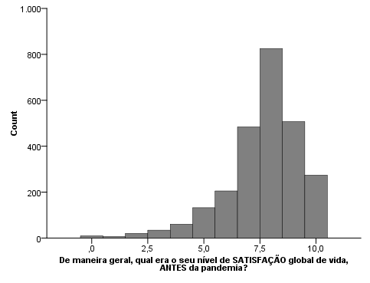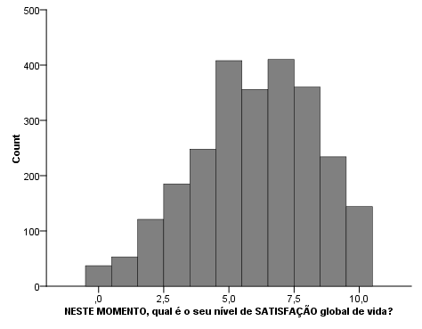
n
n
Now what is your overall life satisfaction level?
In general, what was your overall life satisfaction before the pandemic?

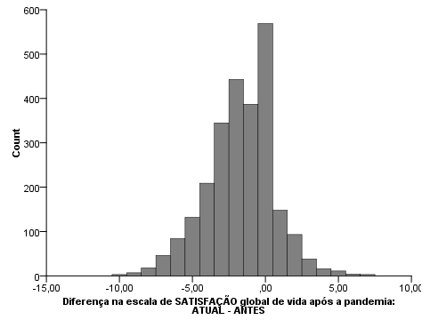
n
Difference in the overall life satisfaction scale during the pandemic (CURRENT - BEFORE)

Figure 1. Histograms of the level of overall life satisfaction

Despite the overall life satisfaction scale presenting values that denote the permanence of satisfaction among university students during the pandemic, when asked to indicate the level of overall life satisfaction before and during the pandemic on a quantitative scale from zero to ten, we observed a reduction. Before the pandemic, the mean satisfaction of university students was 7.66 and dropped to 6.00 during the pandemic. A percentage of 65% respondents indicated greater satisfaction before the pandemic compared to during the pandemic, that is, most respondents have a general perception that they have become less satisfied with life since the beginning of the pandemic. It is also noteworthy that 22.3% reported the same satisfaction in both periods, that is, for this group the pandemic did not bring a loss of satisfaction with life.
Following the study, through cluster analysis, individuals could be grouped into two groups to identify them in terms of perceptions of social isolation. Cluster 1, called Low Perception, is formed by 41.83% of university students who have a low perception of both the impacts of social isolation on the worsening of their health, and the low sense of protection that social isolation can cause. Cluster 2, called High Perception, is composed of individuals (53.17%) who perceive greater impacts of the pandemic due to social isolation, both in the worsening of their health and in the strong feeling of protection that social isolation provides. Table 3 lists the results of the t-student test for the mean differences between the two groups.

Table 3
Descriptive statistics of dimensions according to the distribution of clusters

Dimension | Cluster 1  N=1,197 (41.83%)  LOW Perception |  |  | Cluster 2  N=1,359 (53.17%)  HIGH Perception |  |  | t-test
Dimension | Mean | Median | Standard deviation | Mean | Median | Standard deviation | Sig.
Social Isolation: Worsening in Health | 2.446 | 2.500 | 0.869 | 4.326 | 4.333 | 0.471 | 0.000
Social Isolation: Feeling of Protection | 4.454 | 4.500 | 0.916 | 4.859 | 5.000 | 0.311 | 0.000
Differences in the Overall Life Satisfaction scale before and during the pandemic | -0.760 | 0.000 | 1.976 | -2.461 | -2.000 | 2.317 | 0.000
Factor: Overall Life Satisfaction | 3.167 | 3.000 | 0.704 | 2.689 | 2.571 | 0.776 | 0.000
Note: Bold values mean significance at 5%

We found significant differences between the two groups for all dimensions analyzed. Specifically, considering the factors that make up social isolation, we corroborated the findings through groups classified in clusters, in which those who perceive a high impact of isolation on their lives (high Perception group) point out that social isolation is capable of offering more protection and promoting greater negative health effects, when compared to the low perception cluster.
In relation to the specific impacts of social isolation on the overall life satisfaction of university students, the group with high perception of social isolation showed, on average, a greater loss of overall life satisfaction on the quantitative scale that scored a level from 0 to 10 before and during the pandemic, with a difference of -2.461, while university students who perceive lesser impacts of social isolation caused by the pandemic (Low Perception group) showed a smaller loss in their satisfaction before and during the pandemic, with a difference of only -0.760, denoting a significant difference of almost 2 points between the two groups. In addition, the group with high perception also had a lower overall life satisfaction (2.689) on the proposed Likert scale compared to the group with low perception (3.167), indicating that those who feel the impacts of social isolation have a greater deterioration of their health and also a higher feeling of protection. They have a lower overall life satisfaction than those who have a low perception of the impacts that social isolation causes.
These results demonstrate that even within a relatively homogeneous group, such as university students, there are significant differences in the perception that social isolation can cause. Thus, seeking to better analyze these possible differences, a chi-square test was applied to identify the different characteristics between these two groups. Table 4 lists the results of the chi-square test for different profile variables.

Table 4.
Contingency Tables: Social Isolation x Explanatory Variables

Variables/Alternatives |  | Total (N=2,556) | Cluster 1 N=1,197 (46.83%)  LOW perception | Cluster 2 N=1,359 (53.17%) HIGH perception | Chi-square
Variable | Alternatives | Number | Percentage | Percentage | Sig.
Are you practicing social isolation guidelines due to the pandemic? | No | 19 | 78.95% | 21.05% | 0.000
 | No, because I work in services considered as essential | 126 | 61.90% | 38.10% | 0.000
 | Yes, partially | 818 | 45.00% | 55.00% | 0.000
 | Yes, totally | 1.593 | 46.20% | 53.80% | 0.000
Factor: Overall Life Satisfaction | Much worse/worse during the pandemic (points 1 and 2 on the scale) | 694 | 20.20% | 79.80% | 0.000
Factor: Overall Life Satisfaction | Remained the same (point 3 on the scale) | 1.390 | 55.10% | 44.90% | 0.000
Factor: Overall Life Satisfaction | Better/Much better during the pandemic (points 4 and 5 on the scale) | 472 | 61.70% | 38.30% | 0.000
Difference in the Overall Life Satisfaction scale before and during the pandemic | Worse during the pandemic (negative values) | 1.674 | 34.20% | 65.80% | 0.000
 | Remained the same (zero value) | 569 | 73.30% | 26.70% | 0.000
 | Better during the pandemic (positive values) | 313 | 66.10% | 33.90% | 0.000
Gender | Male | 774 | 60.30% | 39.70% | 0.000
Gender | Female | 1.572 | 39.40% | 60.60% | 0.000
Gender | I prefer not to answer/not to classify myself | 210 | 52.40% | 47.60% | 0.000
Marital status | Single | 2.205 | 44.80% | 55.20% | 0.000
Marital status | Married/Stable union | 351 | 59.50% | 40.50% | 0.000
Children | No | 2.321 | 45.40% | 54.60% | 0.000
Children | Yes | 235 | 61.30% | 38.70% | 0.000
Monthly family income | I don’t have my own income | 693 | 44.60% | 55.40% | 0.000
Monthly family income | Up to R$1,045.00 | 725 | 43.90% | 56.10% | 0.000
Monthly family income | Between R$ 1,045.01 and R$ 2,090.00 | 544 | 45.20% | 54.80% | 0.000
Monthly family income | Between R$ 2,090.01 and R$ 3,135.00 | 264 | 49.20% | 50.80% | 0.000
Monthly family income | Between R$ 3,135.01 and R$ 4,180.00 | 114 | 64.00% | 36.00% | 0.000
Monthly family income | Between R$ 4,180.01 and R$ 6,270.00 | 99 | 57.60% | 42.40% | 0.000
Monthly family income | Above R$ 6,270.01 | 117 | 54.70% | 45.30% | 0.000
Are you taking course(s) remotely? | No | 1.590 | 50.40% | 49.60% | 0.000
Are you taking course(s) remotely? | Yes | 966 | 41.00% | 59.00% | 0.000
Note: Bold values mean significance at 5%

The two groups differed significantly in all variables studied. The group with high perception and that most feels the impacts of social isolation caused by the COVID-19 pandemic is composed of 79.8% respondents who perceived a worsening in overall life satisfaction and whose majority is practicing some form of isolation, either partial or total. This group included the majority of women, singles, childless and those without their own income or with an income of up to R$ 3,135.00, what goes in line with the study of Alvarenga et al. (2023). Even for those who may were more used to the virtual world seemed to be very frightening by facing changes in their working and studying life’s, as well as their contact with friends and family that had to take place isolated and lonely (Jacó-Vilela et al., 2022).
On the other hand, in the group that perceived a lower impact of social isolation contains most university students who do not practice isolation and those who do not notice changes or identify improvements in their overall life satisfaction during the pandemic. This group is formed by the majority of male university students, those with children and those with higher incomes (above R$ 3,135.00). These results are consistent with studies indicating that the psychological effects of the pandemic are greater in women and in individuals with low economic status (Fitzipatrick et al., 2020, Browning et al., 2021). In general, students with fewer resources, during times of pandemic, are at greater risk of dropping out of school and affecting their mental health (Usuga Jerez et al., 2023).
In order to better assess the impact of social isolation on overall life satisfaction, the structural equation model was estimated. Table 5 and Figure 2 present the results.

Table 5
Adjustment statistics for the integrated model

Adjustment indices | Appropriate  adjustment levels ¹ | Integrated model
Adjustment indices | Appropriate  adjustment levels ¹ | Proposed | Final
Chi-square (value) | - | 927.582 | 401.545
Chi-square (probability) | > 0.050 | p- 0.000 | p- 0.000
Degrees of freedom | - | 87 | 81
Chi-square / Degrees of freedom | < 5.000 | 10.662 | 4.957
GFI - Goodness of Fit | > 0.950 | 0.953 | 0.979
CFI - Comparative Fit Index | > 0.950 | 0.964 | 0.986
NFI - Normed Fit Index | > 0.950 | 0.960 | 0.983
TLI- Tucker-Lewis Index | > 0.950 | 0.956 | 0.982
RMR - Root Mean Square Residual | < 0.080 | 0.051 | 0.043
RMSEA - R. M. S. Error of Approximation | < 0.060 | 0.061 | 0.039
Note: ¹Appropriate levels for the Adjustment Statistics based on Hooper et al. (2008) and Hu and Bentler (1999).

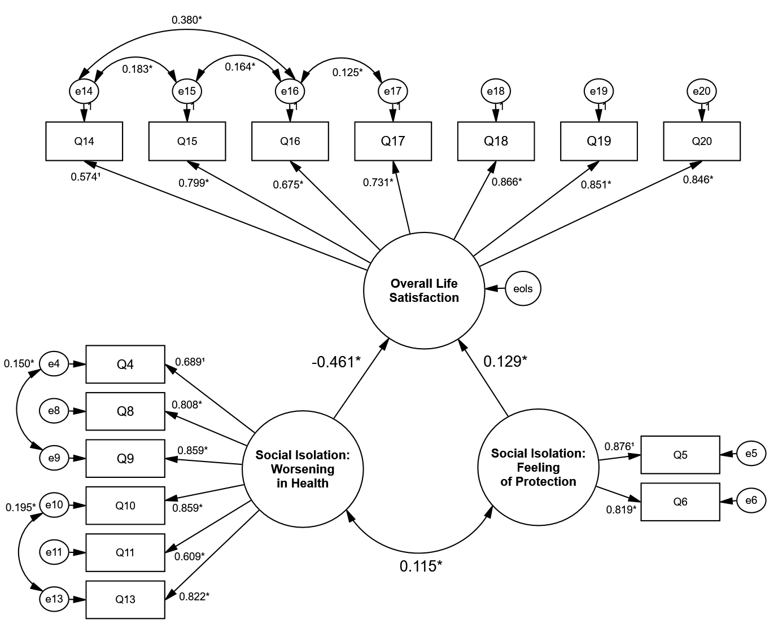

Figure 2. Final models with standardized relationship coefficients and significance
Note. *p<0.01; ¹z-value not calculated, where the parameter was set as 1, due to the model’s requirements.

The initial model presented chi-square/degrees of freedom above the desired level (Table 5). Thus, the strategy of improving the model was adopted, in which some correlations between the errors of the variables that made theoretical sense were inserted, obtaining an appropriate final model.
The variables that most impact on Overall Life Satisfaction are the variables that deal with satisfaction (Q18) and fulfillment (Q20) with life, in addition to the statement that the individual is a happy person (Q19). When analyzing the variables that make up social isolation, with regard to their impact on worsening health, the feelings of anguish (Q10) and mood swing (Q9), due to social isolation are those that have the greatest impact in this regard. As for the two variables that deal with social isolation and its power to represent a feeling of protection, both have a high impact on it, with emphasis on the one dealing with the effectiveness of containing the dissemination of the coronavirus due to social isolation.
Finally, we found that the two dimensions of social isolation significantly impact the perception of loss of overall life satisfaction due to the pandemic. The more the individual identifies the worsening in health during the process of social isolation, the greater their perception of loss of satisfaction with life. On the other hand, the greater the feeling that social isolation is able to protect against COVID-19, the lesser the loss of overall life satisfaction of the individual. These results are validated by Dymecka, Gerymski and Machnik-Czerwik (2021a, 2021b) and Duong (2021), who report that consequences of social isolation, such as the loss of routine and social and physical contact, lead to a reduction in satisfaction with the life.

Final considerations
The pandemic had imposed an emergency situation in public health system and led several countries to recommend social isolation, which brought economic, social and psychological impacts. In this study, we sought to assess the effect of social isolation on the loss of overall life satisfaction among university students.
The results indicated that the pandemic brought about a loss of overall life satisfaction for two thirds of the students, corroborating recent studies that indicate the effects of the pandemic on life satisfaction in the general population. The group with the highest perceptions of loss are women, single, those without children and those without their own income.
The perception of worsening health due to social isolation had demonstrated a significant impact on the loss of life satisfaction. These findings call for public agents and higher education authorities to collaborate and urgently pay attention to vulnerable student groups while seeking to resolve the diverse, mostly negative, consequences of the prolonged COVID-19 pandemic (Aristovnik et al., 2020) and after the end of the pandemic situation too. In addition, the loss of satisfaction in young groups, such as university students, suggests that the psychological consequences of the pandemic could generate significant increases in the demand for psychological treatments in the health system (Macêdo & Farinha, 2022) and special care of educational institutions during the pandemic and in the resumption of face-to-face activities (Da luz et al., 2023).
A limitation of this study is the fact that the research was carried out via the internet due to the situation of social distancing. Future research may broaden the discussion of the backgrounds and consequences of loss of overall life satisfaction and longitudinal studies are still promising.

References
Alvarenga, M. A. S., Souza Guilhermino, C., de Azevedo, T. G., Mansur-Alves, M., Alvares-Teodoro, J., Correa Ribeiro, P. C., Martins Teodoro, M. L., & Ribeiro Bandeira, P. F. (2023). Longitudinal study on mental health of university students and the COVID-19 pandemic: comparisons and perspectives. Revista Interamericana De Psicología/Interamerican Journal of Psychology, 57(1), e1838. https://doi.org/10.30849/ripijp.v57i1.1838
Ammar, A., Chtourou, H., Boukhris, O., Trabelsi, K., Masmoudi, L., Brach, M., ... & ECLB-COVID19 Consortium. (2020). COVID-19 home confinement negatively impacts social participation and life satisfaction: a worldwide multicenter study. International Journal of Environmental Research and Public Health, 17(17), 6237. https://doi.org/10.3390/ijerph17176237
Aristovnik, A., Keržič, D., Ravšelj, D., Tomaževič, N., & Umek, L. (2020). Impacts of the COVID-19 pandemic on life of higher education students: A global perspective. Sustainability, 12(20), 8438. https://doi.org/10.3390/su12208438
Brasil (2020). LEI Nº 13.979, de 6 de Fevereiro de 2020 - Dispõe sobre as medidas para enfrentamento da emergência de saúde pública de importância internacional decorrente do coronavírus responsável pelo surto de 2019. Available at: https://www.planalto.gov.br/ccivil_03/_ato2019-2022/2020/lei/l13979.htm
Browning, M. H., Larson, L. R., Sharaievska, I., Rigolon, A., McAnirlin, O., Mullenbach, L., ... & Alvarez, H. O. (2021). Psychological impacts from COVID-19 among university students: Risk factors across seven states in the United States. PloS one, 16(1), e0245327. https://doi.org/10.1371/journal.pone.0245327
Byrne, B. M. (2010). Structural equation modeling with AMOS: Basic concepts,applications, and programming (2 ed). Routledge. NY, USA.
Cao, W., Fang, Z., Hou, G., Han, M., Xu, X., Dong, J., & Zheng, J. (2020). The psychological impact of the COVID-19 epidemic on college students in China. Psychiatry Research, 112934. https://doi.org/10.1016/j.psychres.2020.112934
Da Luz, R. T., Vieira, K. M., Klein, L. L., & Giacomelli, G. S. (2023). Percepções Discentes sobre o Ensino Remoto Durante a Pandemia da Covid-19. EaD em Foco, 13(1), e1968-e1968. https://doi.org/10.18264/eadf.v13i1.1968
Diener, E., & Suh, E. (1997). Measuring quality of life: Economic, social, and subjective indicators. Social Indicators Research, 40(1), 189-216.
Diener, E., Lucas, R. E., & Oishi, S. (2002). Subjective well-being: The science of happiness and life satisfaction. Handbook of positive psychology, 2, 63-73.
Duong, C. D. (2021). The impact of fear and anxiety of Covid-19 on life satisfaction: Psychological distress and sleep disturbance as mediators. Personality and Individual Differences, 178, 110869. https://doi.org/10.1016/j.paid.2021.110869
Dymecka, J., Gerymski, R., & Machnik-Czerwik, A. (2021a). Fear of COVID-19 as a buffer in the relationship between perceived stress and life satisfaction in the Polish population at the beginning of the global pandemic. Health Psychology Report, 9(2), 149-159. https://czasopisma.bg.ug.edu.pl/index.php/HPR/article/view/5755
Dymecka, J., Gerymski, R., & Machnik-Czerwik, A. (2021b). How does stress affect life satisfaction during the COVID-19 pandemic? Moderated mediation analysis of sense of coherence and fear of coronavirus. Psychology, health & medicine, 27(1), 280-288. https://doi.org/10.1080/13548506.2021.1906436
Fitzpatrick, K. M., Harris, C., & Drawve, G. (2020). Living in the midst of fear: Depressive symptomatology among US adults during the COVID‐19 pandemic. Depression and Anxiety, 37(10), 957-964. https://doi.org/10.1002/da.23080
Germosén, G. O., Bello-Castillo, I., & Sánchez-Vincitore, L. (2023). Cyberchondria during the COVID-19 pandemic: Its relationship with health anxiety, state anxiety and trait anxiety. Revista Interamericana De Psicología/Interamerican Journal of Psychology, 57(2), e1726. https://doi.org/10.30849/ripijp.v57i2.1726
Hair, J.F., Black, W.C., Babin, B.J. and Anderson, R.E. (2014), Multivariate data analysis: Pearson new international edition. Pearson Education Limited, Essex
Hooper, D., Coughlan, J., & Mullen, M.R. (2008). “Structural equation modelling: Guidelines for determining model fit”, Electronic Journal of Business Research Methods, 6(1): 53-60.
Hu, L. T., & Bentler, P. M. (1999). Cutoff criteria for fit indexes in covariance structure analysis: Conventional criteria versus new alternatives. Structural equation modeling: a multidisciplinary journal, 6(1), 1-55.
Hutz, C. S. (2014). Avaliação em Psicologia Positiva. Porto Alegre: Artmed, 2014.
Islam, M. A., Barna, S. D., Raihan, H., Khan, M. N. A., & Hossain, M. T. (2020). Depression and anxiety among university students during the COVID-19 pandemic in Bangladesh: A web-based cross-sectional survey. PloS one, 15(8), e0238162. https://doi.org/10.1371/journal.pone.0238162
Jacó-Vilela, A. M., Toledo Quadros, L. C. de, & Carneiro da Cunha, C. (2022). Mobilize, invent and intervene in the University context: research, prevention and intervention as actions against the pandemic COVID - 19 . Revista Interamericana De Psicología/Interamerican Journal of Psychology, 56(2), e1624. https://doi.org/10.30849/ripijp.v56i2.1624
Kassir, G., El Hayek, S., Zalzale, H., Orsolini, L., & Bizri, M. (2021). Psychological distress experienced by self-quarantined undergraduate university students in Lebanon during the COVID-19 outbreak. International Journal of Psychiatry in Clinical Practice, 25(2), 172-179. https://doi.org/10.1080/13651501.2021.1900872
Kline, R.B. (2015), Principles and practice of structural equation modeling, 4th ed., The Guilford Press, New York, USA.
Kuppens, P., Realo, A., & Diener, E. (2008). The role of positive and negative emotions in life satisfaction judgment across nations. Journal of Personality and Social Psychology, 95(1), 66. https://psycnet.apa.org/doi/10.1037/0022-3514.95.1.66
Lawton, M. P. (1991). A multidimensional view of quality of life in frail elders. In The concept and measurement of quality of life in the frail elderly (pp. 3-27). Academic Press.
Lipovetsky, G. (2207) A Felicidade Paradoxal: ensaio sobre a sociedade do hiperconsumo. São Paulo: Companhia das Letras, 2007.
Macêdo, S., & Farinha, M. G. (2022). Serviços Escola de Psicologia no Brasil: desafios e possibilidades às práticas clínicas em tempos de pandemia. Revista Interamericana de Psicología/Interamerican Journal of Psychology, 56(1), 1-14. https://doi.org/10.30849/ripijp.v56i1.1549
Ministério da Educação - MEC (2020a). Portaria Nº 343, de 17 de Março de 2020 -Dispõe sobre a substituição das aulas presenciais por aulas em meios digitais enquanto durar a situação de pandemia do Novo Coronavírus - COVID-19. Available at: https://www.planalto.gov.br/ccivil_03/portaria/prt/portaria%20n%C2%BA%20343-20-mec.htm
Ministério da Educação - MEC (2020b). Portaria Nº 544, de 16 de Junho de 2020 - Dispõe sobre a substituição das aulas presenciais por aulas em meios digitais, enquanto durar a situação de pandemia do novo coronavírus - Covid-19. Available at: http://www.in.gov.br/en/web/dou/-/portaria-n-544-de-16-de-junho-de-2020-261924872
Nguyen, H. C., Nguyen, M. H., Do, B. N., Tran, C. Q., Nguyen, T. T., Pham, K. M., ... & Duong, T. V. (2020). People with suspected COVID-19 symptoms were more likely depressed and had lower health-related quality of life: the potential benefit of health literacy. Journal of Clinical Medicine, 9(4), 965. https://doi.org/10.3390/jcm9040965
Pereira, A. T., Cabaços,C., Araújo,A. et al.. (2021). COVID-19 psychological impact: The role of perfectionism. Personality and individual differences, 184, 111160. https://doi.org/10.1016/j.paid.2021.111160
Qiu, J., Shen, B., Zhao, M., Wang, Z., Xie, B., & Xu, Y. 2020. A nationwide survey of psychological distress among Chinese people in the COVID-19 epidemic: implications and policy recommendations. General Psychiatry, 33(2): e100213. http://dx.doi.org/10.1136/gpsych-2020-100213
Sa, S. D., Werlang, B. S. G., & Paranhos, M. E. (2008). Intervenção em crise. Revista Brasileira de Terapia. Cognitiva, 4(1): 1-10.
Usuga Jerez, A. J., Vanegas Mendez, S. N. ., Tapias Soto, M. F. ., Villabona Perez, J. M. ., & Lemos Ramírez, N. V. (2023). Desperation among university students during SARS-COV-2 virus quarantine. Revista Interamericana De Psicología/Interamerican Journal of Psychology, 57(2), e1397. https://doi.org/10.30849/ripijp.v57i2.1397
Wang, C., Pan, R., Wan, X., Tan, Y., Xu, L., Ho, C. S., & Ho, R. C. (2020). Immediate psychological responses and associated factors during the initial stage of the 2019 coronavirus disease (COVID-19) epidemic among the general population in China. International Journal of Environmental Research and Public Health, 17(5), 1729. https://doi.org/10.3390/ijerph17051729
Zhang, Y., & Ma, Z. F. (2020). Impact of the COVID-19 pandemic on mental health and quality of life among local residents in Liaoning Province, China: A cross-sectional study. International Journal of Environmental Research and Public Health, 17(7), 2381. https://doi.org/10.3390/ijerph17072381
Zhang, S. X., Wang, Y., Rauch, A., & Wei, F. (2020). Unprecedented disruption of lives and work: Health, distress and life satisfaction of working adults in China one month into the COVID-19 outbreak. Psychiatry Research, 288, 112958. https://doi.org/10.1016/j.psychres.2020.112958

Received:
Accepted:

