Abstract
A recent meta-analysis revealed that not only gain-framed persuasion messages induce positive emotions in the audience whereas loss frames induce negative emotions, but also positive emotions enhance the influence of gain frames whereas negative emotions augment the effects of loss frames; emotions appeared to mediate effects of framed messages on the public’s compliance with a recommendation. Since it is known that women experience more negative emotions than men, we evaluated in the present exploratory study gender biases in negative emotions induced by images accompanying texts with nutritional advice to prevent severity of COVID-19 symptoms. The texts were non-loss framed. Using photos of a coffin versus a family, we found a robust image x gender interaction amongst hospital personnel in Lima, Peru: whereas the coffin tended to increase the negative emotions of women, those of men presented an opposite tendency. We conclude that the intervention of emotions in the persuasion process implies that different adherences of men and women to the same message are likely and this should be studied. Researchers who ignore gender in visual framing studies may attain distorted conclusions.

Moderación por el género de los efectos experimentales del encuadre visual de mensajes de nutrición/COVID-19 sobre emociones negativas

Resumen
Un reciente meta-análisis reveló que mensajes persuasivos enmarcados en ganancias inducen emociones positivas en la audiencia mientras que mensajes encuadrados en pérdidas inducen emociones negativas; más aún, la experiencia de emociones positivas potencia la influencia de los encuadramientos de ganancia mientras que las emociones negativas aumentan los efectos de los enmarques de pérdida. Esto sugiere que los efectos de los encuadres de ganancia versus pérdida en la adherencia del público al mensaje son mediados por emociones. Como se sabe que las mujeres experimentan más emociones negativas que los hombres, en el presente estudio exploratorio nosotros evaluamos sesgos de género en las emociones negativas inducidas por imágenes que acompañaban a textos con recomendaciones nutricionales para prevenir la severidad de los síntomas de COVID-19. Los textos estuvieron encuadrados en no-pérdidas. Usando fotos de un ataúd versus una familia, encontramos una robusta interacción imagen x género entre trabajadores de un hospital en Lima, Perú: mientras que el ataúd tendía a aumentar las emociones negativas de las mujeres, aquellas de los hombres presentaban una tendencia opuesta. Así, concluimos que la intervención de emociones en un mismo proceso de persuasión puede terminar en adherencias diferentes de hombres y mujeres al mensaje y esto debe estudiarse. Los investigadores que ignoren la variable género en el encuadramiento visual de mensajes pueden arribar a conclusiones distorsionadas.

Palabras clave – mensajes de salud, género, emociones, encuadramiento de ganancia, encuadramiento de pérdida, experimento

Considerable research efforts have been deployed in the past 30 years to study the public’s compliance with health messages depending on their focus on the promised gain or loss of a valued attribute whose attainment is contingent on the behavioral adherence to the recommendation. For example, “If you eat well, you will improve your health” (gain), “If you eat badly, you will miss the opportunity to improve your health” (non-gain), “If you eat badly, you will damage your health” (loss), and “If you eat well, you will avoid damaging your health” (non-loss) (Carfora et al., 2021). Since the inception of the concept of gain- versus loss-framing in the field of information processing (Kahneman & Tversky, 1979) and its popularization in health psychology (Rothman & Salovey, 1997), prospect theory (Tversky & Kahneman, 1981) has had an important impact as a framework capable of explaining the persuasion capacities of each frame (e.g., Wansink & Pope, 2015). According to this theory, “the value function in the domain of gains is concave with a risk-averse tendency, whereas the value function in the domain of losses is convex with a risk-seeking tendency. The theory also asserts that individuals are more inclined to avoid loss than to seek gain with the same amount of expected value” (Nan, 2018, p. 372). For instance, performing a breast self-examination is a risky behavior for a woman considering that a tumor could be detected; in this case, the theory predicts maximization of the motivation to take this risk (Meyerowitz & Chaiken, 1987). Numerous studies have addressed the relative advantages of gain and loss frames in the presence of varying levels of risk, but the meta-analyses of the literature have shown no robust difference in their persuasive effects (O’Keefe & Jensen, 2007, 2009). Consequently, researchers now focus their efforts on identifying and testing moderating variables (e.g., Masumoto et al., 2019; Petzell & Noel, 2021; Shamaskin et al., 2010; Updegraff & Rothman, 2013).
Actually, research on framing has paid attention to moderators for a long time. Dual processes theory proposed that under facilitating circumstances or motivation to scrutinize the message carefully, loss-framed messages will generate loss aversion, whereas limited or superficial information processing will give gain-framed messages a persuasive advantage (e.g., Maheswaran & Meyers-Levy, 1990). And regulatory focus theory, considering that individuals with a prevention focus are concerned with protection, safety, and responsibilities, whereas those with a promotion focus are concerned with advancement, aspirations, and accomplishments, postulates that these orientations will make more persuasive, respectively, loss- and gain-framed recommendations (e.g., Higgins, 1997).
The theoretical and empirical challenges we deal with in the present article are posited by the participation of affect in framing processes (Mikels et al., 2020). A recent meta-analysis of the framing literature showed that message frame type directs the emotional response elicited in the audience, with gain frames inducing positive emotions and loss frames inducing negative emotions; moreover, the experience of positive emotions enhances the influence of gain frames whereas negative emotions augment the effects of loss frames (Nabi et al., 2020). These findings suggest a need for taking into account the effects of gender on the effects of framed messages considering that women have a greater propensity to depression (Kushner, 2017) and neuroticism (Ormel et al., 2013) than men and, in the general population, show greater susceptibility to negative emotions than men according to neuroimaging (e.g., Yuan et al., 2009) as well as in life settings (e.g., Borrachero et al., 2014). But research on framing has not paid much attention to gender. A few studies, some based exclusively on one gender while others performed gender comparisons, have addressed male-female differences, yielding contradictory findings. With one exception (O’Keefe & Wu, 2012), those conducted in health settings indicate that loss-framed messages have a tendency to be more persuasive to female audiences (Kong et al., 2016; Kim, 2010; Toll et al., 2008); outside the health area, females have shown more compliance when a positively framed message was used (Hasseldine & Hite, 2003; Putervu, 2010). On the other hand, many studies failed to detect frame x gender interactions (e.g., Nan, 2012).
In the present exploratory research, we asked whether there are gender biases in the processes whereby health messages induce emotions. More specifically, as the second wave of the COVID-19 pandemic was at its peak in Lima, Peru and workers at a public hospital were dying, we predicted those of female gender to react with more negative emotions than males to a message entailing COVID-19 despite that women are at less risk than men for severe symptoms of the disease (CDC COVID Response Team, 2020) and this information was already in the local public domain. Our choice of limiting the messages to texts versus combining them with images was based on a literature filled with contradictions about their respective advantages. The combination of text and image can be a complex task with uncertain outcomes (e.g., Gerend & Maner, 2011; Hollands & Marteau, 2016; Lee et al., 2018; Seo, 2020). Nonetheless, since visuals elicit more powerful emotions than text (Sontag, 2018), we decided to frame the communication visually in the context of verbal texts.
Method
Subjects
San Juan de Lurigancho Hospital in Lima, run by Peru’s Ministry of Health, had
1400 workers. Invitations to help in a 5-minute evaluation of a COVID-19 prevention poster were sent to their cell phones as the second wave of the COVID-19 pandemic in Lima was at its peak. All the contacts were virtual.
Experimental Design
The poster stated that specific vitamins and minerals can help prevent severity
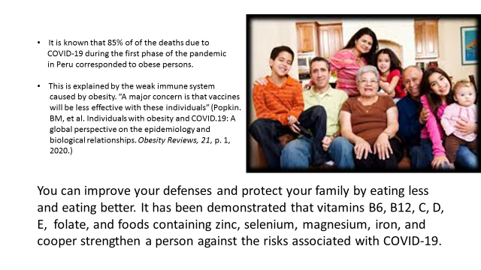
of the disease (Zabetakis et al., 2020) and that “you can improve your defenses and protect your family” (by following the recommendation). The reference to death statistics in the text configured a non-loss condition. One of the visual frames was a photo of transportation of a coffin out of a hospital in the poster. The comparison photo was one of a smiling large family at home. In order to evaluate the robustness of the expected findings, we crossed the image treatment with a text treatment that addressed COVID-19 risks for obese persons (Wadman, 2020) vis-à-vis the general immunological risk associated with inflammation and comorbidities (Zabetakis et al., 2020). The Qualtrix application allowed us to randomly assign, in the simplest way, the individuals who accepted to participate in the study to the four treatment conditions of the between-subject factorial experiment. The texts were in Spanish. Figures 1 and 2 present two of the four combinations.
Figure 1. Poster implementing the Obesity + Family condition that was presented to the study participants.
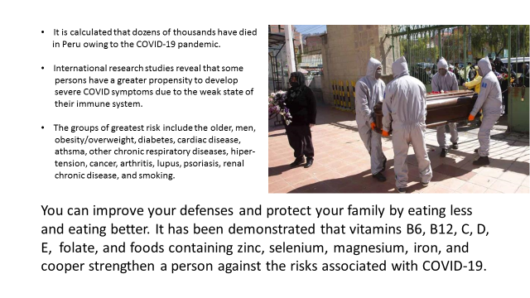
Figure 2. Poster implementing the Immunology + Coffin condition that was presented to the study participants.
Measures
Personal Information. Prior to the required task, participants provided information on their sex, age, education level, height, weight, comorbidities, whether they had or had had COVID-19, and whether they had daily contact with clients. The comorbidities are those in the second paragraph of Figure 2. To obtain body mass index (BMI) scores we divided weight by squared height.
Negative Emotions. Participants were asked to evaluate the poster’s attention-getting, clarity, and usefulness. Then, they responded “Nothing”, “Some”, or “A lot” to whether they felt preoccupation, anxiety, sadness, fear, and tranquility. The tranquility item received inverse scoring (3, 2, 1).
Transparency and Openness
We followed the ethical standards of the National Institute of Health of Peru (MINSA, 2020). Also, we followed the Universal Declaration of Ethical Principles for Psychologists (Parsonson, 2021), the International Ethical Guidelines for Biomedical Research Involving Human Subjects (Van Delden & van der Graff, 2016) and the declarations of the ISP regarding ethical behavior (ISP, 2019). The Unit of Training and Education of Hospital San Juan de Lurigancho authorized data collection and provided the personnel’s cell phone numbers. The informed consent of the participants was expressed in their willingness to respond to the questionnaire after reading the informed consent text.
Considering the opportunity costs of waiting until the variance of the subjects’ emotions scores were known, we sent the invitation in the absence of an estimation of needed sample size and waited for responses from June 4 to June 30, 2021. The response rate was 21% (N = 291). However, only 188 participants offered responses to all the emotion items and thus were able to contribute data for confirmatory factor analyses. N was 180 in the application of a multivariate general linear model (MGLM); the excluded participants omitted to declare gender or lacked information for the calculation of BMI. The data set is available at https://figshare.com/s/77e4796020a391d1c0af.
Results
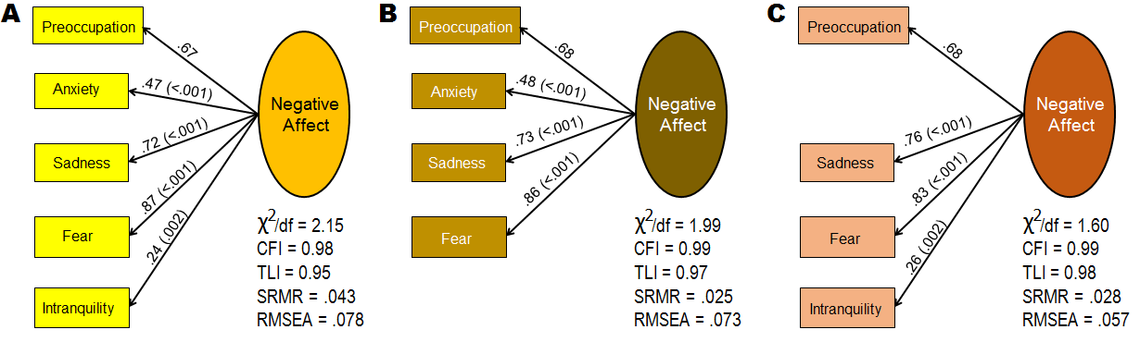
Participants’ responses to the emotion items behaved as observables of a consistent latent variable when the anxiety item was eliminated (Figure 3). The criteria of model fit to the data used were chi-squared divided by degrees of freedom (χ²/df) < 2 or 3 (Schreiber et al., 2006), standardized root mean square residual (SRMR) ≤ .07,
Figure 3. Results of confirmatory factor analyses of negative emotion scores (N = 188). (A) Negative Affect based on five items. (B) Negative Affect excluding intranquility. (C) Negative Affect excluding anxiety.
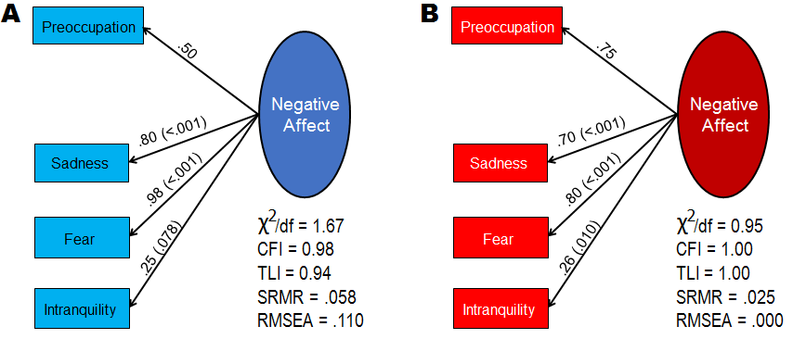 Figure 4. Results of confirmatory factor analyses of negative emotion scores (preoccupation, fear, sadness, intranquility) per gender. (A) Men (N = 57). (B) Negative Affect for women (N = 124).
comparative fit index (CFI) ≥ .93, Tucker-Lewis index (TLI) ≥ .92, and root mean square error of approximation (RMSEA) ≤ .07 (Bagozzi & Yi, 2012). The factor structure replicated well in women (Figure 4B), but it was not as well fitted in men (Figure 4A). Nonetheless, Cronbach’s α reliability was satisfactory for the sum of four item scores in the whole group (.72) and per gender (men = .69, women = .71). But the distribution of the four-item sum was pronouncedly skewed (see Figure 5A). We attempted to normalize the distribution by transforming the sum into a trichotomy with 1 (sum = from 1 to 7 or 16.0%), 2 (sum = from 8 to 11 or 64.3%), and 3 scores (sum =
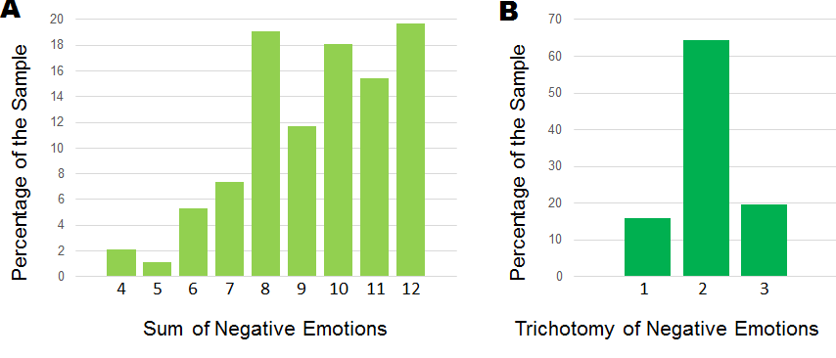
Figure 5. Frequency distribution of emotion scores. (A) Sum of negative emotions. (B) Trichotomy of negative emotions. (N = 188).
12 or 19.7%) (see Figure 5B). Since both scales were non-normal (Lilliefors’ corrected p < .001 from Kolmogorov-Smirnov test), we recurred to bootstrapping in the MGLM utilized to test the study hypothesis targeting both scales as dependent variables.
One-hundred and twenty-three women and 57 men had scores on all the variables to be used in the MGLM. In this group, average age was 36.97 years, 70.0% had university education, 79.4% had daily contact with clients, 51.7% had or had had COVID-19, 20.0% were obese while 45.0% only had overweight, and 16.7% presented other comorbidities. The MGLM included image, gender, text, and their interactions as independent variables and all the other measures as covariates. The number of cases per cell ranged from 11 to 34. Only the image x gender interaction (p = .011) and BMI (p = .073) emerged with significance levels below .100 in the multivariate tests (Pillai trace, Wilks’ lambda, Hotelling’s trace, Roy’s main root). It can be seen in Table 1, which shows the results of the between-subject test, that image x gender, daily contact with clients, and BMI presented effects on the sum of negative emotions, but BMI failed to
Table 1
Results of between-subject test from multivariate general lineal model (N = 180).
 | Sum of Negative Emotions |  |  | Trichotomy of Negative Emotions
Source | F | p | eta² | F | p | eta²
Image (I)  Gender (G)  Text (T)  I x G  I x T  G x T  I x G x T  Age  Education  Had COVID-19  Client contact  Body Mass Index  Other Comorbidities | 0.90  0.54  1.29  8.27  0.37  0.83  0.11  0.67  0.02  0.01  4.58  3.64  0.23 | .343  .508  .258  .005  .542  .365  .740  .416  .893  .945  .034  .058  .631 | .005  .003  .008  .047  .002  .005  .001  .004  .000  .000  .027  .021  .001 | 0.00  1.31  0.32  8.99  1.01  0.38  0.53  1.24  0.03  0.05  3.20  0.84  0.27 | .966  .254  .545  .003  .315  .537  .466  .268  .871  .829  .075  .360  .604 | .000  .000  .002  .051  .006  .002  .003  .007  .000  .000  .029  .005  .002

Table 2
Results of bootstrapped parameter estimation based on 1000 samples from MGLM.
 | Sum of Negative Emotions |  |  | Trichotomy of Negative Emotions
Source | B | Standard  Error | p | B | Standard  Error | p
Image (I)  Gender (G)  Text (T)  I x G  I x T  G x T  I x G x T  Age  Education  Had COVID-19  Client contact  Body Mass Index  Other Comorbidities | -1.30  -0.88  -0.02  1.63  0.18  0.36  0.42  0.01  -0.04  -0.02  -0.77  0.07  0.19 | 0.63  0.50  0.45  0.91  0.78  0.79  1.26  0.02  0.34  0.31  0.35  0.03  0.44 | .040  .093  .972  .074  .846  .654  .755  .435  .920  .951  .042  .040  .659 | -0.31  -0.17  -0.03  0.44  0.05  -0.02  0.28  0.01  -0.02  -0.02  -0.20  0.01  0.06 | 0.18  0.16  0.15  0.26  0.24  0.25  0.38  0.01  0.10  0.10  0.10  0.01  0.14 | .074  .278  .824  .083  .832  .930  .482  .273  .887  .833  .055  .305  .633
Note. In the interactions, one cell is compared with the other three cells. N = 180.
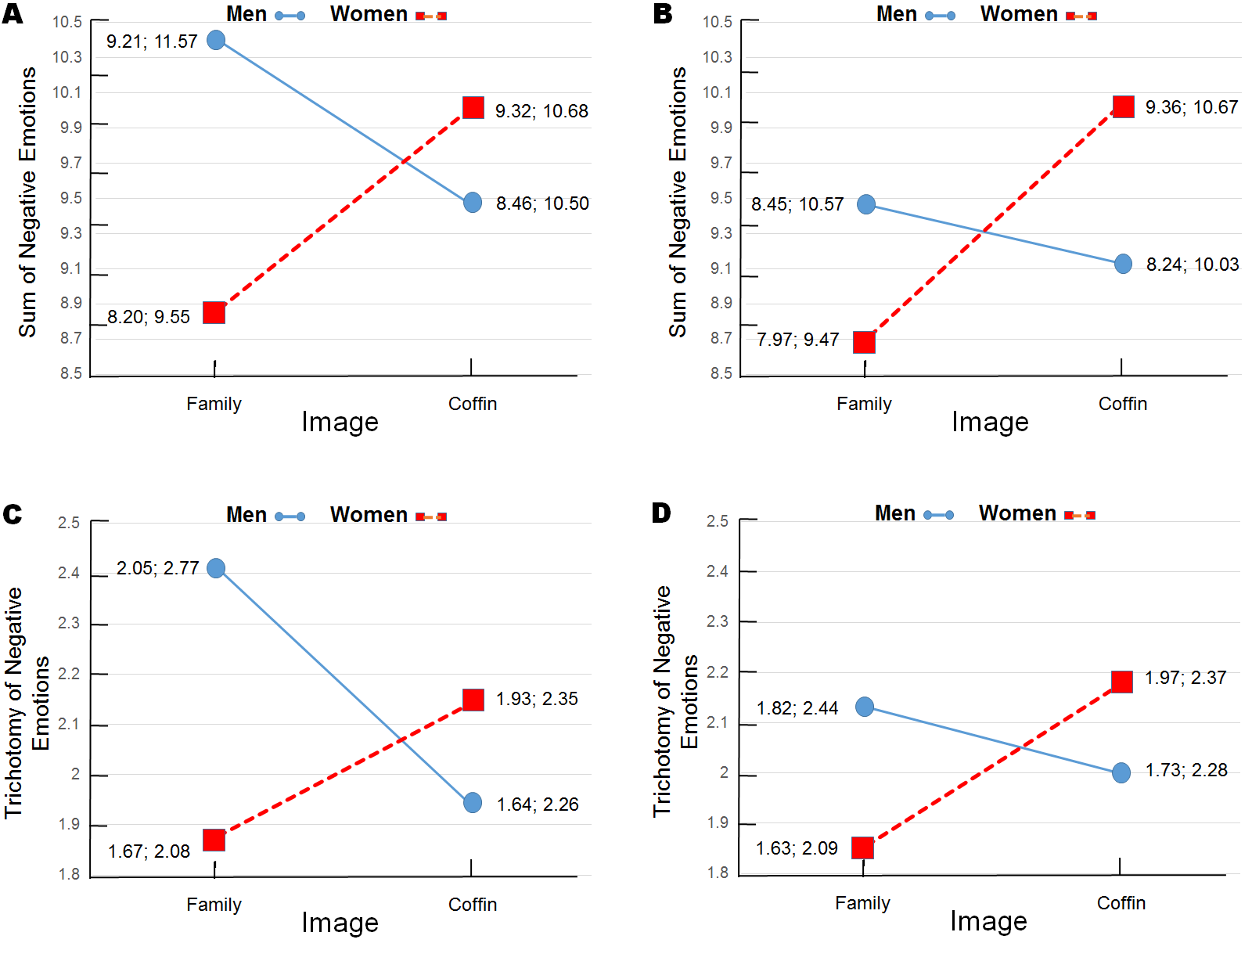
do so with respect to the negative emotions trichotomy. All these results reappeared in the bootstrapped parameter estimation, which in addition presented main effects of image (both dependent variables) and gender (only the sum). These main effects, however, become irrelevant when one considers the cross-over of the means depicted in

Figure 6. Estimated means from multivariate general lineal model depicting image x gender interaction. (A) Sum of negative emotions at obesity text. (B) Sum of negative emotions at immunology text. (C) Trichotomy of negative emotions at obesity text. (D) Trichotomy of negative emotions at immunology text. Bootstrapped 95% confidence intervals of the means with Bonferroni adjustment are also offered (1000 samples). N = 180.
Figure 6. The robustness of the image x gender interaction is highlighted by its recurrence across two texts and two measures. On the other hand, there was a tendency for women to score higher than men under the coffin condition, but without statistical significance. The estimated means for the sum of negative emotions were 9.31 (95% CI = 8.63, 9.99) for men and 10.01 (95% CI = 9.54, 10.48) for women. In the case of the trichotomy, the estimated means were, respectively, 1.98 (95% CI = 1.77, 2.18) and 2.15 (95% CI = 2.01, 2.30).

Discussion
Whereas the study results showed a statistically non-significant tendency for women to present more negative emotions than men in the presence of an unhealthy outcome, the robust and significant image x text interaction observed revealed a tendency for women to increase their negative emotions from the comparison condition to the coffin photo, whereas men showed the opposite tendency. This is consistent with evidence that men and women experience negative emotions differently and upholds our claim that gender differences should be addressed in the study of the processes whereby message framing influences adherence behavior, especially when emotions are targeted and visuals are used. Our finding provides an alternative explanation to Wansink and Pope’s (2015) conclusion that health personnel prefer designing loss-framed health messages because health occupations press toward processing health information differently from the general population; the fact that most health workers are women could be a deeper cause of the commented phenomenon. The gender difference observed in the factor analysis of emotion items contradicts evidence of factor invariance across genders (e.g., Perkins et al., 2019) and merits further research attention.
We expected a moderate image x gender interaction, not the crossover of the means. Perhaps the intriguing men’s results can be explained by their higher mortality risk with COVID-19 compared to women under the family photo and reactance under the coffin photo, that is, the implicit derogation of the message that occurs when one perceives an attempt to coerce personal freedom through a message that does not leave other options than complying (Dillard & Shen, 2005), such as the implicit “Comply or die!” in our message to men.
Future research will have to clarify these processes and add specificity to the role of gendered emotions in adherence behavior; emotion is only one of the variables relevant to decision-making (Lerner et al., 2015). While current theories assimilate the study findings, we recommend researchers to compare genders when studying effects of visual framing on emotions. Otherwise, results in the global sample may distort the findings. And future studies should overcome the limitations of the present research. The measurement of negative emotions was constrained by our offer of taking only five minutes from respondents’ time. The intranquility item, which emerged with a low loading in the confirmatory factor analyses, needs replacement. Situations where positive emotions prevail need attention and data on thoughts coming to mind while viewing the images should be collected. The external validity of the findings needs evaluation, too. Peru is a country at the margins of the Western civilization. Replications will be needed in other countries despite evidence that Peruvian women, like women elsewhere in the world, present higher neuroticism than men, including higher withdrawnness and higher volatility (León et al., 2017).
The Authors declare that there is no conflict of interest.
References
Bagozzi, R.P., & Yi, Y. (2012) Specification, evaluation, and interpretation of structural
equation models. Journal of the Academy of Marketing Science, 40, 8-34.
Borrachero, A.B., Brígido, M., Mellado, L., et al. (2014) Emotions in prospective
secondary education teachers when teaching science content, distinguishing by
gender. Research in Science & Technological Education, 32, 182-215.
DOI: 10.1080/02635143.2014.909800
Brehm, S.S., & Brehm, J.W. (1981) Psychological reactance: A theory of freedom and
control. New York: Academic Press.
Carfora, V., Pastore, M., & Catellani, P. (2021) A cognitive-emotional model to explain
message framing effects: Reducing meat consumption. Frontiers in Psychology,
published 29 March 2021. DOI: 10.3389/fpsyg.2021.583209.
CDC COVID Response Team. (2020) Characteristics of health care personnel with
COVID-19 — United States. https://doi.org/10.15585/mmwr.mm6915e6
Dillard, J.P., & Shen, L. (2005) On the nature of reactance and its role in persuasive

health communication. Communication Monographs, 72, 144-168,

DOI: 10.1080/03637750500111815
Gerend, M.A., & Maner, J.K. (2011) Fear, anger, fruits, and veggies: Interactive effects
of emotion and message framing on health behavior. Health Psychology, 30, 420–423. doi:10.1037/a0021981

Hasseldine, J., & Hite, P.A. (2003) Framing, gender and tax compliance. Journal of

Economic Psychology, 24, 517-533. doi:10.1016/S0167-4870(02)00209-X
Higgins, E.T. (1997) Beyond pleasure and pain. American Psychologist, 52, 1280–300.
Hollands, G.J., & Marteau, T.M. (2016) Pairing images of unhealthy and healthy foods
with images of negative and positive health consequences: Impact on attitudes
and food choice. Health Psychology, 35, 847–851. DOI: 10.1037/hea0000293.
Kahneman, D., & Tversky, A. (1979) Prospect theory: An analysis of decision under
risk. Econometrica: Journal of the Econometric Society, 24, 263-291.

Kim, H.J. (2010) The effects of gender and gain versus loss frame on processing breast

cancer screening messages. Communication Research, 39, 385-412.
https://doi.org/10.1177/0093650211427557
Kong, G., Cavallo, D.A., Camenga, D.R., et al. (2016) Preference for gain- or loss-
framed electronic cigarette prevention messages. Addict Behavior, 62, 108-113,
doi:10.1016/j.addbeh.2016.06.015
Kushner, K. (2017) Why is depression more common among women than among men?
The Lancet Psychiatry, 4, 140-158. https://doi.org/10.1016/S2215-0366(16)30263-2
Lee, Y-I, Jin, Y., & Nowak, G. (2018) Motivating influenza vaccination among young
adults: The effects of public service advertising message framing and text
versus image support. Social Marketing Quarterly, 24, 89-103.
DOI: 10.1177/1524500418771283
León, F.R., Morales, O., Vértiz, H., & Burga-León, A. (2017) Universality of gender
differences in 10 aspects of personality: A study of younger and older adult
Peruvians. Personality and Individual Differences, 112, 124-127.
https://doi.org/10.1016/j.paid.2017.02.060
Lerner, J. S., Li, Y., Valdesolo, P., & Kassam, K. S. (2015). Emotion and decision
making. Annual Review of Psychology, 66, 799–823.
doi:10.1146/annurev-psych-010213-115043
Maheswaran, D., & Meyers-Levy, J. (1990) The influence of message framing and issue
involvement. Journal of Marketing Research, 27, 361–67.
Masumoto, K., Shiozaki, M., & Taishi, N. (2019) The impact of age on goal-framing
for health messages: The mediating effect of interest in health and emotion
regulation PLoS ONE, 15: e0238989.
https://doi.org/10.1371/journal.pone.0238989
Meyerowitz, B.E., & Chaiken, S (1987) The effect of message framing on breast self-
examination, intentions and behavior. Journal of Personality and Social
Psychology, 52, 500-510.
Mikels, J.A., Young, N.A., Liu, X., et al. (2020) Getting to the heart of the matter in
later life: The central role of affect in health message framing Gerontologist,
20, 1–7. doi:10.1093/geront/gnaa128
MINSA (2020) Resolución Ministerial N° 233-2020. Lima: Ministerio de Salud del
Perú, 27 de abril de 2020.
Nabi, R.L., Walter, N., Oshidary, et al., (2020) Can emotions capture the elusive gain-
loss framing effect? A meta-analysis. Communication Research, 47, 1107-1110. https://doi.org/10.1177/0093650219861256
Nan, X. (2012) Communicating to young adults about HPV vaccination:
Consideration of message framing, motivation, and gender. Health
Communication, 27, 10-18. DOI: 10.1080/10410236.2011.567447
Nan, X., Daily, K., & Qin, Y. (2018) Relative persuasiveness of gain- vs. loss-framed
messages: a review of theoretical perspectives and developing an integrative
framework. Review of Communication, 18, 370-390.
https://doi.org/10.1080/15358593.2018.1519845
O’Keefe, D. J., Jensen, J. D. (2007). The relative persuasiveness of gain-framed loss-
framed messages for encouraging disease prevention behaviors: A meta-analytic
review. Journal of Health Communication, 12, 623-644.
doi:10.1080/10810730701615198
O’Keefe, D. J., Jensen, J. D. (2009). The relative persuasiveness of gain-framed and
loss-framed messages for encouraging disease detection behaviors: A meta-
analytic review. Journal of Communication, 59, 296-316.
doi:10.1111/j.1460-2466.2009.01417.x
O’Keefe, D.J., & Wu, D. (2012) Gain framed messages do not motivate sun protection:
A meta-analytic review of randomized trials comparing gain-framed and loss-
framed appeals for promoting skin cancer prevention. International Journal of
Environmental Research and Public Health, 9, 2121-2133. doi:10.3390/ijerph9062121
Ormel, J., Bastiaansen, A., Riese, H., et al. (2013) The biological and psychological
basis of neuroticism: Current status and future directions. Neuroscience and
Biobehavioral Reviews, 37, 59-72.
http://dx.doi.org/10.1016/j.neubiorev.2012.09.004
Parsonson, K.L. (2021) The universal declaration of ethical principles for psychologists.
In K. L. Parsonson (Ed.), Handbook of International Psychology Ethics.
Routledge. DOI https://doi.org/10.4324/9780367814250
Perkins, B.A., Satkus, P., & Finney, S.J. (2019) Examining the factor structure and
measurement invariance of test emotions across testing platform, gender, and
time. Journal of Psychoeducational Assessment, 38, 969-981.
DOI: 10.1177/0734282920918726
Petzel1, Z.W., & Noel, J.G.2 (2021) Don’t drink and drive, it’s a prime: Cognitive
effects of priming alcohol congruent and incongruent goals among heavy versus
light drinkers. Journal of Health Psychology, 26, 2966–2972.
DOI: 10.1177/1359105320934166
Putrevu, S. (2010) An examination of consumer responses toward attribute- and goal-
framed messages. Journal of Advertising, 39, 5-24.
DOI 10.2753/JOA0091-3367390301
Rothman, A.J., & Salovey, P. (1997) Shaping perceptions to motivate healthy behavior:
The role of message framing. Psychological Bulletin, 121, 3–19.
Seo, K. (2020) Meta-analysis on visual persuasion– Does adding images to texts
influence persuasion? Athens Journal of Mass Media and Communications,
6, 177-190. doi=10.30958/ajmmc.6-3-3
Schreiber, J. B., Stage, F. K., King, J., Nora, A., & Barlow, E. A. (2006). Reporting
structural equation modelling and confirmatory factor analysis results: A review.
The Journal of Educational Research, 99, 324-337.
Shamaskin, A.M., Mikels, J.A., & Reed, A.E. (2010) Getting the message across: Age
differences in the positive and negative framing of health care messages.
Psychology and Aging, 25, 746–751 DOI: 10.1037/a0018431
Sontag, J.M. (2019) Visual framing effects on emotions and mental health message
effectiveness. Journal of Communication in Healthcare, 11, 30-47. https://doi.org/10.1080/17538068.2018.1435017
Toll, B.A., Salovey, P., O’Maley, S.S., et al. (2008) Message framing for smoking
cessation: The interaction of risk perceptions and gender. Nicotine & Tobacco
Research, 10, 195–200. https://doi.org/10.1080/14622200701767803
Tversky, A., & Kahneman, D. (1981) The framing of decisions and the psychology
of choice. Science, 211, no. 4481, 453–8.
Updegraff, J.A., & Rothman, A.J. (2013) Health message framing: Moderators,
mediators, and mysteries. Social and Personality Psychology Compass, 7, 668-
679. https://doi.org/10.1111/spc3.12056
Van Delden, J.J.M., & van der Graff, R. (2016) Revised CIOMS International Ethical
Guidelines for health-related research involving humans. Journal of the
American Medical Association. Published Online: December 6, 2016.
doi:10.1001/jama.2016.18977
Wadman, M. (2020) Why obesity worsens COVID-19. Science, 369, 1280-1281.
https://doi.org/10.1126/science.369.6509.1280
Wansink, B., & Pope, L. (2015) When do gain-framed health messages work better than
fear appeals? Nutrition Reviews, 73, 4-11. https://doi.org/10.1093/nutrit/nuu010
Yuan, J., Luo, Y., Yan, J.H., Meng, X., Yu, F., & Li, H. (2009) Neural correlates of the
females’ susceptibility to negative emotions: An insight into gender-related
prevalence of affective disturbances. Human Brain Mapping, 30, 3676-3896.
DOI: 10.1002/hbm.20796
Zabetakis, I., Lordan, R., Norton, C., & Tsoupras, A. (2020) COVID-19: the
inflammation link and the role of nutrition in potential mitigation. Nutrients, 12,
1466. https://doi.org/10.3390/nu12051466

