Team Psychological Capital: Comparative Psychometric Study of Two Versions of the Team Psychological Capital Questionnaire (24 and 12 items)

Abstract
The globalized and competitive world puts pressure on organizations to be increasingly faster, flexible, and innovative. To this end, the concept of positive organizational behavior (POB) and, in specific, team psychological capital (PsyCap), is particularly relevant. Indeed, teams are increasingly seen as critical to organizational success, and so the study of psychological capital at the team level provides a significant contribution to both research and applied fields. Assessing the levels of psychological capital and/or the dimensions that compound the construct (self-efficacy, resilience, hope and optimism) and understanding how to promote this may provide organizations with an important advantage. The most common measuring instrument of PsyCap is the Psychological Capital Questionnaire (PCQ), which offers a version of 24 items and a reduced version of 12 items. Thus, we aim to evaluate the psychometric properties of each of the scale’s versions, with the team as a referent, as well as comparing the constructs computed and seeing the correlations between them. For this purpose, confirmatory factor analyses were conducted to test the correlated four-factor structure and a four-factor with a second-order factor structure of both scales. The results supported the two concurrent models for the two versions: a four-factor structure and PsyCap as a higher-order construct. Furthermore, a high correlation between both scales’ versions was found, concluding that both measures of PsyCap have a very high degree of overlap, with practical advantages in using the short version of the scale.
Keywords: team psychological capital; team psychological capital questionnaire; team; psychometric study.

Introduction
Nowadays, there is a growing pressure to study positive psychological resources and to focus on positive organizational behavior (POB), which derives from the need to answer the demands on organizations to be increasingly fast, flexible and innovative. Thus, it is essential to effectively manage the knowledge, experiences, and skills of employees (Luthans et al., 2004). The globalized and competitive world that characterizes today’s reality generates the need for organizations to create value. Psychological capital (PsyCap) plays an important part in this process since it can have a strong positive impact on organizations. According to Luthans et al. (2007b, p.3), PsyCap is defined as
“an individual’s positive psychological state of development and is characterized by (1) having confidence (self-efficacy) to take on and put in the necessary effort to succeed at challenging tasks; (2) making a positive attribution (optimism) about succeeding now and in the future; (3) persevering toward goals and, when necessary, redirecting paths to goals (hope) in order to succeed; and (4) when beset by problems and adversity, sustaining and bouncing back and even beyond (resiliency) to attain success.”
In fact, employees characterized by hope, optimism, self-efficacy and resilience - the four dimensions of PsyCap - reveal a greater capacity to resist and succeed in the dynamic and global environment that organizations are faced with. Therefore, it is essential to focus on the promotion of employees’ positive psychological abilities (Ouweneel et al., 2012). Such a view led to an evolution in terms of the investment in financial, human and/or social capital. Indeed, the focus must be on the investment in psychological capital, adapted to each reality (Luthans et al., 2007a). The need to access individuals' levels of psychological capital has led to the development of a measurement instrument, which is the most used to assess PsyCap - the Psychological Capital Questionnaire (PCQ), developed by Luthans et al. (2007a).
Despite the existence of a vast array of literature on the subject, one of the main areas emerging within the scope of PsyCap focuses on perceiving and measuring it as a collective construct. Evidence supports the idea that different attitudes and behaviors of individuals can be seen as phenomena that characterize the collective makeup of those individuals (Heled et al., 2015). However, the emergence of studies about collective PsyCap, namely team PsyCap, follows the extant literature on teams, which is gaining increasing relevance. In fact, the globalization and interdependence of markets are among the factors that have most contributed to the growth of teamwork in organizations, which has increased by 50% or more in the last two decades (Cross et al., 2016). This growth can be explained by the fact that teamwork is indispensable for the pursuit and fulfillment of common goals (O'Neill & Salas, 2018).
Knowledge of individual and team PsyCap has the major advantages of allowing organizations to apply planned interventions and events, triggering positivity, efficacy, and collaboration. However, studies on the construct of psychological capital have been mostly focused on the individual level. It was only recently that literature began to point to the possibility of studying PsyCap at the collective level (Heled et al., 2015). The study of collective PsyCap requires the adaptation of the PCQ, that is, the referent must be changed to a collective referent, such as the work team, instead of the individual. Rebelo et al. (2018) stressed the importance of transposing the PsyCap measure to the team level and of its independent relevance from the individual level. Thus, the authors adapted PCQ for the team level, with results indicating that it is a reliable, stable, and promising adaptation.
The existing studies on the PCQ scale mostly focus on the individual level of analysis (Luthans & Youssef, 2017). However, given the growing relevance of team PsyCap, it becomes crucial not only to evaluate the dimensionality of the 24-item team PCQ scale and of the 12-item short scale, but also to make a comparison between both scales, to understand if they are measuring constructs that can be assumed to overlap. This study is even more important when considering the need to provide organizations and researchers with simple and quick yet reliable tools to access PsyCap.
To continue the assessment of the psychometric properties of the PCQ at the team level, we aim to study the construct validity of both versions of the scale (24 and 12 items), namely the four-factor structure and PsyCap as a higher-order construct, as well as to compare the level of association between the constructs in both versions.

Emergence of the psychological capital construct
For a long time, the history of psychology was strongly marked by the focus on the most negative and pathological aspects of human behavior. In fact, in 1954, Maslow warned about the importance of shifting the focus of psychology to more positive aspects and areas. However, it was only after 2000 that “positive psychology” was introduced through the contribution of Seligman and Csikszentmihalyi (2000), who stated that the goal of the positive psychology movement is to initiate a change of focus in psychology. In this sense, psychology must worry not only about psychopathological aspects, but also about the construction and development of human potential. This idea has extended to the workplace, where positivity has also become a central concern (Luthans & Youssef, 2007). In fact, Luthans (2002a) recognized the importance of incorporating positive psychology in organizational behavior, introducing the term positive organizational behavior (POB), which focuses on the strengths of human beings and their psychological abilities. Luthans (2002a, p. 59) defined POB as “the study and application of positively oriented human resources strengths and psychological capacities that can be measured, developed, and effectively managed for performance improvement in today’s workplace.” Thus, the definition presented points out that for a construct to be part of the POB concept, it must be based on theory and research, and assessed with reliable psychological instruments. Additionally, it should have a “state-like” focus, which means that capacities must be malleable, unlike traits, that tend to be fixed (Luthans et al., 2007a). Also important is the criterion of the positive impact on work-related individual-level performance and satisfaction, the relevance of which allows positive organizational behavior to be distinguished from the positive psychology movement, as well as preventing the POB from being an end in itself. It is, indeed, a means of achieving an impact on performance (Luthans & Avolio, 2009). Finally, there is the criterion of relative singularity, that is to say, the constructs must be positive and unique for the field of organizational behavior.
The emphasis on POB allows the development of more effective leaders and work teams, and their states can be developed through formal training programs, mentoring or coaching relationships, among others (Luthans, 2002a). Indeed, it was the movement of positive psychology and, more specifically, POB, that provided the basis for the development of PsyCap as a construct of this new and positive approach.

Definition of Psychological Capital
There is consensus in the literature regarding the definition presented by Luthans et al. (2007b, p. 3). The aforementioned criteria for PsyCap as part of the POB concept were met by the dimensions of self-efficacy, optimism, resilience and hope. The concept of self-efficacy, based on Bandura's theory of social learning, is defined by Stajkovic and Luthans (1998, p. 4) as “an individual’s convictions (or confidence) about his or her abilities to mobilize the motivation, cognitive resources, and courses of action needed to successfully execute a specific task within a given context.” Self-efficacy is seen as a state that can be developed and managed, revealing a strong impact on human performance. The “hope” dimension consists of three main concepts: action, path, and goals, where the action is the determination for the goals and the paths correspond to the way the goals are achieved (Snyder et al., 1996). Hope is a positive concept that can be developed and measured, but also managed to influence performance in the workplace. Regarding optimism, Seligman (1998) is one of the main authors that approached the concept, defining it as the attributions that are made and the explanatory style that is used in response to events. It presents guidance for evaluating past or recent events. Optimism can also be measured, managed, and developed. However, it needs to be carefully developed, as disadvantages such as the establishment of unrealistic goals can also arise. It is important to develop a realistic and flexible optimism, which allows adaptation according to circumstances (Luthans, 2002a). As such, this optimism is perceived as a desired characteristic in workers, especially at the level of leaders (because the optimism of the leader drives the optimism of the rest of the team), as it is associated with higher levels of motivation, satisfaction, aspiration, retention, and perseverance, being liable to development. The fourth dimension of PsyCap is resilience, defined as the ability to recover when faced with a failure and associated with the concept of adaptability (Block & Kremen, 1996). Luthans (2002b) states that resilience also concerns the ability to recover from positive changes, progress, and increased responsibility. Initial studies on the concept revealed that it is a capacity possessed by few (Luthans, 2002a). However, advances in the literature support that this ability is part of the daily life of all individuals and can be developed (Tugade et al., 2004).
Nevertheless, further studies pointed out that these four psychological resources present a superior contribution when combined in a broad construct, identifiable as PsyCap. That is, even though the four dimensions have their specificities and potential, PsyCap as a compound construct of the four factors (a higher-order construct) is mostly better as a predictor with a significant impact on desirable outcomes, such as performance and job satisfaction (Luthans & Youssef, 2007). In this way, the constructs of self-efficacy, hope, optimism, and resilience constitute a more comprehensive construct-psychological capital. The studies carried out, particularly the work of Luthans et al. (2007a), indicate that individuals with high levels of general psychological capital perform better than those who have only one dimension of PsyCap, since it has a greater number and level of positive psychological resources. Therefore, global PsyCap is a multidimensional construct, that is to say, it corresponds to the shared variance of the four dimensions that constitute it (the constructs are highly related and integrated). PsyCap corresponds to the whole and it is, therefore, greater than the sum of the dimensions that constitute it (self-efficacy, optimism, hope and resilience) (Avey, 2014; Luthans et al., 2007b). In other words, different psychological constructs can share common processes that influence motivation and behavior, and the higher order construct represents the common source of variance, making the connection with the constructs of hope, optimism, resilience, and self-efficacy (Luthans et al., 2007a).
PsyCap is also context-specific, usually the work context. It is also considered “state-like,” as it is malleable and liable to development, able to be adapted to each organization and more stable than emotions. Nevertheless, psychological capital is also measurable, and the most widely used way to measure psychological capital is the PCQ scale.

Psychological capital as a collective construct
As abovementioned, studies on PsyCap mainly focus on the individual level of analysis. In fact, the very definition of the construct presented by Luthans et al. (2007b) considers it a state of positive and individual psychological development. However, the literature has evolved in the sense of studying PsyCap as a collective phenomenon. PsyCap as a team phenomenon allows a focus on shared mental models that emerge through team members’ communication and interactions (Dawkins et al., 2018). In addition, collective PsyCap can be seen as a resource for promoting positive attitudes and behaviors in employees, which, in turn, impacts satisfaction, as well as organizational outcomes and performance (Heled et al., 2015). The importance of collective PsyCap is also explained by the cross-level relationship between team PsyCap and individual-level outcomes (such as job satisfaction and turnover intentions) since individuals develop social relations at work and are influenced by the capacities of the team (West et al., 2009). Indeed, Heled et al. (2015) sought to contribute to the study of psychological capital as a team construct, using literature to explain how individuals' attitudes and behaviors can become a phenomenon that characterizes a collective. Studies in the field of social psychology reveal that team members develop shared mental models that allow them to communicate and that they can set up a collective PsyCap (Lim & Klein, 2006). Dawkins et al. (2015) recall the principles of social contagion, which refers to the process of communication and exchange of information between members of a group, resulting in the adoption of attitudes and beliefs shared by others. As such, social contagion can contribute to the emergence of the collective PsyCap. Similarly, Peterson and Zhang (2011) understand collective psychological capital as the product of the interactive dynamics of team members. Finally, Walumbwa et al. (2009) defined collective PsyCap as the product of interactive exchanges between members that creates a sense of group capacity to achieve the desired collective goals.
Furthermore, collective PsyCap is also supported by the existing references to the collective in each of its four resources. Bandura (1997) addressed the concept of collective self-efficacy. West et al. (2009) stated that teams can share an optimistic posture towards achieving positive results, as well as developing a shared capacity to trace alternative paths to achieve the goals (hope). Finally, it has also been supported that resilience can be a collective phenomenon, concerning the team's ability to adapt to the demands of the environment (Zhang & Liu, 2012).
The conceptualization and the assessment of PsyCap at the collective level, however, requires the adaptation of the measuring instrument. In this sense, one of the existing strategies includes the “referent shift consensus model,” which focuses on the perception that an individual has about their team. Thus, the referent is changed to represent the collective-level construct. In other words, instead of asking participants to assess their confidence in their own abilities, they are asked to assess their confidence in the collective skills of the team to perform a given task (Luthans & Youssef, 2017). When measuring collective PsyCap with this approach, a team member can have a high level of individual PsyCap and the perception of a low level of team psychological capital, as they are constructs operating in a different way and, for this reason, this model is recommended to measure the collective psychological capital. In fact, the influence of the collective PsyCap is better assessed when team members are asked to reflect on the skills shared by the team, and not when the referent is the individual level (Dawkins et al., 2015).

Measuring PsyCap: The PCQ (24- and 12-item versions)
Among the characteristics of PsyCap, there is consensus regarding the fact that it is a measurable construct. The PCQ-24 -Psychological Capital Questionnaire - is the most used instrument to measure PsyCap at the individual level and was developed and empirically tested for validity by Luthans and colleagues (2007a). This instrument consists of a total of 24 items, six items for each of the four dimensions that make up PsyCap, adapted from existing measures previously developed for each of the constituent constructs (Avey, 2014): hope (Snyder et al., 1996), resilience (Wagnild & Young, 1993), optimism (Scheier & Carver, 1985) and self-efficacy (Parker, 1998). The adaptation essentially went through the inclusion of context ("at work"), as well as "here and now" and the items were chosen in order to explore the psychological resources similar to a state (Luthans & Youssef, 2017). As such, these measures formed the basis from which the PsyCap questionnaire was developed, following two main criteria: each of the four constructs should have equal weight, so the six best items for each of the four measures would be those selected, and the selected items should present content validity as they are relevant to the workplace and adaptable to changes (Luthans et al., 2007a). These criteria made it possible to select the 24 items that make up the PCQ, with response options on a 6-point Likert scale (1 = strongly disagree, 2 = disagree, 3 = somewhat disagree, 4 = somewhat agree, 5 = agree, 6 = strongly agree), in which the participant must describe how he/she thinks about him/herself when he/she answers the questionnaire (Luthans et al., 2007a).
Studies on the PCQ-24 scale have demonstrated that it is a reliable instrument and a predictive measure of performance, satisfaction, and affective organizational commitment at the individual level (Luthans et al., 2006; Luthans et al., 2007b). Luthans et al. (2008b) analyzed the dimensionality of the scale, through the use of confirmatory factor analysis (CFA), in order to support the four-factor structure and also PsyCap as a higher-order construct, with adequate indexes for the tetra structure of psychological capital with six items for each dimension. Specifically, both the four-factor and second-order structures obtained have adequate fit adjustment. The analyses carried out by Luthans et al. (2007a) conclude that PsyCap has discriminant validity compared to other constructs, such as personality traits, and criterion validity with job satisfaction. Additionally, the usefulness of PsyCap has also been compared to each of its four dimensions, in order to understand whether this higher-order construct is actually more “useful” than the measures of each dimension. The conclusions point out that PsyCap is more consistent regarding the prediction of performance and satisfaction than each of its individual resources, which strengthens PsyCap as a higher order core factor (Luthans & Youssef, 2017). The PCQ scale has been adapted to other cultures and languages, for example, Görgens-Ekermans and Herbet (2013), who assessed the psychometric qualities of PCQ-24 for the South African context. The results indicate that the four-factor structure fits the data. However, the authors flagged items 13 (when we have a setback at work, we have a hard time recovering and moving on) and 20 (if something bad can happen to us at work, it will) - two of the three reverse items - due to the possibility of having problematic behavior. Cid et al. (2020) adapted the scale to the Brazilian context by conducting a CFA to analyze the quality of adjustment of the second-order structure. The reverse items of the scale (13, 20 and 23 - at work, things never go our way) had loadings below .45 and, therefore, they were removed, leaving a solution of 21 items. The results indicated satisfactory fit indicators. Mónico et al. (2014) conducted a study with Portuguese workers and concluded that the PCQ's four-factor model presented good adjustment (the authors removed items 13 and 20), supporting the four dimensions originally proposed by Luthans et al. (2007a), with 22 items.
Despite the good conclusions reported, the PCQ-24 scale has presented some drawbacks, particularly due to its size, which is a concern for organizational leaders. Additionally, the scale presents reverse items, which is also seen as a less positive point because they usually reduce scale reliability, due to reasons such as language proficiency (Peterson & Chang, cited in Luthans & Youssef, 2017).
In order to overcome the abovementioned issues, a reduced version was developed and validated, the PCQ-12 (Luthans et al., 2008a). This scale is composed by 12 items derived directly from the PCQ-24 and rated on the same 6-point Likert scale: four items representing hope (two for each of the hope mechanisms: agency and pathways), three items representing efficacy, two items representing optimism, and three items representing resilience (Avey et al., 2011; Luthans et al., 2008a). According to Luthans et al. (2008a), who used the short scale translated into Mandarin Chinese for the first time, the 12-item version of PCQ does not have the same high reliability as the original scale, but it is very close to acceptable levels.
The PCQ-12 scale has important advantages. In fact, besides the short length that lowers fatigue and enables cooperation, the shorter version has no reverse-scored items, which seem to tend to compromise the measure. In addition to these advantages, the items that are included in PCQ-12 are more appropriate for translation and use across cultures, as shown with the measurement invariance study of Wernsing (2014) across 12 cultures, as well as to adaptation to contexts beyond the workplace (Luthans & Youssef, 2017). In addition, the studies by Luthans et al. (2008a), Avey et al. (2011) and Norman et al. (2010) demonstrated that the scale presents strong evidence of reliability of construct validity.

PCQ (Psychological Capital Questionnaire) adapted to the team level
The conceptualization of PsyCap at the team level implies the adaptation of the measurement instruments, which need to have the team as a referent, since it is the model recommended due to its ability to represent the collective-level construct (Newman et al., 2014). As stated earlier, this reformulation work has already been carried out, with results indicating that it is a reliable and promising adaptation (e.g., Rebelo et al., 2018).
Indeed, the study by these authors used the PCQ-24 items developed by Luthans et al. (2007a) and worked on a version translated into Portuguese, which was additionally reformulated to have the team as a referent. To evaluate the adequacy of the adaptation of the questionnaire to Portuguese and to the team level, a pilot study was carried out in a team from the services sector. It aimed to identify and correct words and items perceived as dubious or subject to different interpretations. After completing the questionnaire, a debate regarding existing doubts and suggestions took place, which led to slight reformulations of a few items. Additionally, the revised version of the questionnaire was submitted for evaluation by two experts and to a specialized translator to verify their agreement with the translation of the items (DeVellis, 2012).
Thus, the questionnaire was applied to the final sample, composed of 82 teams and 353 members. The scale was evaluated on its psychometric proprieties, namely the structure, using principal components analysis (PCA). This analysis led to a tetra-factorial structure, accounting for 65.83% of the total variance, after dropping six items, which include all the three reverse items of the scale. This scale reveals adequate reliability, as Cronbach’s alphas estimated for the four resources were above .70 (Nunnally, 1978): .90 for self-efficacy, .85 for hope, .80 for optimism and .75 for resilience. Then, a CFA was also conducted, with psychological capital as a second-order factor. The CFA supported PsyCap as a higher-order construct (Rebelo et al., 2018).
Other authors also measured team PsyCap with the referent at team level. West et al. (2009) measured team optimism, team efficacy and team resilience using six items per dimension from PCQ that were adapted to have the team as a referent. In their research, participants were assigned to team projects. The data regarding team optimism, team efficacy and team resilience was collected in team project-1 and team project-4 and they both showed reliability (team project-1 α’s team efficacy = .94, team resilience = .76 and team optimism = .83; team project-4 α’s team efficacy = .96, team resilience = .76 and team optimism = .75). Walumbwa et al. (2009), in turn, assessed team PsyCap through eight items retrieved from PCQ-24, resulting in a Cronbach’s alpha of .79. They performed a CFA, and the results indicate that the model fits the data. Mathe-Soulek et al. (2014) used an 11-item scale (an item from hope dimension -“at this time, I am meeting the work goals that I have set for myself” - was dropped from the PCQ-12 in a prior analysis due to low factor loading) to measure team PsyCap, with a Cronbach’s alpha of .90. The authors conducted a CFA, and the results indicate that all factor loadings were above .40 and the second-order model showed an adequate fit. Lastly, Heled et al. (2015) measured team collective PsyCap with the revised PCQ with 11 items used in the studies of Mathe-Soulek et al. (2014). They performed a CFA that led to dropping three items due to factor loadings and an eight-item scale emerged with better results than the 11-item scale.
Hence, the few studies that have emerged (Heled et al., 2015; Mathe-Soulek et al., 2014; Rebelo et al., 2018; Walumbwa et al., 2009; West et al., 2009) using the PCQ scale (or some of their dimensions or items) with the team as a referent obtained satisfactory results. As previously mentioned, scale length is perceived by many organizational leaders as a weakness, so it is important to continue the studies around team PsyCap in both versions of the scale (24 and 12 items). As such, we aim to test the four-factor and second-order structure of team PCQ-24 and team PCQ-12. The decision to access PsyCap as a second-order factor relates to the history of the construct itself, as it is always perceived as a higher-order construct compound of four dimensions (self-efficacy, hope, resilience, and optimism), that represents the common source of variance (Luthans et al., 2007a). Another goal is to compare the constructs computed by the team PCQ (24 and 12 items), in order to evaluate what level of overlap can be considered between them. Indeed, if the dimensions of both scales are revealed to be highly correlated, it allows extension of the construct validity studies of team PCQ and recommendation of the use of the 12-item scale, considering the benefits for researchers and organizations in terms of sparing resources, particularly time.

Method
Sample characterization
The sample is composed of 907 subjects from 206 teams. The teams belong to 140 organizations, from several activity sectors, namely industrial, associative, and trade and services, the latter being the most representative. Regarding the subjects' sociodemographic characteristics, 895 answered the question of age and the average is 36.71 (SD = 11.94), varying between 18 and 70 years old. Most respondents are female (n = 894; 61.9%). With respect to academic qualifications 38.7% (n = 882) completed 12 schooling years or have lower qualifications, followed by 35.9% of subjects with an academic degree. The tenure in the organization has an average of 9.66 years (SD = 10.14). As for tenure in the current team, the average is approximately five years (SD = 6.75). The teams have an average of six elements (SD = 3.75), varying between three and 22 elements.
Data collection procedures
The sample was collected in two large research projects focusing on team functioning and effectiveness carried out by the research group between 2016 and 2019. To be considered a team in these studies, it was necessary to be constituted by three or more elements; the members had to be recognized and recognize themselves as a team; they must have interdependent relationships and interact regularly to achieve a common goal (Lourenço et al., 2014).
The data collection was based on a non-probabilistic sample procedure, the convenience (or accessibility) sampling method, which presupposes the use of interpersonal and contact networks (Hill & Hill, 2005). The initial contact with the organization was established in person or by email, along with the document of the collaboration project. This document provided a detailed explanation of the scope and goals of the research project, the variables to be analyzed, the type of collaboration proposed, the steps and methods of data collection, as well as the rights and duties of the researchers and organizations.
The application of the questionnaires was carried out in-person or through an online version. This multi-modal procedure has the advantage of responding to the preferences and skills of respondents and increases the overall response rates across different groups’ profiles (Lavrakas, 2008). The entire procedure followed the ethical assumptions of research in psychology, namely the informed consent of the participants, as well as the confidentiality and anonymity of the data, and the voluntary nature of the participation in the study.
Measure
The team PCQ scale with 24 items adapted by Rebelo et al. (2018) was applied to the sample. This scale has the team as a referent and consists of 24 items adapted from the PCQ developed by Luthans et al. (2007a), six for each of the PsyCap resources: items 1 to 6 evaluate self-efficacy (an item example is “in our team, we feel confident sharing information to a group of colleagues”, items 7 to 12 evaluate hope (an example is “in our team, at this moment, we consider ourselves a very successful team”, items 13 to 18 evaluate resilience (such as “in our team, we are able to overcome the difficult moments at work, since we have already gone through difficulties before”), and items 19 to 24 evaluate optimism (an item example is “in our team, when it comes to our work, we always look on the bright side of things”). The instrument has a 6-point Likert scale (1 = strongly disagree, 2 = disagree, 3 = somewhat disagree, 4 = somewhat agree, 5 = agree, 6 = strongly agree), in which the participant must describe how he/she thinks about him/her team when he/she answers the questionnaire.
The PCQ-12 is derived from the PCQ-24 and is composed by 12 items selected from the original scale and rated on the same 6-point Likert scale: four items representing hope (two for each of the hope mechanisms: agency and pathways), three items representing efficacy, two items representing optimism, and three items representing resilience (Avey et al., 2011; Luthans et al., 2008a). To come up with those items, Avey et al. (2011) used the criteria of Stanton et al. (2002); that is, they first selected the items from the confirmatory factor analyses loadings available in previous literature. After that, the criteria of contribution of the items to the scales internal reliability was considered. In third place, they selected the items that allowed the breadth of the construct to be maximized. Lastly, the numbers of items per component were considered.

Statistical procedure
In order to assess the scale's construct validity and test the four-factor and second-order structure of both versions of the PCQ scale (24 and 12 items), a CFA (CFA) was performed with IBM SPSS AMOS 25 software, using the maximum likelihood (ML) estimation method. The decision about the goodness-of-fit of the models was supported in the formal hypothesis test, chi-square, and, as this test is very sensitive to sample size and model complexity, in a chosen set of fit indexes. For the analysis undertaken, the following indexes were considered being the most common recommendation with CFA: comparative fit index (CFI), which evaluates the model fit by comparing the discrepancy between the data and the hypothesized model (values range between 0 and 1, with 1 being the best model fit); Tucker-Lewis index (TLI), which makes up for the negative bias issues (values approaching 1 are considered a good model fit); standardized root mean square residual (SRMR), that “can be viewed as the average discrepancy between the correlations observed in the input matrix and the correlations predicted by the model” (Brown, 2015, p. 70) and root mean square error of approximation (RMSEA), which assesses how the model fits to the population, with values of 0 indicating perfect fit. The cut-off points considered for the assessment of the models were .90 for CFI and TLI, and .07 for RMSEA and SRMR (Brown, 2015; Hair et al., 2006). As for the loadings, a cut-off of .45 was considered as fair association (Tabachnick & Fidell, 2007). Cronbach's alphas were also computed to evaluate the internal consistency of the team PCQ scale (24 and 12 items), both in global latent variable and each of its four dimensions, with a cut-off of .65 being adopted (DeVellis, 2012).

Results
Dimensionality and reliability of the 24 and the 12-items version of Team PCQ
Regarding the original scale structure (24 items), a set of concurrent models were tested using CFA. The first model tested assumed the hypothesis that all items were represented in a single factor. The results indicated that PsyCap is not represented by a single factor solution (see Table 1), and we then proceeded to a CFA to test the four-factor original model (see Table 1). The inspection of the standardized solution revealed that items 13, 20 and 23 had low loadings (.230, .191, .175, respectively), meaning that their association with the imposed structure was weak, and they were excluded, leaving a 21-factor solution. The items excluded are reversed and similar levels of association were also verified in previous studies (Rebelo et al., 2018). The retained structure was tested using the same CFA procedure, initially for a single-factor model, that did not reveal results that supported this option, as expected (see Table 1). Then a new CFA was performed to test the four-factor structure of the scale, which revealed an overall good fit adjustment [χ² (183) = 894.989, p < .001, CFI = .923, TLI = .911, SRMR = .046, RMSEA = .066], with loadings between .453 and .806 (see Figure 1). Finally, a CFA was conducted with the 21-item structure and team psychological capital as a second-order factor. The results showed also a model with a very good level of adjustment [χ² (185) = 906.612, p < .001, CFI = .922, TLI = .911, SRMR = .047, RMSEA = .066] and loadings ranged between .456 and .804 (see Figure 2). Although the difference in the chi-square of the two models was significant, both show very good adjustment and very similar goodness-of-fit values.
As for the 12-item version, the procedure was identical. More specifically, a CFA was conducted assuming a single-factor structure and the results revealed that it was not an adequate solution (see Table 1). Then, we performed a CFA to test the four-factor structure of the scale, which revealed good level of overall adjustment [χ² (48) = 294.332, p < .001, CFI = .946, TLI = .926, SRMR =. 044, RMSEA = .075] and loadings between .434 and .823 (see Figure 3). Finally, a CFA was also computed with the 12 items and team psychological capital as a second-order factor [χ² (50) = 302.677, p < .001, CFI = .945, TLI = .927, SRMR = .045, RMSEA = .075]. The loadings range between .438 and .824 (see Figure 4). Similarly to the 21-item version, in the 12-item scale, the difference in the chi-square of the four-factor and the second-order factor structures is statistically significant, but both structures show very good levels of adjustment and very similar goodness-of-fit values. The results of each model are summarized in Table 1.

Table 1. Concurrent Models Goodness-of-fit
Models | χ² | df | Δ χ² | CFI | TLI | SRMR | RMSEA
PCQ-24
Single-factor 24 items | 2509,153 | 252 |  | .772 | .750 | .0716 | .099
Four-factor 24 items | 1543,900* | 246 | 965,253*** | .869 | .853 | .0639 | .076
Single-factor 21 items | 1896,517 | 189 |  | .815 | .794 | .0633 | .100
Four-factor 21 items | 894,989 | 183 | 1001,528*** | .923 | .911 | .0462 | .066
Second order 21 items | 906,612 | 185 | -11,623** | .922 | .911 | .0471 | .066
PCQ-12
Single-factor 12 items | 750,735 | 54 |  | .848 | .814 | .0640 | .119
Four-factor 12 items | 294,332 | 48 | 456,403*** | .946 | .926 | .0446 | .075
Second order 12 items | 302,677 | 50 | -8,345* | .945 | .927 | .0455 | .075
Note. Statistics: Chi-square (χ²); Comparative fit index (CFI); Tucker and Lewis Index (TLI); Standardized Root Mean Squared Residual (SRMR); Root Mean Square Error of Approximation (RMSEA).
* p<.050; ** p<.010; *** p<.001.

Summing up, the statistical indicators of goodness-of-fit for the models tested revealed better adjustment indexes for the two four-factor models (12 and 21 items), as well as for the two second-order models (12 and 21 items). In Figures 1 (12-item four-factor model), 2 (21-item four-factor model), 3 (12-item second-order model) and 4 (21-item second-order model), we show the retained structures, as well as the correlations between factors and the items’ loadings.
Subsequently, the Cronbach’s alphas for both scales (12-item and 21-item) and for the dimensions that constitute each one were estimated. Thus, regarding internal consistency, the total score of the 21-item scale presented an alpha of .93. Regarding each dimension, team self-efficacy had an α = .88, team hope an α = .87, team resilience an α = .75, and team optimism an α = .79. On the other hand, the 12-item scale total score presented an alpha of .87, and the dimensions also had adequate values (team self-efficacy - α = .79; team hope - α = .84; team resilience - α = .64 and team optimism - α = .72).
Team PsyCap assessment: comparing the two versions of the Team PCQ scale
After the dimensional assessment of both scale versions, the aim was to compare the two versions of the instrument. Therefore, the correlations between the 12-item and 21-item versions of the scale were performed. The results are shown in Table 2. All the equivalent subscales correlated above .90, which means that they are measuring very similar constructs or mostly overlapping dimensions. The team hope dimension is, on both scales, the one that is most associated with team PsyCap, followed by team self-efficacy. On the 21-item scale, the least associated dimension with team PsyCap is team optimism, while on the 12-item scale, team resilience is the least associated with team PsyCap. The highest correlations are at the level of the team PsyCap global scale; that is, the 12-item scale is highly correlated with the 21-item scale (r = .979), so we can safely support that it is possible to measure PsyCap at team level with most similar results using the short version of the scale.
Table 2. Correlations between the 21-item scale and the 12-item scale (n = 907)
21-item  scale  12-item  scale | Self-efficacy | Hope | Resilience | Optimism | PsyCap
Self-efficacy | .956*** | .691*** | .511*** | .536*** | .834***
Hope | .706*** | .969*** | .589*** | .599*** | .870***
Resilience | .467*** | .500*** | .934*** | .471*** | .681***
Optimism | .543*** | .612*** | .496*** | .910*** | .740***
PsyCap | .850** | .890** | .776** | .753** | .979**
*** p<. 001

Discussion
With this paper, we aim to extend the validation studies of the most used PsyCap measuring instrument considering the two versions - PCQ-24 and PCQ-12 - adapted with the team level as referent. In the literature , PsyCap has been perceived as an integrated construct, a higher-order latent variable; that is, PsyCap provides an additional contribution to the four dimensions that make it up (Luthans et al., 2007a). Our results reinforce that team PsyCap cannot be perceived as a single-factor solution, but rather as a construct compound of four dimensions (team self-efficacy, resilience, hope and optimism). Moreover, the similarity between the four-factor models and the second-order models should be highlighted. Both scales (21 and 12-items versions) allow their use at the level of the four correlated dimensions, with team PsyCap as a second-order construct. This finding increases flexibility when analyzing the data in alignment with the research goals and/or the purpose of the organizational diagnosis. In terms of organizational diagnosis, a company may want to measure the levels of psychological capital of its teams, using one of the versions of the scale for this purpose and, thus, as a higher-order construct. However, if the findings point to a specific dimension with particularly low levels, it is possible for the company to provide training that meets this need. Thus, it will make sense to look at the data according to the four-factor structure, to further explore each of the four dimensions. Even so, from the conceptual point of view, we believe it is relevant to consider team PsyCap as a higher-order construct, given the existing theoretical support (Luthans et al., 2007a).
In our analysis, the team PCQ-24 scale was reduced to 21 items due to the reverse items that showed low loadings. In fact, in previous studies with the 24-item team PCQ scale reverse items were dropped, as they presented similar behavior (e.g., Rebelo et al., 2018). Cid et al. (2020) adapted the PCQ-24 scale to the Brazilian context with individuals as the referent, and the results are in line with ours, since the reverse items of the scale were also removed due to low loadings, leaving a solution of 21 items. Regarding the scale of 12 items, some authors indicate dropping an item (Mathe-Soulek et al., 2014), but this was not verified in our analysis. Additionally, Cronbach's alphas revealed adequate values, and when analyzing the total-item correlation there was no indication that any more items should be dropped. The only item that caused some concern was item 15, belonging to the resilience dimension - “working on our own” - which obtained lower loadings both on the 21-item scale and on the 12-item scale. Except for this item, all the other loadings are above .50. However, although lower, the loadings were not below .40 and, considering that the content of the item is not covered by the rest of the resilience items, we decided to keep it in the analysis, since the models presented good fit adjustment with it and it is an important theoretical aspect of the subconstruct that must be mapped, namely the ability of the team to work on its own. Nevertheless, we believe that we must pay close attention must be paid to the behavior of this item in the future.
Moreover, we calculated the correlations between the scales of 21 items and 12 items, as well as the higher-order factors, and concluded that they were very high, which reveals that both scale versions measure the same construct and, as such, it is possible to use one or the other. All the constructs in the study, the four dimensions and the integrated latent variable of team PsyCap, overlap in both versions of the scale. At this point, it is important to note that the use of the team PCQ-12 scale presents several practical advantages, specifically the fact that it is a smaller version, enhancing cooperation and reducing participant fatigue (Luthans & Youssef, 2017). As already mentioned, according to those authors, the PCQ-12 scale also stands out because its items are more amenable to translation and use in different cultures.

Conclusions
The organizational world increasingly depends on the existence of teams which are capable of answering the challenges and obstacles imposed (O’Neill & Salas, 2018). In this context, it is relevant to approach team PsyCap not only at a theoretical level but also at a practical and empirical level, to understand and intervene in the teams' psychological capital levels. For this, it is essential to have robust and reliable instruments to assure the quality of this assessment. Indeed, the present work reinforces the use at the team level of the PsyCap measurement scale - PCQ 21 and 12-items versions - supporting the idea that psychological capital can be measured at the collective level (Heled et al., 2015). Studies about PsyCap focus particularly on the individual level and the transition to the team level as a referent is a recent process, which is fully supported by the findings of the present work. This conclusion also results in an important practical contribution for organizations, since it supports the fact that they can measure psychological capital in order to later intervene on its level in their teams. The results support both the four-factor and second-order structures of the team PCQ scale (21 and 12 items) and that it is possible to use either version, depending on the research and/or organizational goals. Nevertheless, it is worth noting the strong correlation found between the two versions of the scale and these results uphold the conclusion that it is advisable to make preferential use of the shorter version of the scale, as this one has equally good psychometric qualities and practical advantages. Within this framework, the present study assumes great importance, as it allowed the validation of the 21-item and 12-item scales with the team as a referent with the benefit of using a short measure. Our study indicates that researchers and organizations can confidently use the team PCQ-12 scale, as it evaluates PsyCap and allows increased cooperation and reduced participant fatigue, which is highly important for the success of the data collection (Luthans & Youssef, 2017).
As a future suggestion, we highlight the relevance of studying the nomological validity of both versions of the scale, relating them to variables of interest, such as team effectiveness. It is also relevant, from our point of view, to carry out invariance tests according to variables that characterize teams, such as team size or team tenure. For an instrument to be widely applied in a heterogeneous population, its psychometric properties must be proved equivalent or invariant in the different subgroups of the population. Thus, it is important to clarify whether the four-factor and second-order structure may be assumed to have invariance in different groups or in the same group but at different times of application (Brown, 2015), for example, after a field intervention program to improve team PsyCap.
Summing up, this work is relevant to research and practice, as it provides empirical support for the measure of PsyCap at the team level using the PCQ scale in its longer or shorter version.

References
Avey, J. B. (2014). The left side of psychological capital: New Evidence on the Antecedents of PsyCap. Journal of Leadership & Organizational Studies, 21(2), 141-149. https://doi.org/10.1177/1548051813515516
Avey, J. B., Avolio, B. J., & Luthans, F. (2011). Experimentally Analyzing the Impact of Leader Positivity on Follower Positivity and Performance. The Leadership Quarterly, 22(2), 282-294. https://doi.org/10.1016/j.leaqua.2011.02.004
Avey, J. B., Luthans, F., & Youssef, C. M. (2009). The additive value of positive psychological capital in predicting work attitudes and behaviors. Journal of Management, 36(2), 430-452. https://doi.org/10.1177/0149206308329961
Bandura, A. (1997). Self-efficacy: The exercise of control. New York: W.H. Freeman and Company.
Becker, G. S. (1993). Human capital: A theoretical and empirical analysis, with special reference to education. University of Chicago Press.
Block, J., & Kremen, A. M. (1996). IQ and ego-resiliency: Conceptual and empirical connections and separateness. Journal of Personality and Social Psychology, 70(2), 349-361. https://doi.org/10.1037/0022-3514.70.2.349
Brown, T. A. (2015). Confirmatory Factor Analysis for Applied Research (2nd ed.). Guilford Publications.
Cid, D. T., Martins, M. D., Dias, M., & Fidelis, A. C. (2020). Psychological capital questionnaire (PCQ-24): Preliminary evidence of psychometric validity of the Brazilian version. Psico-USF, 25(1), 63-74. https://doi.org/10.1590/1413-82712020250106.
Coutu, D. L. (2002). How Resilience Works. Harvard Business Review, 80(5), 46-50.
Cross, R., Rebele, R., & Grant, A. M. (2016). Collaborative Overload. Harvard Business Review, 74-79.
Dawkins, S., & Martin, A. (2015). Chapter 4: Enhancing the psychological capital of teams: adapting an individual-level intervention for multi-level delivery and evaluation. In Corporate wellness programs: Linking employee and organizational health (pp. 79-100). Edward Elgar Publishing. https://doi.org/10.4337/9781783471706.00013
Dawkins, S., Martin, A., Scott, J., & Sanderson, K. (2015). Advancing conceptualization and measurement of psychological capital as a collective construct. Human Relations, 68(6), 925-949. https://doi.org/10.1177/0018726714549645
Dawkins, S., Martin, A., Scott, J., Sanderson, K., & Schüz, B. (2018). A cross-level model of team-level psychological capital (PsyCap) and individual- and team-level outcomes. Journal of Management & Organization, 1-20. https://doi.org/10.1017/jmo.2018.27
DeVellis, R. F. (2012). Scale Development: Theory and applications (3rd ed.). Thousand Oaks: Sage Publications.
Görgens-Ekermans, G., & Herbert, M. (2013). Psychological capital: Internal and external validity of the psychological capital questionnaire (PCQ-24) on a South African sample. SA Journal of Industrial Psychology, 39(2), 1-12. https://doi.org/10.4102/sajip.v39i2.1131
Hackman, J. R., & Oldham, G. R. (1980). Work redesign. Reading, MA: FT Press.
Hair, J., Black, W., Babin, B., Anderson, R. & Tatham, R. (2006). Multivariate data analysis (6th ed.). New Jersey: Pearson Prentice Hall.
Heled, E., Somech, A., & Waters, L. (2015). Psychological capital as a team phenomenon: Mediating the relationship between learning climate and outcomes at the individual and team levels. The Journal of Positive Psychology, 1-12. https://doi.org/10.1080/17439760.2015.1058971
Hill, M. M., & Hill, A. (2005). Investigação por questionário (2ª ed.). Edições Sílabo.
Lavrakas, P. J. (2008). Encyclopedia of survey research methods. Thousand Oaks, CA: Sage Publications, Inc. doi: 10.4135/9781412963947
Lim, B., & Klein, K. J. (2006). Team mental models and team performance: A field study of the effects of team mental model similarity and accuracy. Journal of Organizational Behavior, 27(4), 403-418. https://doi.org/10.1002/job.387
Lourenço, P. R., Dimas, I. D., & Rebelo, T. (2014). Effective workgroups: The role of diversity and culture. Journal of Work and Organizational Psychology, 30, 123-132. https://doi.org/10.1016/j.rpto.2014.11.002
Luthans, F. (2002a). Positive organizational behavior: Developing and managing psychological strengths. Academy of Management Executive, 16(1), 57-72. https://doi.org/10.5465/ame.2002.6640181
Luthans, F. (2002b). The need for and meaning of positive organizational behavior. Journal of Organizational Behavior, 23(6), 695-706. https://doi.org/10.1002/job.165
Luthans, F., Avey, J. B., Avolio, B. J., Norman, S. M., & Combs, G. M. (2006). Psychological capital development: Toward a micro-intervention. Journal of Organizational Behavior, 27(3), 387-393. https://doi.org/10.1002/job.373
Luthans, F., Avey, J. B., Clapp-Smith, R., & Li, W. (2008a). More evidence on the value of Chinese workers' psychological capital. The International Journal of Human Resource Management, 19(5), 818-827.
Luthans, F., Avolio, B. J., Walumbwa, F. O., & Li, W. (2005). The psychological capital of Chinese workers: Exploring the relationship with performance. Management and Organization Review, 1(02), 249-271. https://doi.org/10.1111/j.1740-8784.2005.00011.x
Luthans, F., Avolio, B. J., Avey, J. B., & Norman, S. M. (2007a). Positive psychological capital: Measurement and relationship with performance and satisfaction. Personnel Psychology, 60(3), 541-572. https://doi.org/10.1111/j.1744-6570.2007.00083.x
Luthans, F., & Avolio, B. J. (2009). The "point" of positive organizational behavior. Journal of Organizational Behavior, 30, 291–307. https://doi.org/10.1002/job.589
Luthans, F., Luthans, K. W., & Luthans, B. C. (2004). Positive psychological capital: Beyond human and social capital. Business Horizons, 47(1), 45-50. https://doi.org/10.1016/j.bushor.2003.11.007
Luthans, F., Norman, S. M., Avolio, B. J., & Avey, J. B. (2008b). The mediating role of psychological capital in the supportive organizational climate-employee performance relationship. Journal of Organizational Behavior, 29(2), 219-238. https://doi.org/10.1002/job.507
Luthans, F., & Youssef, C. M. (2004). Human, Social, and Now Positive Psychological Capital Management: Investing in People for Competitive Advantage. Organizational Dynamics, 33(2), 143-160. https://doi.org/10.1016/j.orgdyn.2004.01.003
Luthans, F., & Youssef, C. M. (2007). Emerging positive organizational behavior. Journal of Management, 33(3), 321-349. https://doi.org/10.1177/0149206307300814
Luthans, F., & Youssef, C. M. (2017). Psychological Capital: An Evidence-Based Positive Approach. Annual Review of Organizational Psychology and Organizational Behavior, 4, 339-366. https://doi.org/10.1146/annurev-orgpsych-032516-113324
Luthans, F., Youssef, C. M., & Avolio, B. J. (2007b). Psychological capital: Developing the human competitive edge. Oxford University Press, USA.
Luthans, F., Youssef, C. M., & Rawski, S. L. (2011). A tale of two paradigms: The impact of psychological capital and reinforcing feedback on problem solving and innovation. Journal of Organizational Behavior Management, 31(4), 333-350. https://doi.org/10.1080/01608061.2011.619421
Mathe-Soulek, K., Scott-Halsell, S., Kim, S., & Krawczyk, M. (2014). Psychological capital in the quick service restaurant industry: A study of unit-level performance. Journal of Hospitality & Tourism Research, 1-23. https://doi.org/10.1177/1096348014550923
Mónico, L., Pais, L., dos Santos, N. R., & Santos, D. (2014). Psychological capital in Portuguese workers: Contributions to the validity and reliability of the psycap questionnaire. Proceedings of the SGEM Conferences on Social Sciences and Arts, 1, 319-326. https://doi.org/10.5593/sgemsocial2014/b11/s1.042
Newman, A., Ucbasaran, D., Zhu, F., & Hirst, G. (2014). Psychological capital: A review and synthesis. Journal of Organizational Behavior, 35, 120-138. https://doi.org/10.1002/job.1916
Norman, S. M., Avolio, B. J., & Luthans, F. (2010). The impact of positivity and transparency on trust in leaders and their perceived effectiveness. The Leadership Quarterly, 21(3), 350-364. https://doi.org/10.1016/j.leaqua.2010.03.002
Nunnally, J. C. (1978). Psychometric theory. McGraw-Hill Companies.
O'Neill, T. A., & Salas, E. (2018). Creating high performance teamwork in organizations. Human Resource Management Review, 28(4), 325-331. https://doi.org/10.1016/j.hrmr.2017.09.001
Ouweneel, E., Le Blanc, P. M., Schaufeli, W. B., & Van Wijhe, C. I. (2012). Good morning, good day: A diary study on positive emotions, hope, and work engagement. Human Relations, 65(9), 1129-1154. https://doi.org/10.1177/0018726711429382
Parker, S. K. (1998). Enhancing role breadth self-efficacy: The roles of job enrichment and other organizational interventions. Journal of Applied Psychology, 83(6), 835-852. https://doi.org/10.1037/0021-9010.83.6.835
Peterson, S. J., & Zhang, Z. (2011). Examining the relationships between top management team psychological characteristics, transformational leadership, and business unit performance. In The Handbook of Research on Top Management Teams (pp. 127-149). https://doi.org/10.4337/9780857933201.00013
Rebelo, T., Dimas, I. D., Lourenço, P. R., & Palácio, Â. (2018). Generating team PsyCap through transformational leadership: A route to team learning and performance. Team Performance Management: An International Journal, 24(7/8), 363-379. https://doi.org/10.1108/tpm-09-2017-0056
Scheier, M. F., & Carver, C. S. (1985). Optimism, coping, and health: Assessment and implications of generalized outcome expectancies. Health Psychology, 4(3), 219-247. https://doi.org/10.1037/0278-6133.4.3.219
Seligman, M. E. (1998). Learned optimism. New York: Pocket Books.
Seligman, M., & Csikszentmihalyi, M. (2000). Positive Psychology: An Introduction. American Psychologist, 55(1), 5-14. https://doi.org/10.1037//0003-066X.55.1.5
Snyder, C. R., Irving, L. M., & Anderson, J. R. (1991). Hope and Health. In Handbook of Social and Clinical Psychology: The Health Perspective (pp. 285-305). Pergamon Press.
Snyder, C. R., Sympson, S. C., Ybasco, F. C., Borders, T. F., Babyak, M. A., & Higgins, R. L. (1996). Development and Validation of the State Hope Scale. Journal of Personality and Social Psychology, 70(2), 321-335.
Stajkovic, A. D., & Luthans, F. (1998). Social cognitive theory and self-efficacy: Goin beyond traditional motivational and behavioral approaches. Organizational Dynamics, 26(4), 62-74. https://doi.org/10.1016/s0090-2616(98)90006-7
Tabachnick, B. & Fidell, L. (2007). Using multivariate statistics (5ª ed.). USA: Pearson Education.
Tugade, M. M., Fredrickson, B. L., & Barrett, L. F. (2004). Psychological resilience and positive emotional granularity: Examining the benefits of positive emotions on coping and health. Journal of Personality, 72(6), 1161-1190. https://doi.org/10.1111/j.1467-6494.2004.00294.x
Wagnild, G. M., & Young, H. M. (1993). Development and psychometric evaluation of the Resilience Scale. Journal of Nursing Measurement, 1(2), 165-178.
Walumbwa, F. O., Luthans, F., Avey, J. B., & Oke, A. (2009). Authentically leading groups: The mediating role of collective psychological capital and trust. Journal of Organizational Behavior.
Wernsing, T. (2014). Psychological Capital: A Test of Measurement Invariance Across 12 National Cultures. Journal of Leadership & Organizational Studies, 21(2), 179-190. https://doi.org/10.1177/1548051813515924
West, B. J., Patera, J. L., & Carsten, M. K. (2009). Team level positivity: Investigating positive psychological capacities and team level outcomes. Journal of Organizational Behavior, 30(2), 249-267. https://doi.org/10.1002/job.593
Zhang, R., & Liu, W. (2012). Organizational resilience perspective: Facilitating organizational adaptation analysis. International. International Proceedings of Economics Development & Research, 28, 55-59.

Figure 1. 21-item four-factor model standardized solution.
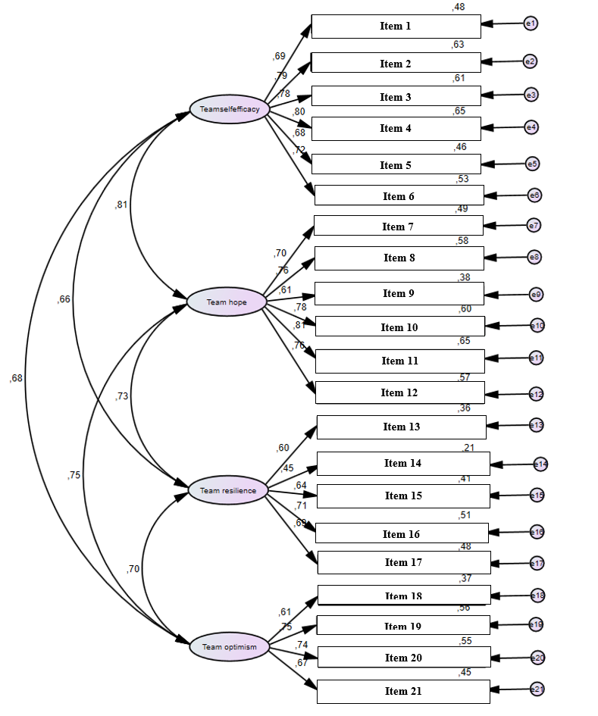
Note: standardized factor loadings and R squares of the observed variables.

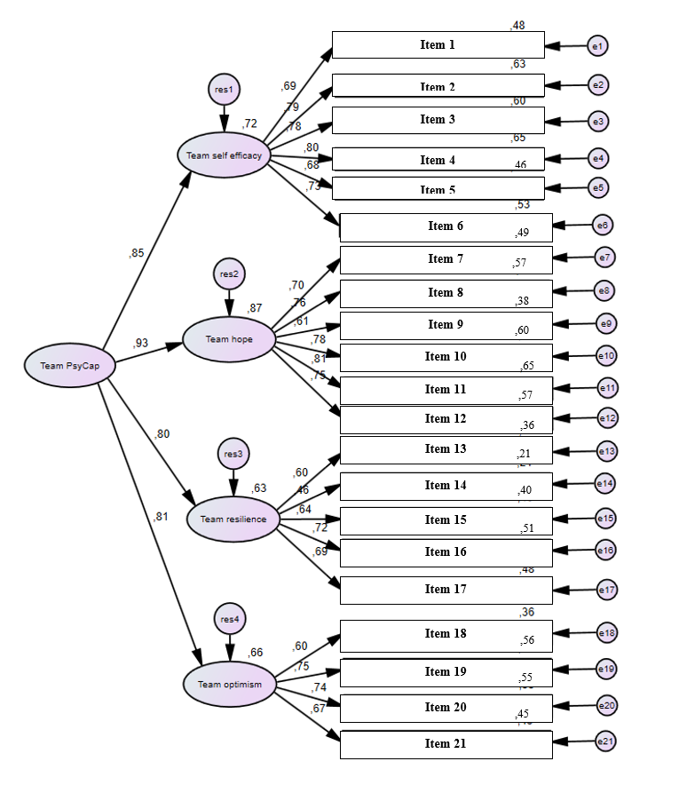
Figure 2. 21-item second-order model standardized solution.

Note: standardized factor loadings and R squares of the observed variables.

Figure 3. 12-item four-factor model standardized solution.
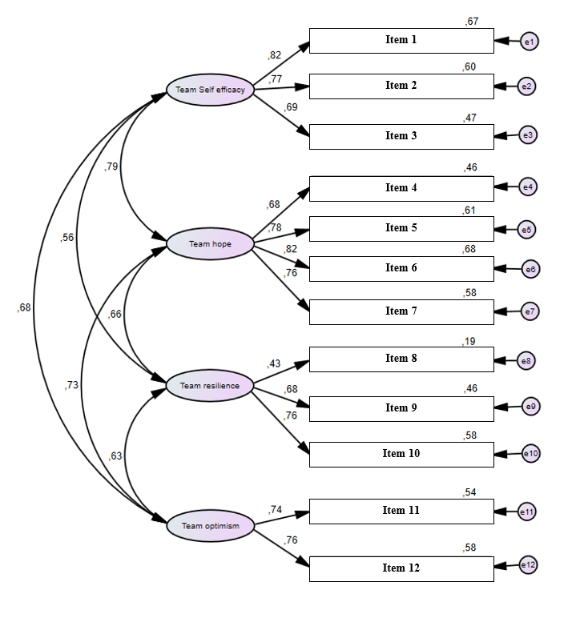 Note: standardized factor loadings and R squares of the observed variables.

Figure 4. 12-item second-order model standardized solution.
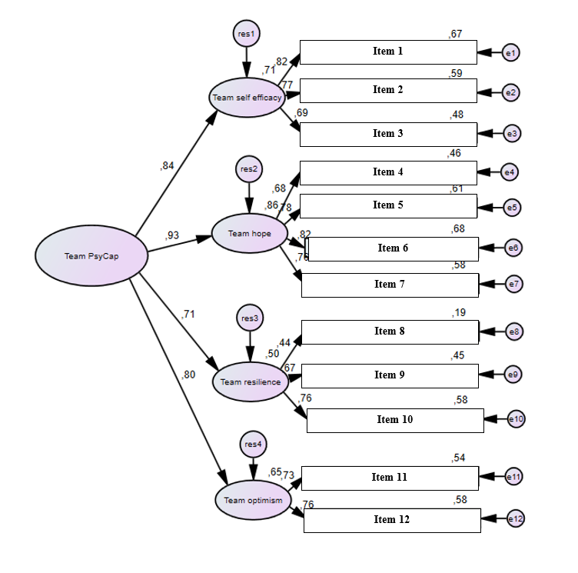 Note: standardized factor loadings and R squares of the observed variables.

