LONG-TERM CONSEQUENCES OF PARENTING BY ANOTHER CHILD IN A POPULATION WITH CHILD MALNUTRITION

Keywords: PARENTING - STRESS - SOCIAL BUFFERING - CHILD MALNUTRITION

Abstract
Malnutrition is a pervasive health concern around the world. Its impact is related to its severity, age at which it begins, and duration. As of now, the impact of the mother’s psychological variables on maltrunition have been hardly studied. In particular, research showing the impact of having a mother raised by a child instead of an adult is absent from the literature. The goal of this work was to assess the effect of being reared by a child on future assessement of quality of care and perceived stress in adulthood, in a population with child malnutrition. Given the absence of previous studies, the nature of the present work was exploratory. We found that mothers that were raised by a child reported higher levels of perceived stress at present and a lower quality of caregiving during infancy. Additionally, they feel incapable of coping with their problems and unable to control the events that affect them. These findings are discussed in the context of Attachment Theory and social buffering.

CONSECUENCIAS A LARGO PLAZO DE LA CRIANZA POR OTRO NIÑO EN POBLACIÓN CON DESNUTRICIÓN INFANTIL

Palabras clave: CRIANZA – ESTRÉS – APOYO SOCIAL – DESNUTRICIÓN INFANTIL

Resumen
La desnutrición infantil es un problema de salud generalizado en todo el mundo. Su impacto está relacionado con su gravedad, edad de inicio y duración. Hasta el momento, el impacto de las variables psicológicas de la madre en la malnutricióntruición ha sido poco estudiado. En particular, la investigación que muestra el impacto de tener una madre criada por un niño, en lugar de un adulto, está ausente de la literatura. El objetivo de este trabajo fue evaluar el efecto de ser criado por un niño sobre la evaluación futura de la calidad del cuidador y el autoreporte de estrés, en una población con desnutrición infantil. Dada la ausencia de estudios previos, la naturaleza del presente trabajo fue exploratoria. Encontramos que las madres que fueron criadas por un niño informaron niveles más altos de estrés percibido en el presente y una menor calidad de cuidado durante la infancia. Además, se sienten incapaces de hacer frente a sus problemas y de controlar los acontecimientos que les afectan. Estos hallazgos se discuten en el contexto de la Teoría del Apego y el apoyo social.

Introduction
According to data from UNICEF (WHO, 2021), at least one of every three children under five years of age in the world suffers from either malnutrition or overweightness, and one of every two suffers from hidden hunger, which affects their growth and development. Around 45% of infant deaths (below five years of age) are related to malnutrition, and occur mainly in countries of low or medium income. At the same time, in these countries, the rates of child overweight and obesity are rising. The COVID-19 pandemic has worsened this crisis, with dire consequences for the most vulnerable children.
The impact of malnutrition is related to its severity, the age at which it starts, and the duration of the period of deprivation. The earlier the signs of malnutrition manifest, the greater the consequences it will have in both growth and development. Among the different types of malnutrition proposed by the WHO (2021), the emaciation refers to that produced as a function of the child’s weight and size, and that can be classified as mild, moderate or severe. A low weight in relation to size in babies can be caused by limitations in the ingestion of the required nutrients for their adequate development, as well as infectious diseases such as diarrhea, which results in weight loss. Babies with signs of chronic emaciation are at risk of presenting arrested development, becoming a predictor of future poverty.
Among the variables that may result in child malnutrition, the mother’s psychological variables have been hardly taken into account. One prevailing characteristic among this population is that children tend to be raised not by an adult, but by other children. A large body of literature has focused on the neglect experienced by children, but little is known about the way it affects those children that are raised by another child. Studies evaluating the short and long term consequences (i.e., in the following generations) of being raised by another child cannot be found in the literature, even though there is evidence of the long term consequences of adverse early experiences. Data in preparation from our laboratory suggest that exposure to early traumatic experiences and having felt unprotected, depressed or anxious frequently increments the stress responses during adulthood.
Stress is a widely studied construct in the scientific literature, given its relevance in psychological, inmunological, neurological, endocrinological, and social aspects, among others (Lazarus & Folkman, 1984). It is defined as any real or perceived threat to the physical or psychological integrity of the individual, resulting in psychological and/or behavioral responses (Hostinar et al., 2014). Early life stress impacts greatly, especially when it happens within the family context. Parents act as a source of safety for their children, partly through social buffering (Sullivan, 2003). Nonetheless, the capacity of children to use the mother as a buffer is dependent on the quality of care. This can also have an effect on early life programming, defined as the process that causes adversity experienced early in life to have an effect in the future. The link between a low quality of care and future outcomes appears to be an impaired regulation of stress responses in infants (Packard et. al., 2021).
Even though there is no record about the consequences of being raised by another child, there is evidence of the risk posed by being raised by an adolescent mother, especifically, risk of poor attachment outcomes associated with detrimental effects in cognitive, adaptive, and behavioral areas (Belsky & Fearon, 2002; Kumar, & Huang, 2021). The theory of attachment has been developed by a myriad of authors, most notable John Bowlby and Mary Ainsworth, followed by Mary Main (Ainsworth, 1982; Bowlby, 1969/1982; Main, Kaplan, & Cassidy, 1985). The description Bowlby provided for attachment was that of an inherent biological responses and behavioral system that serves the purpose of providing satisfaction of certain basic needs. Main et al. (1985) studied adult attachment representations, that is, how adults remember what they experience early in life, and found that these representations exert an influence in the attachment categorization of their own children. When a mother is reflective, responsive and sensitive towards her children, secure attachment follows, which leads to the development of trust, confidence and resilience during those children’s later life.
A variable that has been systematically studied for its effects attenuating the negative consequences of stress is social buffering. A vast body of evidence shows that the hypothalamic-pituitary-adrenal axis can be regulated by the presence of conspecifics (Gunnar & Hostinar, 2015). This effect has been observed in several different species, such as humans and rats, and under different situations, including everyday stress and maternal separation. The characteristics of the stimulus that acts as a buffer differ among the different stages of development (Stanton and Levine, 1990). Stimuli coming from the mother seem to be effective in reducing stress during the early ontogeny. The evidence shows that the social buffering mechanisms are associated to the presence of the maternal odor (Packard et. al., 2021). Furthermore, support from the family and partner are tightly related with the mothers’ emotional state, as well as the nutritional state of the infants. Paredes et al. (2017), after carrying out a case and control study in a high-complexity hospital in Colombia, managed to determine that inadequate social support during the gestational period, along with socioeconomic and educational level of the mother are predictors of low weight of newborn infants.
New evidence also indicated that parents that exhibit unhealthy attachment towards their children are not effective buffers. Social buffering becomes compromised when the caregiver is under stress as a consequence of resource scarcity. This was studied with a model of resource scarcity in rats, that models abusive caregiving produced by maternal stress by providing insufficient bedding material to the mothers to construct their nests. It was discovered that the interactions with and caregiving of the offspring are highly affected. This manipulation results in alterations of maternal behaviors, including rough handling of the pups and reduced nurturing behaviors (Raineki et al., 2012). Unpublished data from our laboratory showed that caregiving under these condition compromises the infants’ growth, and such growth retardation was observed until adulthood (i.e., lower weight, body length and skull width).
The objective of this research was to assess the effects of being reared by another child on caregiver quality and stress responses in adulthood, in mother of a population with child malnutrition. This was an exploratory study, since there were no local data available and no previous evidence was found in the literature about this topic. The hypothesis was that parenting by another child, rather than an adult, would decrease the quality of care and increase perceived stress responses during adulthood in the mothers.

Method
Sample
The sample consisted of 111 mother-child dyads assisting the Argentinean centers Haciendo Camino from Chaco and Santiago del Estero (n=58), Ayres de Esperanza (n=18) and Llegando a vos (n=35) from Buenos Aires, that assist families whose children are exposed to resource scarcity conditions and diagnosed with malnutrition. It was required that every child was six years old or less for their mother to participate in the survey. The mothers’ age ranged from 16 to 46 years old, with most of them found in the 20-34 range. To be admitted to the centers, the dyads go through a lengthy evaluation of different variables, including occupation and educational level of the parents, sanitary conditions of the house, income level, growth and developmental measures, and current health conditions.

Data Collection
A semi-directed interview developed by the research group was used to collect the data. Some of the questions were extracted from the following instruments:
- Generalized Anxiety Disorder Screener (GAD-7; Soto-Balbuena et al., 2021)
- Validación argentina del Cuestionario MOS de Apoyo Social Percibido (Rodríguez Espínola, & Enrique, 2007)
- Parental Bonding Instrument (PBI; Espinoza Marca, 2016)
- Perceived Stress Scale (PSS, Remor, 2006)
These questions were reformulated to make the language appropriate to the target population. The remaining questions were formulated by the researchers in order to evaluate maternal stress and social buffering.
Procedure
The interviews took place through the Google Meet platform during the days when the participants attended the corresponding center. They lasted approximately 15 minutes, and were completed in a single session. The questions asked can be found in Appendix 1. Before beginning, they were requested to sign an informed consent explaining the details of the research, the conditions of their participation, and how the obtained data would be handled. Due to the lack of local data regarding the variables under study, the nature of the research was exploratory. The Universal Declaration of Ethical Principles for Psychologists (IAAP & IUPsyS, 2008), the International Ethical Guidelines for Biomedical Research on Human Subjects (CIOMS, WHO & PAHO, 2016) and the PSI declarations regarding ethical behavior in psychology have been followed at the time of presentation (ISP, 1978, 2008a, 2008b, 2014, 2016, 2018, 2019). The protocol was approved by the Ethics Committee of the Universidad Abierta Interamericana (approval number: 0-1071). There is no conflict of interest in this publication.

Data Analysis
Pearson’s Chi-Square tests, and Pearson’s linear correlation coefficients were calculated.

Caregiver index
We constructed an index to measure the perceived quality of the main caregiver. To this end, we used the following questions:
- Was he/she affectionate towards you?
- Did he/she help you with everything you needed?
- Did he/she allow you to do what you enjoyed?
- Was he/she cold or distant towards you?
- Did you feel loved by him/her?
- Did he/she talk to you?
Affirmative responses to all but the fourth question, which was counted in the opposite way, added a point to the index, which thus ranged from zero to six. A higher index corresponds to a better quality perceived.

Perceived stress index
Additionally, we developed an index of stress perceived at present using the following questions:
- Do you sometimes feel that it is hard for you to relax?
- Do you usually feel that you can handle the things that are important to you? Or do you frequently feel that what happens to you escapes your control?
- Do you feel that your problems come all at once and you cannot solve them?
Affirmative responses to the first and third questions added one point to the index, and so did a response to the second one indicating that they cannot control what happens to them. Additionally, we categorized each mother as stressed or not stress based on the open question “in general, how do you feel nowadays? Do you feel good in general? Or are you stressed about something? For example, something related to your family, or money”. Being categorized as stressed added one further point to the index. Thus, higher indexes correspond to greater perceived stress levels.

Results
Fig.1 shows the proportion of mothers that were raised by an adult or a child caregiver. It can be seen that 27.78% of the mothers had a child caregiver when they were children, while the rest were raised by an adult.

Figure 1.
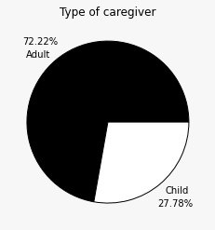
Figure 1. Percentage of mothers raised by an adult or another child during their childhood.

A Chi-Square test revealed an apparent dependency between the type of caregiver and the stress perceived at present time ($χ^{2}(4, N=108)=11.07, p=.026, V=.316$), with higher stress indexes found among those raised by a child (see Fig. 2).

Figure 2.

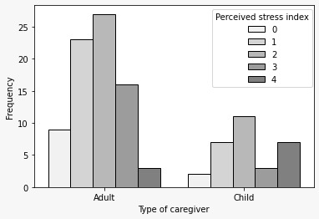
Figure 2. Frequencies in the Index of Perceived Stress of mothers who have been raised by an adult or another child.

Another dependency is apparent between the caregiver index and type ($χ^{2}(6, N=108)=15.06, p=.02, V=.368$): higher indexes are more likely to be found if the caregiver was an adult, which suggests that mothers who have been raised in their childhood by an adult, report that they have had a higher quality of care (see Fig. 3).

Figure 3.

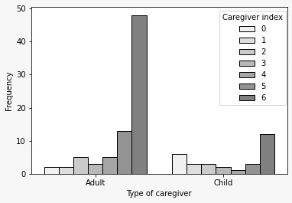
Figure 3. Frequencies in the Caregiver Index of mothers who have been raised by an adult or another child.

Some apparent dependencies were also found between the type of caregiver and questions related to current stress (Do you usually feel that you can handle the things that are important to you? Or do you frequently feel that what happens to you escapes your control?, $χ^{2}(1, N=108)=5.48, p=.019, V=.222$; see Fig. 4) and perceived quality of the caregiver (Was he/she affectionate towards you?, $χ^{2}(1, N=108)=4.49, p=.034, V=.201$; see Fig. 5).

Figure 4.

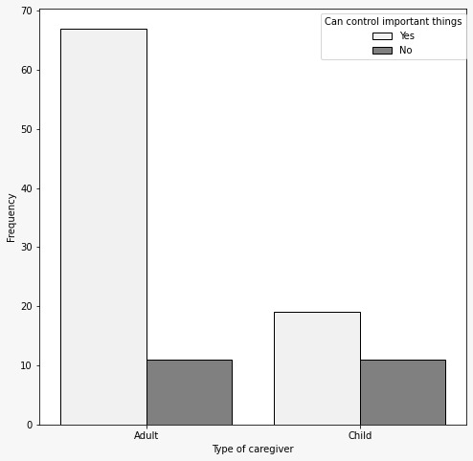
Figure 4. Frequencies in current stress related to the type of caregiver (Do you frequently feel that what happens to you escapes your control?).

Figure 5.

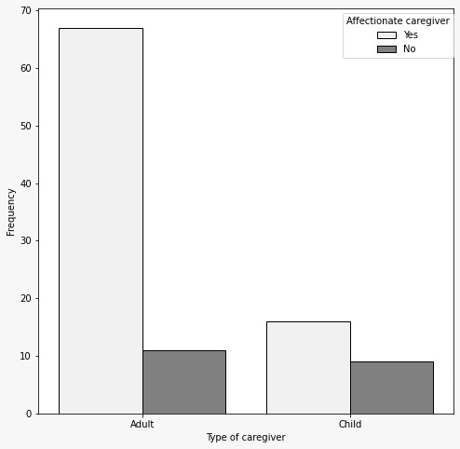
Figure 5. Frequencies in perceived quality of care provided by the caregiver during the mother's childhood, related to the type of caregiver (Was he/she affectionate towards you?).

A marginally significant dependency was also found between the type of caregiver and the question “When you were little, did you have enough money to buy food and clothes?” ($χ^{2}(1, N=108)=3.74, p=.053, V=.184$; see Fig. 6).

Figure 6.

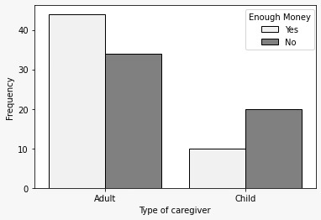
Figure 6. Frequencies in responses “yes” or “no” based on the question “When you were little, did you have enough money to buy food and clothes?”, depending on the type of caregiver.

A negative correlation was found between the perceived stress and caregiver indexes ($r(111)=-.23, p=.015$), implying that better quality of care is associated with lower stress perceived at present time. This result can be observed in Fig. 7.

Figure 7.

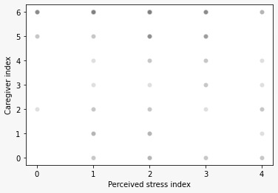

Figure 7. Negative correlation between the perceived stress and caregiver indexes. Better quality of care is associated with lower stress perceived at present time.

Discussion
Mothers raised by another child, instead of an adult, during their childhood reported higher levels of perceived stress at present and a lower quality of caregiving during infancy. Furthermore, they expressed a lower capacity for problem solving and feeling that they are unable to control the events that affect them. These results are novel and constitute a valuable contribution to the field of developmental psychology in a context of child malnutrition, which has been barely explored so far.
Children raised by another child are exposed, on the one hand, to maternal isolation, and on the other, to a poor quality of care, as described by the mothers in the present study. Exposure to each of these conditions would seem to be associated with long-term consequences. Myron Hofer, among others, showed during the 1980s that parents have a pivotal role in the regulation of their children’s physiology and behavior. Separation from the mother resulted in dysregulations of many physiological functions and behaviors in children (Hofer, 1981; 1994). Already during the 1960s, Bowlby’s Attachment Theory drew attention to the role of parents in reducing fear in their children. Especifically, less fear is exhibited when children are exposed to novel or threatening situations if one of the parents is present (Bowlby,1969). However, a poor quality of care results in increased hormone levels related to stress, and attenuates the ability of the attachment figure to decrease their stress responses (Packard et al., 2021). This elevation in stress levels can disrupt brain development, which can be prevented by social buffering. When social buffering is hindered, however, the opposite is observed: stress-hormones levels are further increased when the caregiver is present.
Studies using animal models reveal that, among other effects, a compromised attachment impedes the pups from using the caregiver as a safety signal. Indeed, higher cortisol levels are found in toddlers exposed to a novel situation if their attachment with their mother is insecure (Nachmias et al., 1996). Furthermore, maternal quality can predict whether stress responses will be inhibited by infants (Albers et al., 2008). We therefore see the lasting consequences of being raised by a child instead of an adult: as seen in this study, this type of caregiver is related to higher stress levels in adulthood, which in turn potentially hinders the capacity of the mother to buffer their own children’s stress. This potentially increases stress levels in those children, thus potentially prolonging the cycle to the next generation.
Even though the results are sound and valuable, we should take into account the exploratory nature of the study. Being an unexplored area, and with the intention of not overwhelming the mothers with prolonged evaluations, we decided to analyze many variables with an instrument developed by the research team. Given the results found here, we will employ reliable and valid instruments to assess each construct in the future.
This study constitutes a starting point to assess to what extent the events that occur in childhood can disturb the breeding and development of subsequent generations, in a population with child malnutrition.

References

Ainsworth, M. D. S. (1982). 14. The Development of Infant-Mother Attachment. In Thebeginning (pp. 133-143). Columbia University Press.
Albers, E. M., Marianne Riksen‐Walraven, J., Sweep, F. C., & Weerth, C. D. (2008). Maternal behavior predicts infant cortisol recovery from a mild everyday stressor. Journal of Child Psychology and Psychiatry, 49(1), 97-103.
Belsky, J., & Fearon, R. P. (2002). Early attachment security, subsequent maternal sensitivity, and later child development: does continuity in development depend upon continuity of caregiving? Attachment & human development, 4(3), 361-387.
Bowlby, J. (1969). Attachment and loss: volume I: attachment. In Attachment and Loss: Volume I: Attachment (pp. 1-401). London: The Hogarth Press and the Institute of Psycho-Analysis.
Bowlby, J. (1982). Attachment and loss: retrospect and prospect. American journal of Orthopsychiatry, 52(4), 664.
Espinoza Marca, L. D. (2016). Propiedades Psicométricas del Instrumento Lazos Parentales en internos de Comunidades Terapéuticas de Trujillo.
Gunnar, M. R., & Hostinar, C. E. (2015). The social buffering of the hypothalamic–pituitary–adrenocortical axis in humans: Developmental and experiential determinants. Social neuroscience, 10(5), 479-488.
Hofer, M. A. (1981). Parental contributions to the development of their offspring. In Parental care in mammals (pp. 77-115). Springer, Boston, MA.
Hofer, M. A. (1994). Early relationships as regulators of infant physiology and behavior. Acta paediatrica, 83, 9-18.
Hostinar, C. E., Sullivan, R. M., & Gunnar, M. R. (2014). Psychobiological mechanisms underlying the social buffering of the hypothalamic–pituitary–adrenocortical axis: A review of animal models and human studies across development. Psychological bulletin, 140(1), 256-282.
International Ethical Guidelines for Health-related Research Involving Humans, Fourth Edition. Geneva. Council for International Organizations of Medical Sciences (CIOMS); 2016.
Kamenetzky, G. V., Suárez, A. B., Pautassi, R. M., Mustaca, A. E., & Nizhnikov, M. E. (2015). Change in the hedonic value of an aversive stimulus in the presence of a pre-exposed odor. Physiology & Behavior, 148, 51-57.
Kumar, M., & Huang, K. Y. (2021). Impact of being an adolescent mother on subsequent maternal health, parenting, and child development in Kenyan low-income and high adversity informal settlement context. PloS one, 16(4), e0248836.
Lazarus, R. S. & Folkman, S. (1984). El concepto de afrontamiento en estrés y procesos cognitivos. Barcelona: Martínez Roca.
López, A. (2020). La influencia de la cualidad del apego sobre las representaciones prenatales maternas en el embarazo.Tesis de Maestría. Universidad Autónoma de Nuevo León. México.
Main, M., Kaplan, N., & Cassidy, J. (1985). Security in infancy, childhood, and adulthood: A move to the level of representation. Monographs of the society for research in child development, 66-104.
Nachmias, M., Gunnar, M., Mangelsdorf, S., Parritz, R. H., & Buss, K. (1996). Behavioral inhibition and stress reactivity: The moderating role of attachment security. Child development, 67(2), 508-522.
Paredes, C., Dorado, H., Martínez, S., Ortíz, R., Arias, S. y López, A. (2017). Relación entre la ausencia de soporte social adecuado durante el embarazo y el bajo peso al nacer. Revista Colombiana de Psiquiatría, 259, 9.
Packard, K., Opendak, M., Soper, C. D., Sardar, H. and Sullivan R. M. (2021). Infant attachment and social modification of stress neurobiology. Front. Syst. Neurosci. 15: 718198.
PSI declarations regarding ethical behavior in psychology retrieved from https://www.psychologicalsociety.ie/source/Code%20of%20Professional%20Ethics%20(Oct%202019).pdf
Raineki, C., Cortés, M. R., Belnoue, L., & Sullivan, R. M. (2012). Effects of early-life abuse differ across development: infant social behavior deficits are followed by adolescent depressive-like behaviors mediated by the amygdala. Journal of Neuroscience, 32(22), 7758-7765.
Remor, E. (2006). Psychometric properties of a European Spanish version of the Perceived Stress Scale (PSS). The Spanish journal of psychology, 9(1), 86-93.
Rodríguez Espínola, S., & Enrique, H. C. (2007). Validación Argentina del Cuestionario MOS de Apoyo Social Percibido. Psicodebate, 7, 155-168.
Soto Balbuena, M. C., Rodríguez Muñoz, M. D. L. F., & Le, H. N. (2021). Validation of the generalized anxiety disorder screener (gad-7) in Spanish pregnant women. Psicothema.
Stanton, M. E., & Levine, S. (1990). Inhibition of infant glucocorticoid stress response: specific role of maternal cues. Developmental Psychobiology: The Journal of the International Society for Developmental Psychobiology, 23(5), 411-426.
Sullivan, R. M. (2003). Developing a sense of safety. Annals of the New York Academy of Sciences, 1008(1), 122-131.
Universal Declaration of Ethical Principles for Psychologists. (2008). Retrieved from http://www.iupsys.org/ethics/univdecl2008.html
World Health Organization. (2021). Levels and trends in child malnutrition: UNICEF.

