A Bibliometric Analysis of Mindfulness in Higher Education: From the Past to the Future

Abstract
Mindfulness is a technique that entails paying deliberate attention, without judgment, to the present moment. The purpose of this study was to compile a list of all scholarly publications on mindfulness in higher education that was available in the Scopus database. This observational, descriptive, and retrospective bibliometric analysis of Mindfulness literature from 1916 to 2012 was designed without regard for language limitations. Specific parameters were used to examine the downloaded findings. The obtained data were analyzed in Excel. The network map distribution of scholarly citations by nation, bibliographic coupling by source, co-citations of cited authors, and co-citations of cited references were shown in VOSviewer. The production in mindfulness statistics spans 4,399 papers, including 134 publications from the first period (1916–2004) that mainly represented a theoretical or spiritual perspective in their definition of mindfulness. It rose significantly throughout the last period (2017-2022), with 2,176 practical studies covering psychological, sociological, and technical levels of higher education. The United States has the most publications. This is the first international bibliometric research of mindfulness in higher education, extending to 1916.
Keywords: mindfulness; higher education; bibliometric analysis; Scopus.

Introduction
Mindfulness is gaining traction in clinical practice and the psychology literature, with Kabat-Zinn (2003), a pioneer in its application, defining it as the awareness that arises from paying attention on purpose, in the present moment, and without passing judgment on the development of experience moment by moment. Mindfulness is a mid-level concept that refers to a deliberate state of mind and serves as a bridge between motivation, cognition, and learning, that enhances awareness of "now" and is defined by a focus on "being" and "living" rather than "doing" or "knowing."
University students seek mental health help due to their adjustment to higher education (Briggs et al., 2012; Macaskill, 2013; Regehr et al., 2013), which includes increased academic expectations, and new social pressures, and foreign locations. The current study includes data derived from a bibliometric examination of the scientific literature on mindfulness in higher education published in all years since 1916 and indexed in Scopus, using a variety of bibliometric methodologies. This study aims to provide a profile of the scientific production indexed in Scopus in terms of productivity over time, distribution by nations, languages, authors, and journals. Similarly, the article's subject matter and citations have been evaluated.
The following research questions occur due to the purpose: What scientific output has been generated on this subject? Which nations produce the most? What was the most widely published language? Which authors contribute the most? What further publications have you made about mindfulness? Which papers receive the most citations?
The paper is structured as follows. The paper begins with an introduction to mindfulness, then develops the state of the art of mindfulness using the publications discovered, and then presents the bibliometric analysis approach. Fourthly, the results of the bibliometric analysis are provided, followed by the findings. Finally, the piece concludes.
The Present State of Mindfulness
Mindfulness is a notion that originated as part of a more comprehensive Buddhist intellectual and spiritual belief system. During the second part of the twentieth century, the critical principles inspired by and derived from this Buddhist philosophy were adopted into psychology (Baer et al., 2006).
Mindfulness-based therapies have been widely integrated into higher-level educational practice (De Bruin et al., 2015). They have been demonstrated to be beneficial in treating a variety of student and educator difficulties (Ergas & Hadar, 2021). This simplicity of implementation and efficacy in solving educational concerns has resulted in the field's rapid expansion (Creswell, 2017; Van Dam et al., 2018).
The following components of higher education were identified in the papers analyzed: i) Students: Academic work and intellectual development require the ability to use and regulate emotions (Enríquez et al., 2017; Gordillo & Herrera, 2015; Reilly, 2021) in order to facilitate thought (Arslan & Asici, 2021; Kiener et al., 2014), increase concentration (Dunn et al., 1999; Kurebayashi, 2021), develop creativity (Capurso et al., 2014; Egri, 2012), and intrinsic motivation (Smyth & Milyavskaya, 2021), they alleviate tension, anxiety, and weariness. ii). Educators: The challenge for educators is to reacquaint themselves with their pupils and reclaim their joy in teaching. More educators are getting mindfulness training, which includes the practice of awareness, acceptance, and inquiry by mindful teachers. They are aware of their pupils' needs, engage those who are "ready", encourage disengaged, and advocate for those who require assistance (Delgado et al., 2010; Woods, 2009). iii) Information technologies are constantly evolving and impacting the teaching and learning process; digital tools have been diversified to support the required areas, such as Virtual environments in which teachers interact with their students, breaking down spatial barriers. Additionally, there are applications to improve concentration, motivation, self-control, compassion, and activity organization and reduce perceived stress, anxiety, depressive symptoms, and social anxiety.

Methodology
Bibliometrics is a field of study centered on searching for statistically regular patterns in the creation and consumption of scientific literature (Ardanuy, 2012). Focuses on scientific output by nation, language, multiple citations, author affiliations, journal impact factor, research fields, and keywords. The findings of the Bibliometric research may be examined in a variety of formats, including maps, tables, graphs, figures, charts, and distribution networks, which provide a meaningful representation of massive data sets.
In this investigation, the open-source program VOSviewer (Van Eck & Waltman, 2010; Van Nunen et al., 2018) was employed to evaluate and visualize the geographical distribution, authorship, number of citations, and keywords (Author keywords and KeyWords Plus). About mindfulness, the references cited in the articles highlight a journal impact factor (JIF) by Scimago Journal Rank (SJR), which is an analytical tool included in Scopus (Mao et al., 2018). Together with publishers, they are assigned an H index, which indicates a period during which at least h articles from an author, nation, journal, or institution, among others, were mentioned at least h times (Mao et al., 2018; Yin et al., 2018).
In this study, the journal impact factor is derived using the SJR’s most recent review of 2021, which is used to evaluate the effect of mindfulness-related publications. The 5-year Impact Factor of the Journal Citation Reports uses the same algorithm as the impact factor (IF). Still, it extends the citation window to 5 years to protect those fields where the interval between publication and citation is longer. Excel was used to create the publication's summary tables by year, nation, language, and other categories. The Scopus database is the source of the extracted data utilized here.
Figure 1 depicts the whole research flowchart for this study. The phrase "mindfulness" was chosen as the core subject, and the timeframe between 1916 and January 2022 was selected. Four thousand three hundred ninety-nine mindfulness-related papers were discovered and assessed for this bibliometric study.
Figure 1
Flowchart of the bibliometric analysis on Mindfulness

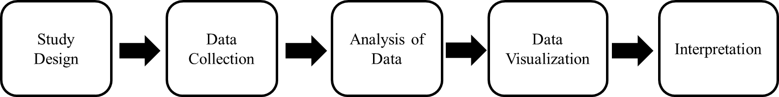
Mindfulness dates back to 1916, when Kuhlmann first referenced it in his work “Mentality Tests: A Symposium”, in which he discusses the dispute around mentality tests. Mindfulness was studied in several disciplines, and incremental progress was made between those studies and the January 2022 publication of “Mindfulness and life satisfaction: The moderating effect of self-control and the moderated moderating effect of resilience” by Liang et al.

Results
Compilation of documents
Regarding data collection, an advanced search of manuscripts was conducted using Elsevier's Scopus database, primarily because of the enormous quantity of academic papers included in its records, which were chosen due to the journals' high-quality standards indexed in said database.
Since our bibliometric study spans from 1916 to 2022, or 106 years of scientific output, we have identified four periods. The first spans 1916 to 2004, the positive turning point in scientific production, while 6-year intervals separate the subsequent three periods. Since the third period, the output of scientific papers has also grown dramatically, as seen in table 1 and figure 2.
Table 1: Number of Documents on mindfulness per period
Period | Record | %
I Period (1916 - 2004) | 143 | 3.25%
II Period (2005- 2010) | 477 | 10.84%
III Period (2011 - 2016) | 1,6039 | 36.44%
IV Period (2017 - 2022) | 2,176 | 49.46%
Total | 4,399 | 100.00%

Figure 2: Evolution of scientific production on mindfulness registered in Scopus
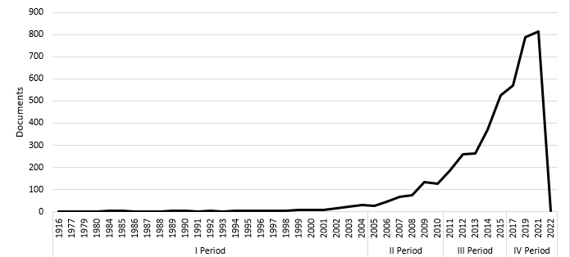
After choosing 4,399 documents, they were categorized by document type, as shown in Table 2. The publications included ten distinct document formats. 73.13 percent of all publications were journaled articles (3,217), followed by book chapter (348; 7.91%) and review (337; 7.66%).
Table 2: Types of Mindfulness Documents
Type of document | Record | %
Article | 3,217 | 73.13%
Book chapter | 348 | 7.91%
Review | 337 | 7.66%
Conference document | 242 | 5.50%
Book | 80 | 1.82%
Note | 80 | 1.82%
Editorial | 43 | 0.98%
Letter | 26 | 0.59%
Conference review | 17 | 0.39%
Brief survey | 8 | 0.18%
Data document | 1 | 0.02%
Total | 4,399

Geographic Distribution Analysis
The publications on mindfulness were assessed based on the researchers' country of origin to establish their distribution by nation. In 36 nations, educational materials on mindfulness in higher education were discovered. 60 percent of the 4,399 mindfulness-related materials were from the United States (43.32%; n=1,882), the United Kingdom (11.63%; n=505), and Australia (5.89%; n=256). Table 3 includes the ten most productive nations based on the total number of papers produced.

Table 3: Top 10 Countries with the highest production on mindfulness
 | Country of Affiliation | Record | %
1 | USA | 1,882 | 43.32%
2 | United Kingdom | 505 | 11.63%
3 | Australia | 256 | 5.89%
4 | Canadá | 237 | 5.46%
5 | Germany | 171 | 3.94%
6 | Spain | 104 | 2.39%
7 | Netherlands | 99 | 2.28%
8 | China | 96 | 2.21%
9 | India | 95 | 2.19%
10 | Italy | 94 | 2.16%
On the other hand, Figure 3 reveals connections between the nations that have generated the most Mindfulness-related texts. Compared to nations such as the Netherlands, Finland, Norway, or New Zealand, Chile is the only country in South America that produces publications that maintains significant links with countries that produce many publications. Nevertheless, 55 entries (1.32%) lack data in the field being examined.
Figure 3: VOSviewer network map of Citation / Country based on document number
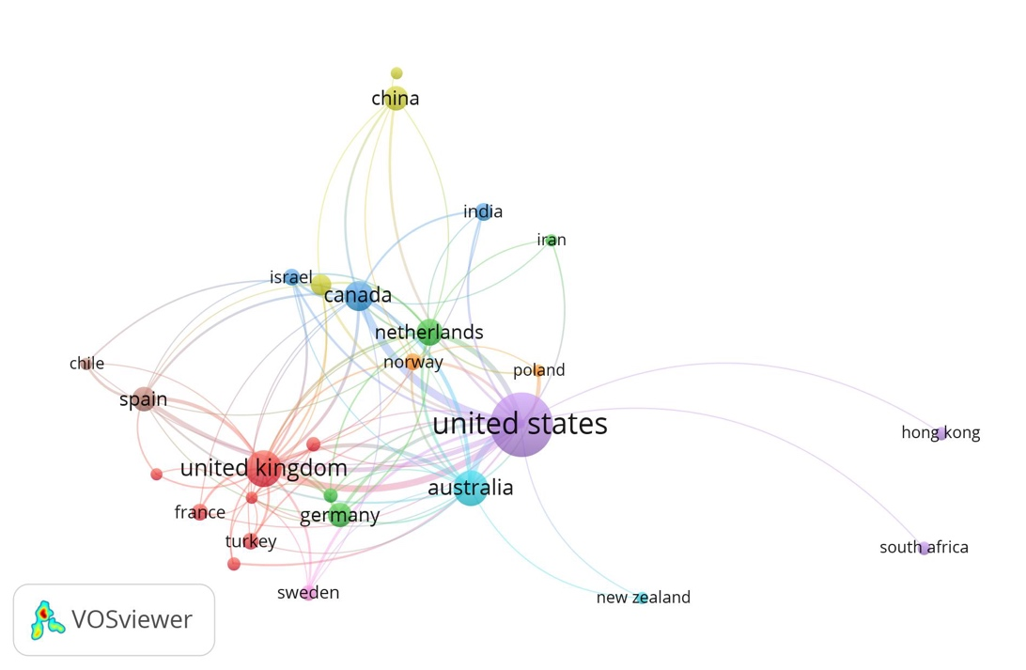
According to Table 4, the majority of mindfulness-related documents have been published in English (697; n=4,264), followed by Spanish (38; n=38), and German (26; n=26).
Table 4: Production of documents on mindfulness by language
Language | Record | %
English | 4,264 | 96.93%
Spanish | 38 | 0.86%
German | 26 | 0.59%
Italian | 19 | 0.43%
Portuguese | 11 | 0.25%
French | 10 | 0.23%
Dutch | 5 | 0.11%
Japanese | 5 | 0.11%
Hungarian | 3 | 0.07%
Russian | 3 | 0.07%
Czech | 2 | 0.05%
Chinese | 2 | 0.05%
Polish | 2 | 0.05%
Turkish | 2 | 0.05%
Other languages | 7 | 0.15%
Total | 4,399 | 100%

Scientific Journal Analysis
Since 1916, there have been 4,399 studies on mindfulness published in journals. Table 5 summarizes the top ten journals that publish materials about mindfulness in order of journal impact factor. However, Mindfulness (10.53%) and Frontiers in Psychology (2.36%) are the most active journals in terms of the number of articles published. Publications about mindfulness come from many different fields, such as education, psychology, business, health, and technology.
Table 5: Top 10 Journal that have the most impact on mindfulness research
 | Journal | Record | % | Quartil | SJR 2021
1 | Current Opinion in Psychology | 43 | 0.98% | Q1 | 2.09
2 | Emotion | 27 | 0.61% | Q1 | 1.83
3 | Mindfulness | 463 | 10.53% | Q1 | 1.25
4 | Personality and Individual Differences | 85 | 1.93% | Q1 | 1.18
5 | Journal of Clinical Psychology | 51 | 1.16% | Q1 | 1.16
6 | Consciousness and Cognition | 46 | 1.05% | Q1 | 0.95
7 | Frontiers in Psychology | 104 | 2.36% | Q1 | 0.87
8 | PLoS ONE | 50 | 1.14% | Q1 | 0.85
9 | Cognitive and Behavioral Practice | 27 | 0.61% | Q2 | 0.75
10 | Current Psychology | 49 | 1.11% | Q2 | 0.51

In terms of the Scimago Journal Rank (SJR) impact factor, Current Opinion in Psychology (2.09), has the highest journal impact factor (JIF), being one of the most important journals in the thematic area, followed by Emotion (1.83) and Mindfulness (1.25).
In order to establish the core of journals with the highest representativeness in mindfulness, Bradford's Law was applied. Of the total number of articles equal to 3,217 published in a total of 1,113 journals, 55 journals were identified as the most productive, considering eight or more articles published in the period 1916-2022. As shown in Figure 4, these journals account for 1,135 articles (41.50%) of the total number of articles published: Mindfulness with 463 published articles (10.63%), Frontiers in Psichology with 104 articles (2.36%); Personality and Individual Differences (85 articles, 1.93%) and PLoS ONE (50 articles, (1.14%).
Figure 4: Representation of Bradford´s Law of Distribution
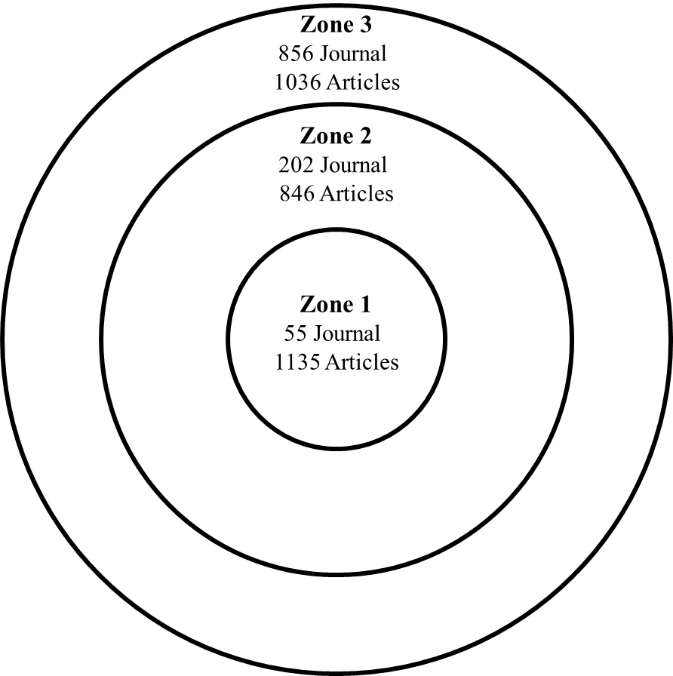
Figure 5 shows that when the relationship between the data sources and the bibliographic coupling is taken into account, Teaching in Higher Education is the journal that has the most connections to other journals, followed by the Journal of English for Academic Purposes. All of the journals have the same number of links to each other. They were put into four groups (green, blue, yellow and red).
Figura 5: VOSviewer Network Map of coupling / bibliographic source based on number of documents
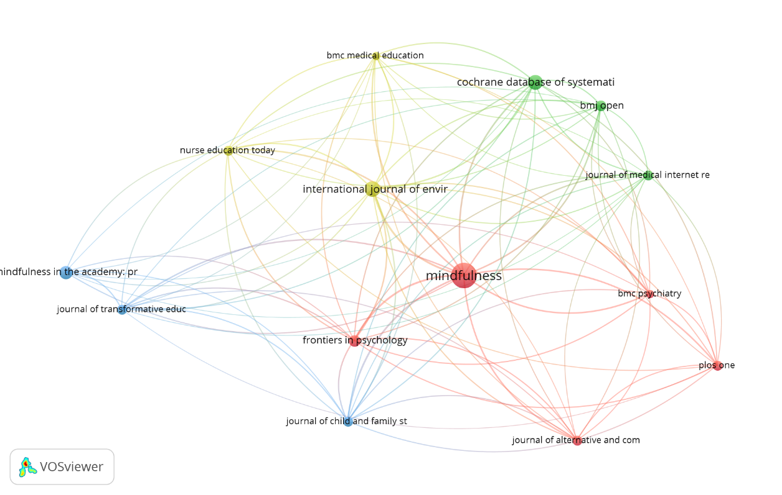
Mindfulness was mainly about the theory behind mindfulness, psychology, and education, which made up 79.6% of the course. Table 6 shows how the percentage of a theme was calculated based on the 4,399 publications in that theme. This helped us see how big the theme was. It's important to point out that areas like Business, Technology, and others are publishing more, which shows that researchers in many different fields are using mindfulness.
Table 6: Thematic areas of research on mindfulness
Thematic area | Record | %
Theoretical Basis of Mindfulness | 1,653 | 37.6%
Psychology | 1,149 | 26.1%
Higher education | 699 | 15.9%
Business | 271 | 6.2%
Information Technology | 257 | 5.8%
Questionnaire Validation | 215 | 4.9%
Literature review | 155 | 3.5%
Total | 4,399

Authors and Co-authors Analysis
As the review of the 4,399 papers goes on, the average number of citations and the H-index is used to figure out which authors are the most influential in mindfulness. Since 1916, 2,838 scholars have done research on mindfulness. Table 7 shows how many papers each scholar has written about mindfulness. This table also shows how often the author was the first person to write something. If the rank of two or three authors was the same, the number of publications where their names came first was compared.

Table 7: Top 10 authors who produce the most about Mindfulness until January 31, 2022 in Scopus
Rank | Autor | Record | Affiliation | H Index | Total  Cites
1 | Anâlayo, Bhikkhu | 23 | Barre Center for Buddhist Studies | 9 | 265
2 | Hyland, Terry | 12 | University of Bolton | 19 | 961
3 | Ergas, Oren | 9 | Beit Berl Academic College | 8 | 210
4 | Charoensukmongkol, Peerayuth | 7 | Thailand National Institute of Development Administration | 19 | 906
5 | Kabat-Zinn, Jon | 6 | University of Massachusetts Medical School | 21 | 14,175
6 | Hanley, Adam W | 6 | The University of Utah | 20 | 908
7 | Akin, Ata | 5 | Acibadem Mehmet Ali Aydinlar Universitesi | 15 | 592
8 | Burrows, Leigh | 5 | Flinders University | 4 | 44
9 | Dane, Erick | 5 | Washington University in St. Louis | 16 | 2,394
10 | Langer, Ellen J. | 5 | Harvard University | 41 | 9,924

There is a list of the top ten authors who have written the most papers on mindfulness. Anâlayo, Bhikkhu from the Barre Center for Buddhist Studies in the United States, and Hyland, Terry from the University of Bolton in the United Kingdom are the authors who have written the most about mindfulness, with 23 and 12 documents, respectively. Figure 6 shows that Kabat-Zinn, J. had the most substantial link strength in Co-citations/Citations based on the weight of the citations.
Figure 6: VOSviewer Network Map of Co-citation / Cited Author Based on Number of Citations
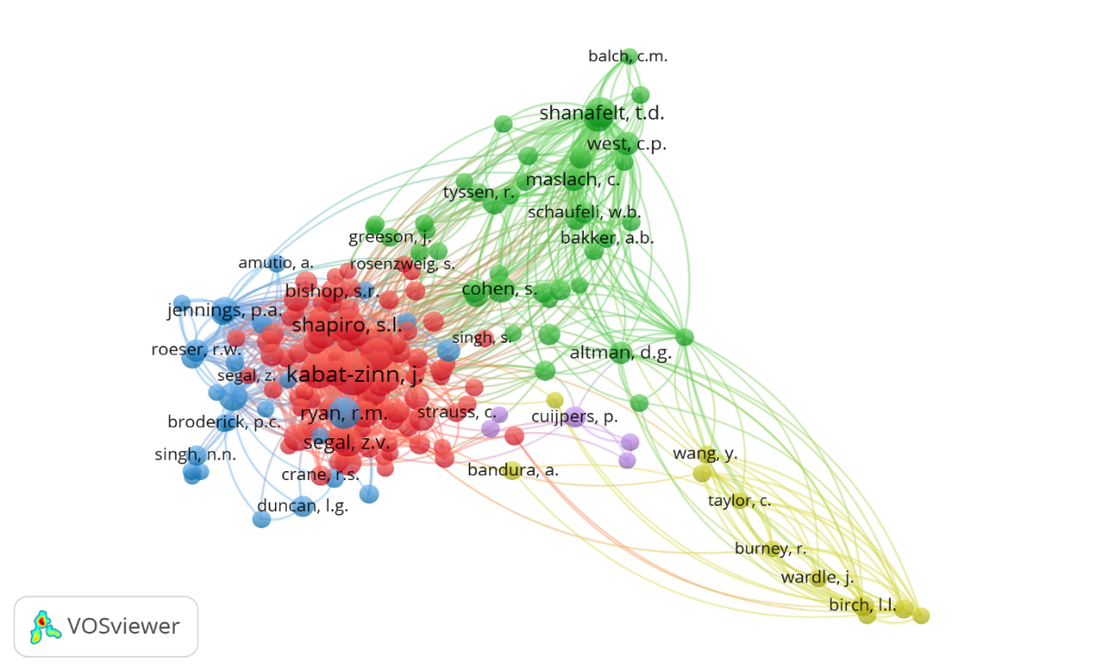
Table 8 shows the ten most-cited publications in the Mindfulness research, information about the author, the year it was published, the name of the document, and the total number of citations from 1916 to January 2022. The article cited the most is called "The Benefits of Being Present: Mindfulness and Its Role in Psychological Well-Being." It was written by Brown and Ryan and published in the Journal of Personality and Social Psychology in 2003.

Table 8: Top 10 most cited documents on mindfulness as of January 31, 2022 in Scopus
First author | Year | Document title | Cites
Brown K.W | 2003 | The Benefits of Being Present: Mindfulness and Its Role in Psychological Well-Being | 5,573
Baer R.A. | 2006 | Using self-report assessment methods to explore facets of mindfulness | 3,348
Kabat-Zinn J. | 2003 | Mindfulness-based interventions in context: Past, present, and future | 3,176
Bishop S.R. | 2004 | Mindfulness: A proposed operational definition | 3,116
Brown K.W. | 2007 | Mindfulness: Theoretical foundations and evidence for its salutary effects | 1,617
Shapiro S.L | 2006 | Mechanisms of mindfulness | 1,587
Baer R.A. | 2008 | Construct validity of the five facet mindfulness questionnaire in meditating and nonmeditating samples | 1,321
Hölzel B.K | 2011 | How does mindfulness meditation work? Proposing mechanisms of action from a conceptual and neural perspective | 1,309
Baer R.A | 2004 | Assessment of mindfulness by self-report: The Kentucky inventory of mindfulness skills | 1,159
Fredrickson B.L | 2008 | Open Hearts Build Lives: Positive Emotions, Induced Through Loving-Kindness Meditation, Build Consequential Personal Resources | 1,136

Keyword Analysis
Keywords capture the posts' primary content. Keyword analysis in mindfulness research aims to find significant study themes and their links. All keywords (Author Keywords and Keyword PLUS) in the mindfulness co-occurrence network are utilized to identify mindfulness-related research topics across disciplines. Larger circles represent keywords that appear more frequently (Voner et al., 2016). The similarity between the terms is indicated by the lines linking them (Danvila-del-Valle et al., 2019). Figure 7 displays 370 keyword-related phrases that appear seven times or more among 4,515 keywords. This image reveals that the most significant correlations between themes occurred between 2015 and 2017 when the most mindfulness-related publications were published.
Figure 7: VOSviewer network map of keyword occurrences.
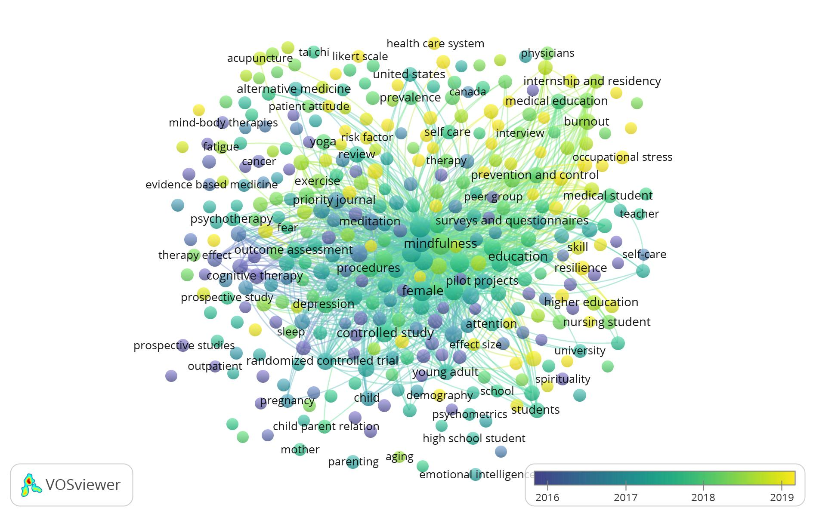
Findings
This study utilized bibliometric analysis to discover the most pertinent papers, journals, authors, and keywords about mindfulness. This methodology is being used in several studies to examine the contributions of scholars in diverse fields of research and the trends and relationships that may arise from their results (Garg & Sharma, 2017). This study would contribute to a better understanding of how mindfulness studies are conducted, the sectors and disciplines in which they are performed, which journals publish the most mindfulness research, and the significance of its variables. It is a problem of relevance and interest on the part of institutions to elevate the academic level of their interest groups and position themselves in a competitive world within the educational setting, especially given the growth over the past decade. This approach permits the examination of articles and other resources using several keywords to establish the relationship between mindfulness-related sub-keywords.
In the past five years, there has been a rise in the number of documents on mindfulness. A considerable increase in publications would not always result in a high citation rate or impact factor. It has been determined that 247 publications have 100 or more citations. A high output of documents does not necessarily suggest a high H index; thus, more citation is more significant than increased production. Because every circumstance is unique, the significance of this research may not be applicable in some situations. The scientific community has now established a definite trend in qualitative research. Numerous papers are published in journals with a high impact factor that falls inside a certain quartile of the journal's citation report.
The primary limitation of the study is that it is limited to the Scopus database; therefore, it is recommended to expand the research using other databases such as Web of Science, JStor, EBSCO, ProQuest, Emerald, SAGE, or others; however, the study is following the research objective, providing pertinent bibliometric data on mindfulness. A new framework might be implemented to expand the theory and evolution of mindfulness.
Conclusions
Bibliometric studies are valuable for monitoring academic progress and intellectual growth in a specific field. This research intended to undertake a bibliometric analysis of the evolution of mindfulness materials using 4,399 Scopus-indexed articles.
Various document formats, countries/territories, authorship, citations, sources, journal impact factor, and keywords are offered as pertinent information to define the research features of the mindfulness study domain. Based on the bibliometric analysis of 4,399 documents, several crucial research metrics were found, including document type, the language of publications, most prominent authors, journal articles, and their related impact factors, nation, and keywords. Whose contribution to this area was the most significant and potential research location.
Since its initial publication in 1916, the number of scientific articles published on mindfulness has expanded exponentially during the past five years, reaching 4,399 publications. This shows that this kind of psychotherapy intervention is seeing a surge in popularity.
Regarding the nations that have published the most articles about mindfulness, the United States stands out as the leading contributor, with English being the predominant language (4,264 documents; 96.9%). The United States was the most prolific producer, followed by the United Kingdom; the five journals with the highest impact factor in this field are Current Opinion in Psychology, Emotion, Mindfulness, Personality and Individual Differences, and Journal of Clinical Psychology.
Consistent with the findings of Dawson et al. (2019), the research point highlights mindfulness, meditation, and relaxation based on the co-occurrence of terms. Education and health are the two most significant fields of study, although other domains are increasing. The interest in mindfulness has shifted away from earlier concepts and approaches, such as meditation, Buddhism, and religion. Also, awareness is the primary instrument for mindfulness. As a result, further study must be conducted on different kinds of interaction between the use of mindfulness across fields.
According to Dawson et al. (2019), mindfulness practice therapies consist of the following: breathing, sitting meditation, body scan method, animal-assisted therapy, Iyengar yoga, brainwave vibration, walking meditation, and mindfulness day to day, explaining that the primary purpose is to be in the present moment. Consequently, mindfulness research encompasses a multidisciplinary sector that includes education, psychology, business, and technology. Due to the increasing interest in mindfulness research, papers having a high impact factor according to the SJR have been included.

References
Ardanuy, J. (2012). Breve introducción a la bibliometría. La base de datos scopus y otros e-recursos del CBUES como instrumento de gestión de la actividad investigadora.
Arslan, Ü., & Asıcı, E. (2021). The mediating role of solution focused thinking in relation between mindfulness and psychological well-being in university students. Current Psychology, 1-10. https://doi.org/10.1007/s12144-020-01251-9
Beddoe, A. E., & Murphy, S. O. (2004). Does mindfulness decrease stress and foster empathy among nursing students?. Journal of Nursing Education, 43(7), 305-312. https://doi.org/10.3928/01484834-20040701-07
Brown, K. W., & Ryan, R. M. (2003). The benefits of being present: mindfulness and its role in psychological well-being. Journal of personality and social psychology, 84(4), 822–848. https://doi.org/10.1037/0022-3514.84.4.822
Capurso, V., Fabbro, F., & Crescentini, C. (2014). Mindful creativity: the influence of mindfulness meditation on creative thinking. Frontiers in psychology, 4, 1020. https://doi.org/10.3389/fpsyg.2013.01020
Chen, Y., Yang, X., Wang, L., & Zhang, X. (2013). A randomized controlled trial of the effects of brief mindfulness meditation on anxiety symptoms and systolic blood pressure in Chinese nursing students. Nurse education today, 33(10), 1166-1172. https://doi.org/10.1016/j.nedt.2012.11.014
Dawson, A. F., Brown, W. W., Anderson, J., Datta, B., Donald, J. N., Hong, K., ... & Galante, J. (2020). Mindfulness‐based interventions for university students: A systematic review and meta‐analysis of randomised controlled trials. Applied Psychology: Health and Well‐Being, 12(2), 384-410. https://doi.org/10.1111/aphw.12188
De Bruin, E. I., Meppelink, R., & Bögels, S. M. (2015). Mindfulness in higher education: Awareness and attention in university students increase during and after participation in a mindfulness curriculum course. Mindfulness, 6(5), 1137-1142. https://doi.org/10.1007/s12671-014-0364-5
De Vibe, M., Solhaug, I., Tyssen, R., Friborg, O., Rosenvinge, J. H., Sørlie, T., & Bjørndal, A. (2013). Mindfulness training for stress management: a randomised controlled study of medical and psychology students. BMC medical education, 13(1), 1-11. https://doi.org/10.1186/1472-6920-13-107
Delgado, L. C., Guerra, P., Perakakis, P., Viedma, M. I., Robles, H., & Vila, J. (2010). Human values education and mindfulness meditation as a tool for emotional regulation and stress prevention for teachers an efficiency study. Behavioral Psychology-Psicologia Conductual, 18(3), 511-532.
Dobie, S. (2007). Reflections on a well-traveled path: Self-awareness, mindful practice, and relationship-centered care as foundations for medical education. Academic Medicine, 82(4), 422-427. https://doi.org/10.1097/01.acm.0000259374.52323.62
Dobkin, P. L., & Hutchinson, T. A. (2013). Teaching mindfulness in medical school: where are we now and where are we going?. Medical education, 47(8), 768-779. https://doi.org/10.1111/medu.12200
Dunn, B. R., Hartigan, J. A., & Mikulas, W. L. (1999). Concentration and mindfulness meditations: unique forms of consciousness?. Applied psychophysiology and biofeedback, 24(3), 147-165.
Duff, C. (2021). Educational policy shifts: A critical review of the emerging trend of mindfulness in education. Policy Futures in Education, 14782103211037286. https://doi.org/10.1177/14782103211037286
Egri, C. P. (2012). Introduction: Enhancing business education through creativity, mindfulness, and accreditation. Academy of Management Learning & Education, 11(4), 703-703. https://doi.org/10.5465/amle.2012.0350
Erogul, M., Singer, G., McIntyre, T., & Stefanov, D. G. (2014). Abridged mindfulness intervention to support wellness in first-year medical students. Teaching and Learning in Medicine, 26(4), 350-356. https://doi.org/10.1080/10401334.2014.945025
Enríquez, H., Ramos, N., & Esparza, O. (2017). Impact of the mindful emotional intelligence program on emotional regulation in college students. International Journal of Psychology and Psychological Therapy, 17(1), 39-48.
Ergas, O. (2014). Mindfulness in education at the intersection of science, religion, and healing. Critical Studies in Education, 55(1), 58-72. https://doi.org/10.1080/17508487.2014.858643
Ergas, O., & Hadar, L. L. (2021). Does mindfulness belong in higher education?–An eight year research of students’ experiences. Pedagogy, Culture & Society, 1-19. https://doi.org/10.1080/14681366.2021.1906307
Gordillo, M. D. G., & Herrera, S. S. (2015). ¿Adquieren nuestros alumnos competencias emocionales en el grado de magisterio?. Opción, 31(2), 532-556.
Hassed, C., De Lisle, S., Sullivan, G., & Pier, C. (2009). Enhancing the health of medical students: outcomes of an integrated mindfulness and lifestyle program. Advances in health sciences education, 14(3), 387-398. https://doi.org/10.1007/s10459-008-9125-3
Harrison, N., & Peacock, N. (2009). Cultural distance, mindfulness and passive xenophobia: Using Integrated Threat Theory to explore home higher education students’ perspectives on ‘internationalisation at home’. British educational research journal, 36(6), 877-902. https://doi.org/10.1080/01411920903191047
Kabat-Zinn, J. (2003). Mindfulness-based interventions in context: Past, present, and future. Clinical Psychology: Science and Practice, 10(2), 144–156. https://doi.org/10.1093/clipsy.bpg016
Kiener, M., Ahuna, K. H., & Tinnesz, C. G. (2014). Documenting critical thinking in a capstone course: moving students toward a professional disposition. Educational Action Research, 22(1), 109-121. https://doi.org/10.1080/09650792.2013.856770
Kinginger, C. (2011). Enhancing language learning in study abroad. Annual review of applied linguistics, 31, 58-73. https://doi.org/10.1017/s0267190511000031
Kurebayashi, Y. (2021). The effect of revised process recording on self‐focus and self‐compassion: A randomized controlled pilot study. Perspectives in Psychiatric Care, 57(3), 1282-1291. https://doi.org/10.1111/ppc.12687
Liang, S., Dong, M., Zhao, H., Song, Y., & Yang, A. (2022). Mindfulness and life satisfaction: The moderating effect of self-control and the moderated moderating effect of resilience. Personality and Individual Differences, 185, 111241. https://doi.org/10.1016/j.paid.2021.111241
Lauricella, S. (2014). Mindfulness meditation with undergraduates in face-to-face and digital practice: a formative analysis. Mindfulness, 5(6), 682-688. https://doi.org/10.1007/s12671-013-0222-x
Mrazek, M. D., Franklin, M. S., Phillips, D. T., Baird, B., & Schooler, J. W. (2013). Mindfulness training improves working memory capacity and GRE performance while reducing mind wandering. Psychological science, 24(5), 776-781. https://doi.org/10.1177/0956797612459659
Moscaritolo, L. M. (2009). Interventional strategies to decrease nursing student anxiety in the clinical learning environment. Journal of nursing education, 48(1), 17-23. https://doi.org/10.3928/01484834-20090101-08
Oberski, I., Murray, S., Goldblatt, J., & DePlacido, C. (2015). Contemplation & mindfulness in higher education. In Global Innovation of Teaching and Learning in Higher Education (pp. 317-340). Springer, Cham. https://doi.org/10.1007/978-3-319-10482-9_19
Peacock, N., & Harrison, N. (2009). “It’s So Much Easier to Go with What’s Easy” “Mindfulness” and the Discourse Between Home and International Students in the United Kingdom. Journal of Studies in International Education, 13(4), 487-508. https://doi.org/10.1177/1028315308319508
Ray, J. L., Baker, L. T., & Plowman, D. A. (2011). Organizational mindfulness in business schools. Academy of Management Learning & Education, 10(2), 188-203. https://doi.org/10.5465/amle.2011.62798929
Reilly, P. (2021). Promoting positive emotions among university EFL learners. Language Learning in Higher Education, 11(1), 153-173. https://doi.org/10.1515/cercles-2021-2013
Ritchhart, R., & Perkins, D. N. (2000). Life in the mindful classroom: Nurturing the disposition of mindfulness. Journal of Social Issues, 56(1), 27-47. https://doi.org/10.1111/0022-4537.00150
Rojiani, R., Santoyo, J. F., Rahrig, H., Roth, H. D., & Britton, W. B. (2017). Women benefit more than men in response to college-based meditation training. Frontiers in psychology, 8, 551. https://doi.org/10.3389/fpsyg.2017.00551
Rosenzweig, S., Reibel, D. K., Greeson, J. M., Brainard, G. C., & Hojat, M. (2003). Mindfulness-based stress reduction lowers psychological distress in medical students. Teaching and learning in medicine, 15(2), 88-92. https://doi.org/10.1207/s15328015tlm1502_03
Salomon, G., & Globerson, T. (1987). Skill may not be enough: The role of mindfulness in learning and transfer. International journal of educational research, 11(6), 623-637. https://doi.org/10.1016/0883-0355(87)90006-1
Schure, M. B., Christopher, J., & Christopher, S. (2008). Mind–body medicine and the art of self‐care: teaching mindfulness to counseling students through yoga, meditation, and qigong. Journal of Counseling & Development, 86(1), 47-56. https://doi.org/10.1002/j.1556-6678.2008.tb00625.x
Slavin, S. J., Schindler, D. L., & Chibnall, J. T. (2014). Medical student mental health 3.0: improving student wellness through curricular changes. Academic Medicine, 89(4), 573. https://doi.org/10.1097/acm.0000000000000166
Smeets, E., Neff, K., Alberts, H., & Peters, M. (2014). Meeting suffering with kindness: Effects of a brief self‐compassion intervention for female college students. Journal of clinical psychology, 70(9), 794-807. https://doi.org/10.1002/jclp.22076
Smyth, A., & Milyavskaya, M. (2021). Mindfully motivated: Can a brief session of mindfulness meditation enhance motivation towards personal goals?. European Journal of Social Psychology. https://doi.org/10.31234/osf.io/dvmkb
Song, Y., & Lindquist, R. (2015). Effects of mindfulness-based stress reduction on depression, anxiety, stress and mindfulness in Korean nursing students. Nurse education today, 35(1), 86-90. https://doi.org/10.1016/j.nedt.2014.06.010
Teper, R., Segal, Z. V., & Inzlicht, M. (2013). Inside the mindful mind: How mindfulness enhances emotion regulation through improvements in executive control. Current Directions in Psychological Science, 22(6), 449-454. https://doi.org/10.1177/0963721413495869
Van der Riet, P., Rossiter, R., Kirby, D., Dluzewska, T., & Harmon, C. (2015). Piloting a stress management and mindfulness program for undergraduate nursing students: Student feedback and lessons learned. Nurse Education Today, 35(1), 44-49. https://doi.org/10.1016/j.nedt.2014.05.003
Wald, H. S., Anthony, D., Hutchinson, T. A., Liben, S., Smilovitch, M., & Donato, A. A. (2015). Professional identity formation in medical education for humanistic, resilient physicians: pedagogic strategies for bridging theory to practice. Academic Medicine, 90(6), 753-760. https://doi.org/10.1097/acm.0000000000000725
Warnecke, E., Quinn, S., Ogden, K., Towle, N., & Nelson, M. R. (2011). A randomised controlled trial of the effects of mindfulness practice on medical student stress levels. Medical education, 45(4), 381-388. https://doi.org/10.1111/j.1365-2923.2010.03877.x
Wells, A. (2002). GAD, metacognition, and mindfulness: An information processing analysis.
Woods, S. L. (2009). Training professionals in mindfulness: The heart of teaching. In Clinical handbook of mindfulness (pp. 463-475). Springer, New York, NY. https://doi.org/10.1007/978-0-387-09593-6_26
Zeidan, F., Johnson, S. K., Diamond, B. J., David, Z., & Goolkasian, P. (2010). Mindfulness meditation improves cognition: Evidence of brief mental training. Consciousness and cognition, 19(2), 597-605. https://doi.org/10.1016/j.concog.2010.03.014

