Abstract
We tested among Peruvian university students the hypothesis that religiosity is associated with unreasonable COVID-19 behavior and that this is explained by negative emotions. We expected different results than those of Kranz et al.’s (2020) study in the general population of the United States considering the intelligence above average of university students. Kranz et al.’s (2020) research addressed the mediation of worry and emotionality in the positive association they observed between religiosity and unreasonable COVID-19 behavior. Religiosity emerged positively associated with reasonable COVID-19 behavior and emotions did not mediate the relationship; this can be attributed to the superior intelligence of university students and suggests a need for comparing religious people with high and low intelligence in each country. We evaluate this evidence considering alternative interpretations, such as the greater collectivism prevailing in Peru than the United States, the prevalence of evangelical fundamentalism versus Catholicism in Peru and the United States, and the methodological differences of the studies.
Keywords – religiosity; reasonable COVID-19 behavior; emotions; United States; Peru

Resumen
Pusimos a prueba entre estudiantes universitarios peruanos la hipótesis de que la religiosidad se asocia con conductas irrazonables frente al COVID-19 y que esto se explica por emociones negativas. La expectativa fue de resultados diferentes a los del estudio de Kranz et al. (2020) en la población general de Estados Unidos considerando que la inteligencia de los estudiantes universitarios es mayor que el promedio. La investigación de Kranz et al. (2020) abordó la mediación de preocupaciones y emocionalidad en la asociación positiva observada entre religiosidad y conducta COVID-19 irrazonable. La religiosidad emergió positivamente asociada con conducta COVID-19 razonable y las emociones no mediaron esta relación; ello es atribuible a la inteligencia superior de los estudiantes universitarios y sugiere la necesidad de comparar las reacciones de personas inteligentes y menos inteligentes con convicción religiosa. En el artículo se evalúa la evidencia tomando en cuenta interpretaciones alternativas tales como el mayor colectivismo que prevalece en el Perú que en Estados Unidos, la prevalencia del catolicismo versus el fundamentalismo evangélico en Perú y Estados Unidos, y las diferencias metodológicas de los estudios.
Keywords – religiosidad; conducta COVID-19 razonable; emociones; Perú; Estados Unidos

Introduction
Research has produced increasing evidence on the relationships between religion and health. Now we know that cardiovascular risk in Japan (Kobayashi et al., 2015) and smoking and alcohol intake in Denmark (Svensson et al., 2020) correlate negatively with religiosity. Religion is usually regarded as a factor in the social environment that to some extent determines the health of populations, both inducing a lifestyle and intervening in the lives of families and social networks through its institutions (George et al., 2002). Religion not only instills self-regulation through its practices and rituals, but also provides a sense of belonging and meaning (van Elk, 2021). Thus, religiosity is positively related to mental health (Garssen et al., 2021; Hoogeveen et al., 2022).
The COVID-19 Case in the United States
One thing may be mental health, another systematic health behavior, and still another the reaction of individuals in the face of a novel pandemic. In the latter case, information and available interventions and remedies are less known or available to individuals. Contradictory scientific reports were published shortly after the COVID-19 pandemic emerged. Religiosity was the leading predictor that Americans engaged in more frequent precautionary behaviors (Perry et al., 2020), but religion represented also a health risk by promoting a vector of disease transmission (Baker et al., 2020). Religious gatherings functioned as contagion events (Bizjak et al., 2020). The reactions of religious people to the pandemic were later reflected in national panel data which revealed that “accounting for relevant correlates …, the likelihood that Americans tested positive for COVID-19 … grew almost linearly as Americans attended in-person worship more frequently during lockdown” (Perry & Grubbs, 2022). That is, the pandemic made individuals more religious, which in turn exposed them to greater health risks and their consequences.
How is it possible that the religiosity that leads to healthier dietary patterns and less smoking associates with unreasonable attitudes and behaviors in the case of COVID-19? An answer is that diet and smoking have long-term consequences whereas the risk of death from COVID-19 is immediate and may cause strong emotions. Kranz et al. (2020) addressed emotions in a study. They developed a model postulating the mediation of worry and emotionality in religiosity’s positive association with unreasonable COVID-19 behavior. In their evaluation of the model, they used items such as “avoiding crowds” and “accumulating toilet paper” to distinguish between reasonable and unreasonable COVID-19 behaviors; applied the 10-item Intrinsic Religious Motivation Scale (Hoge, 1972); and adapted the State-Trait Inventory for Cognitive and Somatic Anxiety (Grös et al., 2007) to measure coronavirus worry (e.g., “I often worry about catching…”) and emotionality (e.g., “My heart beats faster when I think…”). Based on an analysis of responses emitted by United States citizens of a nationally representative sample, they concluded that, “with regard to preventive behavior, highly religious participants reported more unreasonable behavior” and attributed this relationship to more intense emotions experienced in relation to the pandemic (Kranz et al., 2020, p. 1).
The Present Study
Was the unreasonable behavior related to religiosity in that study really attributable to experiencing more intense emotions? Whereas the Kranz et al. (2020) model was successful in terms of fit to the data, it was not considering the size and different sign of the emerging path coefficients from religiosity to coronavirus worry (b = -.07) and emotionality (b =.10). These were significant by virtue of sample size (N = 1,182), yet the variance explained in the “correct” mediator did not surpass .01. The low variance explained in the mediators suggests that the significance of their path coefficients is unlikely to recur in smaller samples and the Kranz et al. (2020) results will add to the replicability crisis in psychology (Pashler & Wagenmakers, 2012). In contrast, religiosity’s direct influence accounted for 9% of the variance in unreasonable COVID-19 behavior. That is, the model did not explain the target variable’s variance by an intervention of emotions but by a direct effect of religiosity.
Kranz et al. (2020) explained their results referring to the negative correlation that exists between religiosity and intelligence. Recently, a large longitudinal study of 4,462 US veterans yielded an r = -.18 between IQ and being a believer in God (Dutton & Kirkegaard, 2022) and a meta-analysis of 89 studies revealed a small but robust association between religiosity and intelligence expressed in an r = -.14 (Dürlinger & Pietschnig, 2022). There is also evidence that the negative intelligence-religiosity correlation is mediated by more versus less analytic behavior (Zuckerman et al., 2019). Intelligent people are more likely to use a more analytic style (i.e., approach problems more rationally). There is also evidence that the control of emotions is improved by cognitive ability (Schmeichel et al., 2008).
Cognitive ability is strongly related to education (Nisbett et al., 2012); one year of education can add four IQ points (Hegelund et al., 2020). Only 53% in the Kranz et al. (2020) sample had college studies. What happens when 100% of a sample do? In the present study, we tested whether religiosity relates negatively to reasonable COVID-19 behavior when all the individual participants have a college education. We expected reasonable rather than unreasonable COVID-19 behavior on the part of both religious and nonreligious people. We also tested whether emotions and behavior are related as in the Kranz et al. (2020) model when emotions are controlled experimentally and COVID-19 behavior is not self-rated but observed.
Method
Context
The research was conducted in Peru. Religious practices (attend weekly, pray daily) are virtually identical in the United States and Peru (Pew Research Center, 2018). The difference entails religious affiliation. Whereas 42% of the population are Protestant, 21% Catholic, 2% Mormon, 1% Jewish, 18% unaffiliated, and 11% atheists or agnostics in the United States (Newport, 2017), 76.0% are Catholic, 14.1% evangelical, 4.8% practice other religions, and 5.1% are irreligious in Peru (INEI, 2017).
Participants
Invitations to give five minutes of their time evaluating a poster on COVID-19 were sent to cell phones of 200 students at a private Peruvian university that has more than 96,000 students. Most of the students lived in Lima or Trujillo, Peru. The sample can be assumed to loosely represent the population of university students in Latin America. All communications were virtual and ruled by the Universal Declaration of Ethical Principles for Psychologists (Parsonson, 2021). Data collection occurred when the second wave of the COVID-19 pandemic was ending in Lima.
Intervention
We created four posters stating that specific vitamins and minerals strengthen the immune system against the risks of the disease. A text treatment which addressed risks for obese persons (Wadman, 2020) vis-à-vis all the comorbidities of COVID-19 (Zabetakis et al., 2020) was crossed with a visual-frame factor defined by a photo of a smiling large family at home and one of transportation of a coffin. This allowed us to control the effects of text and avoid confounding with the visual manipulation of emotions. The texts were in Spanish. Figure 1 presents two posters that represent all of the experimental combinations. The Qualtrics application randomly assigned participants to the four posters.
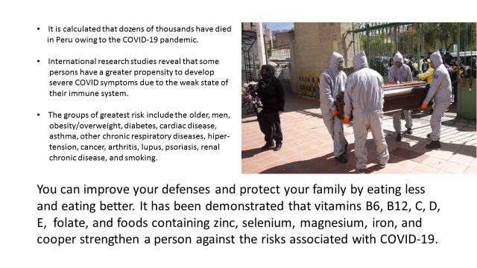
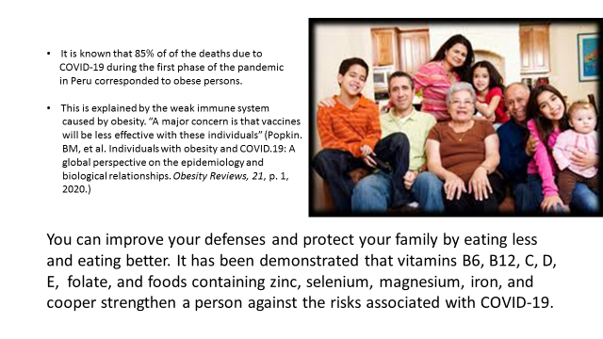
Figure 1. Two of the four posters used in the study, translated to English.
Measures
Participants provided information on their age, gender, height, weight, comorbidities, and whether they had or had had COVID-19. The comorbidities are those in the second paragraph of the second figure. We measured religiosity using four items of the Centrality of Religiosity Scale (Huber & Huber, 2012): thinking about religious issues, taking part in religious services, praying, and feeling that a divinity intervenes in one’s life. Ratings of the anxiety, fear, preoccupation, sadness (Negative Affect, NA), curiosity, happiness, and tranquility (Positive Affect, PA) experienced when looking at the poster were collected. To exert further control, we measured the cognitive impact of the poster (attention-getting, clarity, usefulness). Then we asked participants whether they were interested in receiving free advice about foods containing the nutrients addressed in the poster and those who responded Yes were asked to write to an e-mail address requesting the guidelines. Scores assigned to levels of the intervention variables were 2 to positive and 1 to negative visual frame and 2 to the comorbidities and 1 to the obesity texts. Two points were assigned to women and one to men. To obtain body mass index (BMI) scores we divided weight by squared height; then, we assigned a 2 score to individuals with 30 or more BMI scores and 1 to those with BMI scores below 30, thus attaining an indicator of obesity. Two points were assigned to individuals having any comorbidity and 1 to those having none and similar was the case of having or having had COVID-19. As for the religiosity items, “Every day” was scored 5, “Once a week” 4, “Once a month” 3, “Once a year” 2, and “Never” 1. The response options for items on cognitive impact of the posters and emotions felt were scored “None” = 1, “Some” = 2, and “A lot” = 3. Scores of 1 (no interest in receiving food guidelines or interest but not writing to the e-mail address) and 2 (writing to the e-mail address requesting the food guidelines) were assigned to measure intention to adhere to the message.
Results
One-hundred and thirty-six participants reached the last question of the questionnaire, about interest in food guidelines. The sample had the following characteristics: 100% Peruvians; 42% lived in Lima, Peru’s capital city; 31% lived in Trujillo, Peru; 27% lived in other Peruvian cities; 12% married, 88% single; 28% studied international business; 27% studied psychology; 23% studied initial education; 15% studied nursing; 7% studied nutrition. Average age was 26.6 years, 64.7% were women, 34.6% had or had had COVID-19, 9.6% were obese, 41.9% had one or more comorbidities, and 71.3% wrote to the e-mail address requesting the guidelines. As for religiosity, 15.4% never thought about religion, 38.2% never went to church, 18.4% never prayed, and 16.2% never thought of a divinity intervening in his/her life.
The Cronbach alphas for summed scores were .83 for religiosity (q = 4), .83 for cognitive impact (q = 3), .80 for NA (q = 4), and .50 for PA (q = 3), which increased to .64 when the curiosity item was excluded. In terms of the omega coefficient (Greene & Yang, 2009; Ventura-León, 2017), the results were: religiosity = .60 (95% CI = [.45, .74]), NA = .81 (95% CI = [.75, .87]), cognitive impact = .85 (95% CI = [.79, .90]), and PA = .62 (95% CI = [.52, .73], which increased to .77 (95% CI = [.69, .84]) when curiosity was excluded. Consequently, we used a PA scale based on two items in
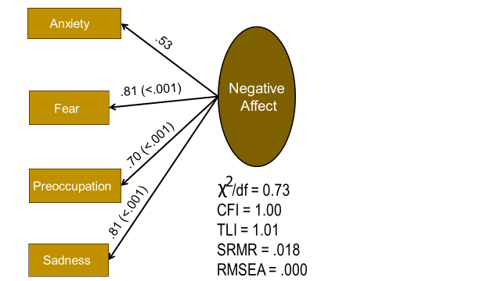
Figure 2. Results of confirmatory factor analysis of Negative Affect items. (N = 122).
subsequent analyses. The one factor validity of the NA scale was satisfactory (see Fig. 2). Religiosity emerged as the sole study variable significantly correlated with intention to adhere to the nutritional recommendation; moreover, the correlation was positive (r = 20, p = .023, N = 131). There were no significant differences between subgroups in this regard. The correlation between adherence and religiosity was similar among women (r = .38, p = .096, N = 86) and men (r = .37, p = .018, N = 41). Dividing the sample at the median, the correlation was lower among the younger than 24 (r = .12, p = .338, N = 65) than the older than 23 (r = .29, p = .020, N = 66), but the difference did not achieve significance (p = .160) and these subgroups did not differ in intention to adhere (t_{df=134} = 0.46, p = .648) nor religiosity (t_{df=134} = -0.81, p = .401).
The Qualtrics randomization resulted in an unbiased distribution of cases. In the evaluation of effectiveness of the randomization, generalized linear models targeted the distribution of gender, age, education, having or having had COVID-19, obesity, and having any comorbidity across cells of the visual-frame and text treatments and their interaction (see Tables 1-3).
Table 1. Results of linear models: Parameter estimation for effects of visual frame, text, and their interaction on religiosity (general linear model) and gender (generalized linear model).
 | ____________Religiosityª_______________ |  |  |  | ______________Gender^{b}_____________
Source | b | SE | p | Partial eta² | b | SE | p | Odds-ratio
Visual frame | 1.11 | 1.12 | .321 | 0.01 | -0.09 | 0.58 | .872 | 0.92
Text | -0.48 | 1.29 | .699 | 0.00 | 0.28 | 0.57 | .606 | 1.32
Visual frame x text | -1.38 | 1.67 | .413 | 0.01 | -0.01 | 0.79 | .989 | 0.99
ª Lineal. N = 131.
^{b} Binary. N = 132.
Table 2. Results of linear models: Parameter estimation for effects of visual frame, text, and their interaction on age (general linear model) and had COVID-19 (generalized linear model).
 | _______________Ageª_______________ |  |  |  | _______Had COVID-19^{b}__________
Source | b | SE | p | Partial Eta² | b | SE | p | Odds-ratio
Visual frame | -1.14 | 2.54 | .647 | 0.00 | 0.34 | 0.89 | .538 | 1.40
Text | -3.30 | 2.69 | .211 | 0.01 | 0.23 | 0.89 | .683 | 1.26
Visual frame x text | -0.56 | 3.40 | .861 | 0.00 | -0.56 | 1.04 | .464 | 0.57
ª Linear. N= 136.
^{b} Binary. N = 135.
Table 3. Results of generalized linear models: Parameter estimation for effects of visual frame, text, and their interaction on obesity and any comorbidity.
 | ____________Obesityª_____________ |  |  |  | _______Any comorbidity^{b}_________
Source | b | SE | p | Odds-ratio | b | SE | p | Odds-ratio
Visual frame | -1.03 | 7.32 | .139 | 0.36 | -0.03 | 0.55 | .949 | 0.97
Text | 0.83 | 12.06 | .173 | 2.29 | -0.39 | 0.55 | .494 | 0.68
Visual frame x text | -0.42 | 12.44 | .358 | 0.66 | -0.09 | 0.76 | .906 | 0.91
ª Binary. N = 136.
^{b} Binary. N = 133.
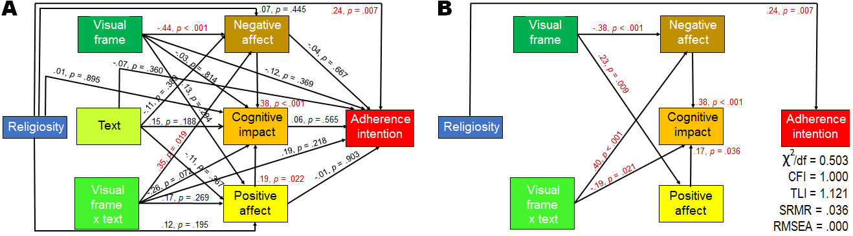
Figure 3. Path coefficients and their significance. (A) Saturated path model. (B) Path model that maximizes fit to the data retaining only significant paths. Model fit indicators are chi-square divided by degrees of freedom, comparative fit index, Tucker-Lewis index, standardized root mean residual, and root mean square error of approximation. The covariation of residuals of positive and negative affect was controlled. N = 122.
We treated religiosity, visual frame, text, and visual frame x text as exogenous variables in mediation analyses encompassing participants with full data. The results in
Fig. 3 indicated a dependence of the three assumed mediators on components of the
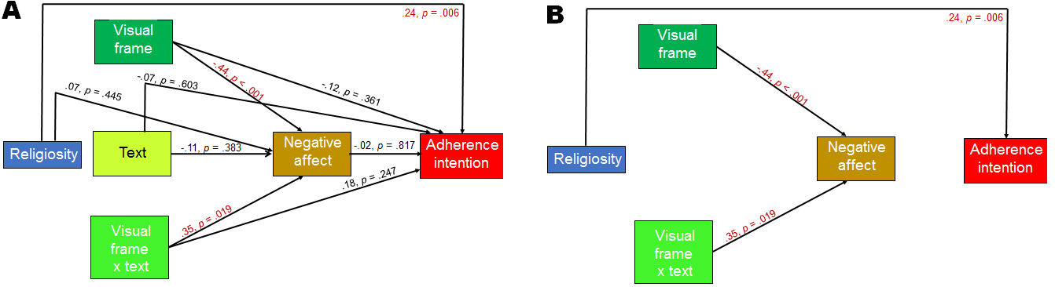
intervention independently of the positive dependence of adherence behavior on religiosity. Exclusion of PA and cognitive impact did not alter the relationships (Fig. 4).
Figure 4. Path models without Positive Affect and cognitive impact. N = 122.
To explore possible interactions of religiosity with the intervention, we dichotomized this variable near the median and used it in a multivariate analysis of variance as a factor along with visual frame. The results in Table 4 were consistent with those of the mediation analyses: the -0.25 b value for the religiosity-adherence
Table 4. Results of multivariate general linear model: Parameter estimation for effects of visual frame, religiosity, and their interaction.
Source | Dependent variable | b | SE | p | Partial Eta²
Visual frame | Negative Affect | 0.87 | 0.55 | .111 | 0.02
 | Positive Affect | -0.77 | 0.34 | .023 | 0.04
 | Cognitive impact | 0.77 | 0.36 | .047 | 0.04
 | Adherence intention | -0.03 | 0.09 | .788 | 0.00
Religiosity | Negative Affect | -0.27 | 0.62 | .663 | 0.00
 | Positive Affect | -0.38 | 0.41 | .359 | 0.01
 | Cognitive impact | -0.28 | 0.39 | .871 | 0.00
 | Adherence intention | -0.25 | 0.12 | .036 | 0.04
Visual frame x | Negative Affect | 0.27 | 0.78 | .726 | 0.00
Religiosity | Positive Affect | 0.23 | 0.53 | .682 | 0.00
 | Cognitive impact | -0.16 | 0.52 | .563 | 0.00
 | Adherence intention | 0.10 | 0.16 | .537 | 0.00

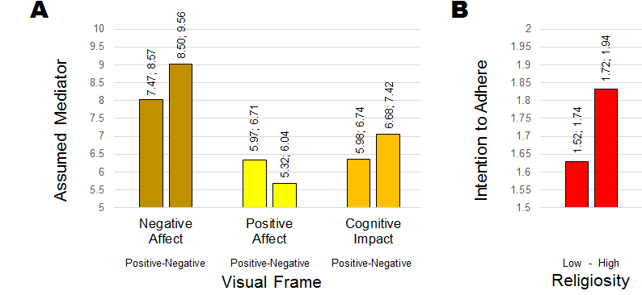
Figure 5. Estimated means from multivariate analysis of variance and their 95% confidence intervals. (A) Effects of visual frame on assumed mediators. (B) Effects of religiosity on adherence intention. N = 131.
relationship reflected a decay in intention to adhere as high religiosity was set at 0 for evaluating effects of low religiosity. No interactions were observed. Fig. 5 depicts the significant effects graphically. Excluding PA and cognitive impact (Table 5) and adding text as a third independent variable did not alter the basic relationships (not shown).
Table 5. Results of multivariate general linear model: Parameter estimation for
effects of visual frame, religiosity, and their interaction on Negative Affect and
intention to adhere.
Source | Dependent variable | b | SE | P | Partial Eta²
Visual frame | Negative Affect | 0.87 | 0.53 | .106 | 0.02
 | Adherence intention | -0.04 | 0.10 | .651 | 0.00
Religiosity | Negative Affect | -0.37 | 0.62 | .558 | 0.00
 | Adherence intention | -0.24 | 0.11 | .041 | 0.03
Visual frame x | Negative Affect | 0.41 | 0.77 | .590 | 0.00
Religiosity | Adherence intention | 0.08 | 0.16 | .595 | 0.00
Notes. Positive visual framing and high religiosity set at 0 for evaluating effects of negative visual frame and low religiosity. Standard errors and probabilities were bootstrapped with 1000 samples. N = 126.
Discussion
We surmise that religion did not have in our study the positive effect on unreasonable COVID-19 behavior that Kranz et al. (2020) observed in the United States because, transcending the cognitive advantage of the United States compared to Peru (Manrique-Millones et al., 2015), low intelligence was probably minimal in our sample, whereas IQ was normally distributed in theirs’. That is, our participants can be assumed to have been more protected cognitively from emotional interference than the American participants with regard to COVID-19 perceived risks. Hence, we would expect that a to-the-letter replication of the Kranz et al. (2020) study revealed a positive relationship between religiosity and reasonable COVID-19 behavior among participants with college education and a negative relationship among the other participants in the study, and perhaps even a mediating effect of emotions among the latter but not among the former. In a study in Poland, participants living in rural areas reported stronger belief in COVID-19 conspiracy beliefs than those living in a large city (Dȩbski et al., 2022); rural-urban differences in intelligence have been widely documented (He et al., 2021; Hernández-Torrano, 2018). Another link to intelligence is provided by the finding that a significantly negative association between religiosity and COVID-19 vaccination intention was mediated by external locus of control (Olagoke et al., 2021); external locus of control is negatively related to IQ (Gale et al., 2008). This line of thinking leads to the prediction of unreasonable pandemic behavior among Peruvian individuals of lower intelligence.
But, why was the behavior of the more religious students more reasonable than that of the less religious students in our study? We conclude that the finding justifies the statement that the health behavior in the face of COVID-19 was more reasonable among the religious people because intelligence was virtually controlled in the sample of students. This would be consistent with evidence on the healthier behavior of religious people in the face of health risks representing less dramatic outcomes than those of COVID-19. The findings suggest the convenience of differentiating more and less intelligent believers in future studies and avoid attributing to religiosity behaviors which may owe more to the cognitive variable than to religiosity itself.
However, several alternative interpretations of the findings cannot be entirely ruled out. Whereas the United States has the highest individualism score of the world, Peru is at the midst of the table (Van de Vliert & Van Lange, 2019, Table S1). Peru has been described as a collectivistic country wherein individualism increases as the individual grows up, is male, and lives in Lima as opposed to being younger, female, and residing in the interior of the country (León, 1996). More studies have confirmed the Peruvian collectivism (León, 1996; Owe et al., 2013; Pinillos & Reyes, 2011; Silfver, 2007) than those which have risen doubts (Fischer et al., 2009; Green et al., 2005; Stefanidis et al., 2013). In Poland, the private and public practice of religion is more intense with greater collectivism of the person (Zarzycka et al., 2016). This is especially relevant to the cultural context of the present study considering experimental findings which indicate that European Americans, that is, the majority of the American population, react to reminders of mortality with a focus on themselves compared to members of the Asian American minority, who react with an increased focus on other people (Ma-Kellams & Blascovich, 2011). Asian Americans are characterized by their collectivism (Chang, 2015; Park & Kim, 2008; Yeh et al., 2006) in contraposition to the majority of the American population. It is possible that, in Peru, being collectivist and more religious is associated with a greater proclivity to think of significant others in the sight of death and act responsibly seeking improved nutrition in a pandemic time, particularly if images designed to arose emotions - the family and the coffin in the posters of the present study - generated collectivistic thoughts in the participants. There is no need to wait until the next pandemic to start testing these hypotheses.
Another alternative interpretation of the findings can attribute the US results of Kranz et al. (2020) to evangelical nationalism and those of Peru to its devotion to the Catholic Church. Perry et al. (2020) distinguished between Christian Nationalism and other religious orientations in the United States. The former would be an ideology mainly assumed by evangelicals “that connects disregard for scientific expertise; a conception of Americans as God’s chosen and protected people; distrust for news media; and allegiance to Trump–Christian nationalism” (p. 405). Perry et al.’s (2020) analysis of Public and Discourse Ethics Survey data showed that Christian nationalism was the leading predictor of engagement in incautious COVID-19 behavior (not wearing a mask, not sanitizing/washing one’s hands). Christian nationalists make up approximately 20 percent of the USA population (Perry et al., 2020). But Schnabel and Schieman (2021) concluded that, regardless of politics, both evangelicals and people who attend religious services more frequently were less likely to see the COVID-19 outbreak as a crisis and less likely to support public health restrictions to limit the spread of the virus. That is, evangelism was not the sole covariate; the more general concept of religiosity explained risky pandemic behavior. However, the Catholic minority exhibited the opposite tendency. That is, the Catholicism of Peruvians should be taken into account in replication studies of the future.
The present research demonstrated that emotions were inconsequential in the causation of reasonable versus unreasonable COVID-19 behavior. This contradicts Kranz et al.’s (2020) opposite claim but is consistent with their reported very weak and contradictory effects of worry and emotionality in the process whereby religiosity affected COVID-19 preventive behavior in their study. Therefore, a conclusion from the present research is that, so far, evidence from two countries contradicts the conception of emotions as vehicles whereby religiosity stimulates reasonable or unreasonable responses to a mortal pandemic. This, evidently, does not mean that scientists should discard as false the hypothesis or that research on the topic should be abandoned. It means that the research should be refined. Emotional cognition is central to religion (Thagard, 2005) and diverse religions recur in their rituals to emotional arousal (Whitehouse, 2020); emotionality mediates the effects of religiosity on health (Morton et al., 2017) and religion and feeling have become inextricably intertwined (Ural & Berg, 2019). To the extent that ritual frequency reinforces the religiosity-emotionality linkage, the hypothesis would seem viable. It could also be asked whether religious people are more emotional. We do not refer here to entities such as the fundamental and affective need for belonging and the like (Williams, 2021). We refer to such raw emotions as feeling full of energy, proud, sad, angry, and the other items of the PANAS’ (Watson et al., 1988) and its successors. The issue will have to be approached with caution considering the possible tendency of some religious groups to inflate the positive and deflate the negative emotions in their questionnaire responses (Vishkin et al., 2019).
We cannot rule out methodological artifacts as causes of the different results observed in the Kranz et al. (2020) study and the Peruvian research. These involved sampling method; sample size; type of research; measurement of religiosity, emotions, and (un)reasonable COVID-19 behavior; reliability of measures; and data analysis. Particularly relevant was the contrast between the representative American sample and the convenience sample utilized in the present research. Another major methodological difference was between self-reported precautionary behavior in studies exposed to common-method variance and observed rational behavior in a controlled experiment.
Beyond these reservations, we conclude from our findings that, in Peru, religiosity was positively correlated with reasonable COVID-19 behavior and that future research on the relationship between religiosity and health should include measurements of intelligence and take advantage of the type of research design we created.
Declarations
This research did not receive any specific grant from funding agencies in the public, commercial, or not-for-profit sectors. The authors do not have conflicts of interest. The data set analyzed is available at DOI: 106084/m9.figshare.21559308. Informed consent from the participants was obtained through Qualtrics. Research procedures were consistent with international ethics standards and with the views of the Ethics Committee of Universidad San Ignacio de Loyola.
References
Baker, J.O., Martí, G., Braunstein, R., Whitehead, A.L. & Yukich, G., 2020. Religion in
the age of social distancing: How COVID-19 presents new directions for
research. Sociology of Religion, 81, 357-370.
https://doi.org/10.1093/socrel/sraa039
Bizjak, T., Stanton, S., McGough, M., & Kasler, D. (2020) “71 Infected with
coronavirus at Sacramento Church. Congregation tells county ‘Leave us alone’.”
Sacramento Bee. https://www.sacbee.com/news/coronavirus/article241715346.
Chang, J. (2015) The interplay between collectivism and social support processes
among Asian and Latino American college students. Asian American Journal of
Psychology, 6, 4. https://doi.org/10.1037/a0035820
Dȩbski, P., Boroń, A., Kapuśniak, N., Dȩbska-Janus, M., Piegza, M., & Gorczyca, P.
(2022). Conspiratorial beliefs about Covid-19 pandemic - can they pose a mental
health risk? The relationship between conspiracy thinking and the symptoms of
anxiety and depression among adult Poles. Frontiers in Psychiatry, 963.
https://doi.org/10.3389/fpsyt.2022.870128
Dürlinger, F., & Pietschnig, J. (2022) Meta-analyzing intelligence and religiosity
associations: Evidence from the multiverse. Plos one, 17(2), p.e0262699.
https://doi.org/10.1371/journal.pone.0262699
Dutton, E., & Kirkegaard, E. (2022) The negative religiousness-IQ nexus is a Jensen
Effect on individual-level data: A refutation of Dutton et al.’s ‘The myth of the
stupid believer’. Journal of Religion and Health, 61, 3253–3275.
https://doi.org/10.1007/s10943-021-01351-1
Fischer, R., Ferreira, M.C., Assmar, E., Redford, P., Harb, C., Norm, S., et al. (2009).
Individualism-collectivism as descriptive norms: Development of a subjective
norm approach to culture measurement. Journal of Cross-Cultural Psychology
40; 187. https://doi.org/10.1177/0022022109332738
Gale, C.R., Batty, G.D., & Deary, I.J. (2008). Locus of control at age 10 years and
health outcomes and behaviors at age 30 years: the 1970 British Cohort Study.
Psychosomatic Medicine, 70, 397-403.
https://doi.org/10.1097/PSY.0b013e31816a719e
Garssen, B., Visser, A., & Pool, G. (2021). Does spirituality or religion positively
affect mental health? Meta-analysis of longitudinal studies. International
Journal for the Psychology of Religion, 31, 4-20.
https://doi.org/10.1080/10508619.2020.1729570

George, L. K., Ellison, C. G., & Larson, D. B. (2002). Explaining the relationships

between religious involvement and health. Psychological Inquiry, 13, 190-200.

https://doi.org/10.1207/S15327965PLI1303_04

Green, E.G.T., Deschamps, J-C., & Páez, D. (2005). Variation of individualism and

collectivism within and between 20 Countries: A typological analysis. Journal

of Cross-Cultural Psychology, 36, 321-339. https://doi.org/10.1177/0022022104273654
Green, S. B., & Yang, Y. (2009). Reliability of summed item scores using structural equation modeling: An alternative to coefficient alpha. Psychometrika, 74, 155-167. https://doi.org/10.1007/s11336-008-9099-3
Grös, D. F., Antony, M. M., Simms, et al. (2007). Psychometric properties of the State-
Trait Inventory for Cognitive and Somatic Anxiety (STICSA): Comparison to the State-Trait Anxiety Inventory (STAI). Psychological Assessment, 19, 369–381. DOI:10.1037/1040-3590.19.4.369
He, X., Wang, H., Chang, F., Dill, S.E., Liu, H., Tang, B., & Shi, Y. (2021) IQ, grit, and
academic achievement: Evidence from rural China. International Journal of
Educational Development, 80, 102306.
Hegelund, E. R., Grønkjær, M., Osler, M., Dammeyer, J., Flensborg-Madsen, T., &
Mortensen, E. L. (2020). The influence of educational attainment on intelligence.
Intelligence, 78, 101419. https://doi.org/10.1016/j.intell.2019.101419
Hernández-Torrano, D. (2018). Urban–rural excellence gaps: Features, factors, and
implications. Roeper Review, 40(1), 36-45.
https://doi.org/10.1080/02783193.2018.1393610
Hoge, R. (1972). A validated intrinsic religious motivation scale. Journal for the
Scientific Study of Religion, 11, 369–376. DOI:10.2307/1384677
Hoogeveen, S., Sarafoglou, A., Aczel, B., et al. (2022) A many-analysts approach to the
relation between religiosity and well-being, Religion, Brain & Behavior.
DOI: 10.1080/2153599X.2022.2070255
Huber, S., & Huber, O.W. (2012) The Centrality of Religiosity Scale. Religions, 3, 710-
724. DOI:10.3390/rel3030710
INEI (2017) Perú: Perfil sociodemográfico (Censo 2017). Lima: Instituto Nacional de
Estadística e Informática.
Kobayashi, D., Shimbo, T., Takahashi, O., Davis, R.B., & Wee, C.C. (2015). The
relationship between religiosity and cardiovascular risk factors in Japan: a large–
scale cohort study. Journal of the American Society of Hypertension, 9, 553-562.
Kranz, D., Niepel, C., Botes, E., & Greiff, F. (2020) Religiosity predicts unreasonable
coping with COVID-19. Psychology of Religion and Spirituality, advance online
publication. DOI:10.1037/rel0000395.
León, F.R. (1996). La orientación valorativa del adolescente peruano: hallazgos e
implicancias. In F. Morante & L. Soberón (eds.), Género, sexualidad, y población desde la perspectiva de las ciencias sociales. Lima: FOMCIENCIAS.

Ma-Kellams, C., & Blascovich, J. (2011) Culturally divergent responses to mortality

salience. Psychological Science, 22, 1019-1024. https://doi.org/10.1177/0956797611413935

Manrique-Millones, D., Flores-Mendoza, C., & Millones-Rivalles, R. (2015)

Intelligence in Peru: Students' results in Raven and its relationship to SES.

Intelligence, 51, 71-78. https://doi.org/10.1016/j.intell.2015.05.004
Morton, K.R., Lee, J.W., & Martin, L.R. (2017) Pathways from religion to health:
Mediation by psychosocial and lifestyle mechanisms. Psychology of Religion
and Spirituality, 9, 06. https://doi.org/10.1037/rel0000091
Newport, F. (2017). Update on Americans and religion. The Gallup Organization.
Retrieved from https://news. gallup. com/poll/224642/2017-update-americans-
religion.aspx
Nisbett, R.E., Aronson, J., Blair, C., Dickens, W., Flynn, J., et al. (2012). Intelligence:
New findings and theoretical developments. American Psychologist, 67, 130-
159. DOI: 10.1037/a0026699
Olagoke, A.A., Olagoke, O.O., & Hughes, A.M. (2021). Intention to vaccinate against
the novel 2019 coronavirus disease: The role of health locus of control and
religiosity. Journal of Religion and Health, 60, 65-80.
https://doi.org/10.1007/s10943-020-01090-9
Owe, E., Vignoles, V.L., Becker, M., Brown, R., Smith, P.B., et al. (2013).
Contextualism as an important facet of individualism-collectivism: Personhood
beliefs across 37 national groups. Journal of Cross-Cultural Psychology, 44, 24-
45. https://doi.org/10.1177/0022022111430255
Park, Y.S., & Kim, B.S. (2008) Asian and European American cultural values and
communication styles among Asian American and European American college
students. Cultural Diversity and Ethnic Minority Psychology, 14, 47.
https://doi.org/10.1037/1099-9809.14.1.47
Parsonson, K.L. (2021) The universal declaration of ethical principles for psychologists.
In K. L. Parsonson (Ed.), Handbook of International Psychology Ethics.
Routledge. DOI:10.4324/9780367814250
Pashler, H., & Wagenmakers, E-J. (2012) Editors’ introduction to the special section on
replicability in psychological science: A crisis of confidence? Perspectives on
Psychological Science, 7, 528-530. DOI: 10.1177/1745691612465253
Perry, S.L., Whitehead, A.L., & Grubbs, J.B. (2020) Culture wars and COVID-19
conduct: Christian nationalism, religiosity, and Americans’ behavior during the
coronavirus pandemic. Journal for the Scientific Study of Religion, 59, 405-416.
DOI: 10.1111/jssr.12677
Perry, S.L., & Grubbs, J.B. (2022) Did worship attendance during lockdown promote
COVID-19 infection? Evidence from national panel data. Socius, 8, 1-11.
https://doi.org/10.1177/23780231221100376
Pew Research Center (2018) The age gap in religion around the world. Appendix B.
https://pewforum.org/2018/06/13/he-age-gap-in-religion-around -the-world/
Pinillos, M-J., & Reyes, A.L. (2011). Relationship between individualist–collectivist
culture and entrepreneurial activity: evidence from Global Entrepreneurship
Monitor data. Small Business Economics, 37, 23–37
https://doi.org/10.1007/s11187-009-9230-6
Schmeichel, B.J., Volokhov, R.N., & Demaree, H.A. (2008) Working memory capacity and the self-regulation of emotional expression and experience. Journal of Personality and Social Psychology, 95, 1526-1540. DOI: 10.1037/a0013345

Schnabel, L., & Schieman, S. (2022) Religion protected mental health but constrained

crisis response during crucial early days of the COVID‐19 pandemic. Journal
for the Scientific Study of Religion, 61, 530-543.
https://doi.org/10.1111/jssr.12720

Silfver, M. (2007). Gender differences in value priorities, guilt, and shame among

Finnish and Peruvian adolescents. Sex Roles, 56, 601–609.

https://doi.org/10.1007/s11199-007-9202-8

Stefanidis, A., Banai, M., & Richter, U.H. (2013) Employee attitudes toward

questionable negotiation tactics: empirical evidence from Peru.

The International Journal of Human Resource Management, 24, 826-852.
https://doi.org/10.1080/09585192.2012.697482
Svensson, N.H., Hvidt, N.C., Nissen, S.P, et al. (2020) Religiosity and health-related
risk behaviors in a secular culture – Is there a correlation? Journal of Religion
and Health, 59, 2381-2396. DOI:10.1007/s10943-019-00919-2
Thagard, P. (2005) The emotional coherence of religion. Journal of Cognition and Culture 5, 58-74.
Ural, N.Y., & Berg, A.L. (2019) From religious emotions to affects: historical and
theoretical reflections on injury to feeling, self and religion. Culture and
Religion, 20, 207-223. https://doi.org/10.1080/14755610.2019.1603168
Van de Vliert, E., & Van Lange, P.A.M. (2019). Latitudinal Psychology: An ecological
perspective on creativity, aggressiveness, happiness, and beyond. Perspectives on Psychological Science 1-25. DOI: 10.1177/1745691619858067
van Elk, M. (2021) Assessing the religion-health relationship: Introduction
to the meta-analysis by Garssen et al., and Two Commentaries. The
International Journal for the Psychology of Religion, 31, 1-3.
DOI: 10.1080/10508619.2021.1877029
Ventura-León, J. L. (2017). Confidence intervals for omega coefficient: Proposal for calculus. Adicciones, 30, 77-78.
Vishkin, A., Bloom, P., & Tamir, M. (2019) Always look on the bright side of life:
religiosity, emotion regulation and well-being in a Jewish and Christian
sample. Journal of Happiness Studies, 20, 427-447.
https://doi.org/10.1007/s10902-017-9956-9
Wadman, M. (2020) Why obesity worsens COVID-19. Science, 369, 1280-1281.
https://doi.org/10.1126/science.369.6509.1280
Watson, D., Clark, L. A., & Tellegen, A. (1988). Development and validation of brief
measures of positive and negative affect: the PANAS scales. Journal of
Personality and Social Psychology, 54, 1063–1070.
https://doi.org/10.1037/0022-3514.54.6.1063
Whitehouse, H. (2020) Emotion, memory and religious rituals: An Assessment of Two
Theories. In Mixed Emotions (pp. 91-108). Routledge.
Williams, J. (2021) The affective need to belong: belonging as an affective driver of
human Religion. International Journal of Philosophy and Theology, 82, 280-
301. DOI: 10.1080/21692327.2021.1978309
Yeh, C.J., Inman, A.G., Kim, A.B., & Okubo, Y. (2006) Asian American families'
collectivistic coping strategies in response to 9/11. Cultural Diversity and Ethnic
Minority Psychology, 12, 134. https://doi.org/10.1037/1099-9809.12.1.134
Zabetakis, I., Lordan, R., Norton, C., & Tsoupras, A. (2020) COVID-19: the
inflammation link and the role of nutrition in potential mitigation. Nutrients, 12,
1466. DOI:10.3390/nu12051466
Zarzycka, B., Tychmanowicz, A., & Goździewicz-Rostankowska, A. (2016) The
interplay between religiosity and horizontal and vertical individualism-
collectivism among Polish Catholic students. Polish Psychological Bulletin.
https://doi.org/10.1515/ppb-2016-0045
Zuckerman, M., Li, C., Lin, S., et al. (2019) The negative intelligence-religiosity
relationship: New and confirming evidence. Personality and Social Psychology
Bulletin, advance online publication. DOI:10.1177/0146167219879122.

