Contemporary Diasporas, Public Policy and Psychoanalysis - a Systematic Review
Diásporas Contemporâneas, Políticas Públicas e Psicanálise - uma Revisão Sistemática
Diasporas Contemporáneas, Políticas Públicas y Psicoanálisis: una Revisión Sistemática
Diasporas contemporaines, politiques publiques et psychanalyse: une revue systématique

Abstract
This article is a systematic review of psychoanalytic writings that proposed public policies aimed at migrants and refugees. The databases used were SciELO, PubMed, LILACS, PsycINFO, and JSTOR. At the beginning of our search, we had 324 articles. After applying exclusion and inclusion criteria, we ended up with 15 articles. Three pairs of referees read all these articles and agreed to include 10 articles in our final database. The selected writings used psychoanalysis as their theoretical basis to discuss contemporary migration and to propose interventions aimed at migrants. We concluded that even though psychoanalysis can be relevant for the study of migrants and for understanding possible interventions aimed at this population, there are only a few articles discussing these themes.
Keywords: immigrants, immigration, human immigration, refugees, and psychoanalysis

Resumo
Este artigo é uma revisão sistemática de escritos psicanalíticos que propuseram políticas públicas destinadas a migrantes e refugiados. As bases de dados utilizadas foram SciELO, PubMed, LILACS, PsycINFO e JSTOR. No início da nossa pesquisa, tínhamos 324 artigos. Após aplicar critérios de exclusão e inclusão, chegamos a 15 artigos. Três pares de árbitros leram todos esses artigos e concordaram em incluir 10 artigos em nosso banco de dados final. Os escritos selecionados utilizaram a psicanálise como base teórica para discutir a migração contemporânea e propor intervenções destinadas aos migrantes. Concluímos que, embora a psicanálise possa ser relevante para o estudo dos migrantes e para compreender possíveis intervenções destinadas a essa população, existem apenas alguns artigos que discutem esses temas. Palavras-chave: imigrantes, migração, migração humana, refugiados e psicanálise

Resumen
Este artículo es una revisión sistemática de escritos psicoanalíticos que proponen políticas públicas dirigidas a migrantes y refugiados. Las bases de datos utilizadas fueron SciELO, PubMed, LILACS, PsycINFO y JSTOR. Al inicio nuestra búsqueda, tenía 324 artículos. Después de aplicar criterios de exclusión e inclusión, nos quedamos con 15 artículos. Tres pares de árbitros leyeron estos artículos y acordaron incluir 10 artículos en nuestra base de datos final. Los escritos seleccionados utilizaron el psicoanálisis como base teórica para discutir la migración contemporânea y proponer intervenciones dirigidas a los migrantes. Concluimos que aunque el psicoanálisis puede ser relevante para el estudio de los migrantes y para comprender posibles intervenciones dirigidas a esta población, solo hay pocos artículos que discuten estos temas.
Palabras-clave: migrantes, migración, migración humana, refugiados y psicoanálisis

Résumé
Cet article propose une revue systématique des écrits psychanalytiques sur les politiques publiques visant les migrants et les réfugiés. Les bases de données utilisées sont SciELO, PubMed, LILACS, PsycINFO et JSTOR. Au début de notre recherche nous avions recensé 324 articles. Après l'application de critères d'inclusion et d'exclusion, nous en avons retenu 15. Trois paires de réviseurs ont lu tous ces articles et ont convenu d'inclure 10 d'entre eux dans la base de données finale. Les écrits sélectionnés ont utilisé la psychanalyse pour discuter de la migration contemporaine et proposer des interventions pour les migrants. En conclusion, bien que la psychanalyse puisse être pertinente pour l'étude des migrants et pour élaborer des interventions, il existe peu d'articles sur ces sujets.
Mots-clés: immigrants, immigration, immigration humaine, réfugiés et psychanalyse

Introduction
According to the United Nations High Commissioner for Refugees (UNHCR, 2020), in April 2019, more than 68.5 million people were forced to abandon their homes due to violence. This number increased by 50% in the past ten years, reaching numbers that were not yet seen post World War 2, when the UN was established. Furthermore, data from the UNHCR reveals that more than half of these migrants were underage.
According to the United Nations Department for Economics and Social Affairs (UN DESA, 2020), in 2020, there were a total of 280.6 million international migrants, which amounts to 3.6% of the World’s population. This number includes people who voluntarily left their home countries and those forced to leave. The UNHCR (2020) predicted that, in 2020, 82.4 million people would be forced to leave their homes and that 26.4 million of those people could be classified as refugees. However, migration was affected by COVID-19, which started having a global effect in the first quarter of 2020. In this direction, the UNHCR notes that there were 1.5 million fewer refugees and asylum seekers than expected. They estimate that the pandemic reduced the number of international migrants in the first semester of 2020 to 2 million people, which was 27% less than what they had predicted would happen from June 2019 to July 2020.
One of the many effects of the pandemic was that many countries closed their borders with the intent of containing the spread of the virus, making it harder to move between nations. It is still early to fully understand the pandemic's effects on global migration; however, it is essential to note that the interruption of migration does not mean that would-be migrants had their needs met in their home countries, nor does it mean that the issues that were driving people out of their countries were solved.
Even though the International Organization for Migration (IOM, 2019) has defined migrants and refugees as different categories due to the severity of circumstances surrounding migration, in this article we decided to refer to both groups as diasporas. We chose to do this because in models that describe contemporary migration, the distinction between migrant and refugee is often not a clear one.
All in all, in this article definitions of migration and refugee are tied to the notion of moving due to the impossibility of remaining in one 's original country. It is important to note that legal definitions of diasporas often end up acting as obstacles to the legitimacy of migrants’ complaints about social, economic, and political precariousness, and serve to prevent migrants from being welcomed in their destination countries (Macedo & Kupermann, 2020). According to Santinho (2013), migrants and refugees shift from a legal status in their home countries to an illegal one when they migrate to a different country. This might be because they did not obey local laws, because the processing of immigration documents by the local government takes too long, or because of reasons whose principles are not understood by laypeople.
Santinho (2013) also adds that most men and women that are refugees used to live stable and calm lives in their home countries, sometimes even being in a comfortable financial and social position. Then, they are struck by a life-threatening situation that is out of their control (such as a war or political conflict) and are forced to leave their countries, becoming refugees. These people then, as refugees, find themselves in the position of prisoners in a particular time and place, unable to decide on how they will live their own lives. They become conditioned by border policies at a global level or by social policies at a national level, which will make them dependent and passive for an extended period. The damage imposed on members of contemporary diasporas causes Lijtmaer (2017) to point out that the term “refugee” was invented by bureaucrats to exclude a certain category of people and that this term “allows actions in the bodies of refugees that would never be allowed in the bodies of people that have full human rights” (p.689)
The inherent complexity of contemporary diasporas shows that reflecting on the implementation of effective public policies is an urgent matter. This process consists not only of gathering data that describes the quality of life of migrants but also of supporting and understanding migrants and acting on the real needs of migrants to develop effective policies of attention and care. It is necessary to recognize the complexity of migratory processes, which bring to light the necessity of taking care of survival needs but are not restricted to them. Contemporary diasporas can be understood as human movements that originated from the precariousness of the social bond. By making evident the desperate search for a new country to live in, diasporas denounce how one’s life can be threatened in contexts of violence and inequality.
Contemporary diasporas show that hopelessness and insecurity about one’s future motivate citizens to leave their home countries. By recognizing the relationship between forced migration and the adverse effects one suffers because of the violence and losses inherent in this process, we used this current article to identify (via a systematic review) the existence of psychoanalytic texts that propose public policies aimed at migrants.
Psychoanalysis being used to discuss social affairs is nothing new. In the book “Group Psychology and the analysis of the ego” (Freud, 1921), Sigmund Freud postulated that from the beginning of life, the subject finds himself inserted in a social context, which has undeniable and decisive effects on his life. Thus, he proposes that relationships with others (or experiences in the intersubjective field) cannot be unaccounted for. According to Freud, it is essential to consider that "In the individual's mental life someone else is invariably involved, as a model, as an object, as a helper, as an opponent, and so from the very first individual psychology, in this extended but entirely justifiable sense of the words, is at the same time social psychology as well” (p. 3).
Psychoanalysis can promote reflections and dialogues via its contributions to public policies, developing an interdisciplinary exchange with other disciplines, which is vital for actions related to the public and political sphere. According to Silva (2014), when psychoanalysts act as researchers and produce knowledge due to their presence in the social field, they encourage questions and reflections that are related to the goals and ideals of public policies. In this direction, this article sought to investigate publications regarding the proposition of public policies, based on contributions from psychoanalysis, aimed at refugees and migrants. With this in mind, we will now discuss what public policies are.

Public policies – Conceptual field
According to Souza (2006), there is not only one definition of public policies. Harold Dwight Lasswell is a pioneer in this theme who emphasized the importance of policy analysis. Lasswell postulates that “decisions and analyses about public policy revolve around answering the following questions: who makes what, why, and what difference does it make” (Souza, 2006, p.24).
Souza (2006) believes that public policy can be understood as the way in which a particular government acts. The results or changes that happen due to the implementation of public policies can be understood as products of programs and platforms that were proposed by governments. According to Agum, Riscado and Menezes (2015), “public policy the discussion and practice of actions related to the content, concrete or symbolic, of decisions recognized as political; that is, the field of construction and performance of political decisions” (p. 16). Souza (2006) also postulates that public policies come into fruition due to political actions that a particular government planned to meet the needs of its population or solve social problems. However, this political relationship often causes proposals of public policies to be developed to gain votes, making it so that they end up not being implemented after the election is over. Furthermore, when candidates seek to gain votes in contexts where xenophobia and the defense of national interests prevails, there is a deficiency in the planning and prioritization of public policies aimed at contemporary diasporas.
By defining public policy as the field of science that seeks to acknowledge the needs of a particular population and propose interventions to address those needs, we used this current systematic review to identify articles published in the past five years that discussed practices of care and attention aimed at contemporary diasporas from a psychoanalytic perspective. We conducted a systematic review of psychoanalytical texts that discuss public policies aimed at migrants and refugees.
Studying contemporary migrations gives rise to some urgent questions, requiring practices that are based on a model of public policy that prioritizes the migrant. This justifies our intention of investigating the contribution of psychoanalysis to this complex field of study, which involves questions of ethics, care, and the recognition of impasses related to otherness.
The importance of a systematic review comes from the fact that by using this methodology, we can identify scientific articles that discuss, critically evaluate, and synthesize one specific theme (Costa & Zoltowski, 2014). By recognizing the many effects present in the social bond and mental health of migrants, this article sought to investigate the answers that psychoanalysis provides to these themes. Migrations affect the one that migrates, as well as the collective sphere. As it is a complex theme, a systematic review allowed us to identify and evaluate the contributions of psychoanalysis to proposals of public policies destined for contemporary diasporas. It is essential to approach this theme broadly, not only from the suffering of migrants but also by paying attention to how migrants are received by the countries they choose to migrate to.

Methods
A systematic review is a research method that aims to investigate the literature produced on a specific theme judiciously and unbiasedly (Sampaio & Mancini, 2007). Sampaio and Mancini (2007) also add that systematic reviews allow information from independent studies to be integrated “about a particular therapy/intervention, which might generate conflicting and/or confirming results, as well as identify themes that need more evidence” (p. 84). Continuing in this direction, Roever (2017) postulates that using a systematic review is a rational and unbiased methodological strategy that allows one to access, organize, evaluate, and integrate scientific data.
Based on what was discussed above, the first step in designing a systematic review is defining its central theme. In this current study, we sought to identify psychoanalytical articles that discussed contemporary diasporas and its controversies, paying special attention to reflections and interventions related to public policies aimed at this population.
We used these databases to find articles for this study: SciELO, PubMed, LILACS, Psycinfo, and JSTOR. We chose these five databases because all of them have a broad range of publications in anthropology, psychology, sociology, and health (Costa & Zoltowski, 2014). After deciding on the databases, the next step was defining the terminology we would use to search the articles. To increase our certainty in our search of papers written on the theme that we were researching, we searched for descriptors in the Medical Subject Headings (MeSH) (MeSH, 2022) and the APA’s Thesaurus of Psychological Terms (APA, 2021). Both are recognized by the databases mentioned above and their indexed journals as tools for finding and determining terms and keywords (Costa & Zoltowski, 2014).
Choosing keywords for a systematic review is an important step that reflects on the results we attain. According to Costa and Zoltowski (2014), when selecting articles to be included in a systematic review, “keywords need to be sensitive enough to adequately evaluate the phenom, indicating a representative number of publications. However, they cannot be too sensitive, as that would include too many articles, making the revision process impossible” (p. 58).
In this revision, we used keywords in English since most of the indexed journals had abstracts written in English. The keywords that we chose were immigrants, immigration, human immigration, refugees, and psychoanalysis. Despite public policies being one of the main themes of this study, when we included public policies as a keyword in our first search, the articles that we found were related to the biomedical sciences, work-life, collective aspects of housing, access to primary care, and other themes, with no mention of psychoanalysis. Based on this, our initial revision of the themes we would include in our search resulted in the abovementioned keywords. We created a string to conduct our search in databases. More specifically, we created a set of descriptors composed of boolean operators. The keywords that we used with the Boolean operators were: (immigrants OR immigration OR human immigration OR refugees) AND psychoanalysis. In our search, we included scientific articles written in Portuguese, Spanish, and English between 2016 and 2020.
We started looking for articles in April 2021. Then, we saved the data we collected and transferred it to a revision app called Rayyan Qatar Computing Research Institute (Rayyan, QCRI). This app allowed us to organize, categorize and archive the articles we found in our database search. It also allows one to quickly access the abstracts of the selected articles while allowing the referees to analyze the articles in a “blind” and impartial manner. Furthermore, the app recognizes repeated articles, making it easy to see when the same paper was present in more than one database (Ouzzani, Hammady, Fedorowicz, & Elmagarmid, 2016).

Results
In the first stage of our systematic review, we selected 324 articles. After removing duplicates, we were left with 304 articles. A pair of referees read and analyzed the abstracts of all these articles. The referees analyzed the abstracts verifying whether they mentioned psychoanalysis in their descriptions. During this stage, the referees only considered articles that mentioned psychoanalysis in their abstracts or included one of the keywords we described in the methods section. This led to the exclusion of 267 articles from the systematic review for not meeting the inclusion criteria. A lot of these were theses, dissertations, or editorials. All articles that received unmatching evaluations from the pair of referees were analyzed by a separate referee who was unaware of the initial evaluation.
After the initial selection, we were left with abstracts for 37 articles. Then we entered a new stage of the systematic review. Here, three pairs of referees were formed, and each pair was responsible for reading one-third of the 37 abstracts. At this stage, for articles to be included, they needed to have psychoanalysis as their primary frame of reference, and we needed to be able to access the full article. Again, all articles that received unmatching evaluations from the pair of referees were read by a separate referee. After this stage, we were left with 15 articles.
In the third stage of the systematic review, the articles were divided between the three pairs of referees so they could read them thoroughly. An essential part of a good systematic review is the efficiency of the evaluating process, which selects the articles that will compose the final database. Thus, all 15 selected articles were judiciously evaluated regarding psychoanalytic writings on public policies aimed at refugees. To facilitate a qualitative evaluation, we developed a reading map to identify the theoretical and argumentative quality of the articles. The topics that were present in the reading map were: the purpose of the article, theoretical contributions to psychoanalysis, reflections related to public policy aimed at refugees, and identification of suggestions or final considerations on the theme that was explored in the article. In this stage, five additional articles were excluded from the systematic review. Again, all articles that received unmatching evaluations from the pair of referees were read by a separate referee. It’s important to note that this only occurred in one instance. After this process, ten articles were selected to compose the final database.
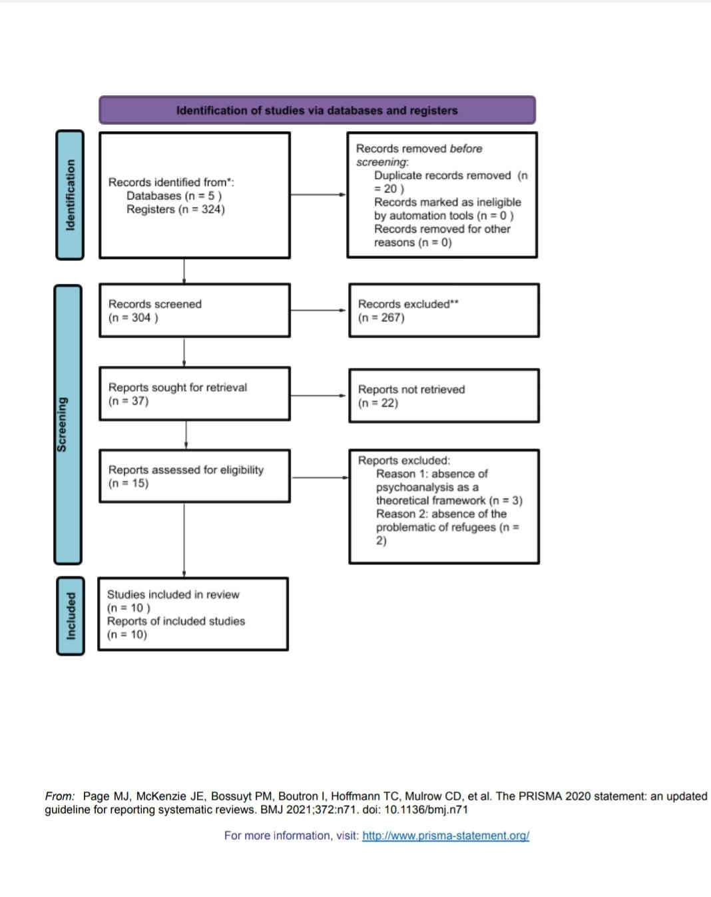

After judiciously reading the selected articles, a reading file was developed to organize the data that was present in each article. To facilitate the discussion of the themes that were exposed by the articles, we attributed them a number from 1 to 10 and developed a flowchart to present this information.

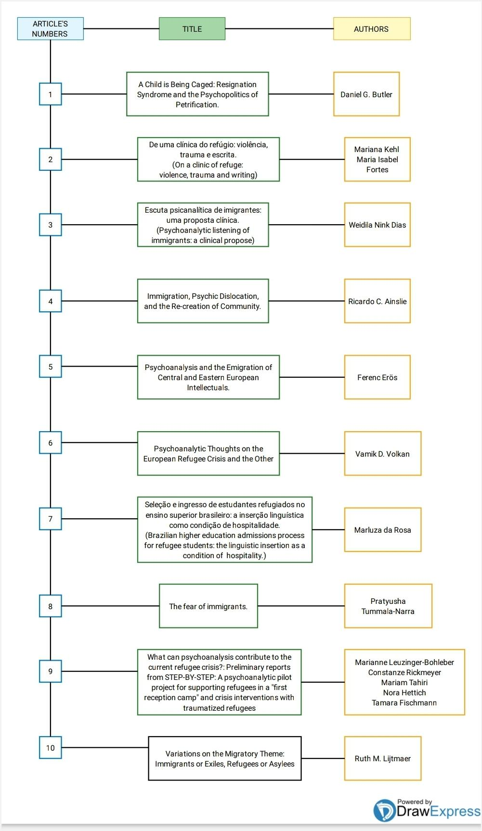

Even though some authors might have had a background in literature or education, most had psychoanalysis and psychology as the basis of their professional education. We were also able to identify that even though migration is a globally relevant theme, all analyzed articles were written in the Americas, specifically in the United States and Brazil. Article 9 was written by German researchers but published in an American journal.
Additionally, in this current review, we identified a scarcity of research investigating migration from a psychoanalytic lens. We found a lot of articles that discussed the mental health of diasporas, specifically concerning PTSD, school absence, and medical treatments. However, there was a small number of articles that matched the inclusion criteria of our systematic review (articles that discussed how psychoanalysis could be used to inform public policy aimed at migrants and refugees),
Out of all the ten articles that constituted our systematic review, only article 7 was not published in a psychoanalytic journal. This article focused on the communication between psychoanalysis and linguistics, and it sought to explore the challenges that refugees, and non-Brazilian students face in the selection process of Brazilian public universities. Psychoanalytic writings facilitate the discussion of the importance of language on the subject’s insertion in a particular culture. The article notes that there are incongruencies between what is warranted by law to migrants and refugees in Brazil and what actually happens when they try to enter public Universities.

Discussion
Most of the articles included in our systematic review aimed to investigate psychoanalysis’ reach and its contribution to the theme of contemporary diasporas. We found that psychoanalytic contributions were particularly relevant when discussing the following themes: trauma, violence, defining the subject, reflections on abandonment, the relationship between natives and foreigners, pathologizing, and conflicts pertaining to otherness. These contributions were predominantly present in arguments that debated migration and refuge. Psychoanalysis and its clinical and theoretical contributions can help one reflect and deal with themes that concern subjectivity and the value of one's insertion into the social bond. However, although psychoanalysis can help in this area, its contributions are still relatively scarce.
Among the articles we used in our research, we found a public policy proposal implemented as a pilot project in a center for receiving refugees in Germany. This pilot was described in article 9, which discusses the implementation of a project that sought to embrace regular psychoanalytic interventions for migrants and refugees. Even though the article discussed preliminary results, it was the only article that effectively described a process for implementing action informed by psychoanalysis in public policy. The article's authors described how they made psychoanalytic treatment available for families of refugees once they arrived in their destination country and how psychoanalytic treatment was also made available for people working in centers that welcome refugees. The authors believe that these psychoanalytic interventions can provide refugees with space to tell their stories, validating their struggles and expectations of living in a new country. According to Lijtmaer (2017), author of article 10, there is an important psychological difference between leaving and disappearing because the latter consists of vanishing without leaving any trace, without any farewells, and without any plans of returning. This disappearance dynamic makes the symbolization of change more difficult, mainly because it involves experiences that can be deemed traumatizing. Article 10 discusses situations in which migrating became necessary, highlighting the subject's experiences of "a period of disorganization, pain/suffering, and frustration, which can produce a catastrophic sensation of loss" (Litjmaer, 2017, p. 688). Therefore, how refugees are received in their destination country significantly impacts the likelihood of them achieving the goals that motivated them to leave their home country. Refugees arrive at their destination countries after facing numerous challenges and are often made to feel invisible because of how they are received by a part of the population of their new country, whom they expected would welcome them. Public policies (strategies that are planned and put into action) have a decisive and fundamental role in welcoming migrants.
Reflections and proposals on the psychoanalytical clinic and the process of listening to the stories that refugees had to tell was a theme present in articles 2 and 3. Like article 9, they highlighted the importance of listening and serving as a witness to the diasporic subject. Both listening and witnessing are fundamental conditions for welcoming and recognizing the singularity of each migrant and their life story. Article 2 explores a refuge clinic based on a reflection of the dangerous and precarious conditions migrants are exposed to in their destination countries. Article 3 discusses the possibilities of clinical interventions for refugees, underscoring the fact that autobiographical narratives by refugees make their traumatizing experiences evident. The authors of article 3 also postulate that migration is a cultural and linguistic movement and that because of that, psychoanalysis should not abstain from studying and developing interventions for this movement. The affirmation that psychoanalysis can and should contribute to public policy is based on the possibility (raised by the article's authors) that the broad listening capacity of psychoanalysis could go beyond a private clinical exercise. Moretto (2019) defends this claim by affirming that the psychoanalytic clinic is not a physical space but a "method that allows for a specific type of relationship to be established with suffering, where a professional leans in to listen to what someone else has to say, showing that he recognizes the existence of their suffering, and intends on treating it – which is not always the same thing as curing it" (p. 66)
The role of rebuilding a notion of community in the subjective world of migrants was one of the themes emphasized in article 4. The author postulates that psychoanalysis can fill the gap that exists between sociology and anthropology, contributing to a greater understanding of the subject that lives in a particular community, while also providing tools to deliberate on migration. As such, the article discusses the relationship between available resources in communities and Donald Winnicott's theoretical contributions to the notion of a transitional object. The space communities offer migrants is compared to a sort of "holding". In this space, the presence of objects like food, music, and language that are a part of a migrant's original culture, might serve as transitional objects favoring the transition of the migrant to their new community.
The risk of psychopathology as a consequence of migration is discussed in article 1 where the author emphasizes the traumatizing effects identified in children of refugees whose families were denied asylum after moving from Eastern Europe to Sweden. These children then started showing an extreme case of apathy named Resignation Syndrome by the article's author. Such a syndrome is articulated in a psychoanalytic and psychopolitical reading, made evident by the denial of a government to provide refuge to the child’s family, which the child experiences as a repetition of the violence they suffered in their past. In this dynamic, it is understood that the psychic mechanism utilized by the child is apathy, which is identified as a coma state (petrification), understood as being the last psychic tool that the refugee child makes use of to, paradoxically, survive.
The social and psychic effects of refuge and migration were topics explored in depth in one of the articles. Among the arguments that were discussed was the fact that refugees go through an important and intense process of grief because they lost their house, job, contact with their friends and family members, customs, etc. In article 6, the experience of biculturalism is portrayed as a possibility of elaborating grief. The author proposes that a feeling of belonging can be experienced in relation to one’s original culture (home country) as well as to one’s new culture (destination country). This would promote the incorporation of new cultural aspects, contributing to the elaboration of experienced losses.
The identification of refugees and migrants as strangers who are associated with dangerous situations and seen as a threat to the citizens of the countries that they migrate to was recognized as an important area for psychoanalytical work in article 8. The article's author proposes that psychoanalysis can help refugees and prepare the people that will welcome them. These people could use psychoanalysis to promote harm reduction by proposing public policies aimed at decreasing the risks that refugees face.
Only article 5 discussed the effects of migration from an intellectual perspective. The article discussed the migration of psychoanalysts, mainly Austro-Hungarian psychoanalysts, who migrated as part of large migration waves due to World War 1 and World War 2. The first migration wave occurred between 1918 and 1919 and had Berlin as the primary destination for migrants. The second wave started between 1931 and 1932, with most migrants moving to the United States to flee Nazism. The article's author postulates that the intellectual exodus from Europe in the 20th Century was an important historical phenomenon because notorious intellectuals and scientists migrated, taking their ideas and skills with them, which would lead to the development of many different fields of study in their destination countries. In this article, the author explored the changes that psychoanalysis (in its theoretical and clinical domains) and psychoanalysts experienced due to these migrations. These changes happened because psychoanalysts had to transform and adapt to the prevalent political and social contexts in their destination countries.
All in all, after gathering data in this systematic review, we observed the heterogeneity and complexity that are inherent to the field of contemporary diasporas. The articles mentioned in this systematic review discussed contemporary diasporas from different and unique perspectives, allowing us to understand how psychoanalysis can contribute to proposals of public policies aimed at migrants.
The relationship between human rights and refuge promotes discourses that are, for the most part, “abstract, idealistic, and uncritical” (Santinho, 2013, p.12) compared to what happens in the lives of refugees and migrants before and after migration. The catastrophic events caused by migration destroy bonds and are a consequence of the actions of people who often don’t recognize their mistakes or their responsibility in this process (Gondar, 2017). This situation is close to what was described by Gondar (2017) as these “cases produce in their victims’ feelings of annihilation which they hardly ever recover from” (p. 213). In this direction, psychoanalysis has a lot of potential for contributing to the psychological health of migrants, especially if we consider its tools of intervention for situations where intense psychological suffering is present due to experiences of indifference and repulsion in the intersubjective space.
González (2016) identified an increase in the production of psychoanalytical articles that discuss migration. González postulated that “the predominant tendency in this developing literature has been to see immigration largely as a psychological damaging process, a traumatic event that poses unprecedented difficulties and usually leaves irremediable scars in these subjects” (Gonzáles, 2016, p. 15). For Moretto (2019), psychoanalysis has tools at its disposal where “the relationship between suffering and singularity is set; the psychological approach to suffering demands from us the recognition of its dimension of singularity” (p. 68). González (2016) also made an important point on the value of psychoanalytic studies, as he postulated that “such analysis has been necessary, to not only ameliorate suffering but also initiate a process of remediation for the dehumanizing tendencies of xenophobia, whose principal mechanism is the erasure of the histories of (subaltern) Others” (p. 15). González believes that psychoanalytical studies about diasporas serve to promote the understanding that “the displacement necessarily occasioned by immigration – especially when forced by economic deprivation or political oppression - is unquestionably a tremendous challenger to subjectivity, but it is also the fertile ground of creativity, the strange place where something new can come into being” (González, 2016, p.16). The myriad of possibilities for creating a new and creative future highlights the importance of the relationship between public policy and psychoanalysis.

Conclusion
This systematic review investigated how psychoanalysis is contributing to public policies aimed at migrants by writing scientific articles. We noted that in the past five years, there were only a few publications on this subject. The qualitative analysis that we conducted on the articles of this systematic review allowed us to identify the unexplored potential of psychoanalytical contributions to the study of migration, this being of particular importance due to the rising number of people finding themselves in refuge or as migrants. Thoroughly reading 15 scientific articles was a consistent and rigorous part of our methodological process. The judicious evaluation employed by the referees while reading the articles allowed us to identify specific elements that would later compose the final database of our systematic review. Therefore, our qualitative analysis broadened access to diverse and unique psychoanalytical writings on public policy.
It is important to note that as contemporary diasporas increase throughout the globe, they also make apparent the difficulties migrants face in their home countries and the rejection they experience when arriving in their destination countries. The dramatic conditions of the social bond are exemplified by the fact that the subject needs to migrate to keep himself and his family alive. Contexts of war, violence, and persecution (a consequence of conditions of precariousness and vulnerability generated by social and economic inequality) are ignored when the migrant is perceived as a threat. Migrants experience violence and indifference daily and are often denied the recognition of their humanity.
The articles discussed in this systematic review showed how psychoanalysis could contribute to the debate on the traumatic effects arising from situations where repulsion to migrants is predominant and where there are dynamics that interfere with them belonging to the social bond. Therefore, it is vital to recognize tools in the psychoanalytical repertoire that might help identify, denounce, and intervene with expressions of violence and inequalities that might contribute to the development of psychopathology.
The ambivalence and contradiction observed in how migrants are received in their destination countries create a distance between subjects and social bonds, generating a gap that demands the insertion of effective public policies. Thus, in reports of violence denouncing vulnerabilities and the difficulty of recognizing migrants as similar, we find a demand for psychoanalysis.
This systematic review allowed us to identify gaps in the psychoanalytic literature and understand how psychoanalytical writings can contribute to put an end to the indifference seen in the social bond, promoting the legitimacy of the rights of migrants, which was our primary motivation for producing this article. To conclude, we want to emphasize that (based on this current study on diasporas, public policy, and psychoanalysis) the most valuable contribution of psychoanalytic writings is in denouncing the subterfuges and violence that impede the recognition of the other as similar.

References

Agum, R., Riscado, P., & Menezes, M. (2015). Políticas Públicas: Conceitos e Análise em Revisão [public policies: concepts and analysis under review]. Agenda Política, 3(2), 12–42. https://doi.org/10.31990/10.31990/agenda.ano.volume.numero
Ainslie, R. C. (2017). Immigration, Psychic Dislocation, and the Re-creation of Community. Psychoanalytic review, 104(6), 695–706. https://doi.org/10.1521/prev.2017.104.6.695
APA. (2021) Thesaurus of Psychological Terms
Retrieved, 09 September 2021, from: https://www.apa.org/pubs/databases/training/thesaurus
Butler, D. G. (2020). A Child is Being Caged: Resignation Syndrome and the Psychopolitics of Petrification. Journal of the American Psychoanalytic Association, 68(3), 333–357. https://doi.org/10.1177/0003065120935594
Costa, A. B. & Zoltowski, A.P.C. (2014). Como escrever um artigo de revisão sistemática. [How to write a systematic review article.] In S. H. Koller, M. C. P. P. Couto & J. V. Hohendorff (Eds.), Manual Produção Científica (pp. 55-70). Penso.
Dias, W. N. (2020). Escuta psicanalítica de imigrantes: uma proposta clínica [Psychoanalytical listening of immigrants: a clinical proposal]. Ide, 42(69), 159-168. http://pepsic.bvsalud.org/scielo.php?script=sci_arttext&pid=S0101-31062020000100015&lng=pt&tlng=pt.
Erős, F. (2016). Psychoanalysis and the Emigration of Central and Eastern European Intellectuals. American journal of psychoanalysis, 76(4), 399–413. https://doi.org/10.1057/s11231-016-9051-8
Freud, S., & Strachey, J. (1989). Group psychology and the analysis of the ego. Norton.
Gondar, J. (2017). O desmentido e a zona cinzenta [The denial and the gray zone]. In J. Gondar, & E. S. Reis (Eds.), Com Ferenczi: clínica, subjetivação, política (pp. 89-100). 7 Letras.
González, F. J. (2016). Only What Is Human Can Truly Be Foreign: The Trope of Immigration as a Creative Force in Psychoanalysis. In Beltsiou J. (Ed.), Immigration Psychoanalysis – locating Ourselves (pp.15-38). Routledge.
Kehl, M., & Fortes, M. I. (2019). De uma clínica do refúgio: violência, trauma e escrita [On a clinic of refuge: violence, trauma, and writing]. Revista Latinoamericana de Psicopatologia Fundamental, 22(3), 520-539. https://doi.org/10.1590/1415-4714.2019v22n3p520.7.
Leuzinger-Bohleber, M., Rickmeyer, C., Tahiri, M., Hettich, N., & Fischmann, T. (2016). What can psychoanalysis contribute to the current refugee crisis? The International journal of psychoanalysis, 97(4), 1077–1093. https://doi.org/10.1111/1745-8315.12542
Lijtmaer, R. M. (2017). Variations on the migratory theme: Immigrants or exiles, refugees or asylees. Psychoanalytic Review, 104(6), 687–694. https://doi.org/10.1521/prev.2017.104.6.687
Macedo, M. & Kupermann, D. (2020). Alteridade e indiferença no contemporâneo: a indizibilidade do outro nas situações de refúgio e migração [Otherness and indifference in contemporary times: not talking about refugees and migration]. In J. Birman, I. Fortes, & M. M. K. Macedo (Eds.), Psicanálise e Política (pp. 97 - 107). Zagodoni
Moretto, M. L. T. (2019) Políticas Públicas, Psicanálise e o lugar do analista [Public policies, psychoanalysis and the analyst 's place]. In E. Broide, & I. Katz (Eds.), Psicanálise nos espaços públicos (pp. 66 - 72). IP/USP ISBN: 978‐85‐86736‐87‐2.
Medical Subject Headings. (2022). Mesh browser. U.S. National Library of Medicine. Retrieved July 2022, from https://meshb-prev.nlm.nih.gov
International Organization for Migration (IOM). (2019). Glossary on Migration. Geneve; International Organization for Migration.
Ouzzani, M., Hammady, H., Fedorowicz, Z. & Elmagarmid, A. (2016). Rayyan—a web and mobile app for Systematic Reviews. Systematic Reviews, 5(1). https://doi.org/10.1186/s13643-016-0384-4
Page, M. J., Mckenzie, J. E., Bossuyt, P. M., Boutron, I., Hoffmann, T. C., Mulrow, C. D., et al. (2021). The PRISMA 2020 statement: an updated guideline for reporting systematic reviews. BMJ, 372: n71. https://doi.org/10.1136/bmj.n71
Roever, L. (2017). Compreendendo os estudos de revisão sistemática [Understanding systematic review studies]. Revista da Sociedade Brasileira de Clínica Médica, 15(2), 127–130. https://www.sbcm.org.br/ojs3/index.php/rsbcm/article/view/276
Rosa, M. (2018). Seleção e ingresso de estudantes refugiados no ensino superior brasileiro: a inserção linguística como condição de hospitalidade [Brazilian higher education admission processes for refugee students: the linguistic insertion as a condition of hospitality]. Trabalhos em Linguística Aplicada, 57(3), 1534-1551. https://doi.org/10.1590/010318138651687356621
Sampaio, R. F., & Mancini, M. C. (2007). Estudos de Revisão Sistemática: Um guia para síntese criteriosa da Evidência Científica [Studies on systematic reviews: a guide for a judicious synthesis of scientific evidence]. Brazilian Journal of Physical Therapy, 11(1), 83–89. https://doi.org/10.1590/s1413-35552007000100013
Santinho, M. C. (2013). Afinal, Que Asilo É Este que não nos protege? [After all, what is this asylum that doesn’t protect us?] Etnografica, 17(1), 5–29. https://doi.org/10.4000/etnografica.2522
Silva, A. C. (2014). Psicanálise e Políticas Públicas: desafios e limites para a relação entre política e sujeito. [Psychoanalysis and Public Policy: challenges and limits for the relationship between politics and subject] Retrieved September, 15 2021, from http://www.psicopatologiafundamental.org.br/uploads/files/vi_congresso/Mesas%20Redondas/97.pdf
Souza, C. (2006). Políticas Públicas: Uma Revisão da Literatura [A systematic review of the literature]. Sociologias, (16), 20–45. https://doi.org/10.1590/s1517-45222006000200003
Tummala-Narra, P. (2020). The fear of immigrants. Psychoanalytic Psychology, 37(1), 50–61. https://doi.org/10.1037/pap0000245
United Nations High Commissioner for Refugees. (2021, June 18). Global Trends: forced displacement in 2020. Copenhagen; UNHCR Global Data Service.
United Nations Department of Economic and Social Affairs, Population Division. (2020). International Migration 2020 Highlights. New York; United Nations.
Volkan V. D. (2017). Psychoanalytic Thoughts on the European Refugee Crisis and the Other. Psychoanalytic review, 104(6), 661–685. https://doi.org/10.1521/prev.2017.104.6.661

