Unlocking Pre-Sleep Habits: Introducing and Validating a New Brief Scale of Device Use Before Sleep

Abstract
The use of technological devices before sleep has become an everyday behavior among adults, adolescents, and teenagers. This habit leads to problems with sleep quality. Therefore, the primary aim was to develop and validate an instrument for the use of devices before sleep (DUBS). Data were collected from 250 participants (57.6% female) in this preliminary report. The study's primary outcomes indicated that the evaluating judges reached a consensus regarding the items' relevance, representativeness, and clarity. Factor analysis revealed a unidimensional structure. However, difficulties were evidenced in the discrimination indexes, difficulty and factor loadings of item 4. Nonetheless, the final model demonstrated appropriate reliability coefficients (α = 0.78 and ω = 0.79) in its unidimensional structure, containing four items. The DUBS instrument has proven to be a reliable measure of the habit of using technological devices before going to sleep, allowing for the implementation of intervention strategies aimed at improving sleep quality.
Keywords: Sleep Habits, Technology Device, Psychometric, Validation, Sleep Quality, Bedtime.
Introduction
Today, technology has taken on unprecedented importance in our daily lives. From dawn to dusk, we constantly interact with various devices and applications that have drastically altered our communication, work, learning, and entertainment. This pervasive technological impact has affected all aspects of society's individual and collective levels, leading to a progressive reduction in the amount of sleep that children, adolescents, and adults get (Chen et al., 2021; Gába et al., 2020; Grummon et al., 2021).
Technological advances have significantly improved physical health. Numerous devices and applications can track physical activity, document exercise routines, and obtain precise health information (Busch et al., 2022; Ferraro et al., 2018). Wearable devices such as smartwatches and activity bands provide detailed tracking of steps taken, calories burned, sleep quality, and heart rate, among other parameters (Krebs & Duncan, 2015; Paré et al., 2018). Specialized mobile applications also provide personalized exercise programs, nutritional advice, and reminders to stay active. These technologies have increased awareness of the importance of physical activity and motivated individuals to adopt healthier and more active lifestyles (Krebs & Duncan, 2015). Technology has become a valuable ally in promoting physical well-being and overall health by providing access to relevant information and tracking tools.
However, technology has negatively affected our physical and mental health habits (Exelmans & Van den Bulck, 2016; Kamaleddine et al., 2022), mainly boredom, sleep, rest, and wakefulness (De-Sola Gutiérrez et al., 2016; Farooqui & Raquib, 2022; Shochat, 2012). Excessive use of electronic devices before bedtime changes our circadian rhythms, making it difficult to fall asleep (Adams et al., 2013; Chang et al., 2015a). Exposure to blue light emitted by screens disrupts the natural production of melatonin, the hormone responsible for regulating our sleep-wake cycle (Lee & Kim, 2019; Russart & Nelson, 2018). Moreover, frequent use of technology at night has been linked to reduced sleep quality and duration, leading to fatigue, lack of concentration, and decreased cognitive performance during the day (Farooqui & Raquib, 2022; Shochat, 2012). Late bedtimes may independently compromise diet quality, as consuming food late at night is associated with increased caloric intake and poorer diet compared to meals eaten earlier in the day (Baron et al., 2011; Spaeth et al., 2013).
The bright screens of electronic devices can make it difficult to fall asleep and increase alertness (Gradisar et al., 2013). Extended usage of these devices before bedtime disrupts standard sleep patterns, resulting in poorer sleep quality. Furthermore, exposure to screen light for one hour at nighttime does not considerably affect melatonin production. However, studying past 1.5 hours leads to less relaxing sleep and elevated performance in mental exams. Continuous exposure to bright screens for five consecutive days can delay the biological clock by 1.5 hours, leading to difficulties waking up early for work or school (Cajochen et al., 2011). Conversely, studies show that using technology device before bedtime can negatively impact sleep quality. Individuals who use electronic device before bedtime report lower satisfaction with their sleeping routines and are more likely to experience drowsiness during daytime activities, including while driving (Gradisar et al., 2013).
Several tools have been designed for assessing pathological cell phone use, Internet addiction, and compulsive technology use (Cho et al., 2014; Kwon et al., 2013). Nonetheless, there is a marked lack of specific instruments for evaluating device use before sleep despite its potentially detrimental effects on sleep quality. This aspect's assessment is crucial to understand better the impact of nocturnal electronic device use on sleep and wakefulness. Furthermore, health professionals can identify potential sleep problems resulting from technological interference more accurately and promptly by utilizing specialized assessment instruments, enabling them to administer suitable treatments. Thus, creating assessment tools that directly address pre-sleep technology device use is crucial in advancing our understanding and approach to this problem.
The validation of this measure will provide a reliable and valid tool to study the impact of technology device use on sleep. It will contribute to the development of appropriate prevention and intervention strategies to promote healthy pre-sleep habits.
Method
Participants
A total of 250 participants were recruited for this research through snowball sampling based on the researchers' scope. Inclusion criteria entailed being at least 18 years old, having regular access to electronic devices before sleep, and not having any diagnosed sleep disorders. Individuals receiving medication that could potentially disrupt sleep or who had medical conditions significantly affecting sleep quality were excluded.
Participants provided informed consent before their involvement in the study. Table 1 shows that the sample consisted of 42.4% men and 57.6% women with an average age of 22.3 (SD = 6.61). Most participants were single (92.4%), with 5.2% married, 2.0% cohabitating, and 0.4% divorced. Additionally, 24.4% had completed primary education, 58.8% had incomplete higher education, 16.4% had completed higher education, and 0.4% had incomplete primary education. Only 34.4% of the participants adhered to a sleep schedule, while 65.6% did not. The participants' average sleep duration per night was 6.7 hours (SD = 1.33 hours).
Instrument
Device Use Before Sleep (DUBS). In this study, we developed a tool to evaluate pre-sleep electronic device usage. We developed the instrument based on existing literature and expert knowledge in the field. The structured questionnaire covers various aspects of electronic device use in the hours leading up to bedtime. We assessed problematic behaviors and difficulties disconnecting from technology device before sleep. The survey included inquiries about the continued usage of technological devices despite fatigue and a relaxing environment. Expert judges conducted a review process to validate the instrument, followed by adjustments based on feedback. Objective language, free from bias and loaded language, was employed throughout. The formal register was maintained, and colloquial language and contractions were avoided. The initial instrument comprised five items rated on a Likert scale ranging from 1 (never) to 5 (always).
Procedures
This study adhered to the principles of the Declaration of Helsinki and was approved by the ethics committee of Universidad de Ciencias y Humanidades. Confidentiality was maintained, and participant privacy was protected using identification codes instead of real names. Participants voluntarily contributed to the study without receiving any financial compensation. They were informed of their right to leave the study at any time without negative consequences. Data collection was conducted in June 2023.
Data Analysis
Data analysis began with the content validation of the instrument through the participation of six experts in the field. All suggestions were weighed carefully, and the necessary modifications were executed before a final version of the instrument was developed. Furthermore, Aiken's V coefficient scores (Aiken, 1980) were obtained from the most recent version of the instrument.
Subsequently, we conducted exploratory factor analysis (EFA). The R Studio program (v. 4.3.1.) and the psych, GPArotation, and parameters packages were employed for this analysis. First, we conducted a descriptive analysis of the items to assess their central tendency, dispersion, and distribution. Then, we set the normality of the data by using the skewness and kurtosis coefficients according to Finney and DiStefano's criteria (Finney & DiStefano, 2013) of ±2 and ±7, respectively.
As the study variable was a Likert-type variable with five response options, we considered its ordinal nature for specific analyses. We evaluated the sample adequacy using the Kaiser-Meyer-Olkin (KMO) index (> .80) and Bartlett's test of sphericity (p < .05). To perform factor analysis, we utilized the weighted least squares (WLS) estimation method. We assessed the Kaiser criterion and factorial acceleration to determine the appropriate number of relevant factors for the analysis. The item factor loadings were evaluated based on the factorial solution, and those below 0.50 were deemed inadequate (Dominguez-Lara, 2018). Additionally, the reliability of the items was assessed using alpha and omega coefficients, which must exceed 0.70 to be considered sufficient (Choi et al., 2009).
Results
Content Validity
The content validity of the measure was assessed through the participation of experts in the field, who conducted a thorough evaluation of the items in terms of their relevance, coherence, and clarity. The results suggest that most items showed high validity in terms of these criteria (Table 1), which supports the adequacy of the instrument's content. Nonetheless, item 4 demonstrated coefficients that significantly deviated from 1 in relevance and coherence.
Table 1. Aiken’s V of Relevance, Coherence, and Clarity of Items
Items | Relevance |  |  |  |  | Representativeness |  |  |  |  | Clarity
 | M | SD | V | CI95% |  | M | SD | V | CI95% |  | M | SD | V | CI95%
1 | 2.43 | 0.98 | 0.81 | 0.60 - 0.92 |  | 2.71 | 0.76 | 0.90 | 0.71 - 0.97 |  | 2.86 | 0.38 | 0.95 | 0.78 - 0.99
2 | 2.86 | 0.38 | 0.95 | 0.78 - 0.99 |  | 2.43 | 1.13 | 0.81 | 0.60 - 0.92 |  | 2.43 | 1.13 | 0.81 | 0.60 - 0.92
3 | 2.57 | 0.79 | 0.86 | 0.65 - 0.95 |  | 2.29 | 1.11 | 0.76 | 0.55 - 0.90 |  | 2.29 | 1.11 | 0.76 | 0.55 - 0.90
4 | 2.00 | 1.00 | 0.67 | 0.45 - 0.83 |  | 2.14 | 1.07 | 0.71 | 0.50 - 0.86 |  | 2.86 | 0.38 | 0.95 | 0.78 - 0.99
5 | 2.71 | 0.76 | 0.90 | 0.71 - 0.97 |  | 2.71 | 0.76 | 0.90 | 0.71 - 0.97 |  | 2.71 | 0.76 | 0.90 | 0.71 - 0.97
Note. M = mean; SD = standard deviation; V = Aiken’s V; CI = Confidence intervals.
Item Analysis
An analysis of the items showed distinct patterns in the participants' responses. Item 1 demonstrated a tendency toward high scores, as evidenced by its mean and skewness, as shown in Table 2. The rest of the items demonstrated a similar high-value trend, which indicated a general preference for "Agree" and "Strongly agree" responses. However, item 5 showed a comparatively uniform distribution compared to the other items.
Furthermore, it was noticed that eliminating item 4 ("I charge my device's battery before sleeping") enhanced the alpha and omega coefficients, which determine the instrument's internal consistency. Inter-item correlations showed that item 4 had a weaker association with the other items, while the other items exhibited strong correlations. Furthermore, it is essential to consider excluding item 4 due to its demonstrated lowest discrimination ability and highest difficulty, as well as item 5. These findings suggest a necessity to exclude item 4.
Table 2. Descriptive, Distribution, Discrimination, Difficulty, Reliability, and Polychoric Correlation of Items
Items | M | SD | g₁ | g₂ | Distribution | a | b | If item dropped |  |  | Polychoric Correlation
 |  |  |  |  |  |  |  | α | ω |  | 1 | 2 | 3 | 4 | 5
1 | 4.21 | 1.04 | -1.29 | 1.09 | 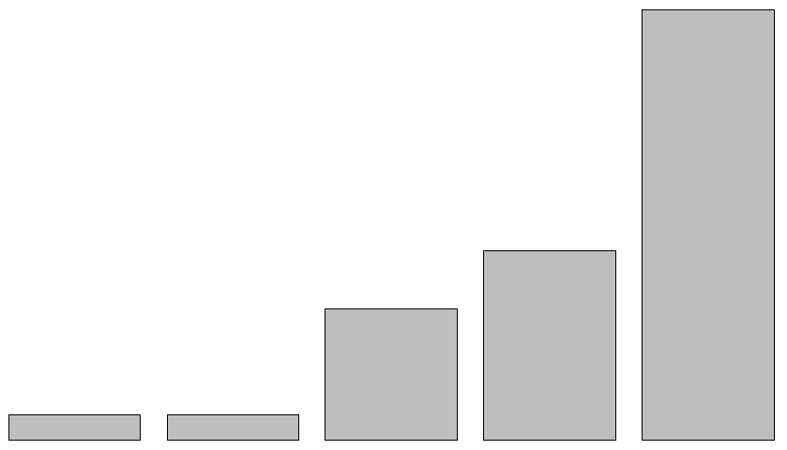 | 0.54 | 0.84 | 0.72 | 0.74 |  | -
2 | 3.66 | 1.34 | -0.65 | -0.76 | 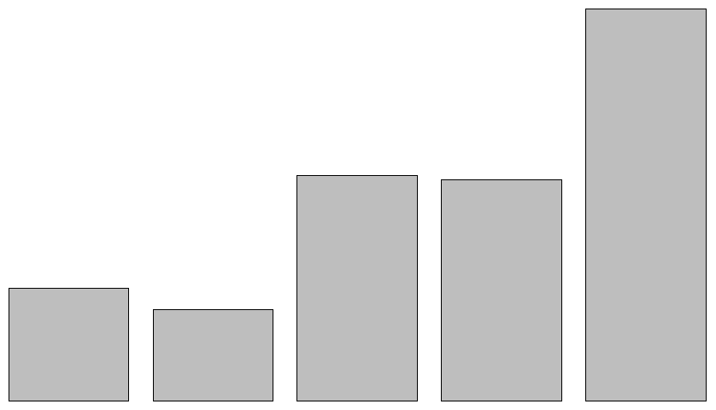 | 0.64 | 0.73 | 0.68 | 0.69 |  | 0.70 | -
3 | 3.34 | 1.23 | -0.25 | -0.89 | 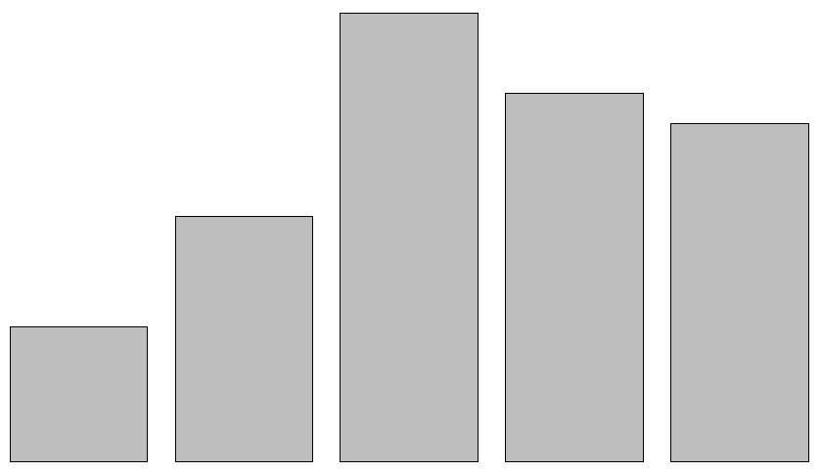 | 0.66 | 0.67 | 0.67 | 0.69 |  | 0.61 | 0.69 | -
4 | 3.56 | 1.33 | -0.54 | -0.85 | 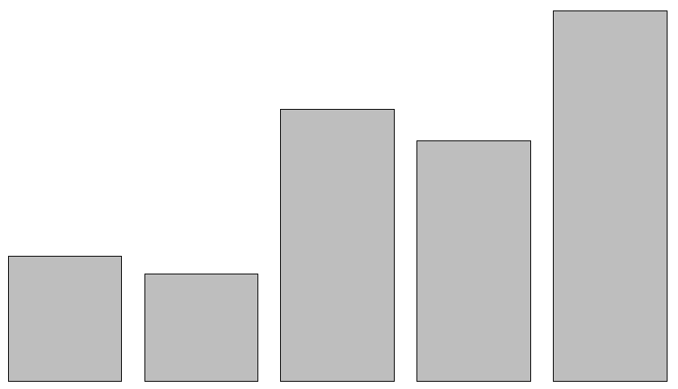 | 0.37 | 0.71 | 0.78 | 0.79 |  | 0.32 | 0.34 | 0.38 | -
5 | 2.90 | 1.24 | 0.16 | -0.89 | 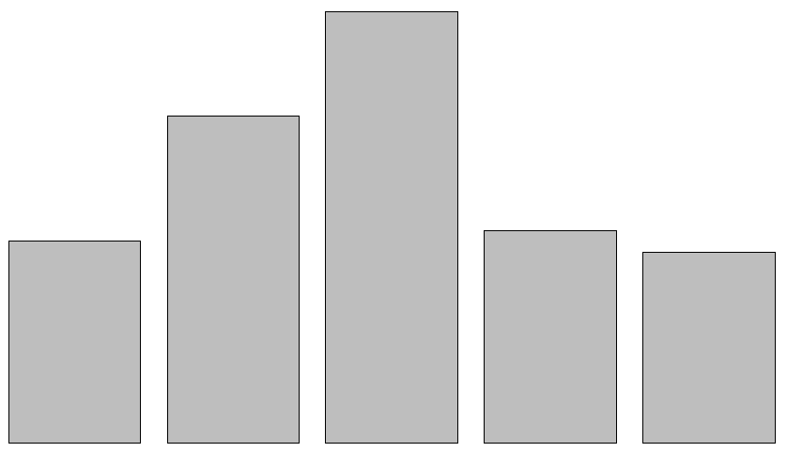 | 0.47 | 0.58 | 0.74 | 0.76 |  | 0.35 | 0.46 | 0.49 | 0.34 | -
Note. Reliability: α = 0.76; ω = 0.78. g₁ = skewness; g₂ = kurtosis; a = discrimination, b = difficulty; α = alpha; ω = omega.
Factor Analysis
An exploratory factor analysis was conducted to explore the underlying structure of the instrument. The KMO test of sampling adequacy yielded a value of 0.78. Additionally, the statistically significant Bartlett's test of sphericity supported the use of this analysis.
To determine the number of factors to be extracted, parallel analysis and Kaiser's criterion were used. Both methods indicated the presence of a single factor in the instrument. Figure 1 displays the factor loadings of the initial model, comprising the five original items. Nonetheless, item 4 was removed because it failed to meet the anticipated factorial weight (0.50), resulting in the final model.
The final model demonstrated satisfactory results regarding the factorial structure. Furthermore, the alpha and omega coefficients were employed to evaluate the instrument's reliability, and both values proved adequate at 0.78 and 0.79, respectively. These findings indicate that the instrument displays strong internal consistency and sufficiently reliable measures of the underlying variables.
Figure 1. First and Final Factorial Model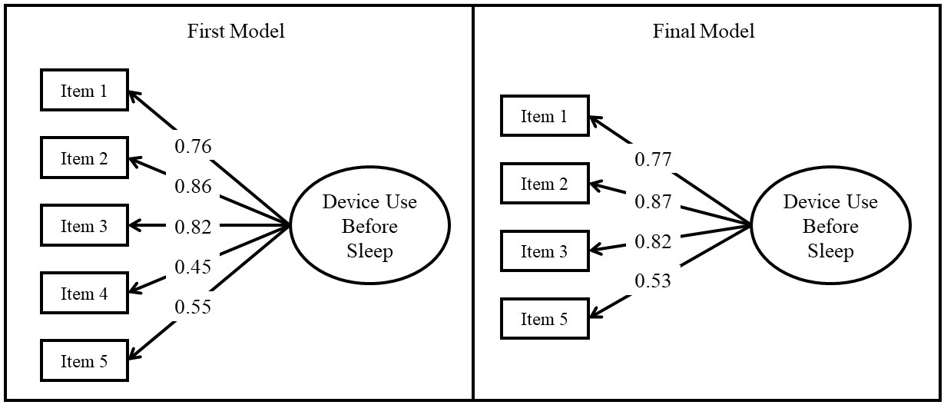
Discussion
The purpose of the study was to develop and validate an instrument to assess device use before bedtime. It is important to emphasize that the use of device before bedtime has been associated with concerns due to its potential negative impact on sleep quality and wakefulness (Chang et al., 2015b; Staples et al., 2021), as well as problems such as technology dependence, anxiety, stress, and poor inhibitory control (Rosen et al., 2016; Rossa et al., 2014), affecting both physical and mental health. In addition, this habit has been found to negatively impact sleep quality, duration, and daytime cognitive performance (Arora et al., 2018; Dimitriou et al., 2015).
The lack of specific instruments to address this phenomenon has been a limitation in previous research, as it hinders the accurate identification of its impact on health and well-being. Therefore, the development and validation of an accurate instrument to measure the use of device before sleep becomes an essential contribution to a more complete understanding of this phenomenon. To achieve an adequate measurement of the phenomenon, the DUBS was designed. This instrument was first subjected to an initial content-based validity process, where it was found that item 4 showed difficulties in the V coefficients in two criteria: relevance, which seeks to determine whether the item plays a fundamental role in the measurement of the indicator in question; and coherence, which refers to the evaluation of whether the item is logically adapted to the variable it is trying to measure (Aiken, 1980). On the other hand, the other items showed a good fit regarding relevance, coherence and clarity.
In terms of validity based on internal structure, exploratory factor analysis was used, yielding a unidimensional model. In this process, a problem arose with item 4 in terms of its discriminability, difficulty, and factor load (Boateng et al., 2018; DeVellis & Thorpe, 2021; Dominguez-Lara, 2018), which led to the decision to eliminate it from the model, resulting in a unidimensional model with four items. This decision was based not only on statistical criteria but also on judgment (Wieland et al., 2017). Excluding items is a common and essential practice when validating measuring instruments (Boateng et al., 2018). Eliminating items that have no relevance or do not fit well with the construct to be measured strengthens the instrument's conceptual coherence and internal consistency, resulting in a solid structural model with adequate reliability indices.
The DUBS instrument proved reliable and valid in assessing behaviors related to electronic device use before bedtime, as evidenced by its optimum alpha and omega coefficients (Raykov & Hancock, 2005). This instrument is the first to be specifically designed to assess this phenomenon, and its importance in the field of health sciences must be recognized. Exploring this behavior will provide new opportunities to understand its impact on physical and mental health and to develop interventions to promote healthier use of technology before bedtime. The DUBS can help understand how these behaviors affect performance and develop strategies to improve productivity and learning. It is also a measurement instrument that can be used to evaluate the effectiveness of interventions designed to reduce the use of electronic devices before bedtime and promote healthier habits.
Despite the findings and contributions of the present study, it is important to highlight some limitations that should be considered when interpreting the results. Using a non-probabilistic sample could limit the generalizability of the results to larger populations. The study exclusively aimed to validate the instrument and did not directly investigate the impact of pre-sleep electronic device usage on individuals' health and overall well-being. Nevertheless, this initial report on the Device Use Before Sleep (DUBS) sets an important precedent for future research. This may include confirmatory studies, invariance analysis, and Item Response Theory (IRT). Numerous possibilities exist for research related to the DUBS, including instrumental, associative, and explanatory analysis, among other research designs.
In conclusion, this study played a crucial role in creating and validating the BUDS tool for evaluating electronic device use before bedtime. The internal structure validity was reinforced through an exploratory factor analysis that resulted in a unidimensional model and the removal of a problematic item. Additionally, the instrument's internal consistency was verified by utilizing alpha and omega coefficients. This provides further evidence of the reliability of the instrument. By incorporating it into future research, we can broaden our comprehension regarding the effects of technology usage before sleeping, identify at-risk populations, and develop effective intervention strategies. The BUDS is promoted as an essential tool to enhance research and encourage healthy sleep practices in a progressively digital world. Its impact on health sciences and potential to improve individuals' quality of life are noteworthy and deserving recognition.
References
Adams, S. K., Daly, J. F., & Williford, D. N. (2013). Article Commentary: Adolescent Sleep and Cellular Phone Use: Recent Trends and Implications for Research. Health Services Insights, 6, HSI.S11083. https://doi.org/10.4137/HSI.S11083
Aiken, L. R. (1980). Content Validity and Reliability of Single Items or Questionnaires. Educational and Psychological Measurement, 40(4), 955–959. https://doi.org/10.1177/001316448004000419
Arora, T., Albahri, A., Omar, O. M., Sharara, A., & Taheri, S. (2018). The Prospective Association Between Electronic Device Use Before Bedtime and Academic Attainment in Adolescents. Journal of Adolescent Health, 63(4), 451–458. https://doi.org/10.1016/j.jadohealth.2018.04.007
Baron, K. G., Reid, K. J., Kern, A. S., & Zee, P. C. (2011). Role of Sleep Timing in Caloric Intake and BMI. Obesity, 19(7), 1374–1381. https://doi.org/10.1038/oby.2011.100
Boateng, G. O., Neilands, T. B., Frongillo, E. A., Melgar-Quiñonez, H. R., & Young, S. L. (2018). Best Practices for Developing and Validating Scales for Health, Social, and Behavioral Research: A Primer. Frontiers in Public Health, 6. https://doi.org/10.3389/fpubh.2018.00149
Busch, L., Utesch, T., & Strauss, B. (2022). Normalised step targets in fitness apps affect users’ autonomy need satisfaction, motivation and physical activity – a six-week RCT. International Journal of Sport and Exercise Psychology, 20(1), 223–244. https://doi.org/10.1080/1612197X.2020.1854820
Cajochen, C., Frey, S., Anders, D., Späti, J., Bues, M., Pross, A., Mager, R., Wirz-Justice, A., & Stefani, O. (2011). Evening exposure to a light-emitting diodes (LED)-backlit computer screen affects circadian physiology and cognitive performance. Journal of Applied Physiology, 110(5), 1432–1438. https://doi.org/10.1152/japplphysiol.00165.2011
Chang, A.-M., Aeschbach, D., Duffy, J. F., & Czeisler, C. A. (2015a). Evening use of light-emitting eReaders negatively affects sleep, circadian timing, and next-morning alertness. Proceedings of the National Academy of Sciences, 112(4), 1232–1237. https://doi.org/10.1073/pnas.1418490112
Chang, A.-M., Aeschbach, D., Duffy, J. F., & Czeisler, C. A. (2015b). Evening use of light-emitting eReaders negatively affects sleep, circadian timing, and next-morning alertness. Proceedings of the National Academy of Sciences, 112(4), 1232–1237. https://doi.org/10.1073/pnas.1418490112
Chen, X., Qiang, Y., Liu, X., Yang, Q., Zhu, Q., Li, B., & Wang, R. (2021). The Prevalence of Insufficient Sleep and Bedtime Delay Among Kindergarten Children Aged 3 to 6 Years in a Rural Area of Shanghai: A Cross-Sectional Study. Frontiers in Pediatrics, 9. https://doi.org/10.3389/fped.2021.759318
Cho, H., Kwon, M., Choi, J.-H., Lee, S.-K., Choi, J. S., Choi, S.-W., & Kim, D.-J. (2014). Development of the Internet addiction scale based on the Internet Gaming Disorder criteria suggested in DSM-5. Addictive Behaviors, 39(9), 1361–1366. https://doi.org/10.1016/j.addbeh.2014.01.020
Choi, J., Fan, W., & Hancock, G. R. (2009). A Note on Confidence Intervals for Two-Group Latent Mean Effect Size Measures. Multivariate Behavioral Research, 44(3), 396–406. https://doi.org/10.1080/00273170902938902
De-Sola Gutiérrez, J., Rodríguez de Fonseca, F., & Rubio, G. (2016). Cell-Phone Addiction: A Review. Frontiers in Psychiatry, 7. https://doi.org/10.3389/fpsyt.2016.00175
DeVellis, R. F., & Thorpe, C. T. (2021). Scale Development: Theory and Applications (5th ed.). SAGE Publishing.
Dimitriou, D., Le Cornu Knight, F., & Milton, P. (2015). The Role of Environmental Factors on Sleep Patterns and School Performance in Adolescents. Frontiers in Psychology, 6. https://doi.org/10.3389/fpsyg.2015.01717
Dominguez-Lara, S. A. (2018). Propuesta de puntos de corte para cargas factoriales: una perspectiva de fiabilidad de constructo [Proposal for cut-offs for factor loadings: A construct reliability perspective]. Enfermería Clínica, 28(6), 401–402. https://doi.org/10.1016/j.enfcli.2018.06.002
Exelmans, L., & Van den Bulck, J. (2016). Bedtime mobile phone use and sleep in adults. Social Science & Medicine, 148, 93–101. https://doi.org/10.1016/j.socscimed.2015.11.037
Farooqui, Q., & Raquib, A. (2022). Technology, Boredom and Intellectual-Spiritual Lethargy: Exploring the Impact of Technology on the Mental Well-being of Over-Stimulated Millennials. Malaysian Journal of Medicine and Health Sciences, 18(s19), 117–128. https://doi.org/10.47836/mjmhs.18.s19.19
Ferraro, V., Stepanovic, M., & Ferraris, S. (2018). Wearable Technology as a Tool to Motivate Health Behaviour: A Case Study. In Wearable Technologies. InTech. https://doi.org/10.5772/intechopen.77002
Finney, S. J., & DiStefano, C. (2013). Nonnormal and categorical data in structural equation modeling. In G. R. Hancock & R. O. Mueller (Eds.), Structural equation modeling: A second course (2nd ed., pp. 439–492). IAP Information Age Publishing.
Gába, A., Dygrýn, J., Štefelová, N., Rubín, L., Hron, K., Jakubec, L., & Pedišić, Ž. (2020). How do short sleepers use extra waking hours? A compositional analysis of 24-h time-use patterns among children and adolescents. International Journal of Behavioral Nutrition and Physical Activity, 17(1), 104. https://doi.org/10.1186/s12966-020-01004-8
Gradisar, M., Wolfson, A. R., Harvey, A. G., Hale, L., Rosenberg, R., & Czeisler, C. A. (2013). The Sleep and Technology Use of Americans: Findings from the National Sleep Foundation’s 2011 Sleep in America Poll. Journal of Clinical Sleep Medicine, 09(12), 1291–1299. https://doi.org/10.5664/jcsm.3272
Grummon, A. H., Sokol, R. L., & Lytle, L. A. (2021). Is late bedtime an overlooked sleep behaviour? Investigating associations between sleep timing, sleep duration and eating behaviours in adolescence and adulthood. Public Health Nutrition, 24(7), 1671–1677. https://doi.org/10.1017/S1368980020002050
Kamaleddine, A. N., Antar, H. A., Ali, B. T. A., Hammoudi, S. F., Lee, J., Lee, T., Bhang, S. Y., Chung, S., & Salameh, P. (2022). Effect of Screen Time on Physical and Mental Health and Eating Habits During COVID-19 Lockdown in Lebanon. Psychiatry Investigation, 19(3), 220–228. https://doi.org/10.30773/pi.2021.0239
Krebs, P., & Duncan, D. T. (2015). Health App Use Among US Mobile Phone Owners: A National Survey. JMIR MHealth and UHealth, 3(4), e101. https://doi.org/10.2196/mhealth.4924
Kwon, M., Lee, J.-Y., Won, W.-Y., Park, J.-W., Min, J.-A., Hahn, C., Gu, X., Choi, J.-H., & Kim, D.-J. (2013). Development and Validation of a Smartphone Addiction Scale (SAS). PLoS ONE, 8(2), e56936. https://doi.org/10.1371/journal.pone.0056936
Lee, E., & Kim, M. (2019). Light and Life at Night as Circadian Rhythm Disruptors. Chronobiology in Medicine, 1(3), 95–102. https://doi.org/10.33069/cim.2019.0016
Paré, G., Leaver, C., & Bourget, C. (2018). Diffusion of the Digital Health Self-Tracking Movement in Canada: Results of a National Survey. Journal of Medical Internet Research, 20(5), e177. https://doi.org/10.2196/jmir.9388
Raykov, T., & Hancock, G. R. (2005). Examining change in maximal reliability for multiple-component measuring instruments. British Journal of Mathematical and Statistical Psychology, 58(1), 65–82. https://doi.org/10.1348/000711005X38753
Rosen, L., Carrier, L. M., Miller, A., Rokkum, J., & Ruiz, A. (2016). Sleeping with technology: cognitive, affective, and technology usage predictors of sleep problems among college students. Sleep Health, 2(1), 49–56. https://doi.org/10.1016/j.sleh.2015.11.003
Rossa, K. R., Smith, S. S., Allan, A. C., & Sullivan, K. A. (2014). The Effects of Sleep Restriction on Executive Inhibitory Control and Affect in Young Adults. Journal of Adolescent Health, 55(2), 287–292. https://doi.org/10.1016/j.jadohealth.2013.12.034
Russart, K. L. G., & Nelson, R. J. (2018). Light at night as an environmental endocrine disruptor. Physiology & Behavior, 190, 82–89. https://doi.org/10.1016/j.physbeh.2017.08.029
Shochat, T. (2012). Impact of lifestyle and technology developments on sleep. Nature and Science of Sleep, 19. https://doi.org/10.2147/NSS.S18891
Spaeth, A. M., Dinges, D. F., & Goel, N. (2013). Effects of Experimental Sleep Restriction on Weight Gain, Caloric Intake, and Meal Timing in Healthy Adults. Sleep, 36(7), 981–990. https://doi.org/10.5665/sleep.2792
Staples, A. D., Hoyniak, C., McQuillan, M. E., Molfese, V., & Bates, J. E. (2021). Screen use before bedtime: Consequences for nighttime sleep in young children. Infant Behavior and Development, 62, 101522. https://doi.org/10.1016/j.infbeh.2020.101522
Wieland, A., Durach, C. F., Kembro, J., & Treiblmaier, H. (2017). Statistical and judgmental criteria for scale purification. Supply Chain Management: An International Journal, 22(4), 321–328. https://doi.org/10.1108/SCM-07-2016-0230

