Psychometric Properties of a New Scale to Measure Patience

Abstract
Background: Patience scales have gained significance in research over the last decade as they serve as a clinical indicator of psychological health. Objective: to determine the construct validity, convergent and discriminant, of a scale to measure patience. Method: An incidental sample of 289 university students, with an average age of 21.36 years, participated. Expert judgment was used as the first filter, then exploratory factor analysis (EFA) was applied with 144 random cases in the sample, and finally, confirmatory factor analysis (CFA) was applied in the rest (145). Pearson's r was also used. Results: The result is a one-dimensional scale, with good fit and appropriate reliability: X² = 2.150; df = 2; X²/df = 1.075; CFI = .999; RMSEA = .023 (90% CI, [.000, 168]); alpha = .75; omega = .75. The scale has convergent validity with the Three-Factor Patience Questionnaire (r = .55 [.45, .78], d = median) and exhibits discriminant validity with the Anger-G Propensity Scale (r = -.29 [-.13, -.46], d = small). Conclusion: It is concluded that the Brief Patience-G Scale has good psychometric properties, and its use is recommended for Spanish-speaking university students.

Keywords
Questionnaire; Construct validity, convergent and discriminant; Reliability; Confirmatory Factor Analysis; University students

Resumen
Antecedentes: las escalas de paciencia han adquirido importancia en la investigación durante la última década ya que sirven como un marcador clínico de salud psicológica. Objetivo: determinar la validez de constructo, convergente y discriminante, de una escala para medir paciencia. Método: participó una muestra incidental de 289 estudiantes universitarios con edad promedio de 21,36 años. Se utilizó como primer filtro el juicio de expertos, luego se aplicó el análisis factorial exploratorio (AFE) con 144 casos aleatorios en la muestra, y finalmente se aplicó el análisis factorial confirmatorio (AFC) en el resto (145). También se utilizó la r de Pearson. Resultados: una escala unidimensional, con buen ajuste y confiabilidad adecuada: X² = 2.150; gl = 2; X²/gl = 1.075; CFI = .999; RMSEA = 0.023 (IC del 90 %, [0.000, 168]); alfa = 0.75; omega = .75. La escala tiene validez convergente con el Cuestionario de paciencia de tres factores (r = 0.55 [0.45, 0.78], d = mediana) y exhibe validez discriminante con la Escala de propensión a la ira-G (r = -0.29 [-0.13, -.46], d = pequeño). Conclusión: la Escala de Paciencia Breve-G tiene buenas propiedades psicométricas, y se recomienda su uso para estudiantes universitarios de habla hispana.

Palabras clave

Cuestionario; Validez de constructo, convergente y discriminante; Confiabilidad; Análisis Factorial Confirmatorio; Estudiantes universitarios

Propiedades Psicométricas de una Nueva Escala para medir Paciencia

Introduction
Patience is a very important psychological characteristic of the three Abrahamic monotheistic religions of Islam, Judaism, and Christianity (Wainwrigh, 2018), but it has been seldom examined scientifically and only recently. Schnitker (2012) in the United States, Khormaei et al. (2014a) in Iran and Deng & Li (2016) in China have developed instruments to measure patience. Schnitker (2012) designed and validated the Three-Factor Patience Questionnaire: 1) interpersonal patience, 2) life hardship patience, and 3) daily hassles patience. For their part, Khormaei et al. (2014a) created and validated the Patience Scale, with five factors: 1) significance, 2) tolerance, 3) satisfaction, 4) persistence and 5) delay. Finally, Deng & Li (2016, p. 807) designed the Buddhist Patience Questionnaire, which has three factors: 1) “… patience to voluntarily endure suffering”, 2) “… patience not to respond with retaliation in the face of the damage suffered” and 3) “… the patience that is reached by ascertaining the circumstances of existence”.
Schnitker (2012, p. 263) defines patience as “... the propensity to wait calmly in the face of frustration, adversity or suffering”. More recently, Schnitker et al. (2017, p. 265) redefined this definition by saying, “… we conceptualize patience as a willingness to suffer - endure or tolerate - that which is perceived as negative circumstances”. In the second definition, there is a substantial change, since it is no longer a propensity to wait but to suffer. This also requires changes in the operational definition, that is, in the trifactorial instrument that was generated under the aegis of the first definition, but this apparently has not been done by the author to date. However, there is an amazing similarity in part of the first definition of patience that Schnitker proposes and that adduced by the apostle Saint Paul (Romans 5, 1-5), who stated that “… suffering begets patience…”. Schnitker's (2012) conceptual approach to patience is open to criticism for at least three reasons. First, she contends that patience is a response to frustration, adversity or suffering. It is true that patience can occur in the face of adversity, frustration or suffering, but probably none of these events are essential for patience to happen. There can be patience in the absence of frustration, adversity or suffering. For example, someone may be patiently waiting at home for their rental car to arrive without any frustration, adversity or suffering. A second criticism of Schnitker's (2012) definition of patience, derived from the first, is that to observe the occurrence of patience, it must be verified that the person is experiencing frustration, adversity or suffering and then the existence of patience must be measured. Finally, the author's approach further conditions patience to be a calm wait, which could occur, but is not necessarily a sine qua non requirement. For example, someone may be in physical pain and not calm at all but patiently waiting for their turn to be seen by the doctor. To call patience calm is to subject it to another restriction against the search for a universal conceptualization. In any case, whether or not patience requires frustration, adversity or suffering and whether or not its nature involves calm is a matter not yet established empirically. Patience implies accepting that what you want will not necessarily happen immediately. What you want to happen could be something that has never happened or something that is already happening that you want to stop. For example, if someone wanted to have a better job, obtaining a better job would require a willingness to wait, among many other things. Additionally, if someone is ill, they need the willingness to wait for the eventual recovery of their health. Therefore, patience can be defined as the interaction between the desired goal and waiting for the goal to occur. This is probably a more general concept of patience. Apparently, the definition of patience offered here is free from the three criticisms discussed above. However, it is also convenient to see where these definitions coincide. Obviously, patience necessarily implies waiting. Without waiting, there is no patience. However, wait for what? The definition of Schnitker (2012) implies that patience is waiting for something that a person desires. Here, there is a coincidence with the approach of Blount & Janicik (1999, 2000), who contend that patience occurs when there is a delay in achieving a goal. Recently, Schnitker et al. (2017) argued that perhaps patience can also occur in situations where the temporal dimension of waiting is not explicit, for example, when dealing with a frustrating family member. However, the temporary component of waiting is still present because what is desired and, therefore, is expected in an indeterminate time, is for the frustrating family member to change his behavior in a given moment.
Mehrabian (1999) coined a typology of patience, dividing it into three categories: 1) short-term patience (e.g., when someone waits on the phone to be connected), 2) long-term patience (e.g., when it is expected to pay the mortgage to later commit to another large loan), and 3) interpersonal patience (e.g., when someone has to accept certain impertinences from a coworker). Schnitker (2012) also created a tripartite typology very similar to that of Mehrabian (1999). Both have the same category of interpersonal patience, which she calls patience in the face of life's difficulties. Mehrabian (1999) described it as long-term patience, and his concept of short-term patience is equivalent to Schnitker’s (2012) patience in the face of life's difficulties or everyday annoyances. For their part, Curry et al. (2008) defined patience as the ability of individuals to prefer future rewards over immediate rewards and the ability to wait for these rewards.
The study reported here is based on interbehavioral theory (Kantor & Smith, 1975) and, particularly, the concept derived from it, known as the interactive style of personality (Ribes-Iñesta, 2009). From this point of view, patience can be seen as an interactive product of the stimulus function, primarily, the achievement of a goal relatively delayed in time and linked to the response function of waiting. The positive and negative relationship of patience with some socially important psychological variables has been documented. For example, Schnitker & Emmons (2007) found a positive relationship of patience with empathy, forgiveness, prudence, fairness, leadership, and subjective well-being. Additionally, Azizi Ziabari et al. (2019) found a positive relationship between patience and mindfulness and a negative relationship between patience and pain in 110 Iranians with heart disease. Likewise, Valikhani et al. (2017) reported an average of less patience in 91 patients with heart disease than in a group of 91 people free of cardiovascular diseases. Schnitker et al. (2020) studied 248 adults (M age = 40.78 years; SD = 18.97) with different psychiatric clinical diagnoses and found a negative relationship between patience and severe depression. Additionally, Schnitker et al. (2017) found in a sample of 406 adolescents of various religious affiliations, but with a majority of Christians, that patience is predicted by religiosity and spirituality. Khormaei et al. (2014b) found in 516 university students that hopelessness could be predicted by a lack of patience. Eliüşük & Arslan (2017) report positive relationships between patience and self-compassion, self-regulation, agreeableness, openness to experiences, and awareness but a negative relationship with neuroticism. Curry et al. (2008) found that more patient people are also more cooperative.
Based on what was discussed and outlined above, a cross-sectional design of an instrumental type was used to analyze the psychometric properties of the psychological measurement tools (Ato et al., 2013). The objectives and hypotheses of this study were as follows. General objective: 1- Develop and validate an instrument to measure patience. Specific objectives: 1-Evaluate the construct validity and internal consistency of an instrument designed to measure patience. 2-Identify the convergent and discriminant validity of an instrument created to measure patience. Hypothesis: 1-The new patience scale will exhibit good goodness of fit and acceptable levels of alpha and omega internal consistency. 2-There will be convergent validity of the new patience scale, corroborated by its positive correlation with the Three-Factor Patience Questionnaire (Schnitker, 2012). 3-There will be discriminant validity of the new patience scale, verified through its negative correlation with the Anger Propensity Scale (APS-G; García-Cadena et al., 2018).

Method

Participants
Study 1 was carried out with an incidental sample of 289 students from the Autonomous University of Nuevo León, an institution of higher public education located in northeastern Mexico. There were 139 (48.10%) men and 150 (51.90%) women. The mean age (M) was 21.36 years, and the standard deviation (SD) was 3.47 years. Regarding perceived socioeconomic level, 11.10% reported a low socioeconomic status, while 8.70% reported a high socioeconomic status. A total of 80.20% of the sample indicated a moderate socioeconomic status. Regarding place of birth, 84.70% were born in the state of Nuevo León, Mexico, 13.35% were born in another state (Tamaulipas, Veracruz, Querétaro, Oaxaca, San Luis Potosí, Jalisco, Guanajuato, Texas, Aguascalientes, Coahuila, Zacatecas, Yucatán, Mexico City, Quintana Roo, Durango or Colima; 1.95% listed no birthplace. The students were studying medicine, administration, architecture, accounting, nursing, criminology, dentistry, philosophy and letters, engineering, nutrition, biological sciences, chemical sciences, international business and international relations.

Instruments
Sociodemographic Questionnaire. Here, questions such as age, sex, perceived socioeconomic status, place of birth, and semester were included.
Three-Factor Patience Questionnaire (QPTF; Schnitker, 2012). This scale originally consisted of 40 items but was reduced by exploratory factor analysis to 11 items, divided in three domains. First, interpersonal patience is measured with five items: 1) “My friends would say I am a very patient friend”, 2) “I am patient with other people”, 3) “I have trouble being patient with my close friends and family”, 4) “When someone is having difficulty learning something new, I will be able to help them without getting frustrated or annoyed”, and 5) “I find it easy to be patient with people”). Second, life hardship patience is measured with three items: 1) “I am able to wait-out tough times”, 2) “I find it pretty easy to be patient with a difficult life problem or illness”, and 3) “I am patient during life hardships”. Third, daily hassles patience is measured with three items: 1) “Although they’re annoying, I don’t get too upset when stuck in traffic jams”, 2) “In general waiting in lines doesn't bother me”, and 3) “I get very annoyed at red lights”. Only two of these items are negative and their responses scored in reverse. The response options on a 5-point Likert scale were 5 = “Very much like me”, 4 = “Like me”, 3 = “Neutral”, 2 = “Unlike me”, and “Not like me at all”.
Regarding construct validity, Schnitker & Emmons (2007) report having found good validity with a measurement model of three correlated factors, with the following goodness of fit indices: (N = 359), CFI = .96, RMSEA = .054. Regarding internal consistency (Cronbach's alpha coefficient), the same authors reported in the first study values from .66 (daily hassles patience) to .70 (life hardship patience) to .80 (interpersonal patience). The scale showed an average alpha of .72. In addition, in two applications, two weeks after the first and second evaluation, the test-retest reliability was .66. In the study reported here, Cronbach's alpha was .74, and the omega was .81; the goodness of fit indicators was X²/df = 2.274; CFI = .938; NNFI = .922; RMSEA = .067 (90% CI [.049, .084]); SRMR = .051.
Anger Propensity Scale-G (APS-G; García-Cadena et al., 2018). This scale was used to determine the discriminant validity of the new patience scale because the literature indicates that there is a negative correlation between anger and patience (Meier, 2019). This scale was validated with 457 participants from the general population (161 women and 296 men). It has four items (e.g., “If someone contradicts me, I get angry”), all positive. The answer options were 4- “Yes”, 3- “It seems so”, 2- “It seems that no” and 1- “No”. The authors report very good construct validity (e.g., CFI = .993; GFI = .996; RMSEA = .051 and SRMR = .0193) and appropriate reliability (alpha = .73; 95% CI [.69, .77], omega = .73). The answer options used in this study were 5- “Of course so”, 4- “Yes”, 3- “It seems so”, 2- “It seems not”, 1- “No” and 0- “Of course not”. In this study, Cronbach's alpha = .77 and McDonald's omega = .77. The goodness of fit indicators was CFI = .948; SRMR = .050; RMSEA = .167 and GFI = .970

Procedure
First, the original patience scale, which consisted of 10 items, was submitted to a panel of experts. A total of 52 psychology professionals participated: seven who have finished their undergraduate studies, 14 master's degree candidates or graduates and 31 doctors. Of these experts, 44 had more than five years of experience, and only two had a year or less. The experts rated the 10 items, answering whether or not they were appropriate to measure patience, defined as “…the psychological disposition to wait as long as necessary to get what you want”. The formula proposed by Lawshe (1975) was used to eliminate the effect of chance in the coincidence of trials. The formula provides a content validity ratio (CVR) for each item as a minimum value to discard the item by random coincidence of the judges in their evaluation. The formula involves subtracting from the number of judges who approve an item, half of the judges who answered and then dividing the result again by half of the judges who responded. Through this mechanism, only two items were eliminated, and eight were approved. Another item (I27), of the eight approved by the panel of experts, was also eliminated for not meeting the criteria of Kline (2011) on skewness (values not greater than 3) and kurtosis (values not greater than 10). Subsequently, undergraduate students in psychology, appropriately trained by one of the authors, were in charge of administering the sociodemographic questionnaire and the battery of scales on the constructs.
Students of the different schools of the Autonomous University of Nuevo León in a corridor esplanade, which is an obligatory step to reach their study center or return to their homes, were invited to participate. They were informed that it was a voluntary study on the psychological characteristics of the university students and that if at any point they felt uncomfortable, they could withdraw from the study. In addition, informed consent was obtained prior to the application of the multiscale. No symbolic or material compensation was given to the participants. Researchers hoped that participants would identify with the age and the role shared with the students administering the questionnaires would be adequate to gain the cooperation of the participants. Further, a gender resource was used, which consisted of having female students administering the questionnaires invite potential male participants and vice versa, in hopes that the natural partner attractiveness for the opposite sex would encourage participation. The QPTF was translated from English to the target language (Spanish) following the reverse translation method (Brislin, 1986). The cross-cultural translation procedures recommended by Núñez et al. (2005) were also considered. EFA was used with the seven items that remained after the expert judgment and corroboration of normality, and the results were subsequently evaluated by CFA.

Data analysis
First, the items that were confirmed by the 52 expert judges were evaluated using the formula of Lawshe (1975) to rule out coincidences due to the effect of chance. Subsequently, EFA was used with 144 cases randomly selected from the sample of 289 university students. To identify the underlying factorial structure of the scale, EFA was performed using Pearson's r because only one of eight items had been eliminated (I27) for not meeting the Kline criteria (2011) on skewness and kurtosis. Likewise, the maximum likelihood (ML) factor extraction method was used since the scale used six response options, which approximated an interval-type measure without serious bias of abnormal distribution. Direct oblimin was used as the rotation method under the assumption that if there were several factors, they would be positively correlated. The Kaiser-Meyer-Olkin coefficient of sampling adequacy and the Bartlett test of sphericity were taken into account. The number of factors under consideration was determined by the number of items observed in the sedimentation graph that exceeded the eigenvalue of 1. Next, the resulting factorial structure through the EFA was submitted to the CFA with 145 students, the rest of the original sample. Eight indices of goodness of fit were selected: 1) SRMR (standardized mean square residual), 2) NNFI (nonnormalized fit index), 3) X²/df (chi squared/degrees of freedom), 4) AGFI (index of adjusted goodness of fit), 5) NFI (normalized fit index), 6) GFI (goodness-of-fit index), 7) CFI (comparative fit index) and 8) RMSEA (mean square error of approximation). The values of the representative indicators of an acceptable level of goodness of fit were 1) SRMR ≤ .10 and RMSEA ≤ .08; CFI, NNFI, NFI, GFI and AGFI ≥ .90; X²/df ≤ 3, while the magnitudes of the following indicators were considered as representatives of a good goodness of fit: 2) CFI, NNFI, GFI, AGFI and NFI ≥.95; X²/df ≤ 2; and RMSEA and SRMR ≤.05 (Baumgartner & Hombur, 1996). As a factor extraction method, Maximum Likelihood (ML) was used. To calculate multivariate normality, values less than 70 (Rodríguez & Ruiz, 2008), the Mardia coefficient (1971), obtained through the AMOS statistical program (v25), was used. The omega (McDonald, 1999) and alpha (Cronbach, 1951) coefficients were used to calculate the construct reliability and that of the ratings, respectively. The MS Excel® module (Caycho-Rodríguez, 2017) was used to estimate the confidence intervals of Cronbach's alpha. To estimate the convergent validity, the correlation (r) of the total scores of the QPTF and those of the Brief Patience-G Scale (BPS-G) was used. Likewise, to evaluate the discriminant validity, the r of the APS-G and the BPS-G scores were calculated. The recommendations of Ferguson (2016) were followed to qualify the effect size of the rs (r ≥ .20 small effect size; r ≥ .50 medium effect size; r ≥ .80 large effect size). The distribution of response frequencies for each item was taken into account to eliminate those that had 60% or more of the responses in one of the response options to prevent an inappropriate bias based on individual differences. Moreover, the SPSS program is inhibited from analyzing the data by exploratory factor analysis if this bias exists in an accentuated way. The normality of the individual items was also estimated using the AMOS program and the values recommended by Kline (2011) that the skewness did not exceed the value of 3 and the kurtosis of 10. Using these criteria, those items that did not comply were discarded.

Ethical considerations
Ethical standards outlined by the Mexican Society of Psychology (2010), the Universal Declaration of Ethical Principles for Psychologists (IAAP & IUPsyS, 2008), and the Declaration of Helsinki (Morris, 2013) regarding human subject research were considered in this study.

Results
Exploratory Factor Analysis
Using the ML factor extraction method and the direct oblimin rotation method, the Kaiser-Meyer-Olkin (KMO) index was .809. Likewise, with an X² of 266.883 and 21 degrees of freedom, the significance of the Bartlett test of sphericity was p <.000. The EFA produced two clearly differentiated factors, which can be observed in Figure 1, since there are only two sets of items that exceed the criterion of a 1 eigenvalue, represented by the first two points of the graph.
The total variance explained by both factors was 46.42%. Table 1 shows the results of the EFA: descriptive, asymmetries and kurtosis of each item and the multivariate one, as well as the factor loadings and commonalities of each item.

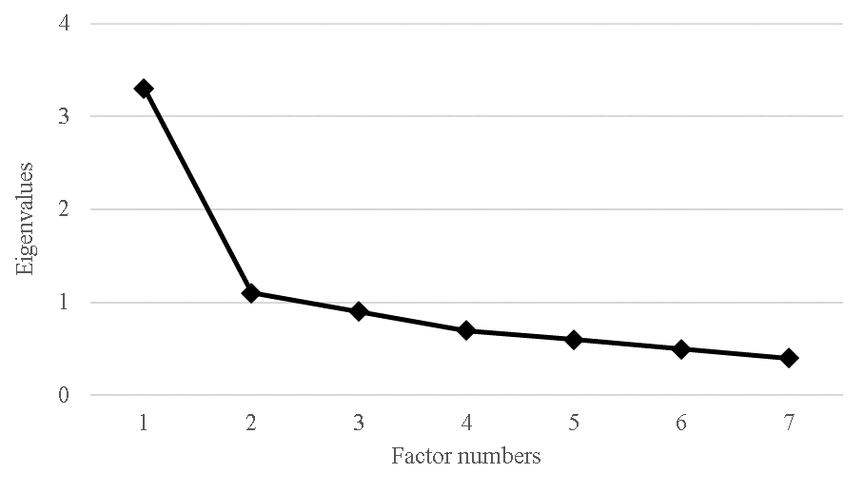
Figure 1. Sedimentation graph of factors with eigenvalues above of 1

Table 1.
Exploratory Factor Analysis of the BPS-G (n=144)
Factor | Item | M | SD | Sk. | K | FLª | CM
1 | When I want something, I can wait to get it. | 3.59 | 1.04 | -1.11 | 1.90 | .703 | .499
 | Although I suffer now, I know that after a while what I want will come. | 3.91 | 0.97 | -1.06 | 1.96 | .581 | .349
 | I will achieve my goal, sooner or later. | 4.01 | 0.98 | -1.15 | 1.75 | .715 | .518
 | The best comes after a while. | 3.54 | 1.04 | -1.01 | 1.80 | .531 | .321
 | You enjoy what you want more, after waiting. | 3.74 | 1.09 | -0.99 | 1.16 | .636 | .464
2 | The bad lasts only a while. | 3.76 | 0.97 | -0.82 | 0.70 | .708 | .505
 | The good comes, even if you must wait. | 3.77 | 1.00 | -0.63 | 0.07 | .769 | .593
Note. M=mean; SD=standard deviation; Sk.=skewness; K=kurtosis; FL=Factor loading; CM=commonality
ª Cutoff point in structure coefficient was .40

Confirmatory Factor Analysis
To verify whether this bifactorial model produced by the EFA with the sample of 144 cases was valid according to the CFA, a second random subsample of 145 cases was used. The goodness of fit of this bifactorial model is as follows: X² = 3.263, GFI = .924, AGFI = .836, NFI = .861, NNFI = .833, IFI = .900, CFI = .897, RMSEA = .125 (90% CI [.085-.168]) and SRMR = .0605. Figure 2 represents the bifactorial model of patience derived from the EFA.

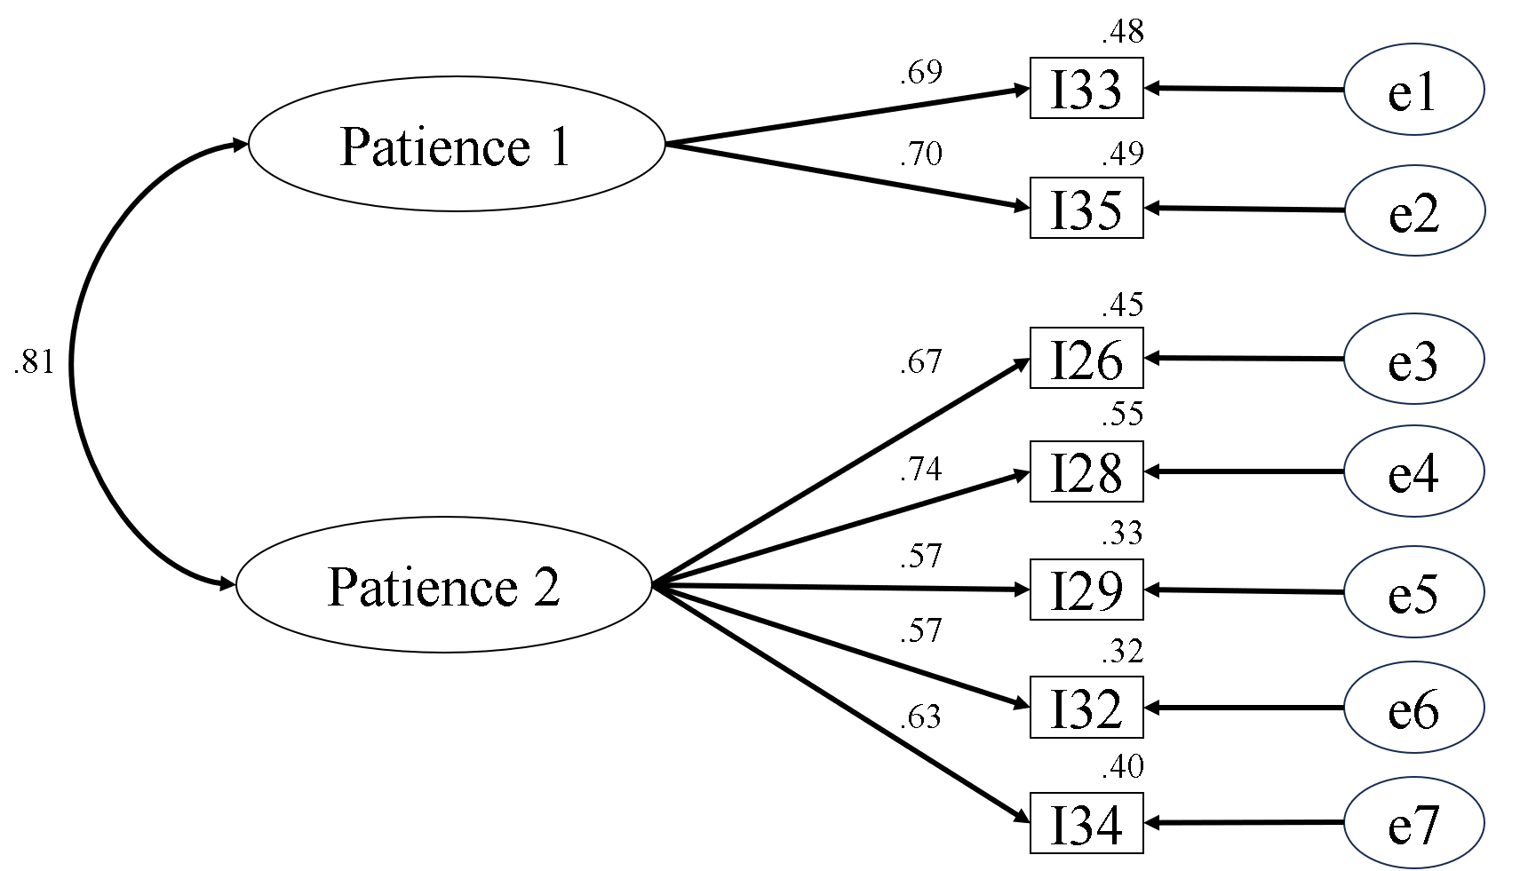

Figure 2. Bifactorial model derived from the EFA with explained variances, factorial loadings, and correlation between factors.

Due to the insufficiency in the validity indicators of this bifactorial model derived from the EFA (see the deficient values, particularly of the RMSEA and the CFI), a second model was tested. This model was one-dimensional with the same seven items from the previous model. Using CFA, its subsample of 145 cases, and the seven items recommended by the EFA now in a single factor, this model was also unacceptable. The data of its goodness of fit (again, both CFI and RMSEA do not reach values acceptable) are as follows: X²/df = 3.532, GFI = .914, AGFI = .829, NFI = .838, NNFI = .813, IFI = .879, CFI = .876, RMSEA = .133 (90% CI [.094-.174]) and SRMR = .0656. Therefore, we proceeded to eliminate those items that had the comparatively lowest factor loadings. Thus, items I29 (λ = .56) and I32 (λ = .56) were immediately discarded. Even so, the goodness of fit did not improve as expected, since again the validity indicators were not satisfactory: X²/df = 3.762, GFI = .954, AGFI = .861, NFI = .901, NNFI = .847, IFI = .925, CFI = .923, RMSEA = .139 (90% CI [.076-.208]) and SRMR = .0656. Therefore, another item was eliminated, having the lowest value among the last five items, that is, I35 (λ = .61). Finally, there are only four items with a minimum factor loading of .58 and a maximum of .76, with a mean = .66. Figure 3 shows the one-dimensional measurement model with a very good goodness of fit: X²/df = 1.075, GFI = .993, AGFI = .964, NFI = .983, NNFI = .996, IFI = .999, CFI = .999, RMSEA = .023 (90% CI [.000 -.168]) and SRMR = .0230.

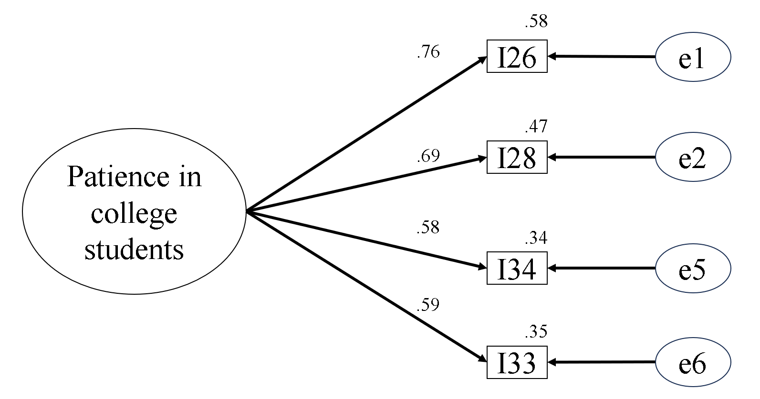
Figure 3. One-dimensional model derived from seven items suggested by the EFA.

Finally, Table 2 shows the one-dimensional structure of the BPS-G, descriptive statistics, correlations between the items, skewness and kurtosis.

Table 2.
Factorial structure of the final version of the BPS-G, descriptive statistics, correlations between the items, skewness, and kurtosis of each item and the multivariate.

Items | M | SD | Sk. | K | I28 | I33 | I34 | I26
I28 - Although I suffer now, I know that after a while what I want will come. | 3.90 | 1.00 | -1.19 | 2.36 | - | .41* | .36* | .54*
I33 - The bad lasts only a while. | 3.70 | 1.03 | -0.86 | 0.92 |  | - | .39* | .42*
I34 - You enjoy what you want more, after waiting. | 3.93 | 1.04 | -1.03 | 0.81 |  |  | - | .44*
I26 - When I want something, I can wait to get it. | 3.57 | 1.15 | -0.85 | 0.71 |  |  |  | -
Note. M=mean; SD=standard deviation; Sk.=skewness; K=kurtosis
* p < .01.

Table 2 shows that while the correlations between the items of the BPS-G are less than .90, it can be said that the items do not present multicollinearity or conceptual overlap (Tabachnick & Fidell, 2007). Likewise, it is observed that the skewness values of the four items do not exceed the tolerable value of 3 (Sk.), as well as that of 10 for kurtosis (K) (Kline, 2011). Table 2 also shows that the multivariate normality is 19.773, which is well below the value of 70 recommended by Mardia (1971).

Three-Factor Patience Questionnaire -QPTF
In this study (N = 289), the model of three correlated factors obtained better goodness of fit than that of a single factor or that of three orthogonal factors. Thus, the CFI = .951, the RMSEA = .061 (90% CI [.043-.079]), NNFI = .934, NFI = .911, GFI = .947, AGFI = .915, X²/df = 2.078 and SRMR = .0497. Instead, the values for the single-factor model were CFI = .938, RMSEA = .067 (90% CI [.049-.084]), NNFI = .922, NFI = .895, GFI = .939, AGFI = .908, X²/df = 2.274 and SRMR = .051. In relation to reliability, in this study, the subscale daily hassles patience obtained an alpha of .127, the subscale life hardship patience achieved a value of .721, and the subscale interpersonal patience reached an alpha of. 542. Considered a single factor, whose 11 items were its indicators, the alpha was .74.

Convergent Validity
The convergent validity of the BPS-G was evaluated by correlating its scores with those of the QPTF in its global rating of the 11 items. An r [289] = .55, p <.01, 95% CI [.35, .70] is found; d [effect size] = medium.

Discriminant Validity
To estimate the discriminant validity, the correlation coefficient r of the BPS-G and the APS-G scores was calculated. We obtain an r [289] = -.29, p <.01, 95% CI [-.15, -.54]; d [effect size] = small.

BPS-G Reliability
The reliability coefficient alpha of the BPS-G scores is located as “respectable” (alpha = .75, according to DeVellis (2003, p. 95-96), while the construct reliability omega was also of = .75.

Discussion
The first hypothesis of this study was that the new patience scale would exhibit good goodness of fit and acceptable levels of alpha and omega internal consistency. According to the data, it can be said that this hypothesis is provisionally supported since the BPS-G presents good goodness of fit and acceptable levels of internal consistency. The second hypothesis stated that there would be convergent validity of the BPS-G, corroborated by its positive correlation with the QPTF, which was found. Finally, the third hypothesis predicted that there would be discriminant validity of the BPS-G, verified through its negative correlation with the APS-G, which was also found. Regarding the magnitude of the observed correlations, they have to be interpreted in terms of the fact that the sample is relatively homogeneous (university students), and the evidence indicates that they are usually lower compared to those of heterogeneous samples (Abad et al., 2011; Pardo et al., 2010).
In this study, patience was theoretically defined as the interaction resulting from a desired goal and a period of waiting to achieve that goal. In terms of interbehavioral theory (Kantor & Smith, 1975), the stimulus function is the goal, and the most important corresponding response function is waiting. In other words, thanks to the reactive biography (the multiplicity of interactions that have occurred in the past) of some people, reaching a goal acquires psychological meaning through what is done, such as the practice of patience, known as letting go over time (waiting), and then achieving the desired goal. Therefore, waiting would imply continuing to do something, not freezing up or feeling emptiness because waiting also probably derives from the confidence that the goal will be achieved sooner or later. The proposed measurement model was chosen in operational terms, empirically supporting this conceptualization, at least in this sample of public university students in northeastern Mexico. The final four items of the scale make explicit or implicit reference to the idea that the goal will be achieved, as long as an indeterminate time is allowed for that to happen. This is understood as a predisposition to wait a given period, as stated by the following scale items: 1) “Even if I suffer now, I know that after a while what I want will come”, 2) “The bad thing lasts only a while”, 3) “You enjoy what you want more, after waiting” and 4) “When I want something, I can wait to get it”. In this sense, these findings also support the theoretical positions that have been adduced by the temporal dimension of waiting in the conception of patience (Blount & Janicik, 1999, 2000; Curry et al., 2008; Mehrabian, 1999 and Schnitker, 2012). Additionally, it can be said that at least two of the items support Schnitker's (2012) conceptualization that patience occurs in the face of suffering and/or adversity: 1) “Even if I suffer now, I know that after a while what I want will come” and 2) “The bad thing lasts only a while”.
Based on these encouraging results on the psychometric properties of BPS-G administered to university students, further study is warranted. Study should be expanded to other psycho-sociocultural groups, such as the general population, and clinical population, should use factorial invariance to know if BPS-G behaves the same between women and men, in older adults and others. The following limitations of this study should be noted. First, there is the possibility that social desirability has occurred by virtue of the nature of the self-report used and biased the results. Therefore, future studies should use other methods to collect data, such as the judgments of third parties related to the participants. In conclusion the Brief Patience-G Scale has good psychometric properties, and its use is recommended for Spanish-speaking university students.

References
Abad, F. J., Olea, J., Ponsoda, V., & García, C. (2011). Medición en ciencias sociales y de la salud [Measurement in social and health sciences]. Síntesis.
Ato, M., López, J. J., & Benavente, A. (2013). Un sistema de clasificación de los diseños de investigación en psicología [A classification system for research designs in psychology]. Anales de Psicología, 29(3), 1038-1059. doi:10.6018/analesps.29.3.178511.
Azizi Ziabari, L. S., Valikhani, A., Abouata-Amlashi, M., & Ireland, M. (2019). Patience mediates the relationship between mindfulness and pain in patients with cardiovascular diseases. Mental Health, Religion & Culture, 22(3), 319-329. doi: 10.1080/13674676.2019.1622518
Baumgartner, H., & Hombur, C. (1996). Applications of structural equation modeling in marketing and consumer research: A review. International Journal of Research in Marketing, 13, 139-161. https://doi.org/10.1016/0167-8116(95)00038-0
Blount, S., & Janicik, G. A. (1999). Comparing social accounts of patience and impatience. Manuscrito inédito, University of Chicago.
Blount, S., & Janicik, G. A. (2000). What makes us patient? The role of emotion in sociotemporal evaluation. Manuscrito inédito, University of Chicago.
Brislin, R. W. (1986). The wording and translation of research instruments. En W. J. Lonner & W. Berry (Eds.), Field methods in cross-cultural research (pp. 137-164). SAGE.
Caycho-Rodríguez, T. (2017). Tamaño del efecto e intervalos de confianza para correlaciones: aportes a Montes Hidalgo y Tomás-Sábado [Effect size and confidence intervals for correlations: Contributions to Montes Hidalgo y Tomás-Sábado]. Enfermería Clínica, 27(5), 331-332. doi: 10.1016/j.enfcli.2017.07.001
Cronbach, L. J. (1951). Coefficient alpha and the internal Structure of tests. Psychometrika, 16(3), 297-334. doi:10.1007/BF02310555
Curry, O. S., Price, M. E., & Price, J. G. (2008). Patience is a virtue: Cooperative people have lower discount rates. Personality and Individual Differences, 44(3), 780-785. doi: 10.1016/j.paid.2007.09.023
Deng, J. J., & Li, T. (2016). Development and validation of the Buddhist Patience Questionnaire. Mental Health, Religion & Culture, 19(8), 807-817. doi: 10.1080/13674676.2016.1266473
Eliüşük, A., & Arslan, C. (2017). Investigation of Patience Tendency Levels in Terms of Self-determination, Self-compassion and Personality Features. Universal Journal of Educational Research, 5(9), 1632-1645. doi: 10.13189/ujer.2017.050921
Ferguson, C. J. (2016). An effect size primer: A guide for clinicians and researchers. In A. E. Kazdin (Ed.), Methodological issues and strategies in clinical research (pp. 301-310. American Psychological Association. doi: 10.1037/14805-020
García-Cadena, C. H., Daniel-González, L., Valle de la O, A., Caycho-Rodríguez, T., & Téllez López, A. (2018). Construct validity of a new scale for assessing anger proneness (APS-G). Salud Mental, 41(5), 229-236. doi: 10.17711/SM.0185-3325.2018.034
IAAP & IUPsyS (2008). Universal Declaration of Ethical Principles for Psychologists. Available from the International Union of Psychological Science Web site: https://www.iupsys.net/about/governance/universal-declaration-of-ethical-principles-for-psychologists.html
Kantor, J. R., & Smith, N. W. (1975). The Science of Psychology: An Interbehavioral Survey. Principia Press.
Khormaei, F., Farmani, A., & Soltani, E. (2014a). The Patience Scale: Instrument development and estimates of psychometric properties. Educational Measurement, 5(17), 50-67. https://doi.org/10.22054/jem.2015.324
Khormaie, F., Farmani, A., & Soltani, E. (2014b). Investigating the Prediction Role of Patience as a Moral Construct and Personality Characteristics in the Hopelessness of University Students. Medical Ethics Journal, 8(28), 167-199. https://api.semanticscholar.org/CorpusID:147013782
Kline, R. B. (2011). Principles and practice of structural equation modeling. Guilford Press.
Lawshe, C. H. (1975). A quantitative approach to content validity. Personnel Psychology, 28(4), 563-575. https://doi.org/10.1111/j.1744-6570.1975.tb01393.x
Mardia, K. V. (1971). Measures of multivariate skewness and kurtosis with applications. Biometrika, 57(3), 519–530. doi:10.1093/biomet/57.3.519
McDonald, R. P. (1999). Test theory: A unified treatment. Erlbaum.
Mehrabian, A. (1999). Manual for the Revised Achieving Tendency (MACH) and Disciplined Goal Orientation (CGO) Scales. Alta Mesa.
Meier, A. N. (2019). Emotions, risk attitudes, and patience. SOEPpapers on Multidisciplinary Panel Data Research, No. 1041. Deutsches Institut für Wirtschaftsforschung (DIW). http://hdl.handle.net/10419/201563
Morris, K. (2013). Revising the Declaration of Helsinki. World Report, 381, 1889-1890. https://doi.org/10.1016/S0140-6736(13)60951-4
Núñez, J. L., Martín-Albo, J., & Navarro, J. G. (2005). Validación de la versión española de la Échelle de Motivation en Éducation [Validity of the Spanish version of the Échelle de Motivation en Éducation]. Psicothema, 17(2), 344-349. https://www.redalyc.org/articulo.oa?id=72717225
Pardo, A., Ruiz, M. A., & San Martín, R. (2010). Análisis de datos en ciencias sociales y de la salud II. [Data Analysis in Social and Health Sciences II]. Síntesis.
Ribes-Iñesta, E. (2009). La personalidad como organización de los estilos interactivos [Personality as the Organization of Interactive Styles]. Revista Mexicana de Psicología, 26(2), 145-161. https://www.redalyc.org/articulo.oa?id=243016315002
Rodríguez, M., & Ruiz, M. (2008). Atenuación de la asimetría y de la curtosis de las puntuaciones observadas mediante transformaciones de variables: Incidencia sobre la estructura factorial [The reduction of skewness and kurtosis of observed variables by data transformation: Effect on factor structure]. Psicológica, 29(2), 205-227. https://www.redalyc.org/articulo.oa?id=16929206
Schnitker, S. A. (2012). An examination of patience and well-being. The Journal of Positive Psychology, 7(4), 263-280. doi: 10.1080/17439760.2012.697185
Schnitker, S. A., & Emmons, R. A. (2007). Patience as a virtue: Religious and psychological perspectives. Research in the Social Scientific Study of Religion, 18, 177-207. doi:10.1163/ej. 9789004158511.i-301.69
Schnitker, S. A., Houltberg, B., Dyrness, W., & Redmond, N. (2017). The Virtue of Patience, Spirituality, and Suffering: Integrating Lessons from Positive Psychology, Psychology of Religion, and Christian Theology. Psychology of Religion and Spirituality, 9(3), 264-275. https://doi.org/10.1037/rel0000099
Schnitker, S. A., Ro, D.B., Foster, J. D., Abernethy, A. D., Currier, J. M., vanOyen Witvliet, C., Root Luna, L. M., Putman, K. M., VanHarn, K., & Carter, J. (2020). Patient patients: Increased patience associated with decreased depressive symptoms in psychiatric treatment. The Journal of Positive Psychology, 15(3), 300-313. doi: 10.1080/17439760.2019.1610482
Mexican Society of Psychology. (2010). Código Ético del Psicólogo [Psychologist's Code of Ethics]. México, D.F.: Trillas.
Tabachnick, B. G., & Fidell, L. S. (2007). Using multivariate Statistics (5a. ed.). Allyn & Bacon.
Valikhani, A., Moustafa, A., & Karimi, A. (2017). Examining patience as a psycho-religious construct in Iranian patients with cardiovascular diseases: a pilot study. Mental Health, Religion & Culture, 20(7), 617-625. doi: 10.1080/13674676.2017.1367372
Wainwright, W. (2018). Monotheism. En E. N. Zalta (Ed.), The Stanford Encyclopedia of Philosophy. Retrieved from URL = <https://plato.stanford.edu/archives/fall2018/entries/monotheism/>.

Received:
Accepted:

