Evaluation of cognitive functioning and laterality in women with polycystic ovary syndrome

Running title: Cognitive functioning and laterality in PCOS
Abstract (English)
Objective
To assess whether laterality and cognitive performance of patients with PCOS is different from those of healthy control group.
Design: Case-control study.
Patient(s): Thirty patients with 30 PCOS and 34 control women were recruited.
Main Outcome Measure(s): Beck Depression Inventory, State and Trait Anxiety Inventory (STAI), hand preference questionnaire, Line Splitting Task (LBT), finger tapping, Rey Auditory Verbal Learning Test (RAVLT), and Stroop Test were administered to the patient and control groups. In addition, blood levels of androgens were measured.
Result(s): Although the depression score in the PCOS group was higher than the control group, there was no significant difference in the STAI scores. Stroop interference scores (SI) were found to be significantly lower in the PCOS group. Evaluation of RAVLT scores revealed significant differences in RAVLT1, RAVLT 2 and RAVLT 8 recognition sub-scores between groups. Hand preference was significantly different between the groups. LBT values of only absolute right-handed subjects (HPS=13) were involved to compare spatial distribution of attention between the groups. It seems that the bisection judgement bias of PCOS group shifted slightly to the right. In univariate analysis of covariance (ANCOVA), the significant interaction was found between LBT scores and DHEA levels.
Conclusion(s): Several cognitive domains and laterality are seemed affected in PCOS.
Key Words: Polycystic ovary syndrome, cognitive functioning, brain laterality

Polycystic ovary syndrome (PCOS) is a complex endocrine disorder characterized by hyperandrogenism, ovulatory dysfunction, and polycystic ovarian morphology (1). Endocrinologic and androgenic disturbance might lead to psychological and mood disturbance (1).
Cognitive differences between the sexes have always been interested and may be due to gender differences (2,3). However, the effects of sex differences both in functional cerebral asymmetry and cognitive functioning have not been resolved yet (3). It has also been demonstrated that exposure to prenatal testosterone may have an effect on cognitive functions (2, 4, 5). However, there are many different results regarding the effects of hyperandrogenism on cognitive functions in adulthood. Generally accepted that women have higher scores on verbal and fine motor tasks than men. Whereas men have higher scores on mathematical abilities and spatial tasks than women (3). But data is limited and unclear. Moreover, it is known that a factor such as depression, which can affect cognitive functions, affects cognitive functions. And depression may be common in patients with PCOS (6).
In this study, we aimed to assess whether the laterality and cognitive performance of patients with PCOS are different from those of the healthy control group.
MATERIALS AND METHODS

Thirty patients with PCOS and 34 control women were recruited in a university hospital outpatient clinic for the study. The diagnosis of PCOS was based on ﻿Rotterdam 2003 criteria (2 out of 3)
1. Oligo- or anovulation,
2. Clinical and/or biochemical signs of hyperandrogenism,
3. Polycystic ovarian morphology
and exclusion of other etiologies. Congenital adrenal hyperplasia, androgen-secreting tumors, and Cushing’s syndrome were excluded by appropriate tests (7). It was preferred that the patients were at least high school graduates.

Exclusion criteria are systemic diseases including renal, cardiovascular, liver diseases and endocrinopathies such as thyroid disease, diabetes mellitus. Moreover, patients using oral contraceptives and other hormonal drugs within the last 6 mounts were also excluded.

Modified-FGS was used to evaluate clinical hirsutism (8).
The study protocol was approved by our Institutional Review Board and informed consent was obtained from each patient.

Laboratory measurements:

Basal hormonal profile was obtained between 2 and 5 days of spontaneous or if it is necessary progesterone induced menstrual cycle. A Venous blood sample was taken between 08:00 - 09:00 A.M. after an overnight fasting period of 8-10 hours, after that all samples were stored at -20 °C until analysis.

Serum FSH, LH, and estradiol levels were measured with chemiluminescent enzyme immunometric assay, using a commercial kit from Diagnostic Products Corp., with an immulite machine. Serum DHEAS and total T levels were measured with chemiluminescence immunoassays (Elecsys 1010/2010 kit, Roche Diagnostics GmbH, Mannheim, Germany). Free T and androstenedione levels were measured by Enzyme Immunoassay (EIA) (DLS; Diagnostics Systems Laboratories Inc., Webster, TX). SHBG was measured by EIA (Bio source Inc.). 17 OH progesterone levels were measured with the ELISA method in a Spectrophotometric device (Bio Tek Instruments Inc., USA) using EIA kits (DSL, Diagnostic System Laboratories Inc., USA).

The Free Androgen Index was calculated with the following formula.

FAI: Free Androgen Index: T (nmol/L) x100/ SHBG (nmol/L)

Evaluation of cognitive functions and severity of depression and anxiety:

In this study, the following tests were applied to all participants.

Beck Depression Inventory (BDI): Depression was scored using the Beck depression scale (9).

State and Trait Anxiety Inventory (STAI): STAI 1 and STAI 2 were used to identify chronic anxiety lasting more than 1 year (10).

Hand preference questionnaire (HPQ): Hand preference scale was developed by Chapman (11). Turkish validity and reliability were done by Nalçaci (12). This questionnaire was developed to assess which hand is predominantly used in the performance of different actions carried out in daily life. It is a 13-question survey. Right hand scored 1, left hand 3, "both of them" response scored 2, thus hand preference was scored as a continuous value between 13 and 39 points. Therefore, as the score increases, there is a shift from right to left (12).

Motor speed was evaluated with finger tapping test. Finger tapping test is a fast and reliable test used in the evaluation of fine motor movement. In this test, all subjects were asked to press the button as fast as possible with the index finger of the right and then the left hand for 20 seconds. This application was made twice. (Right, left) (13).

Spatial distribution of attention was evaluated using the Line Bisection Task (LBT). LBT is a simple and reliable test for assessing the spatial distribution of attention (14). In LBT, it was requested to draw the midpoint of a total of 10 different sized lines extending 1 cm from 9 cm to 18 cm. The deviation of the line from the midpoint was calculated and included in the analysis. Here, after a reliable test, right hand dominant individuals generally have a very slight right neglect (Pseudo-neglect) in most individuals. Because the right hemisphere is responsible for managing attention.

Rey Auditory Verbal Learning Test (RAVLT): RAVLT is a neuropsychological test designed to assess verbal memory and also provides rich data on multiple memory processes, and memory abilities. When applying this test, 2 lists of 15 words each were used (list A and list B). In the first 5 repetitions, the words in list A were read in the same order with gaps of approximately 1 second, and when finished, the person was asked to remember the words read (Rey 1-5). (Total count of word remembered in the first trial indicates immediate verbal memory. Trials 1 and 5 show the learning performance). In the sixth application, list B was read and the patient was asked to remember the words in this list (Rey 6). List B in the sixth application is the interference list, which is expected to have a disruptive effect on remembering the words in List A. After this interference trial, the participant is immediately asked to recall the words from List A, which she heard five times previously (Rey 7). After 20 minutes, the participant is asked to recall the words in list A again (Rey 8). This application provides information about the 'delayed recall' task. Then, they were asked to indicate the words in list A from a list of 50 words including 15 new words from list A, 15 from list B, and 20 new words. The last application is the recognition application (Recognition) (15).

(Stroop Test): The Stroop test includes 3 cards: word (W), color (C), and colored word (WC). In the 1st, the person reads the words directly, in the 2nd, she says the names of the colors in the list, in the 3rd one, she reads the word list printed with a different ink color than the written word, in the 3rd list, the Stroop effect is observed. The Stroop effect is characterized by the fact that when the individual is obliged to say the color of the ink instead of reading the word itself, it slows down compared to plain reading (19, 20). The following formula was used to calculate the Stroop interference scores of the participants.

Stroop interference= WC- [(WxC)/(W+C)]

Statistical Analysis

Statistical analyses were performed with the Statistical Package for Social Sciences, version 21.0 (SPSS, Inc., Chicago). The results were expressed as mean + SD. Differences between the means were analyzed by the student t-test. Comparison of the STAI and BDI scores of the groups was made with the student t-test. Student t-test was also used to compare the mean hand preference scores of the groups. It was used chi- square test for nominal values. ANCOVA test was applied to look at the effect of PCOS and related hormones on cognitive test performances. For all implementations of RAVLT, individual groups were compared by Student's t-test. All analyzes were performed two tailed and p<0.05 was considered statistically significant.

RESULTS

Demographic and clinical characteristics of the groups are shown in Table 1. There was no significant difference between mean age and education level (p=0.066, p= 0.188, respectively, Table 1). When the groups were compared in terms of BMI and FGS scores, as expected, these values were statistically higher in the PCOS group (p=0.006, p<0.001, respectively, Table 1).

The blood parameters and hormone values of the groups are also presented in Table 1. Among these parameters, free testosterone, and FAI showed statistically higher levels, on the other hand, 17-OH progesterone showed borderline statistically significant elevation. (p=0.002, p=0.006 and p=0.050, respectively). As expected, SHBG levels were found to be statistically lower in the PCOS group (p<0.05).
Cognitive Tests results are shown in Table 2. In the PCOS group, the depression scale showed borderline significance. There was no difference between the groups in terms of STAI (anxiety) (p < 0.05).

Hand preference questionnaire: No significant difference was observed when the participants were compared according to the groups in terms of the hand preference scores (p= 0.540). To understand the effect of hormones on hand preference, the ANCOVA test was performed using DHEA-S and free testosterone as covariates, group as constant factor and hand preference as independent variable. Accordingly, although no effect of free testosterone on hand preference was observed, DHEA had a nearly significant effect (F_{(1,60)}=0.364, p=0.433; F_{(1,60)}=3.923, p=0.05, respectively). The Absolute right-handedness rate was statistically lower in the PCOS group (p=0.04).

Finger tapping test: Repeated measures ANCOVA was also applied for finger tapping test and it revealed a significant main group effect F_{(1,61)}=4.606, p=0.036). Accordingly, the control group made more finger tapping than the PCOS group. At the same time, the hand preference effect was also detected (F_{(1,61)}=72.796, p <0.001). Finally, as expected, right hand and hand preference interaction was determined (F_{(1,61)}=15,381, p <0.001).

Line Bisection Task (LBT): In the line bisection task, there was no significant difference between the groups in terms of the mean distance from the center. However, due to the possibility that hand preference has an effect on the spatial distribution of attention in PCOS, in order to eliminate this effect, absolute right-handed (Hand Preference Score: 13) individuals were included in the comparison between the groups and a comparison was made with the student's t test again. In this analysis, 14 patients remained in the patient group and 25 in the control group. Accordingly, a significant difference was found between the groups in terms of distance from the center (p=0.025). In the ANCOVA test, free testosterone and DHEA-S were treated as covariance, LBT as the dependent variable, group as independent variable. According to this; significant main group effect and significant DHEA effect were detected (F_{(1,60)}= 6.303, p=0.015), (F_{(1,60)}= 6.814, p=0.011, respectively).

RAVLT: Since each subgroup test of RAVLT differs, each application was compared between groups separately with Student's t test. In these comparisons, it was observed that there was a significant difference between the groups in Rey1, Rey 2, Rey 8, and Rey recognition practices. In all these applications, the performance of the control group was better (Figure 1).

Stroop test: In order to compare the groups in terms of Stroop test performances, the number of words read for each of the 3 tests (word, color, color-word card) was put into the student's t test separately (Table 3). As a result of the comparison of the groups, it was observed that the PCOS group performed significantly worse in all 3 cards (Figure 1). However, when the Stroop interference score was calculated, it was revealed that the groups did not differ in their capacity to resist the interference of the dominant response (p=0.44).

DISCUSSION

Women with PCOS have elevated serum levels of testosterone, androstenedione, and DHEAS (1, 21). In this study, patients with PCOS displayed higher plasma levels of androgens than controls, as expected.

While a borderline level of depression was observed in PCOS group in this study, no change was observed in anxiety tests. Moreover, no relationship was observed with depression in terms of other cognitive functions and lateralization in this study. Although Barnard et al. stated in their study that depression impairs cognitive functions, Sukhapure et al. showed that depression and anxiety do not impair cognitive functions, similar to our study (2,19). We think that depression is mild and does not affect cognitive disorders and occurs through different mechanisms. Soyupek et al., found that the presence of depression in particular negatively affected hand function. But there was no change in hand strength and dexterity in patients with PCOS in their study. In their study, hand dexterity were evaluated with the grooved pegboard test (18). In our study, hand preference questionnaire was used and there was no difference in the hand questionnaire scores between the 2 groups, but the absolute right-handedness rate was lower in the polycystic patient group. In other words, the rate of people doing all their work with their right hand was lower in patients with PCOS than in controls. No statistically significant effects of androgens on handedness were observed, and only DHEA-S was found to be borderline effective (p=0.05). When we evaluated fine motor speed performance in PCOS, PCOS patients exhibited significantly slower finger tapping performance than the control group in right hand. The low scores observed on the left hand in the PCOS group did not reach statistical levels.

There is limited study in the literature about cognitive functioning and cerebral asymmetry in PCOS (2,4,20). It is believed that males and females demonstrate differing cognitive functioning because of differences in the levels of androgens and estrogen (2). Barnard et al. studied mental rotation and spatial rotation and word recognition tasks in patients with PCOS and the effects of antiandrogen therapy on these parameters. While no significant difference was observed in mental rotation and spatial rotation, on the contrary, impaired performance in terms of speed and accuracy was observed in word recognition tasks. Anti-androgen therapy had a minimal effect on improving some functions. They found that PCOS was not associated with masculinized cognitive functioning (2). On the contrary, Sukhapure et al. showed that cognitive functions change with testosterone. Similarly, we have seen in our study that dehydroepiandrosterone may be important in some cognitive functions (19). Franik et al. also found that free testosterone was associated with verbal psychomotor speed. Androstenedione level showed a negative correlation in executive functions. 17-OH-P levels had a positive effect on phonological verbal fluency scores (21). In another study, lower performance was observed in the PCOS patient group, especially in cognitive functions such as verbal fluency, verbal memory, and manual dexterity, where women are more advantageous. Furthermore, no significant changes were observed in male advantage parameters such as mental rotation, spatial visualization, spatial perception, or perceptual speed (4). The same authors later showed in a prospective randomized study that anti-androgen and estrogen treatment improved verbal tests. However, most cognitive tests could not be corrected with this pharmacological treatment and it was stated that these tests could not be easily corrected with hormonal treatment (22). Contrary to all these studies, Barry et al found that patients with PCOS had an advantage over other women in visuospatial cognition, and this was positively correlated with testosterone (20). Although we found in our study that many cognitive functions were affected and decreased in patients with PCOS, we found that only spatial distribution of attention (LBT) may be related to DHEA in PCOS group with absolute right handedness. Rees et al. evaluated cognitive function and white matter microstructure with diffusion tensor MRI. Cognitive performance decreased in the PCOS group. It was also stated that the white matter microstructure may be affected by insulin and androgens, and this relationship in PCOS may be different from the control group (23).

In our study, the LBT test, in which we evaluated spatial perception in PCOS patients, was not statistically different from controls. Only in the absolute right-handed group, the LBT test was statistically significantly shifted more to the left, which shows us that the pseudo-neglect state of the right brain is more common in the absolute right-handed groups. Moreover, only spatial distribution of attention (LBT) may be related to DHEA in PCOS group with absolute right handedness. When we looked at the literature, we could not find any study on LBT test in PCOS.

The effects of DHEA on the human brain have not yet been clarified. DHEA is found in higher concentrations in the human brain than in the plasma and is actually a neuro-steroid, synthesized de novo in the brain. It modulates the effects of various receptors in the brain, such as the γ-aminobutyric acid type A (GABA A) receptor, the NMDA receptor, and the sigma subtype 1 (σ1) receptor (24). Davis et al. also found that cognitive functions increased in women with high DHEA sulfate levels in their study (25). In our study, the effect of DHEA-S was observed especially in absolute right-handed group.

In this study, PCOS patients performed significantly worse on the RAVLT test than the controls in the first and second repetitions. According to these test results, immediate verbal memory is impaired in patients with PCOS. However, the learning curve with repetitions did not show statistically significant differences. It has also been observed that long 'delayed recall' task recognition application is impaired in patients with PCOS. Rey recall being worse than controls also indicates a difference in priming. Even if we say that language, which is a cognitive domain that strongly displays laterality, is affected in PCOS, it is difficult to say that lateralization is different in PCOS patients. This shows us that PCOS patients may have problems with attention, but they are not different from controls in terms of verbal memory. Similarly, when we look at the literature, verbal learning studies using different tests show that verbal learning may be impaired in PCOS patients (4,22). Again, in an evaluation in the literature where both the RAVLT and the Stroop test were performed, similar to our study, it was observed that both tests were negatively affected in patients with PCOS (26).

The Stroop test is basically a neurocognitive test that measures frontal lobe functions such as information processing speed, selective attention skills, the ability to inhibit cognitive interference. Interestingly, in this study, PCOS patients read fewer words on all 3 cards, but there was no significant difference between the groups in terms of the Stroop interference score. That is, although their reading speed is slow, their ability to resist interference, which is an executive function, is not different from controls.

The limitation of this study is the relatively small size of our patient group.

This is the first study to address the effect of hormones on lateralization through motor and attention in PCOS. The findings of this study primarily reveal a change in spatial attention in PCOS independent of hormones. However, it also revealed that DHEA also had a significant effect, albeit mildly.

Tests regarding cognitive functions vary greatly in patients with PCOS. However, studying subgroups in patients with PCOS may provide more accurate information. Because in our study, patients with absolute right hands had different results than other patients.

CONCLUSION

In the present study, interpreting findings as a whole, showed us that there would be a general slowness in PCOS which has been suggested with slower finger tapping performance in absolute right-handed group, slower reading in Stroop test.

Immediate verbal memory and word recall were also statistically significantly lower in patients with PCOS. There is no robust evidence to claim that PCOS is a clinical condition in which laterality has been changed according to the line bisection tasks.

There is not enough data to show that androgens affect cognitive functions in polycystic ovary. Further studies are needed regarding the effectiveness of DHEA in this regard.

There are no any conflicts of interest for all authors.

This study was presented as a poster presentation at the 25th European Congress of Obstetrics and Gynaecology in conjunction with 15th Congress of Turkish Society of Obstetrics and Gynecology. (May 17-21, 2017)

References
1. Azziz R, Carmina E, Chen Z, Dunaif A, Laven JSE, Legro RS, et al. Polycystic ovary syndrome. Nature reviews Disease primers 2016;2:16057.
2. Barnard L, Balen AH, Ferriday D, Tiplady B, Dye L. Cognitive functioning in polycystic ovary syndrome. Psychoneuroendocrinology 2007;32(8–10):906–14.
3. Sanders G, Sjodin M, de Chastelaine M. On the elusive nature of sex differences in cognition: hormonal influences contributing to within-sex variation. Archives of sexual behavior 2002;31(1):145–52.
4. Schattmann L, Sherwin BB. Testosterone levels and cognitive functioning in women with polycystic ovary syndrome and in healthy young women. Hormones and Behavior 2007;51(5):587–96.
5. Schöning S, Engelien A, Kugel H, Schäfer S, Schiffbauer H, Zwitserlood P, et al. Functional anatomy of visuo-spatial working memory during mental rotation is influenced by sex, menstrual cycle, and sex steroid hormones. Neuropsychologia 2007;45(14):3203–14.
6. Cooney LG, Dokras A. Depression and Anxiety in Polycystic Ovary Syndrome: Etiology and Treatment. Current Psychiatry Reports. 2017;
7. Revised 2003 consensus on diagnostic criteria and long-term health risks related to polycystic ovary syndrome. Fertility and sterility 2004;81(1):19–25.
8. Yildiz BO, Bolour S, Woods K, Moore A, Azziz R. Visually scoring hirsutism. Human reproduction update 2010;16(1):51–64.
9. Beck AT. A systematic investigation of depression. Comprehensive psychiatry 1961;2(3):163–70.
10. Spielberger CD, Gonzalez-Reigosa F, Martinez-Urrutia A, Natalicio LFS, Natalicio DS. The state-trait anxiety inventory. Revista Interamericana de Psicologia/Interamerican journal of psychology 1971;5(3 & 4).
11. Chapman LJ, Chapman JP. The measurement of handedness. Brain and cognition 1987;6(2):175–83.
12. Nalçaci E, Kalaycioğlu C, Güneş E, Ciçek M. Reliability and validity of a handedness questionnaire. Turk Psikiyatri Dergisi= Turkish Journal of Psychiatry 2002;13(2):99–106.
13. Schmitt L. Finger-tapping test. Encyclopedia of autism spectrum disorders 2013;1296.
14. Schenkenberg T, Bradford DC, Ajax ET. Line bisection and unilateral visual neglect in patients with neurologic impairment. Neurology 1980;30(5):509.
15. Bean J. Rey auditory verbal learning test, Rey AVLT. Encyclopedia of clinical neuropsychology 2011;2174–5.
16. Stroop JR. Studies of interference in serial verbal reactions. Journal of Experimental Psychology 1935;
17. Scarpina F, Tagini S. The stroop color and word test. Frontiers in Psychology. 2017;
18. Soyupek F, Guney M, Eris S, Cerci S, Yildiz S, Mungan T. Evaluation of hand functions in women with polycystic ovary syndrome. Gynecological Endocrinology 2008;24(10):571–5.
19. Sukhapure M, Eggleston K, Douglas K, Fenton A, Frampton C, Porter RJ. Free testosterone is related to aspects of cognitive function in women with and without polycystic ovary syndrome. Archives of Women’s Mental Health 2022;25(1):87–94.
20. Barry JA, Parekh HSK, Hardiman PJ. Visual-spatial cognition in women with polycystic ovarian syndrome: the role of androgens. Human Reproduction 2013;28(10):2832–7.
21. Franik G, Krysta K, Witkowska A, Dudek A, Krzystanek M, Madej P. The impact of sex hormones and metabolic markers on depressive symptoms and cognitive functioning in PCOS patients. Gynecological Endocrinology 2019;35(11):965–9.
22. Schattmann L, Sherwin BB. Effects of the pharmacologic manipulation of testosterone on cognitive functioning in women with polycystic ovary syndrome: a randomized, placebo-controlled treatment study. Hormones and Behavior 2007;51(5):579–86.
23. Rees DA, Udiawar M, Berlot R, Jones DK, O’Sullivan MJ. White matter microstructure and cognitive function in young women with polycystic ovary syndrome. The Journal of Clinical Endocrinology & Metabolism 2016;101(1):314–23.
24. Maninger N, Wolkowitz OM, Reus VI, Epel ES, Mellon SH. Neurobiological and neuropsychiatric effects of dehydroepiandrosterone (DHEA) and DHEA sulfate (DHEAS). Frontiers in neuroendocrinology 2009;30(1):65–91.
25. Davis SR, Shah SM, McKenzie DP, Kulkarni J, Davison SL, Bell RJ. Dehydroepiandrosterone sulfate levels are associated with more favorable cognitive function in women. The Journal of Clinical Endocrinology & Metabolism 2008;93(3):801–8.
26. Huddleston HG, Jaswa E, Casaletto K, Neuhaus J, Yaffe K. POLYCYSTIC OVARY SYNDROME AND DIFFERENCES IN BRAIN HEALTH AT MID-LIFE: RESULTS FROM THE CARDIA COHORT. Fertility and Sterility 2022;118(4):e44–5.

Table 1. General characteristics and blood parameters of all participants
 | PCOS (n:30)  Mean±SD | Control (n:34)  Mean±SD | p
Age (Years) | 22.7±2.24 | 24.2±3.81 | 0.066
Education  High school  College student  University graduate | 8  16  6 | 7  13  14 | 0.188
BMI (kg/m²) | 22.9±3.64 | 20.7±2.45 | 0.006
FGS | 8.87±3.49 | 5.71±2.29 | <0.001
Hb (gr/dL) | 12.92±1.16 | 13.08±1.33 | 0.626
FSH (mIU/mL) | 5.38±1.52 | 6.024±2.30 | 0.198
LH (mIU/mL) | 9.14±3.74 | 9.76±10.38 | 0.851
LH/FSH | 1.82±1.02 | 1.98±4.41 | 0.847
E₂ (pg/mL) | 64.88±65.40 | 77.59±73.31 | 0.470
T Testosterone (ng/mL) | 0.560±0.29 | 0.456±0.26 | 0.131
F Testosterone pg/mL | 2.71±2.12 | 1.33±0.68 | 0.002
17 OH Progesteron ng/mL | 1.57±1.20 | 1.089±0.56 | 0.050
Androstenedione (ng/mL) | 3.58±1.69 | 2.91±1.96 | 0.147
DHEA-S (⎧U /dL) | 290.39±167.13 | 226.48±67.96 | 0.058
SHBG (nmol/L) | 34.21±20.65 | 46.29±25.94 | 0.045
FAI* | 2.59±2.2 | 1.24±0.8 | 0.06
Insulin (⎧U/mL) | 11.80±6.47 | 9.82±4.48 | 0.166
T Cholesterol (mg/dL) | 167.33±37.75 | 158.94± 33.38 | 0.349
LDL (mg/dL) | 90.67±31.53 | 83.21±28.85 | 0.327
HDL (mg/dL) | 56.13±9.16 | 60.16±12.12 | 0.143
*: Free Androgen Index

Table 2. Cognitive tests results
Cognitive Tests | PCOS (n:30)  Mean±SD | Control (n:34)  Mean±SD | p
BDI | 10.07±6.878 | 6.74±6.307 | 0.048
STAI-1 | 56.67±13.904 | 58.68±11.502 | 0.529
STAI-2 | 54.50±9.504 | 56.41±8.968 | 0.411
HPQ | 15.50±4.67 | 14.76±4.86 | 0.540
Absolute Right Hand | % 36 | % 64 | 0.04
Right Hand 1 (Tapping) | 78.33±8.8 | 84.35±7.9 | 0.006
Right Hand 2 | 79.27±9.8 | 84.03±7.3 | 0.03
Left Hand 1 | 67.40±78.7 | 70.44±77.8 | 0.145
Left Hand 2 | 67.63± 9.9 | 69.68±6.7 | 0.148
LBT_{mean} (mm) | -0.04±0.20 | 0.039±0.19 | 0.108
LBT_{mean} (mm)*  13 cutoff | -0.096 ± 0.21  (n: 14) | 0.042 ± 0.15  (n:25) | 0.025
Rey 1 | 7.07±1.660 | 8.44±1.926 | 0.003
Rey 2 | 9.97±2.428 | 11.56±1.521 | 0.002
Rey 3 | 11.50±41.697 | 12.24±1.653 | 0.084
Rey 4 | 12.97±1.691 | 12.79±1.452 | 0.662
Rey 5 | 12.53±2.161 | 13.35±1.368 | 0.081
Rey 6 | 6.57±1.775 | 7.12±1.855 | 0.231
Rey 7 | 12.30±1.860 | 12.79±2.086 | 0.324
Rey 8 | 11.73±2.57 | 12.94±1.984 | 0.038
Rey Recognition | 13.67±1.863 | 14.65±0.646 | 0.010
Stroop 1 | 99.5 ±13.33 | 108.79±13.07 | 0.007
Stroop 2 | 71.10±12.25 | 77.53±12.63 | 0.043
Stroop 3 | 43.90±8.39 | 49.24±8.95 | 0.017
Stroop interference | 2.96±6.04 | 4.26±7.22 | 0.44

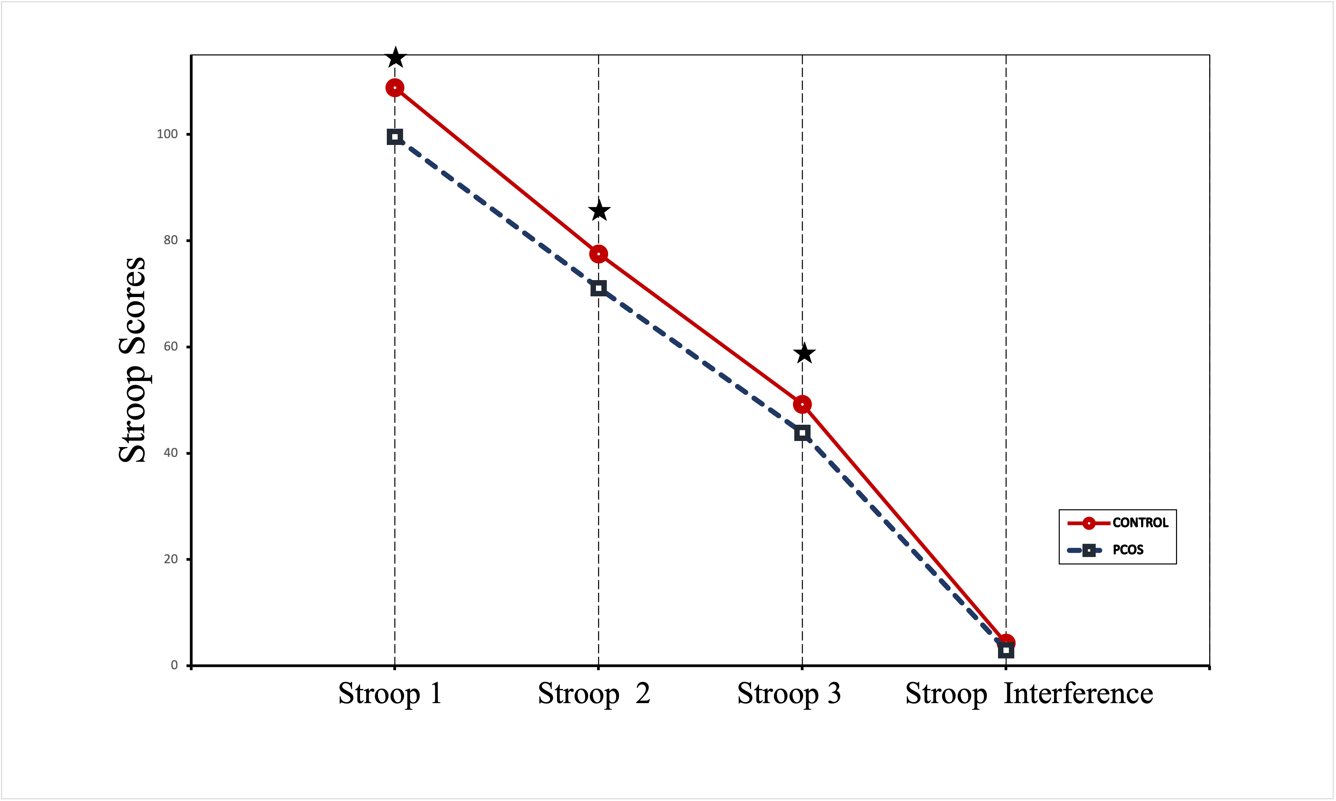
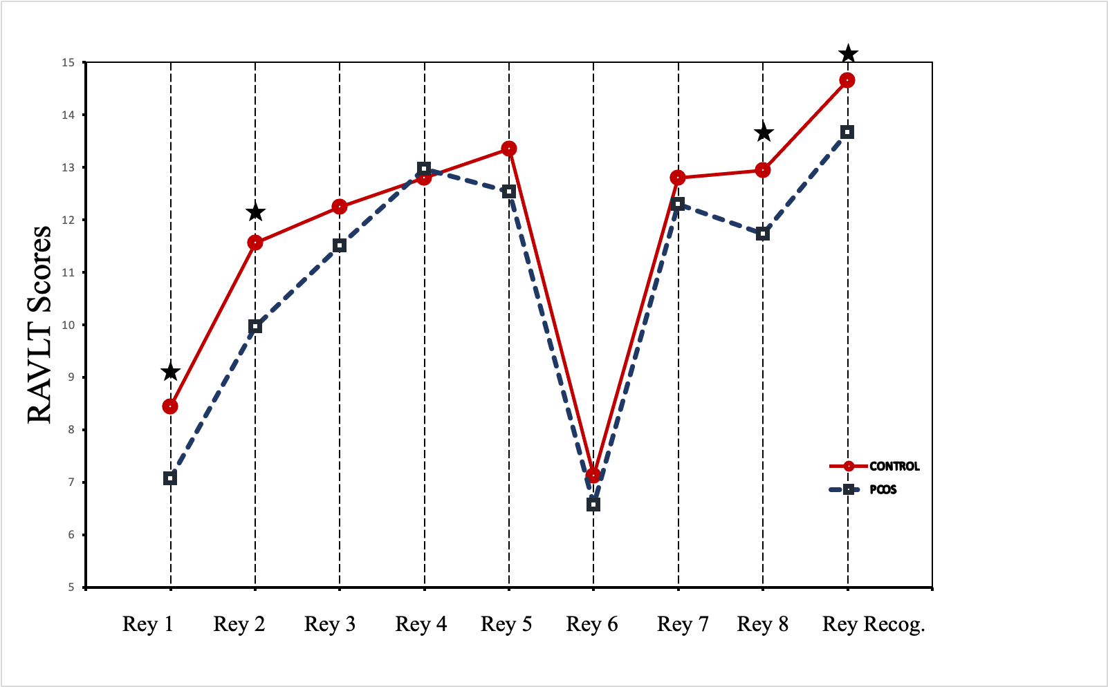

Figure 1. Demonstration of RAVLT and Stroop values in patients and control groups.
: p<0.05

