Mindfulness and Acceptance and Commitment Therapy for Obsessive-Compulsive Disorder: A Single-Case Experimental Design Applied via the Internet
Abstract
Background: Obsessive-Compulsive Disorder (OCD) is characterized by obsessions (unwanted thoughts or images) and compulsions (repetitive behaviors). Traditional psychological and pharmacological treatments have shown efficacy but also have notable limitations, including high dropout rates and adverse effects. Aim: This study evaluates the effects of an intervention combining Mindfulness and Acceptance and Commitment Therapy (ACT) for treating OCD, focusing on enhancing psychological flexibility and reducing symptom interference. Method: An experimental single-case design (A-B) with follow-up was employed, involving 8 adult female participants aged 25-44 from Colombia, Mexico, Argentina, and Venezuela. Participants were selected based on a Y-BOCS score of 25 or higher. The intervention was delivered in a synchronous virtual group format, lasting 4 weeks, with a 4-week baseline and a 2-week follow-up. Measures included weekly assessments of OCD symptoms, anxiety, depression, cognitive fusion, and mindfulness skills. Results: The intervention led to significant reductions in OCD symptoms, anxiety, and cognitive fusion, along with increased mindfulness skills and psychological flexibility. The Tau-U analysis showed moderate to large effect sizes. Wilcoxon signed-rank tests indicated statistically significant improvements in all evaluated indicators (p < .05). Conclusion: The combined mindfulness and ACT intervention was efficacy in reducing OCD symptom interference and improving psychological flexibility and quality of life. These findings suggest that this approach may be a viable alternative to traditional treatments, offering a more adaptable and patient-centered option.
Keywords: OCD, mindfulness, Acceptance and Commitment Therapy, psychological flexibility, single-case design.

Resúmen
Introducción: El Trastorno Obsesivo-Compulsivo (TOC) se caracteriza por obsesiones (pensamientos o imágenes no deseados) y compulsiones (conductas repetitivas). Los tratamientos psicológicos y farmacológicos tradicionales han demostrado eficacia, pero también tienen limitaciones notables, como altas tasas de abandono y efectos adversos. Objetivo: Este estudio evalúa los efectos de una intervención que combina Mindfulness y Terapia de Aceptación y Compromiso (ACT) para tratar el TOC, enfocándose en mejorar la flexibilidad psicológica y reducir la interferencia de los síntomas. Método: Se empleó un diseño experimental de caso único (A-B) con seguimiento, con 8 participantes adultas de 25 a 44 años de Colombia, México, Argentina y Venezuela. Las participantes fueron seleccionadas con base en una puntuación de Y-BOCS de 25 o más. La intervención se realizó en un formato de grupo virtual sincrónico, con una duración de 4 semanas, un periodo de línea base de 4 semanas y un seguimiento de 2 semanas. Las medidas incluyeron evaluaciones diarias y semanales de los síntomas de TOC, ansiedad, depresión, fusión cognitiva y habilidades de mindfulness. Resultados: La intervención condujo a reducciones significativas en los síntomas de TOC, ansiedad y fusión cognitiva, junto con un aumento en las habilidades de mindfulness y flexibilidad psicológica. El análisis Tau-U mostró tamaños del efecto moderados a grandes. Las pruebas de rangos con signo de Wilcoxon indicaron mejoras estadísticamente significativas en todos los indicadores evaluados (p < .05). Conclusión: La intervención combinada de mindfulness y ACT fue eficaz para reducir la interferencia de los síntomas del TOC y mejorar la flexibilidad psicológica y la calidad de vida. Estos hallazgos sugieren que este enfoque puede ser una alternativa viable a los tratamientos tradicionales, ofreciendo una opción más adaptable y centrada en el paciente.
Palabras clave: TOC, mindfulness, Terapia de Aceptación y Compromiso, flexibilidad psicológica, diseño de caso único.

Introduction
Obsessive-Compulsive Disorder (OCD) is characterized by obsessions (unwanted thoughts or images) and compulsions (repetitive behaviors). Obsessions can vary, encompassing concerns about symmetry, contamination, unacceptable religious or sexual thoughts, safety, or harm. Its etiology is complex, involving genetic, biological, and contextual factors (Soffer-Dudek, 2023). Today, various psychotherapeutic approaches are used to address OCD, with a particular interest in understanding the role of learning mechanisms in the maintenance of this disorder (Capawana, 2019).
One of the most commonly used treatments is Prolonged Exposure Therapy with Response Prevention (ERP), which involves exposing individuals to stimuli associated with obsessions and preventing the compulsions that alleviate distress. However, this approach can be demanding and aversive for some patients, increasing the likelihood of treatment dropout, with refusal rates of 15% and dropout rates of 15-20% (Öst, 2015). From the perspectives of patients, families, and healthcare professionals, the application of ERP is often misunderstood. Additionally, therapists without the necessary expertise perceive ERP as a harsh, cruel therapy that may harm the therapeutic alliance (Schneider et al., 2020). These findings underscore the importance of evaluating therapists' perceptions and experiences to optimize the implementation of therapy in the context of OCD (Exner et al., 2024).
Another widely used treatment is pharmacological therapy, which includes a variety of medications as Selective Serotonin Reuptake Inhibitors (SSRIs), antidepressants, antipsychotics, anticonvulsants, benzodiazepines, and opioids, among others (Swierkosz-Lenart et al., 2023). Although some medications have shown acceptable results in terms of symptom reduction and quality of life indicators many patients exhibit reluctance or poor adherence to pharmacological treatment regimens and often report adverse or side effects such as insomnia, headaches, gastrointestinal issues, and sexual dysfunctions (Kayser, 2020).

Contextual therapies offer an alternative therapeutic approach aimed at enhancing psychological flexibility by transforming verbal-linguistic processes related to behavior. These therapies place special emphasis on mechanisms such as mindfulness, perspective-taking, psychological acceptance, and cognitive defusion (Blanco-Donoso et al., 2021; Hayes et al., 2012). Evidence supports that Acceptance and Commitment Therapy (ACT) can reduce OCD symptoms, increase psychological flexibility, and improve quality of life (Evey & Steinman, 2023). Similarly, a recent meta-analysis found that mindfulness-based interventions can effectively improve OCD symptoms and related issues such as depression and insomnia, potentially enhancing other foundational therapies (Chien et al., 2022.
Considering this, our study proposes an intervention that integrates mindfulness and Acceptance and Commitment Therapy (ACT) for treating OCD. The aim is to enhance mindful awareness and cognitive defusion skills, facilitating individuals to connect with the present moment, accept private events, and enhance psychological flexibility. This combined approach seeks to provide customized treatment options that cater to individual needs and contexts, ultimately aiming to improve the quality of life for individuals affected by OCD."
Methods
Participants
Eight adult women participated in the intervention. Three inclusion criteria were considered: being over 18 years old, scoring 25 or higher on the Y-BOCS scale, and having access to an electronic device such as a computer or tablet with internet for intervention sessions. Recruitment was conducted online via social media platforms using convenience sampling. Six participants completed the entire intervention and follow-up evaluations. All participants were female, aged between 25 and 44 years, and of various nationalities (Colombia, Mexico, Argentina, and Venezuela).
Design
A single-case experimental design A-B + follow-up was utilized, collecting repeated measures across all phases. This approach allows for comparing outcomes and differs from other designs by recording repeated dependent measures during baseline and treatment phases. Additionally, it helps understand the causality of experimental behavioral trends and provides insights into potential sources of variability (Kazdin, 2016). A maximum period of 4 weeks was set for the baseline phase, 4 weeks for the intervention phase, and 2 weeks for the follow-up.
Instruments
Screening
Yale-Brown Obsessive Compulsive Scale (Y-BOCS): Evaluates the severity and types of OCD symptoms, assessing time spent, interference, distress, resistance, and control. It consists of 10 items and demonstrates high internal consistency (α = .89) and good inter-rater reliability (r = 0.98, p < 0.0001) (Yacila et al., 2016).
Related symptoms
Overall Depression Severity and Impairment Scale (ODSIS): Consists of 5 items and evaluates the severity and functional impairment resulting from depressive symptoms over the past week. It has strong psychometric properties and internal consistency (α = .95) (Sandora et al., 2021).
Overall Anxiety Severity and Impairment Scale (OASIS): Consists of 5 items and assesses the frequency and intensity of anxiety symptoms, as well as functional impairment over the past week. It demonstrates robust psychometric properties and internal consistency (α = .95) (Sandora et al., 2021).
Process measures
Cognitive Fusion Questionnaire (CFQ): Measures the degree of cognitive fusion using a Likert scale with 7 items. The Spanish version has a unifactorial structure and good internal consistency (α = .87) (Ruiz et al., 2016).
Acceptance and Action Questionnaire-II (AAQ-II): Assesses experiential avoidance, the ability to be present in the moment, and engaging in actions consistent with personal values despite experiencing unwanted psychological events. It consists of 7 items and demonstrates strong psychometric properties (α = .88) (Ruiz et al., 2016).
Five Facet Mindfulness Questionnaire-Short Form (FFMQ-SF): Measures mindfulness ability across five facets: Observing, describing, acting with awareness, non-judging, and non-reacting. It consists of 20 items and exhibits strong psychometric properties and internal consistency (α = .861) (Sosa, 2019).
Satisfaction with Life Scale (SWLS): Measures self-perceived well-being and life satisfaction, consisting of 5 items with adequate psychometric properties (α = .89) (Ruiz et al., 2019).
Procedure
This study adhered to the ethical principles of psychologists and the code of conduct of the American Psychological Association (APA), the declarations of the ISP, as well as Law 1090 of 2006, which regulates the practice and research of psychology in Colombia and the completed a blinded peer review evaluation by experts assigned by the Research Center in Psychology at [Hidden for blind review purposes], who endorsed the research proposal and its ethical aspects.
After receiving approval from the evaluation panel, a brief intervention protocol based on mindfulness and cognitive defusion for addressing OCD was developed (This protocol drew from resources such as "The Mindfulness Workbook for OCD" (Corboy & Hershfield, 2020), "ACT Made Simple" (Harris, 2009), and "The Mindful Self-Compassion Workbook" (Germer & Neff, 2018) (To access a session-by-session description of the protocol, please refer to Table 1).
Subsequently, three expert judges in clinical psychology and contextual therapy training reviewed and assessed the clarity, coherence, and fidelity of the protocol using a 5-point Likert scale (with 5 indicating maximum clarity, coherence, and fidelity in each domain). The expert evaluation yielded average scores of 4.8, 4.2, and 4.7, respectively.
Concurrently, an informed consent form and assessment battery were developed through Google Forms to collect pre- and post-treatment data, as well as repeated measures. Participant recruitment was conducted through social media channels. A timeline of 5 weeks was established for baseline, 6 weeks for intervention, and 2 weeks for follow-up assessments.
The developed protocol comprises 6 group sessions (virtual or in-person), each approximately two hours long, with supplementary asynchronous activities. It included psychoeducation on OCD, mindfulness, defusion techniques, and practical exercises focused on personal values (for a detailed protocol description, see Table 1).
Individuals who met the inclusion criteria attended an assessment and informative session led by the first author. Once final inclusion criteria were met and informed consent was obtained from all participants, baseline evaluations commenced. Baseline data was collected weekly for four weeks.
The intervention sessions were conducted synchronously via a virtual platform that allowed video calls. The sessions were administered by the first author, who underwent postgraduate training in ACT and mindfulness, receiving one year of supervised training from the second author, a doctoral-level clinical psychologist specializing in mindfulness. None of the participants deemed it necessary to undergo additional sessions or sought supplementary therapeutic support. Participants did not receive compensation upon completing the study.
Data Analysis
To determine the intervention's effect, a statistical analysis plan was established using a non-parametric approach that integrated visual trend analysis and the TAU-U test, which is recommended for single-case designs with small samples to ascertain if a particular intervention has a specific effect on the variables of interest (Scheff, 2016). Additionally, additional analyses were conducted to confirm treatment effects and the reliability of observed changes, including Wilcoxon signed-rank tests and the reliable change index.
For the repeated measures analyses, a daily self-report of an item from the Y-BOCS were used, as well as the self-report of time spent on compulsions daily. Additional weekly measures were collected on anxiety and depression symptoms, as well as clinical processes like cognitive fusion, self-reported life satisfaction and mindfulness skills. Finally, the full Y-BOCS was used as a pre- and post-treatment measure to determine the changes that occurred in this screening test. All measures were collected over a period of 10 weeks.

Table 1.
Content of the mindfulness and defusion program
Session | Content of the Session | Exercises | Homework
1 | Psychoeducation: Obsessive-Compulsive Cycle. Introduction to mindfulness (basic principles). Introductory exercise. (Corboy & Hershfield, 2020) (Germer & Neff, 2013). | • "Understanding my obsessions and compulsions"  • "Connecting with the present"  • "The broken dam" (OCD)  • "Recognizing judgments" | Identifying when in "autopilot mode".
2 | Promotion of acceptance of private experiences through mindfulness exercises. Shifting perspective on OCD and its implications. (Corboy & Hershfield, 2020) (Harris, 2009). | • "Conscious breathing"  • "An ACT exercise" | Conducting everyday activities consciously.
3 | Development of the ability to connect with the present moment non-judgmentally. Psychoeducation on values and goals. Guided mindfulness exercise for psychological acceptance. (Harris, 2009). | • "Observing"  • "Attention" - cloud-watching exercise  • "Mindfulness and my values" | Guided mindfulness exercise to promote acceptance (audio).
4 | Psychoeducation on cognitive fusion and defusion. Practical exercises to distance oneself from obsessive thoughts. Connection with values. (Harris, 2009). | • "Erasing a memory"  • "Don't think about"  • "How to overcome anxiety"  • "Recognizing fusion and defusion"  • "Taking distance" | Observing obsessions and compulsions.
5 | Development of cognitive defusion skills with exercises and metaphors. Focus on valuable actions. Visualization of a video on cognitive defusion. (Harris, 2009). | • "Taking distance and redirecting actions" | Watching a video on cognitive defusion and identifying key learnings.
6 | Recognition and acceptance of private experiences. Identification of actions aligned with values. Relapse prevention and socialization of skills. Completion of values and actions worksheet. (Harris, 2009). | • "The unwanted guest"  • "Values and committed actions worksheet" | Maintaining skill practice and completing worksheets.

Results
Visual analysis of daily measures
Figure 1 shows significant fluctuations on the Y-BOC item about the interference of obsessive thoughts in daily life activities in all participants at baseline. Once treatment began, these fluctuations tended to stabilize, ranging between scores of 1 and 3 for most of the intervention period. Following treatment, a noticeable decrease in the level of interference scores was observed among all participants, with participants 1, 2, and 4 showing the most pronounced reductions. Similarly, the reported time spent on compulsions decreased as the treatment progressed, maintaining low levels in all participants during the follow-up, as depicted in Figure 2.
With regard to OASIS measures, at baseline, participants exhibited fluctuations in some scores. Before starting treatment, these scores remained stable. During the sessions, participants 1, 3, and 5 maintained these levels, while participants 2, 4, and 6 showed a decrease. Overall, a reduction in anxiety interference with daily activities was observed following the treatment phase transitions. Similar to previous indicators, variations in ODSIS scores were observed at baseline, fluctuating between extremes. During the intervention sessions, increasing stability was noted, with a subsequent decrease in depression symptomatology observed primarily in participants 2, 4, 5, and 6 upon conclusion of the process.
In process measures, the CFQ shows a decreasing trend that was identified from the intervention phase onwards, which persisted through follow-up. At follow-up, all participants reported fusion scores below the clinical reference threshold (between 20 and 24 points). Regarding, in measures FFMQ-SF, visual analysis indicated a general trend towards increased mindfulness skills from the beginning of treatment. Finally, there was overall stability on SWLS measures among all participants, accompanied by a progressive improvement observed at the beginning of the intervention in self-perceived well-being and life satisfaction at the conclusion and subsequent follow-up.

Figure 1.
Daily self-report of OCD symptoms interference.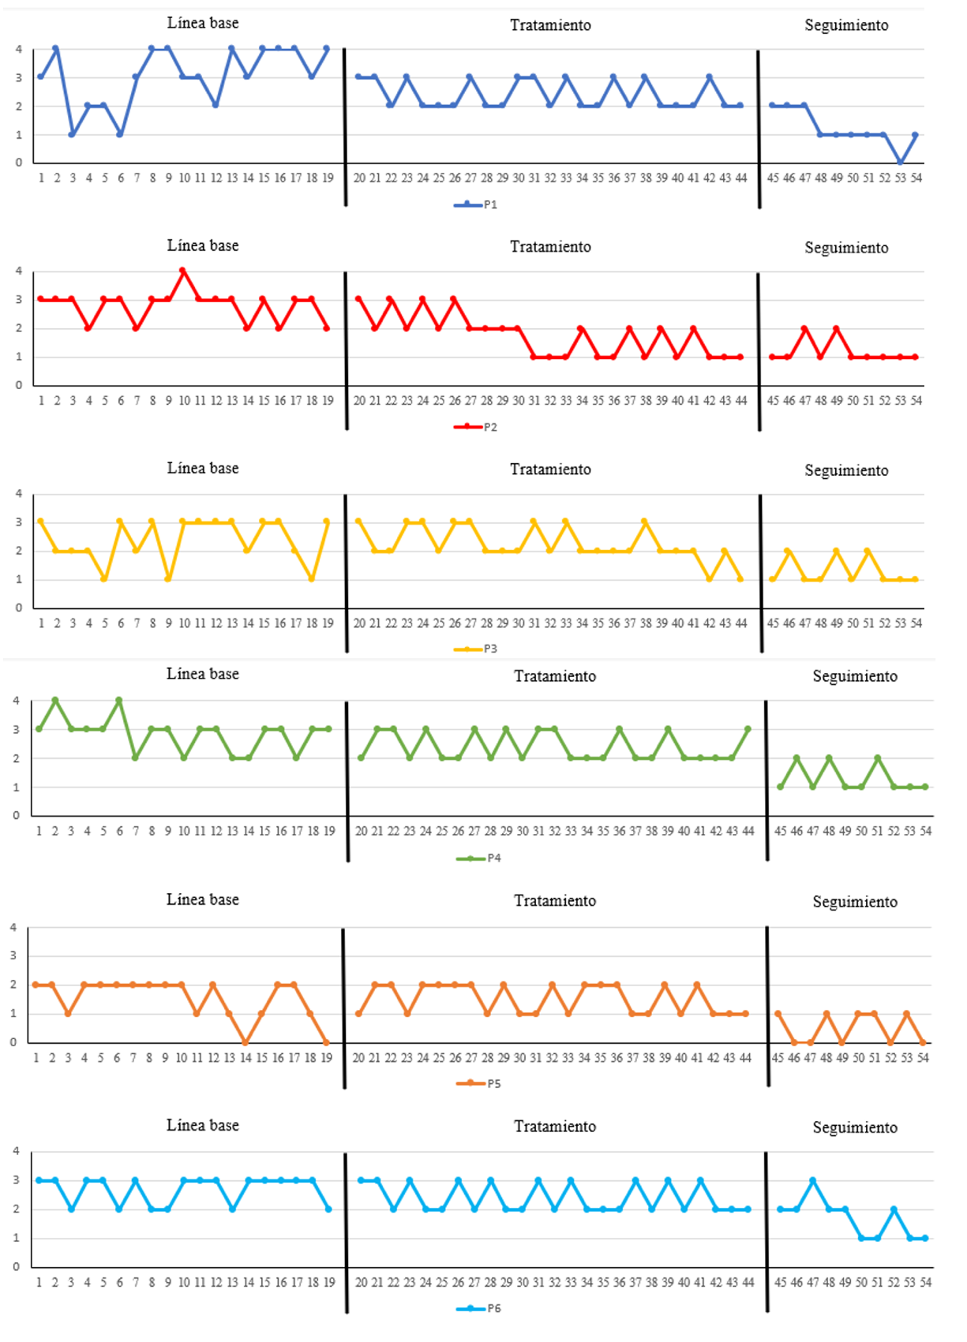

Figure 2.
Self-report of time spent on compulsions
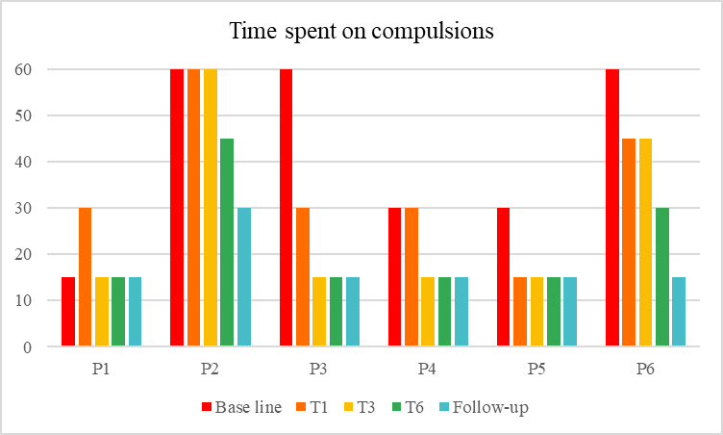

Tau-U Analysis
Tau-U, a statistical method designed for the quantitative analysis of Single-Case Experimental Design (SCED) data, serves as a complement to visual analysis by providing significance testing. This approach measures the degree of nonoverlap between baseline and intervention phases, as well as trends within the intervention phase. In the current study, Tau-U was utilized to assess the effects of the treatment, offering insights into statistically significant changes observed across measures of anxiety, depression, cognitive fusion, and mindfulness.
The results obtained show statistically significant changes with effect sizes ranging from moderate to large in measures of anxiety for 5/6 participants (p<.05), depression for 2/6 participants (p<.05), cognitive fusion 6/6 participants (p<.05), and mindfulness skills for 5/6 participants (p<.05). These changes were observed in comparisons between baseline and intervention. Detailed results of these analyses can be found in Tables 2, 3, 4, and 5.

Table 2.
Statistical significance and effect size OASIS - Anxiety.
Análisis | S | Pares | TAU | TAUb | DE | Z | P Valor | CI 90%
P1 | -17 | 24 | -0,70 | -0,79 | 9,38 | -1,81 | 0,07 | -1<>-0.06
P2 | -23 | 24 | -0,95 | -0,97 | 9,38 | -2,45 | 0,01* | -1<>-0.31
P3 | -18 | 24 | -0,75 | -0,78 | 9,38 | -1,91 | 0,05* | -1<>-0.10
P4 | -22 | 24 | -0,91 | -0,95 | 9,38 | -2,34 | 0,01* | -1<>-0.27
P5 | -11 | 24 | -0,45 | -0,48 | 9,38 | -1,17 | 0,24 | -1<>0.18
P6 | -15 | 24 | -0,62 | -0,63 | 9,38 | -1,59 | 0,10* | -1<>0.01
TAU  Weighted | -106 | 144 | -0,73 | -0,7737 | - | -4,61 | <.001 | -0.99<>-  0.47
*p<.05

Table 3.
Statistical significance and effect size ODSIS - Depression.
Análisis | S | Pares | TAU | TAUb | DE | Z | P Valor | CI 90%
P1 | -21 | 24 | -0,87 | -0,89 | 9,38 | -2,23 | 0,02* | -1<>-0.232
P2 | -6 | 24 | -0,25 | -0,27 | 9,38 | -0,63 | 0,52 | -0.893<>0.393
P3 | -6 | 24 | -0,25 | -0,26 | 9,38 | -0,63 | 0,522 | -0.893<>0.393
P4 | -3 | 24 | -0,12 | -0,15 | 9,38 | -0,31 | 0,74 | -0.768<>0.518
P5 | -19 | 24 | -0,79 | -0,80 | 9,38 | -2,02 | 0,04* | -1<>-0.149
P6 | -6 | 24 | -0,25 | -0,27 | 9,38 | -0,63 | 0,52 | -0.893<>0.393
 | -61 | 144 | -0,42 | -0,45 | - | -2,65 | 0,007 | -0.686<>-0.161
*p<.05

Table 4.
Statistical significance and effect size CFQ – Cognitive Fusion.
Análisis | S | Pares | TAU | TAUb | DE | Z | P Valor | CI 90%
P1 | -22 | 24 | -0,91 | -0,91 | 9,38 | -2,34 | 0,01* | -1<>-0.27
P2 | -24 | 24 | -1 | -1 | 9,38 | -2,55 | 0,01* | -1<>-0.35
P3 | -24 | 24 | -1 | -1 | 9,38 | -2,55 | 0,01* | -1<>-0.35
P4 | -23 | 24 | -0,95 | -0,97 | 9,38 | -2,45 | 0,01* | -1<>-0.31
P5 | -24 | 24 | -1 | -1 | 9,38 | -2,55 | 0,01* | -1<>-0.35
Baseline correction
P6 | -18 | 24 | -0,75 | -0,75 | 9,38 | -1,91 | 0,05 | -1<>-0.10
TAU  Weighted | - 135 | 144 | -0,93 | -0,94 | - | -5,87 | <.001 | -1<>-0.67
*p<.05

Table 5.
Statistical significance and effect size FFMQ-SF – Mindfulness skills.
Analysis | S | Pares | TAU | TAUb | DE | Z | P Valor | CI 90%
P1 | 16 | 24 | 0,66 | 0,66 | 9,38 | 1,70 | 0,08 | 0.02<>1
P2 | 24 | 24 | 1 | 1 | 9,38 | 2,55 | 0,01* | 0.35<>1
P3 | 20 | 24 | 0,83 | 0,83 | 9,38 | 2,13 | 0,03* | 0.19<>1
P4 | 23 | 24 | 0,95 | 0,97 | 9,38 | 2,45 | 0,01* | 0.31<>1
P5 | 22 | 24 | 0,91 | 0,91 | 9,38 | 2,34 | 0,01* | 0.27<>1
P6 | 24 | 24 | 1 | 1 | 9,38 | 2,55 | 0,01* | 0.35<>1
TAU  Weighted | 12  9 | 144 | 0,89 | 0,89 | - | 5,61 | <.001 | 0.63<>1

Table 6.
Wilcoxon Singed- rank test
Measure 1 |  | Measure 2 | W | z | df | p | Hodges-  Lehmann Estimate | Rank-Biserial Correlation | SE Rank-  Biserial Correlation
YBOCS  Pre | - | YBOCS  Post | 21.000 | 2.201 | 0.036* |  | 22.000 | 1.000 | 0.425
FFMQ-  SF Pre | - | FFMQ-SF  Post | 0.000 | - 2.201 | 0.036* |  | -46.000 | -1.000 | 0.425
CFQ Pre | - | CFQ Post | 21.000 | 2.201 | 0.036* |  | 21.000 | 1.000 | 0.425
AAQ-II  Pre | - | AAQ-II  Post | 21.000 | 2.201 | 0.034* |  | 21.000 | 1.000 | 0.425
SWLS  Pre | - | SWLS  Post | 0.000 | - 2.201 | 0.034* |  | -8.000 | -1.000 | 0.425
OASIS  Pre | - | OASIS  Post | 21.000 | 2.201 | 0.031* |  | 9.000 | 1.000 | 0.425
ODSIS  Pre | - | ODSIS  Post | 21.000 | 2.201 | 0.034* |  | 7.000 | 1.000 | 0.425
Note: BOCS (Yale-Brown Obsessive Compulsive Scale), FFMQ-SF (Five Facets Mindfulness Questionnaire- Short Form), CFQ (Cognitive Fusion Questionnaire), AAQ-II (Acceptance and Action Questionnaire-II), SWLS (Satisfaction with Life Scale), OASIS (Overall Anxiety Severity and Impairment Scale), and ODSIS (Overall Depression Severity and Impairment Scale). *p<.05

Wilcoxon signed-rank test and reliability change index
Pre- and post-treatment analyses were conducted to compare the mean Y-BOCS scores before and after the intervention, identifying significant differences. The Wilcoxon signed-rank test (see Table 6) revealed statistically significant changes across all evaluated indicators (p < .05). Raincloud plots in Figure 4 visually depict these changes, enhancing the understanding of the Wilcoxon signed-rank test results.
Additionally, reliability indices were obtained using Jacobson & Truax's (1991) Reliable Change Index for ODSIS, OASIS, and CFQ measures, identifying changes associated with the intervention for all participants in anxiety and cognitive fusion measures, and for 4 participants in depression measures.

Figure 4.
Raincloud plots Wilcoxon signed-rank test
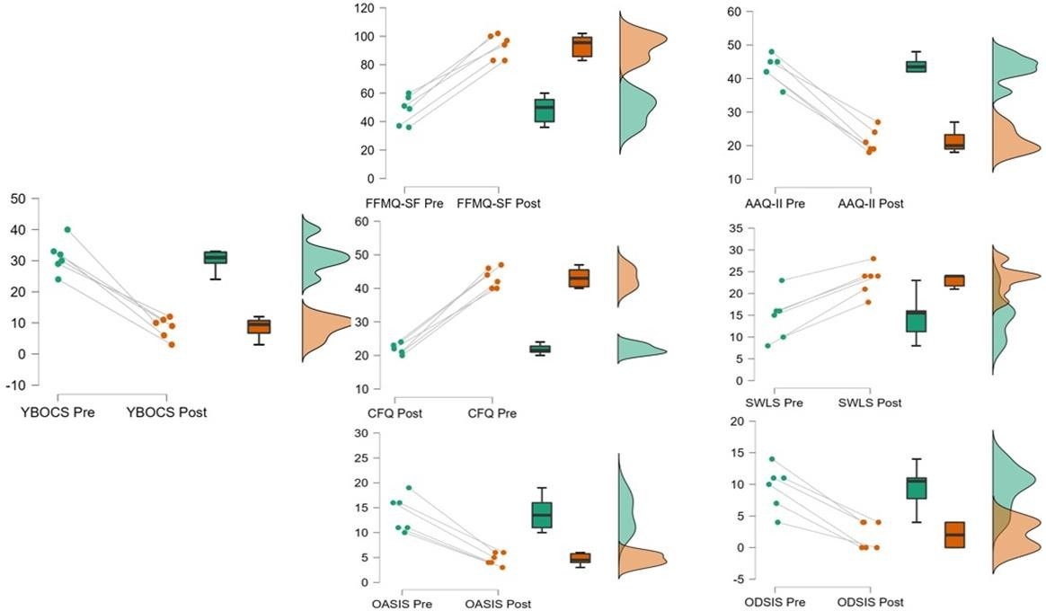

Discussion
The aim of this research was to examine the effect of a protocol based on mindfulness and cognitive defusion on symptoms of OCD, anxiety, depression, cognitive fusion, and mindfulness skills. Our results revealed a significant effect observed in OCD symptoms, anxiety, cognitive fusion, and mindfulness skills. Overall, for this sample of individuals, this brief protocol administered in a synchronous virtual format proved effective in reducing OCD symptoms, cognitive fusion, and anxiety symptoms, while enhancing mindfulness skills, psychological flexibility, and quality of life.
These findings are consistent with previous research (Laurito et al., 2022; Reis et al., 2024), which has indicated that approaches utilizing mindfulness and contextual therapies contribute to symptom improvement in OCD, depressive symptoms, and quality of life. Additionally, these approaches have been associated with increased psychological flexibility through promoting acceptance of internal experiences and actions aligned with personal values. Similarly, in a systematic review conducted by Soondrum et al. (2022), Acceptance and Commitment Therapy (ACT) was proposed as a promising therapeutic model for intervening in cases of OCD, with significant results associated with reductions of up to 50% in symptoms. While interventions like prolonged exposure therapy and CBT remain the most scientifically supported psychological treatments, mental health professionals may also consider mindfulness and ACT as alternative therapeutic approaches. This consideration is warranted because, despite the efficacy of exposure-based treatments alone, some individuals may not achieve adequate symptom reduction or may experience relapses (Kolar et al., 2023).
A notable aspect of this study is the data regarding the time spent on compulsive behaviors reported by participants, which demonstrated a gradual decrease during the treatment phase. These behaviors were replaced by alternative actions aligned with personal values, potentially influencing improvements in indicators of quality of life and well-being. This underscores the importance of measuring time spent on compulsive behaviors in research, as it serves as a simple yet meaningful indicator linked to adaptive functioning in individuals (Del Arco et al., 2014). Additionally, the 75% completion rate in our study sample supports the hypothesis that a focus not centered on symptoms or direct exposure to feared stimuli may enhance participant adherence and reduce the likelihood of dropout (Rupp et al., 2019).
Limitations and future directions
The results of the present study need to be interpreted considering its limitations, particularly the challenge in generalizing these findings to other populations and individuals due to the study's design. Therefore, future research could benefit from employing a design that allows for better control of variables, larger sample sizes, and a more diverse participant pool. As all participants were female, it is not possible to determine the sensitivity or efficacy of this protocol with a gender-diverse sample. Additionally, considering that the follow-up window was two weeks, drawing conclusions about the maintenance of intervention effects in the medium to long term should be explored in future studies with follow-up measures extending to at least three months.
While the data collected are preliminary in nature, their perspective is promising and paves the way for future research in this field. Our implementation of psychotherapy through technology-mediated channels sheds light on the potential benefits of interventions delivered via such platforms, emerging as a promising alternative by facilitating the dissemination of evidence-based therapies and promoting equitable access, thereby reducing the mental health care gap for individuals located in diverse corners of the world.
In conclusion, based on the results of our study, this mindfulness and ACT-based approach emerges as another therapeutic alternative for treating OCD, given its focus on expanding adaptive repertoires rather than solely symptom reduction as seen in more traditional psychotherapy approaches.

References
Blanco-Donoso, L. M., García-Rubio, C., Gallardo, J. A., Pereira, G. L., De La Pinta, M. L. R., Rubio, J. J. Á., & Garrosa, E. (2021b). ACT-based Stress Management Training Aimed at Improving Workers’ Mental Health in an Intensive Care Unit: A Mixed Methods Study1. Clínica Y Salud, 32(3), 111–117. https://doi.org/10.5093/clysa2021a12
Capawana, M. R. (2019). A Developmental Psychopathology Perspective of Obsessive-Compulsive Disorder. Current Psychiatry Research and Review/Current Psychiatry Research and Reviews, 15(2), 105–115. https://doi.org/10.2174/1573400515666190314162612
Corboy, T. y Hershfield, J. (2020). Guía práctica de mindfulness para el TOC: Un manual para superar las obsesiones y las compulsiones mediante el mindfulness y la Terapia Cognitivo Conductual. Editorial Desclée De Brouwer. co
Chien, W. T., Tse, M., Chan, H. Y. L., Cheng, H. Y., & Chen, L. (2022). Is mindfulness-based intervention an effective treatment for people with obsessive-compulsive disorder? A systematic review and meta-analysis. Journal of Obsessive-compulsive and Related Disorders, 32, 100712. https://doi.org/10.1016/j.jocrd.2022.100712
Del Arco Jódar, R., Gómez, M. T., & Soliveres, C. G. (2014). Intervención cognitivo-conductual en el manejo de obsesiones y compulsiones de lavado en una niña con trastorno obsesivo-compulsivo. Revista De Psicología Clínica En Niños Y Adolescentes, 1(2), 141–148. https://dialnet.unirioja.es/descarga/articulo/4742031.pdf
Evey, K. J., & Steinman, S. A. (2023). A Systematic review of the use of Acceptance and Commitment therapy to treat Adult Obsessive-Compulsive Disorder. Behavior Therapy, 54(6), 1006–1019. https://doi.org/10.1016/j.beth.2022.02.009
Exner, C., Kleiman, A., Haberkamp, A., Hansmeier, J., Milde, C., & Glombiewski, J. A. (2024). Metacognitive therapy versus Exposure and Response prevention for obsessive-compulsive disorder – a non-inferiority Randomized controlled trial. Journal of Anxiety Disorders, 102873. https://doi.org/10.1016/j.janxdis.2024.102873
Germer, C. K., & Neff, K. (2018). The Mindful Self-Compassion Workbook: A proven way to accept yourself, build inner strength, and thrive. http://ci.nii.ac.jp/ncid/BB2781742
Harris, R. (2009). ACT made simple: An Easy-To-Read Primer on Acceptance and Commitment Therapy. Oakland, CA: New Harbinger.
Hayes, S. C., Pistorello, J., & Levin, M. E. (2012). Acceptance and Commitment therapy as a unified model of behavior change. the Counseling Psychologist, 40(7), 976–1002. https://doi.org/10.1177/0011000012460836
Kayser, R. (2020). Pharmacotherapy for Treatment-Resistant Obsessive-Compulsive Disorder. the Journal of Clinical Psychiatry, 81(5). https://doi.org/10.4088/jcp.19ac13182
Kazdin A. E. (2016). Single-case research designs: Methods for clinical and applied settings. Oxford University Press.
Kolar, D. R., Meule, A., Zisler, E. M., Schwartz, C., & Voderholzer, U. (2023). Effects of acceptance-based strategies on psychological responses to disorder-relevant stimuli in inpatients with obsessive–compulsive disorder: An experimental study. Journal of Behavior Therapy and Experimental Psychiatry, 81, 101890. https://doi.org/10.1016/j.jbtep.2023.101890
Laurito, L. D., Loureiro, C. P., Faro, L., Dias, R. V., Torres, B., Moreira‐de‐Oliveira, M. E., Santos-Ribeiro, S. D., De Menezes, G. B., Fontenelle, L. F., Davis, C. H., & Twohig, M. P. (2022). Acceptance and Commitment Therapy for obsessive compulsive disorder in a Brazilian context: Treatment of three cases. Journal of Contextual Behavioral Science, 24, 134–140. https://doi.org/10.1016/j.jcbs.2022.04.002
Philip, J., & Cherian, V. (2021). Acceptance and Commitment Therapy in Obsessive–Compulsive Disorder: A Case study. Indian Journal of Psychological Medicine, 44(1), 78–82. https://doi.org/10.1177/0253717621996734
Reis, A., Westhoff, M., Quintarelli, H., & Hofmann, S. G. (2024). Mindfulness as a therapeutic option for obsessive-compulsive disorder. Expert Review of Neurotherapeutics, 1–7. https://doi.org/10.1080/14737175.2024.2365945
Ruiz, F. J., Suárez-Falcón, J. C., Riaño-Hernández, D., & Gillanders, D. (2017). Psychometric properties of the Cognitive Fusion Questionnaire in Colombia. Revista Latinoamericana De Psicologia, 49(1), 80–87. https://doi.org/10.1016/j.rlp.2016.09.006
Ruiz, F. J., Suárez-Falcón, J. C., & Riaño-Hernández, D. (2016). Psychometric properties of the Mindful Attention Awareness Scale in Colombian undergraduates. Suma Psicológica, 23(1), 18–24. https://doi.org/10.1016/j.sumpsi.2016.02.003
Ruiz, F. J., Suárez-Falcón, J. C., Flórez, C. L., Odriozola-González, P., Tovar, D., López-González, S., & Baeza-Martín, R. (2019). Validity of the Satisfaction with Life Scale in Colombia and factorial equivalence with Spanish data. Revista Latinoamericana De Psicologia, 51(2). https://doi.org/10.14349/rlp.2019.v51.n2.1
Rupp, C., Jürgens, C., Doebler, P., Andor, F., & Buhlmann, U. (2019). A randomized waitlist-controlled trial comparing detached mindfulness and cognitive restructuring in obsessive-compulsive disorder. PloS One, 14(3), e0213895. https://doi.org/10.1371/journal.pone.0213895
Öst, L., Havnen, A., Hansen, B., & Kvale, G. (2015). Cognitive behavioral treatments of obsessive–compulsive disorder. A systematic review and meta-analysis of studies published 1993–2014. Clinical Psychology Review, 40, 156–169. https://doi.org/10.1016/j.cpr.2015.06.003
Sandora, J., Novák, L., Brnka, R., Van Dijk, J. P., Tavel, P., & Maliňáková, K. (2021). The abbreviated Overall Anxiety Severity and Impairment Scale (OASIS) and the Abbreviated Overall Depression Severity and Impairment Scale (ODSIS): Psychometric Properties and evaluation of the Czech versions. International Journal of Environmental Research and Public Health 18(19), 10337. https://doi.org/10.3390/ijerph181910337
Scheff, S. W. (2016). Fundamental statistical principles for the neurobiologist: A survival guide. Elsevier.
Schneider, S. C., Knott, L. E., Cepeda, S. L., Hana, L. M., McIngvale, E., Goodman, W. K., & Storch, E. A. (2020). Serious negative consequences associated with exposure and response prevention for obsessive‐compulsive disorder: A survey of therapist attitudes and experiences. Depression and Anxiety, 37(5), 418–428. https://doi.org/10.1002/da.23000
Soffer‐Dudek, N. (2023). Obsessive-compulsive symptoms and dissociative experiences: Suggested underlying mechanisms and implications for science and practice. Frontiers in Psychology, 14. https://doi.org/10.3389/fpsyg.2023.1132800
Sosa-Ochoa, M. (2019). Propiedades psicométricas de la escala Five Factor Mindfulness Questionnaire FFMQ en una muestra Colombiana. https://repositorio.konradlorenz.edu.co/bitstream/handle/001/2235/RAI- 911172013.pdf?sequence=2&isAllowed=y
Soondrum, T., Wang, X., Gao, F., Liu, Q., Fan, J., & Zhu, X. (2022). The Applicability of Acceptance and Commitment Therapy for Obsessive-Compulsive Disorder: A Systematic Review and Meta-Analysis. Brain Sciences, 12(5), 656. https://doi.org/10.3390/brainsci12050656
Swierkosz-Lenart, K., Santos, J. F. a. D., Elowe, J., Clair, A., Bally, J. F., Riquier, F., Bloch, J., Draganski, B., Clerc, M., Moyano, B. P., Von Gunten, A., & Mallet, L. (2023). Therapies for obsessive-compulsive disorder: Current state of the art and perspectives for approaching treatment-resistant patients. Frontiers in Psychiatry, 14. https://doi.org/10.3389/fpsyt.2023.1065812
Yacila, G. A., Águila, L. C., Sanchez-Castro, A. E., Reyes-Bossio, M., & Tejada, R. A. (2016). Traducción y adaptación cultural del Yale-Brown Obsessive Compulsive Scale (Y-BOCS) para trastornos obsesivos compulsivos. Acta Médica Peruana, 33(3), 253. https://doi.org/10.35663/amp.2016.333.125

