THEORETICAL MODEL FOR PERSONAL SUCCESS

Abstract. The goal of the research represented in the article is to develop a theoretical model for personal success. The core is the life activity standard chosen by a person, which manifests itself at three levels: existential, social, and vital. The existential standard is characterized by an aspiration for true calling, spiritual development. The social standard is associated with self-realization in the social relations field. The vital standard involves aiming at homeostasis, with a personality focus on physical and sensual satisfaction. Standard formations set the substantial content of personal success; they are patterns that allow a person to choose a life strategy and a behavior model within certain time, or in particular conditions. As a result of theoretical analysis of scientific literature on a personal success problem, the main value-semantic and emotional-volitional characteristics in its contents are marked. Value-semantic substance of personal success includes affirmations, values, and goals in significant life spheres, self-actualization, peculiarities of one's own life perception, and attitude towards other people. Emotional-volitional characteristics within the presented model are as follows: awareness and expression of one's needs, feelings and emotions, independence and self-control, self-efficacy and assessing one's merits, subjective well-being, self-satisfaction, and vital activity experience. These characteristics affect success image in the individual’s consciousness, identification of life priorities, achievement of the desired level of self-realization through the experience of subjective well-being and a sense of satisfaction. The scientific novelty of the research is the developed theoretical model for personal success that can make it possible to formulate a working hypothesis later, to select necessary psychological methods, and to follow the logic of empirical study of value-semantic and emotional-volitional characteristics within the structure of personal success associated with the dominant vital activity standard.
Keywords: personality success; vital activity standard; emotional-volitional sphere; value-semantic sphere; values; goals; self-control; self-actualization; self-efficacy; satisfaction.

- Introduction
Success issues are progressively coming to the fore. People are surrounded by information that promotes methods and technologies for achieving success based upon different values and paradigms. Indeed, within modern life conditions the role of a person's active attitude to self-development increases, one must discover a supporting point in oneself.
Life success includes personal success and is mostly determined by it. At the same time, each person interprets personal success differently, putting their own sense into it, which affects the life trajectory overall and a choice of behavior models to achieve significant goals (Shockley et al, 2016). For some people, it is important to be self-oriented; they wish to become rich and famous, to have authority and influence. Others focus on productive social interaction and collaboration, but there are also people who aspire to apply their talents and lives to create and to help others. Career success can also be of vital importance (Salisu et al, 2020; Shockley et al, 2016).
Nowadays some researchers pay attention to the gender aspects of personal success (Adapa & Sheridan, 2021; Koekemoer, Olckers, & Schaap, 2023).
In this research personal success acts as a complex of manifestations of value-semantic and emotional-volitional characteristics of a person, interconnected with the accepted life standard, reflecting the positive result of activities aimed at achieving a significant goal and meaning, leading to a feeling of harmony with the world and oneself.
Based upon the investigated theoretical material it is marked that many scientists have common consent: only an individual may evaluate personal success, and that is its specific feature (Klochkova, 2002; Satorra & Saris, 1985).
Value-semantic and emotional-volitional characteristics’ research is connected with a number of methodological difficulties: absence of integral success theory; multiplicity in interpreting the notion “personal success”; absence of approach to its research methods and separate structural elements.
One of the authors of this article systematized the study of a success phenomenon in Russian psychology (Dvoretskaya & Loshchakova, 2016). There are not enough empirical studies of personal success, as a result, an aggregate picture of this phenomenon has not been obtained yet, and its specific nature has not been fully disclosed, and requires further work. Therefore, this phenomenon has become a subject of the research interest.
The authors consider that personal success depends on the emotional-volitional and value-semantic characteristics of an individual, the psychological basis for which is a chosen vital activity standard. Therefore, the basic concept of the study was the one of an integrated person by M. Ya. Dvoretskaya (Dvoretskaya & Loshchakova, 2016). The author connects the implementation of the vital activity standard with a clear vision of the desired future, prospects and orientation of vital activity in a person's view and the associated life purpose. The standard can be presented at a vital, social or existential dominant level.
The vital activity standard is oriented towards hedonism, consumption, manipulation, pursuance for sensual and physical pleasure, material benefits. The social standard is accompanied by orientation towards socialization, trust-based relations with others, achievements in professional, family and public life spheres. The existential standard is connected with spiritual development, orientation, conscience, creative life, harmonious relations with the surrounding community and oneself.
While choosing one or another vital activity standard, a person, thereby, sets the lifeline direction leading to personal success.
Therefore, as a result of the theoretical comprehension of a problem to solve the authors faced a task to develop a model of significant value-semantic and emotional-volitional characteristics of personal success. The invariant features of these characteristics will depend on the chosen vital activity standard.
The theoretical model for personal success allows describing the structure of the studied phenomenon and its connections with other phenomena. The model contributes to the formulation of a current hypothesis, the selection of diagnostic tools and following the logic of the experimental stage of the study, the interpretation of the obtained results.

- Materials and Methods
The basic goal of the study is to identify and to justify value-semantic and emotional-volitional characteristics in personal success structure. The tasks of the research included: working out a theoretical model for personal success for the selection and testing methodological tools for diagnosing value-semantic and emotional-volitional characteristics of personal success; arranging and conducting empirical research; empirical model development; the preparation of recommendations for practical psychologists based upon the obtained results.
A following hypothesis was made: personal success is determined by value-semantic and emotional-volitional characteristics in its structure, the content of which is connected with the accepted vital activity standard. The hypothesis required experimental verification, it is necessary to get a theoretical model. The theoretical analysis and systematization of scientific approaches, provisions of the studied phenomenon were carried out; the approach matching of the notion of success and wellness; the study of experimental data represented in publications by foreign and Russian psychological scientists; theoretical and empirical modeling (Dvoretskaya & Loshchakova, 2016).

- Results
The theoretical model for personal success is represented by pattern 1.
The suggested model shows that value-semantic characteristics within the structure of personal success include: affirmations, values and goals in specific life spheres, aiming at self-actualization, perception of one's own life and attitude towards other people.
Affirmations. From the viewpoint of K.D. Davydova affirmations influence cognitive processes, emotional expressions, and personal behavior. Affirmations ascertain an individual’s value orientation, a focus sphere (Davydova, 1975). They determine personal meanings, certain action readiness, motion direction stability, and help to vindicate their own judgements, to express their opinion, to create an attitude and assess events. Therefore, value-semantic component of personal success cannot do without affirmations’ perception; they are an important characteristic in achieving it.
Goals (terminal values). The basic elements of value-semantic sphere constitute values and meanings, the main function of which is associated with goals achievement and arranging relationships between a person and the community (Korzhova, 2015). Personal values include needs, expectations, convictions, wishes that predetermine a choice in problematic situations. Awareness of values is represented in the form of value orientations, which influence the ways of a person’s self-realization (Kalyutkin & Sukhobskaya, 1996).
Thus, values and meanings constitute the motivational basis for personal success, orienting a person's life and activities, determining their judgments, actions, a degree of social activity, the arrangement of life priorities, etc.
Life spheres. Human values are actualized in various life spheres (professional, family, public, etc.), determine the attitude to other people, to oneself, to the community, and the key actions motives.
Self-actualization. Self-actualization is a result of realizing the main values, goals and significant life spheres. Self-actualization means self-fulfillment. It is seen as a process, meaning and lifestyle. Scientists consider personal success as self-actualization or self-realization, it acts as their assessment (Karpov, 2003). Self-actualization is manifested in the peculiarities of one's own life perception and attitude towards other people.
The acceptance of values presupposes an act of volition and emotional recognition in the form of positive assessment. Emotions and volition play an important role in socialization, influencing a person’s mental activity.
Volition and emotions are inseparable from each other; their source is common - needs. The scientific community has common opinion that emotions and feelings determine behavior. Satisfaction (or dissatisfaction) with oneself and one's deeds is reflected in them. The emotional and volitional characteristics of personal success in the proposed model include awareness and expression of one's feelings and emotions, independence and self-control, self-efficacy and assessing one's merits, subjective well-being and the experiencing self-satisfaction and one's life activity satisfaction. Some comments are to be made on their content.
Awareness and expressing feelings and emotions. Herein the success issue emotions are a reflection of a person's attitude to significant phenomena; they express direct experiences associated with needs satisfaction or dissatisfaction. Through emotions, a person is able to evaluate events depending on personal meaning. They also demonstrate relations between motive and success or an assessment of its probability. Emotional sufferings are motivating and activating. At the same time, emotions can be stored in memory for a long period of time (the so-called “emotional memory”), when cases of success or failure are recorded, and they determine actions of a person, taking into account previous life experience.

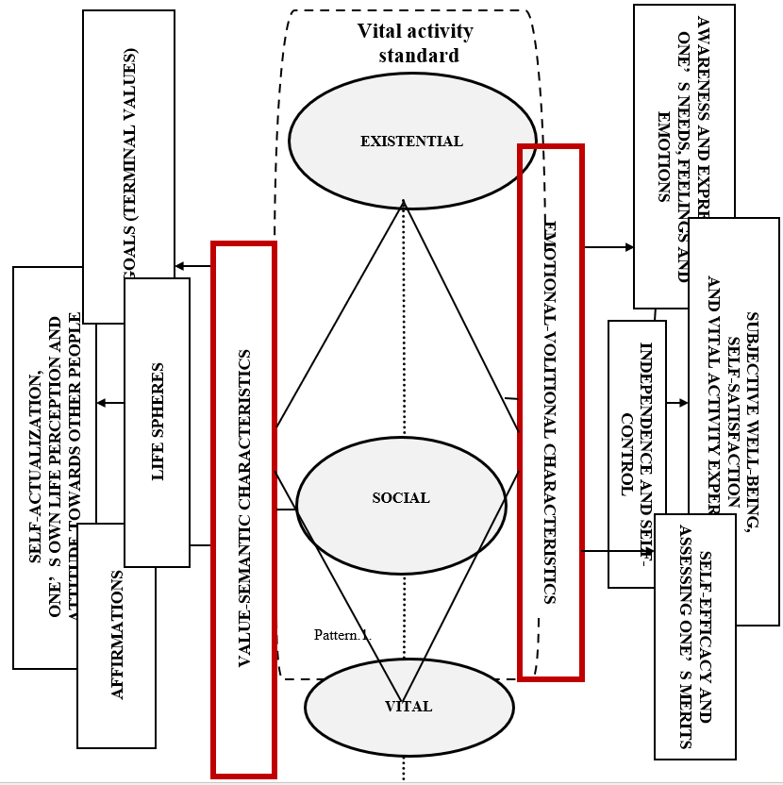

Fig 1. Theoretical model for personal success. Source: Compiled by the authors.

Independence and self-control. From the psychological point of view, volition always acts as a conscious self-organization and self-regulation of a person’s activities to achieve a desired goal. The volitional basis of the personality consists of processes, which provide a connection between intentions and actions. The volition component of personal success contributes to the goal achievement under different challenges.
Volitional self-regulation is closely connected with the value-semantic sphere: the more meaningful a person's life is, the higher is their level of self-regulation and volitional characteristics severity: goal commitment, obstinacy, endurance, independence, etc. The purpose of volitional self-regulation is to manage emotion conditions, which are of great value for vital activity success.
Self-control is a constituent part of personal self-regulation, coping behavior, conscious control over actions, emotion conditions and motives. Capacity of volitional self-control increases responsibility for actions.
Self-control determines personal success, activity efficacy; it contributes significantly to experiencing a life satisfaction feeling. The higher the level of self-control is, the higher are life satisfaction, psychological well-being, positive emotions manifestations rates, and vice versa.
Self-efficacy and own merit rating. Self-efficacy is manifested in a person's awareness of their personal potential for being productive in various cases of social interaction (activity and communication), and confidence in effective self-realization in these situations (Gaidar, 2008). Self-efficacy actualizes internal motivation, emotions expression, and choice of behavior forms. A high level of self-efficacy associated with success expectation often leads to success. In fact, self-efficacy is a condition of psychological readiness for successful behavior.
Reflection as an understanding of one's actions and emotion conditions promotes assessing one's merits (Karpov, 2003). Reflective assessment of one's merits contributes to self-actualization, achievement of maximum efficacy and activity success. Within our research, reflexivity factor shows how much a person is inclined to be aware of their own success and failures. It affects success self-rating.
Subjective well-being and the experience of satisfaction with oneself and one's life activity (Dementiy & Kupchenko, 2016). М.Р. Bityanova (2003) believes that it is not possible to speak of success without a person's subjective experience of the objectively obtained result. One can achieve much, but the “price” to pay will lead to empty feeling, anxiety, grief, etc. Another one can progress slightly without losing anything, but this will be a big commitment towards overcoming personal limitations and towards victory, reflecting in feelings of joy and emotional uplift. The subjective well-being of a person is an integral psychological formation that combines the assessment and emotional attitude of a person to their life, the community and oneself, which is of special personal significance. Due to this experience, a person acknowledges psychological characteristics, which help them to cope with life obstacles, provide behavior flexibility within changing circumstances, while interacting with people, contribute to self-respect and respect for other people around.
Value-semantic person entities, social psychological attitudes, behavior strategies, as well as socialization conditions influence the subjective well-being. Well-being depends on what is more significant, valuable for a person, their aspirations intensity towards something.
A high level of subjective well-being is a result of a person’s self-actualization, it ensures their mental health.
The external criteria of subjective well-being are often as follows: the general quality of a person's life and a virtuous life, which is determined by the possession of socially desirable characteristics and the system of values typical for this culture. The internal indicator is associated with the harmonious satisfaction of one's own desires and aspirations, the proportionality of goals and opportunities; a feeling of internal balance, integrity, happiness (dominance of positive emotions over negative ones).
K.A. Abulkhanova-Slavskaya emphasizes a connection between success, self-satisfaction and life satisfaction. According to the scientist, it is satisfaction that provides a loyalty and trueness of life feeling (Abulkhanova-Slavskaya & Berezina, 2001). Virtually it is the only source of vitality, initiative and changes, aspiration to move forward. A person can experience satisfaction well-being because the achieved result agreed with expectations or surpassed them. Such satisfaction can appear from the goal achievement process itself, absorption in it. Due to permanent satisfaction feeling stronger activity motivations are formed, self-esteem and self-respect level changes. Life satisfaction is associated with well-being, activity level, creative work availability, life certainty. As a result, the developed theoretical model implies its own invariant features of value-semantic and emotional-volitional characteristics depending on the chosen vital activity standard.

- Discussion
Value-semantic and emotional-volitional spheres play an essential role in success issue context; they are always identifiable to achieving specific goals. Actions towards the same goal can be both successful and unsuccessful, and even neutral. Ignoring these spheres characteristics may lead to the fact that, as a result, a person will follow the imposed success stereotype without paying any attention to its subjective psychological content.
The “personal success” term does not have an unambiguous interpretation nowadays. A specific psychological theory of success in general has not been developed yet. As an independent problem, this type of success has been studied relatively recently, so theoretical models for personal success cannot be found in scientific publications. However, the model for personal success in this article and its structural content complement a number of studies where personal success is being studied and has corresponding meanings (Averina, Slavskaya & Berezina, 2001; Kolovskaya, 2000).
To be successful a person needs to analyze their inner potential, develop the strong points of their own personality, and use the available psychological resources rationally. Therefore, personal growth is an integral part of achieving success (Averina & Alexandrova, 2011).
To some extent, the phenomena of personal success and personal growth are interrelated and reflect on each other. Need for perfection, self-realization and self-actualization are linking these phenomena; both phenomena determine the direction for change and the source of this determination is the personality itself (Abulkhanova-Slavskaya & Berezina, 2001). The difference is that personal growth in psychological theory and practice is studied as a process, and personal success is seen as a result (Korzhova, 2015). For example, the movement towards success may be limited by the problem of personal growth.
The personal success is achieved through the readiness for self-development, the ability to harmonize the relationship with oneself and the life around, the ability to cooperate with others, manage oneself and circumstances.

- Conclusion
Personal success lies in each human. However, to get a positive result it is not enough to wish to succeed. On the way to achieving personal success, the first phase starts with value-semantic and emotional-volitional self-regulation.
According to the developed theoretical model, at the experimental stage the authors will consider the following value-semantic and emotional-volitional characteristics of personal success: the vital activity standard as a basis of personal success and related to it; affirmations as values manifestation, goals and significant life spheres that determine personal orientation, self-actualization, perception of one's own life and attitude towards other people, awareness and expression of one's feelings and emotions; self-efficacy as a self-belief; assessment of their merits through reflection; decision-making discretion and emotions and behavior self-control; subjective well-being, satisfaction with oneself and one's vital activity.
The obtained theoretical results formed the basis for further empirical research.
The received research data will assist practicing psychologists in conducting coach sessions, psychological counseling, working out specialized programs and practical courses related to personal success problems.
The theoretical model of value-semantic and emotional-volitional characteristics of personal success may be helpful in actual human resources management practice in an organization: vacancy selection procedures, implementing young employees’ adaptation and career planning programs, employee pool formation, conducting certification tests.

Conflict of Interests
The authors declare no conflict of interests.

References
Abulkhanova-Slavskaya, K. A., & Berezina, T. N. (2001). Personality Time and Life Time. Saint-Petersburg: Aletia.
Adapa, S., & Sheridan, A. (2021). A case of multiple oppressions: women’s career opportunities in Malaysian SME accounting firm. International Journal of Human Resources Management, 32, 2416–2442. DOI: 10.1080/09585192.2019.1583269
Averina, A. J., & Alexandrova, L. A. (2011). Potential of a Person: Structure and Diagnostics. Moscow: Sense.
Bityanova, M. R. (2003). Achievement and wellness. School Counsellor, 40, 12–17.
Davydova, K. D. (1975). Social Attitude as a Psychological Phenomenon. Moscow: Social psychology and philosophy.
Dementiy, L. I., & Kupchenko, V. E. (2016). Self-control as a predictor of students’ mental well-being. Philosophy and Social Sciences, 2, 76–81.
Dvoretskaya, M. Ya., & Loshchakova, A. B. (2016). Success image in modern psychological research. Retrieved from http://mir-nauki.com/PDF/09PSMN216.pdf
Gaidar, M. I. (2008). Personal self-efficacy development among psychology students during university education. (Dissertation). Kursk: Kursk State University.
Kalyutkin, Y. N., & Sukhobskaya, G. S. (1996). Personality. Inner World and Self-Realization: Ideas, Concepts, Views. Saint-Petersburg: Tuscarora.
Karpov, A. V. (2003). Reflexivity as a psychological attribute and methods of its diagnosis. Psychology Magazine, 24(5), 45–57.
Klochkova, O. Y. (2002). Social and Personal Success: The Problem of Correlation. Moscow: Institute of Socio-Political Studies of the Russian Academy of Sciences.
Koekemoer, E., Olckers, C. & Schaap, P. (2023). The subjective career success of women: The role of personal resources. Frontiers in Psychology, 14. https://doi.org/10.3389/fpsyg.2023.1121989
Kolovskaya, L. V. (2000). Personality and Success. Krasnoyarsk: Krasnoyarsk State Technical University.
Korzhova, E. Y. (2015). Personal Psychology: Typology of Theoretical Models. Internally Integral Personality Models. Birobidzhan: Priamur State University.
Salisu, I., Hashim, N., Mashi, M. S., & Aliyu, H. G. (2020). Perseverance of effort and consistency of interest for entrepreneurial career success. Journal of Entrepreneurship in Emerging Economies, 12, 279–304. https://doi.org/10.1108/JEEE-02-2019-0025
Satorra, A., & Saris, W. E. (1985). Power of the likelihood ratio test in covariance structure analysis. Psychometrika, 50, 83–90. https://doi.org/10.1007/BF02294150
Shockley, K. M., Ureksoy, H., Rodopman, O. B., Poteat, L. F., & Dullaghan, T. R. (2016). Development of a new scale to measure subjective career success: a mixed-methods study. Journal of Organizational Behavior, 37, 128–153. DOI: 10.1002/job.2046

