The Role of Anomie in the Relationship between Political Orientation and Authoritarianism
Abstract
Recently, several anti-democratic and authoritarian demonstrations by extreme right-wing movements have been observed in Brazil. This study aimed to test an explanatory structural model of authoritarianism via the mediating role of the dimensions of the state of anomie (rupture of the social fabric and collapse of political leadership). The sample included 157 participants who answered the Perception of Anomie Scale (PAS), a measure of authoritarianism, political positioning, and sociodemographic items. The model showed good fit indices (CFI = 0.95; TLI = 0.95; SRMR = 0.080; RMSEA = 0066, 95% CI [0.047, 0.085]). The findings show that right-wing political positioning predicted higher levels of perceived rupture of the social fabric and collapse of political leadership, which in turn predicted higher levels of authoritarianism. Political positioning proved to be a stronger predictor in explaining levels of authoritarianism. A significant indirect effect was observed for the perception of the breakdown of political leadership but not for the perception of the breakdown of the social fabric. It is understood that the loss of a sense of unity and low trust in the members of society does not affect the relationship between political positioning and support for authoritarian measures but rather the perception of the collapse of political leadership. The findings are discussed in the context of the recent transition of government to the left, high political polarization, the Brazilian social, political, and economic context, and the state of anomie among Brazilians.
Keywords: anomie; authoritarianism; politics.
O Papel da Anomia na Relação entre Orientação Política e Autoritarismo

Resumo
Recentemente, foram observadas diversas demonstrações antidemocráticas e autoritárias por movimentos de extrema direita no Brasil. Nesse sentido, o objetivo da pesquisa foi testar um modelo estrutural explicativo do autoritarismo, via o papel mediador das dimensões do estado de anomia (ruptura do tecido social e colapso das lideranças políticas). A amostra contou com 157 participantes, que responderam a Escala de Percepção de Anomia (PAS), uma medida de autoritarismo, posicionamento político e itens sociodemográficos. O modelo apresentou bons índices de ajuste (CFI = 0,95; TLI = 0,95; SRMR = 0,080; RMSEA = 0066, IC 95% [0,047, 0,085]). Os achados demonstram que o posicionamento político de direita predisse maiores níveis da percepção de ruptura do tecido social e colapso das lideranças políticas, que, por sua vez, predisseram maiores níveis de autoritarismo. O posicionamento político demonstrou ser um preditor mais forte na explicação dos níveis de autoritarismo. Foi observado um efeito indireto significativo para a percepção de colapso das lideranças políticas, mas não para a percepção de ruptura do tecido social. Compreende-se que a perda de um sentido de união e a baixa confiança nos integrantes da sociedade não afeta a relação entre o posicionamento político e o apoio a medidas autoritárias, mas sim a percepção de desmoronamento das lideranças políticas. Os achados são discutidos diante do contexto da recente transição de governo para a esquerda, da alta polarização política, do contexto social, político e econômico brasileiro e do estado de anomia entre brasileiros.
Palavras-chave: anomia; autoritarismo; política.

The Role of Anomie in the Relationship between Political Orientation and Authoritarianism
Brazilians have experienced a recent transition of power to a left-wing government with the election of Lula in 2022. However, the previous years were accompanied by the presence of a far-right president, with authoritarian, religious, and meritocratic speeches, and the rise of far-right movements with an emphasis on nationalism, discrimination, religious sectarianism, militarism, and anti-democratic agendas (Costa & Silveira, 2018; Saad-Filho & Boffo, 2021; Silva & Rodrigues, 2021).
The country has problems such as high levels of corruption, inequality, violence, and poverty (Gonçalves, 2024; Oliveira, 2023). Furthermore, based on the Political Stability Index, which assesses the likelihood of a disorderly transfer of power, violent demonstrations, and inter-group conflicts, Brazil appears to be one of the most politically unstable countries, in 122nd place out of 193 countries (The Global Economy, 2024). After Lula's victory in 2022, different events occurred that illustrate this, such as the attempted invasion of the Federal Police and the attempted coup on January 8, 2023 (Hubertus, 2022; Rodrigues et al., 2023).
It should be noted that in countries with rapid economic growth and rapid social change, such as Brazil, the experience of anomie, which corresponds to a fragility in the individual's beliefs about the norms that keep society cohesive, tends to be high, given a perception of the political, social and economic collapse of society (Teymoori et al., 2016).
The feeling of uncertainty due to a society's instability and the perception of lack of control can favor authoritarianism's adherence to protecting people from existential threats associated with the experience of anomie, restoring the perception of individual and collective control and well-being (Teymoori et al., 2017).
Based on this concept, Lima et al (2022) demonstrated that a higher state of anomie is associated with higher levels of authoritarianism and, consequently, a political positioning to the left. It is important to note that the data from this study was collected during the Bolsonaro administration. From this perspective, it is necessary to continuously evaluate this state's role in the relationship between political positioning and authoritarianism, given that Brazil is highly polarized politically (Ribeiro & Simões, 2023). Evidence shows that anomie is associated with higher rates of violence, crime, and popular uprisings in a society (Teymoori et al., 2017), 2017), and, at an individual level, a greater propensity to adhere to beliefs in conspiracy theories, to endorse populism, to oppose diversity rights and to engage less in health behaviors, such as vaccination against COVID-19 (Bebouraka et al., 2024; Galgali et al., 2023; Manunta et al., 2024; Mao et al., 2024).
In this sense, we proposed an explanatory model for the present study in which political positioning will explain higher levels of authoritarianism through a higher state of anomie.
Authoritarianism
Authoritarianism arises from the belief that force is necessary to impose an ideology, mainly through violence and the propagation of anti-democratic ideas (Costa & Silveira, 2018). Thus, one factor that results in authoritarianism is insecurity. Therefore, it is a mechanism for people to feel safe when anguish and uncertainty exist (Fromm, 1941). Feldman and Stenner (1997) state that manifestations of authoritarianism are more frequent when there is a perception of threat, influencing political and social attitudes.
For an authoritarian system to become established, it is essential to have a leader who propagates ideas along these lines. However, the presence of people disseminating this ideology in line with authoritarian thoughts is equally important, as they are the figure's spokespeople. In this way, authoritarianism unites individuals to legitimize a common idea using different means of discourse, whether religious, political, or military (Costa & Silveira, 2018). In Brazil, adherence to authoritarian socio-political attitudes has been observed predominantly among people who identify with the political right (Vilanova et al, 2018, 2022).
Furthermore, according to Silva (2021), authoritarian practices promote hateful and violent discourse against various minority groups through fake news. From this perspective, political behavior is directly linked to the participation of individuals in organizations that manage aspects of power in society (Wachelke & Hammes, 2009).
Anomie
Durkheim (2000) refers to anomie as a social disorder caused by the breakdown of rules. In this sense, the state of anomie can be altered when unexpected changes occur that break the norms present in the environment, making them unstable and weakening their power, consequently generating collective dissatisfaction.
From another perspective, Merton (1938) points out that social norms can be understood as continuing the behaviors, actions, and ideals formed in society and disseminated in culture. Thus, when these norms are weak or contradictory, anomie arises, resulting in the development of deviant behavior (Suxberger & Pacheco, 2019).
Teymoori et al. (2017) sought a definition of anomie closer to the field of psychology. From this perspective, they understand this factor as the breakdown of social interaction and regulation, in which old individual beliefs are transformed into shared perceptions. This breakdown can occur in two ways: by disintegration - related to the perception that the social fabric is in decline and thus there is no sense of unity and trust between people, generating a weaker bond and causing higher division of groups — or by deregulation — corresponding to the collapse of leadership, i.e. when the perception that a leader is no longer seen as effective and legitimate.
People with high levels of anomie and perceived uncertainty about the social context tend to value authoritarian measures and follow leaders who defend these principles (Teymoori et al., 2017). To investigate this phenomenon, Lima et al (2022) studied the relationship between political positioning and the desire for authoritarian leaders and the state of anomie. The results showed that people with a lower perception of a leader in collapse, one of the dimensions of anomie, had greater confidence in more authoritarian political leaders, such as former president Jair Bolsonaro, and identified with a political position on the right. In a French context, Mahfud and Adam-Troian (2019) showed that people with more violent and extremist behaviors tend to have higher levels of anomie.
Additionally, in a study conducted by Teymoori et al. (2016), from January 2014 to February 2015, among 28 countries investigated, it was identified that Brazilians had high levels of anomie and that poverty, unemployment, and inequality predicted greater anomie. Given the scenario of political conflicts, violent demonstrations, and political polarization in the country, especially given the January 8 attack by far-right groups after the electoral victory of a left-wing president, it seems that people further to the right may have shown more manifestations of authoritarianism due to a higher state of anomie.
The literature on anomie in Brazil is still developing, and the state of anomie among citizens can strengthen harmful effects on society, such as the functioning of a society with anti-democratic practices (Pizarro et al., 2024) - which highlights the importance of further research and understanding of the phenomenon in the Brazilian context. In this sense, seeking to contribute to the literature on anomie in Brazil, this research seeks to evaluate the mediating role of the dimensions of anomie in the relationship between the subject's political positioning and support for authoritarian measures. The model of this relationship can be seen in Figure 1 below.
Figure 1
Proposed explanatory structural model of authoritarianism
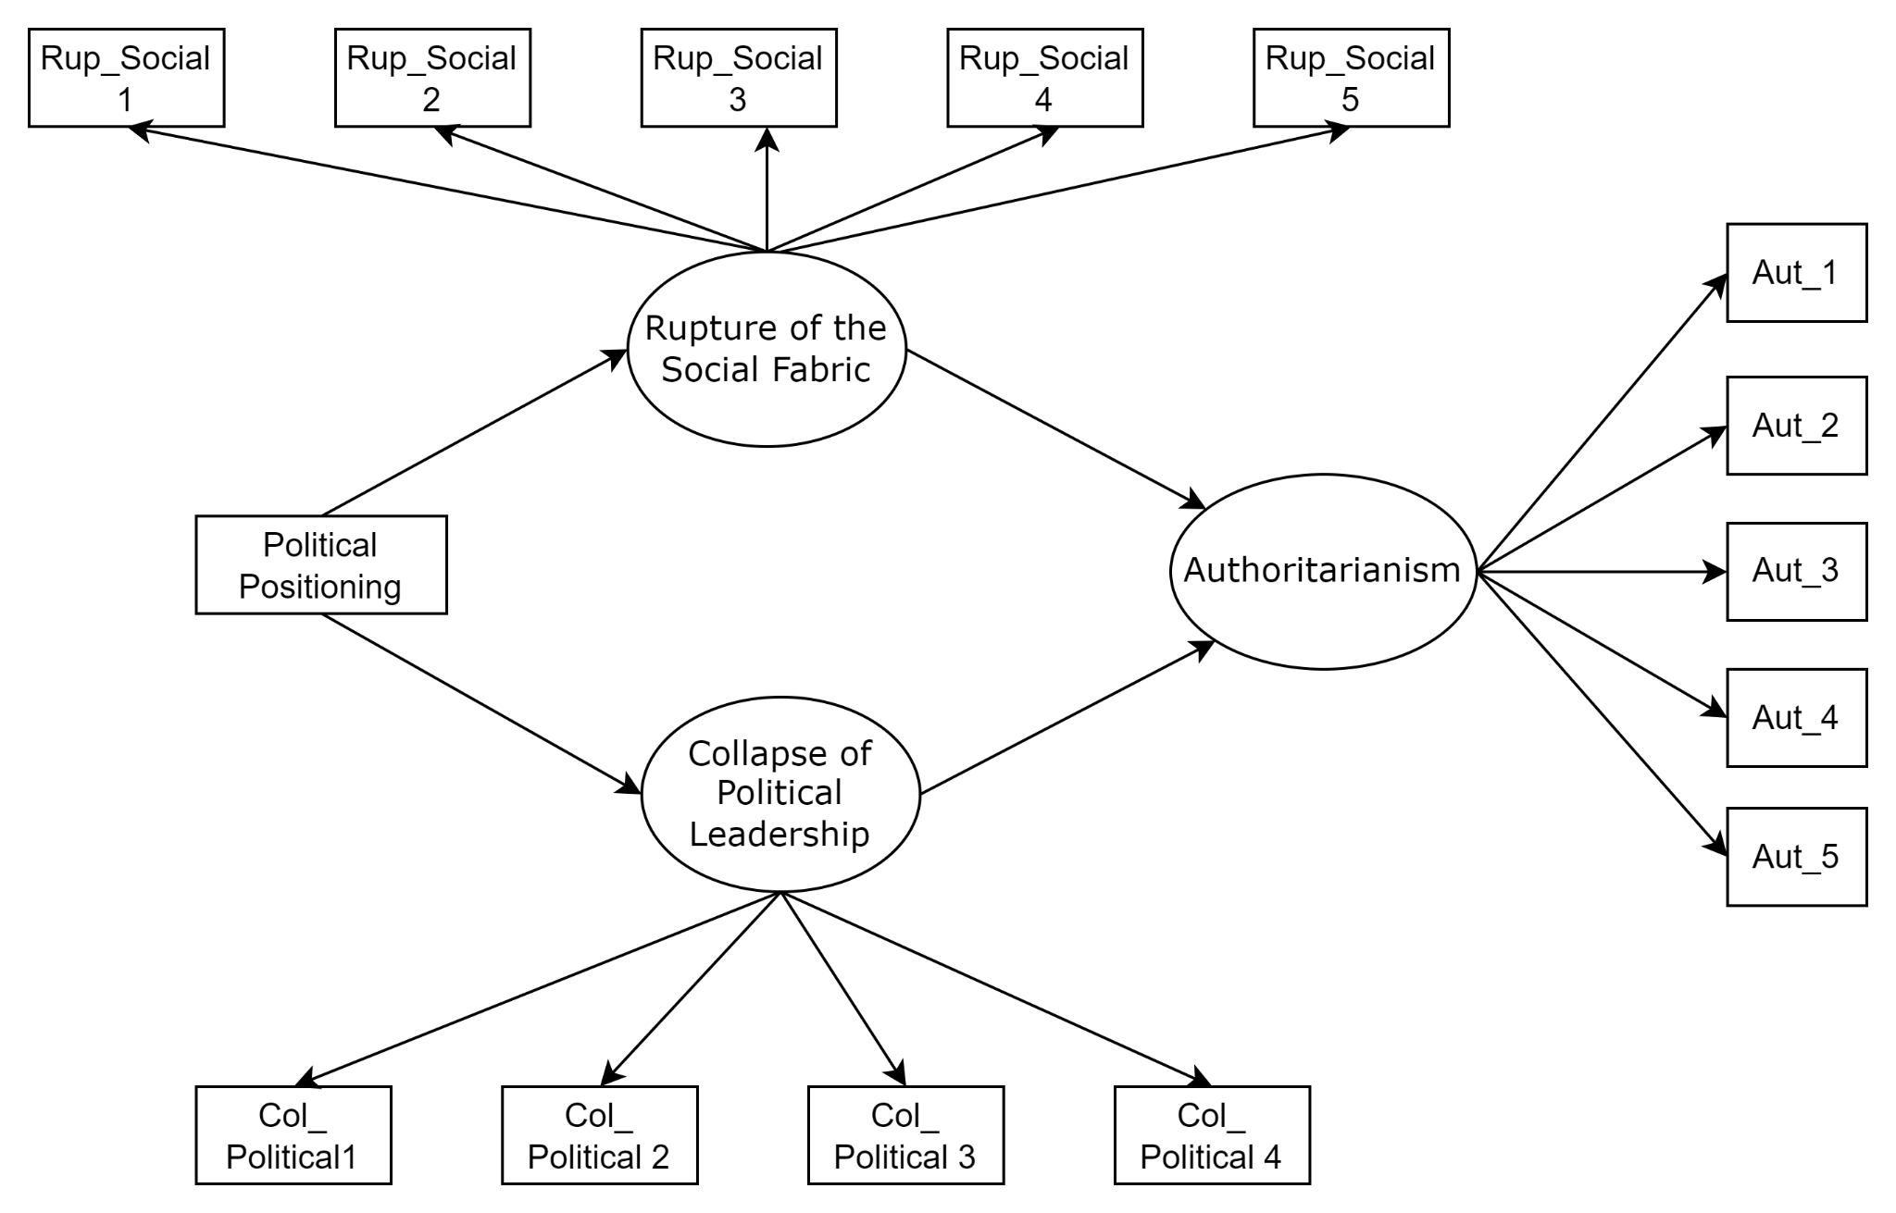

Methods
Participants
The inclusion criteria for participating in the study were being over 18, living in Brazil, and having access to the Internet. A total of 157 people took part in the survey, aged between 18 and 64 (M=31.5; SD=12.97), 71.3% identified themselves as female, 79.6% lived in the Federal District, and 56% identified themselves with a left-wing political stance. Based on the final sample (N = 157), a post hoc power analysis was conducted using the semPower package in R (Moshagen & Bader, 2024). Considering the degrees of freedom (75) and the RMSEA value (0.066) of the main model tested, with an α = 0.05, the analysis showed a power of 95%, which demonstrates a sufficient sample size for the analyses.
Instruments
Anomia Perception Scale (PAS). The anomie scale developed by Teymoori et al (2016) and translated for the Brazilian context by Lima et al (2019) was used to identify the state of anomie in the population. This scale is made up of two dimensions. The first dimension, Rupture of the Social Fabric (α=0.66; ω=0.72), has items such as: “People are cooperative” and “People think that there are no clear moral rules that should be followed.” The second dimension, Collapse of Political Leadership (α=0.77; ω=0.84), has items such as: “The government works for people's well-being” and “The government is legitimate.” The items were used as proposed by Lima et al (2022), given that certain items had a low contribution to the consistency of the measures. Thus, five items from the first dimension and four from the second dimension were used. We also used a Likert scale from 1 (totally disagree) to 5 (totally agree).
Authoritarianism. A reduced measure was used to measure authoritarianism, adapted from the Right-Wing Authoritarianism Scale (Altemeyer, 1988; Duckitt et al., 2010), adapted and with evidence of validity for Brazil (Vilanova et al, 2018). The scale has four dimensions: Authoritarianism, Contestation of Authority, Traditionalism, and Submission to Authority. However, the five items with the highest factor loadings were used only from the Authoritarianism dimension of the adaptation study for the Brazilian context, with items such as: “The way things are going in this country, severe measures will be needed to straighten out the thugs, criminals and perverts”; and “The situation in our country is getting so serious that firm action would be justified if it eliminated the troublemakers and led us back to our true path.” The measure showed excellent reliability indices (α=0.88; ω=0.89). The items were evaluated on a Likert scale from 1 (totally disagree) to 5 (totally agree).
Sociodemographic questionnaire. A questionnaire was administered with sociodemographic items such as gender, age, state of residence, salary income, racial identification, schooling, marital status, and political identification, with 1 corresponding to totally left and 5 to totally right.
Procedures
The research was submitted to the Ethics Committee and approved under opinion no. XXX.XXX.XXX and CAEE XXXXXXXX.X.XXXX.XXXX. Initially, the participants were presented with a form consisting of the Free and Informed Consent Form (FICF), containing information about volunteering, the anonymity of the research, the prospect of duration, the low physical, psychological, and moral risks during the study and the e-mail address of one of the people responsible for the research in case there were any questions or feedback. After accepting, the participants answered the Perceived Anomie Scale (PAS), the measure of authoritarianism, and the Sociodemographic Questionnaire. Five-point response scales were used to reduce mental effort and improve the quality of responses (Krosnick, 1991).
Data Analysis
Data analysis was carried out using the R programming language, version 4.3.2. The following packages were used: summarytools (Comtois, 2022), dplyr (Wickham et al., 2023), correlation (Makowski et al., 2020), and lavaan (Rosseel, 2012). The results were analyzed using descriptive statistics tests to identify form measures such as mean, standard deviation, and data assumptions. Firstly, correlations were made between the measures. The explanatory structural model was tested using structural equation modeling. Next, in the analyses, a model was tested with the items from the dimensions of Rupture of the Social Fabric and Collapse of Political Leadership grouped into a latent variable, Anomie, to verify the effects and fit indices of the model. Next, the main structural model of the study was tested, analyzing the mediation effects of each dimension between political positioning and authoritarianism.
Results
Initially, a correlation test was carried out. Political positioning showed significant associations with the perception of the breakdown of the social fabric, b = 0.19, 95% CI [0.04, 0.34], p = 0.047, with the perception of the breakdown of political leadership, b = 0.29, 95% CI [0.14, 0.43], p < 0.001, and with authoritarianism, b = 0.41, 95% CI [0.27, 0.53], p < 0.001. Authoritarianism showed significant associations with the perception of the breakdown of the social fabric, b = 0.18, 95% CI [0.03, 0.33], p = 0.047, and with the perception of the collapse of political leadership, b = 0.30, 95% CI [0.15, 0.44], p < 0.001. The perception of the breakdown of the social fabric was not significantly associated with the perception of the breakdown of political leadership, b = 0.14, 95% CI [-0.02, 0.29], p = 0.084. In addition to the lack of a significant association between the dimensions of anomie, there were marginally significant associations between the perception of the breakdown of the social fabric and political positioning and authoritarianism.
Structural equation modeling analysis was then conducted to test the mediation effect of anomie on the relationship between political positioning and authoritarianism. To this end, the latent variable anomie included items from Rupture of the Social Fabric and Collapse of Political Leadership. The model results showed that the further to the right, the higher the levels of anomie, which therefore showed higher levels of authoritarianism. It was also observed that the greater the anomie, the greater the levels of authoritarianism. However, the model showed unsatisfactory model fit indices (CFI = 0.83; TLI = 0.83; SRMR = 0.125; RMSEA = 0119, CI 95 [0.104, 0.135]). The results can be seen in Table 1 and Figure 2.
Table 1
Model parameters with political positioning, anomie, and authoritarianism.
Construction | B | EP | b | p | R²
Anomie |  |  |  |  | 0,17
Political Positioning | 0,15 | 0,04 | 0,41 | < 0,001
Authoritarianism |  |  |  |  | 0,27
Anomie | 0,83 | 0,26 | 0,29 | 0,001
Political Positioning | 0,33 | 0,09 | 0,32 | < 0,001
Na mediação, os resultados foram significativos para o efeito indireto, B = 0,13, EP = 0,04 b = 0,12, IC de 95% [0,05; 0,20], p = 0,001, e para o efeito total, B = 0,46, EP = 0,08 b = 0,44, p < 0,001.
Figure 2
Factor loadings of latent variables.
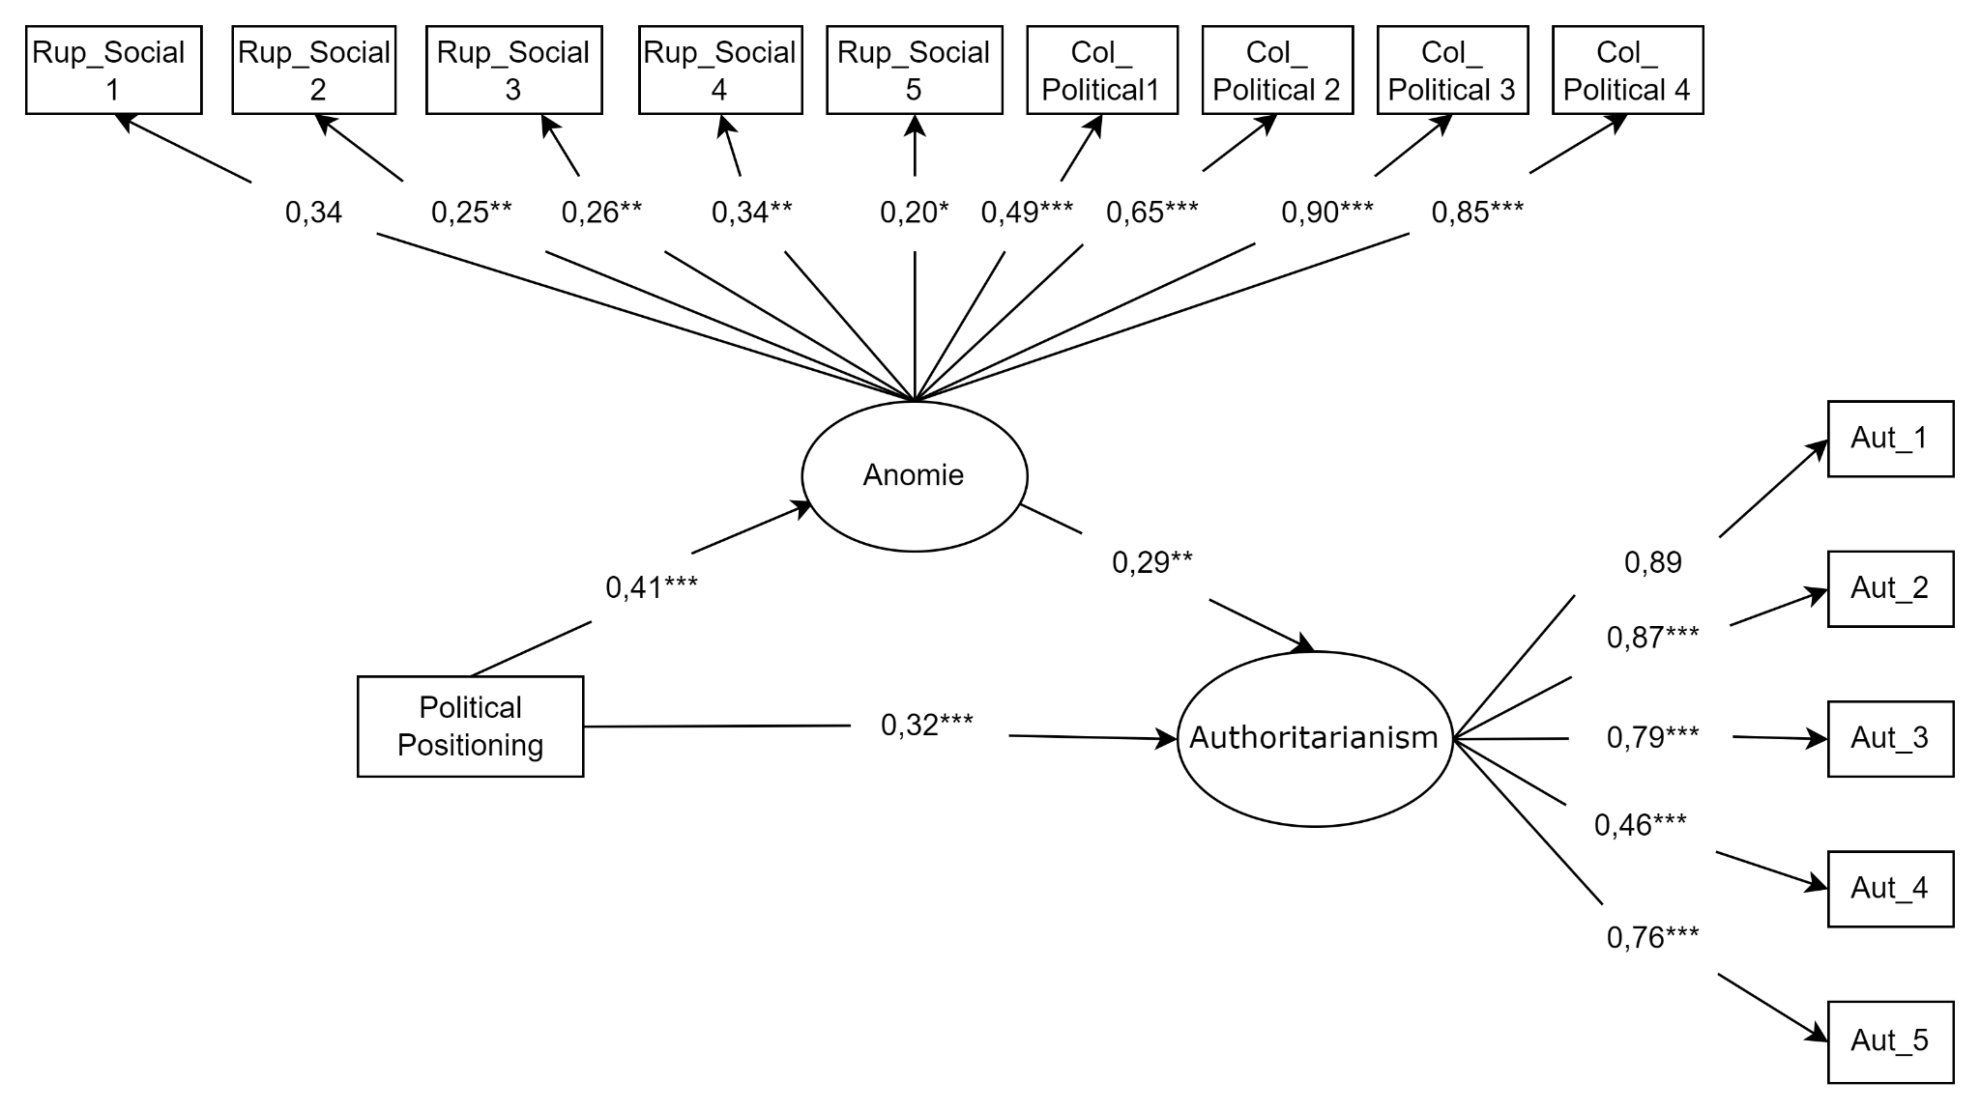
Note: * p < 0,05. ** p < 0,01. *** p < 0,001.
The model was then tested to analyze the mediating effects of the perception of the breakdown of the social fabric and the collapse of political leadership on the relationship between political positioning and authoritarianism. The model with the anomie dimensions showed good fit indices (CFI = 0.95; TLI = 0.95; SRMR = 0.080; RMSEA = 0.066, 95% CI [0.047, 0.085]). The results of this model showed that political positioning predicted the perception of the breakdown of the social fabric and the collapse of political leadership. In turn, it was observed that the higher the levels of perception of the breakdown of the social fabric and the breakdown of political leadership, the higher the levels of authoritarianism. Political positioning also had a direct effect, showing that the further to the right, the higher the levels of authoritarianism. The results can be seen in Table 2 and Figure 3.
Table 2
Parameters of the model with political positioning, rupture of the social fabric, collapse of political leadership, and authoritarianism.
Construct | B | EP | b | p | R²
Rupture of the Social Fabric |  |  |  |  | 0,10
Political Positioning | 0,20 | 0,06 | 0,31 | 0,001
Collapse of Political Leadership |  |  |  |  | 0,13
Political Positioning | 0,20 | 0,05 | 0,37 | < 0,001
Authoritarianism |  |  |  |  | 0,28
Rupture of the Social Fabric | 0,34 | 0,15 | 0,21 | 0,021
Collapse of Political Leadership | 0,45 | 0,16 | 0,24 | 0,004
Political Positioning | 0,30 | 0,09 | 0,29 | 0,001
The effects of the mediation analysis on the perception of social disruption were observed. There was a marginally significant indirect effect, B = 0.07, EP = 0.04 b = 0.06, 95% CI [-0.005; 0.14], p = 0.068, and a significant total effect, B = 0.37, EP = 0.09, b = 0.35, p < 0.001. For the effects of the mediation analysis with the perception of leadership breakdown, a significant indirect effect was presented, B = 0.09, EP = 0.04 b = 0.09, 95% CI [0.02; 0.16], p = 0.012, and a significant total effect, B = 0.39, EP = 0.09 b = 0.38, p < 0.001.
Figure 3
Factor loadings of latent variables.
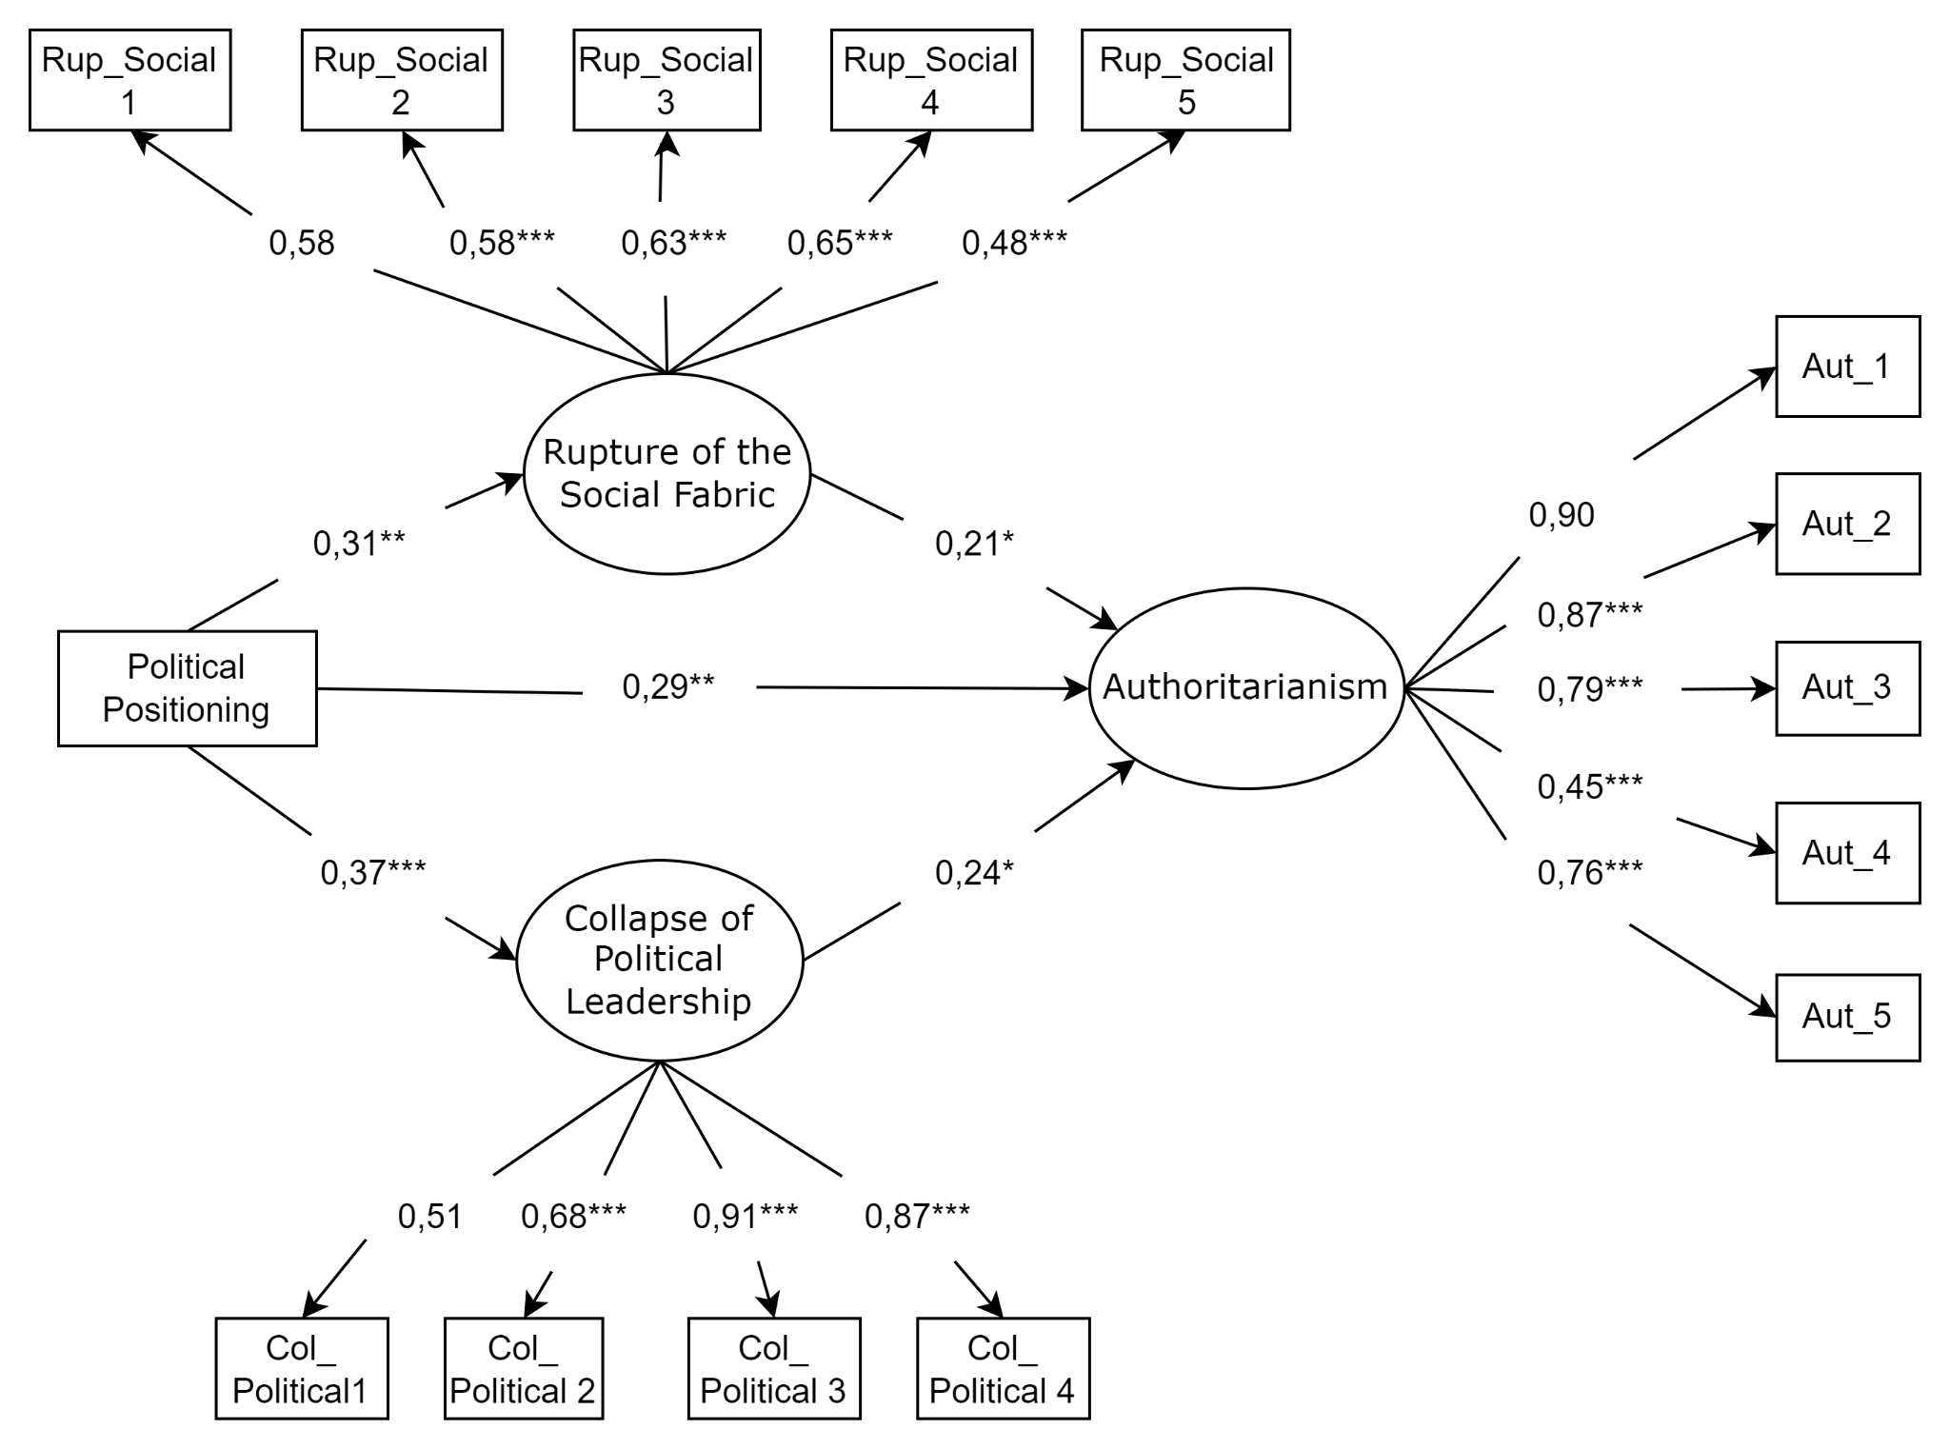
Note: * p < 0,05. ** p < 0,01. *** p < 0,001.
Discussion
This study sought to assess how the dimensions of anomie can mediate the relationship between an individual's political positioning and endorsement of authoritarian measures. Initially, it was observed that there are significant positive associations between the variables of perception of anomie, political positioning, and authoritarianism. Thus, in this period, factors linked to a lack of trust and hopelessness in the moral standards present in a society, such as the perception of the breakdown of the social fabric and the collapse of political leadership due to the feeling of anomie (Teymori, 2016), showed associations with right-wing political orientation and the endorsement of authoritarian measures.
The modeling analyses showed that the model's fit indices were unsatisfactory when a single latent variable was used for anomie, which involved the dimensions of perceived social disruption and collapse of political leadership, in the explanatory model tested. However, when mediation was carried out with the dimensions of anomie separated by two latent variables, the model showed satisfactory model indices.
Thus, when the perception of a rupture in the social fabric was evaluated as a mediator in the relationship between political positioning and authoritarianism, it was not possible to find a significant indirect effect. Thus, the loss of a sense of unity and low trust in the members of society (Teymoori, et al., 2017) does not affect the relationship between political positioning and support for more authoritarian measures.
This result can be explained by the need for more adaptation of this variable to the Brazilian context since the items in this dimension are general and broad. Teymoori et al (2016) point out that factors that modify the population's perception of anomie are indicators of social functioning, including corruption and economic inequality. From this perspective, Brazil's widespread economic and social inequality (Oliveira, 2023; Gonçalves, 2024) can lead to the perception that the social fabric is broken being naturalized.
Thus, in a complementary way, the findings may suggest that the perception of disruption to the social fabric has not been perceived by Brazilian society, as society witnesses various phenomena normalized or trivialized in everyday life. In contrast, the perception of the decline of a leader occurs more easily in this population because roles of authority are more representative and have greater visibility, given the social identity of a political group in a context of intense political polarization.
With regard to the perception of the collapse of political leadership, it was noted that this was a partial mediator in the relationship between the two variables. In other words, the further a person is positioned to the right, the greater the perception that a leader is ineffective and, therefore, the greater the tendency to support authoritarian measures. This result differs from those found in the study by Lima et al (2022) since the findings showed that people with a more right-wing position had a lower perception of a leader in collapse and a greater desire for authoritarian leaders.
One element that influences these conclusions is the social and political context in which the studies occurred. Lima et al. (2022) surveyed a pandemic context with an extreme right-wing leader in power. This study, on the other hand, was carried out in the year of transition to a left-wing government. In this sense, anomie indices seem to have been rising among people who identify with the right-wing and declining for people who identify with the left wing because of the transition of government.
Following the 2022 elections, this political change, characterized by a presidential contest between candidates with different ideological discourses, caused different repercussions. Lula's victory caused a loss of reference for part of the conservative and Bolsonaro population (Bocchi, 2021). Consequently, this affected the state of anomie since the effect predicted by the group did not occur (Durkheim, 2000), resulting in waves of crimes, such as the January 8 event and the burning of buses and cars in December 2022 (Rodrigues et al., 2023; Caramori, 2022).
Thus, this result becomes relevant in the current political context due to the intensifying polarization in Brazil, reinforcing conservative ideas (Ortellado et al., 2022). It is understood that people were experiencing the transition from an extreme right-wing leader to a more left-wing one. Therefore, the perception of ineffectiveness and illegitimacy of the new leader on the part of right-wing voters was higher, affecting their state of anomie (Teymoori et al., 2017).
In addition, the “Brazilian way,” which refers to disrespect for rules and laws, is widespread in the country (Barbosa, 2005). In this sense, this practice impacts order and becomes a mechanism for social transition (Pilati et al., 2011). Therefore, these contextual factors may have a major impact on how the sample understood and evaluated these items.
Based on the above, it is essential to note that the study has some limitations, including the restriction relating to the sample. Most participants considered themselves female, more than 70% are residents of the Federal District, and more than 50% consider themselves politically left-wing. Given this, future studies must diversify the participants. In addition, it is suggested that future studies make adjustments to the scale, such as including items that consider the Brazilian context, as well as collecting data at different times to check changes in the perception of anomie according to the season and larger samples.
It is important to note that the theory of anomie postulates that its dimensions are highly interrelated, which was not found in this study. A study by Teymoori et al. (2016) showed that among the 28 countries investigated, Brazil appeared to have the highest levels of anomie in a data collection carried out between January 2014 and February 2015. The authors also found an association between poverty, unemployment inequality, and greater anomie.
Finally, this study contributes findings that indicate the role of anomie in the relationship between political positioning and authoritarianism in a context of growing polarization. Considering the Brazilian context of political instability and inequalities, citizens tend to adhere to beliefs in conspiracy theories, endorse populism, and undermine collective health efforts to control contagious and vaccine-preventable diseases, such as COVID-19 (Bebouraka et al., 2024; Galgali et al., 2023; Manunta et al., 2024; Mao et al., 2024). Therefore, this work promotes theoretical progress on the perception of anomie as a relevant factor in current political and social discussions.

References

Barbosa. L. (2005). Jeitinho brasileiro. A arte de ser mais igual que os outros (6ª ed.). Rio de Janeiro: Campus.
Bebouraka, M. P. T. À., Mouafo, A. V. D., Lontio, S. N., & Messanga, G. A. (2024). “They are just lgbtq people and nothing else!” Theorizing and measuring the “perceived inclusion of an outgroup members within individuals’ ingroups”(PIOMI) to Evaluate Inclusive Social Tolerance in the Multiple Identities Perspective. International Journal of Applied Psychology, 14(1), 15-43. 10.5923/j.ijap.20241401.02
Bocchi, J. C. (2021). Anomia E Hipocondria Nas Relações Entre Corpo, Saúde e o Sofrimento Na Contemporaneidade. Sofia, 9(2), 185–200. https://doi.org/10.47456/sofia.v9i2.32443
Caramori, I. (2022, 13 de Dezembro). Bolsonaristas radicais queimaram 3 carros e 5 ônibus e depredaram delegacia em ato em Brasília. g1. Acesso em: https://g1.globo.com/df/distrito-federal/noticia/2022/12/13/bolsonaristas-queimaram-7-carros-e-4-onibus-e-depredaram-delegacia-em-ato-em-brasilia-dizem-bombeiros.ghtml
Comtois, D. (2020). Summarytools: Tools to quickly and neatly summarize data. https://CRAN.R-project.org/package=summarytools
Costa, L. C. S., & Silveira, É. L. (2018). Efeito Bolsonaro: anatomia do autoritarismo. Os efeitos do autoritarismo: práticas, silenciamentos e resistência (im) possíveis. São Paulo: Pimenta Cultural, 1, 13-35. 10.31560/pimentacultural/2018.945.13-35
Durkheim, E. (2000) O Suicídio: estudo de sociologia. São Paulo: Martins Fontes.
Feldman, S., & Stenner, K. (1997). Perceived threat and authoritarianism. Political Psychology, 18(4), 741–770. https://doi.org/10.1111/0162-895X.00077
Fromm, E. (1941). Escape from freedom. Farrar & Rinehart.
Galgali, M. S., Helm, P. J., & Arndt, J. (2023). Feeling too isolated to be vaccinated? The contributing role of subjective interpersonal isolation factors towards COVID-19 vaccine hesitancy and resistance. Social science & medicine (1982), 323, 115865. https://doi.org/10.1016/j.socscimed.2023.115865
Gonçalves, R. (2024, abril 20). Renda do brasileiro aumentou, mas a desigualdade continua gigante. Correio Braziliense. https://www.correiobraziliense.com.br/economia/2024/04/6841806-renda-do-brasileiro-aumentou-mas-a-desigualdade-continua-gigante.html
Hubertus, N., Porto, D., & Coelho, G. (2022, 12 de dezembro). Brasília tem tumulto e ônibus queimados após tentativa de invasão à sede da PF. CNN Brasil. Acesso em: https://www.cnnbrasil.com.br/politica/manifestantes-tentam-invadir-predio-da-policia-federal-em-brasilia-diz-a-pm/
Krosnick, J. A. (1991). Response strategies for coping with the cognitive demands of attitude measures in surveys. Applied cognitive psychology, 5(3), 213-236.
Lima, M. E. O., de Almeida, J. N., de França, D. X., & Santos, I. J. (2022). O surgimento de líderes autoritários: Significados das posições direita-esquerda e sentimento de anomia. O direito à convivência comunitária nos serviços de acolhimento institucional, 22(53), 449-466. https://pepsic.bvsalud.org/scielo.php?script=sci_arttext&pid=S1519-549X2022000200011
Mahfud, Y., & Adam-Troian, J. (2021). “Macron demission!”: Loss of significance generates violent extremism for the Yellow Vests through feelings of anomia. Group Processes & Intergroup Relations, 24(1), 108–124. https://doi.org/10.1177/1368430219880954
Makowski, D., Wiernik B., Patil I., Lüdecke D., & Ben-Shachar, M. (2022). “correlation: Methods for Correlation Analysis.” Version 0.8.3. https://CRAN.R-project.org/package=correlation
Manunta, E., Becker, M., Vignoles, V. L., Bertin, P., Crapolicchio, E., Contreras, C., Gavreliuc, A., González, R., Manzi, C., Salanova, T., & Easterbrook, M. J. (2024). Populism, Economic Distress, Cultural Backlash, and Identity Threat: Integrating Patterns and Testing Cross-National Validity. Personality and Social Psychology Bulletin, 0(0). https://doi.org/10.1177/01461672241231727
Mao, J.-Y., Zeng, Z.-X., Yang, S.-L., Guo, Y.-Y., & van Prooijen, J.-W. (2024). Explaining the paradox of conspiracy theories and system-justifying beliefs from an intergroup perspective. Political Psychology, 45, 299–318. https://doi.org/10.1111/pops.12924
Merton, R. K. (1938). Social Structure and Anomie. American Sociological Review, 3(5), 672–682. https://doi.org/10.2307/2084686
Moshagen, M., & Bader, M. (2024). semPower: General power analysis for structural equation models. Behavior Research Methods, 56, 2901–2922. https://doi.org/10.3758/s13428-023-02254-7
Oliveira, F. M. de. (2023). Desigualdade social: uma trajetória de insistência no Brasil . Contribuciones a las Ciencias Sociales, 16(7), 6750–6766. https://doi.org/10.55905/revconv.16n.7-151
Ortellado, P., Ribeiro, M. M., & Zeine, L. (2022). Existe polarização política no Brasil? Análise das evidências em duas séries de pesquisas de opinião. Opinião Pública, 28, 62-91. https://www.scielo.br/j/op/a/xLJ4grqd96n3VmVx3XsGv5D/abstract/?lang=pt
Pilati, R., Milfont, T. L., Ferreira, M. C., Porto, J. B., & Fischer, R. (2011). Brazilian jeitinho: understanding and explaining an indigenous psychological construct. Interamerican Journal of Psychology, 45 (1), 27-36. https://journal.sipsych.org/index.php/IJP/article/view/134
Pizarro, J. J., Cakal, H., Méndez, L., Zumeta, L. N., Gracia-Leiva, M., Basabe, N., Navarro-Carrillo, G., Cazan, A.-M., Keshavarzi, S., López-López, W., Yahiiaiev, I., Alzugaray-Ponce, C., Villagrán, L., Moyano-Díaz, E., Petrović, N., Mathias, A., Techio, E. M., Wlodarczyk, A., Alfaro-Beracoechea, L., … Páez, D. (2024). Sociopolitical consequences of COVID-19 in the Americas, Europe, and Asia: A multilevel, multicountry investigation of risk perceptions and support for antidemocratic practices. Political Psychology, 45, 407–433. https://doi.org/10.1111/pops.12930
Rodrigues, M., Torres, F., Garzon, M., Cardoso, C. (2023, 10 de janeiro). Bolsonaristas invadem Congresso, Planalto e STF em manifestação antidemocrática. Metrópoles. Acesso em: https://www.metropoles.com/distrito-federal/bolsonaristas-extremistas-manifestacao-brasilia.
Rosseel, Y. (2012). “lavaan: An R Package for Structural Equation Modeling.” Journal of Statistical Software, 48(2), 1–36. https://doi.org/10.18637/jss.v048.i02
Saad-Filho, A., & Boffo, M. (2021). The corruption of democracy: Corruption scandals, class alliances, and political authoritarianism in Brazil. Geoforum, 124, 300-309. https://doi.org/10.1016/j.geoforum.2020.02.003
Silva, M. G. D., & Rodrigues, T. C. (2021). O Populismo de direita no Brasil: neoliberalismo e autoritarismo no governo Bolsonaro. Mediações - Revista De Ciências Sociais, 26(1), 86–107. https://doi.org/10.5433/2176-6665.2021v26n1p86
Suxberger, A. H. G., & Pacheco, W. E. P. (2019). A Teoria da Anomia nos Crimes Cibernéticos. Delicate Revista de Estudos Interdisciplinares sobre o Delito, 4(7), 104-125. https://doi.org/10.24861/2526-5180.v4i7.105
Teymoori, A., Bastian, B., & Jetten, J. (2017). Towards a Psychological Analysis of Anomie. Political Psychology, 38(6), 1009–1023. http://www.jstor.org/stable/45094405
Teymoori, A., Jetten, J., Bastian, B., Ariyanto, A., Autin, F., Ayub, N., Badea, C., Besta, T., Butera, F., Costa-Lopes, R., Cui, L., Fantini, C., Finchilescu, G., Gaertner, L., Gollwitzer, M., Gómez, Á., González, R., Hong, Y. Y., Jensen, D. H., . . . Wohl, M. (2016). Revisiting the measurement of anomie. PLoS ONE, 11(7), e0158370. https://doi.org/10.1371/journal.pone.0158370
The Global Economy. (2024). Political stability—Country rankings. https://www.theglobaleconomy.com/rankings/wb_political_stability/
Vilanova, F., Segundo, D. S. A., Stucky, J. L., Duarte, M. Q., & Costa, A. B. (2022). Você é de direita? Efeitos preditivos do autoritarismo e do preconceito na autocategorização na direita. Revista Psicologia Política, 22(53), 143-153. https://pepsic.bvsalud.org/scielo.php?script=sci_arttext&pid=S1519-549X2022000100010
Vilanova, F., Sousa, D. A. D., Koller, S. H., & Costa, A. B. (2018). Adaptação transcultural e estrutura fatorial da versão brasileira da escala Right-Wing Authoritarianism. Trends in Psychology, 26, 1299-1316. https://doi.org/10.9788/TP2018.3-07Pt
Wachelke, J. F. R., & Hammes, I. C. (2009). Representações sociais sobre política segundo posicionamento político na campanha eleitoral de 2006. Psicologia em Estudo, 14, 519-528. https://www.scielo.br/j/pe/a/wWWDYS4nb35Bcn7mvsvScQB/
Wickham, H., François R., Henry L., Müller K., & Vaughan, D. (2023). dplyr: A Grammar of Data Manipulation. R package version 1.1.4, https://github.com/tidyverse/dplyr, https://dplyr.tidyverse.org

