Perceived environmental quality of school explains why students’ sustainable behavior results in psychological wellbeing

ABSTRACT
Despite the well documented positive psychological consequences of sustainable behaviors, possible mechanisms of this relationship have not been thoroughly investigated. Moreover, little attention has been paid to these consequences in university environments, especially in the majority world. This study aimed to assess the possible mediating role that perceived environmental quality might play in the relationship between sustainable behavior and psychological wellbeing in students from various public and private universities. Three-hundred and six undergraduate students at Mexican universities responded to an instrument including items assessing the social and physical quality of their school environment, self-reported sustainable behaviors (prosocial and pro-environmental) and psychological wellbeing. Results of four structural models testing the mediating role of perceived environmental quality showed that this factor partially explains the effect of sustainable behavior on wellbeing. These results suggest that, to some extent, students obtain psychological wellbeing from their environmental conservation effort because such effort results in environmental quality.
KEY-WORDS: Sustainable behavior, environmental quality, wellbeing, mediation.

Sustainable behavior (SB) encompasses actions aimed at protecting the physical and human environment, which include but are not limited to prosocial and pro-environmental behaviors. Research suggests that the practice of sustainable behaviors not only result in an improvement in environmental quality but also in psychological outcomes such as increased or improved positive feelings and psychological states like wellbeing, satisfaction, intrinsic reinforcement and happiness (Author, 2010; Carrero, Valor, & Redondo, 2020; Moll, Krueger, Zahn, Pardini, Oliveira, & Grafman, 2006). Evidence further suggests that when people perceive SBs as generating positive repercussions, they tend to continue to engage in those environmentally protective activities (Author, 2016). As such, the relationship between the practice of sustainable behaviors and individual positive psychological outcomes requires further investigation. Specifically, does environmental quality mediate the effect of sustainable behaviors on psychological wellbeing. This is especially important in understudied populations such as students in Latin America. Understanding these mechanisms may inform the design of more effective interventions promoting sustainable practices.
Mediation analysis is one method of examining relationships between SB and other components of the sociophysical environment. Mediation examines mechanisms by which a variable affects another variable through a third intermediate variable. For this study, it is proposed to how variable (1) sustainable behavior affects another variable (2) psychological wellbeing through an intermediate variable (3) environmental quality.
Positive consequences of sustainable behavior
The relationship between the practice of sustainable behaviors and positive psychological outcomes has been well documented. Furthermore, evidence suggests that individuals can anticipate the positive psychological states that will be derived from their practice of pro-ecological and pro-social behaviors. This anticipation motivates SB as actions that are expected to result in a hedonically pleasurable or morally rewarding experience (Doell et al., 2021), a phenomenon known as “warm glow” (Jia & van der Linden, 2020). Ahn and Kim (2023) found that positive anticipated psychological consequences for self (PCS) of SB, specifically positive emotions from the purchase of ecologically friendly products, included feeling better, feeling proud, feeling like a good person, and feelings of happiness. Similarly, sustainable behavior has been demonstrated to produce satisfaction, a positive feeling derived from fulfillment of one’s wishes or expectations (Iwata, 2002; Ertz & Sarigöllü, 2019). Additional research has focused on relationships between SB and positive psychological consequences such as intrinsic reinforcement, happiness, satisfaction, and psychological wellbeing (Author, 2016). Sustainable behaviors also appear to bring about feelings of self-efficacy, competence motivation, and autonomy, all of which are components of intrinsic reinforcement (de Young, 1996; Author, 2016; Villacorta et al., 2003).
Happiness is a well-known correlate of SB. Author (2010) showed that American and Mexican students reporting higher levels of sustainable actions also reported higher levels of happiness, a relationship also demonstrated in a sample of students in Korea (Choi, 2016). In a study conducted in India, Tiwari (2016) investigated energy conservation behaviors, recycling, sustainable mobility and transportation, waste avoidance and social behaviors toward conservation, among others. All dimensions of sustainable behavior significantly predicted participant happiness.
Sustainable behavior and wellbeing
The relationship between sustainable behaviors and positive outcomes like wellbeing is well documented. Author (2011) reported that psychological wellbeing was more enhanced in individuals reporting higher engagement in sustainable actions in a sample of participants in Mexico. Kaida & Kaida (2016) found that pro-environmental behavior could enhance not only present subjective well-being but also expectations of future subjective well-being. Furthermore, a meta-analysis conducted by Zawadski, Steg, & Bouman (2020) found a significant, positive relation (overall r = .24) between pro-environmental behavior and wellbeing.
Despite previous literature focused on relationships between sustainable behavior and positive outcomes, a limited number of studies have set out to investigate why wellbeing is a positive consequence of SB. Some authors have theorized that the relationship between SBs and wellbeing may be positive because the practice of pro-environmental behaviors is perceived as meaningful (Venhoeven et al., 2020). A behavior is meaningful if it is perceived as important, significant, and the morally right thing to do (van der Werff et al., 2013). In the Zadawaski et al. (2020) meta-analysis, the relation was particularly strong for indicators of pro-environmental behavior and subjective wellbeing which seem to reflect meaning, such as sustainable purchase decisions (r = .29) and for warm glow (r = .40).
Costs associated to practicing sustainable behavior may partially explain why people do not experience the positive psychological consequences of SB as strongly or as frequently as others. In a study, Author (2020) found that these costs modify the relationship between SB and wellbeing suggesting that behavioral costs in part explain such relationships, as they appear to decrease its strength. In this same study, Big-Five personality traits did not show a significant modifying relationship between SB and wellbeing. Furthermore, Haverkamp, Welsch, & Ziegler (2022) found that subjective wellbeing is significantly and positively correlated to costly pro-environmental behaviors but not to similar costless or low-cost behaviors.
As such, the role of perceived or actual cost that sustainable behaviors play in resultant positive emotional states is unclear. A possible explanation for this phenomenon could reside in the perceived effect sustainable behaviors have on environmental quality. It is possible that people experience wellbeing as a consequence of sustainable behavior because these practices result in improved or better conserved environments. Previous research suggests sustainable behaviors may result in wellbeing through environmental quality. A theoretical perspective is the foundational concept that the experience of wellbeing is related to the construction of environments that meet the needs of the individual and others in the shared environment (Diener, Wirtz, Biswas-Diener, Tov, Kim-Prieto, Choi, & Oishi, 2009). These theoretical environments are high-quality, produced by sustainable actions.
Another empirical hint comes from Zhang and Tu (2021), which found that green building residents have a higher assessment of their residential environment. Such assessment increased the level of their residential satisfaction, which subsequently enhanced their quality of life and wellbeing. In educational settings, evidence exists of a positive association between the physical quality of schools (functional spaces, aesthetically pleasing features, road infrastructure surrounding school, school safety, etc.) and wellbeing experienced by students (Dao, Kerbs, Rollin, Potts, Gutierrez, Choi, Creason, Wolf, & Prevatt, 2006; Castilla, Llinares, Bravo, & Blanca, 2017; Shi, Gou, & Chen, 2014). Further, intervention studies have shown that an intervention aimed at increasing prosocial behavior improve school climate and academic achievement (Caprara, Kanacri, Gerbino, Zuffiano, Alessandri, Vecchio, et al., 2014). Likewise, a positive behavior support intervention in middle school students improved school climate as well as student outcomes (Caldarella, Shatzer, Gray, Young, & Young, 2011). The literature thus suggests that both taking care of the environment and others (i.e., sustainable behaviors) may increase environmental quality and thus lead to better personal outcomes, such as wellbeing.
The present study chose to investigate associations between sustainable behaviors and positive emotional outcomes in the university environment because the educational setting is fundamental for the development of a pro-sustainability orientation. Moreover, the university setting is unique in the sense that it has its own physical and social ecosystem, which can be used to study by proxy larger and more complex social transactions. Indeed, there have been previous studies that have shown the association between school university environment and mental health and wellbeing. A recent systematic review demonstrated a link between physical environments and physical and mental health in college students (Ding, Lee, Chen, Song, Newman, Lee, et al., 2023). Moreover, supportive school climate was the most potent predictor (Fink, 2014). Importantly, perception of school climate is more negative for minoritized groups, which can lead to decreased psychological wellbeing (Koo, 2021). One way to improve school environments is to increase sustainable behaviors, that is, actions that take care of others and the environment.
The main aim of this study was to investigate the direct and indirect relationship between sustainable behaviors (taking care of others and the environment) and wellbeing. Considering previous research, it was predicted that sustainable behaviors and wellbeing will have an indirect relationship through environmental quality. Corroborating if university students experience wellbeing as consequence of practicing SB, and what such experiences mean, may inform likely interventional strategies to promote SB in educational (and other) scenarios.

Method
Participants
The sample consisted of 306 students from various universities in a city in northwestern Mexico (M = 21.69; S.D. = 3.91). A majority of the sample reported their gender as being a woman (66%), with men representing 30% and non-binary respondents 1% of the sample (2% chose not to respond). Participants were primarily undergraduate students (90.78%), with 5.5% pursuing a master’s degree and 3.28% pursuing doctoral studies.
Instruments
Environmental quality. The study assesses environmental quality using a previously validated instrument developed specifically for use in university environments (Author, 2022). The assessment consisted of six homogeneous item clusters (HICs) (Simms & Watson, 2007). Three HICs examine the quality of the physical environment (classroom, campus road infrastructure, and safety), while the other three focus on quality of the social environment (student-teacher relationship, between students’ relationships, and institutional justice). The entire scale contained 52 self-report items, using a Likert-type response format (1 = strongly disagree to 5 = strongly agree).
Sustainable behaviors. Sustainable behaviors were evaluated using previously validated scales of altruism and pro-environmental behaviors (Author, 2009) as well as eight items focused on civic behaviors that contribute to community and university development, adapted from Astin, Vogelgesang, Misa, Anderson, Denson, Jayakumar, Saenz, & Yamamura (2006). In total, 28 items evaluating actions aimed at protecting the physical and social environment were used. The scales utilized a self-report format with Likert-type responses ranging from 1 (strongly disagree) to 5 (strongly agree).
Psychological wellbeing. Psychological wellbeing was assessed via 10 items exploring perceptions of self-concept, lifetime achievement, life purpose, direction and meaning, and continuous growth. The previously validated (Author, 2022) scale elicited Likert-style responses ranging from 1 (strongly agree) to 5 (strongly disagree).
Procedure
Students were invited to participate through announcements made on the University website as well as other electronic and social media. Individuals who agreed to participate were asked to visit the campus psychology lab. Students were assigned private rooms and provided with tablets or laptop computers to respond to selected instruments. Before beginning, individuals were assigned a participant number and were explained the objectives of the study. Participants were informed that their collaboration was completely voluntary and confidential and that they could withdraw from the study at any time. Subsequently, participants were asked to sign an electronic informed consent agreement. The entire procedure was in accordance with the Code of Ethics of the Mexican Society of Psychology (Sociedad Mexicana de Psicología, 2010) and approved by the Ethics Committee of the University of Sonora, Mexico. The Instruments were administered using the Qualtrics platform.
Data analysis
SPSS v23 and JASP were used to calculate means and standard deviations for continuous variables, frequencies for categorical variables and Cronbach's alphas to assess reliability. In addition, the theoretical models were tested through structural modeling, using EQS (Bentler, 2006). To test the hypothesis of a mediating influence of environmental quality on the relationship between sustainable behavior and wellbeing, the association between the exogenous factor “sustainable behavior” (indicated by civic, altruistic and pro environmental behaviors) and “psychological wellbeing” as endogenous variable, was firstly assessed. In a second model, the association between SB and environmental quality (indicated by institutional justice, and physical and social quality) was estimated. Then, in a third model, the relationship between environmental quality and wellbeing was estimated. Finally, a model including these three variables was specified and tested. In this model, environmental quality served as a variable mediating the link between sustainable behavior and wellbeing, keeping the direct association between this behavior and wellbeing. If the direct association between sustainable behavior and wellbeing becomes substantially reduced, environmental quality is considered a purely mediator variable (Baron & Kenny, 1986). The procedures used the non-parametric Robust ML method. Goodness of Fit indices included X², which was expected to be non-significant, the Bentler Bonnet Normed Fit (BBNFI), Bentler Bonnet Non-Normed Fit (BBNNFI) and the Comparative Index (CFI) whose values are expected to be higher than .90. In addition, the approximate square root of the error (RMSEA) was calculated; the value must be less than <.08 (Zhang & Savalei, 2016). Given the large sample size of this sample (n=306), the relative χ2 (dividing the χ2 fit index by the degrees of freedom) was calculated to reduce the dependence of χ2 on sample size. According to Schumacker and Lomax (2004) if this ratio is less than 5 the model is deemed to have good fit.

Results
All instruments showed acceptable internal consistency reliability (Clark & Watson, 1995) (α = .60 - .90, AIC=.21 - .50). See Table 1 for univariate statistics (means and standard deviations) and reliability.
---------------------------------------------------------------
Insert Table 1 about here
----------------------------------------------------------------
Figure 1 shows the results of the model testing the direct effect of sustainable behavior on wellbeing. The model showed acceptable goodness of fit (Chi-square: 7.74, 2 d.f., p ‹ .05; BBNFI = .90, CFI = .97; RMSEA = .09). All indicators of Sustainable Behavior loaded significantly (p < 0.05), confirming convergent validity for the measures. Sustainable behavior resulted positively and significantly associated with wellbeing (β = .42). The variance explained by this model was 17% (R² = .17).
---------------------------------------------------------------
Insert Figure 1 about here
----------------------------------------------------------------
In turn, Figure 2 exhibits the model of Sustainable Behavior influencing environmental quality. The model produced an acceptable goodness of fit (Chi-square: 55.02, 25 d.f., p ‹ .05; BBNFI = .90, CFI = .93; RMSEA = .06). As in the previous model, the factor loadings of all indicators for Sustainable Behavior and Environmental Quality were significant (p < 0.05). The effect of Sustainable Behavior on Environmental Quality was also significant and positive (β = .21). The model suggests that Sustainable Behavior explains a 5% of environmental quality variance.
---------------------------------------------------------------
Insert Figure 2 about here
----------------------------------------------------------------
In the model shown in Figure 3 the direct effect of environmental quality on wellbeing is presented. The model also showed acceptable goodness of fit (Chi-square = 28.96, 13 d.f., p ‹ .05; BBNFI = .92, CFI = .95; RMSEA = .06). This effect is β = .31, with a R² = .09.
---------------------------------------------------------------
Insert Figure 3 about here
----------------------------------------------------------------
Finally, Figure 4 shows a model demonstrating the associations between Sustainable Behavior, Environmental Quality and Wellbeing. This model exhibited acceptable goodness of fit (Chi-square = 72.48, 32 d.f., p ‹ .05; BBNFI = .90, CFI = .92; RMSEA = .06). Introducing environmental quality in the equation results in a decreased direct effect of SB on wellbeing (from β = .42, as shown in figure 3, to β = .37 in this figure). The direct effect of environmental quality on wellbeing also decreased (from β = .31 to β = .23). The variance explained by this model was 23%.
---------------------------------------------------------------
Insert Figure 4 about here
----------------------------------------------------------------
Discussion
This study confirmed the significant effect that sustainable behavior has on wellbeing in a sample of Mexican university students. It further expanded previous results by including a possible mechanism through which sustainable behaviors can lead to wellbeing: its effect on physical and social environments.
These results are congruent with the initial study conducted by Author (2011) assessing the association between SB and wellbeing (current study: r=.42 Author: r=.49). Moreover, these results are consistent with a recent meta-analysis by Zawadski et al (2020) showing similar effect sizes (r=.40). Despite extensive evidence of these links there are few studies that have explored the mechanisms through which this relationship appears.
The present study sought to explore if environmental quality may explain the sustainable behaviors-wellbeing link. A series of structural models were specified and tested to elucidate whether environmental quality was a mediator of that link. The combined results of those models suggest that environmental quality acts as a mediator. These results further suggest that environmental quality is one consequence of sustainable behavior, and the experience of wellbeing is one more outcome emerging from environmental quality. The results also suggest that people seek to improve their environment (both physical and social) when they practice pro-ecological, civic and pro-social behaviors. This is in congruence with previous results showing that sustainable behaviors result in an enhanced quality of environments (Caprara et al, 2014). If successful, such an improved environment would be a direct cause for wellbeing and SB an indirect cause and this could explain, at least partially, why wellbeing is a result of sustainable behavior. In other words, sustainable behaviors aim to generate high quality positive environments (Author, 2015). Further, these environments produce wellbeing which, in turn, may motivate the practice of more sustainable behaviors (Zelenski & Desrochers, 2021). This would constitute a virtuous circle in which sustainable behaviors help the maintenance of environmental quality, that leads to wellbeing, that leads to sustainable behaviors, and so on.
The present study was conducted in the context of an educational setting: a university campus. A substantial part of a school environmental quality depends on students, faculty, administrators and maintenance staff, and this quality refers not only to the physical component of the educational setting, but also to the social climate. People in this environment must cooperate to maintain classrooms, laboratories, offices, gardens, streets, and buildings in a good state. They also must be involved in the effort of creating and maintaining respectful, supportive, and reciprocal relationships between peers and among staff, faculty, and students. Adding the element of institutional justice (fair and applicable rules for harmonic relations) allows a fundamental piece to environmental quality that should be considered if a high-quality environment is intended to be achieved.
Since environmental quality is a likely mechanism through which sustainable behaviors lead to wellbeing, investing in various and diverse elements that improve university environment quality is of outmost importance. It is crucial given that it leads to better learning outcomes as well as social integration and coexistence (Caldarella et al, 2011); additionally, because a high-quality environment is perceived as a result of prosocial and pro-environmental behaviors that lead to the experience of wellbeing (Koo, 2021).
Important limitations of this study should be mentioned. A number of indicators of environmental quality were not incorporated in the used instruments, including some habitability and naturalness aspects (temperature, noise, humidity, volume of spaces, green areas, etc.). However, these indicators are hard to study as a unitary continuous construct and thus beyond the scope of the study. These indicators should be investigated in future studies. Moreover, although a university campus is an educational setting, it is not necessarily representative of every type of school existing either in Mexico or elsewhere, so that investigating the relationships among sustainable behaviors, environmental quality and wellbeing must include every level of educational setting (elementary, high school, professional). However, university settings in Latin America are an understudied context and can provide proxy insights given that it stands as its own ecosystem. Prospective studies in a variety of settings are recommended aimed at testing our results: family scenarios (households), workplaces, hospitals, institutional places, parks, recreational settings, etc. In these studies, community samples should be included, to investigate the replicability of the association between sustainable behaviors and wellbeing in other settings.
The suggestion that sustainable behavior is an indirect predictor of wellbeing through environmental quality does not exclude the direct association with wellbeing. Nor that environmental quality is the only mediator factor explaining why SB leads to improved wellbeing. As the literature suggests, if a sustainable behavior is meaningful its impact on wellbeing is enhanced (Venhoeven et al., 2020). Also, the cost associated with pro-environmental actions appears to affect resulting feelings of wellbeing (Author, 2020). Other factors that may encourage SBs and resulting wellbeing should be investigated such as psychological restoration, mindfulness, and related aspects. Despite the formerly stated limitations, and other possible explanations, these results suggest that environmental quality is a plausible explanation of the influence of pro environmental and prosocial behaviors on wellbeing in an educational setting. This explanation may inform the implementation of interventional strategies aimed at promoting both sustainable actions and psychological wellbeing, at least in an educational setting.

References
Ahn, I., & Kim, S. H. (2023). Measuring the motivation: A scale for positive consequences in pro-environmental behavior. Sustainability, 16(1), 250.
Astin, A. W., Vogelgesang, L. J., Misa, K., Anderson, J., Denson, N., Jayakumar, U., Saenz, V., & Yamamura, E. (2006). Understanding the effects of service-learning: A study of students and faculty. Report to the Atlantic Philanthropies.
Baron, R., & Kenny, D. (1986). The moderator-mediator variable distinction in social psychological research: Conceptual, strategic, and statistical considerations. Journal of Personality and Social Psychology, 51, 1173–1182.
Author (2010).
Bentler, P. (2006). EQS, Structural Equations Program Manual. Los Angeles: Multivariate Statistical Software, Inc.
Caldarella, P., Shatzer, R. H., Gray, K. M., Young, K. R., & Young, E. L. (2011). The effects of school-wide positive behavior support on middle school climate and student outcomes. RMLE online, 35(4), 1-14.
Caprara, G. V., Kanacri, B. P. L., Gerbino, M., Zuffiano, A., Alessandri, G., Vecchio, G., ... & Bridglall, B. (2014). Positive effects of promoting prosocial behavior in early adolescence: Evidence from a school-based intervention. International Journal of Behavioral Development, 38(4), 386-396.
Carrero, I., Valor, C., & Redondo, R. (2020). Do all dimensions of sustainable consumption lead to psychological well-being? Empirical evidence from young consumers. Journal of Agricultural and Environmental Ethics, 33, 145-170.
Castilla, N., Llinares, C., Bravo, J. M., & Blanca, V. (2017). Subjective assessment of university classroom environment. Building and Environment, 122, 72–81.
Choi, J. (2016). Sustainable behavior: Study engagement and happiness among university students in South Korea. Sustainability, 8(7), 599.
Clark, L. A., & Watson, D. B. (1995). Constructing validity: Basic issues in objective scale development. Psychological Assessment, 7, 309-319.
Author (2009).
Author (2016).
Author (2016).
Author (2011).
Author (2020).
Dao, T. K., Kerbs, J. J., Rollin, S. A., Potts, I., Gutierrez, R., Choi, K., Creason, A. H., Wolf, A., & Prevatt, F. (2006). The association between bullying dynamics and psychological distress. Journal of Adolescent Health, 39(2), 277–282.
De Young, R. (1996). Some psychological aspects of a reduced consumption lifestyle: The role of intrinsic satisfaction and competence motivation. Environment & Behavior, 28, 358-409.
Diener, E., Wirtz, D., Biswas-Diener, R., Tov, W., Kim-Prieto, C., Choi, D. W., & Oishi, S. (2009). New measures of well-being. In E. Diener (Ed.), Assessing well-being (pp. 247–266). Springer.
Ding, Y., Lee, C., Chen, X., Song, Y., Newman, G., Lee, R. J., ... & Sohn, W. (2023). Exploring the association between campus environment of higher education and student health: A systematic review of findings and measures. Urban forestry & urban greening, 128168.
Doell, K. C., Conte, B., & Brosch, T. (2021). Interindividual differences in environmentally relevant positive trait affect impacts sustainable behavior in everyday life. Scientific Reports, 11(1), 20423.
Ertz, M., & Sarigöllü, E. (2019). The behavior-attitude relationship and satisfaction in proenvironmental behavior. Environment and Behavior, 51(9-10), 1106-1132.
Fink, J. E. (2014). Flourishing: Exploring predictors of mental health within the college environment. Journal of American College Health, 62(6), 380-388
Haverkamp, T. K., Welsch, H., & Ziegler, A. (2022). The relationship between pro-environmental behavior, economic preferences, and life satisfaction: Empirical evidence from Germany (No. 04-2022). MAGKS Joint Discussion Paper Series in Economics.
Iwata, O. (2002). Coping Style and Three Psychological Measures Associated with Environmentally Responsible Behavior. Social Behavior and Personality, 30, 661-669
Jia, L., & van der Linden, S. (2020). Green but not altruistic warm‐glow predicts conservation behavior. Conservation Science and Practice, 2(7), e211.
Kaida, N., & Kaida, K. (2016). Pro-environmental behavior correlates with present and future subjective well-being. Environment, Development and Sustainability, 18, 111-127.
Koo, K. (2021). Am I welcome here? Campus climate and psychological well-being among students of color. Journal of Student Affairs Research and Practice, 58(2), 196–213.
Moll, J., Krueger, F., Zahn, R., Pardini, M., de Oliveira-Souza, R., & Grafman, J. (2006). Human fronto–mesolimbic networks guide decisions about charitable donation. Proceedings of the National Academy of Sciences, 103(42), 15623–15628.
Shi, S., Gou, Z., & Chen, L. H. C. (2014). How does enclosure influence environmental preferences? A cognitive study on urban public open spaces in Hong Kong. Sustainable Cities and Society, 13, 148–156.
Schumacker, R. E., & Lomax, R. G. (2004). A beginner’s guide to structural equation
modeling (Second Edition). Lawrence Erlbaum Associates.
Simms, L. J., & Watson, D. (2007). The construct validation approach to personality scale construction. In R. W. Robins, R. C. Fraley, & R. F. Krueger (Eds.), Handbook of Research Methods in Personality Psychology (pp. 240–258). The Guilford Press.
Sociedad Mexicana de Psicología. (2010). Código ético del psicólogo. Mexico: Trillas.
Tiwari, G. K. (2016). Sustainable behaviors and happiness: An optimistic link. The International Journal of Indian Psychology, 4(1), 127-136.
Author (2022). Positive school environment, sustainable behaviour and well-being among higher education students. PsyEcology, 13(2), 159-200.
van der Werff, E., Steg, L. & Keizer, K. (2013). It is a moral issue: the relationship between environmental self-identity, obligation-based intrinsic motivation and pro-environmental behavior. Global Environmental Change, 23, 1258–65.
Venhoeven, L. A., Bolderdijk, J. W., & Steg, L. (2020). Why going green feels good. Journal of Environmental Psychology, 71, 101492.
Villacorta, M., Koestner, R., & Lekes, M. (2003). Further Validation of the Motivation toward the Environment Scale. Environment & Behavior, 35, 486-505.
Zawadzki, S. J., Steg, L., & Bouman, T. (2020). Meta-analytic evidence for a robust and positive association between individuals’ pro-environmental behaviors and their subjective wellbeing. Environmental Research Letters, 15(12), 123007.
Zelenski, J. M., & Desrochers, J. E. (2021). Can positive and self-transcendent emotions promote pro-environmental behavior? Current Opinion in Psychology, 42, 31-35.
Zhang, X., & Savalei, V. (2016). Bootstrapping Confidence Intervals for Fit Indexes in Structural Equation Modeling. Structural Equation Modeling: A Multidisciplinary Journal, 23(3), 392–408.
Zhang, D., & Tu, Y. (2021). Green building, pro-environmental behavior and well-being: Evidence from Singapore. Cities, 108, 1029

Table 1. Univariate statistics and reliability of scales
______________________________________________________________________
SCALE/Items Mean Std. Dev. Alpha AIC
PHYSICAL ENVIRONMENTAL QUALITY
CLASSROOM QUALITY .61 .27
Classroom light acceptable for activities 3.84 1.02
Classrooms are clean 3.90 0.95
Always projectors in the classroom 3.29 1.41
Equipment necessary for teaching is present 3.17 1.28
PERCEIVED SAFETY .72 .34
Little crime in campus and surroundings 3.33 1.09
Dangerous to walk around campus during day 3.91 1.01
I worry that my property could be stolen at campus 3.30 1.14
I don’t mind staying at university at night 3.08 1.18
No one would physically attack me in or out classroom 3.75 1.04
ROAD INFRASTRUCTURE .71 .27
Streets around campus in good condition 3.92 0.83
Streets around easy to walk or cycle 3.54 1.05
Pavements around campus in good condition 3.90 0.82
Pedestrian crossings are well signposted 4.07 0.84
Pedestrian and bike routes are clearly marked 3.58 1.02
Rubbish/litter on streets around campus 3.96 0.92

SOCIO-ENVIRONMENTAL QUALITY
INSTITUTIONAL JUSTICE .76 .21
Every member can comment on important decisions 3.22 1.08
It is difficult to change rules at university 2.20 0.88
Leaders support members even against other members 2.66 0.86
Difficult to change after a decision was made 2.48 0.86
A place where to go if you have any health problems 4.11 0.77
A place where to go if you have any academic problems 4.04 0.81
Members have confidence in authorities 2.92 1.02
All members are encouraged to have their own opinions 3.44 0.94
Authorities respect tights of all members equally 3.36 1.05
There is a place where complaints can be made 3.80 0.91
Authorities are impartial in decision-making 2.88 0.94
Administrative processes are made known to all 3.55 1.03
STUDENT-TEACHER RELATONSHIP .85 .37
Teachers, students find it hard to understand one another 3.08 1.00
Faculty members and students communicate decisions 3.74 0.85
Students may comment when rules are established 3.57 1.00
My teachers and I work together to solve problems 3.55 0.84
Faculty members ask us if we understand the material 3.88 0.86
Teachers ask me if teaching materials are useful 3.61 0.98
Teachers understand how students feel 2.93 1.04
Close relationship between teachers and students 3.13 1.01
Students can approach teachers when having problems 3.63 0.88
Teachers makes effort to answer questions 3.97 0.81
RELATIONSHIPS BETWEEN STUDENTS .85 .37
Classmates and I are flexible about activities in class 3.80 0.83
There are bad feelings among my classmates 3.72 1.01
Classmates feel very close to each other 3.35 0.90
My classmates and I are accepted for who we are 3.90 0.76
It is easier to talk with outsiders than with classmates 3.25 1.05
My classmates and I help and support each other 3.87 0.83
My classmates and I share interests and hobbies 3.62 0.90
My classmates and I are affectionate of one another 3.63 0.92
We support one another even if we disagree 3.60 0.92
My classmates and I listen and respect each other’s view 3.80 0.82

SUSTAINABLE BEHAVIOR
CIVIC BEHAVIOR .60 .21
I take part in outreach activities with my community 4.17 0.90
I prefer to buy from local business 2.72 1.14
I vote in local elections 3.88 1.00
I attend and support local events 3.79 1.12
I share the positive aspects of my university community 3.17 1.09
I communicate with officials about university issues 3.86 0.78
ALTRUISTIC BEHAVIOR .75 .25
I feel sympathy for people less fortunate than I am 3.95 0.80
I donate time or money for people in need 3.53 1.00
I help others even when there is no direct benefit for me 4.02 0.75
If someone I don’t know asks for help, I would help 3.92 0.81
I would lend something that is important to me 2.68 1.07
I could give up material wealth for the common good 3.62 0.95
I ask how I can help when I see people in need 3.73 0.85
I volunteer for causes that help others in my free time 2.91 1.16
PRO-ECOLOGICAL BEHAVIOR .81 .27
I never throw rubbish/litter on the street 4.21 0.93
I get involved in community clean-up projects 2.51 1.08
I buy eco products even if they cost more 3.02 1.08
I water plants at night 3.15 1.19
I keep and reuse paper 3.73 1.07
Whenever possible, I recycle 4.12 0.83
I buy products in packages that I can reuse 3.80 0.97
I buy seasonal fruits and vegetables 3.88 0.91
I talk to friends about environmental problems 3.59 1.04
I turn the air conditioning if going out 4.27 0.97
I reuse items when possible 4.27 0.70
I encourage my friends to recycle 3.52 1.11

WELLBEING .90 .50
I am proud of myself 3.72 0.99
I feel I have accomplished a lot 3.89 1.01
I feel good when I think about my accomplishments 3.63 1.07
I have a clear direction in my life 4.09 0.92
I am proud of who I am and the life I live 4.32 0.80
I feel optimistic 4.26 0.81
I feel hopeful about the future 4.08 0.90
I feel like I have a lot ahead 4.07 0.88
I feel like I have a lot of interesting things to do 3.65 1.13
My goals are a source of satisfaction 3.92 1.04
______________________________________________________________________

Figures

Figure 1

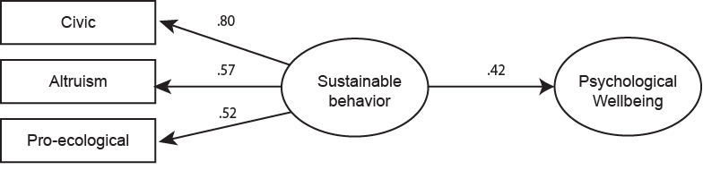

Figure 1. Model of the direct association between sustainable behaviors and wellbeing showed acceptable goodness of fit (χ2(2) = 7.74, p ‹ .05, relative χ2=3.87; BBNFI = .90, CFI = .97; RMSEA = .09. R² = .17).

Figure 2
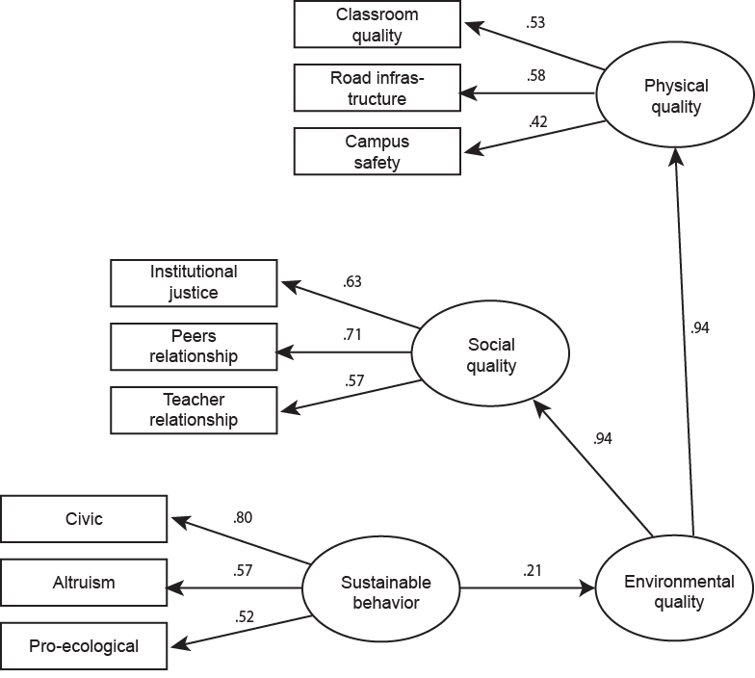

Figure 2. Model of the direct association between sustainable behaviors and environmental quality showed acceptable goodness of fit (χ2(25) = 55.02, p ‹ .05, relative χ2=2.20; BBNFI = .90, CFI = .93; RMSEA = .06. R² = .05).

Figure 3
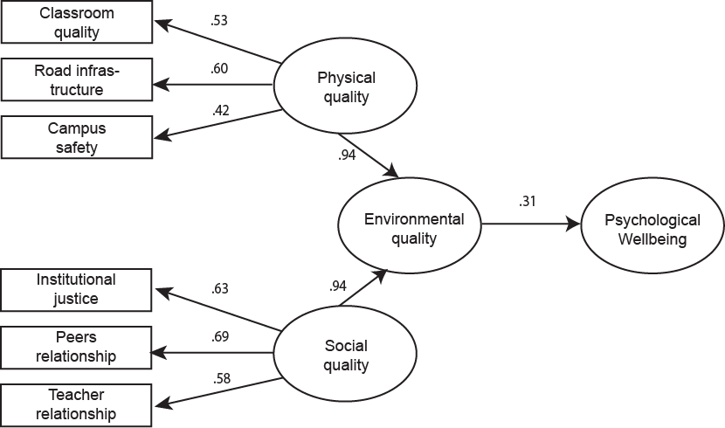

Figure 3. Model of the direct association between environmental quality and psychological wellbeing showed acceptable goodness of fit (χ²(13) = 28.96, p ‹ .05, relative χ²= 2.22; BBNFI = .92, CFI = .95; RMSEA = .06. R² = .09).

Figure 4

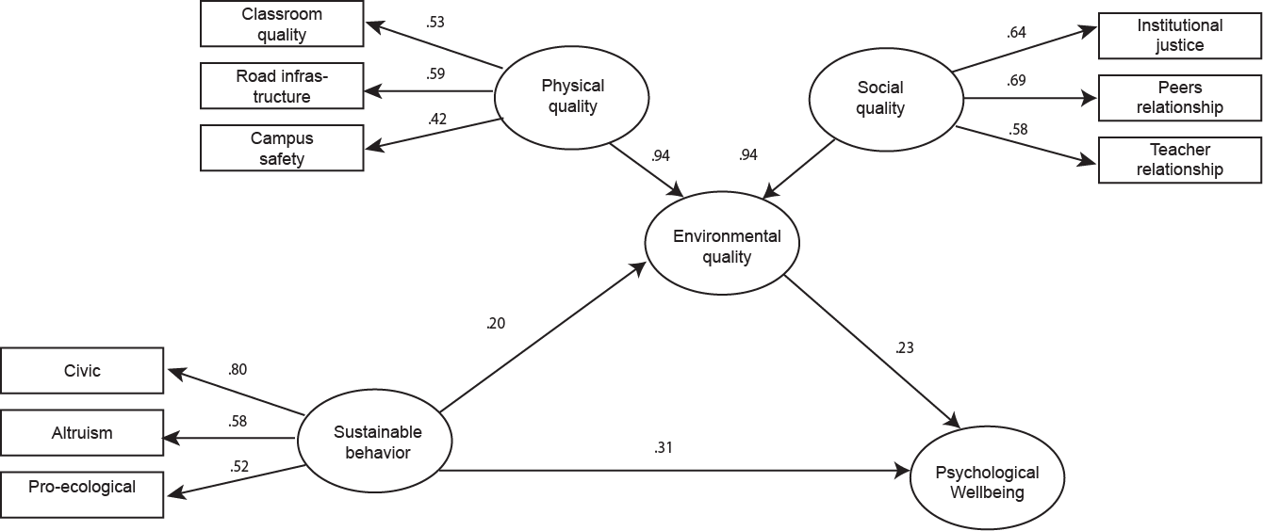

Figure 4. Model of the indirect association between sustainable behavior and psychological wellbeing environmental quality showed acceptable goodness of fit (χ2(32) = 72.48, p ‹ .05, relative χ2= 2.26; BBNFI = .90, CFI = .92; RMSEA = .06. R² = .23).

