Cognitive Abilities as a Predictive Factor of Socioeconomic Issues in Brazilian States.

Keywords: cognitive skills; socioeconomic indexes; predictive cognitive factors; Brazil.

Habilidades Cognitivas como Fator Preditivo de Questões Socioeconômicas em Estados Brasileiros.

Palavras-chave: habilidades cognitivas; índices socioeconômicos; fatores cognitivos preditivos; Brasil.

ABSTRACT
There is a strong correlation between cognitive abilities and the social status of individuals, as well as between the average cognitive abilities of a nation's citizens and the development of their environment. A study conducted in Brazil aimed to investigate these relationships. The school performance of 36,000 high school students from 27 Brazilian states was analyzed in relation to various socio-economic state indexes. Pearson correlation analysis was employed to assess the strength and direction of the relationship between cognitive abilities and socio-economic variables. The results showed a positive correlation (r = 0.680) between cognitive capacity and favorable socio-economic indicators (e.g., social well-being). In contrast, a negative correlation (r = -0.915) was found between cognitive capacity and adverse variables such as crime and mortality. These results indicate that cognitive abilities can be a predictive factor for the social development of a nation.

Keywords: cognitive skills; socioeconomic indexes; predictive cognitive factors; Brazil.

RESUMO
Há uma forte correlação entre as habilidades cognitivas e o status social dos indivíduos, bem como entre as habilidades cognitivas médias dos cidadãos de uma nação e o desenvolvimento de seu ambiente. Um estudo conduzido no Brasil teve como objetivo investigar essas relações. O desempenho escolar de 36.000 estudantes do ensino médio de 27 estados brasileiros foi analisado em relação a vários índices socioeconômicos estaduais. A análise de correlação de Pearson foi empregada para avaliar a força e a direção da relação entre as habilidades cognitivas e as variáveis ​​socioeconômicas. Os resultados mostraram uma correlação positiva (r = 0,680) entre a capacidade cognitiva e indicadores socioeconômicos favoráveis ​​(por exemplo, bem-estar social). Em contraste, uma correlação negativa (r = -0,915) foi encontrada entre a capacidade cognitiva e variáveis ​​adversas, como crime e mortalidade. Esses resultados indicam que as habilidades cognitivas podem ser um fator preditivo para o desenvolvimento social de uma nação.

Palavras-chave: habilidades cognitivas; índices socioeconômicos; fatores cognitivos preditivos; Brasil.

Introduction
According to differential psychology, cognition can be understood as the global ability that enables humans to reason, plan, solve problems, assimilate complex concepts, learn from experience, and acquire knowledge (Arvey et al., 1994). There is considerable consensus in the psychological community regarding the close relationship between social development and cognitive abilities (Demetriou et al., 2019; Georgiou et al., 2020). In fact, in various nations, studies have shown a strong association between reasoning ability and the socioeconomic progress of different states within a country (Lynn et al., 2018). Therefore, cognition exhibits, at both intra- and inter-group levels, a positive correlation with socioeconomic status, health, and longevity, while being negatively associated with infant mortality and crime (Georgiou et al., 2020).
Among cross-cultural studies on the relationship between cognitive ability and socioeconomic status, Lynn et al. (2018) study, covering a sample of 22 countries, stands out. The results pointed to positive associations between reasoning and social indicators such as education (r = 0.59), health (r = 0.49), and income (r = 0.56). Conversely, a negative link was observed between reasoning ability and fertility (r = -0.51) and crime (r = -0.20).
The connection between cognition and social development is equally evident within the same nations (Borgonovi & Pokropek, 2017). An analysis conducted in different regions of the United States found a positive correlation of 0.59 between GDP and cognition, highlighting the importance of cognitive skills in economic growth (Lynn et al., 2018). Furthermore, this positive correlation was found in 13 regions of England (r=0.73), 90 regions of France (r=0.61), 19 regions of Italy (r=0.94), 18 regions of Spain (r=0.42), 16 regions of Germany (r=0.27), 31 regions of China (r=0.42), 47 regions of Japan (r=0.51), and 12 regions of Turkey (r=0.81) (Lynn et al., 2017).
The link between cognitive abilities and social conditions is likely rooted in the educational context. On average, students with higher IQ levels tend to perform better in school assessments, exhibit more extensive and up-to-date knowledge about the world, and remain engaged in academic studies for longer periods (Demetriou et al., 2019). While other variables like emotional factors may influence academic development, none is more impactful than intelligence (Flores-Mendoza et al., 2015). Due to the close relationship between academic performance and cognition, the former has been used as a proxy measure of cognitive abilities (Demetriou et al., 2019; Rindermann, 2008, 2012).
In Brazil, the study conducted by Lynn et al. (2017) used PISA (Program of International Student Assessment) test scores as a proxy indicative of reasoning ability to investigate the relationship between cognitive abilities and the social and economic variables of the 27 Brazilian federal units. The researchers found significant positive associations between cognitive ability and education (r = 0.74), income (r = 0.79), life expectancy (r = 0.88), and access to water (r = 0.81). On the other hand, as expected, negative correlations were observed between cognition and infant mortality (r = -0.87), poverty (r = -0.87), violence (r = -0.64), and fertility (r = -0.71).
Unlike Lynn et al. (2017) study, which relied on aggregated data, i.e., the averages of PISA International Program scores for each Brazilian state, the present study will use individual scores from the National High School Examination (ENEM) as a proxy measure of cognitive ability. ENEM is a national assessment by the Brazilian government for high school students, covering various areas of knowledge and being used as a selection criterion for higher education. Individual data (raw scores) are superior to aggregated data as the latter have the limitation of losing individual variation information. Thus, the present study uses individual scores and subsequently calculates the average for each Brazilian state in mathematics and language and their technologies, components strongly correlated with overall cognition (Caemmerer et al., 2020; Mauro & Gomes, 2010).
The interconnection between cognitive ability, social development, and socioeconomic indicators is essential for understanding the complex dynamics shaping the progress of a society. Understanding the underlying factors in this relationship can have significant implications for public policies, educational interventions, and development strategies. As we face increasingly complex challenges in the 21st century, ranging from improving education to addressing social disparities, in-depth research on how cognition is linked to social and economic indicators is crucial for guiding efforts and resources effectively and informed. This study aims to contribute to this understanding in relation to the 27 Brazilian federal units, using the National High School Examination (ENEM) as a proxy measure of cognitive ability and exploring the correlations between school performance, socioeconomic indicators, and social well-being.
Our hypothesis is that cognitive abilities represented by school performance in mathematics and language are strongly associated with the social and economic conditions in the Brazilian federal units.
Method
Participants
A sample of 36,619 students who took the Brazilian ENEM exam in 2019 was analyzed. These students were stratified according to the sizes of the Brazilian regions (42% of the sample is represented by the Southeast Region, 28% from the Northeast, 12% from the South, 10% from the North, and 8% from the Midwest). Table 1 shows the sample size by region and state, as well as the mean and standard deviation in the ENEM school-cognitive test.
Please note that "ENEM" refers to the National High School Examination in Brazil.
Table 1.
Average performance on the ENEM cognitive school test across the 27 brazilian states.
Braziliam State | Sample | ENEM (mean) | Standard Deviation
Acre | 278 | 491,04 | 62,86
Alagoas | 695 | 499,05 | 71,12
Amapá | 275 | 495,81 | 61,72
Amazonas | 849 | 495,93 | 67,25
Bahia | 2156 | 506,88 | 57,26
Ceará | 1670 | 513,61 | 76,32
Distrito Federal | 681 | 539,98 | 83,63
Espírito Santo | 927 | 533,37 | 80,48
Goiás | 1274 | 521,59 | 73,3
Maranhão | 1572 | 492,15 | 68,93
Mato Grosso do Sul | 488 | 516,42 | 72,47
Mato Grosso | 579 | 508,63 | 75,03
Minas Gerais | 4542 | 541,50 | 78,93
Paraíba | 1112 | 512 | 74,69
Paraná | 1518 | 537,30 | 73,26
Pará | 1284 | 492,58 | 67,43
Pernambuco | 1529 | 516,41 | 75,46
Piauí | 977 | 498,98 | 76,55
Rio de Janeiro | 2909 | 536,69 | 74,98
Rio Grande do Norte | 888 | 516,64 | 77,20
Rio Grande do Sul | 1565 | 539,34 | 73,46
Rondônia | 395 | 501,06 | 65,11
Roraima | 185 | 505,45 | 65,23
Santa Catarina | 844 | 539,01 | 72,49
São Paulo | 6488 | 546,71 | 76,54
Sergipe | 631 | 510,85 | 70,01
Tocantins | 308 | 491,34 | 68,93
Southeast | 14866 | 539,57 | -
North East | 11230 | 507,39 | -
South | 3927 | 538,55 | -
North | 3574 | 496,17 | -
Midwest | 3022 | 521,65 | -

Brazilian Socioeconomic Database
Demographic data were collected from the Brazilian databases of IBGE (Brazilian Institute of Geography and Statistics) and the Atlas of Human Development in Brazil. ENEM data were obtained through INEP (National Institute for Studies and Educational Research) (Enem, 2023).
The social and economic data used for analysis were as follows:
1) Life Expectancy: the average number of years that an individual born in the same year can expect to live (IBGE, 2014).
2) Fertility: an estimate of the average number of children a woman would have by the end of her reproductive period (45 years) (IBGE, 2016).
3) Violence: measured through the number of homicides in one year (IBGE, 2015).
4) Infant Mortality: the rate of death of children in the first year of life observed over one year (IBGE, 2016).
5) Poverty: per capita household income below R$ 140.00 (Atlas Brazil, 2017).
6) GDP (Gross Domestic Product): income of Brazilian states per year (IBGE, 2017).
7) Weight: median of 15-year-old men and women (IBGE, 2008).
8) Height: median of 15-year-old men and women (IBGE, 2008).
9) Child Labor: work performed by children under 16 years of age (IBGE, 2010).
10) Suicide Rate: mortality rate due to suicide (IBGE Atlas Brazil, 2017).
Data Analysis
First, the ENEM score was validated as a proxy measure of cognitive ability through its correlation with the R1 intelligence test data (Silva & Alves, 2018) from 20 Brazilian states. Access to this data was made possible through the Laboratory for the Assessment of Individual Differences, which studies the update of the mentioned instrument, and with the authorization of the VETOR publisher, which markets the test in Brazil. The R1 test database (Silva & Alves, 2018) contained data from 2569 participants from 24 Brazilian states, however, four states (Acre, Rio Grande do Norte, Rondônia, and Tocantins) had limited data (fewer than seven participants) and were decided to be excluded. Therefore, only data from 20 Brazilian states were used. Since the raw test scores showed a statistically significant correlation with age (r = 0.28, p = 0.001), the scores were transformed into z-scores while controlling for age. The formula (z * 15) + 100 was then used to obtain an IQ scale, which was correlated with the average ENEM score.
Subsequently, socioeconomic indicators were reduced to latent indicators through exploratory factor analysis.
Finally, a linear correlation analysis was conducted between the proxy measure of cognitive ability and the scores of latent social variables. These analyses were carried out using the SPSS statistical software.

Ethical Aspects According to International Standards
The collection, recording, and anonymity of participants will not be violated at any point during the research process. According to the Ministry of Health, Executive Secretariat of the National Health Council, National Commission of Research Ethics, studies involving census research and research utilizing aggregated value databases without the possibility of individual identification do not require international ethical committee evaluation. Therefore, the article complies with international ethical norms (see at <https://conselho.saude.gov.br/images/Of%C3%ADcio_Circular_17_SEI_MS_-_25000.094016_2022_10.pdf> accessed on January 8, 2024).

Results
Validation of ENEM Scores as a Proxy Measure of Cognitive Ability.
ENEM scores correlated with the average IQ of 20 Brazilian states at 0.74 (Figure 1), which can range between r = 0.37 and r = 0.87, considering a 95% confidence interval for aggregated data (Torres, 2020). This result indicates that, effectively, the average ENEM scores could represent a proxy measure of cognitive capacity, with the advantage that ENEM scores come from a representative sample of each Brazilian state.
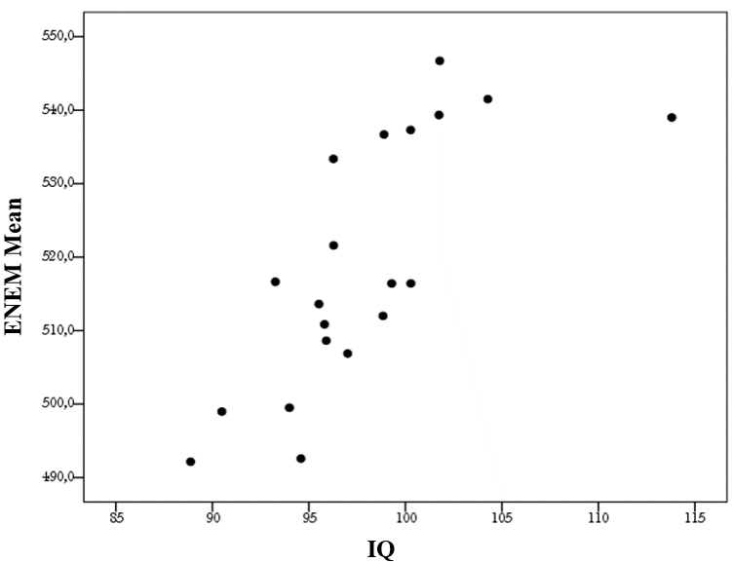
Figure 1. Scatterplot of performance on the school-cognitive exam (ENEM) and the average IQ of 20 brazilian states. r = 0.74, p < 0.001.

ENEM School-Cognitive Test and Social Indicators of Brazilian States
In Table 2, it is observed that all variables, with the exception of child labor rate and suicide rate, maintained a moderate to high correlation among them. This meant that the higher the score on the ENEM school-cognitive test, the higher were the socio-economic indices considered favorable for a nation, such as life expectancy (r = 0.89) and GDP (r = 0.55). Additionally, as expected, a negative correlation was observed between the ENEM school-cognitive test and indicators considered adverse for a nation, such as infant mortality rate (r = -0.89), poverty rate (r = -0.77), and homicide rate (r = -0.51). The cognitive measure (IQ) also shows correlations with social measures in the same direction as the ENEM school-cognitive test.
Table 2
Correlation matrix of the ENEM scores and social variables across the 27 brazilian states.
 | 1 | 2 | 3 | 4 | 5 | 6 | 7 | 8 | 9 | 10 | 11
1 | 1 | 0.57** | 0.56** | -0.89** | -0.82** | 0.89** | -0.77** | 0.55** | -0.51** | -0.15 | 0.19
2 |  | 1 | 0.78** | -0.63** | -0.43* | 0.56** | -0.67** | 0.57** | -0.49** | 0.25 | 0.17
3 |  |  | 1 | -0.60** | -0.60** | 0.56** | -0.62** | 0.53** | -0.34 | 0.15 | -0.05
4 |  |  |  | 1 | 0.72** | -0.88** | 0.69** | -0.44* | 0.47* | 0.06 | -0.23
5 |  |  |  |  | 1 | -0.65** | 0.66** | -0.37 | 0.32 | 0.01 | -0.12
6 |  |  |  |  |  | 1 | -0.74** | 0.45* | -0.58** | -0.12 | 0.24
7 |  |  |  |  |  |  | 1 | -0.36 | 0.55** | -0.18 | -0.37
8 |  |  |  |  |  |  |  | 1 | -0.48* | -0.19 | -0.14
9 |  |  |  |  |  |  |  |  | 1 | -0.11 | -0.46*
10 |  |  |  |  |  |  |  |  |  | 1 | 0.44*
11 |  |  |  |  |  |  |  |  |  |  | 1
IQ | 0.74** | 0.62** | 0.54* | -0.75** | -0.64** | 0.77** | -0.70** | 0.33 | -0.58* | 0.36 | 0.45*
Note: 1=ENEM, 2=Weight, 3=Height, 4=Infant Mortality, 5=Fertility, 6=Life Expectancy, 7=Poverty Rate, 8=GDP 2018, 9=Homicide Rate, 10=Child Labor, 11=Suicide Rate. The IQ refers to the average performance of 20 Brazilian states based on the R1 intelligence test. **n.sig = 0.01, *n.sig. = 0.05.
On the other hand, in Table 2, positive and negative correlations are observed. The positive ones were termed variables of social well-being (e.g., life expectancy), and the negative ones were named as variables of social adversity (e.g., infant mortality).
From the correlation matrix, an exploratory factor analysis was conducted using the maximum likelihood method with the four variables considered as indicators of social adversity (infant mortality, fertility rate, poverty rate in 2017, and homicide rate) due to their significant negative correlation with the ENEM school-cognitive test. The Kaiser-Meyer-Olkin sampling adequacy test was 0.75, and the Bartlett's test of sphericity was significant (p-value = 0.000). Principal axis factoring indicated that a single factor accounted for 68.3% of the variance. The scores of this latent factor, referred to here as social adversity, negatively and significantly correlated at -0.92 (p = 0.000) with the scores of the ENEM school-cognitive test, a coefficient that can vary between 0.76 and 0.96 for a 95% confidence interval for aggregated data (Torres, 2020). Figure 2 presents the scatterplot.
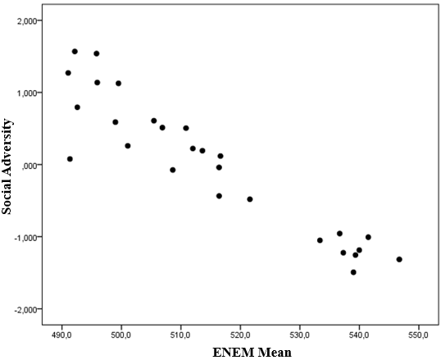
Figure 2. Scatterplot of the social adversity factor and performance on the School-Cognitive Exam (ENEM) across the 27 brazilian states. r = -0.919, p < 0.001.

Similarly, an exploratory factor analysis was performed using the maximum likelihood method with the five variables considered as indicators of social well-being (weight, height, life expectancy, and GDP in 2018) that showed a positive correlation with the ENEM school-cognitive test. The Kaiser-Meyer-Olkin sampling adequacy test was 0.78, and Bartlett's test of sphericity was significant (p-value = 0.000). Principal axis factoring indicated that a single factor accounted for 68.4% of the variance. The scores of this latent factor, referred to as social well-being, correlated positively at 0.68 (p < 0.001) with the average performance in the ENEM school-cognitive test, a coefficient that can vary between 0.35 and 0.85 for a 95% confidence interval for aggregated data (Torres, 2020). Figure 3 presents the scatterplot.

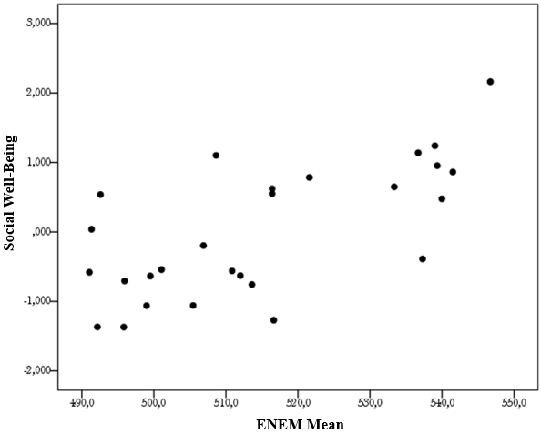
Figure 3. Scatterplot depicting the correlation between the social well-being factor and the performance on the cognitive ENEM exam across the 27 Brazilian states. r = 0.680, p < 0.001.

Discussion
The present study aimed to investigate the relationship between cognitive ability and socioeconomic indicators in the 27 Brazilian states. To do so, the scores of the ENEM school performance were used. First, the validation of the ENEM score as a proxy measure of cognitive abilities was obtained by considering the high correlation with the psychometric intelligence test R1. The results pointed to a positive relationship (0.74) between general cognitive abilities, also known as general intelligence, and socioeconomic variables. These results corroborate the findings of Lynn et al. (2017), who used the PISA test as a proxy measure of cognitive abilities. It is important to note that psychometric cognition followed the same trend as the ENEM school-cognitive test, except for the suicide rate, which did not show a significant association with ENEM scores but did with IQ.
Overall, the results indicated a positive association between cognitive abilities and indicators of social well-being, such as life expectancy and Gross Domestic Product (GDP). Conversely, negative correlations were observed between general cognitive abilities and indicators of social adversity, such as infant mortality and homicide rates. Specifically, a strong negative correlation was found between reasoning and infant mortality (r = -0.89), a finding consistent with other studies conducted in various countries, such as the United States (r = -0.54), England (r = -0.78), and India (r = -0.39) (Demetriou et al., 2020; Dutton & Lynn, 2014; Lynn et al., 2018). The explanation for this association may be related to the scarcity of resources that often accompanies low cognitive abilities, resulting in a higher infant mortality rate. However, it is important to note that cognition can also indirectly impact infant mortality since parents with higher cognitive abilities are capable of avoiding accidents and have more knowledge regarding infant nutrition (Meldrum et al., 2017), which contributes to a reduction in infant mortality rates.
It is believed that the positive correlation between life expectancy and general cognitive abilities follows a similar logic to that observed in the relationship between intelligence and infant mortality. More intelligent individuals can acquire knowledge about healthy lifestyles, disease prevention, and responsible health-related decision-making (Wraw et al., 2018). Moreover, they may have more access to resources and information about quality medical care and healthy food choices, which can increase life expectancy (Demetriou et al., 2020). For example, in a study conducted in the United Kingdom, it was found that people with higher scores on cognitive tests were more likely to adopt healthy behaviors such as regular physical exercise, a healthy diet, and abstaining from tobacco (Sánchez-Izquierdo et al., 2023). Another study conducted in Israel showed that reasoning ability was positively associated with health measures, such as low levels of cholesterol and blood pressure, and a reduced risk of diabetes, heart disease, and stroke (Cohen-Manheim et al., 2016). Finally, the high correlation between cognitive abilities and longevity found in the present analysis is consistent with findings in various countries, such as the United States (Lynn et al., 2018) and India (Demetriou et al., 2020).
Considering that general cognitive abilities are a strong predictor of high life expectancy and low infant mortality, which are health indicators, it would be reasonable to assume that cognition is correlated with weight and height. The results confirmed this hypothesis, showing that general cognition is moderately and positively correlated with weight (r = 0.57) and height (r = 0.56). Therefore, it is possible to suggest that individuals with greater cognitive resources tend to have better financial and dietary conditions, contributing to better physical development in terms of weight and stature.
Next, a factor analysis was conducted to enhance the understanding of the relationship between cognition and socioeconomic levels. This analysis aimed to synthesize multiple study variables into a reduced number of latent variables capable of representing the dataset. The results indicated that the variables could be grouped into two distinct factors: adverse socioeconomic indices and favorable indices. The exploratory factor analysis of the four variables associated with adverse indices (infant mortality, fertility rate, poverty rate, and homicide rate) showed a significant negative correlation with school-cognitive performance as measured by the ENEM exam. Figure 2 illustrates how the scores of this factor, called social adversity, are strongly and negatively correlated (-0.93) with ENEM scores.
Figure 3 displays the scatterplot of the factor analysis of the four variables (weight, height, life expectancy, and GDP in 2018), which showed a significant positive correlation with cognitive school performance measured by the ENEM exam. The scores of the factor, referred to as social well-being, exhibited a positive correlation of 0.68 with the average performance in the ENEM exam.
In conclusion, it can be said that the relationship between psychometric cognition and social variables is a research topic that does not yet have a definitive answer in the literature. It is possible that this correlation is a consequence of the impact that cognition has on socioeconomic conditions, or that a better socioeconomic situation drives better cognitive outcomes. Another possible explanation is that intelligenc plays an important role in academic performance and, consequently, in access to higher-qualified jobs and better financial conditions.
Conclusions

In conclusion, the differences that separate individuals in their cognitive performance are strongly related to various life outcomes. In this sense, the present study investigated the association of cognitive abilities (measured by the score of the school-cognitive ENEM exam) with socioeconomic conditions. High cognitive levels were associated with better social and economic conditions. This result was similar to that found in a previous study that used the international PISA exam as an indicator of cognitive ability, corroborating the international literature on cognitive differences and their importance as a predictive factor for a better quality of life.
However, an intriguing question remains about the dynamics of this relationship. Whether cognitive ability impacts social conditions or vice-versa, or if there is a complex interaction between both, remains a challenge to be explored. Ultimately, this study emphasizes the crucial role of cognitive abilities in shaping the social and economic landscape, providing fertile ground for future investigations into the underlying mechanisms of this intricate connection.
Declarations
Ethics approval and consent to participate:
Ok (See Methods)
Consent for publication:
Ok
Availability of data and materials
Ok
Competing interests:
There are no competing interests
Funding:
Dear Interamerican Journal of Psychology
I would like to inform you that this manuscript did not receive any funding. Please let me know if any further information is required.
Best regards,

Authors' contributions:
All authors have contributed significantly to the article.

References
Arvey, D., Bouchard, J., Carroll, B., Cattell, B., Cohen, B., Dawis, V., & Willerman, L. (1994). Mainstream science on intelligence. Wall Street Journal, 13(1), 18–25.
Borgonovi, F., & Pokropek, A. (2017). Mind that gap: The mediating role of intelligence and individuals’ socio-economic status in explaining disparities in external political efficacy in 28 countries. Intelligence, 62, 125–137. https://doi.org/10.1016/j.intell.2017.03.006
Caemmerer, J. M., Keith, T. Z., & Reynolds, M. R. (2020). Beyond individual intelligence tests: Application of Cattell-Horn-Carroll Theory. Intelligence, 79. https://doi.org/10.1016/j.intell.2020.101433
Cohen-Manheim, I., Pinchas-Mizrachi, R., Doniger, G. M., Simon, E. S., Sinnreich, R., & Kark, J. D. (2016). Measures of carotid atherosclerosis and cognitive function in midlife: The Jerusalem LRC longitudinal study. Intelligence, 57, 73–80. https://doi.org/10.1016/j.intell.2016.05.003
Demetriou, A., Kazi, S., Makris, N., & Spanoudis, G. (2020). Cognitive ability, cognitive self-awareness, and school performance: From childhood to adolescence. Intelligence, 79. https://doi.org/10.1016/j.intell.2020.101432
Demetriou, A., Kazi, S., Spanoudis, G., & Makris, N. (2019). Predicting school performance from cognitive ability, self-representation, and personality from primary school to senior high school. Intelligence, 76. https://doi.org/10.1016/j.intell.2019.101381
Dutton, E., & Lynn, R. (2014). Regional Differences in Intelligence and their Social and Economic Correlates in Finland. Mankind Quarterly, 54(3), 447–456. https://doi.org/10.46469/mq.2014.54.3.10
Enem. (2023). Instituto Nacional de Estudos e Pesquisas Educacionais Anísio Teixeira | Inep. https://www.gov.br/inep/pt-br/areas-de-atuacao/avaliacao-e-exames-educacionais/enem
Flores-Mendoza, C., Mansur-Alves, M., Ardila, R., Rosas, R. D., Guerrero-Leiva, M. K., Maqueo, M. E. L. G., Gallegos, M., Colareta, N. R., & León, A. B. (2015). Fluid intelligence and school performance and its relationship with social variables in Latin American samples. Intelligence, 49, 66–83. https://doi.org/10.1016/j.intell.2014.12.005
Georgiou, G. K., Guo, K., Naveenkumar, N., Vieira, A. P. A., & Das, J. P. (2020). PASS theory of intelligence and academic achievement: A meta-analytic review. Intelligence, 79. https://doi.org/10.1016/j.intell.2020.101431
Lynn, R., Antonelli-Ponti, M., Aparecido, J., Silva, D., & Meisenberg, G. (2017). Differences in Intelligence and Socio-Economic Outcomes across the Twenty Seven States of Brazil CORRELATIONS BETWEEN INTELLIGENCE, HEAD CIRCUMFERENCE AND HEIGHT: EVIDENCE FROM TWO SAMPLES IN SAUDI ARABIA View project Dimensions of scientific quality View project. https://www.researchgate.net/publication/317551627
Lynn, R., Fuerst, J., & Kirkegaard, E. O. W. (2018). Regional differences in intelligence in 22 countries and their economic, social and demographic correlates: A review. In Intelligence (Vol. 69, pp. 24–36). Elsevier Ltd. https://doi.org/10.1016/j.intell.2018.04.004
Mauro, C., & Gomes, A. (2010). AVALIANDO A AVALIAÇÃO ESCOLAR: NOTAS ESCOLARES E INTELIGÊNCIA FLUIDA EVALUATING THE SCHOOL EVALUATION: THE GRADE SCHOOLS AND FLUID INTELLIGENCE. In Psicologia em Estudo (Vol. 15).
Meldrum, R. C., Petkovsek, M. A., Boutwell, B. B., & Young, J. T. N. (2017). Reassessing the relationship between general intelligence and self-control in childhood. Intelligence, 60, 1–9. https://doi.org/10.1016/j.intell.2016.10.005
Rindermann, H. (2008). Relevance of education and intelligence at the national level for the economic welfare of people. Intelligence, 36(2), 127–142. https://doi.org/10.1016/j.intell.2007.02.002
Rindermann, H. (2012). Intellectual classes, technological progress and economic development: The rise of cognitive capitalism. Personality and Individual Differences, 53(2), 108–113. https://doi.org/10.1016/j.paid.2011.07.001
Sánchez-Izquierdo, M., Fernández-Ballesteros, R., Valeriano-Lorenzo, E. L., & Botella, J. (2023). Intelligence and life expectancy in late adulthood: A meta-analysis. In Intelligence (Vol. 98). Elsevier Ltd. https://doi.org/10.1016/j.intell.2023.101738
Silva, M. A., & Alves, I. C. B. (2018). Estudo normativo do R-1: Teste Não Verbal de Inteligência para uma região da Bahia-Brasil. Estudos Interdisciplinares Em Psicologia, 9(3supl), 38. https://doi.org/10.5433/2236-6407.2018v9n3suplp38
Torres, D. J. (2020). Describing the Pearson R distribution of aggregate data. Monte Carlo Methods and Applications, 26(1), 17–32. https://doi.org/10.1515/mcma-2020-2054
Wraw, C., Der, G., Gale, C. R., & Deary, I. J. (2018). Intelligence in youth and health behaviours in middle age. Intelligence, 69, 71–86. https://doi.org/10.1016/j.intell.2018.04.005

