Adolescent interpersonal relationships and prosocial behavior: Qualitative research

Abstract
The aim of this study is to describe and interpret the subjective theories of a group of Chilean high school students regarding the relationship between adolescents’ social interactions and prosocial behavior. Qualitative methodology, a case study design and theoretical sampling to select 23 high school students from Chile, was employed. Episodic interviews were conducted and data were analyzed using Thematic coding, Grounded Theory and specific analysis related to subjective theories. The findings suggest that adolescents engage in complex multidimensional information processing that involving social, contextual and personal factors when deciding to act prosocially with their peers. The discussion critically analyzed the results in light of available scientific evidence and the study´s limitations, while proposing new avenues for future research on adolescents’ prosocial behavior.

Keywords
prosocial behavior; adolescence; students; subjectivity; quality relationship

Resumen
El objetivo de este estudio es describir e interpretar las teorías subjetivas de un grupo de estudiantes secundarios chilenos, sobre la relación entre las interacciones sociales adolescentes y el comportamiento prosocial adolescente. Se utiliza metodología cualitativa, un diseño de estudio de caso y un muestreo teórico de 23 estudiantes de educación secundaria, Chile. Los datos se analizaron con codificación temática, teoría fundamentada y análisis específico de teorías subjetivas. Se encontró que los adolescentes realizan un complejo procesamiento multidimensional de la información social, contextual y personal para decidir y actuar prosocialmente con sus pares. En la discusión, se analizan los resultados a la luz de la literatura, se identifican limitaciones del estudio y algunas sugerencias para la investigación del comportamiento prosocial adolescente.

Palabras clave

Comportamiento prosocial; adolescencia; estudiante; subjetividad; relación de calidad

Relaciones interpersonales adolescentes y comportamiento prosocial: estudio cualitativo
Introduction
Recently, BBC News Mundo (May 3, 2023) reported the detention of a 13-year-old teenager for an attack on a school in Serbia that resulted in the deaths of at least eight students and a guard. On the other hand, environmental activist Greta Thunberg addressed world leaders at the World Economic Forum in Davos, stating, "Our house is on fire. I am here to tell you that our home is burning" (BBC News Mundo, April 24, 2019).
The question of what leads a person to choose prosocial behavior over antisocial behavior remains of great interest in the field of social sciences (Wong, 2023). This study aims to understand what drives adolescents to engage in prosocial behavior based on the influence of their interactional context with peers.
Prosociality is one of the most important positive behaviors in individuals and social groups. It is understood as voluntary, intentional, and gratuitous helping behavior toward a person or social group (Pfattheicher et al., 2022). It has been linked to greater social cohesion and the construction of more humanitarian societies (Gerben & Gert-Jan, 2022). During adolescence, prosocial behavior is fundamental for social adjustment, highly dynamic, and primarily determined by social influences (Crone & Achterberg, 2022). This is because, during adolescence, individuals exhibit a significant need to contribute to society and be a part of it by developing shared goals (Fuligni, 2019). One of the most influential social agents in adolescent development is peers. Currently, there is a body of evidence demonstrating that interactions with peers during adolescence play a significant role in adaptive and maladaptive behaviors (Laursen & Veenstra, 2021). In the case of prosociality, studies show a relationship between adolescent interactions with peer groups exhibiting positive behaviors and the production of prosocial behaviors (Wagemaker et al., 2022).
Despite the aforementioned findings, there is a recognized need to address the limitations present in prosocial behavior research. One such limitation is the scarcity of studies that focus on the individual, employing qualitative approaches that allow for an understanding of adolescents' experiences and subjectivity in the development of the prosociality (Carlo & Padilla-Walker, 2020). This study addresses adolescent´s prosocial behavior and their social interactions with peers through the lens of subjective theories (STs). STs are a type of beliefs that individuals develop in everyday life to explain their own behavior, the behavior of others, and the functioning of the world in general (Catalán, 2021; Flick, 2018). Moreover, STs facilitate the investigation of individuals' subjectivity as they integrate experiential knowledge with explanatory knowledge.
Building on the aforementioned points, this study seeks to answer the question: What are the subjective theories of a group of Chilean high school students regarding the relationship between adolescent social interactions and prosocial behavior? The general objective is to describe and interpret these STs. Specifically, the study aims to: (a) describe the social relationships between adolescent peers that promote and inhibit prosocial behavior in this age group, based on the students' STs, (b) describe the relationships between schoolmate that promote and inhibit adolescent prosociality, based on the students' STs, (c) describe the relationship between adolescent friendships and the production of prosocial behavior, based on the students' STs, and (d) propose a comprehensive qualitative model that explains adolescent prosocial behavior based on their interactions with peers and the identified STs.
Prosocial behavior in the adolescence
Prosociality is a voluntary, intentional, and altruistic behavior directed towards one or more individuals. It entails some level of cost to the benefactor (Pfattheicher et al., 2022) and can manifest in various forms. It has been regarded as a complex construct due to its multidimensional nature, characterized by different types of assistance aligned with specific goals and contextual settings (Padilla-Walker et al., 2018).
Regarding theories of prosocial behavior, there are various approaches that consider social, cultural, biological, familial, and psychological factors (Mesurado, 2022). Taking a broader view, two theoretical positions have been proposed. The first positions cognitive-motivational factors such as empathy at the core of prosocial behavior (Mesurado et al., 2022), while the second emphasizes the behavioral manifestation of prosociality. From a sociocognitive perspective, during adolescence, prosocial behavior emerges as a result of the development of cognitive capacities and socioemotional skills through maturation processes and social interaction. The cognition of adolescents is influenced by contextual factors such as the assessment of the effectiveness of responses in interpersonal relationships based on peer feedback, approval, and support within an endogroup normative system. Additionally, internalized beliefs and peer group values impact the adolescent's social cognition, thereby regulating social interactions and prosocial behavior to some extent (Farrell et al., 2017).
The development of prosociality is crucial during adolescence as it plays a significant role in social adjustment and lays the groundwork for more compassionate and healthy adolescent and adult behavior (Crone & Achterberg, 2022). Adolescent peers play a pivotal role in shaping prosocial behavior. For instance, peer popularity (Rodríguez et al., 2022), academic prestige within the friend group, and positive peer norms influence greater adolescent prosociality. Conversely, socially deviant behaviors within peer groups are negatively associated with adolescent prosociality (Zhu et al., 2020). The quality of friendship among adolescent peers has been shown to be significantly related to varying levels of prosocial behaviors. High-quality friendship is understood as a dynamic, intimate, affectionate, voluntary, relatively stable, and reciprocal dyadic relationship, characterized by greater commitment, mutual preference, and increased task effectiveness (Di Norcia et al., 2022). Conversely, negative friendship involves power asymmetry and lack of reciprocity among friends, which is associated with negative emotions and even psychological symptoms (Schwartz-Mette et al., 2020).
Quality friendships in adolescence are crucial for developing sociocognitive skills such as perspective-taking, empathy, conflict resolution, negotiation, and subjective well-being (Bowker & Weingarten, 2022). Evidence suggests that high-quality adolescent friendships are associated with assertiveness and prosocial behavior, whereas negative friendships correlate with aggression and withdrawal (Rodríguez et al., 2022).
Another fundamental type of interaction for adolescents is that established with school peers. It has even been argued that school is the most significant context of interaction for adolescents (Ellinge et al., 2023). This context forms a broad network of interactions that daily include a range of opportunities for learning and exhibiting prosocial behaviors (Hammond et al., 2023). Students need to learn and adhere to a set of explicit and implicit norms in school, such as respect, kindness, and prosociality. However, norms and rules constructed through student interactions may not always align with those explicitly stated by the school, potentially influencing whether negative and disruptive school climates are fostered (Busching & Krahé, 2020). There is evidence that prosocial school behaviors involve being friendly, standing up for others, including those without social groups, avoiding fights, and teasing. These behaviors primarily arise in the socialization spaces that schools provide (Hammond et al., 2023). Moreover, students' prosocial relationships are associated with better bonds with their peers and teachers, along with reduced disruptive behaviors in school (Carlo et al., 2011).
The aforementioned findings could be related to the discoveries presented by Su and Wang (2022) in Chinese adolescent students. The authors found that a stronger sense of connection and the need for connection with other students significantly correlates with prosocial behavior among them. According to Hashemi et al. (2020), increased motivation to interact with others enhances levels of trust, understanding of others, social support, and consequently, prosocial behavior.
Subjective theories and prosocial behavior
An individual's determination to engage in prosocial behavior is not always contingent on objective reasons (Berman et al., 2018). However, the subjective dimension of prosocial behavior has not been adequately considered (Padilla-Walker, 2018). One way to address this limitation in the study of prosocial behavior is through the use of STs. STs are a type of belief characterized by their argumentative or explanatory structure, which individuals develop in everyday life and use to describe, explain, and predict their own behavior, others' behavior, and the world in general (Flick, 2018). Moreover, STs serve to guide decision-making and actions by either inhibiting, promoting, or maintaining them (Catalán, 2021).
The study of lay STs and their relationship with the development of socioemotional competencies began several decades ago (Miller, 1988). Regarding prosocial behavior, Reisenauer's research (2009) described the STs that parents develop to explain the development of social skills in their children, including prosocial behavior, revealing complex explanations. Meanwhile, González-Palta et al. (2021) found lay STs related to the need for help and support from volunteers during emergencies, where the emotional impact of such experiences hinders affected individuals from orienting themselves towards helping others in that circumstance. Also, in the context of socio-natural disasters, Alvarado et al. (2019) documented STs that reflect a complex assessment of risk and the capacity to provide assistance in socio-natural disaster contexts. Finally, Author1 (2020) sought to reconstruct the subjective theory (ST) regarding prosocial behavior among a group of Chilean secondary education adolescents. Among their findings, they discovered that adolescents hold STs that inhibit the formal learning of prosocial behavior in educational contexts, believing instead that this behavior develops during early childhood and within the family environment.
Method
Participants
This study is part of a larger mixed-methods research. The mixed-methods study included a non-random sample of 414 Chilean secondary school adolescents -these high school provide education in scientific, humanistic and technical-professional fields- to whom the Prosocial Behavior Scale by Caprara et al. (2005) was applied. From the quantitative sample, 23 students were interviewed, including students with high (X̅+Ɛ), low (X̅-Ɛ), and average levels of prosocial behavior, as measured by the applied scale. The students were 14 to 20 year old. A theorical sampling strategy was adopted (Flick, 2018). It began with of 10 students, considering criteria for qualitative representativeness of cases, involving students from different educational levels, both sexes and different levels of prosocial behavior. In a second phase, eight students with experience in school leadership positions (e.g., class presidents and secretaries) and volunteering were included. This was done to gain more precise, in-depth, and detailed knowledge of adolescent interpersonal relationships and prosocial behavior. The theoretical data saturation was achieved with these 18 students. In a final sampling phase, an additional 5 students were included to communicatively validate of the preliminary results obtained with the sample of 18 adolescents (Flick, 2018). Inclusion criteria considered that students (a) were enrolled in any educational level of the high school and (b) had a sufficient level of reading and writing skills to respond to the data collection instruments.
Table 1
Sampling qualitative
 | High school 1 | High school 2 | High school 3 | Total
Man | 7 | 2 | 2 | 11
Woman | 4 | 8 | - | 12
1st year | 2 | 4 | - | 6
2st year | 5 | 3 | - | 8
3st year | 2 | 2 | 2 | 6
4st year | 2 | 1 | - | 3
Student leader | 3 | 7 | 1 | 11
Volunteer student | 2 | - | - | 2
High level of prosociality | - | 4 | - | 4
Low level of prosociality | 1 | 1 | - | 2
Average level of prosociality | 7 | 4 | 6 | 17
Design
A descriptive-interpretative study was conduced using a qualitative methodology in order to understanding the research problem form the subjective know of the adolescent (Flick, 2018). A instrumental case study design was used (Stake, 2010), integrate for a group of the high school student, Atacama, Chile.
Materials
Eighteen episodic interviews were conducted, achieving theoretical data saturation. In a final stage, five additional episodic interviews were conducted aimed at the communicative validation of the preliminary results obtained. The episodic interview is a data collection instrument specially used to research subjective theories (Flick, 2018). The assumption of this interview is that people are more likely to develop subjective theories when they draw on biographical experiences related to the topic under investigation. In this study we question to the students about your experiences in the thematic and we request to elaborate subjective explanation, subjective definitions about prosocial behavior. The interviews lasted approximately 20 to 45 minutes. They were audio recorded and administered at the high school. A thematic script was used which included: (a) interpersonal relationships with peers that promote and inhibit adolescent prosocial behavior; (b) interpersonal relationships with students and adolescent prosocial behavior; (c) adolescent friendship and prosocial behavior.
Procedure
The students and their parents were contacted through the high school administrations. The research and ethical criteria were explained, and informed consent and/or assent forms were provided, which were signed by the adolescents and their parents. The data collection instruments were administered on the high school.
Data analysis
Data analysis consisted in a combination of techniques, considering procedure of the Thematic coding (Flick, 2018), Ground theory (Strauss & Corbin, 2002) and specific analyze to subjective theories (Catalán, 2021). In thematic coding, first, a within-case analysis is carried out, which consists of representing the case according to a motto, a summary of the data for the case and themes and sub-themes. Second, in inter-case analysis, each case was compared to build a common thematic axis. In this research, due to space constraints, only the thematic structure common (inter-case results) to all cases. Thirdly, grounded theory's axial and selective coding were applied to address the interpretative objective of this study. Axial coding aimed to establish relationships among the thematic subcategories identified to the each them elaborated. Selective coding identified a core thematic category and established relationships among the developed thematic categories. Both coding were conducted following Flick's (2018) suggestion, which involves creating a relationship map (graph) and a brief text. Finally, for the specific analysis of STs (Catalán, 2021), the codes developed in the previous analysis procedures were STs identified in the text based on their argumentative structure (“this occurs because...”). Additionally, the action orientation of the identified STs was interpreted, that is, whether they maintain, initiate, or inhibit prosocial behavior (Catalán, 2021). Throughout this process, data analysis proceeded incrementally as information was collected until theoretical saturation was achieved.
Ethical considerations
This research has followed the ethical standards outlined in the Code of Ethics for Psychologists of Chile. The Universal Declaration of Ethical Principles for Psychologists (IAAP & IUPsyS, 2008), the International Ethical Guidelines for Biomedical Research Involving Human Subjects (CIOMS, WHO & PAHO, 2016) and the declarations of the ISP regarding ethical behavior at the time of submission (ISP, 1978, 2008a, 2008b, 2014, 2016, 2018, 2019) have also been followed. Finally, this study was reviewed by an academic committee of a doctoral program at an Argentine university.
Results
The results of the inter-case analysis, axial coding, selective coding, and action orientation of ST are presented. For axial and selective coding, a summary of the communicative validation results is included (Table 2).
Table 2
Communicative validation results
Coding type | Result | Adolescents' answers
Axial coding: adolescent interactions and prosocial behavior | Model approval | It's important to know and trust in the peers to be prosocial. Sometimes, the beneficiary might not seek help due to fear of the peer group. Biographical and situational empathy are crucial for prosocial behavior.
Axial coding: student interactions and prosocial behavior | Model approval | Group assistance to victims of violence is safer than individual assistance. Prosocial behavior is more frequent among schoolmate than with strangers, due to the greater trust among schoolmate.
Axial coding: adolescent friendship and prosocial behavior | Model approval | Greater trust among friends promotes prosocial behavior within and outside the group.
Selective coding: adolescent interactions and prosocial behavior | Model approval | Positive social climates promote prosocial behavior. It is important to protect personal integrity to behave prosocially.
Adolescents’ interactions and prosocial behavior
STs were found that explain adolescent prosocial behavior based on the interpersonal relationships with the pairs. These STs are classified as initiators and inhibitors of prosocial behavior (Table 3).
Table 3
Subjective theories about prosocial behavior and adolescents’ interpersonal relationships
Initiators STs | Involves
To behave prosocially, it is necessary to know the beneficiary adolescent. | Sensibility, interest and understanding of the problems, needs and life of the beneficiary.
To behave prosocially, it is necessary to feel biographic empathic with the pair. | Situational empathic: experience with problem of the pair. Biographic empathic: experience with the life of the pair.
To behave prosocially, it is necessary a positive interaction with the adolescents. | Respect, closeness, kindness, and honesty among adolescents. Aproval of the prosocial behavior.
To behave prosocially, it is necessary to assess the help as pertinent. | Level of relevance of the help; willingness to receive the help. Ethical behavior in delivering the help, capabilities to help, and organization of the help.
Inhibitors STs | Involves
The prosocial behavior is inhibited within social group characterized by negative norms. | Hostile and aggressive groups that intimidate and control potential benefactors and beneficiaries
Prosocial behavior is inhibited by social apathy. | Mocking others' needs. Indifference and intolerance among adolescents.
Prosocial behavior is inhibited when adolescents have lower social and emotional skills | Insecurity and shyness in the benefactor and beneficiary. Fear of rejection in requesting and delivering assistance. Low assertiveness, shame, and pride in seeking help.
Axial coding of adolescents’ interactions and prosocial behavior
The STs found demonstrate that when adolescents interact, they evaluate a set of psychosocial conditions to decide whether to seek help -in the case of the potential beneficiary- and to determine whether help will be provided -in the case of the potential benefactor- Trust in social interaction is fundamental for deciding whether to offer or request help and depends on biographical and situational empathy with the needy, socio-emotional skills for helping, a social group that approves and values prosocial behaviors, and a safe social environment for confiding problems and needs. When these conditions are less present, trust decreases and, consequently, prosocial behavior among adolescents reduce (Figure 1).
Figure 1.
Axial coding of adolescents’ interactions and prosocial behavior.
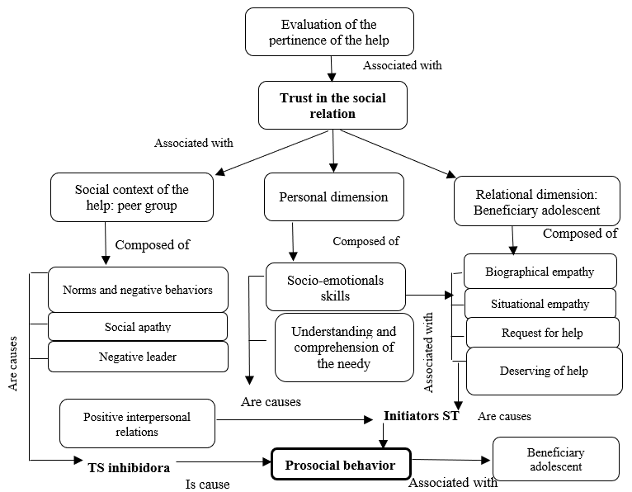

Adolescents´ interactions in the school context and prosocial behavior
STs that describe adolescent interactions in the school context that promote and inhibit prosocial behavior were found. Table 4 displays these findings.
Table 4
Subjective theories of the adolescents´ interactions with the schoolmate and prosocial behavior
Initiators STs | Involves
To behave prosocially in the school, it is necessary a mechanism of organizing help. | Use of class council of the school to organize help.
To behave prosocially in the school, it is necessary that the schoolmate have credibility. | Expertise in helping others and socioemotional skills (respect, friendliness, public speaking).
To behave prosocially in school, it is necessary have resources. | Materials, economics, temporary and psychological resources (empathy, understanding of the schoolar problems, courage).
To behave prosocially in the school, it is necessary have camaraderie. | Close relationship, affectionate and trusting relationship in the school.
Inhibitors STs | Involves
Prosocial behavior is inhibited when the schoolmate is not known. | Not knowing the life, needs, problems and longings of the schoolmate.
Prosocial behavior is inhibited when the student is emotionally fragile, because it avoids the pain of the schoolmate. | Avoidance pain of the schoolmate, to the personal protection.
Prosocial behavior is inhibited when the student does not attribute meaning to the help. | Not knowing the aim of the help.
Prosocial behavior is inhibited when there is a negative school climate and school violence. | Feeling humiliated for having a problem. Mockery of the students' needs. Disloyalty among students. jealousy and envy.
Axial coding of adolescents´ interactions in the school and prosocial behavior
Prosocial behavior among schoolmates needs a positive school climate. Protecting personal integrity is crucial during this developmental period, and within the school context, adolescent relationships are highly frequent. Therefore, adolescents will engage in prosocial behaviors at school only when they perceive a safe environment where their psychological integrity is preserved. Negative school climate will inhibit this positive behavior (Figure 2).
Figure 2.
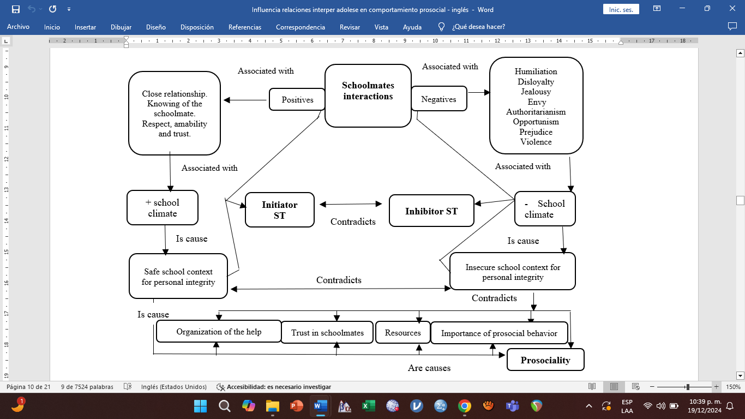
Axial coding: relationship among schoolmates and prosocial behavior.

Adolescents’ friendships and prosocial behavior
The majority STs promote the production of prosocial behaviors through high-quality friendship relationships, whereas low-quality friendships inhibit such behaviors. In adolescent groups, high-quality friendships are characterized by adequate intimacy, trust, loyalty, knowledge, and understanding of the friend. These elements provide security when offering support to the out-group. Joint experiences among friends are essential for being receptive to help and requests for help to from both the ingroup and the outgroup. On the other hand, low-quality friendships are characterized by an absence of reciprocity in support, exploitation of the friend's kindness, and a form of loyalty understood as a possessive and jealous bond that prohibits helping other adolescents. Furthermore, adolescents view prosocial behavior as integral to interpersonal relationships among friends. This aligns with a ST of friendly relationships that emphasizes the essence of friendship and promotes helping behaviors such as frequently inquiring about each other's well-being, providing material help, offering advice, offering emotional support, disciplining, and protecting against school violence.
Finally, adolescents explain the circumstances under which friends manage to influence their peers to display prosocial behaviors. When there is closeness and affinity, there is greater receptiveness to positive advice from friends, as well as increased confidence and trust to dare to help others. For example, the interviewed case nine explained that when he met his new group of friends, they influenced him by inviting him to empathize with the needs of other adolescents.
Axial coding adolescents´ friendships and prosocial behavior
The friendship among adolescents and its relationship with prosocial behavior is explained based on a ST that integrates prosociality as part of the nature of this bond. The quality of friendship affects greater or lesser prosocial behavior. Thus, when adolescents perceive high quality in their friendships, prosocial behavior and both in- and out-group prosocial influence are promoted (Figure 3).
Figure 3.
Axial coding adolescents´ friendships and prosocial behavior.
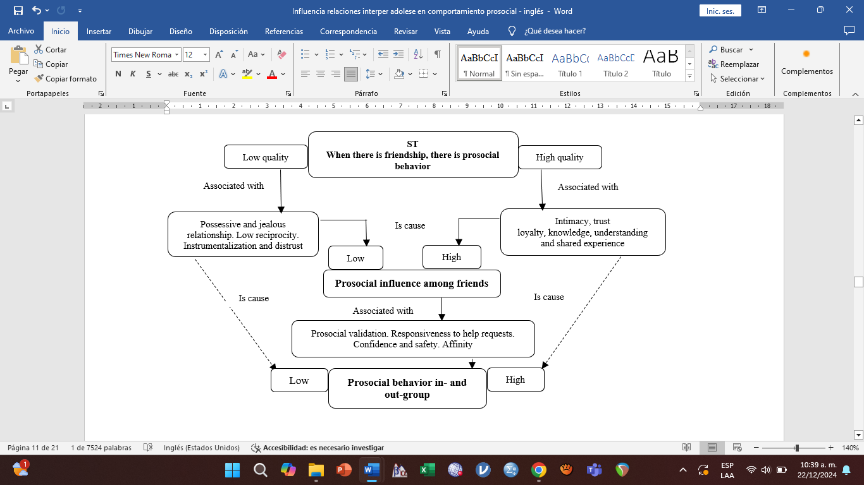
Selective coding: Adolescents´ relationships and prosocial behavior
In adolescent interactions prosocial behavior occurs to the extent that social, personal, and interactional conditions are present that to not harm the integrity and personal identity, self-esteem, and self-concept of both the benefactor and the beneficiary of the help. In this process, adolescents evaluate the degree of existing trust and safety: the benefactor needs to trust the beneficiary, considerer them honest, and in need of help. They also need to feel in the social environment and trust in their own abilities. Meanwhile, the beneficiary need to feel secure and trust the benefactor to communicate the problem and ask for help. They also need to feel secure in the social environment, recognize they have a problem, and need help. Thus, when personal, social, and interactional conditions are favorably assessed, prosocial behavior is more likely to occur. Evaluating the relational dimension -the quality of the benefactor-beneficiary relationship- can mitigate the influence of a negative assessment of personal and social dimensions on prosocial behavior (Figure 4).
Figure 4.
Selective coding: Adolescents´ relationships and prosocial behavior.
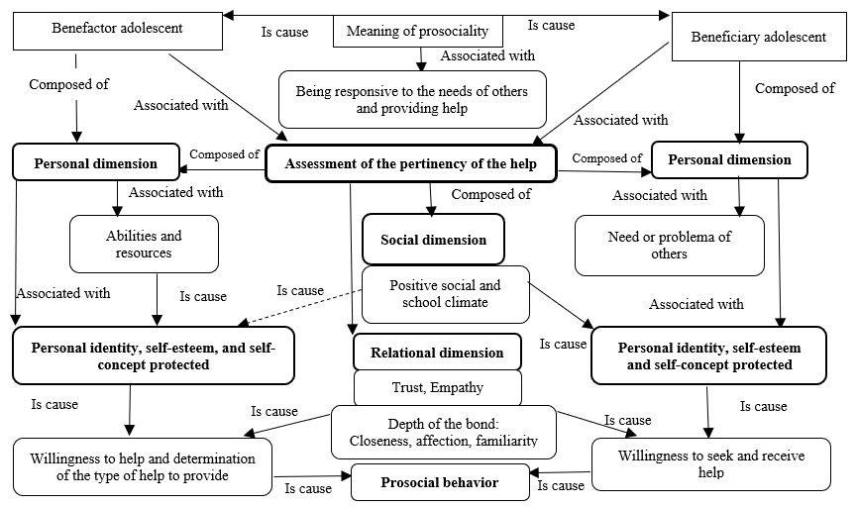
Discussion
This study aimed to describe and interpret the STs of a group of Chilean secondary school students regarding the relationship among adolescent social interactions and adolescent prosocial behavior. The study identified STs that describe the interactional conditions that promote and inhibit adolescent prosocial behavior within their peer group, and qualitative models were developed to explain how this behavior emerges from these conditions. The findings confirm the importance of prosocial behavior during this developmental period and the fundamental role that adolescent peers play in its development (Crone & Achterberg, 2022). Overall, based on the results of this study, adolescents establish a variety of interpersonal relationships with their peers that act as either promoters or inhibitors of the prosocial behavior. They also understand, interpret, make decisions, and guide their prosocial behavior based on the STs developed in this context (Author1, 2020).
The first specific objective of this study aimed to describe the social relationships among adolescents that promote and inhibit prosocial behavior during this age period, from the students' Sts. It was found that knowing and understanding peers, in addition to establishing a positive relation with them, promotes prosocial behavior. Other studies have provided similar evidence. For example, Su and Wang (2022) have linked greater adolescent prosociality with the need for connection among adolescents. In addition, Alvarado et al. (2019) reported a greater persistence of prosocial behavior in response to a socio-natural disaster when young volunteers know each other and have positive relationships. These results also demonstrate a complex information processing when adolescents offer help to others. They use a ST that allows them to evaluate the appropriateness of responding prosocially. This finding has also been reported in previous studies of STs and prosocial behavior, particularly in emergency situations. González-Palta et al. (2021) found that the readiness to help in emergencies occurs only when individuals present arguments in their STs that serve as indicators of an optimal personal and familial condition for helping others. These results are replicated in the study by Alvarado et al. (2019) on STs in volunteers during socio-natural disasters. In the case of adolescents, this can be explained by their frequent self-evaluation of performance and the assessment by peers of others' behavior, especially when responding prosocially may involve social costs.
Also, inhibitory STs for prosocial behavior were found in adolescent interactions. A peer group with negative norms and behaviors, social apathy, and a limited socioemotional skills for helping peers are inhibitors of prosocial behavior. These findings align with previous studies that have identified limitations on prosocial behavior. For example, low emotional support within a group (Cui et al., 2020), social rejection and socially deviant behaviors (Zhu et al., 2020) are noted. Regarding prosocial apathy, it has been described as a lack of motivation to help others, a risky factor especially during adolescence, and more frequent when prosocial behavior involves high costs (Hewitt et al., 2023). Additionally, appropriate development of social skills is necessary (Beffe & Waitling, 2023). The results of this study indicate that shame, pride, insecurity, and low assertiveness in both the benefactor and the beneficiary are significant inhibitors of prosocial behavior. Adolescents prefer to avoid assuming the role of benefactor due to the fear of making mistakes. González-Palta et al. (2021) also found STs that identify shame and pride as inhibitors of help-seeking behavior during socio-natural disasters.
An axial model of adolescent interactions and their relationship with prosocial behavior was developed. Trust in peer relationships is fundamental in deciding whether or not to engage in prosocial behavior and depends on a positive evaluation of the individual, contextual, and relational dimension in which the need for help arises. When the evaluation is positive, prosocial behavior is more likely to occur. This model contributes to the sociocognitive theory of prosocial behavior (Rubio et al., 2022) and highlights the complex multidimensional processing of information in adolescents as a key factor for engaging in prosocial behavior.
The second specific objective aimed to describe the peer relationships in school that promote and inhibit adolescent prosociality, from the students' STs. Factors that promote prosocial behavior include the organization of help within the educational context; the credibility of peers who influence others to help; awareness of school-related issues to empathize with them; and positive bonds between students. Conversely, inhibiting factors include prejudices toward peers due to a lack of knowledge about each other's lives; lack of mental resilience in the face of another student's pain; absence of meaning attributed to prosocial behavior; and negative school climates. These findings are particularly relevant in the field of prosocial behavior research in educational contexts, given the limited scientific attention that has been devoted to prosociality in schools (Hammond et al., 2023).
While the literature indicates that schools are environments where opportunities to exhibit and learn about prosocial behaviors are provided daily (Hammond et al., 2023), the STs of the adolescents in this study present specific arguments that can initiate or inhibit prosocial behaviors in this context. Establishing school mechanisms to create conditions that favor prosocial behavior and mitigate those that inhibit it could be considered part of socio-emotional education and coexistence plans in schools. In a STs study on the teaching and learning of prosociality in a Christian community (Author1 et al., 2019), findings similar to those of this study were reported. For prosocial behaviors to occur, a close, affectionate social climate is necessary, where it is deemed essential to connect with others, as they need help to achieve salvation.
In the axial model developed in this research, based on the characteristics of the school climate, students assess whether it is safe for their personal integrity to behave prosocially with their peers. Positive school climates present conditions that favor prosocial behavior, while negative school climates inhibit prosociality because they constitute an unsafe and dangerous social environment.
The third objective was to describe the relationship between adolescent friendships and the production of prosocial behavior, based on the students' STs. A ST was found that integrates prosocial behavior as part of what is defined as friendship. The literature has defined friendship as a positive (Di Norcia et al., 2022) or negative (Schwartz-Mette et al., 2020) bond. From the STs of the study participants, prosocial behavior is considered an inherent attribute of quality friendships. It was also found that typical prosocial behaviors among friends include maintaining constant concern for each other, providing material help, offering emotional support, disciplining, advising against negative behaviors, and even protecting friends from danger and violence. Conversely, the qualitative study by Bergin et al. (2003) described the meaning of a negative friendship for adolescents. The concept of false friendship was proposed to refer to those who intentionally involve others in conflicts and fights for amusement, defining this behavior as selfish.
In line with the above, another ST found explains that higher quality friendships lead to greater prosocial behavior in adolescents. The ST describes that a high-quality friendship considers intimacy, trust, loyalty, understanding, and shared experiences. Conversely, a "bad friendship" inhibits prosocial behavior and involves a lack of reciprocity, the exploitation of the friend's kindness, and loyalty understood as a possessive and jealous bond that prohibits helping other adolescents. A similar result was found by Bayar et al. (2020). These authors have indicated that intrinsic prosocial motivation increases in positive interactional contexts, such as a quality friendship, while it decreases when the adolescent is part of groups with negative behaviors.
Finally, the manner in which adolescents explain prosocial influence among friends was identified, with several criteria being noted: closeness and affinity, as these facilitate the validation of prosocial behaviors within and outside the group; receptivity to requests for help; and having a safe space within the group of friends. To date, the literature has identified mechanisms of adolescent prosocial influence such as belonging to a prosocial peer group (Farrel et al., 2017), integrating into a group with positive norms (Logis et al., 2013), receiving group approval for prosocial behavior (Crone & Achterberg, 2022), and the types of peer groups one integrates into, for example, a popular group (Rodríguez et al., 2022). The findings obtained complement the above and align with the importance attributed to positive friendship bonds, as they create an interactional context in which adolescents feel safe, sympathize due to affinity, and dare to be prosocial because of greater intimate acceptance (Cuadros & Berger, 2016). Additionally, Heathwood (2014) has pointed out that people possess TS that associate subjective well-being with having friends, a psychological state that could be ideal for adolescents to develop confidence and security when fostering socio-emotional competencies such as prosociality.
In the developed axial model, higher quality friendship within a peer group implies intimacy, trust, loyalty, understanding, and shared experiences; whereas lower quality friendship generates a possessive, distrustful, and exploitative environment. The prosocial influence among friends depends on this type of interactional context, which involves approval of prosocial behaviors, receptivity to requests for help, and a safe group to practice prosocial behaviors.
The final objective was to propose a comprehensive qualitative model that explains adolescent prosocial behavior, based on adolescent interactions with their peers and the identified ST. The selective model offers a comprehensive theory that understands adolescent prosocial behavior through interpersonal relationships with peers, grounded in complex multidimensional information processing. Adolescents find themselves in an interactional context, assuming the roles of benefactor and beneficiary, by: a) self-assessing their abilities and resources, b) evaluating the social context, and c) considering the relationship with the beneficiary of the help. Based on a metacognitive process of evaluating these three psychosocial levels, they determine the relevance of the help, focusing on the protection of their personal integrity and identity. When adolescents conclude that their prosocial behavior will benefit a peer and will not harm their own integrity and identity, the prosocial behavior will be enacted.
This comprehensive model contributes to the social theories (Labroo et al., 2023) -particularly regarding the effect of contextual factors on adolescent relationships- and cognitive theories of prosocial behavior (Rubio et al., 2022), emphasizing information processing, rational decision-making, and adolescents' mentalization capacities. It is an integrative model that demonstrates how adolescents, likely due to the cognitive development occurring during this period, process personal, social, and relational information to anticipate the impact of prosocial behavior on themselves and others.
A limitation of this study is that the sample consists of students from subsidized private high schools. Future studies could expand the sample to include public school populations.
Finally, it is important to note that further qualitative studies are needed to contribute to the understanding of this positive behavior through the experiences and beliefs of individuals. The subjective explanations and justifications for this behavior provide valuable knowledge for adolescents in deciding whether or not to engage in prosocial behavior within social groups.
References
Alvarado, R., Pradenas, C., Yáñez, N., Cuadra, D., & Sandoval, J. (2019). Teorías subjetivas del comportamiento prosocial: significados, desarrollo y motivaciones de jóvenes voluntarios ante un desastre socionatural. Liberabit, 25(2), 251-266. https://doi.org/https://doi.org/10.24265/liberabit.2019.v25n2.08
Bayar, Y., Sayıl, M., & Kındap, Y. (2020). The relationship of autonomous motivation to prosocial behavior: Mediator role of prosocial friends and friendship quality among Turkish adolescents. Research on Education and Psychology, 4(1), 98-113. http://dergipark.org.tr/rep
BBC Mundo (03 de mayo de 2023). Detienen a un menor de 13 años por ataque en una escuela en Serbia en el que murieron al menos 8 alumnos y un guardia. https://www.bbc.com/mundo/noticias-internacional-65472186
BBC News Mundo (24 de abril de 2019). 5 adolescentes que están cambiando el mundo. https://www.bbc.com/mundo/noticias-48037692
Beffe, J., & Watling, J. (2023). Understanding children's prosocial behavior and classroom affiliative relationships: A social network analysis. Infant and Child Develoment, 32(6), 1-17. https://doi.org/10.1002/icd.2469
Bergin, C., Talley, S., & Lynne, L. (2003). Prosocial behaviors of young adolescents: a focus group study. Journal of Adolescence, 26(1), 13-32.
Berman, J. Z., Barasch, A., Levine, E. E., & Small, D. A. (2018). Impediments to effective altruism: The role of subjective preferences in charitable giving. Psychological Science, 29(5), 834-844. https://doi.org/10.1177/0956797617747648
Bowker, J., & Weingarten, J. (2022). Temporal approaches to the study of friendship: Understanding the developmental significance of friendship change during childhood and adolescence. Advances in Child Development and Behavior, 63, 249-272. https://doi.org/10.1016/bs.acdb.2022.04.005
Busching, R., & Krahé, B. (2020). With a little help from their peers: The impact of classmates on adolescents’ development of prosocial behavior. Journal of Youth and Adolescence, 49(9), 1849-1863. https://doi.org/10.1007/s10964-020-01260-8
Caprara, G. V., Steca, P., Zelli, A., & Capanna, C. (2005). A new scale for measuring adults' prosocialness. European Journal of Psychological Assessment, 21(2), 77-89. https://doi.org/10.1027/1015-5759.21.2.77
Carlo, G., & Padilla-Walker, L. (2020). Adolescents’ prosocial behaviors through a multidimensional and multicultural lens. Child Development Perspectives, 14(4), 265-272. https://doi.org/10.1111/cdep.12391
Carlo, G., Crockett, L., Wilkinson, J., & Beal, S. (2011). The longitudinal relationships between rural adolescents’ prosocial behaviors and young adult substance use. Journal of Youth and Adolescence, 40(9), 1192-1202. https://doi.org/10.1007/s10964-010-9588-4
Catalán, J. (2021). Análisis de investigación educacional cualitativa. Aprendiendo a usar y generar conocimiento. Editorial Universidad de La Serena.
CIOMS, OMS & OPS (2016). Pautas éticas internacionales para la investigación relacionada con la salud con seres humanos. https://cioms.ch/wp-content/uploads/2017/12/CIOMS-EthicalGuideline_SP_INTERIOR-FINAL.pdf
Crone, E., & Achterberg, M. (2022). Prosocial development in adolescence. Current Opinion in Psychology, 44, 220-225. https://doi.org/10.1016/j.copsyc.2021.09.020
Author 1 (2019).
Author1 (2020).
Cuadros, O., & Berger, C. (2016). The protective role of friendship quality on the wellbeing of adolescents victimized by peers. Journal of Youth and Adolescence, 45, 1877-1888. https://doi.org/10.1007/s10964-016-0504-4
Cui, L., Criss, M. M., Ratliff, E., Wu, Z., Houltberg, B. J., Silk, J. S., & Morris, A. (2020). Longitudinal links between maternal and peer emotion socialization and adolescent girls’ socioemotional adjustment. Developmental Psychology, 56(3), 595-607. https://doi.org/10.1037/dev0000861
Di Norcia, A., Bombi, A. S., Pinto, G., Mascaro, C., & Cannoni, E. (2022). Representation of friendship and aggressive behavior in primary school children. Frontiers in Psychology, 13, 1-10. http://doi.org/10.3389/fpsyg.2022.835672
Ellinge, J., Mess, F., Bachner, J., von Au, J., & Mall, C. (2023). Changes in social interaction, social relatedness, and friendships in education outside the classroom: A social network analysis. Frontiers in Psychology, 14, 1-12. https://doi.org/10.3389/fpsyg.2023.1031693
Farrell, A. D., Thompson, E. L., & Mehari, K. R. (2017). Dimensions of peer influences and their relationship to adolescents’ aggression, other problem behaviors and prosocial behavior. Journal of Youth and Adolescence, 46(6), 1351-1369. https://doi.org/10.1007/s10964-016-0601-4.
Flick, U. (2018). An introduction to qualitative research (6ta ed.). Sage.
Fuligni, A. J. (2019). The need to contribute during adolescence. Perspectives on Psychological Science, 14(3), 331-343. https://doi.org/10.1177/1745691618805437
Gerben, A., & Gert-Jan, L. (2022). Moving the self and others to do good: The emotional underpinnings of prosocial behavior. Current Opinion in Psychology, 44, 80-88. https://doi.org/10.1016/j.copsyc.2021.08.029
González-Palta, I., Castro-Carrasco, P. J., Cabrera, E., Jamet, P., & Leal-Soto, F. (2021). Generating subjective theories after a disaster: The role of personality. Revista Colombiana de Psicología, 30(2), 13-26. https://doi.org/10.15446/rcp.v30n2.79061
Hammond, S., Hill, R., & Edwards, V. (2023). Prosocial behavior in school contexts. In T. Malti & M. Davidov (eds.), The Cambridge Handbook of Prosociality: Development, Mechanisms, Promotion (442-458). Cambridge Handbooks in Psychology. Cambridge University Press.
Hashemi, N., Marzban, M., Sebar, B., & Harris, N. (2020). Religious identity and psychological well-being among middle-eastern migrants in Australia: the mediating role of perceived social support, social connectedness, and perceived discrimination. Psychology of Religion and Spirituality, 12, 475-486. http://doi.org/10.1037/rel0000287
Heathwood, C. (2014). Subjective theories of well-being. In B. Eggleston & D. E. Miller (eds.), The Cambridge Companion to Utilitarianism. Cambridge Companions to Philosophy (199-219). Cambridge University Press.
Hewitt, S., Habicht, J., Bowler, A., Lockwood, P., & Hauser, T. (2023). Probing apathy in children and adolescents with the apathy motivation index–child version. Behavior Research Methods, 36, 3982-3994. https://doi.org/10.3758/s13428-023-02184-4
IAAP & IUPsyS (2008). Universal Declaration of Ethical Principles for Psychologists. https://www.iupsys.net/about/governance/universal-declaration-of-ethical-principles-for-psychologists.html
ISP (1978). Resolución sobre la práctica psicológica y los derechos humanos. Revista Latinoamericana de Psicología, 10(2), 298-299. http://doi.org/10.333.23rlp10i2.298-299
ISP (2008a). Declaración de la Mesa Directiva de la SIP sobre Terapias de Conversión. https://archive.org/details/sip-2008a-declaracion-sobre-terapias-de-conversion
ISP (2008b). Consideraciones Éticas de la SIP. https://archive.org/details/sip-2008b-declaracion-sobre-principios-eticos
ISP (2014). Declaración de la SIP sobre Refugiados menores de edad en tránsito a los Estados Unidos. https://archive.org/details/sip-2014-declaracion-sobre-ninos-migrantes-en-centro-america
ISP (2016). Declaración de la SIP de apoyo a psicólogas y psicólogos colombianos que promueven los acuerdos de paz. https://archive.org/details/sip-2016-declaracion-apoyo-a-acuerdos-de-paz-en-colombia
ISP (2018). Position Statement of the Inter-American Psychological Society (SIP). https://archive.org/details/sip-2018-position-statement-on-immigration
ISP (2019). Declaración de la SIP sobre experticia de psicólogas y psicólogos en el campo de la salud mental y las ciencias del comportamiento. https://archive.org/details/sip-2019-declaracion-experticia-en-salud-mental
Labroo, A. A., Khan, U., & Su, S. J. (2023). Reconsidering prosocial behavior as intersocial: A literature review and a new perspective. Consumer Psychology Review, 6(1), 92-108. https://doi.org/10.1002/arcp.1088
Laursen, B., & Veenstra R. (2021). Toward understanding the functions of peer influence: A summary and synthesis of recent empirical research. Journal of Research on Adolescence, 31(4), 889-907. https://doi.org/10.1111/jora.12606
Logis, H. A., Rodkin, P. C., Gest, S. D., & Ahn H‐J. (2013). Popularity as an organizing factor of preadolescent friendship networks: Beyond prosocial and aggressive behavior. Journal of Research on Adolescence, 23(3), 413-423. https://doi.org/10.1111/jora.12033
Mesurado, B., Resett, S., Oñate, M., & Vanney, C. (2022). “Hero,” a virtual program for promoting prosocial behaviors toward strangers and empathy among adolescents: A cluster randomized trial. Journal of Social and Personal Relationships, 39(9) 1-17. https://doi.org/10.1177/02654075221083227
Miller, S. A. (1988). Parents’ beliefs about children’s cognitive development. Child Development, 59, 259-285.
Padilla-Walker, L. M., Memmott-Elison, M. K., & Nielson, M. G. (2018). Longitudinal change in high-cost prosocial behaviors of defending and including during the transition to adulthood. Journal of Youth and Adolescence, 47, 1853-1865. https://doi.org/10.1007/s10964-018-0875-9
Pfattheicher, S., Asbjørn, Y., & Thielmann, I. (2022). Prosocial behavior and altruism: A review of concepts and definitions. Current Opinion in Psychology, 44, 1-14. http://doi.org/10.1016/j.copsyc.2021.08.021
Reisenauer, C. (2009). Subjektive theorien über die entwicklung der sozialen kompetenzen von vorschulkindern (Diplomarbeit Magistra der Naturwissenschaften). Universität Wien.
Rodríguez, L. M., Moreno, J. E., Hess, C. D., Ghiglione, M. E., & Mesurado, B. (2022). Calidad de la amistad en adolescentes: Evaluación en población argentina. Revista Evaluar, 22(1), 28-42. https://doi.org/10.35670/1667-4545.v22.n1.37415
Rubio, F., Neira, C., Villacura-Herrera, C., & Castillo, R. (2022). First and second-order theory of mind as predictors of cooperative behaviors in preschool and school children. Psykhe, 31(SI1), 1-15. https://doi.org/10.7764/psykhe.2021.36317
Schwartz-Mette, R. A., Shankman, J., Dueweke, A. R., Borowski, S., & Rose, A. J. (2020). Relations of friendship experiences with depressive symptoms and loneliness in childhood and adolescence: A meta-analytic review. Psychological Bulletin, 146(8), 664–700. https://doi.org/10.1037/bul0000239
Stake, R.E. (2010). Investigación con estudio de casos. Morata
Strauss, A., & Corbin, J. (2002). Bases de la investigación cualitativa. Técnicas y procedimientos para desarrollar la teoría fundamentada. Editorial Universidad de Antioquia.
Su, N., & Wang, H-P. (2022). The influence of students’ sense of social connectedness on prosocial behavior in higher education institutions in Guangxi, China: A perspective of perceived teachers’ character teaching behavior and social support. Frontiers in Psychology, 13, 1-14. http://doi.org/10.3389/fpsyg.2022.1029315
Wagemaker, E., van Hoorn, J., & Bexkens, A. (2022). Susceptibility to peer influence on prosocial behavior in adolescents with mild intellectual disability or borderline intellectual functioning. Research in Developmental Disabilities, 120(104143), 1-12. https://doi.org/10.1016/j.ridd.2021.104143
Wong, W. (2023). Editorial: Prosocial and antisocial behavior and personality. Frontiers in Psychology, 14, 1-2. https://doi.org/10.3389/fpsyg.2023.1285957
Zhu, N., Lu, H. J., & Chang, L. (2020). Effects of peer influences and life-history strategy on chinese junior high school students’ prosocial and antisocial behaviors. Frontiers in Education, 5(593744), 1-8. https://doi.org/10.3389/feduc.2020.593744

Received:
Accepted:

