Exploring the Relationship between Imagining of the Future, Belief in a Just World, and Belief in God: Age-Related Specificities

Abstract
The study of the associations between the Imagining of the Future, Belief in a Just World, and Belief in God provides valuable insights into human nature and spirituality. Research in this area can significantly enhance contemporary understanding of the sociocultural processes shaping society. The aim of this study was to examine the relationships between future-oriented Imagining, Belief in a Just World, and Belief in God across different age groups. The sample consisted of 398 participants aged between 19 and 65 years (M = 35.1; SD = 15.3). The "youth" group included 218 individuals aged 19–25 (M = 21.7; SD = 1.9), while the "adults" group comprised 180 individuals aged 40–65 (M = 51.3; SD = 5.8). The results revealed age-specific patterns in the associations between Imagining of the Future, Belief in a Just World, and Belief in God. Belief in a Just World was significantly influenced by Near-Future Imagining, particularly those related to Morality and Health reflecting expectations of advancements in medicine and spiritual-moral development. However, no direct associations were found between Belief in a Just World d and near-future imagery. This may suggest that, at the current stage of societal development, Near-Future Imagining do not reflect Belief in a Just World. Belief in God was most strongly associated with the Morality factor, interpreted as an anticipated improvement in moral values in the future.

Keywords: Imagining, Future, young people, adults people, Personal Belief in Just World Belief in God.

Explorer la relation entre l’imagination du futur, la croyance en un monde juste et la croyance en Dieu : spécificités liées à l’âge
Résumé
L’étude des liens entre l’imagination du futur, la croyance en un monde juste et la croyance en Dieu offre un éclairage précieux sur la nature humaine et la spiritualité. Les recherches dans ce domaine peuvent contribuer de manière significative à la compréhension contemporaine des processus socioculturels qui façonnent la société. Cette étude avait pour objectif d’examiner les relations entre l’imagination tournée vers le futur, la croyance en un monde juste et la croyance en Dieu chez différents groupes d’âge. L’échantillon comprenait 398 participants âgés de 19 à 65 ans (M = 35,1 ; ÉT = 15,3). Le groupe des « jeunes » comprenait 218 individus âgés de 19 à 25 ans (M = 21,7 ; ÉT = 1,9), tandis que le groupe des « adultes » était composé de 180 individus âgés de 40 à 65 ans (M = 51,3 ; ÉT = 5,8). Les résultats ont révélé des schémas spécifiques à l’âge dans les associations entre l’imagination du futur, la croyance en un monde juste et la croyance en Dieu. La croyance en un monde juste était significativement influencée par l’imagination du futur proche, en particulier dans les domaines de la moralité et de la santé, reflétant des attentes d’avancées médicales et de développement spirituel et moral. Toutefois, aucune association directe n’a été observée entre la croyance en un monde juste et les représentations du futur proche. Cela pourrait indiquer qu’à ce stade du développement sociétal, l’imagination du futur proche ne reflète pas nécessairement la croyance en un monde juste. La croyance en Dieu était fortement associée au facteur de la moralité, interprété comme une attente d’amélioration des valeurs morales dans le futur.
Mots-clés : imagination, avenir, jeunes, adultes, croyance personnelle en un monde juste, croyance en Dieu

Theoretical Framework
Introduction
The Imagining of the Future is not merely an individual act of fantasizing, but a socially constructed phenomenon shaped by culture, history, social interactions, and collective narratives. It is a product of collective activity. There exist shared imagining of the future that are held by members of specific groups or societies. Language plays a particularly important role in shaping future imagination, as it serves as a tool for constructing meanings and imagining of the future (Goñi, Raveau, & Bravo, 2024).
The Imagining of the Future at the individual level is a fundamental human capacity that occupies a significant portion of waking thought and has a substantial impact on personal well-being (Schubert et al., 2020).
The process of Imagining of the Future can elicit both positive and negative images. For instance, research by Rubin (2013) demonstrates that when individuals reflect on society as a whole—and especially on the future of the world—these images tend to be considerably more pessimistic, with themes of decline and negative development being mentioned or selected far more frequently (Rubin, 2013).
Future images are mental models constructed based on one’s understanding of the past and present, value systems, as well as knowledge, expectations, fears, and hopes regarding what lies ahead (Rubin, 2013; Nikula et al., 2020). These imagining of the future can be created both by individuals and by groups (Nikula et al., 2020).
Collective imagination of the future is a complex form of human activity that is inherently narrative in nature and encompasses political, psychological, and cultural dimensions (Nikula et al., 2020).
Future images may be associated with socio-psychological characteristics that shape and influence individuals’ perceptions of what should or should not happen in the future. These images of the future can be linked to the belief in a just world—the conviction that good things happen to good people and that everyone ultimately gets what they deserve—which can serve as a psychological buffer against feelings of helplessness. Such belief helps individuals cope with perceived injustices, maintain inner balance, and sustain hope. Belief in God often functions as a source of support and hope, helping individuals find meaning in adversity and cope with stress. In this way, it contributes to psychological adaptation and well-being.

The Relationship between Imagining of the Future and Belief in a Just World
Belief in a just world (PBW) refers to the conviction that people generally get what they deserve—that bad individuals will be punished and good individuals will be rewarded. This concept, originating in social psychology, was first introduced by Melvin Lerner in the 1960s (Lerner, 1980).
PBW is closely linked to how individuals construct their imagining of the future and contextualize their expectations and goals. It influences both the personal imagination of one’s own future and the broader perception of social events and justice (Lerner, 1980).
According to the concept of PBW, individuals need to believe that the world is just and predictable in order to maintain psychological comfort. This belief allows people to perceive the world as more controllable and stable, thereby fostering positive expectations about the future (Lerner, 1980).
Lerner argues that PBW functions as a cognitive defense mechanism that helps individuals cope with the anxiety stemming from the realization that the world can be unpredictable and unjust. Through this lens, people make decisions and interpret their life experiences: “Good things should happen to good people, and bad people should suffer the consequences of their actions” (Lerner, 1980).
PBW helps individuals maintain long-term goals and sustain motivation by reinforcing the belief that their efforts will ultimately be rewarded. Individuals with a strong belief in a just world tend to hold optimistic expectations about their future outcomes, particularly when they perceive themselves as “good” and morally upright people.
Self-awareness and PBW may be closely intertwined, shaping personal imagining of the future. People with strong beliefs in justice are more likely to believe that if they work hard and behave ethically, their efforts will be rewarded in the future. This reflects an organized and predictable perception of the future (Hafer & Bègue, 2005).
In a certain sense, the belief in a just world (PBW) can be linked to the concept of karma—a culturally embedded idea that actions directly influence future outcomes, both positively and negatively.
PBW allows individuals to look toward the future with confidence. The belief that appropriate actions will lead to fair outcomes helps people navigate life’s challenges and cope with stressful events. Those who hold this belief tend to view the future in a more positive light, experiencing a greater sense of control over their fate and anticipated outcomes (Dalbert, 2001).
PBW also guides individuals in social interactions and may help reduce the tendency to make negative predictions about the future.
Belief in a just world can be seen as an adaptive psychological mechanism through which people manage uncertainty and anxiety. It supports psychological resilience, particularly during times of crisis (Hafer & Bègue, 2005).
PBW helps to reduce cognitive dissonance and avoid feelings of external control. Individuals tend to predict that positive actions will lead to positive future outcomes, which lowers stress associated with uncertainty. PBW encourages adherence to social and moral norms, as individuals believe that conforming to these standards will ensure a future aligned with such values (Hafer & Bègue, 2005).
PBW plays a significant role in shaping future imagery. It helps maintain psychological comfort, motivates individuals to pursue long-term goals, and enhances the sense of control over one’s destiny. Moreover, PBW contributes to the formation of a temporal and causal framework through which the future is expected to justly reward or punish individuals based on their present actions.
Beliefs about justice, such as the belief in a just world (PBW), can serve as an important personal resource (Dalbert, 1999; Lipkus, Dalbert, & Siegler, 1996). Many individuals also hold the belief that life progressively improves over time—an outlook that represents a key dimension of temporal self-evaluation (Wilson & Shanahan, 2019).
Thus, personal belief in a just world and future imagery are mutually reinforcing constructs. PBW may serve as a foundation for developing positive expectations and motivation, while the envisioned future, in turn, reinforces these beliefs by helping individuals visualize their goals and aspirations more clearly.

The Relationship between Imagining of the Future and Belief in God
The study of the relationship between belief in God and future imagery represents a compelling area of interdisciplinary inquiry, bridging psychology, sociology, and religious studies. Belief in God can influence how individuals think about the future—including their expectations, hopes, and fears. These influences are closely tied to questions of meaning in life, hope for an afterlife, or notions of divine providence.
Belief in God often serves as a powerful source of motivation, fostering the development of a positive imagination of the future. Religious beliefs can shape perceptions of desirable outcomes by encouraging followers to think in terms of future rewards—both in this life and in the afterlife. This, in turn, may enhance self-regulatory capacities by enabling individuals to manage impulses and delay gratification in pursuit of more meaningful, long-term goals (McCullough & Willoughby, 2009).
Imagining the future is actively employed in religious practice—processes such as prayer and meditation can reinforce future-oriented imagining, fostering hope and anticipation of future blessings. Positive future imagery may also help individuals cope with adversity and stress by offering comfort in the belief that their efforts and suffering are meaningful and will ultimately be rewarded (McCullough & Willoughby, 2009).
Imagining the future and belief in God may be interconnected through the search for meaning and purpose in life, as discussed in Steger et al.’s (2006) Meaning in Life Questionnaire. Belief in God can serve as a significant source of meaning and direction, enabling individuals to form positive expectations about the future. Faith in a higher power or divine plan may help people manage life’s uncertainties by offering a framework of hope and trust in a better future (Steger et al., 2006).
On the other hand, the capacity to imagine the future may enhance spiritual exploration and religious conviction. Individuals who actively envision their hopes and dreams for the future may be more inclined to seek meaning in their experiences and actions. A sense of meaning is often connected to personal goals, and belief in God may inspire these goals and aspirations, adding depth and significance to their pursuit and attainment (Steger et al., 2006).
Imagining the future plays a vital role in human life, enabling individuals to form expectations, set goals, and regulate their emotional experiences. Belief in God can serve as a source of hope, alleviating fears and uncertainties related to the future. When people believe in a higher power, they may feel reassured that, even in the face of adversity, their life holds deeper meaning. Such faith can support psychological well-being and provide inner peace during difficult times (Pargament, 1997).
In the context of coping, belief in God can function as a psychological mechanism through which individuals manage adversity. For example, when faced with situations beyond their control, people may turn to prayer, spiritual practices, or support from a religious community. These practices not only assist in navigating moments of crisis but also help individuals visualize a positive future grounded in hope and faith (Pargament, 1997).
Belief in God may also shape the way individuals imagine their future by promoting positive thinking and the development of life goals aligned with spiritual values. As a result, individuals with strong faith may perceive the future with greater optimism and make more deliberate decisions guided by moral and ethical principles they view as divinely inspired (Pargament, 1997).
Imagining the Future encompasses an individual's ability to envision and plan their life, and belief in God can significantly influence how this future is perceived and organized. Belief in God often serves as a source of hope and confidence regarding what lies ahead. Individuals who believe in a higher power frequently report feeling protected and guided by clear moral principles, which contributes to the formation of more positive expectations about their lives. This effect is partly due to the role of religious beliefs in enhancing emotional well-being and reducing stress, both of which support an individual’s capacity to generate optimistic future projections (Koenig, McCullough, & Larson, 2001).
The process of imagining the future is closely linked to how individuals perceive and interpret life events. Religious concepts such as fate, divine providence, or the possibility of redemption can alter how people understand and respond to life’s challenges, enabling more adaptive coping. This perspective may improve overall quality of life, including both physical and mental health outcomes (Koenig, McCullough, & Larson, 2001).
Moreover, religious belief may motivate individuals to engage in proactive behaviors aimed at improving both their own lives and the lives of others. Acts of service, altruism, and participation in religious communities can contribute to more constructive imagining of the future and foster active engagement in its realization (Koenig, McCullough, & Larson, 2001).
It is also important to note that differences in religious perspectives may influence future-oriented thinking in diverse ways. For some individuals, strict adherence to religious dogma may constrain their mental horizons, while for others, it may serve as a source of inspiration and creative freedom (Koenig, McCullough, & Larson, 2001).
Imagining the Future, typically associated with expectations and dreams, may be deeply rooted in religious faith. Such faith can provide a framework for interpreting and perceiving the future as something meaningful and purposeful, rather than a series of random or arbitrary events (Carrette & King, 2005).
Thus, the relationship between Imagining the Future and belief in God can be multifaceted. Religion may foster the development of values and ideals that guide the imagination and shape how individuals envision their future. In turn, Imagining the Future may reinforce religious faith by encouraging individuals to adhere to their beliefs and by fostering a sense of the presence of a higher power that supports them through difficult times.
This reciprocal relationship creates a complex context in which faith and Imagining the Future continuously intersect and co-construct one another. Their interaction contributes to the development of a deeply personal sense of meaning in life, where future expectations and spiritual beliefs intertwine to form a foundation for psychological well-being and life satisfaction.
The connection between Imagining the Future and belief in God is reflected through hope, interpretation of life events, and active engagement in community life. These factors jointly influence individuals’ overall life satisfaction and health. This relationship is significant not only for understanding individual coping mechanisms but also for the formation of personal goals and the construction of life meaning.
Conclusions:
As the analysis of the constructs of Belief in a Just World and Belief in God has demonstrated, both are closely connected to Imagining the Future. Belief in a Just World serves as a psychological foundation for the development of positive expectations and motivation, while imagining the future reinforces this belief by helping individuals to envision their goals and aspirations with greater clarity.
Similarly, Belief in God and religious faith can contribute to the development of values and ideals that shape the imagination of the future. In turn, Imagining the Future may strengthen religious beliefs by encouraging individuals to adhere to their convictions and by fostering a sense of the presence of a higher power that provides support during challenging times. The relationship between Imagining the Future and belief in God is reflected in hope, the interpretation of life events, and active engagement in community and social life.

Method
Participants
The study included a total of 398 participants ranging in age from 19 to 65 years (M = 35.1, SD = 15.3), comprising 225 women and 173 men.
Two distinct age groups were identified:
- Youth group: 218 participants aged between 19 and 25 years (M = 21.7, SD = 1.9), including 115 women and 103 men.
- Adults group: 180 participants aged between 40 and 65 years (M = 51.3, SD = 5.8), including 110 women and 70 men.

Measures
Imagining of the Future. The Imagining of the Future questionnaire developed by T. Murashko, A. Ruzha, and A. Kolesov (Murashko et al., 2025) was used in the present study. The Imagining of the Future questionnaire consists of 50 items, including 25 positive and 25 negative future-oriented statements. Each item pair comprises two opposing statements—one reflecting a positive future and the other a negative future. Future orientation was assessed in two temporal dimensions: the near future, referring to events expected to occur within the respondent’s lifetime, and the distant future, referring to a broader, more global or long-term perspective. Responses were rated using a 4-point Likert scale ranging from 0 (It will never happen) to 3 (Yes, it will happen), with intermediate options being 1 (Rather no than yes) and 2 (Rather yes than no).
The scoring procedure follows a predefined key. For each thematic scale of the Imagining of the Future questionnaire, a score is calculated by subtracting the negative item score from the corresponding positive item score. These difference scores are then summed within each of the five thematic domains: Health, Statehood, Morality, Individuality, and Sociality, preserving their sign.
The overall score for each thematic scale ranges from –15 to +15 points. The total score for the Imagining of the Future questionnaire is obtained by summing all five scales, with a possible range from –75 to +75. A positive total score reflects a predominantly positive future imagination, whereas a negative total score indicates a predominantly negative view of the future.
The Health factor in both the near and distant future encompasses imaginings related to life expectancy, the effectiveness of medical care, the emergence of new diseases, access to quality of life, and attitudes toward nutrition.
On the positive end of the spectrum, individuals envision an increase in life expectancy, advances in medical effectiveness, and the elimination of many currently incurable diseases. A high quality of life is expected to become universally accessible. Nutritional standards are imagined to improve through the development of energy-efficient, high-quality, and palatable food products enabled by new technologies.
Conversely, on the negative end, respondents anticipate a decrease in life expectancy, a decline in the effectiveness of medical treatments, and the emergence of numerous new, difficult-to-treat diseases. High quality of life is imagined to be accessible only to a small, affluent minority. Nutritional conditions are expected to worsen, with quality food becoming increasingly scarce and less accessible.
The Statehood factor, as it pertains to both the near and distant future, reflects individuals’ imaginings concerning population distribution, the persistence or dissolution of state power, disparities between countries (social, economic, ideological, and political), national identity, and attitudes toward environmental issues.
On the positive end of the spectrum, the global population is expected to become more evenly distributed; centralized state power is envisioned to diminish or disappear; inter-country disparities—whether social, economic, ideological, or political—are anticipated to lessen. National identity is imagined as a valued and respected aspect of humanity, and ecological conditions are expected to improve.
On the negative end, population density is projected to intensify around major urban centers; state structures are expected to persist; social, economic, ideological, and political differences between nations are imagined to become more pronounced. National identity may be perceived with indifference, and environmental conditions are expected to deteriorate.
The Morality factor, assessed in both the near and distant future, encompasses individuals’ perceptions of moral values, the relevance of spiritual needs, attitudes toward collective well-being, self-awareness, and freedom.
On the positive pole, individuals are expected to become more morally oriented: a greater number of people will adhere to ideals such as goodness, justice, duty, and honor. Spiritual values and humanistic needs will be seen as central guiding principles. The pursuit of collective well-being—marked by cooperation and shared interests—will become a significant aspect of human life. Religious self-awareness will prevail, and individuals will generally experience a heightened sense of freedom in terms of self-expression and life choices.
On the negative pole, a decline in moral standards is anticipated: values such as goodness, justice, duty, and honor will lose their societal relevance. Spiritual needs and humanistic concerns will be perceived as unimportant. The pursuit of individual well-being will dominate, often at the expense of communal values. Scientific self-awareness will replace religious perspectives, and individuals will report feeling less free in expressing themselves and in choosing their life paths.
The Individuality factor, assessed in both the near and distant future, reflects imagined prospects regarding access to education, opportunities for professional fulfillment, financial well-being, attitudes toward family relationships, and overall perceptions of happiness.
On the positive pole, high-quality and well-rounded education will become increasingly accessible. Opportunities for professional self-realization will expand, and overall financial well-being is expected to improve. Family life will remain an important aspect of people's lives, and individuals will generally experience greater happiness, characterized by joy, positive thinking, and optimism.
On the negative pole, access to quality and diverse education will decline. Opportunities for professional development will become more limited, and people will experience lower levels of financial stability, making it more difficult to sustain a livelihood. The traditional family structure may diminish in importance or cease to exist altogether. Individuals are expected to report lower levels of happiness, with emotions such as despondency, depression, and disappointment becoming more prevalent.
The Sociality factor, assessed in both the near and distant future, encompasses individuals’ imagined perceptions of safety, social connectedness, societal stability, inequality, and the value placed on creativity.
On the positive pole, life on Earth is expected to become safer—both physically and economically—due to advancements in technology that reduce various risks. Individuals will experience greater social inclusion, characterized by increased emotional support, empathy, and kindness within society. Life will be perceived as more stable and predictable, social inequality will decline, and creativity, including engagement with various forms of art, will become more highly valued and widely practiced.
On the negative pole, life is anticipated to become more dangerous, with heightened physical and economic risks. People are expected to feel more socially isolated, with societal dynamics marked by indifference, fear of closeness, and growing distrust. Life will become less stable and more uncertain, social inequality will rise, and the societal demand for creativity and artistic expression will diminish.
The “Personal Belief in a Just World Scale” (PBW) developed by C. Dalbert (1999) was used to assess participants’ belief in personal justice. The scale consists of 7 items rated on a 6-point Likert scale. Total scores range from 7 to 42, with higher scores indicating a stronger personal belief in justice.
A high score reflects the perception that one generally deserves what happens in their life and believes that events and decisions affecting them are fair, with injustice being viewed as an exception. In contrast, a low score reflects the belief that one generally does not deserve what happens to them, perceives life events and decisions as unfair, and regards justice as an exception rather than the rule.
Belief in God. To assess religious belief, a brief questionnaire consisting of four items was developed for the present study. The first item asked participants to rate the extent to which they perceive themselves as believers in God on a scale from 0 ("Not at all") to 10 ("Very strongly"): “To what extent do you consider yourself a believer in God?”
The second item was a self-identification question: “Do you consider yourself a religious person?” Responses were rated on a 4-point scale: = “No,” 2 = “Rather no than yes,” 3 = “Rather yes than no,” 4 = “Yes.”
The third item assessed religious behavior: “Do you feel the need to attend religious services (e.g., go to church)?” Responses were rated on the same 4-point scale as above.
The fourth item measured observance of religious traditions: “Do you observe religious traditions and holidays?” Responses: 1 = “No,” 2 = “No, but I occasionally do,” 3 = “Mostly yes,” 4 = “Yes.”
Higher scores indicate a stronger self-perception of belief in God based on traditional religious practices and values. The total score can range from 3 to 24 points.
Since the obtained scale scores did not follow a normal distribution, Spearman’s rank-order correlation coefficient was used to assess the presence of statistically significant associations between variables.

Procedure
The study was conducted in Latvia in 2023 and employed two formats: online and group-based sessions involving 10 to 15 participants. The group-based format was administered to young adults at higher education institutions across Latvia. Each participant in the group format received a printed questionnaire. The older adult participants completed the survey online. This part of the sample included parents and relatives of the younger participants, representing the mature generation. Throughout the study, the principles of anonymity and confidentiality were strictly upheld.
The research received ethical approval from the Ethics Committee (Approval No. 4, dated December 16, 2024).

Results
Belief in a Just World and Near-Future Imagining in Youth and Adults
No significant effects of near-future factors on the Belief in a Just World were found in either the youth or adults groups.
In the youth group, a statistically significant correlation was observed between Belief in a Just World and the near-future factor Morality (rs = .149, p = .028). However, no regression models between these variables reached statistical significance.
In the adult group, a statistically significant correlation was also found between Belief in a Just World and the near-future factor Morality (rs = .162, p = .029). Similarly, no significant regression models were identified between these variables.
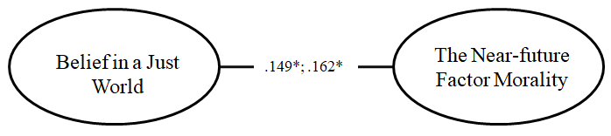
*p ≤ 0.05
Figure 1 Associations Between Belief in a Just World and Near-Future Imagining Factors in Both Groups

The higher the level of Belief in a Just World (BJW)—reflected in the conviction that individuals, overall, believe they deserve what happens to them and perceive events and important decisions in their lives as fair, with injustice seen as an exception—the more frequently individuals tend to orient toward a positive imagining of near-future Morality. Conversely, the lower the level of BJW—characterized by the belief that individuals do not deserve what happens to them, do not perceive fairness in life events and important decisions, and view justice as an exception—the more often individuals tend to orient toward a negative imagining of near-future Morality.
Thus, in the near future, both groups demonstrate a slight association between Belief in a Just World (BJW) and the imagining of the near future in the domain of Morality. However, in both groups, the observed correlations are of low statistical significance and small effect size, and therefore may be considered negligible. These findings warrant further, more in-depth investigation. Overall, no substantial associations between Belief in a Just World and imagining of the near future were identified in either group.

Belief in a Just World and Distant-Future Imagining in a Youth Sample
In the youth group, Belief in a Just World (BJW) was significantly associated with several factors of imagining the distant future: Sociality (rs = .200, p = .003; linear model F(1, 216) = 17.325, p < .001, R² = .074; effect size: small-to-moderate), Morality (rs = .207, p = .002; linear model F(1, 216) = 14.027, p < .001, R² = .061; effect size: small-to-moderate), Statehood (rs = .263, p < .001; linear model F(1, 216) = 12.471, p = .001, R² = .055; effect size: small-to-moderate), and Health (rs = .183, p = .007; linear model F(1, 216) = 10.576, p = .001, R² = .047; effect size: small).
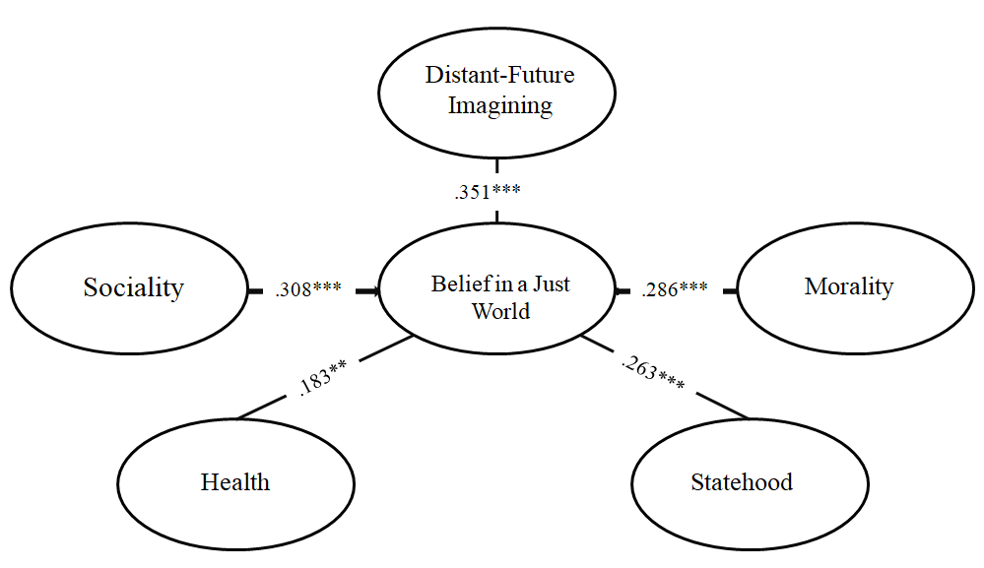 *p ≤ 0.05; **p ≤ 0.01; ***p ≤ 0.001
Figure 2. Associations Between Belief in a Just World and Distant-Future Imagining in the youth group
The higher the level of Personal Belief in a Just World, which reflects the extent to which young people generally believe that they deserve what happens to them and perceive life events and important personal decisions as fair—with injustice viewed as an exception—the more frequently they tend to demonstrate a positive Distant-Future Imagining in the domains of Sociality, Morality, Statehood, and Health. Conversely, the lower the level of Personal Belief in a Just World—indicating that young people tend to believe they do not deserve what happens to them and perceive important life events and decisions as unfair—the more frequently they demonstrate a negative Distant-Future Imagining Future in these same domains.
The contribution to sustaining Personal Belief in a Just World among young people is significantly accounted for by the Distant-Future Imagining variables Sociality (β₁ = .308, p < .001) and Morality (β₂ = .286, p < .001). This suggests that in order to strengthen young people's belief in a just world, improvements in their future-oriented imagining of social connectedness and moral development are necessary. The regression model, assessed via ANOVA, was highly significant: F(2, 217) = 19.662, p < .001.

Belief in a Just World and Distant-Future Imagining in a Sample of Adults
In the group of adults, belief in a just world was significantly associated with the Sociality factor of distant-future imagining (rs = .192, p = .010).

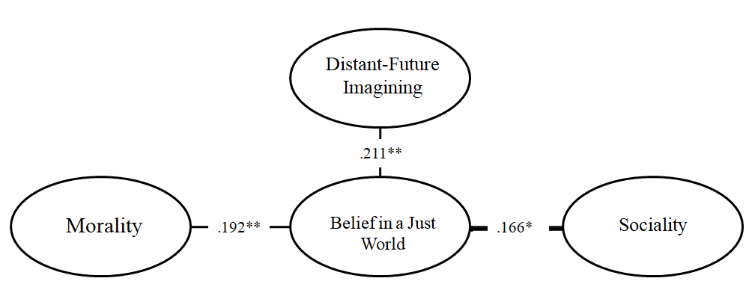
*p ≤ 0.05; **p ≤ 0.01; ***p ≤ 0.001
Figure 3. Associations between Belief in a Just World and Distant-Future Imagining in the group of adults

The higher the level of belief in a just world—expressed in the perception that individuals generally believe they deserve what happens to them, that they are treated fairly, that life events and important personal decisions are seen as just (with injustice viewed as an exception)—the more frequently they tend to engage in positive distant-future imagining related to Sociality.
Conversely, the lower the level of belief in a just world—reflected in the view that individuals generally believe they do not deserve what happens to them, that they are treated unfairly, that life events and important personal decisions are perceived as unjust (with justice being the exception)—the more likely they are to engage in negative distant-future imagining in the domain of Sociality.
The primary contribution to the maintenance of belief in a just world among adults is made by the Morality factor of distant-future imagining (β₁ = .166, p = .026). An increase in belief in a just world among this group requires a corresponding enhancement in distant-future imagining related to morality. The proposed model, tested using analysis of variance (ANOVA), was statistically significant: F(1, 179) = 5.055, p = .026.
Thus, in both groups, associations were identified between belief in a just world and the distant-future imagining domains of Morality and Sociality. In the youth group, significant associations were also found between belief in a just world and the distant-future imagining factors of Health and Statehood. This may be due to the fact that advancements in medicine and societal infrastructure are perceived by young people as moral benchmarks in the construction of a just world.
Overall, in both age groups, there is a consistent relationship between belief in a just world and Distant-Future Imagining.

Belief in God and Near-Future Imagining in a Youth Sample
Among young people, belief in God was significantly associated with several factors of near-future imagining. Specifically, it was positively correlated with the Morality factor (rs = .278, p < .001; linear model: F(1, 216) = 22.028, p < .001, R² = .093; medium-to-low effect size), the Health factor (rs = .210, p = .002; linear model: F(1, 216) = 7.581, p = .006, R² = .034; small effect size), and the Statehood factor (rs = .212, p = .002; linear model: F(1, 216) = 8.145, p = .005, R² = .036; small effect size). A significant correlation was also found with the Sociality factor (rs = .154, p = .023), although no regression models were identified for this dimension.

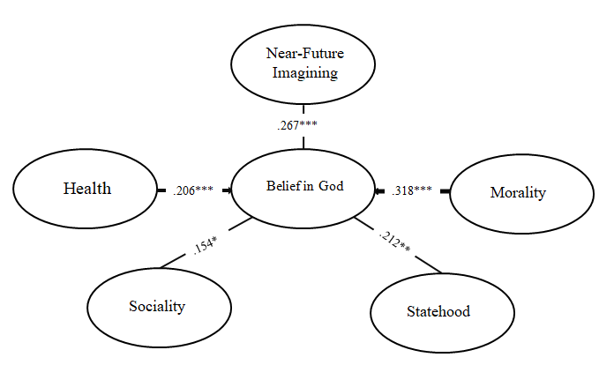
*p ≤ 0.05; **p ≤ 0.01; ***p ≤ 0.001
Figure 4. Associations between Belief in God and Near-Future Imagining in the youth group

Higher levels of Belief in God — characterized by young individuals identifying themselves as religious, regularly attending church, and observing religious traditions—are associated with more frequent positive near-future imagining in the domains of Morality, Health, Statehood, and Sociality.
Conversely, lower levels of Belief in God — reflected in young individuals identifying as non-religious, not attending church, and not practicing religious traditions — are linked to more frequent negative near-future imagining in the same domains.
The strongest contributions to the maintenance of Belief in God among youth were made by the near-future imagining factors of Morality (β₁ = .318, p < .001) and Health (β₂ = .206, p = .001). Increases in belief in God are associated with improvements in these dimensions of near-future imagining. The presented model, tested using analysis of variance (ANOVA), was highly significant: F(2, 217) = 16.729, p < .001.

Belief in God and Near-Future Imagining in Adult Sample
Belief in God among adults was significantly associated with the Morality factor of near-future imagining (rs = .192, p = .01; linear model: F(1, 178) = 19.771, p < .001, R² = .100; medium-to-low effect size).
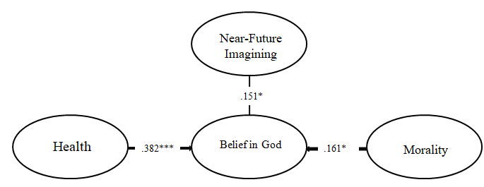
*p ≤ 0.05; **p ≤ 0.01; ***p ≤ 0.001
Figure 5. Associations between Belief in God and Near-Future Imagining in the group of adults

Higher levels of belief in God—reflected in adult individuals identifying themselves as religious, regularly attending church, and observing religious traditions—were associated with more frequent positive near-future imagining in the domain of Morality.
Conversely, lower levels of belief in God—reflected in individuals identifying as non-religious, not attending church, and not observing religious traditions—were associated with more frequent negative moral imagining of the near future.
The maintenance of belief in God among adults was significantly influenced by the near-future imagining factors of Morality (β₁ = .382, p < .001) and Health (β₂ = .161, p = .031). Increases in belief in God within this group are associated with improvements in these dimensions of near-future imagining. The model, tested using analysis of variance (ANOVA), was highly significant: F(2, 179) = 19.771, p < .001.
Thus, in both age groups, belief in God was influenced by near-future imagining related to Morality and Health.
In the youth group, additional associations were found with the near-future imagining domains of Sociality and Statehood.
Overall, in both groups, there is a consistent relationship between belief in God and near-future imagining.

Belief in God and Distant-Future Imagining in a Youth Sample
Belief in God among young people was significantly associated with several dimensions of distant-future imagining. The strongest correlation was observed with the Morality factor (rs = .456, p < .001; linear model: F(1, 216) = 69.52, p < .001, R² = .243; medium-to-large effect size). A weaker but still significant correlation was found with the Statehood factor (rs = .153, p = .024), although no significant regression model was identified for this dimension. Additionally, belief in God was significantly associated with the Individuality factor (rs = .144, p = .034; linear model: F(1, 216) = 6.061, p = .015, R² = .027; small effect size).

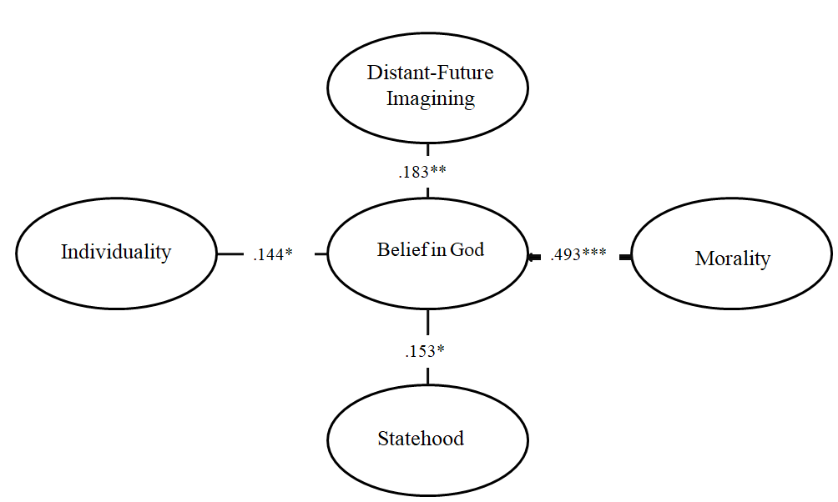
*p ≤ 0.05; **p ≤ 0.01; ***p ≤ 0.001
Figure 6. Associations Between Belief in God and Distant-Future Imagining in the youth group

Higher levels of belief in God—reflected in young individuals who identify as religious, regularly attend church, and observe religious traditions—are associated with more frequent positive distant-future imagining in the domains of Morality, Statehood, and Individuality.
Conversely, lower levels of belief in God—typical of individuals who consider themselves non-religious, do not attend church, and do not follow religious traditions—are linked to more frequent negative distant-future imagining in the same domains.
The primary contribution to the maintenance of belief in God among young people was made by the Morality factor of distant-future imagining (β₁ = .493, p < .001). Increases in belief in God in this group are associated with improvements in this dimension. The model, tested using analysis of variance (ANOVA), was highly significant: F(1, 217) = 69.520, p < .001.

Belief in God and Distant-Future Imagining in a Adult Sample
Belief in God among adults was significantly associated with distant-future imagining in the domains of Morality (rs = .460, p < .001; linear model: F(1, 178) = 93.314, p < .001, R² = .344; large effect size) and Individuality (rs = –.177, p = .017; linear model: F(1, 178) = 6.593, p = .011, R² = .036; small effect size). In the subgroup of non-believing adults, a negative correlation was found between belief in God and distant-future imagining in the Individuality domain (rs(101) = –.233, p = .019).
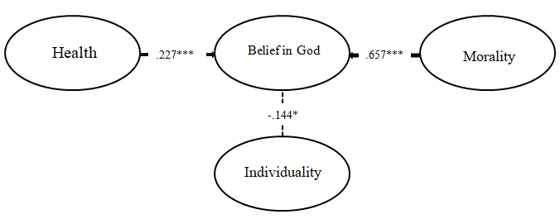
*p ≤ 0.05; **p ≤ 0.01; ***p ≤ 0.001
Figure 7. Associations Between Belief in God and Distant-Future Imagining in the group of adults
Higher levels of belief in God—characteristic of individuals who regularly attend church and observe religious traditions—were associated with more frequent positive distant-future imagining in the domains of Morality, Individuality, and Statehood. Conversely, lower levels of belief in God—typical of individuals who identify as non-religious, do not attend church, and do not practice religious traditions—were associated with more frequent negative distant-future imagining in the same domains.
Belief in God among adults was significantly predicted by the distant-future imagining variables Morality (β₁ = .657, p < .001) and Health (β₂ = .227, p < .001). Increases in these factors were associated with higher levels of belief in God. The regression model, tested using analysis of variance (ANOVA), was highly significant: F(2, 179) = 56.679, p < .001.
Thus, in both age groups, the distant-future imagining domain of Morality played a significant role in shaping belief in God. Among adults, additional influence was observed from the domain of Sociality. Furthermore, in this group, a significant negative correlation was found with the domain of Individuality. In contrast, among young adults, positive correlations were found with the distant-future imagining domains of Individuality and Statehood. However, these associations were of low statistical significance and small effect size; therefore, they may be considered negligible and warrant further investigation.
Overall, a substantial and consistent relationship between belief in God and distant-future imagining was observed only in the youth sample.

Table 1. Correlations between Imagining of the Future, Belief in a Just World and Belief in God
 | N=218 «youth» |  | N=180 «adults»
 | PBW | Belief in God | PBW | Belief in God
Near-Future Imagining | .109 | .267*** | .080 | .151*
Health_near | .096 | .210** | -.041 | .060
Statehood_near | .101 | .212** | .006 | .033
Morality_near | .149* | .278*** | .162* | .192**
Individuality_near | .052 | .103 | -.002 | -.101
Sociality_near | .008 | .154* | .043 | .102
Distant-Future Imagining | .351*** | .183** | .211** | .056
Health_distant | .183** | .078 | .127 | .109
Statehood_distant | .263*** | .153* | -.028 | -.027
Morality_distant | .207** | .456*** | .128 | .460***
Individuality_distant | .048 | .144* | -.075 | -.177*
Sociality_distant | .200** | -.102 | .192** | -.140
*p ≤ 0.05; **p ≤ 0.01; ***p ≤ 0.001

Table 2. Multiple Regression Analysis for Two Age Groups
Dependent Variable | Independent Variables |  |  |  |  |  | Model Significance
Dependent Variable | «youth» | β | p | «adults» | β | p | «youth» | «adults»
PBW | no |  |  | no |  |  | p ≥ .05 | p ≥ .05
Belief in God | Morality_near | .318 | < .001 | Morality_ near | .382 | < .001 | F(2, 217) = 16.729, p < .001 | F(2, 179) = 19.771, p < .001
Belief in God | Health_near | .206 | .001 | Health_ near | .161 | .031 | F(2, 217) = 16.729, p < .001 | F(2, 179) = 19.771, p < .001
PBW | Sociality_distant | .308 | < .001 | Morality_distant | .166 | .026 | F(2, 217) = 19.662, p < .001 | F(1, 179) = 5.055, p = .026
PBW | Morality_distant | .286 | < .001 |  |  |  | F(2, 217) = 19.662, p < .001 | F(1, 179) = 5.055, p = .026
Belief in God | Morality_distant | .493 | < .001 | Morality_distant | .657 | < .001 | F(1, 217) = 69.520, p < .001 | F(2, 179) = 56.679, p < .001
Belief in God |  |  |  | Health_distant | .227 | < .001 | F(1, 217) = 69.520, p < .001 | F(2, 179) = 56.679, p < .001

Table 3. Regression Analysis Results in the Young Group

Variables, N=218 «youth» |  | Effect Size |  | Statistical
Independent | Dependent | R² | 99% CI | Significance of the Model
Distant-Future Imagining | PBW | .152 | [.037;.266] | Linear model F(1, 216) = 38.576, p < .001
Health_distant | PBW | .047 | [-.024;.118] | Linear model F(1, 216) = 10.576, p = .001
Statehood_distant | PBW | .055 | [-.022;.132] | Linear model F(1, 216) = 12.471, p = .001
Morality_distant | PBW | .061 | [-.019;.141] | Linear model F(1, 216) = 14.027, p < .001
Sociality_distant | PBW | .074 | [-.013;.161] | Linear model F(1, 216) = 17.325, p < .001
Distant-Future Imagining | Belief in God | .052 | [-.023;.127] | Linear model F(1, 216) = 11.792, p <= .001
Morality_distant | Belief in God | .243 | [.114;.372] | Linear model F(1, 216) = 69.520, p < .001
Individuality_distant | Belief in God | .027 | [-.028;.082] | Linear model модель F(1, 216) = 6.061, p = .015

Table 4. Regression Analysis Results in the Adult Group
Variables, N=180 «adults» |  | Effect Size |  | Statistical
Independent | Dependent | R² | 99% CI | Significance of the Model
Morality_ distant | Belief in God | .344 | [.198;.49] | linear model F(1, 178) = 93.314, p < .001

Discussion
As previous studies have shown (Dalbert, 2001; Hafer & Bègue, 2005, among others), belief in a just world (BJW) and imagining of the future are mutually reinforcing constructs. BJW can serve as a foundation for the development of positive expectations and motivation, while future imagination strengthens these beliefs by enabling individuals to visualize their goals and aspirations more clearly.
The study revealed a modest association between Belief in a Just World (BJW) and the near-future dimension of Imagining of the Future—Morality—in both age groups. This association may be attributed to the connection between BJW and near-future imagination, particularly in the context of the need for spiritual values, general well-being, self-awareness, and freedom.
Individuals with a strong belief in a just world tend to place high value on spiritual and moral aspects of life. They strive for harmony, kindness, and altruism—values that reflect their inner convictions about fairness and decency. These values shape a positive future outlook in which collective efforts contribute to improving life conditions.
Belief in a just world implies the idea that all people have equal opportunities for success. This belief can foster a sense of social solidarity, motivating individuals to work toward the common good. When people believe that their actions matter and can lead to positive change, they are more likely to engage in civic activities and volunteerism, which supports the development of a healthier social climate.
A stronger belief in a just world may also enhance self-awareness and self-esteem. When individuals perceive their efforts as leading to positive outcomes, their confidence in their actions increases, serving as a foundation for personal growth. This heightened self-awareness is reflected in the formation of a hopeful vision of the near future, wherein individuals recognize their role in building a more just society.
BJW is also closely related to perceptions of freedom. Those who believe in justice often associate freedom with responsibility. For them, the freedom to choose is accompanied by the awareness that their choices affect others. This awareness forms the ethical foundation for a society in which individual freedoms are exercised within the framework of collective well-being.
Thus, the observed association between belief in a just world and the near-future dimension of Imagining of the Future—Morality—serves as a conceptual foundation for building communities oriented toward justice and harmony.
In both groups, associations were identified between Belief in a Just World (BJW) and the distant-future dimensions of Imagining of the Future—Morality and Sociality. This may be explained by the role BJW plays in shaping moral orientations, as individuals who believe that good actions are rewarded and bad actions punished tend to internalize moral norms that foster responsibility and altruism.
The need for spiritual values is closely linked to BJW. Religious teachings often frame justice as a central aspect of divine order, which serves as a foundation for seeking deeper spiritual meaning. In turn, this spiritual engagement promotes moral development and motivates efforts to improve societal life.
Individuals who believe the world is just are more likely to demonstrate concern for others and invest in improving their communities. By doing so, they contribute to the creation of environments where moral values and mutual support serve as fundamental societal principles.
Belief in a just world may also positively influence self-acceptance and confidence. When people perceive their actions as meaningful and capable of producing positive outcomes, this reinforces their inner confidence and promotes active engagement. Such beliefs help individuals recognize their role within society and strengthen their moral foundations.
Furthermore, individuals who view justice and freedom as compatible are more inclined to actively advocate for both their own rights and the rights of others. In this context, a belief in a just world provides a platform for dialogue on civil liberties, ensuring that they are respected and protected.
Thus, BJW appears to contribute to the development of moral values and ethical behavior, while also reinforcing a commitment to collective well-being, heightened self-awareness, and respect for freedom.
In the group of young adults, significant associations were identified between Belief in a Just World (BJW) and the distant-future dimensions of Imagining of the Future—Health and Statehood.
Among youth, BJW often reflects their hopes and expectations about the future. Young people tend to construct a vision of a world where social justice, access to healthcare, and quality nutrition are normative. Moreover, BJW may function as a psychological buffer, helping individuals cope with current social and personal challenges. They may envision a future in which technology and progress rectify past injustices and promote a more equitable society.
Increases in life expectancy and advancements in medical science may reinforce this perception of a just world. As medical technologies, new treatment methods, and genetic engineering evolve to potentially eliminate many previously incurable diseases, youth begin to believe in the possibility of fairness within the healthcare system. Success stories of scientific breakthroughs and technological innovation inspire visions of a future where access to quality healthcare is equitable for all.
Contemporary youth are highly engaged in discussions around social justice and inequality. Influenced by globalization and digital technologies, they are often involved in social movements and advocacy. Imagining a sustainable future in which everyone has equal opportunities helps maintain belief in a just world. This worldview supports the aspiration to improve living conditions for all and underscores the importance of equitable access to resources such as education, healthcare, and food.
Environmental issues and sustainable development also shape young people’s perception of the future. The belief that emerging technologies can lead to more efficient resource use and improved food quality is a vital component of their future orientation. The development of sustainable agricultural systems and environmentally friendly food production generates hope that overall quality of life may improve for everyone, while minimizing environmental harm.
Young people often perceive the future as a space of opportunity and hope.
Contemporary youth are growing up in an era of globalization, where information, culture, and economic systems are becoming increasingly transnational. This fosters a worldview in which national boundaries and ideologies lose their former significance, contributing to the belief in a more just global order free from ethnonational conflicts. Young people may envision a future in which differences between countries and social groups are less pronounced and no longer lead to social or economic inequalities.
Issues of social justice and equality are particularly salient for younger generations. Many youth-led movements and forms of activism focus on combating ethnic, racial, and economic biases. A vision of state authority as hierarchical yet subject to societal oversight is often perceived as more fair and desirable. This reflects a broader aspiration for decentralization of power and the development of more democratic forms of governance.
At the same time, young individuals may associate national pride with the positive aspects of their own culture, fostering opportunities for deeper intercultural understanding and respect. This outlook supports the hope for a future in which diverse identities are not only accepted but seen as a source of enrichment for humanity as a whole.
Thus, the relationship between young people's belief in a just world and their distant future imagining is largely shaped by their aspiration to improve current living conditions and their vision of a world free from prejudice and conflict. These future-oriented images reflect their desires, hopes, and active commitment to creating change in their own lives and in society at large. Belief in a just world helps establish moral frameworks for the future, while also reinforcing a commitment to collective well-being, the development of self-awareness, and respect for freedom.
Previous research (Steger et al., 2006; McCullough & Willoughby, 2009; Koenig, McCullough, & Larson, 2001, among others) has shown that the relationship between imagining the future and belief in God may be multifaceted. Religious faith can contribute to the development of values and ideals that guide imagination and shape how individuals envision their future. In turn, imagining the future can reinforce religious belief by encouraging individuals to adhere to their convictions, providing them with a sense of the presence of a higher power that supports them during challenging times.
In both groups, Belief in God is significantly influenced by proximal Imagining of the Future dimensions such as Morality and Health. This may be because future-oriented images that are filled with ideas of morality, spirituality, and collective well-being help individuals recognize their connection to something greater than themselves. Several factors may underlie this relationship.
The need for spiritual values often intensifies during times of uncertainty and crisis. When society faces challenges such as emerging diseases, declining quality of life, or inefficiencies in healthcare systems, individuals may turn to faith for comfort and meaning. Faith can serve as a psychological anchor, offering hope for a better future and helping individuals find personal significance in difficult circumstances.
Attitudes toward collective well-being and self-awareness also appear to influence religious belief. In societies that value mutual aid, solidarity, and the development of moral standards, there may be a heightened collective consciousness of a higher power or divine order that promotes harmony. Under such conditions, faith may be perceived as a means of achieving the common good.
Attitudes toward freedom, life expectancy, and quality of life further emphasize the importance of personal values. When faith provides a framework or moral compass for achieving these goals, it becomes particularly attractive. Individuals seeking self-development may find meaning in faith as a source of wisdom and guidance that helps them navigate life’s challenges.
The availability of nutritious food and concern for health may also be linked to religious belief, as many religious teachings offer prescriptions and recommendations regarding diet, lifestyle, and bodily care. Individuals who identify with a religion may view adherence to these teachings as a way of honoring God and safeguarding their health.
Finally, the emergence of new illnesses and the challenges faced by modern society evoke fear and uncertainty. In this context, faith can have a profound impact—both individually and collectively—by helping people find meaning and hope in difficult times. Thus, proximal Imagining of the Future and its influence on moral and spiritual values operate through a person’s relationship with the surrounding world, their needs, and aspirations. This connection enables individuals to either strengthen or reinterpret their Belief in God in light of life’s evolving realities.
In the group of young adults, additional associations were identified between Belief in God and proximal Imagining of the Future dimensions such as Sociality and Statehood. This may be due to the fact that contemporary youth often face uncertainty and rapid changes in the global landscape. Belief in God can serve as a source of meaning that helps them cope with challenges. This search for spiritual identity and existential coherence may shape their vision of the future, including their reflections on social organization, political systems, and environmental concerns.
Young people tend to be especially sensitive to issues of justice and inequality. Belief in God may reinforce ideals of social justice and equity. These values may manifest in their views on equitable population distribution, access to resources, economic development, and overall safety. Youth may support more humanistic and ethical approaches to governance or, conversely, advocate for limiting political power based on principles of justice and public service, as often emphasized in religious teachings.
Contemporary world religions increasingly highlight human responsibility for the planet. This emphasis may lead young individuals to adopt more proactive stances on environmental issues and sustainable development, directly influencing their imagining of the future, security, and social inclusion.
Moreover, Belief in God is often intertwined with national identity, especially in countries with deeply rooted religious traditions. This connection can foster a sense of unity among youth and strengthen their ties to native culture and history, thereby shaping their perceptions of intergroup differences and future global challenges.
Faith can also inspire creativity and self-expression. Spiritually inspired youth may seek ways to realize their ideas and aspirations, whether through artistic expression or social and ecological initiatives. These efforts often reflect their commitment to values such as equality and justice.
Conversely, a lack of belief in God may be associated with feelings of instability and existential risk, whereas religious faith may offer emotional and spiritual support. A variety of factors related to Belief in God permeate different aspects of young people’s lives, influencing their Imagining of the Future and shaping their perspectives on critical themes such as social justice, environmental responsibility, political authority, and national identity. While this relationship may be more pronounced in certain cultural and social contexts, it remains a significant element in understanding the dynamics of contemporary youth worldviews.
In both groups, distal Imagining of the Future related to Morality was found to influence Belief in God. This may be explained by the notion that envisioning a morally elevated future and a life guided by high spiritual standards can reinforce Belief in God as the source of these values. Many religious traditions emphasize the significance of moral virtues, and imagining a more ethical world may be perceived as the realization of a divine plan.
The human drive toward collective well-being and cooperation may also be interpreted as an echo of a divine call for unity and love for others. Such aspirations contribute to the formation of a collective consciousness that supports and strengthens religious belief. When societies begin to assign greater importance to spiritual values, individuals may increasingly view religion as a meaningful and essential component of life. This can enhance trust in the belief that God, or a higher power, guides humanity toward these ideals.
The sense of freedom in self-expression and in choosing one’s life path may foster a more personal and profound relationship with faith. Individuals may begin to seek spiritual fulfillment, leading them to explore religious questions and engage in a more sincere pursuit of divine connection. In contexts where religious identity is regarded as a vital part of community life, maintaining “Belief in God” may be socially and culturally reinforced. This creates a milieu in which faith is perceived as an integral component of a prosperous future.
Thus, a positive and morally grounded Imagining of the Future may act as a catalyst for strengthening religious faith, as individuals seek greater meaning and purpose in their lives through the development of spiritual and ethical ideals.
In the group of older adults, the concept of Sociality also emerged as a significant influence on their distal Imagining of the Future. This may be attributed to the dynamic interplay between “Belief in God” and individuals’ religious beliefs, which tend to evolve in later stages of life depending on how they perceive their long-term future. At this stage, individuals are often more aware of concerns related to their personal future, health, and overall well-being.
The degree of perceived security—both physical and financial—can affect existential reflection. When individuals experience greater life stability and confidence in their future, they may feel less inclined to engage in spiritual seeking or to question the existence of higher powers. Conversely, in times of uncertainty and instability, faith can serve as a vital source of hope, comfort, and emotional resilience.
The need for belonging increases with age. If older adults feel they can become part of a supportive religious community with shared traditions and values, this may strengthen their faith. In contexts of high social inclusion and civic engagement, faith may become an integral part of one’s social environment and self-concept. A stable life situation may reduce the felt need for religious belief, while adverse circumstances—such as economic hardship or personal crises—can elevate the importance of faith by providing existential meaning and direction during difficult times.
Social inequality may exacerbate feelings of injustice and helplessness, prompting individuals to seek solace in religion. Faith can offer responses to questions about the meaning of life and justice, along with hope for life after death or future transformation. Older adults often pursue self-expression and creativity, both of which may be deeply connected to their religious worldview. Religion can offer access to profound emotional and spiritual experiences, as well as opportunities for creative expression through worship, artistic engagement, or service.
Thus, the interplay of perceived safety, social inclusion, life stability, and creative aspirations shapes a unique perspective on “Belief in God” among older adults. Their Imagining of the Future, alongside the lived reality of their current stage of life, is closely tied to religious beliefs, rendering the question of faith multifaceted and deeply individual.
Thus, proximal Imagining of the Future and its influence on moral and spiritual values function through individuals’ connection to the surrounding world, as well as their needs and aspirations. This connection allows individuals to either reinforce or reconsider their Belief in God in accordance with the changing realities of life.
Among young people, the level of Belief in God not only helps shape moral frameworks but also contributes to the development of individuality, fostering positive civic engagement and a strong commitment to personal ideals. For older adults, Belief in God may be associated with moral resilience, a sense of safety, social inclusion, life stability, creative fulfillment, and hope for favorable outcomes. Together, these factors contribute to positive associations with both proximal and distal Imagining of the Future.
Limitations of the study: The data were collected from a sample of individuals residing within a shared cultural and informational environment. Additionally, the sample was not gender-balanced, with women comprising the majority of participants.

References
Carrette, J., & King, R. (2005). Selling Spirituality. Routledge.
Dalbert, C. (1999). The world is more just for me than generally: About the Personal Belief in a Just World Scale’s validity. Social Justice Research, 12(2), 79–98. doi:10.1023/A:1022091609047.
Dalbert, C. (2001). The justice motive as a personal resource: Dealing with challenges and critical life events. New York: Kluwer Academic/Plenum Publishers. M.A. Busseri, et al. Personality and Individual Differences 167 (2020) 110242 4
Goñi, J.I., Raveau, M.P., & Bravo C. (2024). Analytical categories to describe imaginations about the collective futures: From theory to linguistics to computational analysis. Futures, Volume 156, February 2024, https://doi.org/10.1016/j.futures.2024.103324
Hafer, C.L., & Bègue, L. (2005). Experimental Research on Just-World Theory: Problems, Developments, and Future Challenges. Psychological Bulletin, 131(1):128-67, DOI:10.1037/0033-2909.131.1.128
Koenig, H. G., McCullough, M. E., & Larson, D. B. (2001). Handbook of Religion and Health.
Oxford Univ. Press.
Lerner, M. J. (1980). The belief in a just world. New York: Plenum.
Lipkus, I. M., Dalbert, C., & Siegler, I. C. (1996). The importance of distinguishing the belief in a just world for self versus for others: Implications for psychological wellbeing. Personality and Social Psychology Bulletin, 22, 666–677.
McCullough, M. E., & Willoughby, B. L. (2009). Religion, Self-Regulation, and Self-Control: Associations, Explanations, and Implications. Psychological Bulletin, 135(1):69-93. DOI:10.1037/a0014213
Murashko, T., Kolesovs, А., & Ruza, А. (2025). Imagining the Future: Instrument development and initial validation. Daugaphils universitāte, Latvija.
Nikula, E., Jarvinen, T., and Laiho, A. (2020). The Contradictory Role of Technology in Finnish Young People’s Images of Future Schools. YOUNG, 28(5): 465–484. https://doi.org/10.1177/1103308819894806
Pargament, K. I. (1997). The Psychology of Religion and Coping. Guilford Press.
Rubin, A. (2013). Hidden, inconsistent, and influential: Images of the future in changing time. Futures, 45, S38–S44.
Schuberta, T., Eloo, R., Scharfen, and J., Morina, N. (2020). How imagining personal future scenarios influences affect: Systematic review and meta-analysis. Clinical Psychology Review. Volume 75. https://doi.org/10.1016/j.cpr.2019.101811
Steger, M. F., Frazier, P., Oishi, S., & Kaler, M. (2006). The Meaning in Life Questionnaire: Assessing the Presence of and Search for Meaning in Life. Journal of Counseling Psychology, 53(1). DOI:10.1037/0022-0167.53.1.80
Wilson, A. E., & Shanahan, E. (2019). Temporal comparisons in a social world. In J. Suls (Ed.). Social comparison in judgment and behavior (pp. 309–347). New York, NY: Oxford University Pres

