The authors did not upload the files for review; the first page contains only an abstract. Please resubmit the files.

First page:
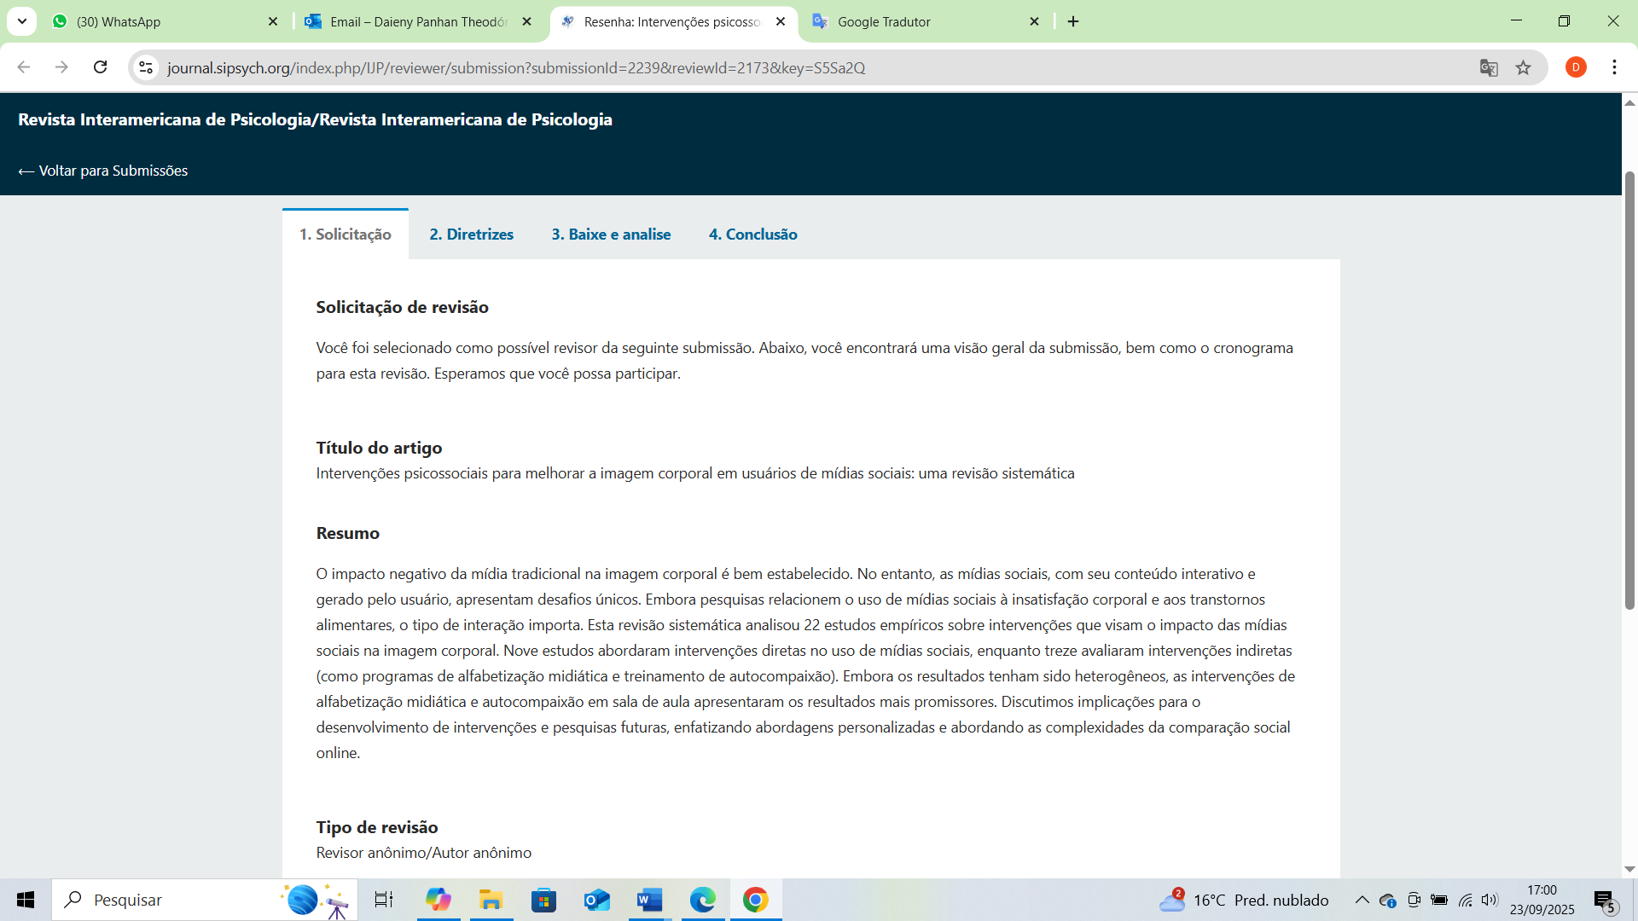

Third page
