Psychosocial Interventions to Improve Body Image in Social Media Users: A Systematic Review

Abstract
The negative impact of traditional media on body image is well-established. However, social media, with its interactive and user-generated content, presents unique challenges. While research links social media use to body dissatisfaction and eating disorders, the type of interaction matters. This systematic review analyzed 22 empirical studies on interventions targeting social media's impact on body image. Nine studies addressed direct interventions on social media use, while thirteen evaluated indirect interventions (like media literacy programs and self-compassion training). Although results were heterogeneous, classroom-based media literacy and self-compassion interventions showed the most promising results. We discuss implications for intervention development and future research, emphasizing tailored approaches and addressing the complexities of online social comparison.
Keywords
social media; body image; body dissatisfaction; psychosocial intervention; media literacy; systematic review.

Resumen
El impacto negativo de los medios de comunicación tradicionales sobre la imagen corporal está bien establecido. Sin embargo, las redes sociales, con sus contenidos interactivos y generados por los usuarios, presentan retos únicos. Aunque las investigaciones relacionan el uso de los medios sociales con la insatisfacción corporal y los trastornos alimentarios, el tipo de interacción es importante. Esta revisión sistemática analizó 22 estudios empíricos sobre intervenciones dirigidas al impacto de las redes sociales en la imagen corporal. Nueve estudios abordaron intervenciones directas sobre el uso de los medios sociales, mientras que trece evaluaron intervenciones indirectas (como programas de alfabetización mediática y formación en autocompasión). Aunque los resultados fueron heterogéneos, las intervenciones de alfabetización mediática y autocompasión basadas en el aula mostraron los resultados más prometedores. Se discuten las implicaciones para el desarrollo de la intervención y la investigación futura, haciendo hincapié en los enfoques adaptados y abordando las complejidades de la comparación social en línea.

Palabras clave
redes sociales; imagen corporal; insatisfacción corporal; intervención psicosocial; literacidad mediática; revisión sistemática.

Intervenciones para mejorar la imagen corporal en redes sociales: Una revisión sistemática
Introduction
Body image is inherently subjective (Grogan, 2021), as there is no direct connection between an individual's internal perception of their body and its external appearance. Social and cultural experiences largely shape this perception, making it highly adaptable to new information and continuous revision. Mass media, including social media, play a crucial role in shaping and altering body image perceptions on a large scale (Diedrichs, 2012; Levine, 2012). Media outlets—such as magazines, television, film, and advertising—promote current beauty standards, influencing consumer behavior (Salinas, 2011). The media conveys norms, ideas, attitudes, and behaviors that help construct social reality, altering the way we perceive it (López-Guimerà et al., 2010). Social media is characterized by rapid and widespread content updates. Instagram, for example, has a "Search and explore" tab that displays photos and videos from public profiles. This introduces users to new content without the need to search for it specifically, further expanding the number of potential targets for social comparison (Sherlock & Wagstaff, 2019).
According to Kemp (2019), there were 3.5 billion active social media users worldwide in 2019, and this number continues to grow each year. Social interactions are now largely defined by user-generated content and exchanges between users (Kaplan & Haenlein, 2010), transforming how individuals relate to themselves, others, and their environment (Burr, 2020). In the Western world, studies have linked social media use to body image concerns and disordered eating behaviors, particularly among younger generations (Rodgers et al., 2016).
A growing body of research suggests that social media use is associated with heightened body image concerns among both young men and women (Fardouly, 2016; Holland, 2016), particularly when individuals engage in appearance-based comparisons with others (Kim & Chock, 2015; Tiggemann & Zaccardo, 2015). Correlational studies indicate that comparing oneself to images of attractive peers (Fardouly, 2015; Fardouly & Vartanian, 2015) may be especially detrimental. Individuals who engage in self-objectification or are frequently exposed to idealized images—such as those of celebrities, peers, and fitness influencers—are more vulnerable to body dissatisfaction and disordered eating behaviors (Rounsefell, 2020).
Social media platforms inherently promote appearance comparisons (Perloff, 2014) by enabling engagement with both close acquaintances and distant peers. This dynamic encourages users to present an idealized version of themselves online (Barry, 2016; Vaterlaus, 2015). Research suggests that younger adolescents may be susceptible to the negative effects of such exposure, since age appears to moderate the impact of social media on body image (Rodgers & Rousseau, 2022). Skepticism, or the critical evaluation of idealized images, may serve as a moderating factor that weakens the link between media exposure, appearance comparisons, and body dissatisfaction (Rodgers, 2019).
The nature of social media engagement significantly influences body image outcomes. Platforms such as Facebook, originally designed for social interaction, have grown to include activities such as gaming and news consumption, which do not affect users uniformly. Studies have shown that individuals who passively consume content created by others—without actively engaging in social interactions on Facebook—experience increased loneliness and reduced social capital (Burke, Marlow, & Lento, 2010). This pattern of non-interactive engagement, later termed "passive usage" (Burke & Kraut, 2011), along with appearance-focused use, has been strongly associated with greater body dissatisfaction (Ryding, 2020).
The relationship between digital technology and well-being has become a growing ethical concern (Floridi, 2015). Digital well-being refers to the impact of technology on human flourishing in an information-driven society (Floridi, 2014). The extensive use of social media has led to additional considerations regarding how these platforms influence self-perception, mental health, and overall quality of life. Given the omnipresence of social media, understanding its potential risks and benefits is critical for developing strategies to mitigate harm while promoting positive engagement.
Researchers have suggested various interventions to reduce the negative effects of social media on body image or even generate positive outcomes. Strategies include reducing time spent on social media, diversifying followed content, and implementing psychoeducational programs such as media literacy training (McLean, 2017; Tamplin, 2018) which have been effective in improving multiple body image-related factors, including reducing the internalization of appearance ideals and concerns about weight and shape (McLean et al., 2015;Wade et al., 2017.; Zuair & Sopory, 2022). Previous studies have incorporated social media literacy into interactive and experiential lessons designed to equip adolescents with the skills for critically evaluating social media content, including advertisements, celebrity posts, and friends' personal pages. Participants also learned strategies for handling negative feedback and reflected on and practiced presenting their authentic selves online with less focus on appearance (Gordon et al., 2021). McLean and collaborators (2017) followed the same line and included strategies to minimize appearance comparisons with images on social media and build resilience against upward comparisons, and Gordon and collaborators (2020) emphasized the digital manipulation of pictures in social media networks. Researchers have also explored interventions such as using disclaimers on digitally altered images (Veldhuis, 2012) and changing peer feedback mechanisms (Veldhuis, 2014).
Psychosocial interventions offer a promising avenue for improving body image by addressing the psychological and social factors that contribute to its disturbance. These interventions encompass a range of approaches, including those that target cognitive processes (e.g., cognitive dissonance-based programs; Stice et al., 2008), enhance coping skills (e.g., media literacy training; McLean et al., 2017), and promote self-acceptance and compassion (e.g., self-compassion interventions; Seekis et al., 2020). Their inclusion is vital because they address the underlying mechanisms linking social media use and body dissatisfaction, rather than limiting exposure. Media literacy interventions appear to be effective in improving body image by developing skills that help individuals resist the negative impact of media-driven body ideals, boost self-esteem and self-efficacy, and encourage a healthier lifestyle (Hendrick et al., 2023).
The positive body image framework emphasizes the role of protective filtering—strategic media consumption designed to preserve body-positive attitudes and minimize distress (Evans, Stutterheim, &(Alleva et al., 2015), 2021; Tylka & Wood-Barcalow, 2015). Emerging evidence shows that, depending on usage, social media can also have positive effects (Rodgers, 2022). To the start date of this research, no systematic review has specifically examined interventions designed to counteract the negative impact of social media on body image. A recent non-systematic review by Mazzeo et al. (2024) addressed mitigating the harms of social media, but it only considered teenagers and used only English keywords. Another recent review (Herriman, 2023) mapped existing literature on interventions aimed at reducing the negative impact of highly visual social networking sites (HVSNS) on mental health, without focusing on body image. It found that while various interventions show promise for improving well-being outcomes, there is a need for more rigorous research, standardized terminology, and greater inclusion of diverse populations, especially adolescents and non-Western cultures.
Thus, the present study aims to conduct a systematic review and attempt a meta-analysis of interventions leveraging social media to improve body image outcomes, providing a comprehensive understanding of their potential benefits and limitations.

Method
Design
The review process was conducted under the PRISMA statement (Moher, Liberati, Tetzlaff & Altman, 2009). Before starting the procedure, it was registered at PROSPERO (Booth, 2011, 2012; Page, 2018) ID: CRD42022366626, under the same name. The review question was "What is the effect of psychosocial interventions design to improve body image in social media users?". The search included any social media user, and the domain being studied was "body image in Social Media Users". There were no inclusion/exclusion criteria for comparator/control.
We defined interventions as those aimed at modifying any psychological or social variable affecting body image. Interventions could be face-to-face or online. Examples include any form of psychotherapy, psychoeducation, cognitive strategies, media literacy, labels and disclaimers, and protective filters, among others. We included studies evaluating the effects of psychosocial interventions aimed at improving body image in social network users (RCTs, quasi-experimental studies, pre-post studies). We reviewed titles and/or abstracts, got via our search strategy and additional sources (including reference searches), to identify eligible studies. Included: intervention studies. Excluded: editorials, and qualitative studies, reviews, study protocols. We assessed for each study whether the measures used have evidence of reliability and validity, whether reported in the included study or elsewhere. We will also assess the percentage loss of participants in longitudinal studies. Two researchers will independently evaluate quality. They will solve disagreements by consensus.
The main outcomes included body image satisfaction; positive body image attitudes; and body image disturbances. The review included studies in English, Spanish, and Portuguese, since these were the languages spoken by the authors. There were no restrictions regarding the date of publication. We synthesized the results from studies sufficiently homogenous in terms of population (sex, age, and diagnosis), interventions, comparisons, and outcome measurement methods to avoid methodological heterogeneity. Other sets of criteria to analyze subgroups or subsets included age sub-groups (early adolescents, late adolescents, young adults); gender; High versus low levels of social media exposure, Mental health diagnosis,Type of study.
The initial search included the following databases: Cochrane Central Register of Controlled Trials (CENTRAL), MEDLINE databases, Embase, PsycINFO, LILACS, ClinicalTrials.gov WHO ICTRP, PsyArXiv (https://psyarxiv.com), MedRxiv (https://www.medrxiv.org), Scopus, and SocINDEX. The first search was performed in December 2022. Keywords used in searches were a combination of social media; body image; body dissatisfaction and intervention. The combinations included both in Spanish and English: ("Social Network" OR "Social Media" OR "Digital Media" OR "Instagram" OR "Facebook" OR "Twitter" OR "TikTok" OR "Internet Addiction" OR "Cell Phone Addiction" OR "Smartphone Addiction" OR "Social Media Exposure" OR "Social Media Influence" OR "Social Media Engagement" ) AND ("adolescent" OR "teen" OR "teens" OR teenager* OR "young" OR "youth" OR "Undergraduate Students" OR "High School" OR "College Student") AND ("Body Image" OR "Body Identity" OR "Body Representation" OR "Body schema" OR "Negative Body" OR "Positive Body" OR "Body Satisfaction" OR "Body Dissatisfaction" OR "Body Appreciation" OR "Image Disturbance") AND ("intervention" OR "disclaimer" OR "label" OR "feedback" OR "Cognitive Strategy" OR "Cognitive Strategies" OR "Protective Filter" OR "Social Media Literacy" OR "Weight Information"). This resulted in 16380 search combinations for each database. Our keyword selection came from previous literature that used those words in relation to our topic of interest. Since no other systematic review of the literature on this topic existed at the start of our review (2022), we opted for the broadest possible search.
Covidence (2023) was used to detect duplicates, screen abstracts and titles, and full text, independently by two authors (SA and CM). Proportionate Agreement, Yes Probability, No Probability, Random Agreement Probability and Cohen's Kappa will be reported for both reviewers. Before conducting the screening, filters applied to exclude titles showing systematic reviews, letters, narrative reviews, theoretical reviews, reviews, qualitative studies, or related to nutrition and food. Then, titles reporting topics unrelated to the research were removed. Conflicts between authors were resolved before proceeding to the full-text screening. When data extraction was performed (prior to final selection to resolve conflicts), the following information was considered: Title, DOI, Conditions, Groups, type of randomization, Type of intervention, General characteristics, Study design, Outcome, Moderators, N, Gender(s) included in sample, Stimuli presented, Sample type, Social media evaluated, Country, Extra measurement method (of the intervention), Main results (outcomes).
We extracted information about the 'Risk of bias' criteria and the methods of participant selection using Revised Cochrane risk-of-bias tool for randomized trials (RoB 2) Short Version Cribsheed (Higgins et al., 2019) and evaluated the risk of bias in each included trial using the seven criteria described. Two review authors (SA and IFB) independently assessed each included study as being at low, high, or unclear (uncertain) risk of bias for each domain. If there were discrepancies between their assessments, and the two review authors could not reach a consensus, a third review author (PL) joined the decision-making process. All three review authors discussed the issue and made a final decision.
In January and February 2025, the search was repeated to update the results, using the same search terms in English and Spanish, in the PubMed database, with the R package rentrez (Winter, 2017). The months January 2023 and January 2025 were set as the time limit to update the search. Because of the number of results (N=13949) and the lack of funds, the free version of Rayyan was used to screen the results (Ouzzanni, 2016; Yu, 2022; Valizadeh, 2022), independently by the same two authors (SA and CM).

Results
On the first search, a total of 457 papers were found, with all the combined searches. Using the COVIDENCE (Veritas Health Innovation) platform, we performed a selection process with 2 researchers deciding separately and afterward solving conflicts (see Fig 1). The second search yielded a final number of 357 results (after discarding duplicates), of which only 3 were included following the inclusion and exclusion criteria, after screening first by title and abstract, and finally by full text. All were added to the previous report of results. A final sample of 22 papers was included in the review (see Table 1, Figure 2).
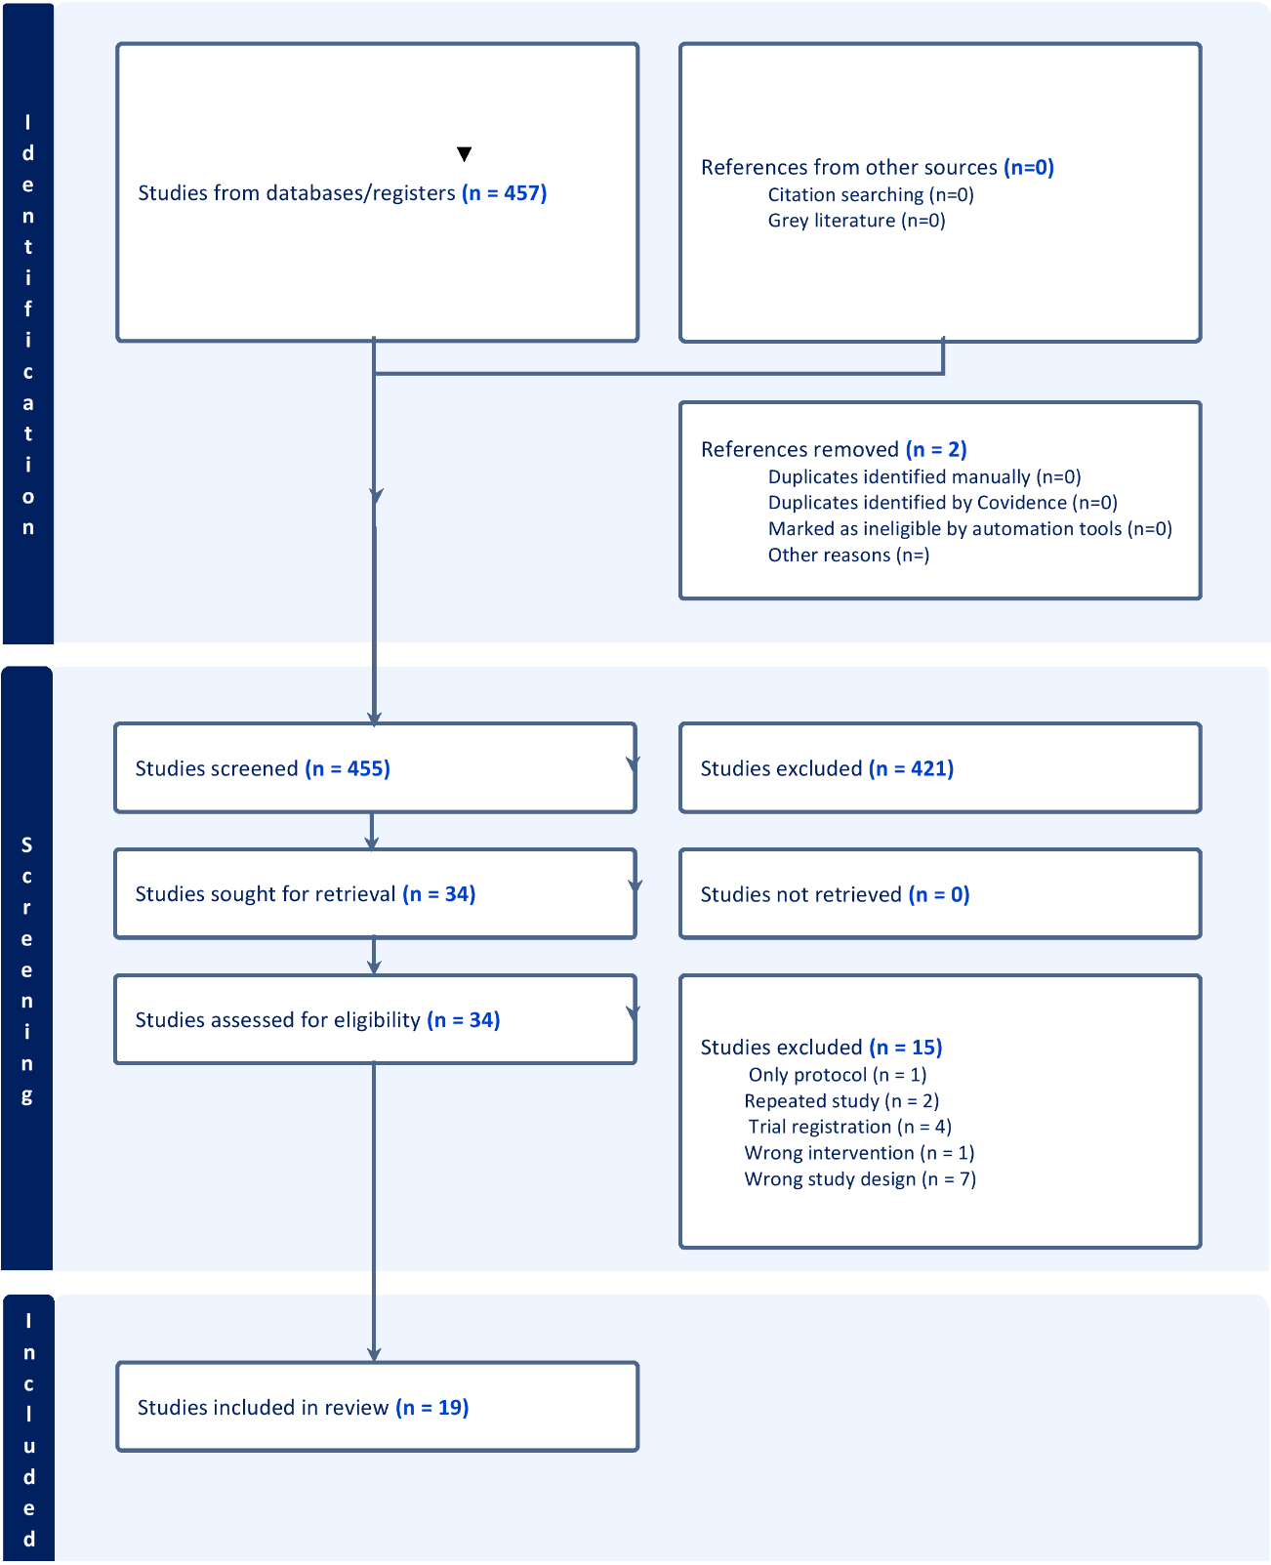
Figure 1. Summary of the PRISMA pipeline of the first search
Reviewer A (CM) and Reviewer B (SA) both agreed to include 18 items and exclude 14 items, while disagreeing on 1 item they both included and 1 item they both excluded. With a 94.12% agreement rate, the two reviewers showed consensus on most items. The probability of agreeing on items to include was 31.23%, while the probability of agreeing on items to exclude was 19.46%. The random agreement probability was 50.69%, reflecting the likelihood of agreement by chance. Cohen's Kappa, which adjusts for chance, was 0.8807, demonstrating a very high level of agreement between the two reviewers. This shows a strong consensus and substantial reliability in their evaluations.
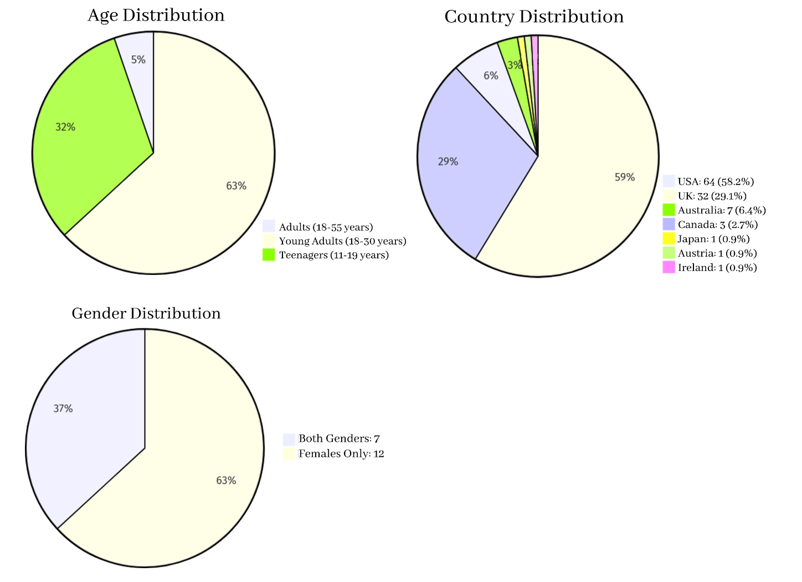
Figure 2. Summary of the studies' population

The results of the risk of bias analysis showed that most studies presented some risk of bias concerns, particularly selection bias, as most of them did not pre-register their studies. The lack of blinding for participants and assessors, as well as the lack of reporting on potential biases, also introduced considerable risk of bias (see Figure 3).
In those studies that shared outcomes and comparisons, we attempted a meta-analysis with RevMan (2020). The high statistical heterogeneity prevented a summary measurement of the overall effect. Therefore, we present the results independently.

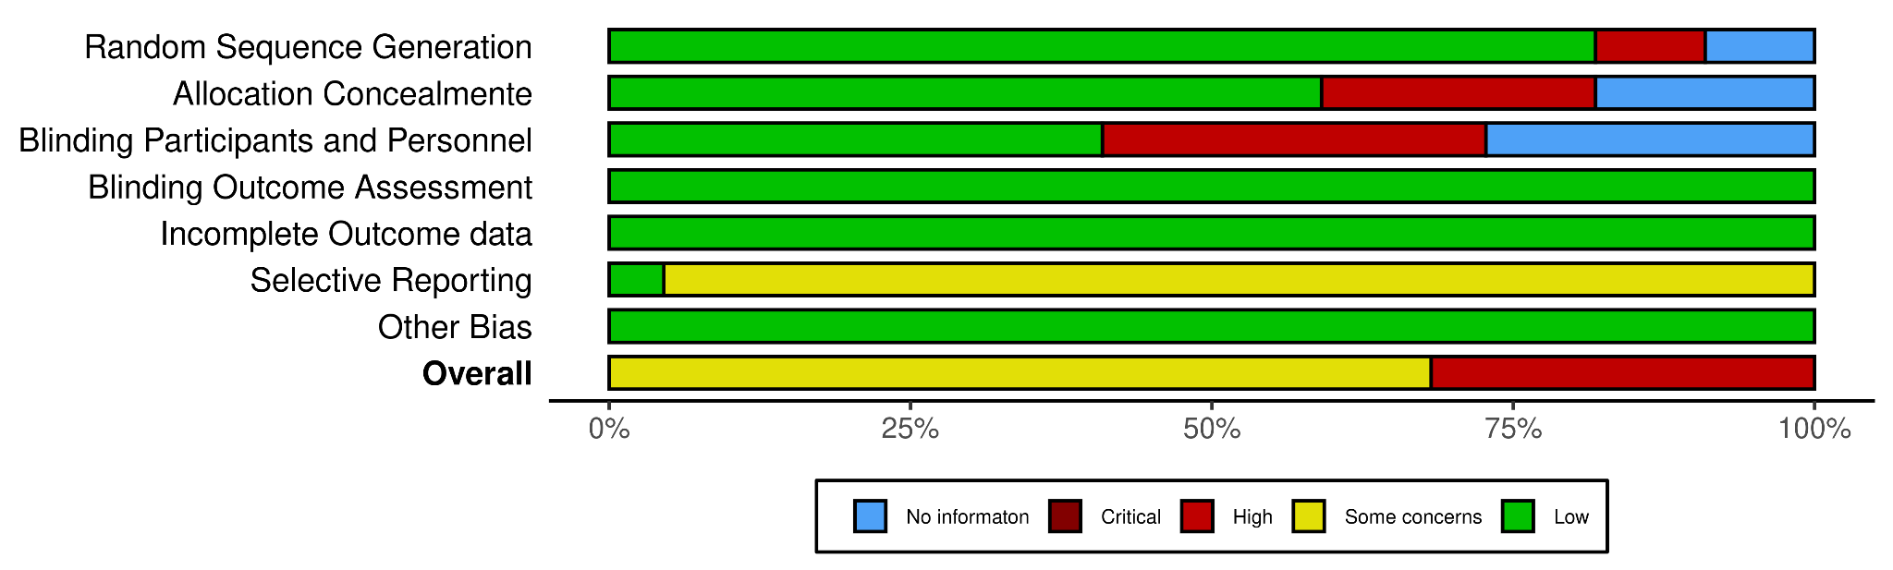
Figure 3. Summary of risk of bias assessment for all included studies.

To statistically compare some studies, we first evaluated the type of intervention: direct intervention on social media use (N=9) or indirect intervention through a psychological program targeting body image and social media literacy (N=13).
Within the direct interventions group, 5 of them evaluated the mitigating effects of adding a disclaimer type of image (Livingston, 2020; Brown,2020; McComb, 2021; Rodgers, 2021; Naderer, 2022). We compared the experimental versus control condition for all of them through the common outcome of body image satisfaction in the post-exposure measurement, using standardized mean differences as not all of them use the same scale to measure it, and baseline measurement was checked to show no differences between groups. However, as only 1 controlled baseline measurement, and only 4 of them included the baseline scores, we compared the differences between pre- and post-intervention scores, leaving only 4 studies (Livingston, 2020; Brown, 2020; McComb, 2021; Rodgers, 2021). Sadly, the heterogeneity score was too high to perform the analysis (I2=97%).

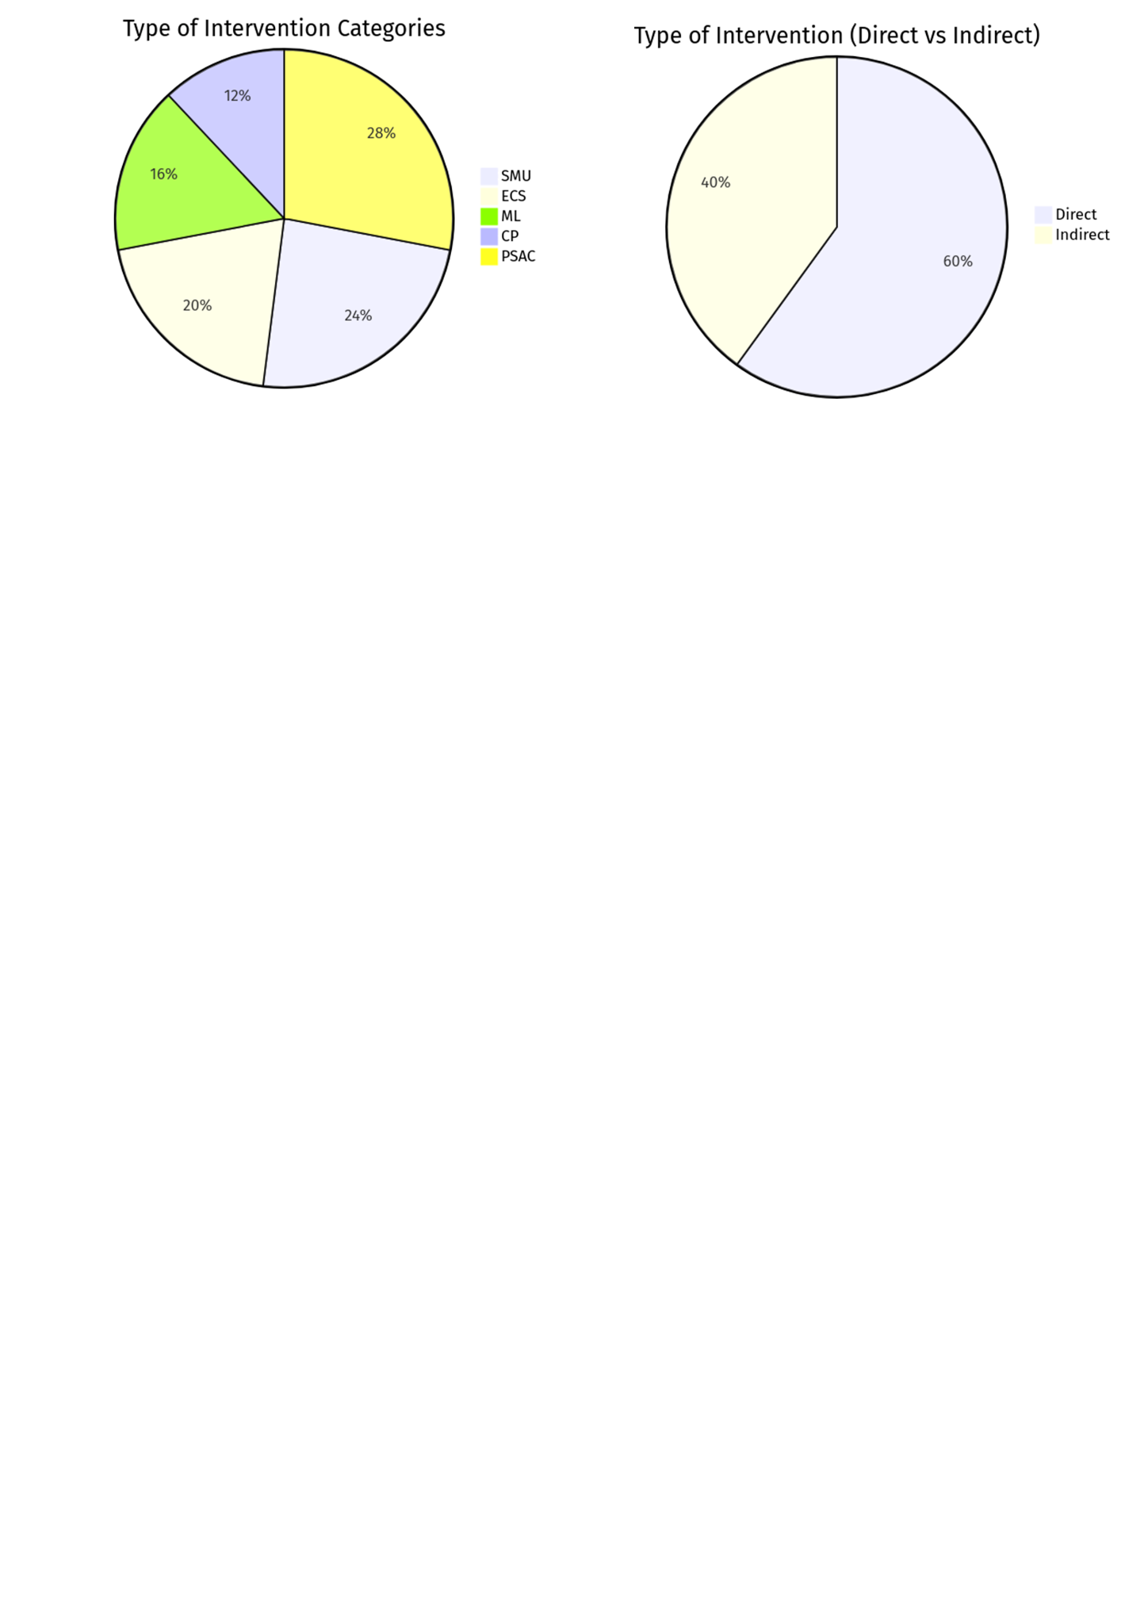
Figure 4. Summary of the studies' type of intervention.

Several studies assessed the impact of disclaimers on body image and mood. Livingston et al. (2020) found that self-disclaimers did not reduce body dissatisfaction or negative mood in women viewing idealized selfies. Similarly, Naderer (2022) and McComb (2021) found no significant effects of disclaimers on body satisfaction. Rodgers (2021) found that labeling unedited selfies improved appearance satisfaction, especially for those with higher social media literacy. Brown and Tiggemann (2020) also found no significant effect of body-positive or disclaimer captions on body image. Couture Bue (2020) found no change in body anxiety or satisfaction, but participants in the disclaimer condition focused on comments.
Two studies evaluated direct interventions on social media. Thai (2021) found that reducing screen time improved appearance esteem in individuals with depression or anxiety. In Parcell's (2023) study, body-positive content improved participants' body image and mood; however, they found no moderating effects for social media literacy.
In terms of media literacy interventions, five studies showed mixed results. Some showed improvements in body satisfaction (Bell, 2022; McLean, 2017), while others did not (Gordon, 2021). Wade (2017) found media literacy reduced eating disorder risk by influencing media internalization. Bennett (2023) showed an app-based media literacy intervention that improved state body satisfaction but had no long-term impact.
Self-compassion interventions also yielded positive results, with three studies showing improved body satisfaction or decreased body dissatisfaction in adolescents and young women. A mindfulness meditation study (Hooper, 2024) found it mitigated the negative effects of idealized images on self-esteem and mood. In contrast, a values-affirmation intervention (Pilot, 2023) showed no significant changes in body dissatisfaction.
Finally, two studies on body-positive content found mixed results. Danthinne (2021) reported no significant effects of a body-positive video, while Campagna (2024) found that a plus-size model video improved body satisfaction but was less effective for those highly invested in appearance or selfies.
Table 1

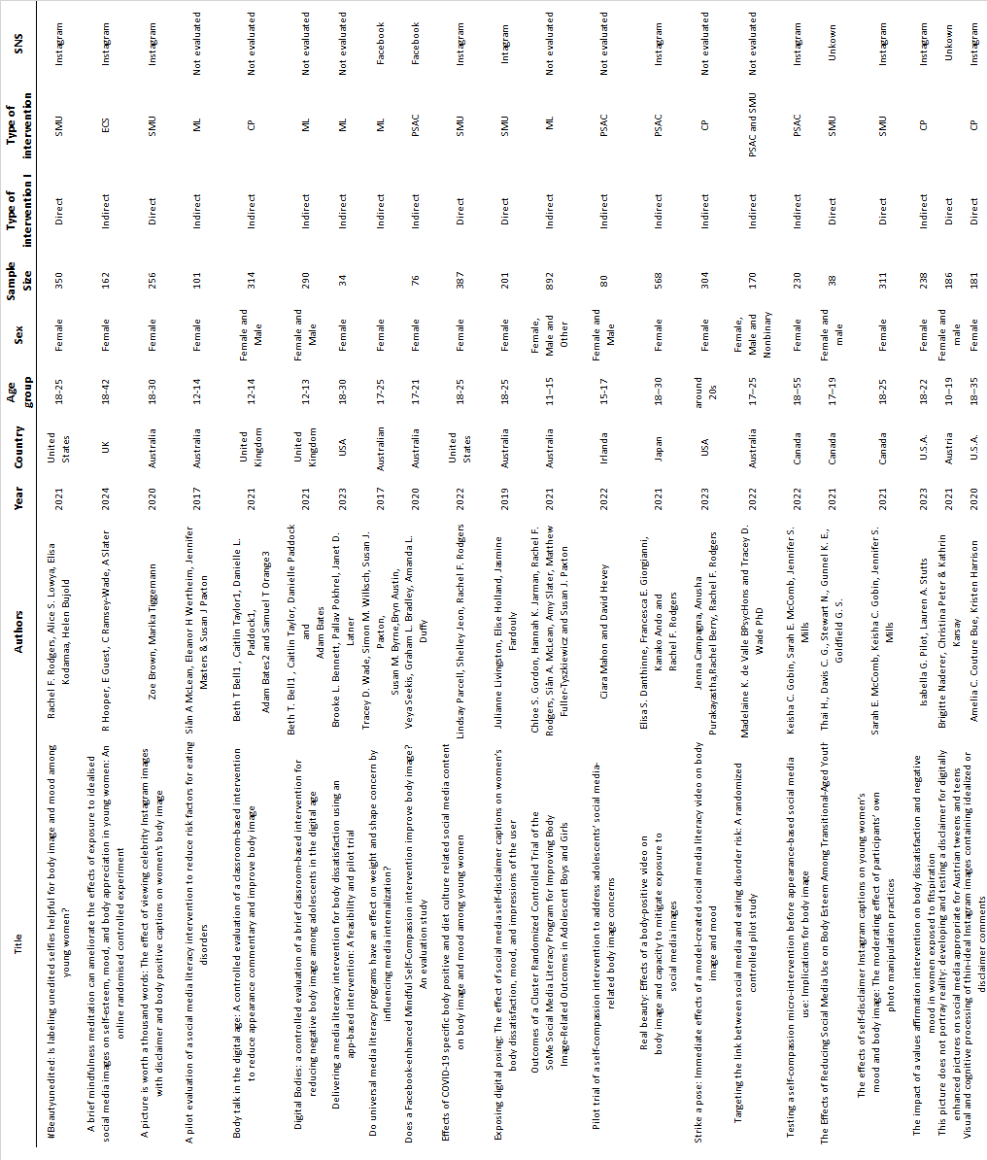

Note. Description of the 22 papers that were selected from the revision. SNS=Social networking sites, CP=cognitive processes, ECS=enhance coping skills, PSAC=promote self-acceptance and compassion, SMU=Social media use-based strategies, and ML=Media literacy.

Discussion
Previous research has consistently shown the media's influence on body image, but social media's emergence has altered our interactions with each other and ourselves. Studies link social media use to body dissatisfaction and eating disorders, but the effects depend on individual platform engagement. While exposure to social media can have negative effects, it can also offer positive benefits. Therefore, this review focused on interventions to mitigate these negative effects.
Only 22 studies tested interventions, but because of their heterogeneity, meta-analysis was not possible. Eight studies focused on direct interventions, such as adding disclaimers or captions to images to reduce the impact of social media, but only one (Rodgers, 2021) found significant effects. Two others showed positive results: one reducing screen time for individuals with depression and anxiety (Thai, 2021), and the other exposing participants to body-positive images (Parcell, 2023), which improved body image and mood.
Fourteen studies evaluated indirect interventions, such as media literacy and self-compassion programs. Five media literacy programs (Wade, 2017; McLean, 2017; Bell, 2021; Bell, 2022; Gordon, 2021) showed limited success, though two studies on young women (Bennet, 2023; Campagna, 2024) found positive short-term effects on body image. Three self-compassion interventions (Seekis, 2020; Gobin et al., 2022; Mahon, 2022) also produced significant results. Other interventions, including body-positive videos (Danthinne, 2021) and values affirmation (Pilot, 2023), had mixed outcomes. Self-affirmation (De Valle, 2022) and mindfulness (Hooper, 2024) interventions showed more consistent success.
A major limitation in comparing studies was the lack of uniform measurement scales. Future research should standardize scales, particularly the body appreciation scale (Tylka, 2015) and consider cognitive processes like appearance commentary and social comparison that influence body dissatisfaction. Constructs specific to social media, such as the Appearance-Related Social Media Awareness Scale (Choukas-Bradley, 2020), social media literacy (Rodgers, 2021; Parcell, 2023), and the Social Media Use Scale (Rodgers et al., 2020), should also be considered.
Five studies evaluated the impact of media literacy interventions (Wade, 2017; McLean, 2017; Bell, 2021; Bell, 2022; Gordon, 2021), which were effective in improving body image. However, these studies were mostly school based, excluding older adults who are not digital natives (Lusk, 2010; Evans, 2020). Given social media's growing popularity, particularly among young adults (Kemp, 2021), social media literacy should focus on individual preferences and social connections. Competency involves monitoring one's behavior, understanding motivations, and regulating interactions (Cho et al., 2022). Interventions should align with adolescents' developmental stages, as these transformations pose unique challenges.
As found in previous studies, the duration of social media use (Huang, 2021) remains important. One study (Thai, 2021) tested an intervention to reduce use among vulnerable groups (with anxiety and depression) and showed positive results. Another study (Thai, 2023) found that limiting smartphone use also improved body image, though the effects in the general population need further investigation.
Limiting social media use is difficult because of its ubiquity (Holland, 2016). Interventions should focus on educating users about the processes and consequences of social media interactions, similar to traditional media literacy (Levine & Murnen, 2009) but updated on current social media.
Most studies measured the impact of interventions in relation to social media use, but few assessed post-use behaviors. Future research should focus on how the use of social media affects users' body image and well-being after interventions. Viewing appearance-ideal content continues to have a negative impact on body image, with minimal differences based on features like captions or comments (De Valle, 2021). Thus, these approaches show limited promise as interventions.
Despite negative effects of social media exposure, it can have positive outcomes by encouraging a rejection of thin ideals. If more users post content rejecting these ideals, social media could help reduce societal pressure to adopt ultra-thin standards (Perloff, 2014; Rodgers, 2022).
Most studies were conducted on WEIRD populations (Henrich, 2010; Muthukrishna, 2020), but body image issues affect men (Murray, 2017) and older adults (Quittkat, 2019; Massey-Stokes, 2023; Finch, 2023). Interventions should be tailored to these populations' unique social media use (Manago, 2022). Future studies should focus on diverse populations and cultural differences, as body image concerns are not limited to Western cultures (Dane, 2023).
Several studies not included in this review proposed relevant interventions. One study (Seekis, 2025) compared three 7-day detox strategies, finding improvements in appearance satisfaction, particularly with Instagram/TikTok detox. Thai et al. (2024) found that limiting smartphone social media use (SMU) to 1 hour a day improved body image in distressed youth. Another study (Mikami, 2024) found that reducing social media use or engaging in a tutorial on social media connectedness improved well-being in emerging adults with elevated psychopathology, with abstinence being the most effective. Smith (2024) found that a one-week break from social media improved body satisfaction and self-esteem in young women, especially those with higher levels of thin-ideal internalization.
Finally, Rutter (2023) found that body-positive content on Instagram improved self-compassion and body image, while appearance-ideal content had negative effects, particularly for those with low self-compassion or disordered eating symptoms. A prospective study (Efrati, 2024) identified parental factors that moderate problematic smartphone use in adolescents, offering pathways for parent training interventions. Studies on social-emotional learning (Setia, 2024) suggest programs incorporating mindful technology use to mitigate the negative mental health effects of social media.
Limitations
This broad research question presented challenges in identifying studies with homogeneous results. Few studies exist, highlighting the need for additional research. As noted in similar studies (Conboy, 2024; Guest, 2019; Herriman, 2023; Hendricks, 2023), more rigorous research with standardized terminology and greater inclusion of diverse populations is needed. Many studies were conducted in English, which may exclude valuable research in non-English languages.

Conclusion
Social media's impact on body image is complex, and the way individuals interact with these platforms influences outcomes. Although the small number of studies and lack of uniformity prevent definitive conclusions, media literacy and self-compassion interventions show promise. Reducing screen time or exposure to body-positive content may mitigate body dissatisfaction, but more research is needed, particularly in diverse populations. Future studies should focus on the long-term effects and effectiveness of social media interventions for body image.

References
Albertson, E. R., Neff, K. D., & Dill-Shackleford, K. E. (2015). Self-compassion and body dissatisfaction in women: A randomized controlled trial of a brief meditation intervention. Mindfulness, 6(3), 444-454. https://doi.org/10.1007/s12671-014-0277-3
Alleva, J. M., Sheeran, P., Webb, T. L., Martijn, C., & Miles, E. (2015). A meta-analytic review of stand-alone interventions to improve body image. PloS one, 10(9), e0139177. https://doi.org/10.1371/journal.pone.0139177
Andres, F. E., Boothroyd, L. G., Thornborrow, T., Chamorro, A. M., Dutra, N. B., Brar, M., ... & Evans, E. H. (2024). Relationships between media influence, body image and sociocultural appearance ideals in Latin America: A systematic literature review. Body Image, 51, 101774. https://doi.org/10.1016/j.bodyim.2024.101774
Barry, B., & Martin, D. (2016). Fashionably fit: Young men's dress decisions and appearance anxieties. Textile, 14(3), 326-347. https://doi.org/10.1080/14759756.2016.1142790
Bell, B. T., Taylor, C., Paddock, D., & Bates, A. (2022). Digital bodies: A controlled evaluation of a brief classroom-based intervention for reducing negative body image among adolescents in the digital age. British Journal of Educational Psychology, 92(1), 280-298. https://doi.org/10.1111/bjep.12449
Bell, B. T., Taylor, C., Paddock, D. L., Bates, A., & Orange, S. T. (2021). Body talk in the digital age: A controlled evaluation of a classroom-based intervention to reduce appearance commentary and improve body image. Health Psychology Open, 8(1), 20551029211018920. https://doi.org/10.1177/20551029211018920
Bennett, B. L., Pokhrel, P., & Latner, J. D. (2023). Delivering a media literacy intervention for body dissatisfaction using an app-based intervention: A feasibility and pilot trial. Eating Behaviors, 50, 101770. https://doi.org/10.1016/j.eatbeh.2023.101770
Booth, A., Clarke, M., Dooley, G., Ghersi, D., Moher, D., Petticrew, M., & Stewart, L. (2012). The nuts and bolts of PROSPERO: an international prospective register of systematic reviews. Systematic reviews, 1, 1-9. https://doi.org/10.1186/2046-4053-1-2
Booth, A., Clarke, M., Ghersi, D., Moher, D., Petticrew, M., & Stewart, L. (2011). An international registry of systematic-review protocols. The Lancet, 377(9760), 108-109. https://doi.org/10.1016/S0140-6736(10)60903-8
Brown, Z., & Tiggemann, M. (2020). A picture is worth a thousand words: The effect of viewing celebrity Instagram images with disclaimer and body positive captions on women's body image. Body Image, 33, 190-198. https://doi.org/10.1016/j.bodyim.2020.03.003
Burke, M., Kraut, R., & Marlow, C. (2011, May). Social capital on Facebook: Differentiating uses and users. In Proceedings of the SIGCHI conference on human factors in computing systems (pp. 571-580). https://doi.org/10.1145/1978942.1979023
Burke, M., Marlow, C., & Lento, T. (2010). Social network activity and social well-being. Proceedings of the 28th international conference on Human factors in computing systems - CHI '10 (pp. 1909–1912). ACM Press. https://doi.org/10.1145/1753326.1753613
Burr, C., Taddeo, M., & Floridi, L. (2020). The ethics of digital well-being: A thematic review. Science and Engineering Ethics, 26(4), 2313-2343. https://doi.org/10.1007/s11948-020-00175-8
Campagna, J., Purakayastha, A., Berry, R., & Rodgers, R. F. (2024). Strike a pose: Immediate effects of a model-created social media literacy video on body image and mood. Eating Behaviors, 53, 101852. https://doi.org/10.1016/j.eatbeh.2024.101852
Cho, H., Cannon, J., Lopez, R., & Li, W. (2022). Social media literacy: A conceptual framework. New Media & Society. 26(2), 941-960. https://doi.org/10.1177/14614448211068530
Choukas-Bradley, S., Nesi, J., Widman, L., & Galla, B. M. (2020). The appearance-related social media consciousness scale: Development and validation with adolescents. Body Image, 33, 164-174. https://doi.org/10.1016/j.bodyim.2020.02.017
Conboy, L., Mingoia, J., Hutchinson, A. D., Reisinger, B. A., & Gleaves, D. H. (2024). Digital body image interventions for adult women: A meta-analytic review. Body Image, 51, 101776.
Couture Bue, A. C., & Harrison, K. (2020). Visual and cognitive processing of thin-ideal Instagram images containing idealized or disclaimer comments. Body Image, 33, 152-163. https://doi.org/10.1016/j.bodyim.2020.02.014
Covidence. (n.d.). Covidence systematic review software. https://www.covidence.org/
Dane, A., & Bhatia, K. (2023). The social media diet: A scoping review to investigate the association between social media, body image and eating disorders amongst young people. PLOS Global Public Health, 3(3), e0001091. https://doi.org/10.1371/journal.pgph.0001091
Danthinne, E. S., Giorgianni, F. E., Ando, K., & Rodgers, R. F. (2022). Real beauty: Effects of a body-positive video on body image and capacity to mitigate exposure to social media images. British Journal of Health Psychology, 27(2), 320-337. https://doi.org/10.1111/bjhp.12547
de Valle, M. K., & Wade, T. D. (2022). Targeting the link between social media and eating disorder risk: A randomized controlled pilot study. International Journal of Eating Disorders, 55(8), 1066-1078. https://doi.org/10.1002/eat.23756
de Valle, M. K., Gallego-Garcia, M., Williamson, P., & Wade, T. D. (2021). Social media, body image, and the question of causation: Meta-analyses of experimental and longitudinal evidence. Body Image, 39, 276-292. https://doi.org/10.1016/j.bodyim.2021.10.001
Diedrichs, P. C. (2012). Media influences on male body image. In T. F. Cash (Ed.), Encyclopedia of body image and human appearance (pp. 547–553). Elsevier.
Efrati, Y., Rosenberg, H., & Ophir, Y. (2024). Effective parental strategies against problematic smartphone use among adolescents: A 6-month prospective study. Addictive Behaviors, 154, 108024.
https://doi.org/10.1016/j.addbeh.2024.108024
Evans, C., & Robertson, W. (2020). The four phases of the digital natives debate. Human Behavior and Emerging Technologies, 2(3), 269-277. https://publons.com/publon/10.1002/hbe2.196
Evens, O., Stutterheim, S. E., & Alleva, J. M. (2021). Protective filtering: A qualitative study on the cognitive strategies young women use to promote positive body image in the face of beauty-ideal imagery on Instagram. Body Image, 39, 40–52. https://doi.org/10.1016/j.bodyim.2021.06.002
Fardouly, J., & Vartanian, L. R. (2015). Negative comparisons about one's appearance mediate the relationship between Facebook usage and body image concerns. Body Image, 12, 82-88. https://doi.org/10.1016/j.bodyim.2014.10.004
Fardouly, J., & Vartanian, L. R. (2016). Social media and body image concerns: Current research and future directions. Current Opinion in Psychology, 9, 1-5. https://doi.org/10.1016/j.copsyc.2015.09.005
Fardouly, J., Diedrichs, P. C., Vartanian, L. R., & Halliwell, E. (2015). Social comparisons on social media: The impact of Facebook on young women's body image concerns and mood. Body Image, 13, 38-45. https://doi.org/10.1016/j.bodyim.2014.12.002
Fardouly, J., Diedrichs, P. C., Vartanian, L. R., & Halliwell, E. (2015). The mediating role of appearance comparisons in the relationship between media usage and self-objectification in young women. Psychology of Women Quarterly, 39(4), 447-457. https://doi.org/10.1177/0361684315581841
Farrell, C., Lee, M., & Shafran, R. (2005). Cognitive-behavior therapy for perfectionism: A preliminary comparison of a single-case series and a waiting list control group. Behaviour Research and Therapy, 43(11), 1465-1475.
Finch, J. E., Xu, Z., Girdler, S., & Baker, J. H. (2023). Network analysis of eating disorder symptoms in women in perimenopause and early postmenopause. Menopause, 31(1), 10-17. https://doi.org/10.1097/gme.0000000000002141
Fishbein, M., & Ajzen, I. (2011). Predicting and changing behavior: The reasoned action approach. Taylor & Francis.
Floridi, L. (2014). The fourth revolution: How the infosphere is reshaping human reality. OUP Oxford.
Floridi, L. (2015). The onlife manifesto: Being human in a hyperconnected era (p. 264). Springer Nature.
Fogelkvist, E., Parling, T., Kjellin, L., & Gustafsson, S. A. (2020). Acceptance and commitment therapy for body dissatisfaction: A randomized controlled trial of a brief intervention for young women. Cognitive Behaviour Therapy, 49(4), 267-280. https://doi.org/10.1017/S1352465816000072
Gobin, K. C., McComb, S. E., & Mills, J. S. (2022). Testing a self-compassion micro-intervention before appearance-based social media use: Implications for body image. Body Image, 40, 200-206. https://doi.org/10.1016/j.bodyim.2021.12.011
Gordon, C. S., Jarman, H. K., Rodgers, R. F., McLean, S. A., Slater, A., Fuller-Tyszkiewicz, M., & Paxton, S. J. (2021). Outcomes of a cluster randomized controlled trial of the SoMe social media literacy program for improving body image-related outcomes in adolescent boys and girls. Nutrients, 13(11), 3825. https://doi.org/10.3390/nu13113825
Gordon, C. S., Rodgers, R. F., Slater, A. E., McLean, S. A., Jarman, H. K., & Paxton, S. J. (2020). A cluster randomized controlled trial of the SoMe social media literacy body image and wellbeing program for adolescent boys and girls: Study protocol. Body Image, 33, 27–37.
Grogan, S. (2021). Body image: Understanding body dissatisfaction in men, women, and children (3rd ed.). Routledge. https://doi.org/10.1016/j.bodyim.2020.02.003
Harriger, J. A., Evans, J. A., Thompson, J. K., & Tylka, T. L. (2022). The dangers of the rabbit hole: Reflections on social media as a portal into a distorted world of edited bodies and eating disorder risk and the role of algorithms. Body Image, 41, 292-297. https://doi.org/10.1016/j.bodyim.2022.03.007
Hendricks E, Jenkinson E, Falconer L, Griffiths C. (2023). How effective are psychosocial interventions at improving body image and reducing disordered eating in adult men? A systematic review. Body Image. https://doi.org/10.1016/j.bodyim.2023.08.004
Henrich, J., Heine, S. J., & Norenzayan, A. (2010). The weirdest people in the world? Behavioral and Brain Sciences, 33(2-3), 61-83. https://doi.org/10.1017/S0140525X0999152X
Herriman, Z., Taylor, A. M., & Roberts, R. M. (2024). Interventions to reduce the negative impact of online highly visual social networking site use on mental health outcomes: A scoping review. Psychology of Popular Media, 13(1), 111. https://psycnet.apa.org/doi/10.1037/ppm0000455
Higgins, J., Savovic, J. Page, M., Sterne, J. (2019). Revised Cochrane Risk-of-Bias Tool for Randomized Trials (ROB 2). SHORT VERSION (CRIBSHEET). Cochrane Method Bias.
Higgins, J. P., Savović, J., Page, M. J., Elbers, R. G., & Sterne, J. A. (2019). Assessing risk of bias in a randomized trial. In J. P. T. Higgins, J. Thomas, J. Chandler, M. Cumpston, T. Li, M. J. Page, & V. A. Welch (Eds.), Cochrane handbook for systematic reviews of interventions (2nd ed., pp. 205-228). Wiley Blackwell.
Holland, G., & Tiggemann, M. (2016). A systematic review of the impact of the use of social networking sites on body image and disordered eating outcomes. Body Image, 17, 100-110. https://doi.org/10.1016/j.bodyim.2016.02.008
Hooper, R., Guest, E., Ramsey-Wade, C., & Slater, A. (2024). A brief mindfulness meditation can ameliorate the effects of exposure to idealised social media images on self-esteem, mood, and body appreciation in young women: an online randomised controlled experiment. Body Image, 49, 101702. https://doi.org/10.1016/j.bodyim.2024.101702
Huang, Q., Peng, W., & Ahn, S. (2021). When media become the mirror: A meta-analysis on media and body image. Media Psychology, 24(4), 437-489. https://doi.org/10.1080/15213269.2020.1737545
Hudson, J. I., Hiripi, E., Harrison, G. P., & Kessler, R. C. (2021). The prevalence and correlates of eating disorders in the National Comorbidity Survey Replication. Biological psychiatry, 61(3), 348-358. https://doi.org/10.1016/j.biopsych.2006.03.040
Jacobi, C., & Fittig, E. (2010). Psychosocial risk factors for eating disorders. In W. S. Agras (Ed.), The Oxford handbook of eating disorders (pp. 123–136). Oxford University Press.
Kaplan, A. M., & Haenlein, M. (2010). Users of the world, unite! The challenges and opportunities of social media. Business Horizons, 53(1), 59–68. https://doi.org/10.1016/j.bushor.2009.09.003
Keel, P. K., & Forney, K. J. (2013). Psychosocial risk factors for eating disorders. International Journal of Eating Disorders, 46(5), 433-439. https://doi.org/10.1002/eat.22094
Kemp, S. (2019, January). Digital 2019. https://p.widencdn.net/kqy7ii/Digital2019-Report-en
Kemp, S. (2021, October 21). Digital 2021 October Global Statshot Report. DataReportal. https://datareportal.com/reports/digital-2021-october-global-statshot
Kim, J. W., & Chock, T. M. (2015). Body image 2.0: Associations between social grooming on Facebook and body image concerns. Computers in Human Behavior, 48, 331-339. https://doi.org/10.1016/j.chb.2015.01.009
Levine, M. P., & Murnen, S. K. (2009). "Everybody knows that mass media are/are not [pick one] a cause of eating disorders": A critical review of evidence for a causal link between media, negative body image, and disordered eating in females. Journal of Social and Clinical Psychology, 28(1), 9-42. https://doi.org/10.1521/jscp.2009.28.1.9
Levine, M. P. (2012). Media influences on female body image. In T. F. Cash (Ed.), Encyclopedia of body image and human appearance (pp. 540–546). Elsevier.
Linardon, J., Wade, T. D., de la Piedad Garcia, X., & Brennan, L. (2018). The efficacy of cognitive-behavioral therapy for eating disorders: A systematic review and meta-analysis. Journal of consulting and clinical psychology, 85(11), 1080. https://psycnet.apa.org/doi/10.1037/ccp0000245
Livingston, J., Holland, E., & Fardouly, J. (2020). Exposing digital posing: The effect of social media self-disclaimer captions on women's body dissatisfaction, mood, and impressions of the user. Body Image, 32, 150-154. https://doi.org/10.1016/j.bodyim.2019.12.006
Livingstone, S. (2014). Developing social media literacy: How children learn to interpret risky opportunities on social network sites. Communications, 39(3). https://doi.org/10.1515/commun-2014-0113
López-Guimerà, G., Levine, M.P., Sánchez-Carracedo, D., y Fauquet, J. (2010). Influence of mass media on body image and eating disordered attitudes and behaviors in females: a review of effects and processes. Media Psychology, 13(4), 387–416. https://doi.org/10.1080/15213269.2010.525737
Lusk, B. (2010). Digital natives and social media behavior: an overview. The prevention researcher, 17(S1), 3-7. ISSN 1086-4385
Mahon, C., & Hevey, D. (2023). Pilot trial of a self-compassion intervention to address adolescents' social media-related body image concerns. Clinical Child Psychology and Psychiatry, 28(1), 307-322. https://doi.org/10.1177/13591045221099215
Manago, A., Walsh, A., & Barsigian, L. (2022). The Contributions of Gender Identity and Gender Ideologies to the Purposes of Social Media Use in Adolescence. Frontiers in Psychology, 13, 8326. https://doi.org/10.3389/fpsyg.2022.1011951
Massey-Stokes, M., Golman, M., Quezada Ochoa, A., Stokes, A., & Robert-McComb, J. J. (2023). Body Image Throughout the Lifespan. In The Active Female: Health Issues throughout the Lifespan (pp. 25-54). Springer International Publishing.
Mazzeo, S. E., Weinstock, M., Vashro, T. N., Henning, T., & Derrigo, K. (2024). Mitigating harms of social media for adolescent body image and eating disorders: a review. Psychology Research and Behavior Management, 2587-2601. https://doi.org/10.2147/PRBM.S410600
McComb, S. E., Gobin, K. C., & Mills, J. S. (2021). The effects of self-disclaimer Instagram captions on young women's mood and body image: The moderating effect of participants' own photo manipulation practices. Body image, 38, 251-261. https://doi.org/10.1016/j.bodyim.2021.04.011
McLean, S. A., Paxton, S. J., Wertheim, E. H., & Masters, J. (2015). Selfies and social media: Relationships between self-image editing and photo-investment and body dissatisfaction and dietary restraint. Journal of Eating Disorders, 3(1), O21. https://doi.org/10.1186/2050-2974-3-S1-O21
McLean, S. A., Wertheim, E. H., Masters, J., & Paxton, S. J. (2017). A pilot evaluation of a social media literacy intervention to reduce risk factors for eating disorders. International Journal of Eating Disorders, 50(7), 847-851. https://doi.org/10.1002/eat.22708
Mikami, A. Y., Khalis, A., & Karasavva, V. (2024). Logging out or leaning in? Soc ial media strategies for enhancing well-being. Journal of Experimental Psychology: General. https://doi.org/10.1037/xge0001668
Moher, D., Liberati, A., Tetzlaff, J., Altman, D. G., & PRISMA Group*. (2009). Preferred reporting items for systematic reviews and meta-analyses: the PRISMA statement. Annals of Internal Medicine, 151(4), 264-269. https://doi.org/10.1016/j.ijsu.2010.02.007
Ouzzani, M., Hammady, H., Fedorowicz, Z., & Elmagarmid, A. (2016). Rayyan—a web and mobile app for systematic reviews. Systematic reviews, 5, 1-10. https://doi.org/10.1186/s13643-016-0384-4
Murray, S. B., Nagata, J. M., Griffiths, S., Calzo, J. P., Brown, T. A., Mitchison, D., ... & Mond, J. M. (2017). The enigma of male eating disorders: A critical review and synthesis. Clinical Psychology Review, 57, 1-11. https://doi.org/10.1016/j.cpr.2017.08.001
Muthukrishna, M., Bell, A. V., Henrich, J., Curtin, C. M., Gedranovich, A., McInerney, J., & Thue, B. (2020). Beyond Western, Educated, Industrial, Rich, and Democratic (WEIRD) psychology: Measuring and mapping scales of cultural and psychological distance. Psychological Science, 31(6), 678-701. https://doi.org/10.1177/0956797620916782
Naderer, B., Peter, C., & Karsay, K. (2022). This picture does not portray reality: developing and testing a disclaimer for digitally enhanced pictures on social media appropriate for Austrian tweens and teens. Journal of Children and Media, 16(2), 149-167. https://doi.org/10.1080/17482798.2021.1938619
Page, M. J., Shamseer, L., & Tricco, A. C. (2018). Registration of systematic reviews in PROSPERO: 30,000 records and counting. Systematic reviews, 7, 1-9. https://doi.org/10.1186/s13643-018-0699-4
Parcell, L., Jeon, S., & Rodgers, R. F. (2023). Effects of COVID-19 specific body positive and diet culture related social media content on body image and mood among young women. Body Image, 44, 1-8. https://doi.org/10.1007/s11199-014-0384-6
Perloff, R. M. (2014). Social media effects on young women's body image concerns: Theoretical perspectives and an agenda for research. Sex Roles, 71(11), 363-377. https://doi.org/10.1016/j.bodyim.2022.11.005
Pilot, I. G., & Stutts, L. A. (2023). The impact of a values affirmation intervention on body dissatisfaction and negative mood in women exposed to fitspiration. Body Image, 44, 36-42.
Prichard, I., O'Toole, S., Wu, Y., Harford, J., & Tiggemann, M. (2021). No likes, no problem? Users' reactions to the removal of Instagram number of likes on other people's posts and links to body image. Body Image, 38, 72-79. https://doi.org/10.1016/j.bodyim.2021.03.007
Quittkat, H. L., Hartmann, A. S., Düsing, R., Buhlmann, U., & Vocks, S. (2019). Body dissatisfaction, importance of appearance, and body appreciation in men and women over the lifespan. Frontiers in Psychiatry, 10, 864. https://doi.org/10.3389/fpsyt.2019.00864
Review Manager (RevMan) [Computer program]. (2020). Version 5.4.1. The Cochrane Collaboration.
Rodgers, R. F., & Melioli, T. (2016). The relationship between body image concerns, eating disorders and internet use, part I: A review of empirical support. Adolescent Research Review, 1(2), 95-119. https://doi.org/10.1007/s40894-015-0016-6
Rodgers, R. F., & Rousseau, A. (2022). Social media and body image: Modulating effects of social identities and user characteristics. Body Image, 41, 284-291. https://doi.org/10.1016/j.bodyim.2022.02.009
Rodgers, R. F., Lowy, A. S., Kodama, E., & Bujold, H. (2021). # Beautyunedited: Is labeling unedited selfies helpful for body image and mood among young women?. Body Image, 39, 156-165. https://doi.org/10.1016/j.bodyim.2021.08.001
Rodgers, R. F., McLean, S. A., & Paxton, S. J. (2019). When seeing is not believing: An examination of the mechanisms accounting for the protective effect of media literacy on body image. Sex Roles, 81, 87-96. https://doi.org/10.10 07/s11199-018-0973-x
Rodgers, R. F., Mclean, S. A., Gordon, C. S., Slater, A., Marques, M. D., Jarman, H. K., & Paxton, S. J. (2021). Development and validation of the motivations for social media use scale (MSMU) among adolescents. Adolescent Research Review, 6, 425-435. https://doi.org/10.1007/s40894-020-00139-w
Rodgers, R. F., Wertheim, E. H., Paxton, S. J., Tylka, T. L., & Harriger, J. A. (2022b). # Bopo: Enhancing body image through body positive social media-evidence to date and research directions. Body Image, 41, 367-374. https://doi.org/10.1016/j.bodyim.2022.03.008
Rounsefell, K., Gibson, S., McLean, S., Blair, M., Molenaar, A., Brennan, L., ... & McCaffrey, T. A. (2020). Social media, body image and food choices in healthy young adults: A mixed methods systematic review. Nutrition & Dietetics, 77(1), 19-40. https://doi.org/10.1111/1747-0080.12581
Rutter, H., Campoverde, C., Hoang, T., Goldberg, S. F., & Berenson, K. R. (2024). Self-compassion and women's experience of social media content portraying body positivity and appearance ideals. Psychology of Popular Media, 13(1), 12. https://psycnet.apa.org/doi/10.1037/ppm0000453
Ryding, F. C., & Kuss, D. J. (2020). The use of social networking sites, body image dissatisfaction, and body dysmorphic disorder: A systematic review of psychological research. Psychology of Popular Media, 9(4), 412. https://psycnet.apa.org/doi/10.1037/ppm0000264
Saiphoo, A. N., & Vahedi, Z. (2019). A meta-analytic review of the relationship between social media use and body image disturbance. Computers in Human Behavior, 101, 259-275. https://doi.org/10.1016/j.chb.2019.07.028
Salinas Ressini, D.F. (2011). Los medios de comunicación, los ideales de belleza y la manifestación de anorexia. Punto Cero,16(23), 18-24.
Seekis, V., Bradley, G. L., & Duffy, A. L. (2020). Does a Facebook-enhanced Mindful Self-Compassion intervention improve body image? An evaluation study. Body Image, 34, 259-269. https://doi.org/10.1016/j.bodyim.2020.07.006
Seekis, V., Mulgrew, K. E., Prichard, I., Manning, H., Wood, I., & Stevenson, C. (2025). To detox or not to detox? The impact of different approaches to social media detox strategies on body image and wellbeing. Body Image, 52, 101849. https://doi.org/10.1016/j.bodyim.2024.101849
Setia, S., Tichy, M., & Gilbert, F. (2024). Innovating social-emotional learning to enhance positive engagement of youth with social media: a comprehensive review of why and how. Cureus, 16(9). https://doi.org/10.7759/cureus.70130
Sherlock, M., y Wagstaff, D.L. (2018). Exploring the Relationship Between Frequency ofInstagram Use, Exposure to Idealized Images, and Psychological Well-Being in Women. Psychology of Popular Media Culture, 8(4), 82-490. https://psycnet.apa.org/doi/10.1037/ppm0000182
Smith, O. E., Mills, J. S., & Samson, L. (2024). Out of the loop: Taking a one-week break from social media leads to better self-esteem and body image among young women. Body image, 49, 101715. https://doi.org/10.1016/j.bodyim.2024.101715
Stice, E., Shaw, H., Burton, E., & Wade, E. (2006). Dissonance and healthy weight eating disorder prevention programs: a randomized efficacy trial. Journal of consulting and clinical psychology, 74(2), 263. https://doi.org/10.1037/0022-006X.74.2.263
Takarangi, M. K., Bridgland, V. M., & Simister, E. T. (2023). A nervous wait: Instagram's sensitive-content screens cause anticipatory anxiety but do not mitigate reactions to negative content. Cognition and Emotion, 37(8), 1315-1329. https://doi.org/10.1080/02699931.2023.2258574
Tamplin, N. C., McLean, S. A., & Paxton, S. J. (2018). Social media literacy protects against the negative impact of exposure to appearance ideal social media images in young adult women but not men. Body Image, 26, 29-37. https://doi.org/10.1016/j.bodyim.2018.05.003
Thai, H., Davis, C. G., Mahboob, W., Perry, S., Adams, A., & Goldfield, G. S. (2024). Reducing social media use improves appearance and weight esteem in youth with emotional distress. Psychology of Popular Media, 13(1), 162. https://psycnet.apa.org/doi/10.1037/ppm0000460
Thai, H., Davis, C. G., Stewart, N., Gunnell, K. E., & Goldfield, G. S. (2021). The effects of reducing social media use on body esteem among transitional-aged youth. Journal of Social and Clinical Psychology, 40(6), 481-507. https://doi.org/10.1521/jscp.2021.40.6.481
Tiggemann, M., & Zaccardo, M. (2015). "Exercise to be fit, not skinny": The effect of fitspiration imagery on women's body image. Body Image, 15, 61-67. https://doi.org/10.1016/j.bodyim.2015.06.003
Tylka, T. L., & Wood-Barcalow, N. L. (2015). The Body Appreciation Scale-2: Item refinement and psychometric evaluation. Body Image, 12, 53-67. https://doi.org/10.1016/j.bodyim.2014.09.006
Tylka, T. L., & Wood-Barcalow, N. L. (2015). What is and what is not positive body image? Conceptual foundations and construct definition. Body Image, 14, 118–129. https://doi.org/10.1016/j.bodyim.2015.04.001
Tylka, T. L., Rodgers, R. F., Calogero, R. M., Thompson, J. K., & Harriger, J. A. (2023). Integrating social media variables as predictors, mediators, and moderators within body image frameworks: Potential mechanisms of action to consider in future research. Body Image, 44, 197-221. https://doi.org/10.1016/j.bodyim.2023.01.004
Valizadeh, A., Moassefi, M., Nakhostin-Ansari, A., Hosseini Asl, S. H., Saghab Torbati, M., Aghajani, R., ... & Faghani, S. (2022). Abstract screening using the automated tool Rayyan: results of effectiveness in three diagnostic test accuracy systematic reviews. BMC Medical Research Methodology, 22(1), 160. https://doi.org/10.1186/s12874-022-01631-8
Vaterlaus, J. M., Patten, E. V., Roche, C., & Young, J. A. (2015). # Gettinghealthy: The perceived influence of social media on young adult health behaviors. Computers in Human Behavior, 45, 151-157. https://doi.org/10.1016/j.chb.2014.12.013
Veldhuis, J., Konijn, E. A., & Seidell, J. C. (2012). Weight information labels on media models reduce body dissatisfaction in adolescent girls. Journal of Adolescent Health, 50(6), 600-606. https://doi.org/10.1016/j.jadohealth.2011.10.249
Veldhuis, J., Konijn, E. A., & Seidell, J. C. (2014). Negotiated media effects. Peer feedback modifies effects of media's thin-body ideal on adolescent girls. Appetite, 73, 172-182. https://doi.org/10.1016/j.appet.2013.10.023
Wade, T. D., Wilksch, S. M., Paxton, S. J., Byrne, S. M., & Austin, S. B. (2017). Do universal media literacy programs have an effect on weight and shape concern by influencing media internalization?. International Journal of Eating Disorders, 50(7), 731-738. https://doi.org/10.1002/eat.22689
Yager, Z., & O'Dea, J. A. (2010). A controlled intervention to promote a healthy body image and reduce risk factors for eating disorders in young children. European Eating Disorders Review, 18(3), 230-239. https://doi.org/10.1093/her/cyq036
Yu, F., Liu, C., & Sharmin, S. (2022). Performance, usability, and user experience of rayyan for systematic reviews. Proceedings of the Association for Information Science and Technology, 59(1), 843-844. https://doi.org/10.1002/pra2.745
Zhao, Y. F., Yin, M. X. C., Huang, M. Y., & Chen, X. Y. (2025). The effectiveness of randomized controlled psychosocial interventions on body image among nonclinical women: A systematic review and meta-analysis. Body Image, 52, 101843. https://doi.org/10.1016/j.bodyim.2024.101843
Zuair, A. A., & Sopory, P. (2022). Effects of Media Health Literacy School-Based Interventions on Adolescents' Body Image Concerns, Eating Concerns, and Thin-Internalization Attitudes: A Systematic Review and Meta-Analysis. Health Communication. Advance online publication. https://doi.org/10.1080/10410236.2020.1813954

