Crucial Role of Parental Support to Help Children Navigate Fear and Anxiety

ABSTRACT
This study examines how parental involvement influences children's ability to regulate emotions and develop resilience when faced with anxiety-inducing situations. The research was conducted a baseline survey to assess the levels of fear and anxiety among children and parental support strategies. The sample included parents of 100 children aged 4-12 years, with data collected through structured questionnaires from schools and online forums. The research utilized quantitative statistical methods, including Chi-Square tests, ANOVA, Cramer’s V test, and correlation analysis, to explore the relationship between parental coping mechanisms and children's ability to manage fear and anxiety. Findings indicate that problem- solving (44.6%) and reassurance (41.6%) were the most effective parental strategies, while punishment showed minimal effectiveness. The study established a moderate positive correlation (0.354) between parental emotional stability and children’s fear regulation, reinforcing the significance of calm parental responses in fostering resilience. Additionally, while 81.2% of parents had never sought external support, awareness of its benefits remained an area for improvement. The results highlight the critical role of parental emotional responsiveness in shaping children's fear management.

Key terms Used: Fear Identification, Parental support, Coping mechanisms, Emotional regulation, Fear triggers
INTRODUCTION
To ensure the optimal growth of children in an ever-evolving world, it is crucial to approach their development holistically. Early childhood is particularly significant, as it lays the groundwork for long-term health, learning, and behavior. Exposure to adverse conditions such as trauma or neglect can hinder development and lead to persistent social and emotional challenges. A child’s development is influenced by the reciprocal interaction of genetic, environmental, and social factors. Key aspects of early life including nutrition, healthcare access, and exposure to enriching stimuli contribute critically to brain development and emotional self-regulation. Coping mechanisms have been shown to reduce anxiety symptoms in children (Bögels et al., 2008). Research indicates that children are most vulnerable during periods of emotional distress, and their coping success is often closely tied to the quality of parental support (Ginsburg, 2009; Rapee et al., 2005).
Fear is a physiological and psychological response to imminent danger, enabling the body to react appropriately to threats (Öst, 1987). In young children, fear is typically triggered by unfamiliar individuals, strange environments, or perceived dangers. As children mature, they begin to experience more complex fears, including those related to social evaluation, academic struggles, and personal insecurities (Muris et al., 2001). Anxiety, in contrast, refers to a diffuse, often non- specific sense of apprehension. Symptoms of childhood anxiety may include persistent worry, irritability, somatic complaints such as headaches or abdominal pain, and restlessness (Kagan, 1997). Although these emotional experiences are a natural part of development, their excessive presence can interfere with daily life and developmental progress (Beidel & Turner, 1998). The origins of fear and anxiety in children are multifactorial, including genetic susceptibility, neurobiological functioning, and environmental stressors such as parenting style and life events (Rapee et al., 2005).
Early identification of anxiety symptoms is essential to ensure timely intervention. In younger children, fears are often tied to specific, tangible threats such as separation from caregivers, fear of the dark, or unfamiliar situations (Muris et al., 2001). These fears tend to subside with age as cognitive and emotional understanding deepens (Kagan, 1997). As children grow, the expression of anxiety becomes more nuanced. School-age children may begin to worry about academic performance, social acceptance, or being judged by authority figures. These concerns can present as physical symptoms, concentration difficulties, irritability, or persistent preoccupation with potential negative outcomes (Beidel & Turner, 1998). Social anxiety, in particular, may lead children to avoid group activities, fearing rejection or embarrassment (Murray et al., 2008).

Significance of the Study
In the contemporary world marked by rapid change and increasing complexity, children are often subjected to a range of stressors that can intensify feelings of fear and anxiety. These stressors may stem from academic expectations, peer relationships, family dynamics, or broader societal and global uncertainties. Against this backdrop, the role of parental support becomes increasingly vital in nurturing the emotional resilience required for children to cope with such challenges. By offering active listening, demonstrating empathy, and creating a nurturing and secure environment, parents can provide children with the confidence to articulate their emotions and develop adaptive coping mechanisms. This study is particularly significant as it underscores the importance of strengthening parent-child relationships as a means of safeguarding mental well-being. It aims to contribute to the growing body of knowledge that supports proactive parental involvement in promoting emotional stability and resilience, thereby enabling children to grow into confident, self-regulated, and emotionally balanced individuals despite the multifaceted challenges of modern life.

Aim
To explore and emphasize the pivotal role of parental support in helping children effectively manage fear and anxiety in the face of modern challenges.

Objectives
- To examine the impact of different types of parental responses in children's ability to manage fear and anxiety.
- To explore the relationship between parental emotional support and children's emotional resilience in facing anxiety-inducing situations.
- To assess the role of parental behavior in promoting healthy coping mechanisms and reducing maladaptive responses to fear.
- To identify key parenting practices that encourage emotional expression, validation, and regulation in children experiencing fear and anxiety.
METHODOLOGY
  - Phase 1: Baseline Survey
The baseline survey was undertaken to collect data on children's levels of fear and anxiety, and to examine parental awareness and the strategies used to support their children. The area selected for the study was Thiruvananthapuram. This district, known for its high literacy rate of 93.02%, with male literacy at 95.06% and female literacy at 91.17% Census data 2011, provided a suitable demographic for the study. The strong educational background of parents in this region offered valuable insights into how literacy levels might influence parenting strategies related to children’s emotional regulation.
The sample included parents of children aged 4 to 12 years, a developmental stage considered critical for the emergence and management of emotional and behavioral patterns. A total of 100 parents were selected from schools and online platforms. Parents having children with severe developmental disabilities or serious mental health conditions not related to fear or anxiety were excluded to maintain the study’s focus and validity.
The survey method was employed to collect quantitative data from the sample. Surveys, involving structured questionnaires, are widely used in research to gather information on individuals’ characteristics, behaviors, and attitudes, making this method appropriate for understanding patterns of parental support and children’s emotional experiences.
A structured questionnaire served as the primary tool for data collection. Questionnaires designed for parents were aimed at capturing data on common fears and anxieties experienced by children, the nature of parental support provided, and the coping mechanisms adopted. The collection of data was conducted in online mode. The questionnaires were distributed through the schools’ WhatsApp groups to ensure convenient and confidential participation. These questionnaires aimed to explore parenting styles, understanding of children's emotional challenges, and supportive practices used by parents. The data collected were compiled, tabulated, analyzed, and interpreted using descriptive and inferential statistics. Statistical tools such as the Chi-square test, ANOVA, Cramér’s V test, and correlation analysis were employed using software such as SPSS and Microsoft Excel.

RESULTS AND DISCUSSION
This chapter presents the findings of the study titled “The Crucial Role of Parental Support in Helping Children Navigate Fear and Anxiety.” The results are systematically organized and discussed under two major headings:

Demographic Details
The demographic characteristics of the respondents (N=101) who participated in the study are summarized in Table 01.

Table No: 01 Demographic Details of the Samples
Sl. No  . | Particulars |  | Respondents
Sl. No  . |  |  | N=101 | %
1 | Age of the Parent | Under 25 | 9 | 8.9
1 | Age of the Parent | 26 – 35 | 70 | 69.3
1 | Age of the Parent | 36 - 45 | 21 | 20.8
1 | Age of the Parent | 46 – 55 | 1 | 1
2 |  | Female | 78 | 77.2
 | Gender of the Parent | Male | 22 | 21.8
 | Gender of the Parent | Prefer not to say | 1 | 1
3 | Age of Child | 4 - 5 years | 55 | 54.5
3 | Age of Child | 6 - 8 years | 22 | 21.8
3 | Age of Child | 9 – 10 years | 15 | 14.9
3 | Age of Child | 11 – 12 years | 9 | 8.9
4 | Gender of Child | Female | 56 | 55.4
4 | Gender of Child | Male | 44 | 43.6
4 | Gender of Child | Prefer not to say | 1 | 1

The analysis of demographic data revealed that a significant proportion of the parents (69.3%) were in the age group of 26-35 years, followed by 20.8% of participants in the 36-45 age group, and 8.9% under the age of 25. A very small fraction (1%) of the respondents were aged between 46-55 years.
In terms of gender distribution, the majority of the respondents were female (77.2%). Male participants constituted 21.8% of the sample, and 1% of the respondents preferred not to disclose their gender. Regarding the age of the children, more than half (54.5%) were in the 4-5 years age group. The 6-8 years group comprised 21.8% of the children, while 14.6% fell in the 9-10 years range. Only 8.9% of children were between 11-12 years of age. When examining the gender of the children, 55.4% were female and 43.6% were male, with 1 % opting not to specify.

Details of the Family

An understanding of the family type, structure, and residential setting is essential in exploring the context in which parental support operates.

Table No: 02

Family Details of the Sample

Sl. N  O | Particulars |  | Respondents N=101 | Percenta ge  (%)
1 | Type of family | Extended family | 2 | 2
1 | Type of family | Joint family | 33 | 32.7
1 | Type of family | Nuclear family | 66 | 65.3
2 | Family Structure | Blended family | 7 | 6.9
2 | Family Structure | Single-parent household | 20 | 19.8
2 | Family Structure | Two-parent household | 71 | 7.3

3 | Current location | Rural area | 34 | 33.7
3 | Current location | Semi-urban area | 30 | 29.7
3 | Current location | Urban area | 36 | 35.6
The data reveals that a majority of respondents (65.3%) come from nuclear families, where children live with their immediate family, typically parents and siblings. A considerable portion (32.7%) live in joint families. Only 2% of respondents reported living in extended family systems. In terms of family structure, most respondents (70.3%) reported living in two-parent households, indicating the presence of both parents in the child’s upbringing often associated with stable emotional support systems. However, 19.8% of the families were single-parent households. Another 6.9% belonged to blended families, comprising step-parents or step-siblings. With regard to current place of residence, 35.6% of the respondents reside in urban areas, Meanwhile, 33.7% are from rural areas. Additionally, 29.7% live in semi-urban regions, which serve as a bridge between rural traditions and urban conveniences.

Socio - economic profile of the samples

Understanding the socio-economic context of the respondents is essential in evaluating the nature and extent of parental support provided to children dealing with fear and anxiety. This section presents an analysis of the educational background of the parents and their monthly family income, as shown in Table 03.

Table No: 03

Socio Economic details of the Samples

SI N  o | Particulars |  | Respondents N= 101 | Percentage (%)
 | Education level | High school | 9 | 8.9
 | Education level | Higher Secondary | 28 | 27.7
 | Education level | Graduation | 51 | 50.5
 | Education level | Post Graduation | 11 | 10.9
 | Education level | others | 1 | 1
 | Monthly family income | 10000/-below | 11 | 10.9
 | Monthly family income | 10001-30000/- | 4 | 4
 | Monthly family income | 30001-50000/- | 46 | 45.5
 | Monthly family income | 50001-100000/- | 26 | 25.7
 | Monthly family income | 100000/-above | 14 | 13.9

An analysis of the educational qualifications reveals that the majority of the respondents (50.5%) are graduates, indicating a relatively high level of academic achievement, which is often associated with enhanced awareness, informed parenting practices, and better access to resources. A considerable proportion (27.7%) have completed higher secondary education, suggesting moderate educational exposure. Postgraduates make up 10.9% of the sample, representing individuals who may possess more refined parenting perspectives through advanced education. A smaller segment (8.9%) of the respondents have completed only high school, which could potentially influence their access to employment and socio-economic mobility. The 'others' category (1%) includes respondents with non-traditional educational pathways or vocational training.
In terms of monthly family income, a large proportion (45.5%) of respondents reported earnings in the range of ₹30,001 – ₹50,000, placing them in the middle-income bracket, which typically offers moderate economic security. About 25.7% of families earn between ₹50,001 – ₹1,00,000, reflecting a level of financial stability that may enable better educational and healthcare access for their children. Additionally, 13.9% belong to the upper-income group, with a monthly income exceeding ₹1,00,000—potentially affording them enriched parenting environments and lifestyle options.
Conversely, 10.9% of the respondents fall into the low-income group, with a monthly income of
₹10,000 or less. This segment may face greater financial constraints, impacting their ability to provide consistent emotional and educational support to their children. A further 4% fall within the lower-middle-income bracket (₹10,001 – ₹30,000), where limited resources could still pose challenges, despite a marginally improved financial situation. These findings highlight the socio- economic diversity of the study population, providing a nuanced understanding of how parental support strategies may vary based on educational attainment and income levels.

Fear Identification

Fear identification refers to the ability to recognize, understand, and label feelings of fear in oneself or in others. It plays a pivotal role in the development of emotional intelligence, particularly during childhood. The capacity to identify fear accurately is foundational to emotional regulation and

resilience, as it enables children to process their experiences more effectively and seek appropriate support. From a parental perspective, the recognition of fear signals in children is essential for timely intervention, reassurance, and guidance.
This section explores the typical scenarios in which children exhibit signs of anxiety or fear as perceived and reported by their parents. These observations form the basis for understanding the contextual triggers of fear and the emotional responses children display in everyday settings.

Common situations where child appears anxious or fearful
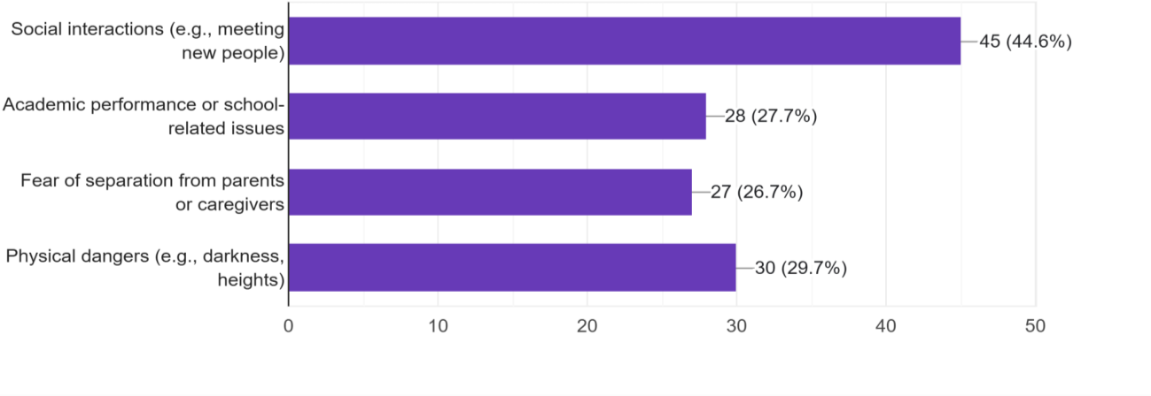
% exceeds due to multiple responses

Figure No : 02
Most common situations where child appears anxious or fearful
The data revealed that social interactions, particularly meeting strangers, emerged as the most frequently reported trigger for anxiety, cited by 44.6% of respondents, which emphasizes that limited exposure to varied social environments can contribute to heightened social anxiety in young children (Beidel & Turner, 2007). Fear related to physical dangers, such as darkness and heights, was reported by 29.7% of the parents. Academic-related fears were also significant, with 27.7% of respondents indicating that their children exhibited anxiety related to school performance, examinations, or classroom activities. The growing impact of academic pressure on children’s mental well-being, especially when performance expectations are perceived as high (Putwain & Symes, 2014). Furthermore, 26.7% of the children were observed to exhibit separation anxiety, particularly in situations involving temporary detachment from their primary caregivers.

Child expressing fear of specific objects or situations
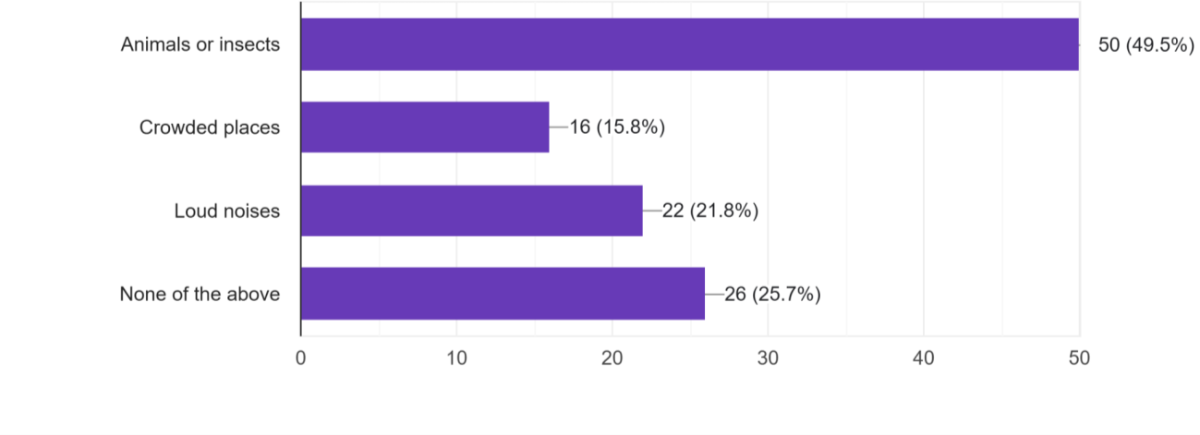
% exceeds due to multiple responses

Figure No : 03
Child expressing fear of specific objects or situations
The findings reveal that fear of insects or animals is the most frequently expressed concern among children, reported by 49.5% of respondents suggests that such fears often arise due to limited exposure, the unpredictability of animal behavior, or their perceived threat (LoBue & DeLoache, 2008). Children may possess an innate predisposition to fear certain animals, such as snakes or spiders, as a protective survival mechanism (Öhman & Mineka, 2001).
Fear of loud noises, including thunder, firecrackers, sirens, or vacuum cleaners, was reported by 21.8% of the parents. Young children, particularly infants and toddlers, are known to have heightened auditory sensitivity, making them more vulnerable to sudden or intense sounds (Hall, 2007). Fear of crowded places was expressed by 15.8% of children, especially in settings such as shopping malls, family events, or public transport. In children with introverted temperament traits or social sensitivity (Schmidt et al., 2009; Rubin et al., 2009). Notably, 25.7% of respondents indicated that their children did not express fear toward any of the specific objects or situations listed. Emotional security contribute significantly to the minimization of childhood fears (Cassidy & Shaver, 2016).

Typical reaction of the child when afraid
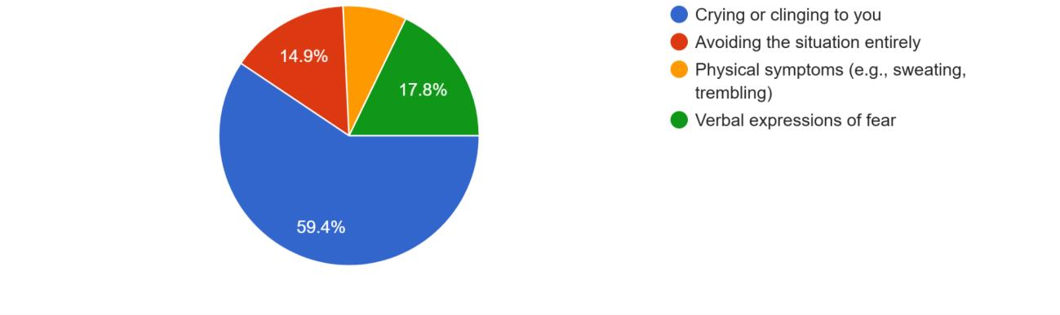
Figure No: 04
Typical reaction of the child when afraid
The data reveal that the most common response exhibited by children when afraid is crying or clinging to parents, reported by 59.4% of the participants. Physiological symptoms such as trembling, sweating, or freezing were observed in 14.9% of children. Avoidance behavior was reported in 7.9% of children, wherein they actively attempt to escape or withdraw from the fear-inducing scenario. While avoidance may offer temporary emotional relief, it has been associated with reinforcing anxiety over time (Field, 2006).
Child’s Coping Mechanisms and Emotional Regulation with fear and anxiety
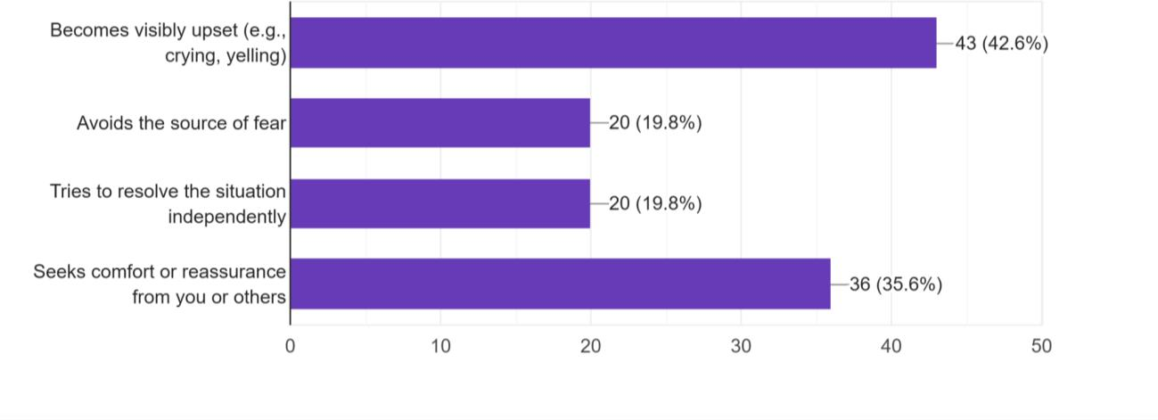
Figure No.:05
Child’s Coping Mechanisms and Emotional Regulation with fear and anxiety
The most frequently reported response was seeking comfort or reassurance from parents, observed in 35.6% of children. The second most common coping behavior was becoming visibly upset crying or yelling, reported in 25.7% of cases. Avoidance of the fear-inducing situation, identified in 19.8% of children, also emerged as a significant response. Interestingly, 19.8% of children demonstrated attempts to resolve the situation independently, suggesting the development of autonomy, self-efficacy, and problem-solving abilities. This proactive response may be attributed to supportive parenting, modelled coping behaviors, and positive past experiences.

Frequency with which children seek emotional support while experiencing fear or anxiety

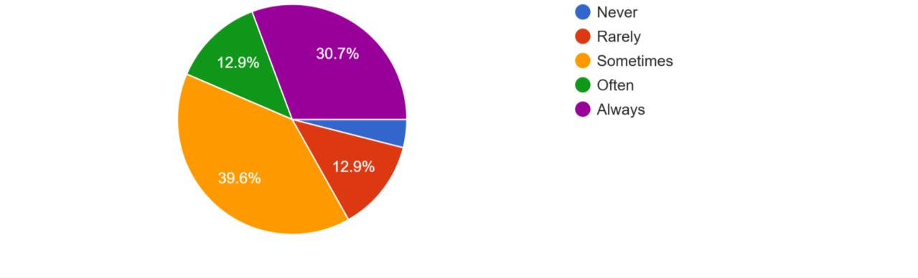
Figure No : 08
Duration seeking emotional support when experiencing fear or anxiety
The most commonly reported response (39.6%) was that children alternated between seeking comfort from their caregivers and attempting to manage their fears independently. A notable portion of children (30.7%) consistently sought comfort from their parents when experiencing fear, indicating a high level of emotional dependence. In contrast, 12.9% of children demonstrated minimal comfort-seeking, which could reflect underlying factors such as shyness, insecure attachment, or a preference for self-reliance. Research by Cassidy and Shaver (2016) suggests that children who seldom express fear may experience difficulties in emotional communication, potentially leading to internalized stress and unaddressed emotional needs.

Effectiveness of Parental Responses to Child’s Fear and Anxiety

Table No : 04
Effectiveness of Parental Responses to Child’s Fear and Anxiety
Effectiveness | Response type
Level | Distraction | Modelling | Problem solving | Reassurance | Punishment
1-Not effective at all | 0 | 0 | 1 | 2 | 1
2- Slightly effective | 1 | 2 | 2 | 5 | 0
3- moderately effective | 3 | 5 | 9 | 10 | 0
4- Very  Effective | 5 | 4 | 20 | 17 | 2
5- extremely effective | 0 | 1 | 3 | 8 | 0
Total |  |  |  |  |  | 101
Reassurance emerged as a highly effective response, with 17 respondents considering it very effective and 8 finding it extremely effective. Previous research indicates that children who receive comfort and validation from their caregivers during anxious moments are more likely to develop resilience and adaptive emotional responses (Eisenberg et al., 2001). Punishment was deemed largely ineffective, with only two respondents considering it very effective and none rating it extremely effective.

Table No : 05
The impact of various parental response types on the effectiveness of managing children's fear and anxiety
Source of variation | Sum of Squares | Degrees of freedom | M S S | Calculated F value | Tabled F value
Effectiveness level | 250.56 | 4 | 62.64 | 5.971 | 3.0069
Response type | 236.56 | 4 | 59.14 | 5.63 | 3.0069
Error | 167.84 | 16 | 10.49
Total | 654.96
Null Hypothesis (H₀): There is no significant difference in the effectiveness of parental response types, meaning all strategies are equally effective in managing children’s fear and anxiety.
Alternative Hypothesis (H₁): Parental response types significantly influence the effectiveness of strategies, indicating that some responses are more beneficial than others.
The analysis revealed that the F-values for both effectiveness level (5.971) and response type (5.63) exceeded the tabled F-value (3.0069), indicating statistical significance. Therefore, the null hypothesis (H₀) was rejected, supporting the conclusion that parental response strategies significantly impact children’s ability to cope with fear and anxiety. These results highlight the importance of employing effective parental strategies, with problem- solving, reassurance, and modelling proving to be far more effective than punishment or distraction.

Table No: 06
Correlation Heat map on the relationship between different parental response types and their effectiveness levels
Effectiveness  Level | Distraction | Problem Solving | Modelling | Reassurance | Punishment
1 | 0 | 0 | 1 | 2 | 1
2 | 1 | 2 | 2 | 5 | 0
3 | 3 | 5 | 9 | 10 | 0
4 | 5 | 4 | 20 | 17 | 2
5 | 0 | 1 | 3 | 8 | 0
The correlation heat map above visually represents the relationship between various parental response types and their corresponding effectiveness levels in managing children's fear and anxiety. As the effectiveness levels rise, problem-solving consistently receives higher ratings, reaching 20 responses at level 4. This suggests that helping children find solutions to their fears is one of the most effective strategies employed by parents. Similar to problem-solving, reassurance ranks high at level 4 (17 responses) and level 5 (8 responses), indicating that emotional comfort and validation are essential in mitigating fear and anxiety in children. Parental modelling, where parents demonstrate calm and confident behavior, gradually improves in effectiveness, peaking at level 4 (20 responses). This finding supports the concept that children often learn to cope by observing and imitating their caregivers' behaviors.
Distraction shows varied results, with a peak at level 4 (5 responses). Although distraction can provide temporary relief in acute anxiety situations, it does not consistently address the underlying causes of fear. Punishment was deemed minimally effective across all levels, with no responses at level 5. This confirms that punitive measures are ineffective in managing children's fear and may even exacerbate anxiety. Overall, problem-solving and reassurance emerge as the most effective techniques for helping children cope with fear and anxiety. Modelling can be beneficial, especially when combined with reassurance, while distraction offers only short-term relief. Punishment, however, is found to be ineffective in promoting emotional well-being.

Level of emotional support provided to child by the parent in anxiety-inducing situations

Table No: 07
Emotional Support and Resilience
Particular | emotional support helping the child become more resilient in facing anxiety-inducing situations.
Particular | Intensity | Agree | Disagree | Neutral | Strongly Agree | Strongly Disagree
 | High | 40.5 % | 2.7% | 18.9% | 35.1% | 2.7%

Level of emotional support provided to the child in anxiety- inducing situations | Low | 66.7% | 0% | 33.3% | 0% | 0%
 | Moderate | 37.8% | 10.8% | 37.8% | 5.4% | 8.1%
 | Very Low | 27.8% | 0% | 0% | 72.2% | 0%
Among parents who provided high levels of emotional support, 40.5% agreed, and 35.1% strongly agreed that emotional support helps their child become more resilient. This is consistent with prior research that underscores the role of secure parental attachment in fostering emotional resilience (Cassidy & Shaver, 2016). Parents who provided moderate emotional support showed mixed responses, with 37.8% agreeing, and 10.8% disagreeing. Among parents who provided low emotional support, 66.7% agreed that emotional support aids in resilience, though no one strongly agreed. In cases where emotional support was very low, 72.2% strongly agreed on the importance of emotional support in fostering resilience, indicating that these parents acknowledge its significance but struggle to provide it effectively.

Parental Emotional Support and its Impact on Children's Coping with Fear and Anxiety

Table No : 09
Parental Emotional Support and its Impact on Children's Coping with Fear and Anxiety
Particular | How parents responses child with cope with fear or anxiety
Particular | Not effective | Slightly effective | Moderately effective | Very effective | Extremely effective | ????
The rate of level of emotional support provided to child in anxiety- inducing situations | High | 5.4 | 2.7 | 24.3 | 62.2 | 5.4
 | Low | 0 | 33.3 | 33.3 | 33.3 | 0
 | Moderate | 5.4 | 16.2 | 37.8 | 37.8 | 2.7
 | Very high | 0 | 0 | 11.1 | 44.4 | 44.4
 | Very Low | 0 | 33.3 | 0 | 33.3 | 33.3
A significant 62.2% of parents providing high emotional support observed their child coping "very effectively," while only 5.4% rated coping as "not effective." These results support existing research indicating that children who receive stable emotional support develop stronger emotional regulation and resilience (Cassidy & Shaver, 2016). Among parents providing moderate emotional support, 37.8% observed their child coping "very effectively," with another 37.8% rating coping as "moderately effective." While this shows a positive impact, 16.2% of parents felt the support was only slightly effective. 33.3% of parents noted that their child coped moderately well, but none reported "extremely effective" coping. Another 33.3% rated coping as only "slightly effective." 33.3% reported their child coping "very effectively," but an equal percentage observed "not effective" coping. The findings suggest a clear trend: higher levels of emotional support are associated with better coping mechanisms in children, reinforcing the importance of parental responsiveness and reassurance. While the correlation coefficient of 0.354 indicates a moderate relationship, other factors such as attachment quality, personality traits, and environmental stability also play a role in children’s ability to manage fear and anxiety.

The influence of parental coping strategies on children's ability to manage fear and anxiety
H0: There is significant influence between parental coping strategies in children’s ability to manage fear and anxiety.
H1: There is no significant influence between parental coping strategies in children’s ability to manage fear and anxiety.

Table No: 11
The influence of parental coping strategies on children's ability to manage fear and anxiety
Test | Value | df | Asymp. Sig. (2- sided)
Pearson Chi- square | 32.69 | 20 | 0.0365
Likelihood Ratio | 30.12 | 20 | 0.0408
Chi-Square and Likelihood Ratio Results: The Pearson Chi-Square test result (χ² = 32.69, df = 20, p = 0.0365) demonstrates statistical significance, as the p-value is less than 0.05. Therefore, the null hypothesis is accepted, confirming a significant association between parental coping strategies and children’s emotional responses. The Likelihood Ratio test (χ² = 30.12, df = 20, p = 0.0408) supports this conclusion, adding robustness to the finding.
Cramer’s V Analysis: Cramer’s V indicates a moderate effect size, signifying that while parental strategies play a meaningful role in shaping children’s responses to fear and anxiety, other contextual and personal factors such as individual temperament, peer influences, and environmental conditions may also impact emotional resilience. These findings emphasize the importance of intentional and emotionally responsive parenting practices. Coping strategies that include emotional validation, structured routines, and open communication tend to foster healthier stress responses in children. Conversely, punitive or neglectful reactions are less effective and may hinder emotional development (Cassidy & Shaver,2016).
Utilization of External Support Systems by Parents
Table No : 12
Seeking External Support for Managing Children's Fear and Anxiety

 | Frequency | Percent
Valid No | 82 | 81.2
Yes | 19 | 18.8
Total | 101 | 100.0
An analysis of the data reveals that a significant majority of parents (81.2%) did not seek external professional assistance such as therapy, counseling, or structured parenting programs when dealing with their child’s fear or anxiety. This trend corresponds with previous research suggesting that parents commonly prefer to manage their children's emotional challenges independently, utilizing methods such as reassurance, distraction, or comfort-driven approaches (Eisenberg et al., 2001).
On the other hand, 18.8% of parents reported seeking external support. For them, engaging professional support was not necessarily an indication of failure, but rather a proactive step towards understanding their child better and fostering a more supportive and peaceful home environment.

Parental Challenges and Support
The table outlines the various challenges parents face when supporting their children through fear and anxiety.

Table No : 13

Challenges Reported by Parents in Supporting Children’s Emotional Needs

Particular | Frequency | Percent | Valid Percent | Cumulative percent
Valid find it difficult to stay calm when my child is upset | 29 | 28.7 | 28.7 | 28.7
Hope my strategies work well at its best | 1 | 1.0 | 1.0 | 29.7
I don’t know a How to respond effectively | 17 | 16.8 | 16.8 | 46.5
I’m not sure what strategies work best | 30 | 29.7 | 29.7 | 76.2
Lack time or resources to support my child properly | 13 | 12.9 | 12.9 | 89.1

My child doesn't want help or reassurance | 10 | 9.9 | 9.9 | 99.0
Nothing | 1 | 1.0 | 1.0 | 100.0
Total | 101 | 100.0 | 100.0
Nearly 29.7% of respondents reported uncertainty about the most effective strategies to use, indicating a need for greater access to parenting guidance and evidence-based interventions. Additionally, 28.7% found it difficult to regulate their own emotions during moments of distress, which may hinder their ability to provide calm and effective support. A notable 16.8% expressed not knowing how to respond effectively, reflecting a lack of confidence or understanding regarding emotional support techniques. Furthermore, 12.9% of parents reported limitations in time or resources, which could be linked to occupational stress, household responsibilities, or financial constraints. These external barriers may restrict the ability to offer consistent and meaningful emotional support. Another challenge identified by 9.9% of parents was the child's resistance to help or reassurance, pointing to deeper emotional barriers or trust issues that complicate intervention efforts. A minimal proportion of parents (1%) reported either relying on hope that their current strategies would suffice or facing no significant challenges at all.
Parental Validation of Children’s Emotions During Fear or Anxiety
Source of Variation | SS | df | MS | F | P-value | F crit
Due to effect of validation | 5.069307 | 1 | 5.069307 | 4.608461 | 0.033019 | 3.888375
Error | 220 | 200 | 1.1
Total | 225.0693 | 201
The above ANOVA table analyzes the influence of parental validation on children’s emotional responses during episodes of fear or anxiety. The F-value (4.608) exceeds the critical F-value (3.888), and the associated P-value (0.033) falls below the standard threshold of 0.05. These results indicate a statistically significant effect, highlighting the importance of parental validation in enhancing a child's emotional regulation. Validation, in this context, refers to a parent's acknowledgment and acceptance of a child's emotional experience. This approach fosters emotional safety and psychological resilience.
Effectiveness of Parenting Practices in Helping Children Manage Fear and Anxiety
Table no : 18
Effectiveness of parenting practices to navigate their child’s fear and anxiety
Source of Variation | SS | df | MS | F | P-value | F crit
Due to  regulation of children experiencing fear and  anxiety | 104.0842 | 1 | 104.0842 | 135.4529 | 3.05E-24 | 3.888375
Error | 153.6832 | 200 | 0.768416
Total | 257.7673 | 201

H0=This means that there is no significant difference in the regulation of children experiencing fear and anxiety
H1=This means that there is a significant difference in the regulation of children experiencing fear and anxiety.
since f> fα , we reject H0
The final ANOVA analysis further supports the critical role of parenting practices in managing children's fear and anxiety. With an exceptionally high F-value (135.45) and a P-value close to zero (3.05E-24), the results provide robust evidence that such interventions significantly contribute to children’s emotional well-being.
In conclusion, validation, emotional expression, and intentional parenting strategies emerge as key components in the emotional development of children. The statistical significance in all three analyses emphasizes that these practices are not just theoretically beneficial but demonstrably impactful. Integrating these approaches into daily routines can create an emotionally nurturing environment that promotes mental health and long-term emotional resilience in children.

CONCLUSION
These findings highlight the critical role of parental involvement in shaping children’s fear management and resilience. While most children benefit from emotional support, the effectiveness of coping strategies varies. Future research could explore individualized intervention methods, long-term impacts of parental emotional regulation, and external influences on fear responses.

Recommendations
Based on the findings of this study, several recommendations can be made to enhance parental effectiveness in supporting children through fear and anxiety.

Strengthening Parental Awareness and Education
  - Develop workshops that provide evidence-based strategies for managing childhood anxiety.
  - Offer accessible resources, such as online guides and webinars, to educate parents on emotional validation and regulation techniques.
  - Encourage self-reflection exercises that help parents recognize their own emotional responses and their impact on their children.

Enhancing Emotional Validation and Communication
  - Teach parents active listening skills to foster open conversations about emotions.
  - Promote reflective responses, ensuring children feel understood rather than dismissed.
  - Incorporate storytelling, art, and play-based activities to help children express their emotions.

Providing Structured Coping Strategies
  - Introduce mindfulness exercises (deep breathing, guided imagery) for emotional regulation.
  - Encourage journaling or other expressive activities to help children process fear and anxiety.
  - Recommend routine-based approaches, offering consistency and stability to reduce anxiety triggers.

Limitations of the Study
While the study provides valuable insights into parental challenges and strategies for supporting children's emotional well-being, some limitations should be acknowledged:
- The study was conducted with a sample of 101 participants, which may not fully represent diverse parenting experiences across different cultural, social, or economic backgrounds.
- The findings rely on self-reported responses, which may introduce bias as participants could either overestimate or underestimate their confidence, awareness, and strategies in managing their child's fear and anxiety.
- The study measures immediate improvements after the program but does not track long- term effectiveness in sustaining parental confidence or behavioral changes over time.
- Limited Exploration of Cultural Factors: Although cultural and societal influences were examined, deeper qualitative insights into how specific traditions, social norms, or family structures shape parental practices could strengthen the study.
- Participants may have provided socially desirable answers, especially in post-program evaluations, leading to possible inaccuracies in the reported improvements.

BIBLIOGRAPHY
  - Barrett, P. M., Dadds, M. R., and Rapee, R. M. (2011). The Friends program: A cognitive- behavioral approach to the prevention of anxiety in children. Journal of Clinical Child and Adolescent Psychology, 40(1), 1-16. https://doi.org/10.1080/15374416.2011.533285
  - Barrett, P. M., Rapee, R. M., Dadds, M. R., & Ryan, S. M. (1996). Family enhancement of cognitive style in anxious children. Journal of Abnormal Child Psychology, 24(2), 187- 203.
  - Beidel, D. C., & Turner, S. M. (2007). Shy children, phobic adults: Nature and treatment of social anxiety disorder. American Psychological Association.
  - Beidel, D. C., and Turner, S. M. (1998). Shyness and social phobia in children. In J. M. T.
  - Bögels, S. M., and Brechman-Toussaint, M. L. (2006). Family issues in the development and treatment of childhood anxiety. Clinical Child and Family Psychology Review, 9(2), 137-154. https://doi.org/10.1007/s10567-006-0009-3
  - Cassidy, J., & Shaver, P. R. (2016). Handbook of attachment: Theory, research, and clinical applications. Guilford Press.
  - Eisenberg, N., and Cumberland, A. (2004). Parental socialization of emotion. Psychological Inquiry, 15(3), 241-244.
  - Eisenberg, N., and Morris, A. S. (2002). Children's emotional regulation and parenting. Child Development, 73(3), 1022-1045. https://doi.org/10.1111/1467-8624.00452
  - Eisenberg, N., Cumberland, A., & Spinrad, T. L. (1998). Parental socialization of emotion.
Psychological Inquiry, 9(4), 241–273. https://doi.org/10.1207/s15327965pli0904_1
  - Eisenberg, N., Cumberland, A., Spinrad, T. L., Fabes, R. A., Shepard, S. A., Reiser, M., ... & Guthrie, I. K. (2005). The relations of regulation and emotionality to children’s externalizing and internalizing problem behavior. Child Development, 76(5), 1112–1131. https://doi.org/10.1111/j.1467-8624.2005.00898.x
  - Eisenberg, N., et al. (1997). The role of emotional regulation in the development of anxiety. Child Development, 68(2), 266-282. https://doi.org/10.2307/1131816
  - Eisenberg, N., Fabes, R. A., & Murphy, B. (2001). Parenting and children's emotional development. Journal of Personality and Social Psychology, 81(3), 687-701.
  - Eisenberg, N., Spinrad, T. L., & Morris, A. S. (2001). Regulation, resiliency, and quality of social functioning. Self and Identity, 1(2), 121–128.
  - Ginsburg, G. S. (2009). The role of parents in the development of anxiety disorders in children. Clinical Child and Family Psychology Review, 12(3), 130-148.
  - Hall, J. W. (2007). Newborn hearing screening and auditory sensitivity. Plural Publishing.
  - Kagan, J. (1997). Temperament and the reactions to novelty. Child Development, 68(3), 535-544.
  - LoBue, V., & DeLoache, J. S. (2008). Detecting the snake in the grass: Attention to fear- relevant stimuli by adults and young children. Psychological Science, 19(3), 284-289.
  - Muris, P., Merckelbach, H., and Mayer, B. (2001). Fear and anxiety in children. Journal of Anxiety Disorders, 15(2), 195-212.
  - Murray, L., Creswell, C., and Schofield, H. (2008). The development of anxiety in childhood: The role of parental support and attachment. Developmental Psychology, 44(6), 1630-1641.
  - Öhman, A., & Mineka, S. (2001). The evolutionary psychology of fear. Psychological Review, 108(3), 483-522.
  - Öst, L. G. (1987). Phobias and the process of change. In E. S. J. (Ed.), Anxiety and Its Disorders (pp. 349-375). Springer.
  - Putwain, D. W., & Symes, W. (2014). Academic pressure and fear of failure in the classroom. Educational Psychology, 34(4), 385-399.
  - Rapee, R. M., Sandberg, S., and Carpenter, J. (2005). The role of parental overprotection in the development of anxiety. Clinical Child and Family Psychology Review, 8(2), 109- 117.
  - Rubin, K. H., Coplan, R. J., & Bowker, J. C. (2009). Social withdrawal and shyness in childhood. Annual Review of Psychology, 60(1), 141-171.
  - Schmidt, L. A., Fox, N. A., & Henderson, H. A. (2009). Temperamental contributions to social behavior. Developmental Psychology, 45(6), 1603-1615.

