The Complex and Dynamic Nature of Educational Processes: Teacher Stress and Coping Mechanisms

Keywords: Teacher stress, coping strategies, interpersonal relationships, job satisfaction.

The Complex and Dynamic Nature of Educational Processes: Teacher Stress and Coping Mechanisms

La Naturaleza Compleja y Dinámica de los Procesos Educativos: Estrés Docente y Mecanismos de Afrontamiento

Abstract
The study explored stress coping strategies in teachers, given the current social, academic, and work challenges. A qualitative perspective and the Modified Coping Strategies Scale (EEC-M) 2021were used to assess the risks associated with the lack of stress-coping strategies in teachers of a private educational institution in Monteria. The results indicate that the absence of a consistent coping pattern resulted in irritability, interpersonal tensions, and emotional repression among teachers. They tend to avoid relationships during crises and look for professional solutions, which negatively affects their performance and well-being, which finally has repercussions in the family environment. A tendency towards waiting for cooling off and internalization with emotional repression is observed, reflecting a fear of implementing coping alternatives. This analysis highlights the manifest need for effective strategies among the population studied.
Keywords: Teacher stress, coping strategies, interpersonal relationships, job satisfaction.

Resumen
El estudio exploró las estrategias de afrontamiento del estrés en docentes de una institución educativa privada en Montería, ante desafíos sociales, académicos y laborales. Se adoptó un enfoque cualitativo utilizando la Escala de Estrategias de Afrontamiento Modificada (EEC-M, 2021). Los resultados muestran la ausencia de un patrón de afrontamiento consistente, lo que genera irritabilidad, tensiones interpersonales y represión emocional. Los docentes tienden a evitar relaciones en momentos de crisis y a buscar ayuda profesional, lo cual afecta su bienestar, desempeño laboral y entorno familiar. Se identificó una tendencia a la espera pasiva y a la interiorización emocional, motivada por el temor a aplicar estrategias alternativas. El análisis destaca la necesidad urgente de fortalecer el afrontamiento efectivo en esta población.
Palabras claves: Estrés docente, estrategias de afrontamiento, relaciones interpersonales, satisfacción laboral.

Introduction

The education process represents one of the most complex and dynamic scenarios, being the performance of the teacher an important part that represents an index of the educational quality of the institution; the teacher is adapted to present changes and efficiently takes advantage of the resources provided (Hidayah et al, 2023). With the evolution of society and education, teachers experience changes in their perception and work environment, affecting their lifestyle, shaping their praxis, and exerting a set of pressures that generate stressful situations. The World Health Organization (2020) highlights stress as a factor that affects productivity and mental health, causing mental and physical dysfunctions that inhibit the development of personalities in every area of life, including the job of an educator.
In this order of ideas, it is evident that teachers face dynamic challenges not only in their praxis, but also in their management of emotions. In Colombia, 33% of teachers have experienced work stress linked to extreme workloads and the lack of a stress management strategy (Rojas, 2020). The reality of the teacher is subject to the educational process, the institution, the students; and likewise, to job demands, where there are variables that affect their coupling and adaptation in the academic environment, given that they cannot create a positive learning environment for the execution of their activities (Ragoonaden, 2017). Teachers also have to work on curricular development of programs and the Institutional Educational Project (PEI in Spanish). There are also tasks of recognition and stimulation of students' abilities, administrative articulation, community and labor integration, as well as scenarios of dialogue with parents and various commemorative, recognition, and extracurricular development activities.
All of the aspects mentioned previously are far from the presumption of the word teaching that is conceived in this area of the country, which shows that from the perspective of Pérez (2015), the exercise of the educator is conditioned by the workload and the assignment of functions in which there is an interaction with different individuals; therefore, a diversity of personalities that configure a work climate, determinant within the emotional process of the individual and a trigger for stress. According to Menghi (2015), stress is the alteration due to the demand of excess of performance in the face of events that are part of a habit or lifestyle. The continuity of the stimulus, considered as adverse, produces physical and mental problems. Lazarus & Folkman (1986) state that it starts as a shock stage, followed by a counter-shock stage; which tries to overcome the situation without success; and finally, a stage of adaptation to stress that will generate symptoms of exhaustion, lack of willingness, and unwillingness to the environment or situation. Likewise, et al., (2020) studied teacher stress and burnout and its relationship to the coping competency and context (3C) theory, this model highlights three critical pathways to intervene in teacher stress, as well as showing the relationship between it and student outcomes.
The teachers may perceive pressure or stress in their jobs due to factors such as using digital tools (Luque, 2022). Similarly, Sierra (2021) identified stressors such as hierarchical supervision and lack of recognition, which generate, in addition to demotivation, occupational stress. In addition to the spiral of interpersonal stressors occurring between work actors, one paper recognized that interpersonal stressors at work evoke interpersonal stressors at home Grandey et al., (2022). In this sense, mechanisms have been created to reduce the pressure that teachers may feel in the work environment, as expressed by Forero (2020), who focused the study on the effects of an intervention to reduce stress and ensure adequate use of the voice in preschool and elementary school teachers. The intervention process consisted of activities, along with knowledge surveys, after which teachers were presented with a video per thematic subject, with basic information and practical exercises for stress management.
It is important to highlight that individuals require processes that allow them to understand the events, assimilate reality, and decide what measures must be taken in stressful situations, which should suggest having clarity in the behavioral patterns of the individual and taking actions before the stressor event to visualize a series of psychosomatic, behavioral, emotional, and cognitive symptoms (Díaz & Aladro, 2016). The objective of the research is to explore the strategies used for coping with various stressful situations, to know their particular situation, and to identify their needs to strengthen coping strategies. This facilitates establishing institutional policies related to self-care and designing strategies as preventive measures of occupational risks that may occur due to the low capacity of community members to implement stress-coping mechanisms (Macías, 2019).

Methodology

The study had a mixed approach, which made it possible to address intervention needs by combining qualitative and quantitative methods. This approach seeks to understand a specific reality. In addition, it uses a measurement scale to locate and relate aspects of analysis in the context (Hernández & Mendoza, 2018). The scope of the study was descriptive, and its purpose was to know the coping strategies of the teachers of the educational institution when faced with stressful situations during their work period in 2023.

Data collection techniques and instruments

Direct observation, recorded in an observation diary, was implemented as a typical strategy of the qualitative research approach. The information obtained was described in detail, establishing a reference parameter to compare the reality with the existing literature. This approach made it possible to understand the context and the scenario in which the actors involved in the process of improving the conditioning factors of the problem live, thus seeking to transform reality (Hernández et al., 2014).
The Coping Strategies Scale - (EEC-M) (Londoño et al., 2006; Ortiz, et al, 2021) (See Annex A), was used in the quantitative component of the research. The adaptation of this scale, originally with 90 items, was adjusted to 60 items to meet the specific objectives of the study. A Google forms questionnaire was used for data collection, with prior disclosure of the process and consent of the participants who were notified of the process and its importance. The instrument was filled up online in a single application moment; teachers from different areas of this educational institution were approached via institutional e-mail. The questionnaire was sent to them after consulting their availability to participate. For the application, there was a previous explanation of the intention of the study, its objectives, and the situational context, as well as an explanation of the handling of the instrument; it was applied with total anonymity for every teacher in a private and individual space.

Population and sample

The study focused on the total population of 80 teachers of a private educational institution in Monteria, 82.5% women and 17.5% men.

Data analysis

Descriptive statistics were used for the analysis of the data collected, using frequency tables and percentages to determine the answers that were reiterative among the participants and to define the factors with the greatest impact on the stress of teachers during work.

Results

The study characterized the population of teachers of the educational institution indicating that the predominant coping style is repressive, with a marked tendency to denial and avoidance. According to the study, teachers adopt a passive and expansive posture, experiencing anxiety and triggering elevated physiological actions. Approximately 70% of the population shows defense codes that can be transformed into aggressiveness and stereotyped actions of weak demands in stressful situations. Only 10% cope flexibly, with non-defensive actions and low levels of avoidance. Regarding communication of discomfort, teachers limit their ways of expression in the work environment, shifting the burden to home. Although it is communicated to family members, there is no tendency to discuss the problem with a professional. Most expect it to resolve itself, with a notable tendency to hostility (above 80%). The search for social support is limited, and the lack of strategies or styles from the welfare management of the educational institution is reflected in the absence of a dynamic coping of stressful situations.
The above can be evidenced in the figures numbered 1 to 9, which follow a pattern of action and recurrence of this perception that is exposed within the parameters of analysis from items 10, 11, 12, 20, 24, 36, 42, 50, and 52 of the applied test. These items were selected because they were the most relevant from the point of view of social behavior and psychological implications such as context avoidance and avoidance. In this sense, Table 1 shows a graph that collects the participant’s answers by items and their corresponding averages in the application, to have a clear and consistent view of how stress-coping and the associated processes are perceived, as well as the implications that it has from the answers obtained. The averages per item are based on the valuation of each point of the scale that follows. From the results obtained, the valuation table seeks to condense the data from the parameterization that goes from 1 to 6 according to the perspective of the interviewee, as follows: 1 Never, 2 Rarely, 3 Sometimes, 4 Frequently, 5 Almost always, 6 Always.
Figure 1.
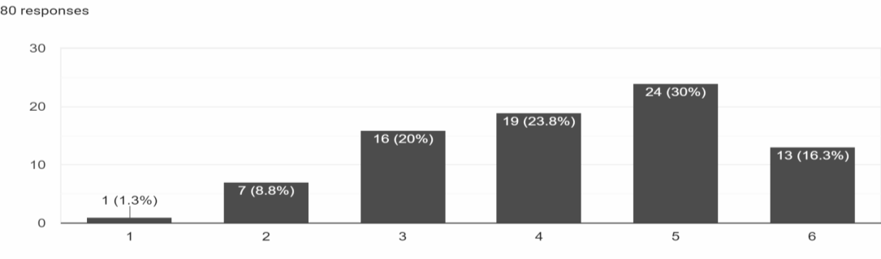
Frequency of Engagement in Leisure Activities as a Stress-Coping Strategy.
Note: 1 Never, 2 Rarely, 3 Sometimes, 4 Frequently, 5 Almost always, 6 Always.
Figure 2 shows the elements from which the percentage of help-seeking is averaged, the trend shows that approximately 60% of the participants never seek help or only do so sometimes.

Figure 2.
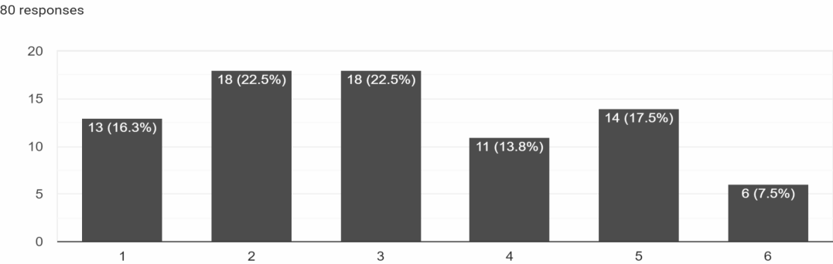
Frequency of Seeking Professional Help as a Coping Mechanism.

Note: 1 Never, 2 Rarely, 3 Sometimes, 4 Frequently, 5 Almost always, 6 Always.
Thus, Figures 1 and 2 are related, with the highest values referring to seeking help as never, almost never, or sometimes. This shows that there is no tendency to seek professional help; participants only seek to engage in activities that distract them instead of facing these situations.
Figure 3 shows that 32.5% of participants leave everything in God's hands as a coping strategy.
Figure 3.
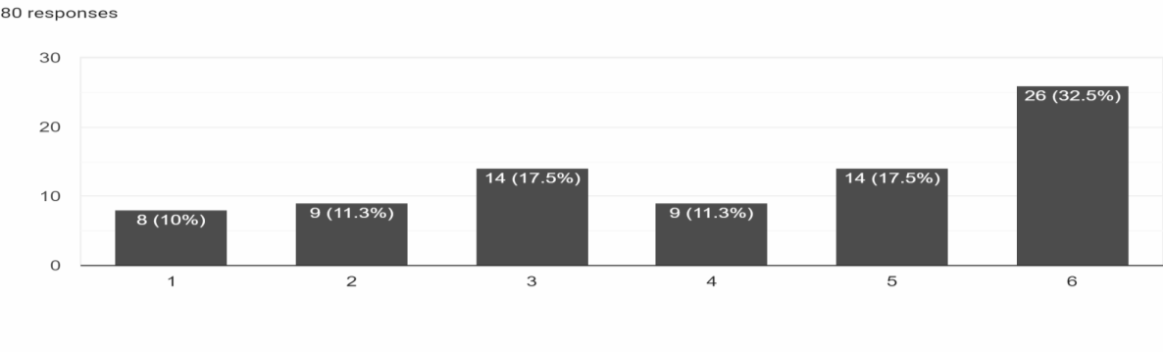
Reliance on Divine Help as a Coping Strategy
Note: 1 Never, 2 Rarely, 3 Sometimes, 4 Frequently, 5 Almost always, 6 Always.
Figure 4 shows that approximately 60% of participants go to their relatives to communicate their feelings frequently, almost always, or always.
Figure 4.
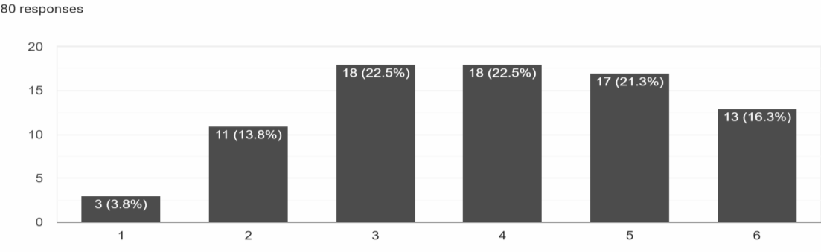
Need to Be Heard by Family or Friends During Stressful Situations
Note: 1 Never, 2 Rarely, 3 Sometimes, 4 Frequently, 5 Almost always, 6 Always.
On the other hand, Figure 5 shows that approximately 63% of the participants turn to family members for guidance as a stress-coping strategy. This, together with the results in Figure 4, shows a tendency to express the need to receive advice on how to deal with the situations they face daily.
Figure 5.
Seeking Advice from Family Members as a Coping Mechanism
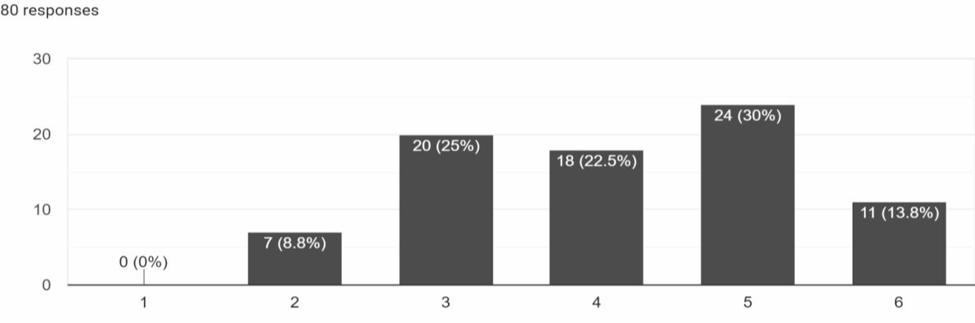
Note: 1 Never, 2 Rarely, 3 Sometimes, 4 Frequently, 5 Almost always, 6 Always.
One of the most subjective patterns is Religion as Figure 6 shows that approximately 54% of the participants frequently, almost always, or always expect a supernatural event to help them solve their situation.
Figure 6.
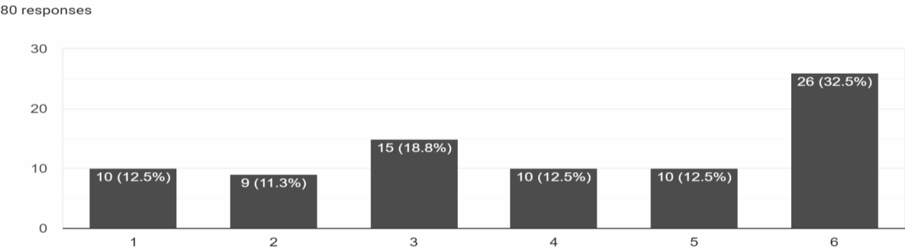
Belief in Miraculous Solutions as a Coping Strategy
Note: 1 Never, 2 Rarely, 3 Sometimes, 4 Frequently, 5 Almost always, 6 Always.
Figure 7, in agreement with Figures 3 and 6, shows that at least 71% of the participants frequently, almost always, or always have faith in God.
Figure 7.
Faith in Divine Intervention to Cope with Stress
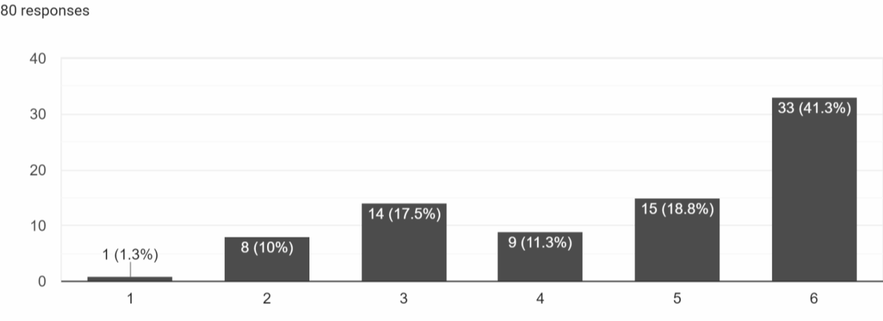
Note: 1 Never, 2 Rarely, 3 Sometimes, 4 Frequently, 5 Almost always, 6 Always.
Figure 8 shows that only 25% of participants ask for professional help frequently, almost always, or always to relieve stress.
Figure 8.
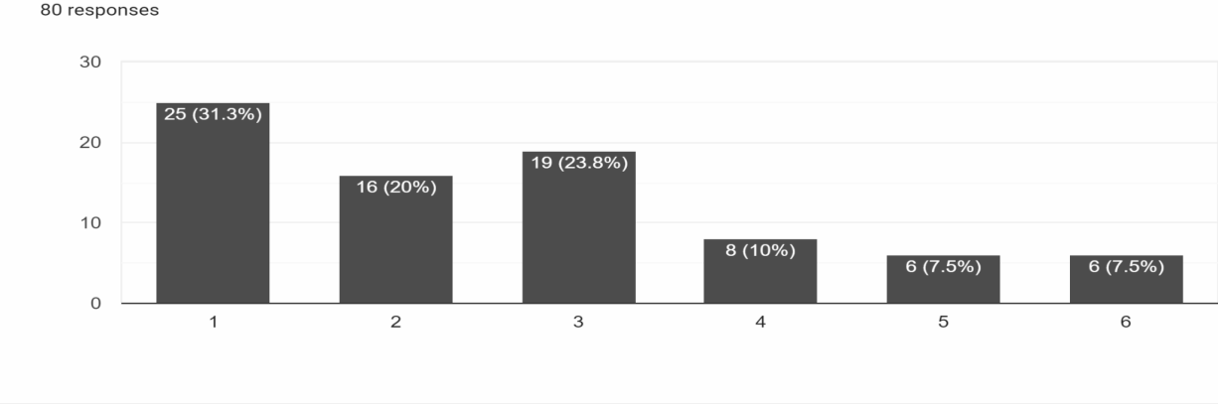
Seeking Professional Psychological Help to Relieve Stress
Note: 1 Never, 2 Rarely, 3 Sometimes, 4 Frequently, 5 Almost always, 6 Always.
In the evaluated context, it is recurrently observed in the participants’ answers to patiently wait for a divine solution, which conditions the actions of the participants. Prayer is presented as a considerable alternative, highlighting the fragility of autonomy to face situations, resulting in the no expression of emotions and denial. This lack of emotional expression puts mental health at risk, manifesting itself in recurrent and increasing irritability, limiting the capacity for expression. Although there is a greater tendency to seek support rather from the family than professional help, this suggests patterns of thinking in alternatives from wrong or insufficient perspectives. Despite the absence of defined patterns or strategies for coping with stress, the test results indicate that they are not inclined toward hostile environments. The graphs presented show the analysis of the role of the teachers of the educational institution in stress scenarios, as shown in Figure 9, evaluating group perceptions.
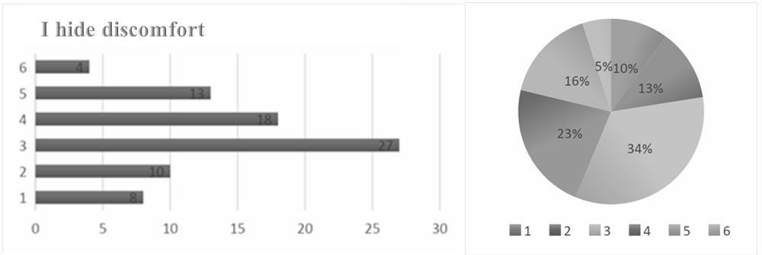
Figure 9. Suppression of Discomfort in the Workplace (Item 24).
Note: 1 Never, 2 Rarely, 3 Sometimes, 4 Frequently, 5 Almost always, 6 Always.

Figure 9 shows that approximately 50% of the participants try to hide their discomfort frequently, almost always, or always. That is, teachers repress discomfort and there is no expression of it, which minimizes the risks of disruption of interpersonal relationships. This shows that there are scenarios within the denial in which elements are sought to minimize the friction and actions that may jeopardize the interpersonal relationships of teachers, allowing for the proposal of better scenarios so that stress does not jeopardize the proper performance of other functions within the workplace.

Discussion

Among findings, there are a series of limitations about stress management, demonstrating that in conventional educational scenarios, there are no defined patterns for stress management due to the absence of coping mechanisms or strategies. Then, there is a recurrence of avoidance as an alternative, not as a solution, but as a means of a pause to avoid stress. In this context, teachers face stressful situations in educational processes, generating fissures in interpersonal relationships. These fissures are associated with behavioral patterns necessary to maintain a work environment that favors assertive communication and contributes to improving the conditions for coping with stress.
Cognitive avoidance is a recurrent response after the test, evidencing a tendency to not address the problem directly. This behavior is associated with denial and the search for alternative outlets that involve distraction, avoiding facing the problem, and adopting a wait-and- see posture, which reflects a perceived lack of skills to cope with stress effectively (Castro & Montero, 2021). The lack of seeking professional support indicates a preference for keeping the problem internal, without communicating it to a professional. This reveals a marked difficulty in expressing and acknowledging the problem, underscoring the crucial need to establish communication processes that integrate teachers into psychological help programs.
These programs would allow dealing with reality and stress in a structured way, avoiding possible emotional or social complications. Up to this point, there is evidence of a strong affinity towards emotional avoidance in coping with stress, manifested in the personal environment of the intervention population. There is a tendency towards hermeticism and reserve, with the formulation of individual action plans suggesting high margins of emotional repression. An orthodox approach is adopted, which allows the regular course of action, seeking momentary alternatives for solutions and avoiding responsibility. It is important to highlight Lazarus & Folkman's (1986) statement that repression and lack of communication may increase the risk of aggressiveness due to difficulty in stress management, manifesting patterns of anger, and a low capacity for emotional management. Although about 20% of teachers show tendencies to express stress, there is no recurrence of venting towards others. This may be due to the acquired ability to mask bad moods, possibly influenced by the positivist and peaceful environment promoted in the institution.
From another perspective, the purpose of the document was to describe the reality of the evaluated context to obtain a deeper understanding of the experiences in the daily work environment, taking into account what was stated by the authors Valadez, et al. (2011) who mention that teachers do not face stress with a single strategy, but regarding their job, they use various possibilities for the solution of conflicts that may arise. Thus, the objective is to know the teachers' strategies to cope with stress and it is expected that they can be oriented towards self- care and job security, seeking to cope with stress and improve both the work environment and the educational processes with students, parents, and other members of the educational community. Despite the lack of an institutional strategy or a defined pattern for dealing with stress, a positive reassessment is highlighted. Although the tendencies of repression and avoidance of reality persist, the need to implement a management plan that provides the community with competencies and skills to direct their behavior towards better alternatives for socialization and effective and assertive communication, thus contributing to social welfare, is recognized. Based on the above, this article and the results obtained open the possibility of visualizing a process that can lead to a set of applicable tools to improve working conditions. These tools can contribute to reducing the triggers of work stress and provide conditions that allow dealing with events consistently and dynamically, without negatively affecting both the job and the emotions. This approach attempts to improve the performance of the process carried out by teachers in the educational institution.

Conclusion

In this article, stress-coping strategies were explored with teachers of a private educational institution in Montería, Córdoba. The Coping Strategies Scale - modified (EEC-M) 2021 was used to evaluate coping practices. The results highlight the influence of teachers' behaviors on the levels of stress management in a specific environment. The lack of a dynamic institutional guide that orients teachers in the timely management of stress, with differentiated professional assistance to improve individual and community well-being, was evidenced.
The absence of a plan for coping with stress translates into social isolation, a decrease in emotional ties, and a propensity to avoid social processes. These deficiencies not only affect communication among peers but also generate hostility due to increased levels of irritability among participants. The findings reveal the need for dynamic behavior patterns to ensure social well-being, addressing stress-coping in a differentially. The importance of concrete actions that provide skills and competencies is highlighted, promoting assertive communication, stress and irritability reduction, strengthening of empathy, and collective work, in contexts that require academic and professional cooperation. Given the relevance of these results, the implementation of a strategy from the management of the institution is suggested. This strategy should include spaces for healthy recreation, physical and mental activity, guidelines for proper nutrition, and support of wellness, with appealing activities to promote socialization and strengthening of emotional bonds.
Likewise, it is proposed the promotion of practices such as breathing management, mental relaxation, emotional expression, and meditation, accompanied by a behavioral follow-up that addresses techniques for cognitive reorganization, assertive communication, distraction, and social valuation. These tools are fundamental for self-recognition and behavioral modeling both inside and outside the institution, contributing to healthy problem-solving.
Table 1
Average per item

ITEMS
1. I vent my  bad mood to  others | 16. I avoid conversations related to the problem | 31. Not until have I clarity on the situation, I can give the best  solution to the problems. | 46. I do my best to hide my feelings from others
2. I try to see the positive aspects of the problem | 17. I express my anger without calculating the consequences | 32. I think the best thing to do is to wait and see what happens. | 47. I take care of many activities so as not to think about the problem
3. I tell family or friends how I feel | 18. I ask family or friends to help me think about the problem | 33. I think the best thing to do is to wait and see what happens | 48. Even if I want to, I am not able to cry
4. I try to learn more about the problem with the  help of a professional | 19. I ask family or friends to help me think about the problem | 34. I resign myself and let things happen | 49. I keep in mind the saying:  "in bad weather, good luck".
5. I attend church | 20. I have faith that God will remedy the situation | 35. I inhibit my own emotions | 50. I try to have  a family member or friend listen to  me when I need  to express my feelings.
6. I hope the solution will come on its own | 21. I do nothing because time tells everything | 36. I look for  activities to distract me | 51. I try to get more information about the problem by asking professionals.
8. I behave in a hostile manner  Towards others | 23. I let things take their course | 37. I deny that I have problems | 52. I leave everything to God’s will
9. I try to take something positive out of the problem | 24. I try to hide my discomfort | 38. I'm out of my mind | 53. I hope that things will work out
10. I ask for advice from a family member or friend to better cope with the problem | 25. I go out to the movies, for a walk, etc. to forget about the problem | 39. As much as I want to, I am not able to express  openly what I feel | 54. I find it difficult to think of possible solutions to my problems
11. I am looking for professional help for guidance | 26. I avoid thinking about the problem | 40. Despite the magnitude of the situation, I tend to take something  positive from it | 55. I try to avoid my emotions
12. I have faith that a miracle can happen | 27. I get carried away by my bad mood | 41. I ask a friend or family member to tell me which would  be the best way to follow. | 56. I put aside the problems  and think about other things
13. I think that with the pass of time the problem  will be solved. | 28. I talk to friends or family members for encouragement or reassurance when I am feeling unwell | 42. I ask for help from a doctor or  psychologist to relieve my stress. | 57. I try to identify the advantages of the problem
14. I establish a plan of action and try to carry it out. | 29. I seek professional help  to reduce my anxiety or discomfort. | 43. I go to church  to place candles or to pray | 58. I seek reassurance through prayer
15. I make sure  that others do not realize what I am  feeling | 30. I pray | 44. I believe that things work themselves out | 59. I expect to know the situation well before I act.
 |  | 45. I analyze the positive and negative aspects of the different alternatives | 60. I let time go by
Note. This table shows the summary of the average of the 60 items from the instrument.
Figure 1 shows that 46% of the participants almost always or always look for alternatives to distract themselves to avoid facing the problematic situations that arise.

References

Díaz, R. R., & Aladro, C. M. (2016) Relationship between the use of New Technologies and overweight children as a problem of Public Health. RqR Enfermería Comunitaria. (Revista de SEAPA); 4 (1): 46- 51. https://dialnet.unirioja.es/descarga/articulo/5353331.pdf
Forero, A. R. (2020). Manejo del estrés y uso adecuado de la voz en docentes de preescolar y básica primaria en una institución educativa del municipio de la Calera Cundinamarca. [Tesis de posgrado, Universidad Antonio Nariño]. Repositorio Universidad Antonio Nariño. http://repositorio.uan.edu.co/handle/123456789/2001
Grandey, AA, Beehr, T. y Hershcovis, S. (2022). Un llamado a la prevención de los factores de estrés interpersonales en el trabajo. Journal of Occupational Health Psychology, 27(1), 3–6. https://doi.org/10.1037/ocp0000318

Herman, K. Reinke, W. & Eddy, C. (2020). Advances in Understanding and Intervening in Teacher Stress and Coping: The Coping-Competence-Context Theory. Journal of School Psychology, 78, 69-74. DOI https://doi.org/10.1016/j.jsp.2020.01.001

Hernandez, R.S., Fernandez. C. C., & Baptista, L.M (2014). Metodologia de la Investigacion (6a edicion) Mc Graw-Hill Interamericana Editores, S.A De C.V. https://www.esup.edu.pe/wp-content/uploads/2020/12/2.%20Hernandez,%20Fernandez%20y%20Baptista-Metodolog%C3%ADa%20Investigacion%20Cientifica%206ta%20ed.pdf

Hernández, S. R., & Mendoza, C. (2018). Metodología de la Investigación: Las rutas cuantitativa, cualitativa y mixta. Mc Graw Hill - Interamericana Editores S.A de C.V. http://repositorio.uasb.edu.bo:8080/handle/54000/1292

Hidayah, R., Wangid, M. N., Wuryandani, W., & Salimi, M. (2023). The influence of teacher efficacy on education quality: A meta-analysis. International Journal of Educational Methodology, 9(2), 435-450. https://doi.org/10.12973/ijem.9.2.435

Lazarus, R. S. & Folkman, S. (1986). Estrés y procesos cognitivos. Evaluación, afrontamiento y consecuencias adaptativas. Nueva York: Martínez Roca. https://dialnet.unirioja.es/servlet/libro?codigo=222981

Londoño, C., Puerta, I.C., Posada, S., Arango, D., & Aguirre-Acevedo, D.C. (2006).
Propiedades psicométricas y validación de la escala de estrategias de coping modificada (EEC-M) en una muestra colombiana. Universitas Psychologica, 5(2), 327-250. https://www.redalyc.org/pdf/647/64750210.pdf

Luque, R. D. (2022). Estrategias de afrontamiento y competencias digitales en el manejo del estrés laboral en docentes de San Juan de Lurigancho, 2021. [Tesis doctoral, Universidad Cesar Vallejo]. Repositorio Institucional de la Universidad Cesar Vallejo. https://repositorio.ucv.edu.pe/handle/20.500.12692/77589

Macías, B. A. (2019). Estrategias del afrontamiento religioso, estrés y sexo, en docentes de educación primaria. Análisis de su relación. Alternativas En Psicología (40), 51 - 64. https://alternativas.me/wp-content/uploads/2018/08/3-Estrategias-del-afrontamiento-religioso- estres-y-sexo.pdf

Menghi, M. S. (2015). Recursos psicosociales y manejo del estrés en docentes. [Tesis doctoral, Universidad Católica de Argentina]. Repositorio Institucional Universidad Católica de Argentina. https://repositorio.uca.edu.ar/handle/123456789/512

Organización Mundial de la Salud. (2020). En tiempos de estrés, haz lo que importa: una guía ilustrada. Organización Mundial de la Salud. https://iris.who.int/handle/10665/336218

Ortiz, B. F. & Gómez, D. N. (2021). Propiedades psicométricas de la Escala de Estrategias de Coping Modificada (EEC-M) en población adulta residente en el municipio de Yopal- Casanare. http://hdl.handle.net/20.500.12749/15709

Pérez, O. (2015). Hacia la Psicosomática: Algunas consideraciones epistemológicas. Revista Electrónica de Psicología Iztacala, 18(4). https://www.revistas.unam.mx/index.php/repi/article/view/53439

Ragoonaden, K. (2017). smartEducation: Developing Stress Management and Resiliency Techniques, LEARNing Landscapes, 10(2), 241-255. https://eric.ed.gov/?id=EJ1253508

Rojas, D. C. (2020, abril 21). Estrés laboral, una enfermedad común que sufre 33% de los trabajadores en Colombia. Asuntos Legales. https://www.asuntoslegales.com.co/actualidad/estres-laboral-una-enfermedadcomun-que- sufre-33-de-los-trabajadores-en-colombia-2995082

Sierra, M. Z. (2021). Factores Estresores y Estrategias de Afrontamiento Utilizadas por los Docentes. [Trabajo de grado, Universidad Antonio Nariño]. Repositorio Universidad Antonio Nariño. https://repositorio.uan.edu.co/items/3307e17e-6298-4912-87a9-eb7f296f28c0

Valadez, A., Bravo, M. C., & Vaquero, J. E. (2011). Estrategias de afrontamiento empleadas por docentes universitarios. Revista Electrónica De Psicología Iztacala, 14(1). https://www.revistas.unam.mx/index.php/repi/article/view/24794
Annex A

Coping strategy scale– modified (EEC-M) (Londoño et al., 2006; Ortiz, et al, 2021) Instructions: The following chart shows different ways that people use to cope with problems or stressful situations they encounter in life. The ways of coping described here are neither good nor bad, better or worse. It is simply that some people use some ways more than others, depending on the problem situation. Try to remember the most stressful situations or problems experienced during the last few years, and answer by marking with an X (in the column indicated) the number that best indicates how habitual this form of behavior has been in the face of stressful situations.
