Jeimy Vélez-Ramos, PhD University of Cartagena CEO Corporation CORCiEM
Jeimy.velez.ramos@gmail.com
July 10th, 2025

Dear Interamerican Journal of Psychology:
We kindly submit the paper entitled "The Complex and Dynamic Nature of Educational Processes: Teacher Stress and Coping Mechanisms". for consideration in Interamerican Journal of Psychology. We confirm that this work is original and has not been published elsewhere, and it is not currently under consideration for publication either.
In this manuscript, we explore coping strategies for teacher stress in response to current social, academic, and work-related challenges. We used a qualitative approach based on the Modified Coping Strategies Scale (EEC-M) 2021, applied to teachers in an educational institution in Montería. The results reveal the need to implement more effective coping strategies to improve teachers' well-being, performance, and interpersonal relationships both inside and outside the workplace.
We believe that this manuscript is relevant to your journal as it offers an in-depth analysis of the factors influencing teacher stress and coping mechanisms. These findings are of great interest to those seeking to improve occupational health in educational settings.
The article is submitted for consideration within the regular publication of the journal.
I declare that I have no conflict of interest and that I am following the ethical standards required by Interamerican Journal of Psychology.
Thank you for considering this manuscript.
Kindly,
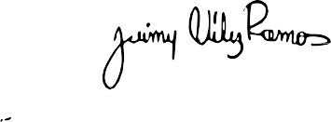

Jeimy Vélez-Ramos

