Figure 1. Total and sex-specific pre-post score differences.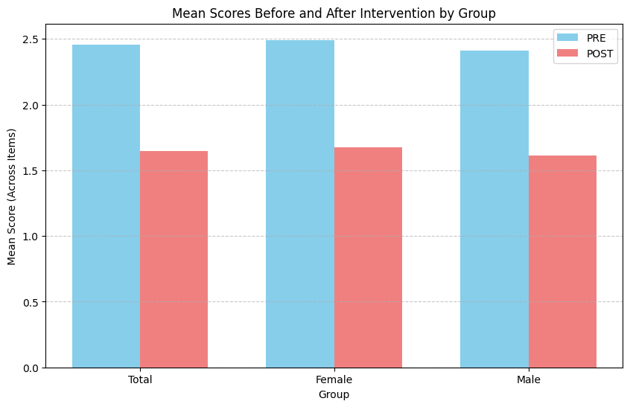

Figure 2. Effect sizes for the total group, by sex, and broken down by item (N = 14).
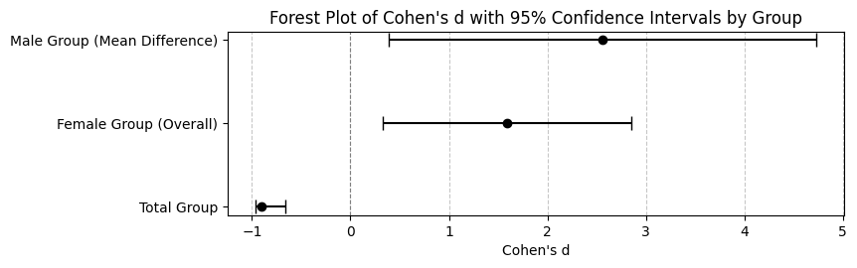
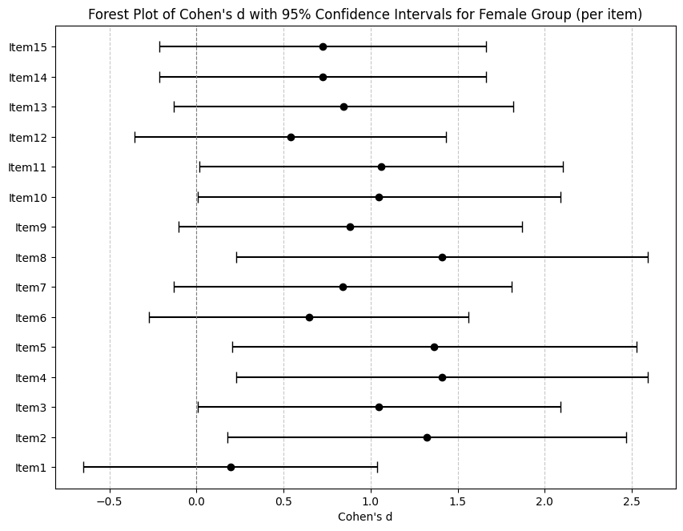 | 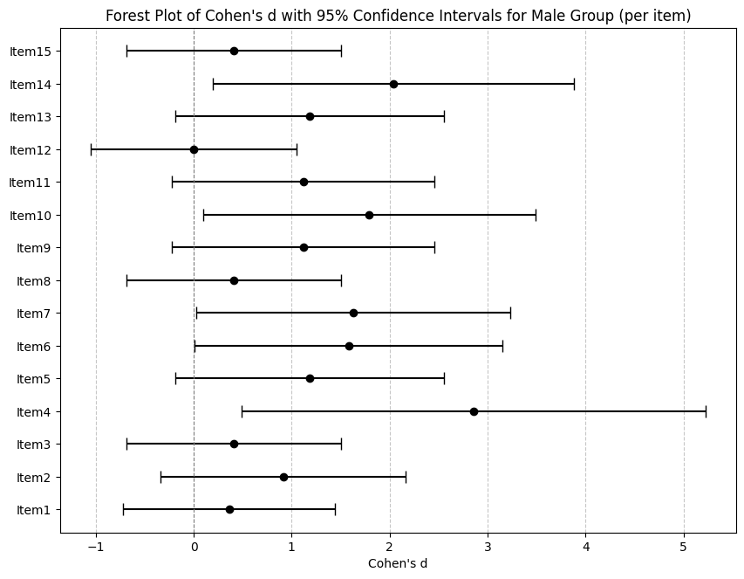
Figure 3. Body Image Scores: PRE vs POST by Sex (N = 14). |  | Figure 4. Individual Change in Body Image Score (PRE to POST).
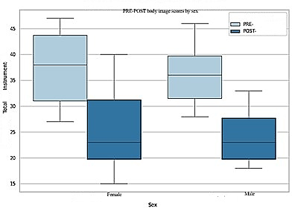 |  | 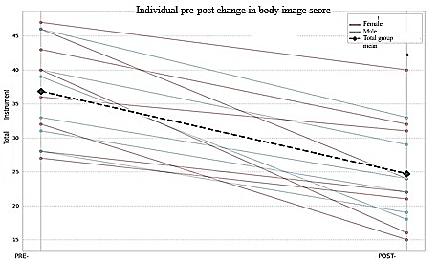

Figure 5. POST Score vs PRE Score by Participant (Scatter Plot with Identity Line). | Figure 6. Distribution of Body Image Scores (PRE vs POST) by Sex (Raincloud Plot).
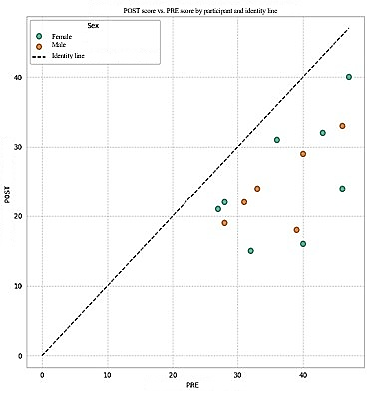 | 