Intervention on Body Image in University Students: A Quasi-Experimental Study
Abstract
This study evaluated the impact of the Body Project program, a cognitive dissonance-based group intervention, on body image among Venezuelan university students using a single-group quasi-experimental design implemented over four in-person sessions led by trained facilitators. The sample consisted of 14 students (8 women and 6 men), with an average age of 22.43 years (SD = 2.82). Body image was assessed before and after the intervention using the Attitudes Towards Body Figure Questionnaire (ATBFQ), in which lower scores reflect a more positive perception. Statistical analysis included normality testing (Shapiro-Wilk), paired t-tests, and calculation of effect size using Cohen’s d. Results showed a significant decrease in scores, from 36.86 (SD = 7.12) to 24.71 (SD = 7.29), with a large effect size (t (13) = 7.145, p < .001; d = –1.909). The improvement was observed in both women and men, indicating a more positive body perception overall. These findings offer preliminary evidence for the effectiveness of the program in this context. Although the small sample size and absence of a control group limit the generalizability of results, the outcomes justify future research using more robust designs to confirm the program’s applicability in the local university population.
Keywords: body image, cognitive dissonance, Body Project, eating disorder prevention, university students.
Intervención en la Imagen Corporal en Estudiantes Universitarios:
Un Estudio Cuasi-Experimental
Resumen
Esta investigación evaluó el impacto del programa Body Project, una intervención grupal basada en la disonancia cognitiva, sobre la imagen corporal en estudiantes universitarios venezolanos empleando un diseño cuasiexperimental de un solo grupo y en cuatro sesiones presenciales dirigidas por facilitadores entrenados. La muestra estuvo conformada por 14 estudiantes (8 mujeres y 6 hombres) con una edad promedio de 22.43 años (DE = 2.82). La imagen corporal se midió antes y después de la intervención mediante el Cuestionario de Actitudes hacia la Figura Corporal (CAFC), en el que puntajes más bajos reflejan una percepción más positiva. El análisis estadístico incluyó pruebas de normalidad (Shapiro-Wilk), pruebas t para muestras relacionadas y cálculo del tamaño del efecto mediante d de Cohen. Los resultados mostraron una disminución significativa en los puntajes, de 36.86 (DE = 7.12) a 24.71 (DE = 7.29), con tamaño del efecto grande (t (13) = 7.145, p < .001; d = –1.909). La mejora se observó tanto en mujeres como en hombres, evidenciando una percepción corporal más positiva. Los hallazgos ofrecen evidencia preliminar sobre la efectividad del programa en este contexto. Aunque el tamaño muestral y la ausencia de grupo control limitan la generalización, los resultados justifican nuevas investigaciones.
Palabras clave: imagen corporal, disonancia cognitiva, Body Project, prevención de trastornos alimentarios, estudiantes universitarios

INTRODUCTION
Body image, a complex and multifaceted psychological construct, encompasses an individual's perceptions, thoughts, emotions, and behaviours associated with their own body (Rodgers et al., 2023). Historically, research in psychology and medicine has explored various forms of bodily perception and experience, initially focusing on body dissatisfaction (Silva et al., 2021). However, the last decade has seen a flourishing of studies on positive body image (Davis et al., 2019; Tylka, 2018; Tylka & Wood-Barcalow, 2015), allowing for a more holistic understanding and the identification of protective and resilience factors.
The contemporary relevance of this construct to mental health is undeniable, given that body image concerns have become a global issue with severe consequences for both mental and physical well-being (Rodgers et al., 2023). For these authors, the dimensions of body image include the cognitive component, referring to thoughts and beliefs about the body; the affective component, encompassing feelings associated with appearance; and the behavioural component, manifested in resultant behaviours such as avoidance or compensatory actions. Body dissatisfaction and preoccupation with appearance, including shape, weight, and other characteristics, involve an evaluation and, at times, an altered perception of one's own body.
Consequently, body image has become a significant concern in current society, largely due to the influence of aesthetic ideals promoted by the media and social networks, as well as the pervasive thinness culture. Indeed, regular exposure to image-related content on social media has been associated with increased body dissatisfaction (Rounsefell et al., 2019). This sociocultural pressure has a considerable impact on vulnerable populations, including young students, among whom overweight is a global problem that can lead to low self-esteem and social stigmatisation (Kaveh Farsani et al., 2020). Although research has traditionally focused on the female experience (MacNeill et al., 2017), body dissatisfaction is relevant for both sexes and across all ages (Rodgers et al., 2023), with men also showing increasing concern about their body image (Jankowski et al., 2018; Silva et al., 2021). The internalisation of these body standards and social comparison, especially fostered by social media, exacerbates negative feelings about the body (Rounsefell et al., 2019). The type of visual content viewed on social media, alongside body dissatisfaction, significantly influences the risk of developing eating disorders (Arjona et al., 2024).
Moreover, a clear link exists between altered body image and Eating Disorders (EDs). Body dissatisfaction is a transdiagnostic risk factor associated with a variety of negative outcomes, including an increased risk of engaging in unhealthy dieting and disordered eating patterns (Rounsefell et al., 2019). Specifically, body image dissatisfaction is a significant risk factor for the manifestation of eating disorders in adolescents (Arjona et al., 2024). Women, in particular, report higher levels of body dissatisfaction and disordered eating compared to men (MacNeill et al., 2017).
Furthermore, empirical evidence indicates that personality factors are significantly related to the experience of body dissatisfaction in both genders (MacNeill et al., 2017; Davis et al., 2019). In this regard, various specific factors negatively influence body image. Among individual factors, low self-esteem and depression indirectly mediate the effect of family communication and body image satisfaction on psychological well-being (Kaveh Farsani et al., 2020). Similarly, body dissatisfaction and body appreciation are associated with personality factors (Davis et al., 2019). In women, high Neuroticism and low Conscientiousness, alongside Extraversion, are significant predictors of body dissatisfaction and disordered eating behaviours (MacNeill et al., 2017). Regarding family factors, communication and family functioning directly affect adolescents' psychological well-being (Kaveh Farsani et al., 2020). Sociocultural factors, such as exposure to digital content and to "influencers," reinforce stereotypes and contribute to body dissatisfaction, given the considerable influence of the type of content found on social media (Rounsefell et al., 2019). Strong pressures to achieve beauty ideals contribute to the global prevalence of these concerns, making body image a complex and multidimensional phenomenon whose alteration has become a global mental health concern (Rodgers et al., 2023).
Given the high prevalence and negative consequences of body image concerns, it is imperative to increase global efforts for their prevention and mitigation. It is essential to develop protocols that promote body satisfaction (Silva et al., 2021), strengthen self-esteem, and foster body appreciation to improve individuals' life satisfaction and self-perceived success (Davis et al., 2019). These preventive and integrative approaches are crucial in both research and the treatment of EDs (Kaveh Farsani et al., 2020).
One such effort is the Body Project programme, a preventive intervention with robust evidence for reducing symptoms of eating disorders. It specifically targets the internalisation of the thin ideal, recognised as a central risk factor in the development of these disorders. Findings from Stice et al. (2019) demonstrate that this programme has shown consistent effectiveness across multiple efficacy trials conducted by independent research teams, outperforming other alternative interventions in terms of effect magnitude. This evidence is fundamental for justifying its large-scale implementation, as it confirms that the results obtained transcend the particular expectations or characteristics of randomised trials.
The programme bases its approach on cognitive dissonance theory, postulated by Leon Festinger in 1957. This theory proposes that psychological discomfort arises when an individual holds inconsistent cognitions (beliefs, attitudes, values, etc.) (Festinger, 1957). This aversive state motivates the person to reduce the discrepancy to restore cognitive coherence. Despite being formulated almost 70 years ago, cognitive dissonance theory remains a fundamental principle in social psychology, and its influence endures in contemporary research, even applying to complex phenomena such as vicarious dissonance (Jaubert et al., 2020). In the Body Project, participants, primarily young women, engage in verbal, written, and behavioural exercises that lead them to voluntarily criticise society's predominant thin ideal (beauty ideal). This process generates cognitive dissonance, motivating participants to reduce their adherence to this unrealistic ideal and align their attitudes with the behaviours they have publicly expressed (Stice, et al., 2000). As a result, the reduction in the internalisation of the thin ideal translates into significant decreases in body dissatisfaction, unhealthy dietary behaviours, negative affect, and symptoms of eating disorders.
The implementation of the Body Project has demonstrated effectiveness across diverse contexts and application modalities. It has operated successfully when led by professional counsellors in secondary schools and universities, and when facilitated by peer educators in university settings. Notably, the use of peer leaders is not only a cost-effective alternative but has, in some cases, proven more effective than interventions led by clinical professionals (Stice et al., 2013). This versatility in application underscores the programme's robustness and its considerable potential for large-scale implementation. It thus solidifies its position as a highly relevant preventive intervention for addressing eating disorders, with a specific focus on dismantling the internalisation of the thin ideal. Its efficacy, validated through multiple independent controlled trials and its superiority over alternative interventions, provides a solid foundation for its widespread dissemination as a valuable and practical tool in the prevention of eating disorders.
However, even though the programme has been tested in different contexts and cultures, including in Latin America (e.g., Unikel-Santoncini et al., 2019), this intervention initiative had not been implemented within the university context of Venezuela. It remained unknown whether the results obtained in various international cultural groups could be replicated with Venezuelan students. Such replication would establish it as a procedure of great importance in preventing at-risk eating behaviours in this population, whose prevalence was already reported as "concerning" in 2022 (Ramírez & Zerpa, 2022). In light of the above, the purpose of this research was to verify the effect of the Body Project programme on young university students in Caracas, Venezuela, providing initial evidence to justify future larger-scale studies to confirm the efficacy of this intervention in the local context.
MATERIALS AND METHODS
Research Design
The research employed a quasi-experimental design of the pre-post single-group type (O1 X O2), which was useful as a randomised controlled trial was not logistically feasible. This design was characterised by the absence of a control group and by measuring the dependent variable (body image) at two time points: before the intervention's implementation (pre-test, O1) and after its completion (post-test, O2) (Shadish et al., 2002).
In the context of this exploratory and feasibility research within the Venezuelan university population, this quasi-experimental design proved appropriate by allowing for intra-group comparisons to evaluate the changes that occurred after the intervention's application. Repeated measurements on the same participants (related measures) enabled the assessment of individual change in body image, thereby maximising the statistical power available with the sample size employed—a benefit inherent in designs where subjects serve as their own controls (Harris, et al., 2006). Therefore, the design facilitated intra-group comparisons to evaluate the changes occurring after the intervention, although it inherently presents limitations for controlling extraneous variables and establishing definitive causal relationships due to the absence of a control group. Nevertheless, it was suitable for this exploratory and feasibility study, as the aim was to provide initial evidence on the efficacy of interventions in specific contexts, such as the Venezuelan university population studied.
Participants
The sample, which was non-randomised in accordance with the research type, consisted of N = 14 participants. These were university students from a public higher education institution in Caracas, Venezuela, comprising 8 women and 6 men. The average age of the participants was M = 22.43 years (SD = 2.82).

Ethical safeguards of research
This study was conducted in full compliance with national and international ethical standards, including the Universal Declaration of Ethical Principles for Psychologists (IAAP & IUPsyS, 2008), the International Ethical Guidelines for Biomedical Research Involving Human Subjects (CIOMS, WHO & PAHO, 2016), current SIP statements (1978, 2008b, 2019), and the principles outlined by Kerlinger & Lee (2002) and the American Psychological Association (APA, 2025). Specific APA provisions regarding confidentiality (§4.0) and informed consent (§8.02) were observed. All participants provided digital informed consent after being fully briefed on the study’s aims, procedures, and confidentiality assurances. Anonymity was guaranteed, and participants retained the right to withdraw at any time, with their well-being protected throughout.Both citations of APA´s Ethical Principles of Psychologists and Code of Conduct.
In effect, prior to the administration of the instruments, each participant provided digital informed consent, having been duly informed of the study’s objectives and the intended use of the data collected. Absolute confidentiality and anonymity of the data were assured, with an explicit commitment not to disclose the names of individuals or specific institutions in the research report. The welfare of participants was safeguarded throughout the study, ensuring the absence of any risk and affirming their right to withdraw from the study at any point should they deem it appropriate, in full compliance with the principles of voluntary informed consent and the absence of coercion.
Intervention
The Body Project program was administered, a group psychoeducational intervention originally designed for young women with body image concerns. Based on the cognitive dissonance approach, it was developed by Eric Stice of the Oregon Research Institute, but Carolyn Becker and her team at Trinity University adapted it for university contexts, including versions for mixed-sex groups (Stice & Presnell, 2007). It consists of four in-person sessions, each lasting approximately 60 to 75 minutes, facilitated by trained professionals. In the present study, the program was applied to mixed-sex groups of university students, maintaining its original structure and objectives. The intervention included: 1) Experiential exercises such as reflective letter writing, self-affirmation tasks in front of a mirror, and dramatisations about extreme eating behaviours; 2) Verbal resistance activities to messages promoting the "thin ideal"; 3) Behavioural challenges aimed at confronting body image-based avoidance; and 4) Body activism practices to challenge harmful social norms.
These dynamics fostered critical reflection on sociocultural messages associated with thinness, seeking a cognitive restructuring that would encourage greater body acceptance and a reduction in the internalisation of the dominant aesthetic ideal. The program utilised visual materials, structured worksheets, and voluntary audiovisual recordings as support tools.
The measurement instrument employed was the Attitudes Towards Body Figure Questionnaire (ATBFQ), a self-report questionnaire developed in Mexico (Unikel-Santoncini et al., 2006). Its purpose is to evaluate the degree of internalisation of the thin ideal and the importance attributed to body weight and figure in Latin American sociocultural contexts. Its development was based on in-depth interviews with women diagnosed with eating disorders, which reinforces its clinical and cultural relevance for Hispanic American populations. The questionnaire comprises 15 items distributed on a four-point Likert scale; higher scores reflect a greater level of internalisation of the aesthetic ideal. Structurally, the ATBFQ presents a bifactorial organisation composed of two closely related dimensions: Factor 1, "Internalisation," integrates seven items focused on adopting sociocultural body standards, while Factor 2, "Beliefs," brings together eight items expressing evaluations and attitudes about body figure and weight. This configuration has been empirically supported by its creators through exploratory and confirmatory factor analyses, with adequate fit parameters (RMSEA = .037; NFI = .976), collectively explaining 60% of the total variance. Furthermore, it possesses high levels of internal consistency (for the total questionnaire α= .93, while the "Internalisation" and "Beliefs" factors obtain coefficients of α= .90 and α= .88, respectively). Additionally, the instrument demonstrated concurrent and predictive validity by correlating significantly with related measures, such as brief questionnaires on at-risk eating behaviours, self-esteem scales, depressive symptomatology, and dimensions of body dissatisfaction. Complementarily, the ATBFQ exhibits discriminant validity by adequately differentiating between clinical and non-clinical groups, achieving correct classification in 83.7% of cases through Mahalanobis discriminant analyses. Finally, its diagnostic capacity reports acceptable levels of sensitivity (.80) and specificity (.80) using a cut-off point of 37, with positive and negative predictive values of .43 and .96 respectively.
Data Analysis
The analysis was conducted using Python, with Google Colab as the execution environment. This relied on the following libraries: pandas for data manipulation and management, numpy for numerical operations, scipy.stats for statistical tests, statsmodels for normality analysis and statistical visualisations, and matplotlib and seaborn for creating graphs. Two sub-DataFrames were created: one for the PRE measurements and another for the POST measurements, along with the demographic variables associated with the PRE measurement. Finally, the score difference for each participant was calculated.
For inferential analysis, statistical tests were performed to compare body image scores between the PRE and POST time points. First, the normality of the distribution of score differences was assessed using the Shapiro-Wilk test, both for the total group and separately for each sex. Student's t-test for the mean difference was estimated for the total group and by sex. The effect size was calculated using Cohen's d for the Student's t-tests.
RESULTS
Below, (see tables 1 and 2), we present the key descriptive statistics for the total body image instrument scores both before (PRE) and after (POST) the intervention, as well as the difference between these scores (POST - PRE). Results are shown for the total participant group and segmented by sex (Female and Male).

Table 1. Descriptive statistics of Attitudes Towards Body Figure Questionnaire (ATBFQ) scores before and after the intervention, and Pre-Post difference (N = 14).
Variable | M | DE | Range | Q₁ | Q₂(Md) | Q₃ | 95% CI for M
ATBFQ Score  Pre-test | 36.86 | 7.12 | 27.00 - 47.00 | 31.25 | 37.50 | 42.25 | [32.74, 40.98]
ATBFQ Score  Post-test | 24.71 | 7.29 | 15.00 - 40.00 | 19.50 | 23.00 | 30.50 | [20.50, 28.92]
Difference Pre-Post | -12.14 | - | - | - | - | - | [-15.70, -8.58]
Table 2. Descriptive statistics of Attitudes Towards Body Figure Questionnaire (ATBFQ) scores and Pre-Post difference, disaggregated by sex (N = 14).
Variable and Sex | N | M | DE | Mín | Q₁ | Q₂ (Md) | Q₃ | Máx | 95% CI for M
ATBFQ Score Pre-test
Female | 8 | 37.38 | 7.86 | 27.00 | 31.00 | 38.00 | 43.75 | 47.00 | [30.81, 43.95]
Male | 6 | 36.17 | 6.68 | 28.00 | 31.50 | 36.00 | 39.75 | 46.00 | [29.16, 43.18]
ATBFQ Score Post-test
Female | 8 | 25.13 | 8.59 | 15.00 | 19.75 | 23.00 | 31.25 | 40.00 | [29.16, 43.18]
Male | 6 | 24.17 | 5.85 | 18.00 | 19.75 | 23.00 | 27.75 | 33.00 | [18.03, 30.31]
Difference Pre-Post
Female | 8 | -12.25 | 7.70 | - | - | - | - | - | [-18.69, -5.81]
Male | 6 | -12.00 | 4.69 | - | - | - | - | - | [-16.92, -7.08]

Observing the descriptive statistics, for the total group (N=14), the mean body image score decreased notably from 36.857 (SD = 7.124) at the PRE-intervention stage to 24.714 (SD = 7.290) at the POST-intervention stage. This reduction is reflected in a mean difference of -12.143 (SD = 6.359), with difference scores ranging from -24 to -5, indicating a general improvement in perceived body image after the intervention (assuming, based on the measurement instrument, that a lower score indicates a more positive body image). The distribution of differences shows that all participants experienced a decrease in their score.
When segmented by sex (see table 3), both women (N=8) and men (N=6) showed a decrease in their mean body image score. The mean decrease for women was from 37.375 (SD = 7.855) to 25.125 (SD = 8.593), with a mean difference of -12.250 (SD = 7.704). For men, the mean decrease was from 36.167 (SD = 6.676) to 24.167 (SD = 5.845), with a mean difference of -12.000 (SD = 4.690). Figure 1 illustrates the variable's behaviour for the total group and by sex, confirming the descriptions above.

Table 3. Total and sex-specific mean differences, before and after, with effect sizes.
Group | N | t | df | p | Cohen´s d  [95% CI]
Total | 14 | 7.14 | 13 | <.001 | 1.91 [.94, 2.88]
Female | 8 | 4.50 | 7 | 0.003 | 1.59 [.33, 2.85]
Male | 6 | 6.27 | 5 | .002 | 2.56 [.39, 4.73]

Although both mean differences are negative (indicating improvement) and of similar magnitude (-12.250 for women and -12.000 for men), the standard deviation of the differences is larger in the female group (7.704) compared to the male group (4.690). This suggests greater variability in the intervention's response among female participants. The medians also reflect a decrease in POST scores for both sexes.
Statistical tests were performed to examine whether there was a significant change in the total body image score between the PRE and POST intervention time points. The normality of the distribution of score differences (POST - PRE) was assessed using the Shapiro-Wilk test. For the Total Group, the test for differences yielded a statistic of W = .876, p = .052. Given this, normality was assumed for the differences in the total group, and a paired-samples Student's t-test was then conducted. The results indicated a t = 7.145(13), p = .000. The conclusion is that the intervention had a statistically significant effect (p < .05), indicating a significant reduction in body image scores after the intervention for the total group (see Figure 2).
Figure 1. Total and sex-specific pre-post score differences.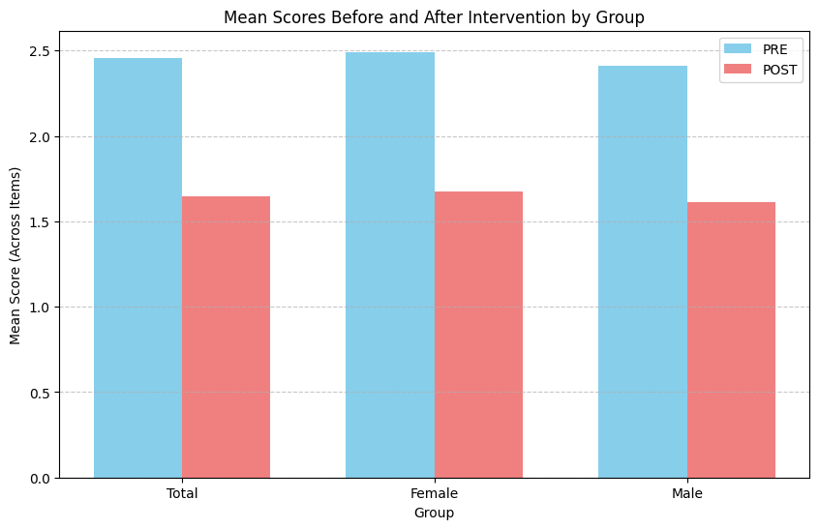
Sex-Specific Analysis and Effect Sizes
For the analysis by sex, the Shapiro-Wilk normality test for differences in the female group showed W = 0.842, p = .080, indicating normality. The paired-samples t-test yielded a value of t = 4.497(7), p = .003. This suggests that the intervention had a statistically significant effect (p < .05) on body image as perceived by women. For the male group, the Shapiro-Wilk normality test for differences produced a statistic of W = 0.839, p = .65, again indicating normality. The paired-samples t-test resulted in a statistic of t = 6.267(5), p = .002, thus demonstrating a statistically significant effect (p < .05) on body image as perceived by men after the intervention.
To complement the hypothesis test results, effect sizes were calculated using Cohen's d for the parametric (t-test) analyses (see Figure 2). For the total group, for which a paired-samples t-test was performed, the calculated effect size was d = -1.909. Considering the absolute value (|1.909|), this result indicates a large effect size, suggesting a substantial difference in PRE and POST intervention body image scores for the group as a whole. In the female group, also analysed with a paired-samples t-test, the effect size was d = -1.590. The absolute value (|1.590|) corresponds to a large effect size, indicating a significant change in body image as perceived by women after the intervention. In the male group, d = -2.56 was obtained, whose absolute value (|2.56|) also signifies a large effect as a consequence of the intervention.

Figure 2. Effect sizes for the total group, by sex, and broken down by item (N = 14).
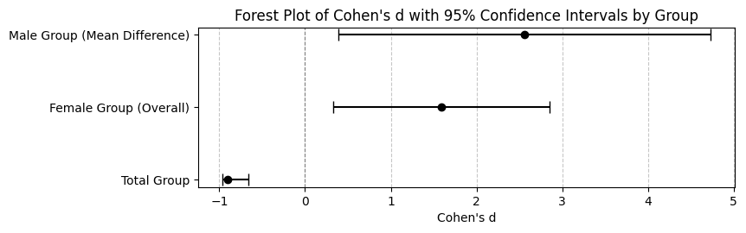
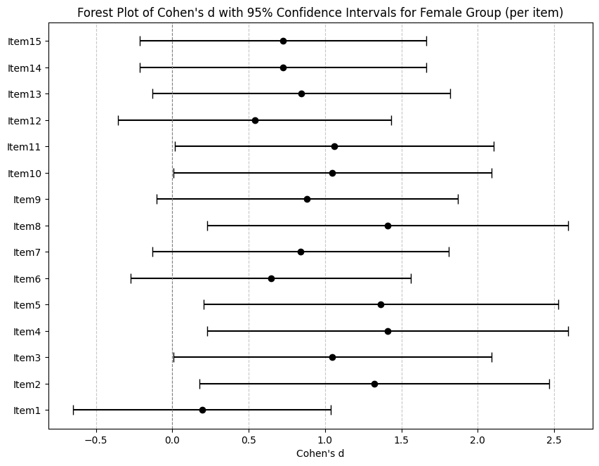 | 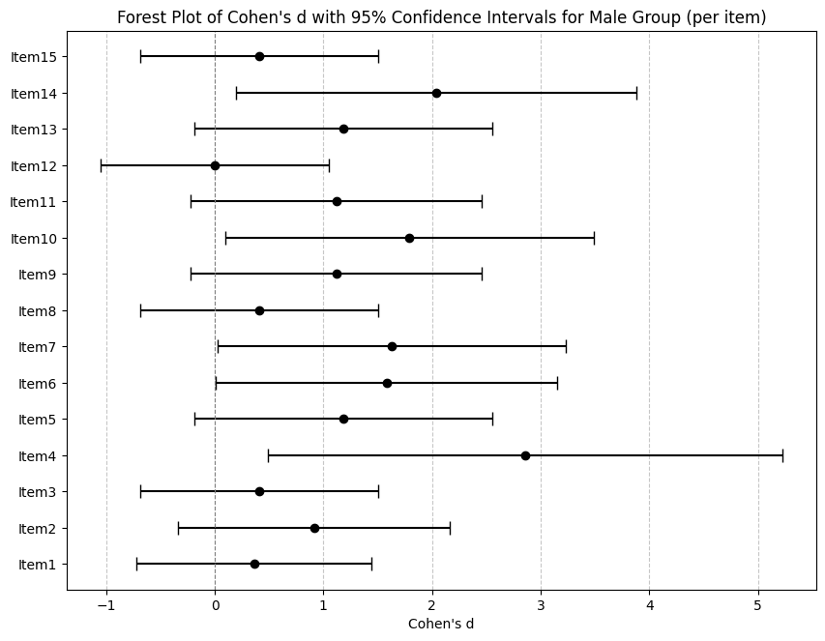
Visualisation of Body Image Score Changes
To complement the statistical results and offer a more intuitive understanding of the observed changes in body image scores, key additional visualisations were generated, shown in Figures 3 to 6. These figures reveal a clear decrease in both the overall range and the central positions (medians) of scores at the POST time point compared to the PRE time point, for both women and men. This can be observed by considering the individual change in scores given to the instrument in Figure 3. Most lines exhibit a negative slope, descending from PRE to POST, visually illustrating that the vast majority experienced a decrease in their scores (see Figure 4). Similarly, in the scatter plot with an identity line (see Figure 5), points below the identity line (where PRE=POST) represent participants whose scores decreased (improved) from PRE to POST, visually reinforcing the conclusion of general improvement. Finally, the Raincloud Plot (see Figure 6) simultaneously displays density, summary statistics, and individual data points, allowing for an appreciation of the overlap and shift in the distributions of scores on the measurement instrument.

Figure 3. Body Image Scores: PRE vs POST by sex (N = 14). | Figure 4. Individual Change in Body Image Score (PRE to POST).
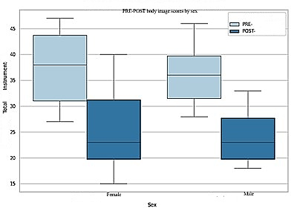 | 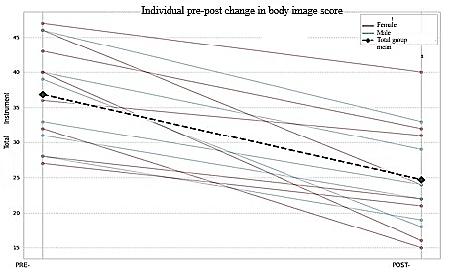

Figure 5. POST Score vs PRE Score by Participant (Scatter Plot with Identity Line). | Figure 6. Distribution of Body Image Scores (PRE vs POST) by Sex (Raincloud Plot).
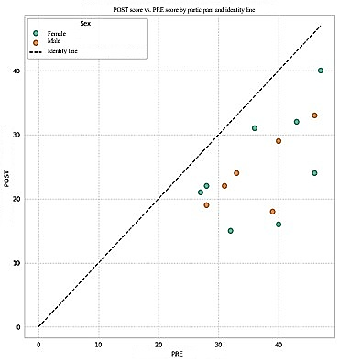 | 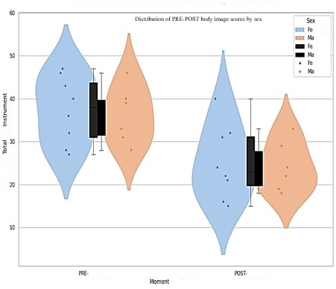

DISCUSSION
The present study evaluated the impact of the group intervention, "Body Project," on the body image of Venezuelan university students, employing a quasi-experimental pre-post design. The results indicate a notable and statistically significant decrease in the mean score of the Attitudes Towards Body Figure Questionnaire (ATBFQ) following the intervention (from 36.86 pre-test to 24.71 post-test), with a large effect size (d = -1.909). This finding is consistent with previous literature supporting the efficacy of the Body Project programme in promoting a healthy body image and reducing risk factors for eating disorders (Stice, 2019).
The relevance of interventions like the "Body Project" is heightened when considering the contemporary influence of social media on body image. Recent research has highlighted that while the negative effect of media on body image has been consistently proven (Rounsefell et al., 2019; Arjona et al., 2024), the nature of social media has transformed the interaction with one's own body and with others. A recent study, for instance, underscores that social media has detrimental effects, generating body dissatisfaction and increasing eating and body image disorders (Abrevaya et al., 2025). It is crucial to note that it is not simple exposure, but rather how individuals interact with these platforms, that determines the impact, thereby justifying the need for psychosocial interventions that address these dynamics. In this sense, implementing programmes such as the "Body Project" is fundamental to counteracting the negative effects of social media use on body image.
The programme's effectiveness was observed in both women (t (7) = 4.497, p = .003; d = -1.590) and men (t (5) = 6.267, p < .001; d = -2.558). This is relevant because, while much of the initial research focused on female populations, recent studies have explored and confirmed the programme's applicability and effectiveness in mixed-sex samples, including men. The cognitive dissonance-based intervention has consistently been shown to reduce the internalisation of the thin ideal, body dissatisfaction, negative affect, and symptoms of eating disorders. Meta-analytical reviews, which included 56 trials with 68 dissonance-based prevention programmes (7808 participants), found average effect sizes of d = .57 for the internalisation of the thin ideal and d = .42 for body dissatisfaction, corroborating the potency of this approach (Stice et al., 2008; Stice et al., 2019).
This robust efficacy in the observed results of this study is attributed to the Body Project's underlying theoretical mechanisms. Empirical research consistently supports that reductions in the internalisation of the thin ideal mediate the programme's effects in decreasing symptoms related to body image and eating disorders (Seidel, et al., 2009; Stice, et al., 2007). Additionally, it has been observed that versions of the programme generating greater cognitive dissonance produce more pronounced symptom reductions compared to those with less dissonance (McMillan, et al., 2011). Beyond symptom reduction, the Body Project has also demonstrated the ability to neutralise the adverse effects of exposure to thin models in adolescents (Halliwell & Diedrichs, 2014) and, at a neurobiological level, to reduce activation in reward-related brain regions when presented with stimuli of thin models (Stice, et al., 2015). These specific findings regarding the mechanisms of action and the ability to counteract negative influences strengthen the understanding of why the programme is so effective and provide a plausible reason for the findings reported here.
The effectiveness of the Body Project has also been investigated across different racial and ethnic groups. Studies indicate that the programme produces relatively similar effects in minority groups compared to white participants, and in some cases, even larger effects were observed in Asian and Hispanic participants (Hudson et al., 2021). This study adds to the evidence that the programme can be a valuable tool for diverse populations, including Latin American ones. For example, more recent research, such as that by Ergut & Keser (2022), has continued to corroborate this adaptability, demonstrating the success of dissonance-based interventions in populations with diverse cultural backgrounds, such as young Turkish university women, where the programme proved effective in reducing body dissatisfaction and at-risk eating disorder symptoms. Similarly, the implementation of the Body Project has been validated in Middle Eastern contexts, such as among young women in Saudi Arabia, where the programme was adapted with positive results, highlighting the universality of body image concerns and the efficacy of dissonance-based interventions despite cultural differences (AlShebali et al., 2021).
Despite the limited sample size (N = 14) and the absence of a control group in this quasi-experimental study, the results obtained are robust, with a considerably large effect size (d = -1.909). This surpasses the average effects observed in previous meta-analyses (Stice et al., 2008; Stice et al., 2019), where the average d for body dissatisfaction is .42. This large effect suggests that the intervention had a clinically significant impact on improving body image in the Venezuelan participants. Although methodological limitations necessitate caution in generalisation, these findings provide promising initial evidence for the implementation of the Body Project in the Venezuelan context.
CONCLUSIONS
The results of this study confirm the effectiveness of the "Body Project" programme in improving body image in a sample of Venezuelan university students, both male and female. The significant reduction in body dissatisfaction scores post-intervention, coupled with a large effect size, validates the applicability of this cognitive dissonance-based programme within a Latin American cultural context. These findings reinforce the growing international evidence regarding the Body Project's efficacy in preventing eating disorders and promoting a positive body image across diverse populations and delivery modalities. Future research should explore the specific mechanisms of change in this population and conduct long-term follow-ups to assess the durability of the effects.
Limitations
The primary limitation is the sample size (N = 14). A reduced sample size restricts the generalisability of the findings to broader populations and limits the statistical power to detect true effects, especially when segmenting by subgroups such as sex. Although significant effects were found, these should be interpreted with caution. The absence of a control group could question the direct attribution of causality to the intervention, as other external factors might have influenced the observed changes.
Another important observation is that the quasi-experimental design employed, given the sample cost, presents inherent limitations, primarily due to the lack of random assignment. This makes it difficult to control for confounding variables, thereby affecting the establishment of definitive causal relationships. Despite these limitations, the results provide promising initial evidence that justifies future larger-scale studies with more robust designs to confirm the programme's efficacy in Venezuelan university students.
Future Research Directions
Based on these preliminary findings and their limitations, future research should consider: 1) Replicating this study with a considerably larger sample size to increase statistical power and the generalisability of the results. 2) Including a control group to more rigorously establish the causality of the intervention's effect. 3) Exploring differences in the intervention's effect by other demographic or psychological variables, if data and sample size permit. 4) Collecting qualitative data or utilising more detailed instruments to better understand the specific aspects of body image that were affected and the mechanisms through which the intervention produces changes. 5) Investigating long-term follow-up to determine the durability of the intervention's effects.
Despite the small sample size, the results provide promising initial evidence of the intervention's positive impact on body image, justifying the undertaking of larger-scale studies with more robust designs.
REFERENCES
Abrevaya, S., Flores Bravo, I. M., Morgenstern, C., Cuello, C., Lopez, P., & Torrente, F. (2025, January 28). Psychosocial Interventions to Improve Body Image in Social Media Users: a Systematic Review. OSF Preprints. https://doi.org/10.31234/osf.io/4qguz_v1
AlShebali, M., Becker, C., Kellett, S., AlHadi, A., & Waller, G. (2021). Adapting the body project to a non-western culture: a dissonance-based eating disorders prevention program for Saudi women. Eating and Weight Disorders - Studies on Anorexia, Bulimia and Obesity, 26, 2503–2512. https://doi.org/10.1007/s40519-021-01104-9
American Psychological Association. (2017). Ethical Principles of Psychologists and Code of Conduct (Includes 2010 and 2016 Amendments).https://www.apa.org/ethics/code
Arjona, Á., Monserrat, M., & Checa, J. C. (2024). Use of Social Media, Satisfaction with Body Image, and the Risk of Manifesting Eating Disorders. Social Sciences, 13(2), 105. https://doi.org/10.3390/socsci13020105
Council for International Organizations of Medical Sciences (CIOMS), World Health Organization (WHO), & Pan American Health Organization (PAHO). (2016). International ethical guidelines for health-related research involving humans. https://cioms.ch/wp-content/uploads/2017/01/WEB-CIOMS-EthicalGuidelines.pdf
Davis, L. L., Fowler, S. A., Best, L. A., & Both, L. E. (2019). The Role of Body Image in the Prediction of Life Satisfaction and Flourishing in Men and Women. Journal of Happiness Studies 21, 505–524. https://doi.org/10.1007/s10902-019-00093-y
Ergut, N., & Keser, E. (2022). Testing the efficacy of the Virtual Body Project in a sample of Turkish female university students using a randomized controlled trial. Journal of Clinical Psychology Research, 6(3), 380–391. https://doi.org/10.57127/kpd.26024438m000103
Festinger, L. (1957). A theory of cognitive dissonance. Stanford University Press.
Jaubert, S., Fillon, A. A., Souchet, L., & Girandola, F. (2020, December 4). Vicarious Dissonance : Meta-analysis. OSF Preprints.https://doi.org/10.31234/osf.io/hc2n3_v1
Halliwell, E., & Diedrichs, P. (2014). Testing a dissonance body image intervention among young girls. Healthy Psychology, 33, 201–204. https://doi.org/10.1037/a0032585
Harris, A. D., McGregor, J. C., Perencevich, E. N., Furuno, J. P., Zhu, J., Peterson, D. E., & Finkelstein, J. (2006). The use and interpretation of quasi-experimental studies in medical informatics. Journal of the American Medical Informatics Association, 13(1), 16–23. https://doi.org/10.1197/jamia.M1749
Hudson, T. A., Amaral, A. C. S., Stice, E., Gau, J., & Ferreira, M. E. C. (2021). Dissonance-based eating disorder prevention among Brazilian young women: A randomized efficacy trial of the Body Project. Body Image, 38, 1–9. https://doi.org/10.1016/j.bodyim.2021.03.008
International Union of Psychological Science (IUPsyS) & International Association of Applied Psychology (IAAP). (2008). Universal declaration of ethical principles for psychologists. https://www.iupsys.net/about/declarations/universal-declaration-of-ethical-principles-for-psychologists/
Jankowski, G. S., Gough, B., Fawkner, H., Halliwell, E., & Diedrichs, P. C. (2018). Young men’s minimisation of their body dissatisfaction. Psychology & Health, 33(11), 1343–1363. https://doi.org/10.1080/08870446.2018.1496251
Kaveh Farsani, Z., Kelishadi, R., & Beshlideh, K. (2020). Study of the effect of family communication and function, and satisfaction with body image, on psychological well-being of obese girls: the mediating role of self-esteem and depression. Child and Adolescent Psychiatry and Mental Health, 14(1), 39. https://doi.org/10.1186/s13034-020-00345-3
Kerlinger, F. N., & Lee, H. B. (2002). Investigación del comportamiento: Métodos de investigación en ciencias sociales (4.ª ed.). McGraw-Hill.
MacNeill, L. P., Best, L. A., & Davis, L. L. (2017). The role of personality in body image dissatisfaction and disordered eating: discrepancies between men and women. Journal of Eating Disorders, 5(1), 44. https://doi.org/10.1186/s40337-017-0177-8
McMillan, W., Stice, E., & Rohde, P. (2011). High- and low-level dissonance-based eating disorder prevention programs with young women with body image concerns: An experimental trial. Journal of Consulting and Clinical Psychology, 79, 129–134. https://doi.org/10.1037/a0022143
Ramírez, A. & Zerpa, C. (2022). Conductas alimentarias de riesgo en estudiantes universitarios venezolanos: prevalencia en la ciudad de Caracas, 2020. GICOS, 7(1), 11-26. https://dialnet.unirioja.es/ejemplar/598517
Rodgers, R. F., Laveway, K., Campos, P., & de Carvalho, P. H. B. (2023). Body image as a global mental health concern. Cambridge Prisms: Global Mental Health, 10, e9. https://doi.org/10.1017/gmh.2023.2
Rounsefell, K., Gibson, S., McLean, S., Blair, M., Molenaar, A., Brennan, L., Truby, H., & McCaffrey, T. A. (2019). Social media, body image and food choices in healthy young adults: A mixed methods systematic review. Nutrition & Dietetics, 76(5), 450–468. https://doi.org/10.1111/1747-0080.12581
Seidel, A., Presnell, K., & Rosenfield, D. (2009). Mediators in the dissonance eating disorder prevention program. Behaviour Research and Therapy, 47, 645–653. https://doi.org/10.1016/j.brat.2009.04.007
Shadish, W. R., Cook, T. D., & Campbell, D. T. (2002). Experimental and quasi-experimental designs for generalized causal inference. Houghton Mifflin.
Silva, W. R. da, Maroco, J., & Campos, J. A. D. B. (2021). Examination of the factorial model of a scale developed to assess body satisfaction in the Brazilian context: a study with people 18 to 40 years old. Eating and Weight Disorders - Studies on Anorexia, Bulimia and Obesity, 26(7), 2217–2228. https://doi.org/10.1007/s40519-020-01102-3
Sociedad Interamericana de Psicología. (1978). Declaración sobre la práctica psicológica y los derechos humanos. https://archive.org/details/sip-1978-declaracion-sobre-practica-psicologica-y-ddhh
Sociedad Interamericana de Psicología. (2008b). Declaración sobre principios éticos de la práctica e investigación en psicología. https://archive.org/details/sip-2008b-declaracion-sobre-principios-eticos
Sociedad Interamericana de Psicología. (2019). Declaración sobre la experticia profesional en salud mental. https://archive.org/details/sip-2019-declaracion-experticia-en-salud-mental
Stice, E., Marti, C. N., Shaw, H., & Rohde, P. (2019). Meta-Analytic Review of Dissonance-Based Eating Disorder Prevention Programs: Intervention, Participant, and Facilitator Features that Predict Larger Effects. Clinical Psychology Review, 70, 91–107. https://doi.org/10.1016/j.cpr.2019.04.004
Stice, E., Marti, C. N., Spoor, S., Presnell, K., & Shaw, H. (2008). Dissonance and Healthy Weight Eating Disorder Prevention Programs: Long-Term Effects from a Randomized Efficacy Trial. Journal of Consulting and Clinical Psychology, 76(2), 329–340. https://doi.org/10.1037/0022-006X.76.2.329
Stice, E., Onipede, Z. A., Shaw, H., Rohde, P., & Gau, J. M. (2021). Effectiveness of the Body Project Eating Disorder Prevention Program for Different Racial and Ethnic Groups and an Evaluation of the Potential Benefits of Ethnic Matching. Journal of Consulting and Clinical Psychology, 89(12), 1007–1019. https://doi.org/10.1037/ccp0000697
Stice, E., & Presnell, K. (2007). The body project: Promoting body acceptance and preventing eating disorders: Facilitator guide. Oxford University Press.
Stice, E., Presnell, K., Gau, J., & Shaw, H. (2007). Testing mediators of intervention effects in randomized controlled trials: An evaluation of two eating disorder prevention programs. Journal of Consulting and Clinical Psychology, 75, 20–32. https://doi.org/10.1037/0022-006X.75.1.20
Stice, E., Rohde, P., Shaw, H., & Marti, N. (2013). Efficacy trial of a selective prevention program targeting both eating disorders and obesity among female college students: 1- and 2-year follow-up effects. Journal of Consulting and Clinical Psychology, 81, 183–189. https://doi.org/10.1037/a0031235
Stice, E., Yokum, S., & Waters, A. (2015). Dissonance-based eating disorder prevention program reduces reward region response to thin models: How actions shape valuation. PLoS One, 10, e0144530. https://doi.org/10.1371/journal.pone.0144530
Tylka, T. L. (2018). Body image: Celebrating the past, appreciating the present, and envisioning the future. Body Image, 24, A1–A3. https://doi.org/10.1016/j.bodyim.2018.01.003
Tylka, T. L., & Wood-Barcalow, N. L. (2015). What is and what is not positive body image? Conceptual foundations and construct definition. Body Image, 14, 118–129. https://doi.org/10.1016/j.bodyim.2015.04.001
Unikel-Santoncini, C., Díaz de León-Vázquez, C., Rivera-Márquez, J. A., Bojorquez-Chapela, L., & Méndez-Ríos, E. (2019). Dissonance-based Program for Eating Disorders Prevention in Mexican University Students. Psychosocial Intervention, 28(1), 29–35. https://dx.doi.org/10.5093/pi2018a17
Unikel-Santoncini, C., Juárez-García, F., & Gómez-Peresmitré, G. (2006). Psychometric properties of the Attitudes Towards Body Figure Questionnaire in Mexican female students and patients with eating disorders. European Eating Disorders Review, 14(6), 430–435. https://doi.org/10.1002/erv.757

