Knowledge and Awareness of Attention Deficit Hyperactivity Disorder (ADHD) in the Residents of Eastern Province, Saudi Arabia: A Cross-Sectional Analysis

Abstract
Attention Deficit Hyperactivity Disorder (ADHD) is a neurodevelopmental disorder that affects individuals of all ages. Although awareness of ADHD has improved in recent years, significant misinformation and gaps in understanding the disorder remain. The current study aimed to determine the knowledge and awareness of ADHD in Eastern Province, Saudi Arabia. An online self-administered questionnaire was distributed to individuals aged 18 years and older. The questionnaire, based on the DSM-5 ADHD diagnostic criteria, with 16 items, measures ADHD awareness in Al-Ahsa City, Saudi Arabia. The questionnaire consisted of two sections: demographic information (age, gender, education level, and profession) and 16 questions measuring respondents' awareness of ADHD. Statistical analyses were performed using SPSS version 27. The results indicated that the majority of participants were Saudi females with a bachelor's degree. Social media was the most common source of information about ADHD. Gender differences were observed in the source of information and treatment preferences, with more females acquiring knowledge from college and endorsing both behavioral therapy and pharmacotherapy. Most participants agreed with the DSM-5 ADHD criteria presented, indicating alignment with the current DSM-5 diagnostic framework. These findings underscore the role of educational institutions and digital platforms in shaping public knowledge about mental health. The study also highlights the necessity for targeted awareness initiatives that are culturally and gender-sensitive.
By identifying specific gaps in knowledge, this research provides a foundation for designing more effective public health interventions. The findings highlight the need for continued awareness and education about ADHD in Saudi Arabia. Gender differences in knowledge acquisition and treatment perception underscore the importance of inclusive awareness efforts. Educating individuals about ADHD can help reduce stigma and misconceptions, leading to earlier diagnosis and intervention.
Keywords: Attention Deficit Hyperactivity Disorder, Awareness, Gender Differences, Eastern Province, Saudi Arabia

Introduction
Attention Deficit Hyperactivity disorder (ADHD) is a neurodevelopmental disorder characterized by inattention, hyperactivity, and impulsivity, which can significantly impact academic, occupational, and social functioning (American Psychaitric Association, 2013). Although ADHD is often associated with childhood, symptoms can persist into adulthood, affecting productivity and quality of life. Notably, ADHD in females often presents differently than in males, with less overt hyperactivity and more internalizing symptoms, such as inattention and emotional dysregulation, leading to underdiagnoses and mismanagement (Acosta, 2023).
Compared to childhood, the prevalence of ADHD in adults seems to be more equal for both sexes; the estimated prevalence of adult ADHD is less than two times higher in males than in women (5.4% vs. 3.2%, respectively) (Kessler et al., 2006); however, when diagnosed with ADHD, women are more likely to be older than males (Grevet et al., 2006). Along with disparities in diagnosis rates, women are less likely than men to use ADHD medications (Castle et al., 2007).
Globally, understanding and awareness of ADHD have grown, but considerable information gaps remain, particularly regarding its expression in females. According to a study by Quinn and Madhoo (2014), when it comes to diagnosing ADHD, women are frequently disregarded because their symptoms related to the disease are less disruptive. In societies like Saudi Arabia, where stigma and cultural norms around mental health can impede candid conversation and prompt interventions, this underdiagnoses is exacerbated (Al-Wardat et al., 2024).
These established guidelines are widely applied in research and clinical practice. During an evaluation, the skilled mental health care professional will attempt to determine the severity to which these symptoms have advanced (Lamb et al., 2008). According to research, ADHD is fairly common in the Arab world and is associated with significant impairment. Despite being extremely prevalent, it has not received enough attention in the Middle East and North Africa (El Hayek et al., 2019). Numerous studies conducted in the Kingdom of Saudi Arabia have revealed a lack of awareness regarding ADHD. They have assessed the following groups: a sample of teachers in Makkah City’s Al-Rusaifah district (Munshi, 2014), female elementary school teachers in Jeddah (Basudan et al., 2019), primary care physicians in the Aseer Region (Al-Ahmari et al., 2018), and medical students at King Abdulaziz University’s Faculty of Medicine in Jeddah (Qashqari et al., 2017). However, another study found that only two-thirds of Riyadh’s male primary school teachers were aware of ADHD (Aldawodi et al., 2018). There was a lack of research comparing male and female knowledge and opinions regarding ADHD in Saudi Arabia. Therefore, this study aimed to investigate the knowledge and awareness of ADHD among the adult population of Saudi Arabia.

Material and Methods

Study Design
A community-based, retrospective, cross-sectional study was conducted in the Eastern Province, Saudi Arabia, between March and November 2024. Ethical approval (anonymized) was granted by the Deanship of Scientific Research, Saudi Arabia, in compliance with the Helsinki Declaration on research involving human subjects. Participants were informed about the purpose and objectives of the research, and informed consent was obtained before participation.

Study Size and Population
Participants were recruited from Saudi Arabia. A total of 410 participants were invited to voluntarily participate in the study, with 385 participants (male = 145; female = 240) completing the questionnaire, yielding a response rate of 93.90%. The remaining 25 participants were excluded from the final analysis because of missing or incomplete answers in the questionnaire. The sample size was calculated by using Slovin’s formula with the population size of 338 participants from the previously published study Alhowaymel and Alenezi, (2022), with a confidence interval of 95% and a margin of error of 5%. The inclusion criteria were male and female Saudi people living in Eastern Province, aged >18 years, and who provided informed consent. Respondents under 18, high school students, and non-Saudi nationals were excluded.

Data Collection
A structured 16-item questionnaire was used to measure ADHD awareness. The questionnaire was based on DSM-5 ADHD diagnostic criteria and included two sections: demographic information, including age, gender, education level, and profession, and the second section contained 16 questions to measure respondents' awareness of ADHD. The survey was translated into Arabic for accessibility. The widely used Google Survey platform (Google LLC, Mountain View, California, USA) was utilized to conduct the online survey. After being properly informed of the purpose of the study, every responder voluntarily consented to take part. The link to the survey was sent to the participants by email and various social media platforms. Participants received no monetary reward for this research. Responses were anonymous, and data were used solely for statistical analysis.

Statistical Analysis
Data were analyzed using SPSS software (version 27.0, SPSS, Inc., Chicago, IL, USA). Categorical variables were reposted as frequencies and percentages. The chi-square test was used to assess the association between categorical variables with statistical significance set at p < 0.05.

Results
The present study invited 410 participants from Eastern Province, KSA. A total of 385 participants finally completed the survey, with 145 (37.7%) males and 240 (62.3%) females. The majority (42.1%) were aged 18-25 years, followed by 26-35 years (32.5%), 36-45 years (21.6%), and >46 years (3.9%). All participants were Saudi nationals, with the highest educational level being a bachelor's degree (78.2%), followed by postgraduate study (14.3%) and high school (7.5%) (Table 1).
Table 1. Demographic characteristics of participants
Variable | N | %
Gender | Male | 145 | 37.7%
 | Female | 240 | 62.3%
Age group | 18-25 | 162 | 42.1%
 | 26-35 | 125 | 32.5%
 | 36-45 | 83 | 21.6%
 | >46 | 15 | 3.9%
Nationality | Saudi | 385 | 100.0%
Educational level | Bachelor degree | 301 | 78.2%
 | High school | 29 | 7.5%
 | Postgraduate study | 55 | 14.3%
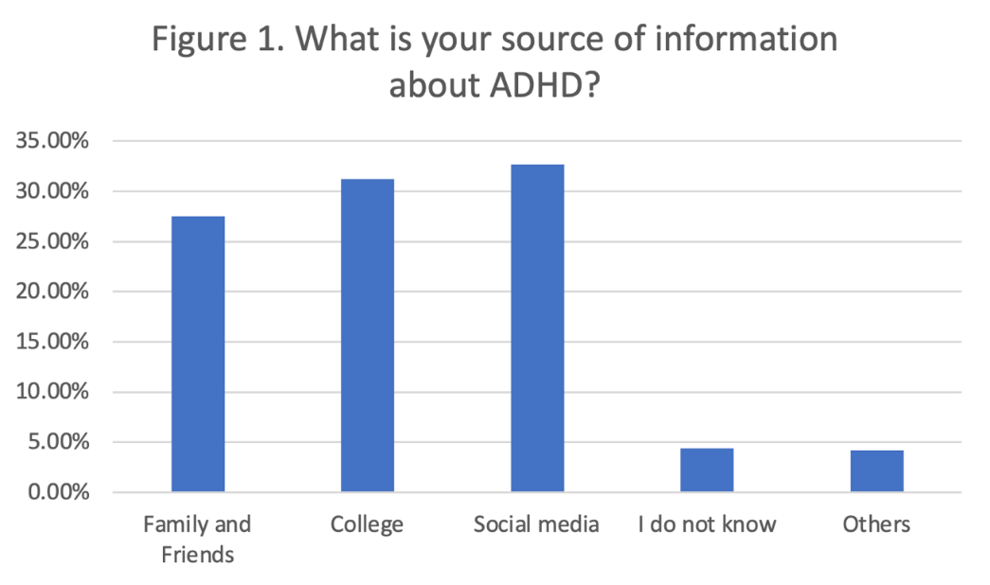
Figure 1. ADHD Source of Information
Figure 1 represents the source of information about ADHD. Out of the 385 participants, the most common source of information about ADHD was social media (32.7%), followed by college (31.2%), and family and friends (27.5%). Only a small percentage of participants reported not knowing the source of information (4.4%) or selecting "others" (4.2%).
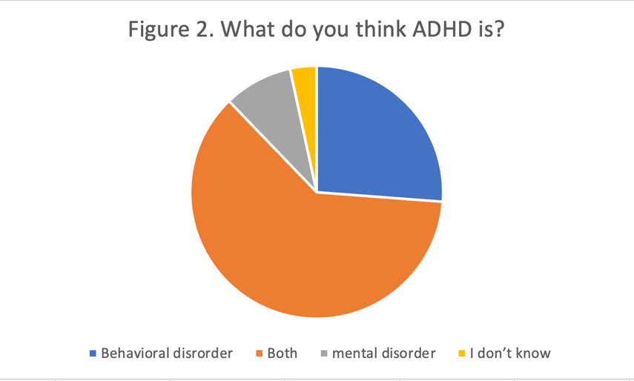
Figure 2. Understanding of participants regarding ADHD
Figure 2 shows the understanding of participants about ADHD; the majority of participants (61.6%) believed ADHD to be both a behavioral and mental disorder. About a quarter (26.2%) believed ADHD to be a behavioral disorder only, while a small percentage (8.8%) believed it to be a mental disorder. Only a few participants (3.4%) reported not knowing what ADHD was.
Table 2. Knowledge of ADHD and gender comparison
 |  | Male |  | Female |  | P-Value
Item assessing the knowledge |  | N | % | N | %
What is your source of information about ADHD? | Family and Friends | 57 | 39.3% | 49 | 20.4% | <0.005*
What is your source of information about ADHD? | College | 13 | 9.0% | 107 | 44.6% | <0.005*
What is your source of information about ADHD? | Social media | 64 | 44.1% | 62 | 25.8% | <0.005*
What is your source of information about ADHD? | I do not know | 3 | 2.1% | 14 | 5.8% | <0.005*
What is your source of information about ADHD? | Others | 8 | 5.5% | 8 | 3.3% | <0.005*
What do you think ADHD is? | Behavioral disorder | 39 | 26.9% | 62 | 25.8% | 0.045*
What do you think ADHD is? | Both | 81 | 55.9% | 156 | 65.0% | 0.045*
What do you think ADHD is? | mental disorder | 16 | 11.0% | 18 | 7.5% | 0.045*
What do you think ADHD is? | I don’t know | 9 | 6.2% | 4 | 1.7% | 0.045*
What do you think are the causes of ADHD? | Physiological | 44 | 30.3% | 39 | 16.3% | 0<0.05^{*a}
What do you think are the causes of ADHD? | Multifactorial | 90 | 62.1% | 168 | 70.0% | 0<0.05^{*a}
What do you think are the causes of ADHD? | Hereditary | 8 | 5.5% | 15 | 6.3% | 0<0.05^{*a}
What do you think are the causes of ADHD? | Nutrition | 3 | 2.1% | 3 | 1.3% | 0<0.05^{*a}
What do you think are the causes of ADHD? | Others | 0 | 0.0% | 8 | 3.3% | 0<0.05^{*a}
What do you think are the causes of ADHD? | I don’t know | 0 | 0.0% | 7 | 2.9% | 0<0.05^{*a}
Based on your information, what are the treatment methods for ADHD? | Behavioral therapy | 21 | 14.5% | 24 | 10.0% | <0.005*
 | Both | 68 | 46.9% | 175 | 72.9% | <0.005*
 | Pharmacotherapy | 47 | 32.4% | 36 | 15.0% | <0.005*
 | I don’t know | 9 | 6.2% | 5 | 2.1% | <0.005*
Table 2 examines gender differences in ADHD knowledge, revealing statistically significant differences across all areas using the Chi-square and Fisher’s Exact Test. Specifically, a higher percentage of females (44.6%) reported college as their primary source of ADHD information compared to males (9.0%). Conversely, a higher percentage of males (39.3%) reported that their source of information about ADHD came from family and friends compared to females (20.4%). Additionally, more females (65.0%) than males (55.9%) perceived ADHD as both a behavioral and mental disorder, while more males (26.9%) than females (25.8%) classified it solely as a behavioral disorder. Regarding ADHD treatment methods, a higher percentage of females (72.9%) supported a combination of behavioral therapy and pharmacotherapy compared to males (46.9%).

Criteria of ADHD Information
Table 3. Frequency of participants about Criteria of the ADHD information
 | Yes |  | No
Criteria item | N | % | N | %
Do you think people with ADHD talk too much? | 321 | 83.4% | 64 | 16.6%
Do you think people with ADHD act and speak without thinking? | 318 | 82.6% | 67 | 17.4%
Do you think people with ADHD call out answers before the question is complete? | 342 | 88.8% | 43 | 11.2%
Do you think people with ADHD have difficulty sustaining attention in tasks or play? | 321 | 83.4% | 64 | 16.6%
Do you think people with ADHD have difficulty organizing tasks/activities? | 328 | 85.2% | 57 | 14.8%
Do you think people with ADHD avoid doing things that require ongoing mental effort that require mental effort? | 256 | 66.5% | 129 | 33.5%
Do you think people with ADHD interrupt when they talk? | 320 | 83.1% | 65 | 16.9%
Do you think people with ADHD cannot play quietly? | 313 | 81.3% | 72 | 18.7%
Do you think people with ADHD cannot stay seated? | 332 | 86.2% | 53 | 13.8%
Table 3 presents participant’s responses about the criteria for ADHD, with the majority of participants responding "yes" to each item. Specifically, the majority of participants believed that people with ADHD talk too much (83.4%), act and speak without thinking (82.6%), call out answers before the question is complete (88.8%), have difficulty sustaining attention in tasks or play (83.4%), have difficulty organizing tasks/activities (85.2%), interrupt when they talk (83.1%), cannot play quietly (81.3%), and cannot stay seated (86.2%) (Table 3).
Overall, the results of this descriptive study suggest that social media is a common source of information about ADHD, with most participants recognizing ADHD to be both a behavioral and mental disorder. Gender differences were found in ADHD knowledge, particularly in the sources of information and treatment preferences. Additionally, the majority of participants agreed with the ADHD criteria presented to them.

Discussion
ADHD, short for attention deficit hyperactivity disorder, is a neurodevelopmental disorder that affects individuals of all ages. Although awareness of ADHD has improved greatly in recent years, there remain significant misconceptions and gaps in understanding the disorder (McLeod et al., 2007). The current study aimed to determine the awareness of ADHD in Eastern Province by analyzing demographic information, sources of information, knowledge about ADHD, gender differences, and criteria for ADHD information.
The results of the study indicated that the majority of participants were Saudi females who had attained a bachelor’s degree as their highest level of education, accounting for 78.2%. Social media was the most common source of information about ADHD, comprising 32.7%, followed closely by college and family/friends. This highlights the importance of utilizing social media platforms to spread awareness and information about ADHD. Numerous research studies conducted in Saudi Arabia have examined the sources from which people learn about attention deficit hyperactivity disorder (ADHD), and they have consistently demonstrated the significance of social media. The results of a previous study (Aldawodi et al., 2018) conducted in Saudi Arabia, which indicated that social media and the internet were the main sources of knowledge regarding ADHD, were supported by the findings of this study. It’s interesting to note that social media is seen favorably throughout the Gulf region. A prevalent issue that has been documented in earlier research is the use of non-medical sources as the primary source of medical information for ADHD (Ohan et al., 2008). To prevent misunderstandings about ADHD, it is crucial to rely on trustworthy sources. Therefore, decision-makers are encouraged to support the creation of a specific ADHD course for different community segments, and faculty training curricula should incorporate education (Irshad, 2017). Since these were the most widely used information sources, distributing these instructional programs across various social media platforms will be very helpful.
Overall, the participants had a good understanding of what ADHD is, with the majority stating that ADHD is a behavioral and mental disorder accounting for (61.6%). However, there were still a few participants who reported not knowing what ADHD was, indicating the need for more awareness and education about the disorder in society. In comparison, a prior study conducted in Medina found that 32.2% of the sample considered it to be a genetic tendency (Ohan et al., 2008). Aljammaz et al. (2023) conducted a cross-sectional survey on 1,148 adults to gauge their knowledge about ADHD. According to the results, 85% of participants agreed that behavioral therapy and early medical treatment are essential for ADHD. Interestingly, the study highlighted how social media is a major source of knowledge regarding ADHD (Aljammaz et al., 2023). Similarly, another study focusing on community knowledge about ADHD in Saudi Arabia found that approximately half of the participants identified social media as their main source of information. This study emphasizes the pivotal role that digital platforms play in disseminating information about ADHD within the community (Abu Alhommos et al., 2022). Higher levels of knowledge (90.0%) were revealed by a prior study that examined teacher’s understanding of ADHD in the Kingdom of Saudi Arabia (Alanazi and Al Turki, 2021). Understanding ADHD is vital, particularly for parents, because it influences how they nurture their affected children. This involves knowing how the illness is diagnosed, how ADHD treatment affects children's daily lives, and how to increase treatment adherence (El Hayek et al., 2019).
Gender differences were also found in the source of information and treatment methods for ADHD. Interestingly, more females reported acquiring knowledge about ADHD from college, while more males received information about ADHD from family and friends. It is important to understand these gender differences, as it can provide insights into how to better target awareness efforts in specific populations. In addition, differences were also found in the preferred treatment approach for ADHD, with more females (72.9%) responding with a combination of behavioral therapy and pharmacotherapy compared to males (46.9%). A recent study in Taiwan found that housewives spend more time monitoring their children's behavior, and as they gain parenting experience, they learn more about ADHD (See et al., 2021). Likewise, a prior study conducted in Korea revealed that female educators knew more about ADHD than their male counterparts (Park et al., 2018).
The majority of participants agreed with the ADHD information presented to them, with agreement rates ranging from 81.3% to 88.8%, in line with the DSM-5 diagnostic criteria (American Psychiatric Association, 2013). This shows that the main symptoms of ADHD, such as impulsivity, hyperactivity, and inattention are well understood. This finding underscores the positive impact of increased exposure to awareness materials. Additionally, the statistics show that the majority of participants understood the clinical presentation of ADHD. This study is consistent with a prior survey conducted in Saudi Arabia that found 90% of teachers knew the subject, underscoring the increased awareness in the educational sector (Aldawodi et al., 2018). Similarly, McLeod et al. (2007) discovered that people’s knowledge of ADHD has increased, especially after being exposed to organized information or awareness initiatives (McLeod et al., 2007). Rodrigo et al. (2011), on the other hand, found that the majority of respondents had inadequate awareness of ADHD symptoms (Rodrigo et al., 2011). The authors attributed this to a limited sample size and a lack of familiarity with digital awareness tools such as social media. DosReis et al. (2010) provided support for this by stressing the necessity of expanding outreach through easily accessible educational platforms in order to enhance ADHD literacy among marginalized communities (Rodrigo et al., 2011). Additionally, Sayal et al. (2018) discovered in their systematic review that there are notable differences in knowledge of ADHD depending on geographic location, educational attainment, and availability of information sources. This underscores the need for culturally and regionally adapted public health campaigns (Alqahtani, 2010).
The current study provides useful information and insight about ADHD awareness in Alahsa City. The findings highlight the critical need for ongoing public education and awareness initiatives on ADHD, focusing on individuals who indicated having limited knowledge of the condition. These results are consistent with earlier studies, such as Alqahtani, (2010), which emphasized the lack of knowledge and common misconceptions regarding ADHD among Saudi Arabian parents and educators (Alshareef et al., 2023). Furthermore, gender disparities in treatment preferences and information sources indicate that awareness campaigns need to be culturally and gender-sensitive (Begum et al. 2024). Alshareef et al. (2023) discovered that men frequently relied on formal channels for mental health information, whereas women were more likely to rely on social networks (AlShamrani et al., 2023). According to AlShamrani et al. (2023), educating communities on ADHD- its symptoms, diagnosis, and available treatments- not only lessens stigma but also makes early detection and management easier. Improving the general public’s understanding of ADHD can have a big impact on how quickly the illness is managed and enhance long-term results for both people and families (AlShamrani et al., 2023).

Conclusion
The present study offers important information about the degree of knowledge and comprehension of Attention-Deficit/Hyperactivity Disorder (ADHD) among the people of Saudi Arabia. The results show that there is a substantial knowledge gap among some individuals, highlighting the critical need for continued public education and awareness campaigns. A significant portion of participants notably stated that they were not familiar with ADHD, indicating that many may not be able to identify its symptoms or understand how it affects day-to-day functioning. Additionally, the study found that there was gender-based disparities in the sources of information about ADHD as well as in the preferred methods of treatment. These variations highlight the crucial importance of creating inclusive awareness campaigns and educational initiatives that consider gender-specific preferences and information accessibility. By tailoring awareness programs to different demographic and cultural segments of the population, these initiatives can ensure broader reach and deeper impact. It is especially important to engage both traditional and digital media in these efforts, as social media has proven to be a dominant but potentially unreliable source of information. Increasing proper information about ADHD, including its symptoms, causes, and treatment options, can help to reduce stigma and correct misconceptions. Such efforts may also improve public attitudes toward mental health overall, encouraging more individuals to seek timely professional help. In the long run, this might promote earlier detection, prompt intervention, and better results for local ADHD sufferers.
Declaration of competing interests

We do not have any conflict of interest over this publication.

Acknowledgements

This study was supported by the Deanship of Scientific Research and the Vice President for Graduate Studies and Scientific Research, Eastern Province University, Saudi Arabia.

Data availability

Data will be made available on request

References
Abu Alhommos, A.K., AlHadab, F.M., Alalwan, R.A., Alabduladhem, S.T., Alnaser, Z.A., Alnami, S.S., 2022. Community knowledge about attention deficit hyperactivity disorder in Saudi Arabia: A cross-sectional study, in: Healthcare. MDPI, p. 54.
Acosta, L.L., 2023. The Intersectionality of Sex, Race, and Ethnicity in Externalizing, Internalizing, and Adaptive Symptoms in Youth With ASD, ADHD, and Comorbid ASD/ADHD. University of Florida.
Al-Ahmari, A.A., Bharti, R.K., Al-Shahrani, M.S., Alharthi, M.H., Alqarni, H.M., Alshehri, H.M., 2018. Knowledge, attitude, and performance of primary healthcare physicians in Aseer Region, Saudi Arabia about attention deficit hyperactivity disorder. J. Fam. Community Med. 25, 194–198.
Al-Wardat, M., Etoom, M., Almhdawi, K.A., Hawamdeh, Z., Khader, Y., 2024. Prevalence of attention-deficit hyperactivity disorder in children, adolescents and adults in the Middle East and North Africa region: a systematic review and meta-analysis. BMJ Open 14, e078849.
Alanazi, F., Al Turki, Y., 2021. Knowledge and attitude of attention-deficit and hyperactivity disorder (ADHD) among male primary school teachers, in Riyadh City, Saudi Arabia. J. Fam. Med. Prim. Care 10, 1218–1226.
Aldawodi, M., Alfageer, H., Al Queflie, S., Masud, N., Al Harthy, N., Alogayyel, N., Alrabah, M., Qureshi, S., 2018. Knowledge and attitude of male primary school teachers about attention deficit and hyperactivity disorder in Riyadh, Saudi Arabia. J Nat Sci Biol Med 9, 257–262.
Alhowaymel, F.M., Alenezi, A., 2022. Adverse childhood experiences and health in rural areas of Riyadh province in Saudi Arabia: A cross-sectional study, in: Healthcare. MDPI, p. 2502.
Aljammaz, W.B., Alruqayb, S.N., Alotaibi, H.M., Alsaeed, R.Z., Alhaqbani, K.A., Albrahim, R., Albogami, S.A., 2023. Attention Deficit Hyperactivity disorder awareness among the Saudi population: A cross sectional study. Majmaah J. Heal. Sci. 11, 82.
Alqahtani, M.M.J., 2010. Attention-deficit hyperactive disorder in school-aged children in Saudi Arabia. Eur. J. Pediatr. 169, 1113–1117.
AlShamrani, F.J., AlMohish, N., AlJaafari, D., AlAbdali, M., Shariff, E., Zafar, A., Shahid, R., AlNahdi, A., AlDawsari, F., Ahmad, S., 2023. Estimated Prevalence Study of Attention-Deficit/Hyperactivity Disorder among Eastern Province Children in the Kingdom of Saudi Arabia. Ann. Afr. Med. 22, 544–548.
Alshareef, H.H., Elzahrany, S.R., Alharthi, R.A., Alsulmai, A.A., Aljabri, S.G., Alamri, G.E., Alharbi, I., Alkhotani, A.M., 2023. Knowledge of and attitude toward attention-deficit/hyperactivity disorder (ADHD) assessed among primary schoolteachers of Makkah City in Saudi Arabia. J. Fam. Med. Prim. Care 12, 2230–2236.
Association, A.P., 2013. Diagnostic and Statistical Manual of Mental Disorders.
Basudan, M., Akbar, N., El-Ghamdi, W., Ibrahim, A., 2019. Knowledge and attitude of female teachers toward ADHD at elementary schools, Jeddah, KSA, 2017. Int. Ann. Med. 3, 693–699.
Begum, N., Pathath, A. W., Elballah, K., Almubireek, M. A., Irshad, S., & Ali, S. I. (2024). Prevalence of Adult Attention Deficit Hyperactivity Disorder among Medical Students, King Faisal University . South Eastern European Journal of Public Health, 1348–1356. https://doi.org/10.70135/seejph.vi.2056
Castle, L., Aubert, R.E., Verbrugge, R.R., Khalid, M., Epstein, R.S., 2007. Trends in medication treatment for ADHD. J. Atten. Disord. 10, 335–342.
El Hayek, G., Saab, D., Farhat, C., Krayem, Z., Karam, E., 2019. Adult ADHD in the Arab world: a review. Arch. Psychol. 3.
Grevet, E.H., Bau, C.H.D., Salgado, C.A.I., Fischer, A.G., Kalil, K., Victor, M.M., Garcia, C.R., Sousa, N.O., Rohde, L.A., Belmonte-de-Abreu, P., 2006. Lack of gender effects on subtype outcomes in adults with attention–deficit/hyperactivity disorder: Support for the validity of subtypes. Eur. Arch. Psychiatry Clin. Neurosci. 256, 311–319.
Irshad, S. 2017. A comparative study of stress and alienation among orphans and normal.
International Journal of Indian Psychology, 2:4, 93.

Kessler, R.C., Adler, L., Barkley, R., Biederman, J., Conners, C.K., Demler, O., Faraone, S. V, Greenhill, L.L., Howes, M.J., Secnik, K., 2006. The prevalence and correlates of adult ADHD in the United States: results from the National Comorbidity Survey Replication. Am. J. Psychiatry 163, 716–723.
Lamb, C., Hall, D., Kelvin, R., Van Beinum, M., 2008. Working at the CAMHS/Adult Interface: Good practice guidance for the provision of psychiatric services to adolescents/young adults. London R. Coll. Psychiatr.
McLeod, J.D., Fettes, D.L., Jensen, P.S., Pescosolido, B.A., Martin, J.K., 2007. Public knowledge, beliefs, and treatment preferences concerning attention-deficit hyperactivity disorder. Psychiatr. Serv. 58, 626–631.
Munshi, A.M.A., 2014. Knowledge and misperceptions towards diagnosis and management of attention deficit hyperactivity disorder (ADHD) among primary school and kindergarten female teachers in Al-Rusaifah district, Makkah city, Saudi Arabia. Int. J. Med. Sci. Public Heal. 3, 444–451.
Ohan, J.L., Cormier, N., Hepp, S.L., Visser, T.A.W., Strain, M.C., 2008. Does knowledge about attention-deficit/hyperactivity disorder impact teachers’ reported behaviors and perceptions? Sch. Psychol. Q. 23, 436.
Park, S., Lee, Y., Lee, E.-S., Kim, C.E., 2018. Public recognition of attention-deficit hyperactivity disorder in Korea: Correct identification, causes, treatments, and social distance. Asian J. Psychiatr. 38, 3–8.
Qashqari, H.F., Alsulami, A.O., Kamal, E.K., Jan, M.M.S., 2017. ADHD awareness among medical students. World J. Res. Rev. 4, 262834.
Quinn, P.O., Madhoo, M., 2014. A review of attention-deficit/hyperactivity disorder in women and girls: uncovering this hidden diagnosis. Prim. care companion CNS Disord. 16, 27250.
Rodrigo, M.D.A., Perera, D., Eranga, V.P., Williams, S.S., Kuruppuarachchi, K., 2011. The knowledge and attitude of primary school teachers in Sri Lanka towards childhood attention deficit hyperactivity disorder. Ceylon Med. J. 56.
Sayal, K., Prasad, V., Daley, D., Ford, T., Coghill, D., 2018. ADHD in children and young people: prevalence, care pathways, and service provision. The lancet psychiatry 5, 175–186.
See, L.-C., Li, H.-M., Chao, K.-Y., Chung, C.-C., Li, P.-R., Lin, S.-R., 2021. Knowledge of attention-deficit hyperactivity disorder among the general public, parents, and primary school teachers. Medicine (Baltimore). 100, e25245.

