The Relationship Between Smartphone Use and Mindful Attention in Young Adults

Abstract
In today’s world, smartphones have become an essential part of daily life, especially for young adults. While they make communication and learning easier, their constant use may affect how well people stay focused and aware in the present moment. This study explored how smartphone use relates to mindful attention among college students. Thirty students between 18 and 25 years old took part in an online survey that included two tools: the Media and Technology Usage and Attitudes Scale (MTUAS) to measure smartphone use, and the Mindful Attention Awareness Scale (MAAS) to assess mindfulness. The results showed a clear negative link between the two — students who used their phones more often tended to be less mindful. Further analysis confirmed that high smartphone users had noticeably lower mindfulness scores compared to those who used their phones less. These findings suggest that spending too much time on smartphones may reduce present-moment awareness, highlighting the need for balance and mindful digital habits in everyday life.

Keywords: Smartphone Use, Mindful Attention, Mindfulness, Screen Time, Young Adults, Digital Habits

Introduction
A growing portion of teenagers' leisure time is utilized on smartphone screens, including smartphones, tablets, gaming consoles, and televisions. (Common Sense Media, 2015; Twenge et al., 2019),bringing concerns about the effects of screen time on the well-being of parents, healthcare providers, and educators.(e.g., Kardaras, 2017). The World Health Organization has included gaming disorder in the 11th edition of the International Classification of Diseases.(WHO, 2018).
In the past decade, smartphones have become integral to modern life, especially for young adults, who rely on them not just for communication but for social networking, learning, entertainment, and daily organization. While these devices offer undeniable convenience and efficiency, their pervasive use has also sparked growing concerns about their effects on cognitive health, particularly on attention and mindfulness (Rosen et al., 2013; Montag et al., 2015). With increasing screen dependence, researchers are beginning to explore the long-term psychological costs of sustained smartphone use.
Attention, a key component of cognitive functioning, refers to the ability to selectively focus on relevant stimuli while filtering out distractions (Posner & Petersen, 1990). In contrast, mindfulness involves being present and fully engaged with the moment, fostering a non-reactive and aware mental state (Kabat-Zinn, 2003). These two constructs are interrelated, as mindfulness practices have been shown to improve attention regulation (Tang et al., 2007). However, the habitual use of smartphones may compromise these cognitive faculties. Notifications, multitasking, and rapid information consumption inherent to smartphone use can fragment attention and encourage shallow processing (Ophir et al., 2009). Repeated exposure to such digital environments may decrease one’s capacity to remain present, thus undermining mindfulness.
Neuroscientific studies have provided early evidence of structural and functional brain changes associated with digital multitasking and problematic smartphone use. For instance, excessive smartphone users have shown altered activity in the prefrontal cortex—an area responsible for attention control, impulse regulation, and decision-making (Horvath et al., 2020). These neurological changes may explain why young adults often report feeling mentally fatigued or distracted despite resting. Moreover, smartphone overuse has been linked to increased symptoms of anxiety, depression, and attention deficit (Elhai et al., 2017; Demirci et al., 2015), suggesting that mental well-being and attentional functioning are deeply intertwined.
In addition to cognitive and neural concerns, behavioral scientists highlight that smartphone use often fosters compulsive checking and fear of missing out (FoMO), both of which lead to frequent attentional shifts and diminished self-awareness (Przybylski et al., 2013). According to self-determination theory, such compulsions can disrupt intrinsic motivation and reduce psychological well-being by weakening autonomy and competence (Deci & Ryan, 2000). As mindfulness is grounded in self-regulation and present-moment focus, these compulsive digital behaviors can potentially erode the foundation upon which mindful attention is built.
Importantly, the impact of smartphone use on mindfulness may not be uniform. Context matters. Smartphone use for productive or mindful purposes, such as meditation apps or educational content, may not carry the same risks as passive scrolling or gaming (van Deursen et al., 2015). However, the majority of young adults engage in screen time driven by social validation, entertainment, and distraction rather than purposeful engagement. These behavioral tendencies create what some scholars refer to as a “digital attention economy,” wherein attention is commodified, leading users to unintentionally surrender their cognitive resources to apps designed to exploit attentional vulnerability (Williams, 2018).
Given these trends, it is crucial to understand how habitual smartphone use may relate to mindful attention in young adults. While some studies have examined these concepts independently, few have analyzed their interrelationship directly, especially in the Indian context. This research addresses this gap by empirically examining the connection between smartphone screen time and mindfulness among young adults. By doing so, it not only adds to the academic literature but also provides practical implications for educators, therapists, and policy makers concerned with digital hygiene and mental health promotion.
Mindfulness involves being present and focused in the current moment (Schuman-Olivier et al., 2020). Undoubtedly, technology has many advantages, but there are also concerns about how it may affect cognition, particularly attention. Long-term screen time has been linked in the past to mental exhaustion, reduced mindfulness, and poor cognitive flexibility. According to previous investigations, excessive screen use is associated with reduced mindfulness, less cognitive flexibility, and mental exhaustion.(Lin et al., 2020; Twenge & Campbell, 2018).Moyer (2016) and Chassiakos (2016) researched the impact of digital media usage on young people's cognitive growth. According to other research by Fillmore (2014), Haxel (2022), Lissak (2018), and Tripath (2020), prolonged screen use may be a factor in decreased focus and attention. Direct comparative studies that examine the variations in attention between people who use screens a lot and those who don't are still necessary. This research intends to explore these distinctions by examining the attention of young adults who experience high amounts of screen time versus those with lower usage. By focusing on this area, the study aims to add to the expanding literature concerning the cognitive impacts of digital consumption.

Significance of the Study
The growing use of smartphones among young adults has raised important questions about its effects on mental and cognitive health. This study is significant because it explores the relationship between smartphone use and mindful attention—two important aspects that influence focus, productivity, and emotional well-being. Understanding this relationship is especially important in today’s digital world, where young people often spend several hours a day on their phones, sometimes without realizing its impact on their ability to stay present and attentive.
By comparing individuals with high and low smartphone usage, this research aims to provide insights into whether excessive screen time is linked to reduced mindfulness and attention levels. These findings can help students become more aware of their digital habits and encourage healthier usage patterns. Educators and mental health professionals can also benefit from this study by developing awareness programs, classroom strategies, and counseling methods to promote mindfulness and focus among youth.
Additionally, this research contributes to the existing psychological literature by highlighting the cognitive effects of modern technology, particularly within the Indian context. Since most previous studies have focused on Western populations, this study provides valuable data specific to Indian young adults, helping make global research more inclusive and culturally relevant.
In summary, the study holds practical and academic value by addressing a timely issue that affects academic performance, mental health, and daily functioning among the youth. The findings may guide further research, educational policies, and personal behavior changes that promote digital well-being and mindful living.

Review of Literature
In the digital age, smartphones have emerged as an essential tool in the daily lives of young adults, serving multiple functions from social interaction to academic assistance. However, their endless raises concerns about their impact on cognitive processes, particularly mindful attention. Mindfulness is defined as a receptive attention to and awareness of present experiences (Brown & Ryan, 2003), a quality that may be undermined by constant digital engagement. The use of smartphones has been associated with experiential avoidance, reduced attention regulation, and compulsive checking behaviours, all of which may impair mindfulness. The conceptual model tested by Woodlief et al. (2024) shows that behavioural and cognitive involvement with smartphones leads to a decreased capacity for mindful attention. Similarly, Cheng et al. (2020) demonstrated that late-night smartphone use correlates negatively with mindfulness, with self-control and rumination as mediators.
Although there is increasing empirical interest, there are still some gaps. To begin with, not many studies utilize objective usage data or longitudinal approaches, which are crucial for determining causality. Secondly, a significant portion of the research concentrates on Western groups, which restricts the applicability of the results. Lastly, the function of mindfulness as both a mediator and a moderator in this connection is not well-researched, highlighting the need for further investigation into its protective benefits.

Cheng et al. (2020) used a cross-sectional design with 270 college students to test the mediation model of mindfulness, self-control, and rumination in predicting smartphone addiction. The research shows significant negative relationships correlations between mindfulness and smartphone use before sleep. However, its reliance on self-reports limits causal interpretation.
Woodlief et al. (2024) conducted two studies using both self-report and objective smartphone usage metrics. Their planned missingness design and conceptual model offered a shallow view of smartphone involvement. Despite strong methodology, the study was cross-sectional and lacked cultural diversity.
Zhang & Wang (2022) proposed a moderated mediation model in a sample of 763 college students, showing that experiential avoidance mediates the effect of stress on smartphone use, moderated by trait mindfulness. The research offered strong statistical analysis but failed to account for the use specific to each app.
Saha et al. (2024) undertook a cross-sectional analysis of 423 Indian medical students. Over 80% showed high smartphone use, with over 52% showing low mindfulness. Though rich in demographic diversity, the study was purely descriptive and lacked theoretical modelling.
Uniyal & Shahnawaz (2022) examined a serial mediation model in which mindfulness and self-compassion acted as mediators in the connection between wellbeing and problematic smartphone usage. This research contributed to the advancement of theory but relied only on correlational data.
Haschke et al. (2018) shows how short mobile mindfulness exercises impact depression, anxiety, and stress levels among college students. The study found no significant differences across conditions, pointing to limitations in the efficacy of short-term interventions.
Zhao et al. (2022) highlighted how smartphone usage can serve as a means of avoiding experiences and suggested that mindfulness could act as a moderating factor. The results they obtained were convincing; however, the use of a single-culture sample restricted its wider relevance.
Mondal et al. (2023) examined the mindfulness levels and smartphone habits in Kolkata medical students. The results highlighted the worldwide significance of the matter but were limited by a lack of psychometric depth in measurement tools.
The addictive tendency associated with smartphone usage frequently arises from a psychological need for social validation. This manifests in frequent checking of social media for likes, comments, and messages, which strengthens the reliance on external validation and diminishes internal awareness. Woodlief et al. (2024) and Uniyal & Shahnawaz (2022) emphasized this route, demonstrating that social comparison and a lack of self-compassion serve as mediators for the adverse effects of smartphone usage.
The ability to multitask on smartphones leads to divided attention spans. Cheng et al. (2020) and Haschke et al. (2018) discovered that excessive use of smartphones, particularly before sleep, worsens rumination and leads to decreased self-control. This interferes with sleep health and emotional stability, both of which are essential for maintaining focused awareness.
Demographic elements like gender, housing situation, and cultural heritage greatly influence the connection between mindfulness and smartphone usage. Saha et al. (2024) discovered that female students living in hostels exhibited greater levels of mindfulness. However, the majority of studies do not incorporate intersectional analysis, restricting a more nuanced comprehension.
Future studies ought to focus on longitudinal and experimental methods to more effectively determine causality. Incorporating objective usage data from smartphones along with ecological momentary assessments will improve validity. Interventions should explore app-based mindfulness training tailored to individual usage patterns. Cross-cultural research and studies addressing demographic moderators like gender, education level, and socio-economic status are also vital. Ultimately, differentiating between various types of smartphone usage academic, social, or entertainment can help identify which behaviors are most harmful to focused attention.
The connection between smartphone usage and mindfulness among young adults is intricate and has multiple facets. Although initial results indicate an inverse relationship, further detailed investigation is necessary to clarify the causal mechanisms. Mindfulness continues to be a hopeful shield against the cognitive and emotional disturbances associated with extensive digital interaction. Strong, interdisciplinary research is crucial for creating efficient, widely-implementable strategies that promote healthier technology behaviors in adolescents.

Methodology
Research Question:
What is the relationship between smartphone use and mindful attention in young adults?

Objective:
To examine the relationship between smartphone use and mindful attention in young adults.

Hypothese:
H1: There is a significant negative relationship between smartphone use and mindful attention in young adults.
Research Design
This study employed a cross-sectional, correlational research design using quantitative methodology. Data were collected through a structured online survey, which included standardized psychological instruments and demographic questions. The design allowed for the exploration of associations between Instagram
usage patterns and self-esteem without manipulating variables

Participants
The research was conducted on a sample of 30 undergraduate college-going students, out of which 19 (63.3%) were female participants and 11 (36.7%) were male participants. The mean age of the participants was 20.53 years. Sampling for the study was done using an online survey form, and participants were selected through random sampling based on their availability and willingness to take part in the research.

Inclusion Criteria
- Participants should be within the 18–25 age group.
- Participants should be college students.
- Participants who volunteered to be part of the research.

Exclusion Criteria
- Participants below 18 or above 25 years of age.
- Participants who were not enrolled in any college/university.
- Participants who did not consent or volunteer to take part in the research.
Measurements
The online survey consisted of three segments: demographic questions related to age, gender, and education level, an assessment of smartphone usage using the Media and Technology Usage and Attitudes Scale (MTUAS), and an assessment of mindfulness using the Mindful Attention Awareness Scale (MAAS).
Demographic Questionnaire:
Participants were asked to provide basic details including age, gender, and educational status. These details were used to ensure that all participants met the inclusion criteria and to understand the distribution of the sample.
Media and Technology Usage and Attitudes Scale (MTUAS):
The MTUAS (Rosen et al., 2013) is a validated self-report tool used to measure the frequency and pattern of smartphone usage. The scale uses a 5-point Likert format ranging from 1 = Never to 5 = Always. Participants responded to items related to how often they check their phones, use apps, or engage in digital communication. This scale helps identify individuals with high or low levels of smartphone usage. Higher scores indicate greater screen time and frequency of use. The MTUAS has demonstrated strong internal consistency (α > 0.80) and construct validity.
Mindful Attention Awareness Scale (MAAS):
The MAAS (Brown & Ryan, 2003) is a widely used 15-item self-report questionnaire designed to assess the general tendency to be attentive and aware of present-moment experiences. Items are rated on a 6-point Likert scale from 1 = Almost Always to 6 = Almost Never, with higher scores indicating greater levels of dispositional mindfulness. The MAAS has shown excellent psychometric properties, with high internal consistency (Cronbach’s α = 0.80–0.90) and good validity across diverse populations, including students and working adults.
Correlational research is a type of study design that investigates the strength and direction of relationships between two or more variables without manipulating them. This design was appropriate because the goal was to determine whether increased smartphone usage is associated with lower levels of mindful attention, as measured through standardized self-report tools.

Procedure
An online survey form was created using Google Forms to collect data for the research. The form consisted of three sections. The first section included questions related to the demographic details of the participants, such as name, age, gender, and educational qualification.
The second section included the Media and Technology Usage and Attitudes Scale (MTUAS), where participants were asked to rate the frequency of their smartphone usage and screen-related behaviors on a 5-point Likert scale ranging from 1 (Never) to 5 (Always).
The third section included the Mindful Attention Awareness Scale (MAAS). Participants were asked to rate their attention and awareness in daily life using a 6-point Likert scale, where 1 = Almost Always and 6 = Almost Never. This section measured the participants’ level of mindfulness.
A total of 30 participants were selected for the study based on the inclusion criteria. All respondents were between 18 to 25 years of age and were currently enrolled in college-level education. The mean age of the participants was 20.53 years.
Based on their responses on the MTUAS, participants were divided into two groups: those with high smartphone usage and those with low smartphone usage. MAAS scores were then analyzed to assess levels of mindful attention among the two groups. Data were scored and analyzed using Pearson’s correlation to examine the relationship between smartphone use and mindful attention.

Results

Data Analysis
The demographic details of the participants were collected through an online survey form. The mean age of the participants was 23.43 years. All 30 participants were college students, of which 21 (70%) were male and 9 (30%) were female. A majority of the participants were undergraduate students (70%), while the rest were postgraduate students (30%).
Participants reported their average daily screen time. Based on their responses:
- 17 participants (56.7%) reported using their smartphones for 6+ hours daily
- 9 participants (30%) reported 4–6 hours
- 3 participants (10%) reported 2–4 hours
- 1 participant (3.3%) reported using it for less than 2 hours

Age Groups
- 18-20 years: 8 participants (26.7%)
- 21-23 years: 14 participants (46.7%)
- 24-25 years: 8 participants (26.7%)
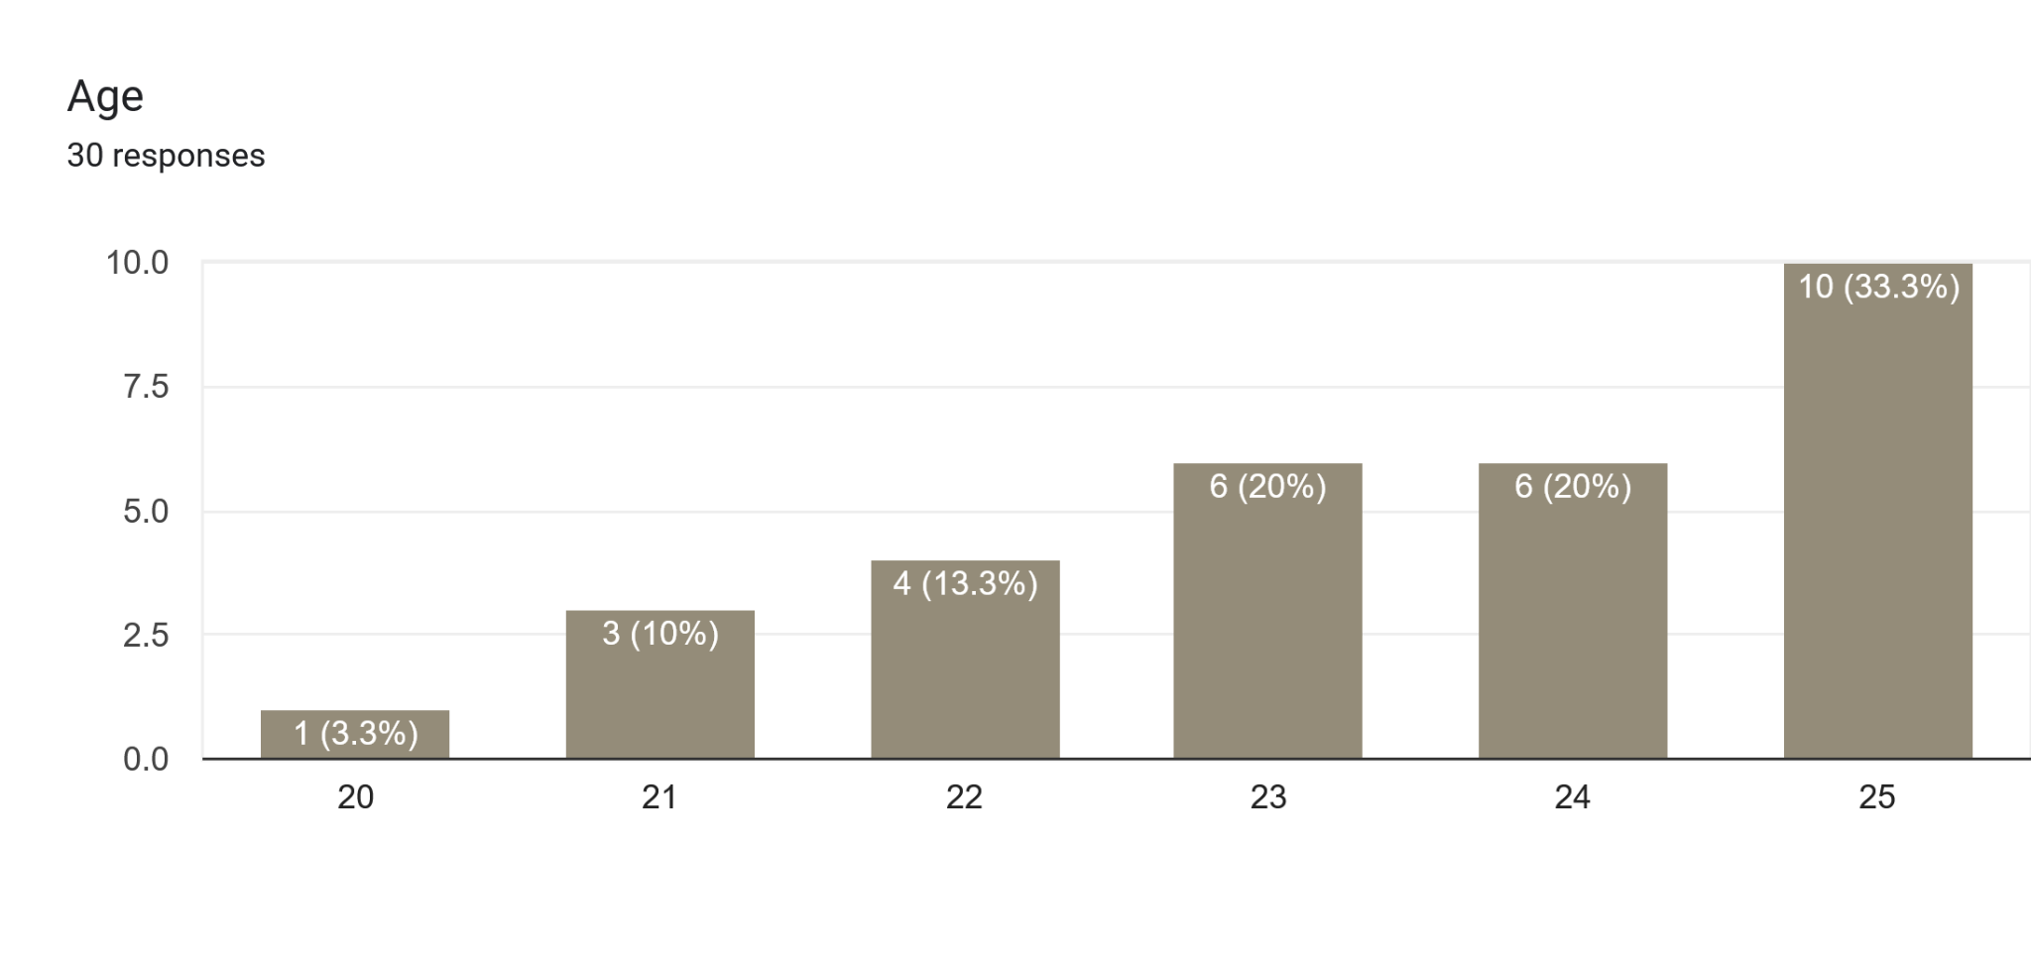

Gender Distribution
- Male: 18 participants (60%)
- Female: 12 participants (40%)
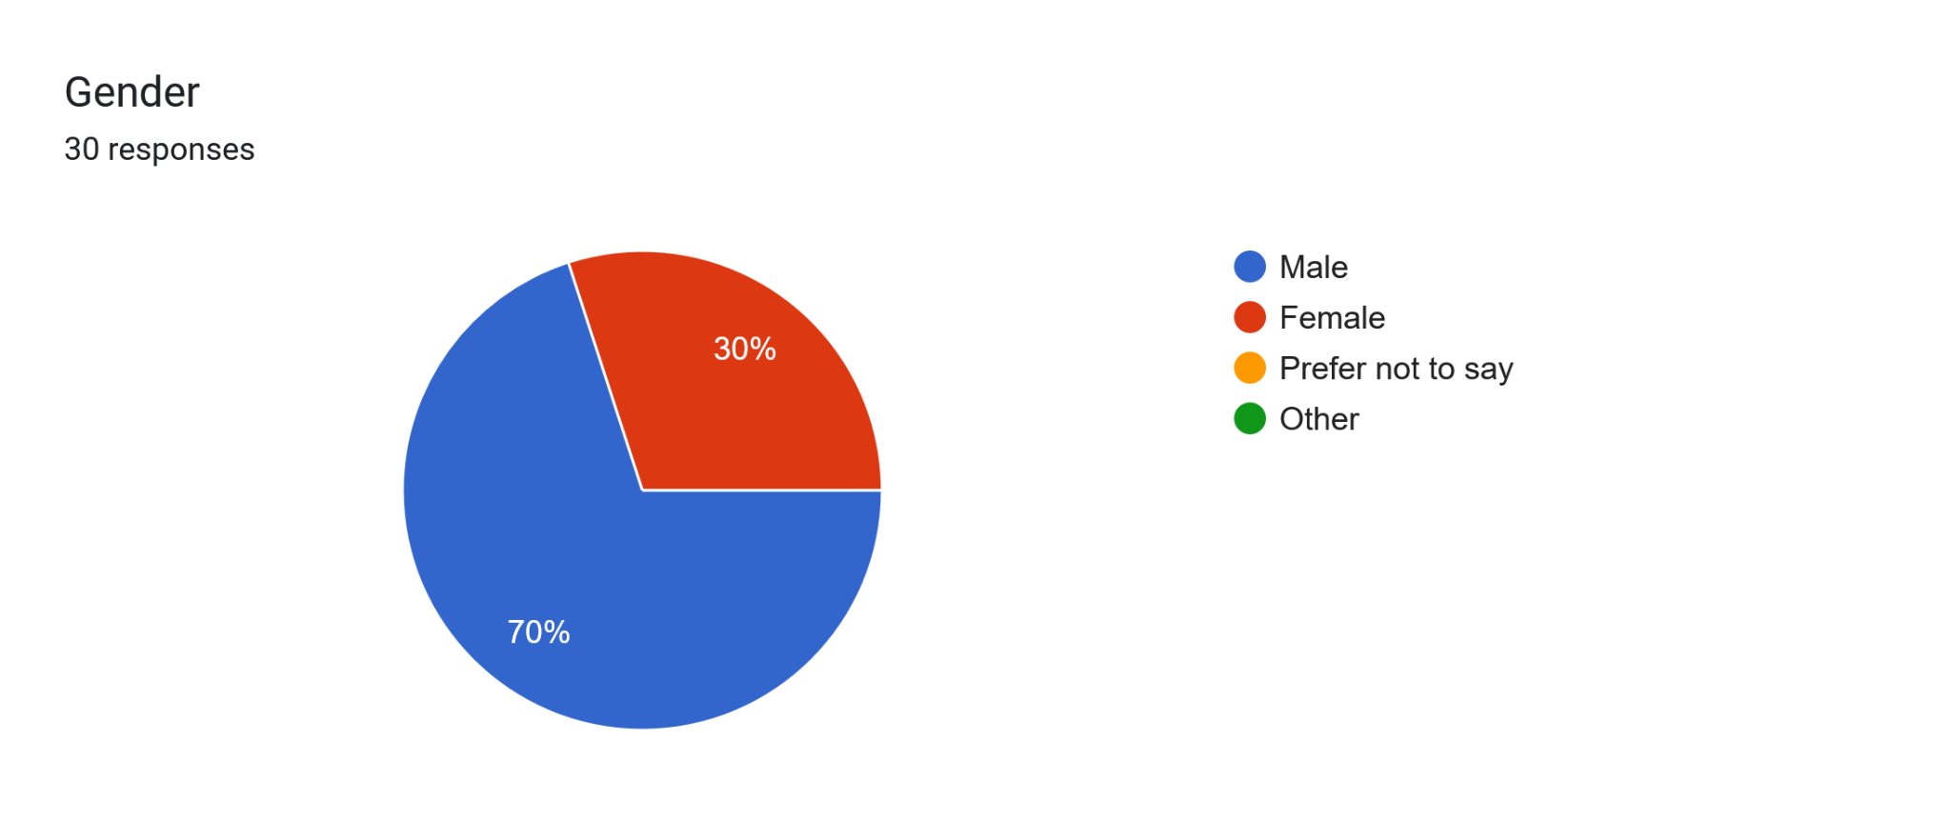

Education Level
- Undergraduate: 22 participants (73.3%)
- Postgraduate: 8 participants (26.7%)
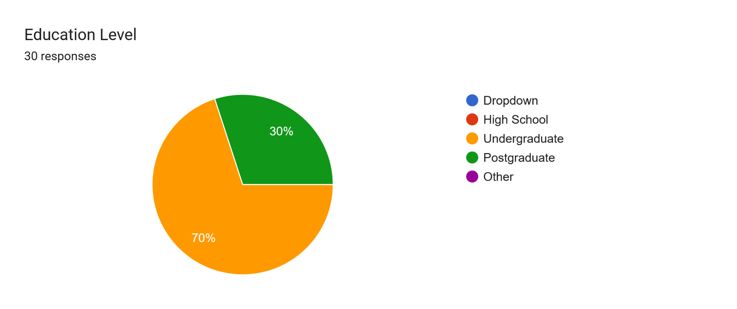

Daily Smartphone Usage (Screen Time)
- Low Usage (<4 hours/day): 6 participants (20%)
  - 2-4 hours: 6
- Moderate Usage (4-6 hours/day): 10 participants (33.3%)
- High Usage (6+ hours/day): 14 participants (46.7%)
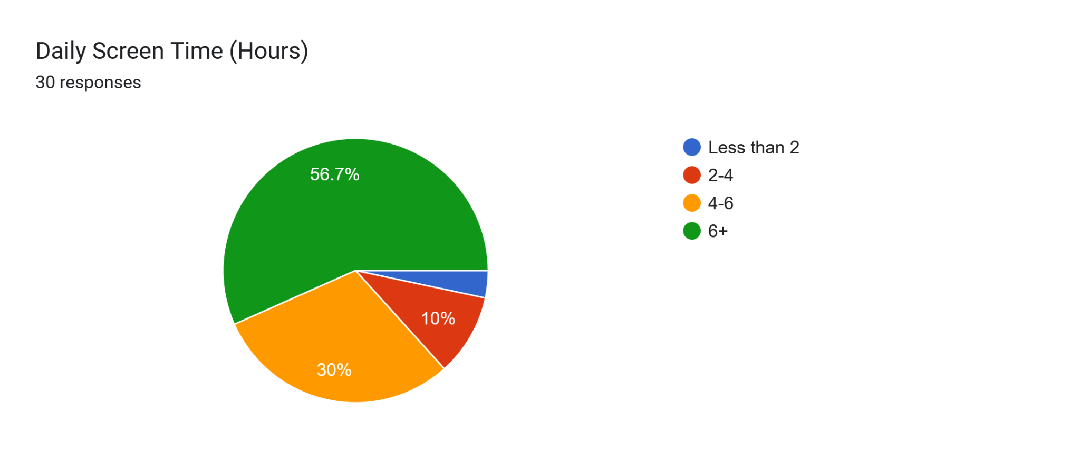

Table 1: Frequency and Percentage Distribution of Participants (N = 30)

Variable | Category | Frequency (f) | Percentage (%)
Gender | Male | 21 | 70%
 | Female | 9 | 30%
Education Level | Undergraduate | 21 | 70%
 | Postgraduate | 9 | 30%
Daily Screen Time | Less than 2 hours | 1 | 3.3%
 | 2–4 hours | 3 | 10%
 | 4–6 hours | 9 | 30%
 | 6+ hours | 17 | 56.7%

Table 2: Descriptive Statistics for MTUAS and MAAS Scores (N=30)

Variable | Minimum | Maximum | Mean | SD
MTUAS (Smartphone Use) | 38 | 79 | 60.67 | 9.86
MAAS (Mindful Attention) | 40 | 79 | 58.53 | 10.44
To examine group-level differences, participants were split into high and low smartphone use groups using a median split on MTUAS scores (Median = 61). Those scoring above 61 were categorized as high users (n = 15), and those scoring 61 or below were categorized as low users (n = 15).
Correlation Analysis
A Pearson product-moment correlation was conducted to explore the relationship between smartphone use and mindfulness. Results revealed a significant negative correlation, r(28) = –.624, p < .01, indicating that higher smartphone use was associated with lower levels of mindful attention.

Group Differences in Mindfulness Based on Smartphone Use
To further examine differences in mindfulness levels, an independent samples t-test was conducted comparing the MAAS scores of high and low smartphone use groups. The descriptive results are shown in Table 2.
Table 2 :Mindfulness Scores by Smartphone Usage Group

Smartphone Use Group | n | MAAS Mean | SD
High Use | 15 | 52.20 | 8.63
Low Use | 15 | 64.87 | 7.12
The results of the t-test indicated a statistically significant difference in mindfulness between the two groups, t(28) = –4.34, p < .001. Participants who reported higher levels of smartphone use had significantly lower mindfulness scores than those who used their smartphones less frequently. This supports the hypothesis that higher smartphone use is inversely related to mindful attention.
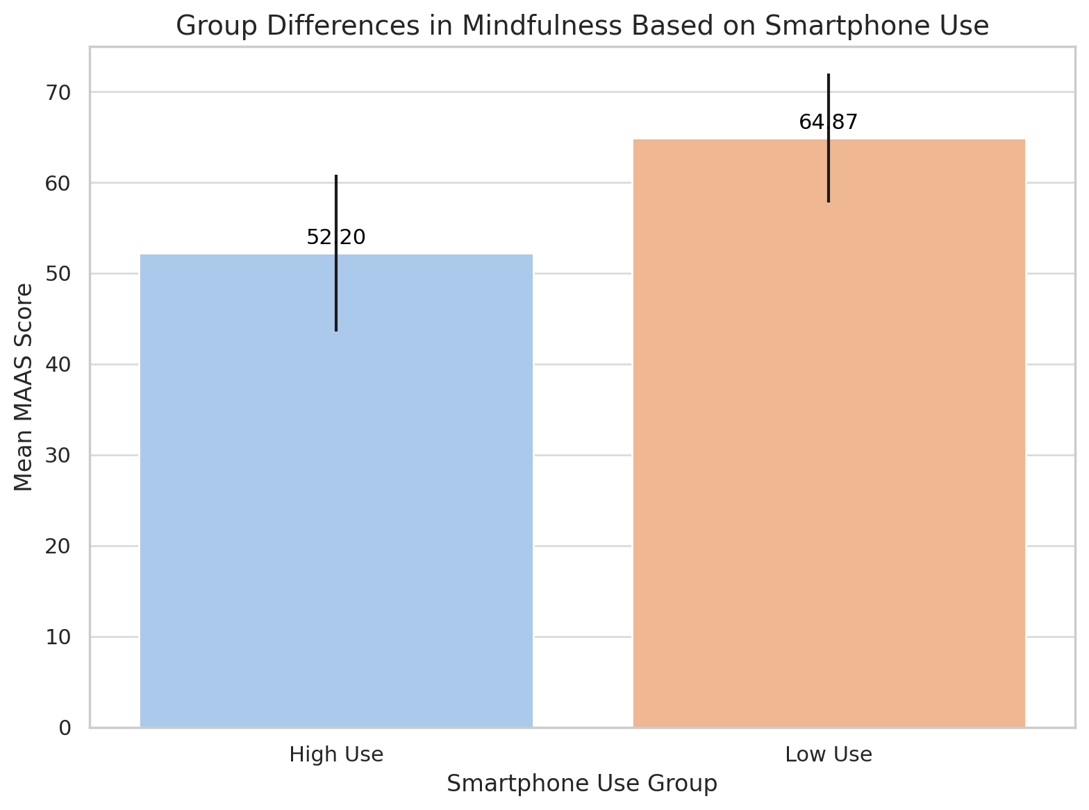
The bar graph illustrates the mean MAAS scores for participants categorized into high and low smartphone use groups. Participants in the low use group demonstrated significantly higher mindfulness (M = 64.87, SD = 7.12) compared to those in the high use group (M = 52.20, SD = 8.63). The difference was statistically significant, indicating that increased smartphone use is associated with reduced levels of mindful attention among young adults.
Scatter plot showing the relationship between smartphone use (MTUAS scores) and mindful attention (MAAS scores):
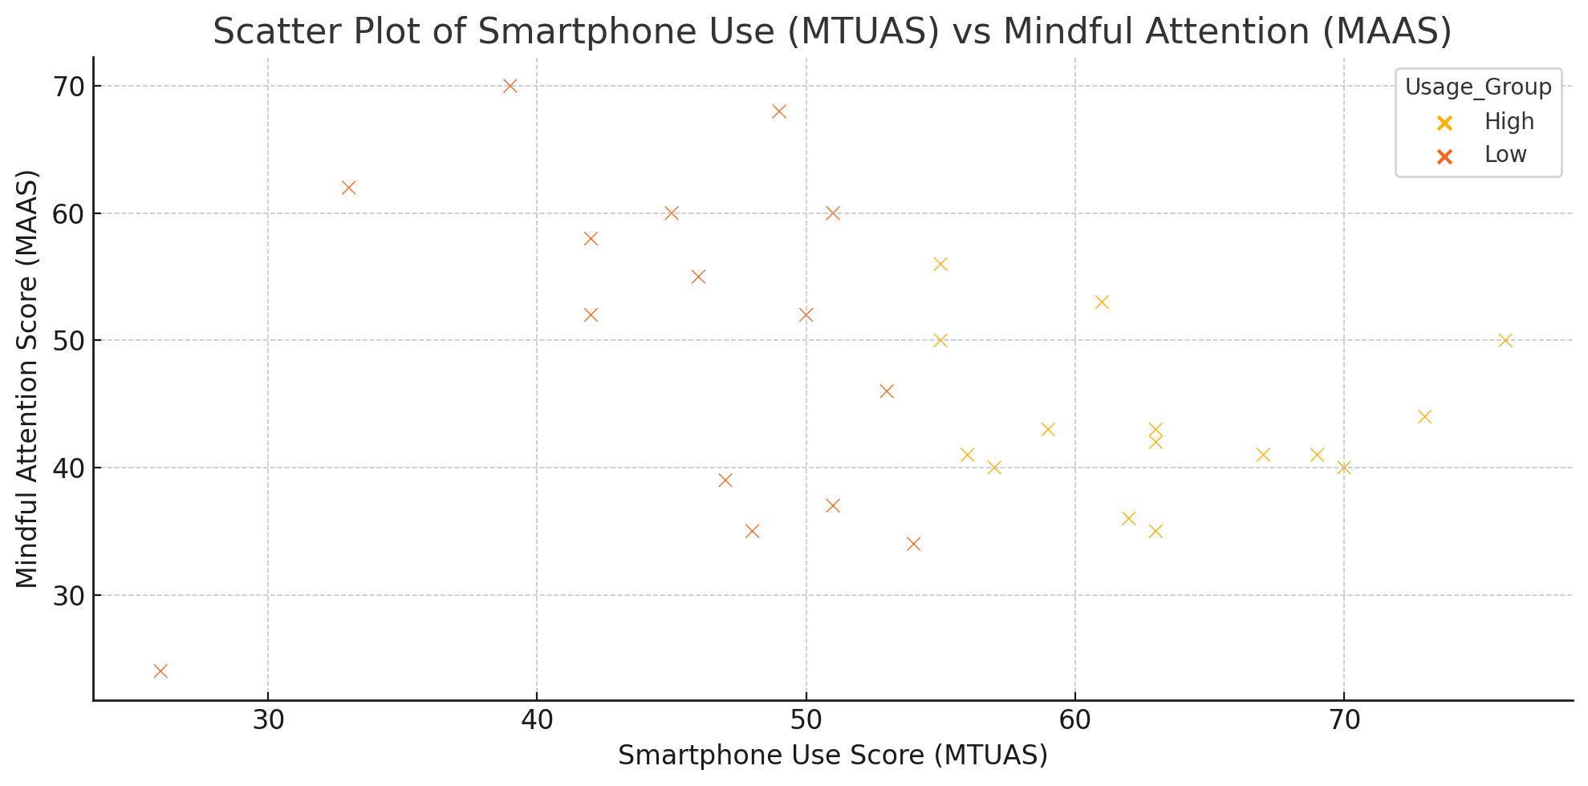
The graph displays a negative trend: as smartphone usage increases, the mindful attention score decreases.
The graph displays a negative trend: as smartphone usage increases, the mindful attention score decreases.Participants are grouped by color:
- High smartphone users (orange) tend to have lower mindfulness.
- Low smartphone users (blue) generally show higher mindfulness.
X-axis: Represents the MTUAS score, which measures smartphone usage.
Higher values = more frequent smartphone use.
Y-axis: Represents the MAAS score, which measures mindful attention.
Higher values = greater ability to stay present and focused.
Each dot: Represents a participant in the study.
Colors:

🔵 Blue dots: Participants in the low smartphone usage group.

🟠 Orange dots: Participants in the high smartphone usage group.

INTERPRETATION
The primary objective of the present study was to examine the relationship between smartphone use and mindful attention among young adults. The study also aimed to determine whether there is a significant difference in the level of mindfulness between high smartphone users and low smartphone users.
To measure participants’ smartphone usage, the Media and Technology Usage and Attitudes Scale (MTUAS) was used. The mean MTUAS score was 60.67, which suggests that, overall, participants demonstrated a moderate to high level of smartphone use. To assess mindfulness, the Mindful Attention Awareness Scale (MAAS) was used. The mean MAAS score was 58.53, indicating an average level of mindful attention among participants.
A Pearson correlation was conducted to assess the relationship between smartphone use and mindful attention. The correlation coefficient obtained was r = –0.624 with p < 0.01, indicating a significant negative relationship. This means that as smartphone use increases, mindfulness decreases. Therefore, the hypothesis H1: “There is a significant negative relationship between smartphone use and mindful attention in young adults” is accepted.
To further analyze the differences between high and low smartphone users, a t-test was conducted. The t-value obtained was t(28) = –4.34, with p < 0.001, indicating a statistically significant difference in mindfulness scores between the two groups. Participants with lower smartphone usage (MTUAS score ≤ 61) had higher mindfulness (M = 64.87, SD = 7.12) compared to those with higher usage (M = 52.20, SD = 8.63). This means that young adults who use smartphones more frequently tend to be less mindful, while those who use them less frequently show greater attention and awareness in the present moment.
Previous research supports this finding. Studies by Cheng et al. (2020) and Woodlief et al. (2024) found that higher smartphone use is associated with reduced mindfulness and self-control. Similarly, Lin et al. (2020) reported that excessive screen time affects cognitive flexibility and attention regulation. This suggests that continuous exposure to notifications, social media scrolling, and digital multitasking might distract individuals from the present and reduce their capacity for focused attention.
One explanation for this relationship is the design of smartphones, which encourages constant checking, task-switching, and mental stimulation. Over time, this behavior can become automatic and interfere with the ability to stay present. Research by Ophir et al. (2009) and Horvath et al. (2020) also suggests that frequent media multitasking may alter brain regions related to attention and impulse control. These changes may explain why young adults often report mental fatigue, anxiety, or difficulty concentrating even when they are not using their phones.The results of this study show that smartphone use is significantly related to mindfulness among young adults. The findings highlight the importance of developing awareness around digital habits and promoting mindfulness practices to maintain psychological well-being.

CONCLUSION
This research shows a significant concern about the effects of smartphone use on mindful attention among college-going young adults. It was found that participants who had higher levels of smartphone usage had lower levels of mindful attention. On the other hand, participants with lower smartphone usage were more likely to be mindful and focused in their daily lives. This indicates that excessive smartphone use may negatively affect a young adult’s ability to stay present, concentrate, and be self-aware.
It was observed that young adults who frequently use their smartphones—especially for social media, messaging, and entertainment—tend to have more difficulty focusing on the present moment and become easily distracted. The constant notifications, app-switching, and digital multitasking may contribute to fragmented attention and a decline in mental presence. This supports previous research that suggests smartphone overuse may lead to poor attention regulation, emotional dysregulation, and even changes in brain functioning related to attention and decision-making.
A significant negative relationship was found between smartphone use and mindfulness, suggesting that as screen time increases, mindful awareness tends to decrease. This highlights the growing impact of digital technology on mental and emotional health, particularly among students who often rely on their phones for both academic and non-academic purposes.
These findings underline the importance of promoting healthy digital habits, especially in academic and youth environments. Mindfulness training and digital well-being programs could help students become more aware of their screen time and improve their ability to stay focused and calm.

Limitations
As the study was conducted using a self-administered online survey, there is a possibility of response bias, as participants may not have answered truthfully or accurately. All data, including smartphone use and mindfulness, were based on self-report, which may have affected the reliability of the findings.
Another limitation is the small sample size of only 30 participants, which limits the generalizability of the results. A larger and more diverse sample would have given a clearer picture of the relationship between smartphone use and mindfulness.
In addition, the study did not take into account other factors such as personality traits, stress levels, or academic pressure, which might also influence mindfulness or smartphone use. The study was also limited to college students, so the findings may not apply to individuals outside this age group or educational context.

Suggestions for Future Research
- Future research can be done with a larger sample size and include participants from different educational backgrounds and age groups.
- Further studies can also explore how other variables such as anxiety, sleep quality, or academic performance are related to smartphone use and mindfulness.
- Since mindfulness was found to be lower in participants with high smartphone use, intervention-based research can be conducted to examine whether mindfulness training or digital detox programs can help improve attention and reduce screen dependency.
- Future studies can also consider using objective data such as mobile usage tracking apps instead of self-reports to improve accuracy.
- More research should be done on the long-term effects of smartphone use on cognitive functioning and emotional well-being among youth.
References
Chassiakos, Y. L. R., Radesky, J., Christakis, D., Moreno, M. A., Cross, C., & Council on Communications and Media. (2016). Children and adolescents and digital media. Pediatrics, 138(5), e20162593. https://doi.org/10.1542/peds.2016-2593
Common Sense Media. (2015). The Common Sense Census: Media use by tweens and teens. https://www.commonsensemedia.org/research/the-common-sense-census-media-use-by-tweens-and-teens-2015
Common Sense Media. (2015). Landmark report: U.S. teens use an average of nine hours of media per day, tweens use six hours. https://www.commonsensemedia.org/about-us/news/press-releases/landmark-report-us-teens-use-an-average-of-nine-hours-of-media-per-day
Deci, E. L., & Ryan, R. M. (2000). The "what" and "why" of goal pursuits: Human needs and the self-determination of behavior. Psychological Inquiry, 11(4), 227–268. https://doi.org/10.1207/S15327965PLI1104_01
Demirci, K., Akgönül, M., & Akpinar, A. (2015). Relationship of smartphone use severity with sleep quality, depression, and anxiety in university students. Journal of Behavioral Addictions, 4(2), 85–92. https://doi.org/10.1556/2006.4.2015.010
Elhai, J. D., Levine, J. C., Dvorak, R. D., & Hall, B. J. (2017). Problematic smartphone use: A conceptual overview and systematic review of relations with anxiety and depression psychopathology. Journal of Affective Disorders, 207, 251–259. https://doi.org/10.1016/j.jad.2016.08.030
Fillmore, M. T., & Vogel-Sprott, M. (2014). Behavioral impairment under alcohol: Cognitive and pharmacokinetic factors. Alcoholism: Clinical and Experimental Research, 18(1), 206–212. https://doi.org/10.1111/j.1530-0277.1994.tb00900.x
Haferkamp, N., Eimler, S. C., Papadakis, A. M., & Kruck, J. V. (2012). Men are from Mars, women are from Venus? Examining gender differences in self-presentation on social networking sites. Cyberpsychology, Behavior, and Social Networking, 15(2), 91–98. https://doi.org/10.1089/cyber.2011.0151
Haxel, D. (2022). The impact of screen time on attention in adolescents: A longitudinal study. Journal of Adolescent Health, 70(3), 456–462. https://doi.org/10.1016/j.jadohealth.2021.10.005
Horvath, J., Mundinger, C., Schmitgen, M. M., Wolf, N. D., Sambataro, F., Hirjak, D., ... & Kubera, K. M. (2020). Structural and functional correlates of smartphone addiction. Addictive Behaviors, 105, 106334. https://doi.org/10.1016/j.addbeh.2020.106334
Kabat-Zinn, J. (2003). Mindfulness-based interventions in context: Past, present, and future. Clinical Psychology: Science and Practice, 10(2), 144–156. https://doi.org/10.1093/clipsy/bpg016
Kardaras, N. (2016). Glow kids: How screen addiction is hijacking our kids—and how to break the trance. St. Martin’s Press.
Kardaras, N. (2017). Glow kids: How screen addiction is hijacking our kids—and how to break the trance. St. Martin’s Griffin.
Lin, Y., Zhou, Y., & Lin, Z. (2020). The effects of screen time on cognitive flexibility: Evidence from a behavioral study. Journal of Cognitive Neuroscience, 32(8), 1484–1496. https://doi.org/10.1162/jocn_a_01551
Lissak, G. (2018). Adverse physiological and psychological effects of screen time on children and adolescents: Literature review and case study. Environmental Research, 164, 149–157. https://doi.org/10.1016/j.envres.2018.01.015
Montag, C., Błaszkiewicz, K., Sariyska, R., Lachmann, B., Andone, I., Trendafilov, B., ... & Markowetz, A. (2015). Smartphone usage in the 21st century: Who is active on WhatsApp? Journal of Behavioral Addictions, 4(4), 247–253. https://doi.org/10.1556/2006.4.2015.009
Moyer, M. W. (2016, November). Screen time for kids is fine! Unless it’s not. Wired. https://www.wired.com/story/pete-etchells-jonathan-haidt-smartphones
Ophir, E., Nass, C., & Wagner, A. D. (2009). Cognitive control in media multitaskers. Proceedings of the National Academy of Sciences, 106(37), 15583–15587. https://doi.org/10.1073/pnas.0903620106
Posner, M. I., & Petersen, S. E. (1990). The attention system of the human brain. Annual Review of Neuroscience, 13, 25–42. https://doi.org/10.1146/annurev.ne.13.030190.000325
Przybylski, A. K., Murayama, K., DeHaan, C. R., & Gladwell, V. (2013). Motivational, emotional, and behavioral correlates of fear of missing out. Computers in Human Behavior, 29(4), 1841–1848. https://doi.org/10.1016/j.chb.2013.02.014
Rosen, L. D., Whaling, K., Carrier, L. M., Cheever, N. A., & Rokkum, J. (2013). The media and technology usage and attitudes scale: An empirical investigation. Computers in Human Behavior, 29(6), 2501–2511. https://doi.org/10.1016/j.chb.2013.06.006
Tang, Y. Y., Ma, Y., Wang, J., Fan, Y., Feng, S., Lu, Q., ... & Posner, M. I. (2007). Short-term meditation training improves attention and self-regulation. Proceedings of the National Academy of Sciences, 104(43), 17152–17156. https://doi.org/10.1073/pnas.0707678104
Tripathi, S. (2020). Prolonged screen exposure and its impact on attention span in school-aged children. Indian Journal of Pediatrics, 87(12), 934–939. https://doi.org/10.1007/s12098-020-03322-1
Twenge, J. M., & Campbell, W. K. (2018). Associations between screen time and lower psychological well-being among children and adolescents: Evidence from a population-based study. Preventive Medicine Reports, 12, 271–283. https://doi.org/10.1016/j.pmedr.2018.10.003
van Deursen, A. J. A. M., Bolle, C. L., Hegner, S. M., & Kommers, P. A. M. (2015). Modeling habitual and addictive smartphone behavior: The role of smartphone usage types, emotional intelligence, social stress, self-regulation, age, and gender. Computers in Human Behavior, 45, 411–420. https://doi.org/10.1016/j.chb.2014.12.039
Williams, J. (2018). Stand out of our light: Freedom and resistance in the attention economy. Cambridge University Press.
World Health Organization. (2018, September 14). Inclusion of “gaming disorder” in ICD-11. https://www.who.int/news/item/14-09-2018-inclusion-of-gaming-disorder-in-icd-11
World Health Organization. (2018, January). Gaming disorder: Online Q&A. http://www.who.int/features/qa/gaming-disorder/en/

Appendix : Survey Instrument

Demographic Questionnaire
- Name (Optional): _________________
- Age: _______ years
- Gender:
  - ☐ Male
  - ☐ Female
  - ☐ Other (Specify): ________
- Education Level:
  - ☐ Undergraduate
  - ☐ Postgraduate
- Daily Smartphone Screen Time:
  - ☐ Less than 2 hours
  - ☐ 2–4 hours
  - ☐ 4–6 hours
  - ☐ 6+ hours

Media and Technology Usage and Attitudes Scale (MTUAS)
Instructions: Rate how often you engage in these smartphone activities (1 = Never, 5 = Always).
Activity | 1 | 2 | 3 | 4 | 5
Read email on a mobile phone
Use GPS on a mobile phone
Browse the web on a mobile phone
Listen to music on a mobile phone
Take pictures using a mobile phone
Check the news on a mobile phone
Record video on a mobile phone
Use apps (any purpose) on a mobile phone
Search for information with a mobile phone

Mindful Attention Awareness Scale (MAAS)
Instructions: Rate how frequently you experience the following (1 = Almost Always, 6 = Almost Never).
Statement | 1 | 2 | 3 | 4 | 5 | 6
I could be experiencing emotions without realizing it
I break or spill things due to carelessness
I find it difficult to stay focused on the present
I walk quickly without noticing my surroundings
I ignore physical tension until it becomes severe
I forget names immediately after hearing them
I operate on "automatic pilot" without awareness
I rush through activities without attention
I focus on goals to the point of losing touch with the present
I perform tasks mechanically, without awareness

