Abstract
AI has inevitably become part of all areas of business and society, including banks and finance houses, and this has necessitated the formulation of various AI ethical frameworks like that of international organisations like UNESCO and EU among others. However, with due consideration of the uniqueness of Islamic finance, guided by Islamic ethical principles, which is built on objectives of shar’ah (maqasid As-Shar’iah), which emphasize benefit’s promotion (that is, jalb al-maslahah) and harm prevention (that is, dar’ al-mafsadah, there is need to explore the possible areas of convergence, divergence or gaps between the global AI ethical principles as prepared by the EU, OECD, UNESCO among others and Islamic finance ethics enshrined in maqasid as-Shariah, therefore, the aim of this paper is to comparatively analyse global AI ethics frameworks as well as Islamic ethical principles, particularly from maqasid as-Shariah perspective, by devising a shariah compliant framework of Islamic AI ethics principles for implementation in the Islamic FinTech sector. The study adopts qualitative content analysis methodology, supported by thematic analysis through manual tagging of the various ethical principles. Findings show that there is a substantial alignment between the three reviewed global AI ethics principles and Islamic ethics principles, notwithstanding the issues of intention and sources of the ethics—secular and divine. The resultant framework would help in guiding AI development in Islamic fintech.
Key Words: Global AI Ethics Framework; Islamic Ethics Principles; Maqasid; Fintech: Islamic Ethical Principles

Introduction
As described by Ramos (2025), the focus of the government across the world is now how Artificial Intelligence (AI) should be regulated rather than whether it should be regulated; therefore, regulation of AI is now a sine qua non in every aspect of our lives.
As mentioned by Rabbani et al. (2022), the adoption of AI has cut across all spheres of lives ranging from businesses, manufacturing and finance among others which makes it a topical issue across the globe and especially in research. while adding that financial institutions including banks, Islamic finance houses of course, now has a huge customer base which also requires getting these customers information through AI and of course through machine learning; but it is not known If the retrieved information is genuine and accurate.
The rapid integration of AI in fintech requires strong ethical frameworks to prevent harm, bias, and misuse. However, Islamic finance offers a unique value-based perspective. It is governed by Shariah ethics that emphasize justice, welfare, and the prevention of harm.

While the mainstream ethical framework includes, e.g., fairness, transparency, accountability, and Islamic ethical values, among others, such as justice, trustworthiness, and harm prevention, there is a need to carry out the comparative analysis between those mainstream AI ethics principles and Islamic ethical values and consequently evaluate how Maqasid as-Shariah (preservation of religion, life, intellect, wealth, and lineage) can guide ethical AI design in financial services.
Therefore, the focus of the study is to compare the secular AI ethics with Islamic moral philosophy considering the use of fintech.

Research Objectives
The main objective of this study is to comparatively analyse the global AI ethics structure as well as Islamic ethical principles, particularly from the maqasid as-Shariah perspective, by devising a structure of Islamic AI ethics principles for implementation in the Islamic FinTech sector.

The specific objectives are as follows:
- To identify key ethical principles found in leading global AI ethics frameworks.
- To examine Islamic ethical principles, particularly those based on Maqasid al-Shariah, relevant to financial technology.
- To compare and contrast global AI ethics with Islamic ethical values in the context of fintech.
- To propose Islamic AI that would guide the development and use of AI in Islamic FinTech.

Research Questions
- How do AI ethics frameworks approach ethical issues in FinTech?
- What are the ethical principles of Islam as enshrined in Maqasid as-Shariah?
- What correlation exists between the global AI ethics and Islamic ethics principles of maqasid shariah?
- How can the global AI ethics be aligned with Islamic ethics principles?

Research Objectives | Research Questions
(1) The main objective of this study is to comparatively analyse the global AI ethics structure as well as Islamic ethical principles, particularly from the maqasid as-Shariah perspective, by devising a structure of Islamic AI ethics principles for implementation in the Islamic FinTech sector. | What convergence or divergence exists between the global AI ethics and Islamic ethics principles (especially maqasid As-Shariah and how can these insights aid Islamic AI ethics framework development for use in Islamic FinTech?
(2) To identify key ethical principles found in leading global AI ethics frameworks | How do AI ethics frameworks approach ethical issues in FinTech?
(3) To examine Islamic ethical principles, particularly those based on Maqasid al-Shariah, relevant to financial technology | What are the ethical principles of Islam as enshrined in Maqasis al-shariah?
(4) To compare and contrast global AI ethics with Islamic ethical values in the context of fintech | What correlation exists between the global AI ethics and Islamic ethics principles of maqasid As-Shariah?
(5) To propose Islamic AI that would guide the development and use of AI in Islamic FinTech. | How can the global AI ethics be aligned with Islamic ethics principles?

Literature Review
Core Ethics Framework
As described by (EU, 2019), for an AI to be reliable and trustworthy, the guideline stipulates that it must fulfill the three (3) conditions of being lawful, ethical and robust. AI has to be lawful by ensuring that all applicable rules are respected. It has to ethically proven by ensuring that core values are also respected and lastly, it must be robust in the sense that it should meet all the technical fundamentals.
The same guideline also list seven (7) major requirements that must be further met for every reliable and trustworthy AI. These requirements are human agency oversight; technical safety and robustness; data governance and privacy; transparency; fairness, diversity and non-discrimination; environmental and societal well-being as well as accountability.
Human agency oversight: For AI to be reliable, people should be empowered not only to enhance the AI decision but also to ensure that people are involved the process through human in command approach, human in the loop as well as human on the loop for a seamless use.
Technical safety and robustness: A seamless AI must be secure and requires resilience. It requires safety and there must be a backup plan in case it fails. So, it must be well grounded, precise, and replicable.
Data governance and privacy: Aside an appropriate data protection, security and privacy, a trustworthy AI must ensure that adopted data must be of good quality, with guaranteed and legitimate access and an effective data governance structure must be adopted.
Transparency: Transparency is paramount for a reliable AI system. This should cover the business model, the data and the entire adopted system. Whoever making use of the system must be doing it willingly as they should be aware they are actually relating with AI. So, the AI system, limitations as well as its capabilities should be known.
Fairness, diversity and non-discrimination: A reliable and trustworthy AI system must be free from any form of biases as it should be fair for use. It must as well foster diversity and should be available to all for use without any form of discrimination be it gender, disability, religion or race.
Environmental and societal well-being: A good AI must developed to be eco-friendly and sustainable. It ought to be beneficial to everyone and must be designed to have positive outcome in both short run and long run.
Accountability: AI mechanism must ensure that the system enhances accountability of its outcomes. There must also be a mechanism that will take care of unintended consequences in place at all time.
In a similar development, OECD came up with AI Principles in 2019 and these were updated in 2024, to take care of policy and technological issues so that they can be relevant at all time. The principle therefore aims to promote the use of AI that is innovative and trustworthy, and that respects the rights of humans as well as democratic values.
The principle emphasized on five (5) key focus of AI governance which are; inclusive growth, sustainable development and well being; respect for privacy, fairness, human rights and rule of law generally; transparency; security robustness and privacy; as well as accountability.
Also, having recognized the fact that AI has been in use widely across the globe, with its attendants and ethical issues that has raised concerns, UNESCO, in 2021, with an acclamation by 193 member states adopted recommendations on AI ethics to correct these anomalies and ensure right values. However, the ethical issues still remain a concern.
Having reviewed global frameworks, this section now turns to Islamic ethical principles rooted in the Maqasid as-Shariah.
Key Islamic Ethical Principles
According to Ahmed (2015), besides the principles of islamic finance focusing on ensuring that economic activities generate economic benefits, it also acknowledges the need to balance morals, spirituality, justice, equity with social wellbeing and ethics
The focus of Shariah as cited by Elias (2012) is to see to a better welfare of people. It centered on ensuring justice, equity, benefit and to promote mercy on Muslims. It should be noted as emphasised by the shariah that whatever that does not consider justice, mercy, benefit and wisdom is not at all part of the Shariah.

According to Güney (2024), while discussing Shariah, its paramount to emphasize on the importance of Maslaha which focuses on the adoption of benefit rather than harm. Meanwhile, citing Ghazālī (1993), Güney (2024) adds that, as emphasised by the Shariah, Maslaha could be described as whatsoever that aims at pursuing what is beneficial in the context of Islamic jurisprudence and preventing what is harmful.
As also mentioned by Dasuki and Bouheraoua (2011), it can also be classified as same as maqasid as they are sometimes used subtitutably. However, they add that Maṣlaḥah has also been used by the scholars as a phenomenon that enhance people’s benefit and discourage corruption and social menace.
As affirmed by Ahmed (2015), the Shariah emphasised that Muslims have the duty of ensuring that they observe and always maintain ethical standard while involved in business, economic and financial transaction in such a way that social wellbeing are also put into consideration. This therefore is in contrary to conventional organisation that its main aim is to maximise profit, firms’ value and shareholders’ wealth, even to the detriment of the society (Ahmed, 2015).

Concerning the convergence of global AI ethical principles and Islamic principles on Islamic finance, Floridi et al. (2018) and Jobin et al. (2019) as cited by Raquib et al. (2022) noted that, over half of 84 documents reviewed on the subject matter adopted the principles of justice and fairness, transparency, non-maleficence, responsibility and privacy in their financial and economic transactions.

Fauzi and Nugroho (2025) mentioned that as guided by the Quran, ethical principle highlights that there should be justice in the usage of adopted phenomenon like AI by ensuring that it is not monopolised or misused. They also emphasised that the use of AI should come with an upheld responsibility; that is, there should be accountability for any activities that involve the use of AI to prevent a negative effect in the society and finally by using phenomenon like AI, shariah teaches that, Haram should be avoided and by ensuring this, it should be employed to enhance beneficial use for individuals and the society at large.
Similarly, Rafikov (2025) mentions some of the Islamic ethics in relation to AI while laying the foundation with the Islamic teaching of human beings as Allah's vicegerent on Earth. Allah says in the Qur’an, “And [mention, O Muhammad], when your Lord said to the angels, ‘Indeed, I will make upon the earth a successive authority (khalīfah).’” (Qur’an 2:30), adding that this role of Allah’s vicegerents is not merely about exercising power and knowledge; it is primarily a trust (amānah) from Allah, which requires us to promote justice, prevent harm, steward creation responsibly, be truthful and honest, avoid harm and corruption, encourage knowledge, responsibility, ethical constraints, consultation, accountability, balance innovations with considerations, transparency, prioritization of common good (Maṣlaḥah), and re-establishment of the purpose of technology in serving humanity’s true interest: improving welfare, establishing justice, and promoting mercy (raḥmah).
This review underscores the need to explore convergence and divergence across ethical paradigms in guiding AI application within Islamic fintech.”
Methodology
The method used for the study is qualitative content analysis, which involves systematically analyzing documents, reports, and literature related to global AI ethics frameworks (e.g., the EU AI Act, OECD AI Principles and UNESCO), Islamic ethical principles (especially Maqasid as-Shariah, Fiqh al-Muamalat, and Islamic finance ethics), and the application of both in FinTech. This is in addition to thematic comparative analysis with the aid of document review and thematic coding, using manual tagging.
Primary data, tagged general codes, are collected from the following documents:
- Global AI ethics documents (EU, OECD, and UNESCO guidelines).
- Classical and contemporary Islamic legal texts on Maqasid, Adl, and ethics

Research Designs
- Qualitative Comparative Analysis using document review and thematic coding with manual tagging

General Codes
- Fairness/Justice (Adl)
- Accountability
- Maslahah
- Prohibition of harm (Darul Mafasid)
- Amanah (trust)
- Transparency
- Human dignity (privacy, satr awrah—covering of private parts, etc.)
- Non-Maleficence
- Bayyinah (clarity and openness)
- Taklif (moral responsibility)

Coding Matrix

General Ethical Codes | Global Ethical Principles (EU, OECD and UNESCO AI Ethics Principes) | Islamic Ethical Principles
Fairness/Justice (Adl) | Yes | Yes
Accountability | Yes | Yes
Maslahah (Public Interest) | Yes | Yes
Prohibition of Harms | Yes | Yes
Amanah (Trust) | Yes | Yes
Transparency | Yes | Yes
Human Dignity | Yes | Yes
Non-Maleficences | Yes | Yes
Bayyinah (Clarity and Openness) | Yes | Yes
Taklif (Moral Responsibility) | Yes | Yes

Methods of Analysis:
- Thematic Content Analysis: Extracting and comparing ethical themes from both global AI ethics principles and Shariah sources.
- Comparative Matrix Development: Mapping similarities, gaps, and alignments.

Findings
Using thematic comparative analysis with the aid of document review and thematic coding and manual tagging, it was observed that there is a convergence between global ethical AI principles and Islamic ethical principles as enshrined in maqasid As-Shariah (objectives of shariah).
Corroborating the above convergence, the findings of the study by Rabbani et al. (2022) highlights that ethical issues relating to AI implementation is statistically related to islamic finance and RegTech. They also confirmed that the ethical issues related to AI implementation can be curtailed by the effective use of RegTech and Islamic finance techniques

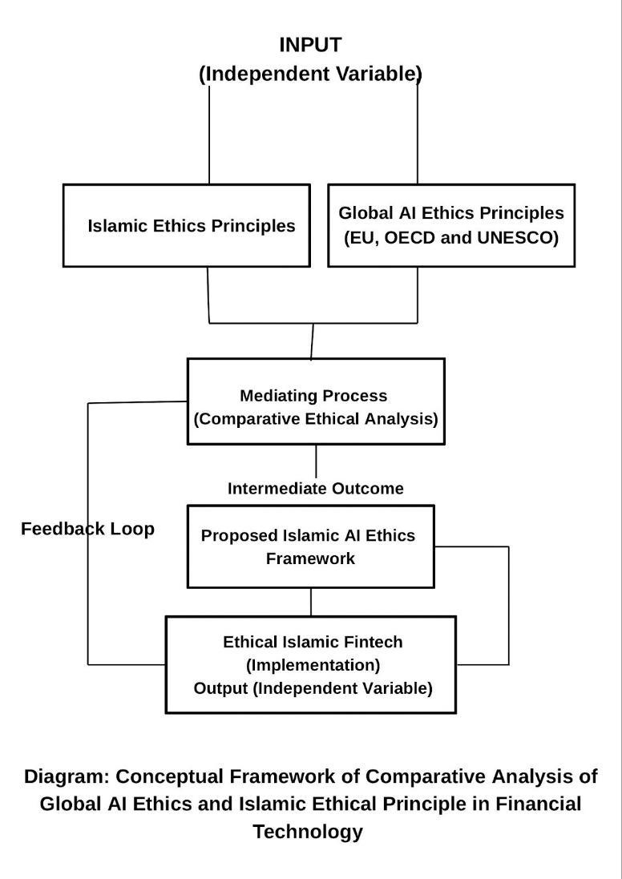

Breakdown of Variable Roles in the Study
Component | Type | Explanation
Global AI Ethics Frameworks | Independent Variable | Provide baseline ethical standards from a global secular context (EU, OECD, and UNESCO AI Ethics Principles).
Islamic Ethical Principles | Independent Variable | Islamic moral standards as enshrined in Maqasid as-Shariah and Fiqh al-Muamalat.
Comparative Ethical Analysis | Mediating Process | Where alignment/convergence, divergence, and synthesis are analyzed.
Proposed Islamic AI Ethics Framework | Intermediate Outcome | Theoretical output that results from the comparative analysis.
Ethical Islamic FinTech (Implementation) | Dependent Variable (Output) | Real-world result: AI is deployed in Islamic FinTech systems ethically and in line with Shariah, subject to review as and when due.

The above framework has the documents of global AI and Islamic ethical principles as inputs and independent variables, which are processed using comparative thematic analysis, ethical mapping, and alignment through manual tagging, which resulted in output (dependent variables), majorly, the convergence between the two ethical principles, denoting an Islamic AI ethical framework for fintech, and serving as a policy recommendation for a Shariah-compliant AI system.
There is also a provision for a feedback loop, arising from review by shariah scholars, AI ethicists, and fintech practitioners.
The framework could be validated by Islamic finance experts and AI ethics researchers.

Conclusion and Discussions
The findings showed a significant overlaps in fairness as well as harm prevention but there was an existence of divergence between the reviewed global Ai ethical principles and Islamic ethical principles. However, the issues of intention and sources of the ethics are same. However, the intention (Niyyah), though very fundamental in Islamic tenets, Islam does not encourage us to investigate and spy into what might be the intentions of the global AI ethical principles formulator.
As mentioned in Quran 49:12, “Believers, avoid being excessively suspicious, for some suspicion is a sin. Do not spy or backbite one another”. Similarly as stated by Qardawwy as cited by the Da’wah Institute of Nigeria (2018), one fundamental rule in Islamic principle is that whatever belongs to the worldly and mundane social transaction (mu’amalat), as against what is prescribed in the religion or devotional worship (Ibaadah) or creed (Aqeedah) is governed by the general principle that state that everything is permissible except what is being prohibited.
References

Ahmed, J (October 9, 2015) Ethics in Islamic Finance: Embracing Duties and Consequences in the Post-Crisis Environment
Retrieved 7 May, 2025 from https://www.ifac.org/knowledge-gateway/discussion/ethics-islamic-finance-embracing-duties-and-consequences-post-crisis-environment

Da'wah Institute of Nigeria (2018) Muslim Relations With Christians, Jews and Others, Pg 67, Published by Da'wah Institute of Nigeria
Retrieved 16 June, 2025 from https://www.google.com/url?sa=t&source=web&rct=j&opi=89978449&url=https://jliflc.com/wp-content/uploads/2018/09/MUSLIM-RELATIONS-WITH-CHRISTIANS-JEWS-AND-OTHERS-by-Dawah-Institute-of-Nigeria-Islamic-Education-Trust-2018.pdf&ved=2ahUKEwiB56WAtvaNAxW9aEEAHdImDtEQFnoECF4QAQ&usg=AOvVaw0v1NbmZWBSE-NIEu4DxXd2

Dusuki, A. W. & Bouheraoua, S. (2011). The framework of Maqasid al-Shariah and its implications for Islamic finance
Retrieved 5 May, 2025 from https://icrjournal.org/index.php/icr/article/view/651/636

Elias, A (2012) Ibn Qayyim on Sharia: Islam is based on justice, mercy, wisdom
Retrieved 2 May, 2025, from https://www.abuaminaelias.com/dailyhadithonline/2012/07/07/ibn-qayyim-maqasid-al-shariah/#:~:text=Ibn%20al%2DQayyim%2C%20may%20Allah,mercy%2C%20benefit%2C%20and%20wisdom.

EU (April 8, 2019) EU Guidelines for Trustworthy
Retrieved 2 May, 2025 from
https://digital-strategy.ec.europa.eu/en/library/ethics-guidelines-trustworthy-ai

Fauzi, R. M & Nugroho, K (2025) The Ethics of AI Usage from Perspective of the Qur'an
Jan 2025 Proceeding ISETH (
Retrieved 14 May, 2025 from https://www.researchgate.net/publication/390898816_The_Ethics_of_AI_Usage_from_Perspective_of_the_Qur'an

Güney, N (2024) Maqāsid al-Sharī‘a in Islamic Finance: A Critical Analysis of Modern Discourses
Retrieved 5 May, 2025 from https://www.mdpi.com/2077-1444/15/1/114
Maududi, A (1972) Tafheem-ul Qur’an
Retrieved 19 June, 2025 from https://islamicstudies.info/reference.php?sura=49&verse=12
OECD (2019) OECD AI Principles overview
Retrieved 5 May, 2025 from https://oecd.ai/en/ai-principles

Rabbani, M. R, Sarea, A, Khan, S, & Abdullah, Y (2022) Ethical concerns in artificial intelligence (AI): The role of RegTech and Islamic finance

Artificial Intelligence for Sustainable Finance and Sustainable Technology: Proceedings of ICGER 2021 1, 381-390, 2022
Retrieved 1 May, 2025 from https://scholar.google.com/scholar?hl=en&as_sdt=0%2C5&q=ethical+issues+of+AI+and+Islam+and+Islamic+finance&btnG=#d=gs_qabs&t=1746122069494&u=%23p%3DxIMkgGjcfm8J

Rafikov, I (2025)
Advanced AI and the Moral Challenge: An Islamic Perspective
Retrieved 21 May, 2025 from https://maqasid.org/blog/advanced-ai-and-the-moral-challenge-an-islamic-perspective/

Raquib, A., Channa, B., & Zubair, T. et al. (2022) Islamic virtue-based ethics for artificial intelligence. Discov Artif Intell 2, 11 (2022). https://doi.org/10.1007/s44163-022-00028-2
Retrieved 14 May, 2025 from https://link.springer.com/article/10.1007/s44163-022-00028-2#Fn7

Ramos, G (2025) Global AI Ethics and Governance Observatory
Retrieved 5 May, 2025 from https://www.unesco.org/ethics-ai/en?hub=32618

UNESCO (2021) Artificial Intelligence: Ethics of AIr
Retrieved 5 May, 2025 from https://www.unesco.org/en/artificial-intelligence

UNESCO (2022) Recommendation on the Ethics of Artificial Intelligence
Retrieved 5 May, 2025 from https://unesdoc.unesco.org/ark:/48223/pf0000381137

