Psychological and Cognitive Indicators with Takotsubo Syndrome and Healthy

Abstract:
Takotsubo syndrome (broken-heart syndrome) is considered a cardiac disorder typically associated with exposure to severe psychological or physical stress, and it clinically resembles acute coronary syndrome. The literature indicates its association with elevated levels of anxiety and depression among patients, in addition to the potential impairment of cognitive functions. This study aims to identify the differences in psychological indicators (anxiety & depression) and cognitive functions between patients with Takotsubo syndrome (TTS) and healthy. The study sample consisted of twenty patients who were selected from the Health Insurance Hospital in Zagazig, Al-Sharqia Governorate, along with twenty healthy participants who were matched with the patient group in terms of demographic characteristics, including gender, age, educational level, and mental state variables. The study instruments included an initial clinical interview for data collection, the Perceived Stress Scale (PSS-10), Raven’s Progressive Matrices Test, the Hospital Anxiety and Depression Scale (HADS), and the Montreal Cognitive Assessment (MoCA). The study revealed a significant increase in anxiety and depression levels, along with cognitive impairment in patients with TTS compared to healthy controls, manifested particularly in executive functions, memory, and attention, thereby reflecting a unique interaction between the brain and the heart in this syndrome. The findings indicate that the psychological and cognitive indicators in patients with TTS are multifactorial in nature, involving an interplay of cerebral hypoperfusion, neurohormonal alterations, and dysfunction of brain networks. They further highlight that understanding this interplay is essential for developing therapeutic interventions aimed at enhancing psychological and cognitive health alongside cardiac medical care.

Keywords: Psychological and Cognitive Indicators- Takotsubo Syndrome - Healthy.
INTRODUCTION
Takotsubo Syndrome (TTS) is a cardiovascular disorder that mimics acute myocardial infarction (MI) and is usually triggered by severe psychological or physical stress, leading to transient left ventricular dysfunction. The syndrome was given this name because of the resemblance of the heart’s shape to a Japanese octopus trap (Takotsubo). It is also known by other terms, including broken-heart syndrome, transient apical ballooning syndrome, ampulla-type cardiomyopathy, and stress-induced cardiomyopathy (Khalid et al., 2024; Weihs et al., 2022).
Most patients recover within a few weeks; however, studies have reported that the mortality rate in the acute phase reaches 4–5%, while long-term complications remain relatively high. Epidemiological estimates suggest that 1–3% of all patients, and 5–6% of those undergoing coronary angiography due to suspected acute coronary syndrome (ACS), are diagnosed with TTS. Data also indicate a prevalence of approximately 2% in the general population, with hospitalization rates ranging from 2.3 to 7.1 per 100,000 individuals annually (Casagrande et al.,2024; Kosek-Nikołajczuk et al.,2025;Pozzi et al.,2022).
Although the exact etiology of the syndrome is not yet fully understood, evidence suggests that psychological stressors and catecholamine release play a central role in its pathogenesis. Clinical observations show that acute physical or emotional events often precede the onset of the syndrome and act as stressors contributing to its occurrence (Shadmand et al.,2024;Y-Hassan & Falhammar,2020).
Clinical observation and evidence-based findings agree that TTS is often preceded by sudden stressful physical or emotional events occurring some time before the acute cardiac event (Ghadri et al.,2018; Templin et al.,2015).
In addition, research indicates that psychological and cognitive interactions influence cardiac health by affecting the secretion of hormones such as norepinephrine, which increases during the acute phase, and by modulating the activity of brain regions involved in stress responses, including the amygdala, hippocampus, and prefrontal cortex (Lovallo,2005; Wittstein et al.,2005), and that emotional stressors act as frequent triggers for TTS (Ghadri et al., 2018).
Nevertheless, most studies have focused primarily on cardiac mechanisms while overlooking psychological and cognitive aspects and their role and frequency in TTS, and thus do not lead to any definitive conclusions (Gorini et al.,2022; Ghadri,2018).
Therefore, the present research aims to examine differences in psychological indicators (anxiety & depression) and cognitive functioning between patients with TTS and healthy individuals, to better understand the psychological and cognitive factors that may contribute to the onset or exacerbation of the syndrome.

METHODS
Study Design
A case–control cross-sectional design was employed to compare patients diagnosed with TTS and healthy participants in terms of psychological and cognitive indicators (Lathouwers et al.,2023).
Study Sample:
A. Psychometric Properties Sample:
This sample consisted of fifteen participants, including patients with heart disease, patients diagnosed with broken heart syndrome, and healthy individuals. All participants shared the same characteristics as those in the main study sample. This subsample was used to verify the psychometric properties of the study instruments.
B. Main Sample:
1.Patient Group:
This group consisted of twenty patients recruited from the Health Insurance Hospital in Zagazig, Al-Sharqia Governorate. Ethical standards approved for psychological research were strictly observed. Inclusion and exclusion criteria were defined as follows:
* Inclusion Criteria:
- Diagnosis by a cardiologist based on the Revised Mayo Clinic Criteria and the International Takotsubo Diagnostic Criteria (Boyd & Solh, 2020).
- Patients had received pharmacological treatment, including Aspocid, Dinitra, Ator, Nitromack, and Concor.
* Exclusion Criteria:
Patients previously subjected to psychological assessment using instruments similar to those employed in this study; patients with other cardiac conditions or chronic medical illnesses; and those with neurological or psychiatric disorders.
2.Healthy Control Group:
This group included twenty healthy participants who were matched with the patient group in terms of age, educational level, and Intelligence. None had a medical history of cardiovascular disease, chronic illnesses, psychiatric or neurological disorders, or organic or functional brain diseases (such as vision or hearing impairments or limb-related problems). They were also free from substance use. Table 1 presents the characteristics of the study sample.
Tools;
1- Interview
All participants underwent an initial data collection interview for patients with broken heart syndrome. This interview included basic demographic information such as sex, age, marital status, education level, occupation, and whether the patient had experienced a stressful event (emotional, physical, or both) lasting a week or more before the onset of symptoms. Additionally, the attending physician obtained medical information, including chronic illnesses, physical symptoms, other health problems, any changes in the electrocardiogram (ECG), and confirmation of whether the patient exhibited symptoms of broken heart syndrome.
2-Perceived Stress Scale (PSS-10)
It is used to assess the degree to which individuals perceive stress in their daily lives during the past month. The scale was developed by Cohen et al.,(1983) and consists of 10 items answered on a Likert scale ranging from 0 (never) to 4 (always). The total score ranges from 0 to 40, with higher scores indicating higher levels of perceived stress. The scale has demonstrated good validity and reliability across multiple studies and diverse cultural contexts, including the Arabic version, which was validated and applied in various medical and psychological studies (Almadi et al.,2012). It has also been employed in subsequent research to confirm its applicability in clinical samples (Chaaya et al.,2010; Mounjid et al.,2022), as well as in academic settings such as university students (Algaralleh et al.,2019). This supports the suitability of the Arabic version of the scale for use in the Arab context, including the sample of the present study.
3- Raven’s Progressive Matrices Test:
This test aims to assess adult intelligence. It was originally developed in the foreign context by the British psychologist John Carlyle Raven in 1938, and was later adapted and standardized in the Egyptian context on a sample with an age range between 5.5 and 68.4 years. The test consists of 36 matrices divided into three groups of increasing difficulty:
- Group A: 12 matrices, where success depends on the individual’s ability to complete a continuous pattern.
- Group AB: 12 matrices, where success relies on the ability to perceive separate figures within a whole pattern based on spatial relationships.
- Group B: 12 matrices, where success depends on understanding the rule governing changes in spatially related figures, requiring the ability for abstract thinking.
Each matrix is presented with six smaller alternatives at the bottom, from which the participant selects the one that correctly completes the upper matrix. Scoring ranges between 0 and 1 for each item. The total raw score is calculated by summing correct responses, then converted into percentile ranks according to chronological age, and subsequently into an intelligence quotient (IQ) corresponding to the percentile rank (Ali, 2016).In the present study, reliability was assessed using Cronbach’s alpha, which yielded a value of 0.752.
4-Hospital Anxiety & Depression Scale (HADS)
Zigmond and Snaith (1983) developed the HADS to assess the severity of psychological symptoms, specifically anxiety and depression, in patients within clinical settings over the past two weeks. The scale consists of 14 items divided into two subscales: seven items measuring anxiety (HADS-A) and seven items measuring depression (HADS-D). Responses are rated on a four-point Likert scale ranging from 0 to 3, with each subscale yielding a total score between 0 and 21, where higher scores indicate greater levels of anxiety or depression. Scores are interpreted as follows: 0–7 = normal, 8–10 = mild symptoms,11–14 = moderate symptoms, and 15–21 = severe symptoms. In the current study, the researchers adapted and standardized the Arabic version of the HADS . to verify its psychometric properties in the Arab context. Criterion validity was established using the Beck Anxiety and Depression Inventories(Ghareeb, 2015; Beck et al.,1988), yielding a correlation coefficient of 0.763, while internal consistency (Cronbach’s alpha) reached 0.843 for anxiety and 0.852 for depression, indicating good levels of validity and reliability.

5-Montreal Cognitive Assessment (MoCA)
Nasreddine et al., (2005) developed the (MoCA), a rapid and effective tool for cognitive evaluation that covers several domains, including executive functions, naming, memory, attention, language and speech, abstract thinking, and temporal and spatial orientation. The maximum total score is 30, with a score of 26 or above considered within the normal range, while lower scores indicate potential cognitive impairment. In the current study, the researchers adapted and standardized the Arabic version of the MoCA to verify its psychometric properties in the Arab context. Criterion validity was established using the Mini-Mental State Examination,MMSE (ElKholy,2019), with a correlation coefficient of 0.782, and internal consistency reliability (Cronbach’s alpha) was 0.764, confirming that the tool demonstrates good levels of validity and reliability.
ETHICAL CONSIDERATION
- An official approval to conduct this research was obtained from the Ethics Committee of the Faculty of Arts, Benha University.
- An official approval was also obtained from the Health Insurance Hospital in Zagazig under the supervision of the Head of the Internal Medicine Department.
- An informal written consent was obtained from all participants.
STATISTICAL ANALYSIS
The collected data was analyzed using the Statistical Package for Social Sciences (IBM Corp. Released 2017. IBM SPSS Statistics for Windows, Version 25.0. Armonk, NY: IBM Corp.). Shapiro-Wilk test was used to assess normality of numerical data. The Chi-Square test was used to examine the relationship between two qualitative variables. Fisher’s Exact test was used to examine the relationship between the two qualitative variables when the expected count was less than 5 in more than 20% of cells. Student t- test was used to assess the statistical significance of the difference between two study group means. Mann-Whitney Test was used to assess the statistical significance of the difference in a non-parametric variable between two study groups. Pearson's and Spearman's correlation analyses were used to assess the strength of association between two quantitative variables. The correlation coefficient defines the strength and direction of the linear relationship between two variables. The ROC Curve (receiver operating characteristic) provides a useful way to evaluate the sensitivity and specificity for quantitative diagnostic measures that categorize cases into one of two groups. The optimum cut-off point was defined as that which maximized the AUC value. A p-value is considered significant if <0.05 at confidence interval 95%.

RESULTS
Table 1. Comparison of demographic, personal, clinical, and affective characteristics among TTS and control groups.
 |  | HC  N=20 |  | TTS  N=20 |  | test | p
Age (years) | Mean±SD | 36±9.7 |  | 35.8±8.4 |  | t =  0.087 | 0.931
Age (years) | Median (min-max) | 37(20-50) |  | 36(22-50) |  | t =  0.087 | 0.931
Sex | Males | 9 | 45.0% | 7 | 35.0% | X2=  0.417 | 0.519
Sex | Females | 11 | 55.0% | 13 | 65.0% | X2=  0.417 | 0.519
Occupation | Employed | 14 | 70.0% | 15 | 75.0% | X2=  0.125 | 0.723
Occupation | Unemployed | 6 | 30.0% | 5 | 25.0% | X2=  0.125 | 0.723
Marital status | Single | 4 | 20.0% | 3 | 15.0% | X2=  3.143 | 0.208
Marital status | Married | 15 | 75.0% | 12 | 60.0% | X2=  3.143 | 0.208
Marital status | Divorced | 1 | 5.0% | 5 | 25.0% | X2=  3.143 | 0.208
Educational level | High school | 10 | 50.0% | 10 | 50.0% | X2=  0.202 | 0.896
Educational level | Post-secondary non-tertiary education | 3 | 15.0% | 4 | 20.0% | X2=  0.202 | 0.896
Educational level | Undergraduate | 7 | 35.0% | 6 | 30.0% | X2=  0.202 | 0.896
Life Stressful events | Constant stress |  |  | 5 | 25.0% | - | -
Life Stressful events | Death of a loved one |  |  | 4 | 20.0% | - | -
Life Stressful events | Domestic violence |  |  | 3 | 15.0% | - | -
Life Stressful events | Quarrels |  |  | 2 | 10.0% | - | -
Life Stressful events | Bad news |  |  | 2 | 10.0% | - | -
Life Stressful events | Bullying exposure |  |  | 1 | 5.0% | - | -
Life Stressful events | Emotional separation |  |  | 1 | 5.0% | - | -
Life Stressful events | Financial crisis |  |  | 1 | 5.0% | - | -
Life Stressful events | Unidentified |  |  | 1 | 5.0% | - | -
Perceived stress scale | Mean±SD |  |  | 34±2.6 |  | - | -
Perceived stress scale | Median (min-max) |  |  | 34.5(29-38) |  | - | -
Raven's Progressive Matrices Test | Mean±SD | 102.5±3.4 |  | 102.4±3.3 |  | t =  0.143 | 0.887
Raven's Progressive Matrices Test | Median (min-max) | 103(95-108) |  | 102.5(95-108) |  | t =  0.143 | 0.887
Raven's Progressive Matrices Test | Median (min-max) | 4.5(2-9) |  | 14.5(10-18) |  | t =  0.143 | 0.887
SD, standard deviation; t-test was used for comparison between parametric data; Mann-Whitney (U) test was used for comparison between non-parametric data; chi-square (X2) was used for comparison between categorical data; *, p<0.05 is considered significant.
Table 1 provides a comparative examination of demographic, personal, clinical, and affective features between the TTS group and the healthy control (HC) group. No significant differences were seen between the groups in terms of age, sex, occupation, marital status, or educational level (p>0.05). The average age was comparable (36 ± 9.7 years for HC and 35.8 ± 8.4 years for TTS, p=0.931). Similarly, the distribution of males and females, employment position, and marital or educational levels exhibited no statistically significant differences.
Among the TTS participants, various stressful life events were documented, including chronic stress (25%), bereavement (20%), domestic violence (15%), disputes and adverse news (10% each), and additional emotional or financial challenges (5% each). The mean score of the Perceived Stress Scale in the TTS group was 34 ± 2.6.
The evaluation of cognitive performance using Raven’s Progressive Matrices revealed no significant differences between the groups (p=0.887).
Table 2. Comparison of affective measurements among TTS and control groups.
 |  | HC  N=20 | TTS  N=20 | test | p
Hospital Anxiety scale | mean±SD | 6.9±2.3 | 16.1±2.4 | U=  0.0 | <0.001*
Hospital Anxiety scale | Median (min-max) | 6.5(4-10) | 16(12-19) | U=  0.0 | <0.001*
Depression scale | mean±SD | 4.9±2.4 | 14.1±2.5 | t =  11.874 | <0.001*
Depression scale | Median (min-max) | 4.5(2-9) | 14.5(10-18) | t =  11.874 | <0.001*
SD, standard deviation; t-test was used for comparison between parametric data; Mann-Whitney (U) test was used for comparison between non-parametric data; chi-square (X2) was used for comparison between categorical data; *, p<0.05 is considered significant.
Affective measurements indicated significant differences: the TTS group demonstrated significantly elevated Hospital Anxiety scores (16.1 ± 2.4 vs. 6.9 ± 2.3, p<0.001) and Depression scores (14.1 ± 2.5 vs. 4.9 ± 2.4, p<0.001) in comparison to controls.
Table 3. Comparison of neuro-cognitive features among TTS and control groups.
 |  | HC  N=20 | TTS  N=20 | test | p
Executive function Score | mean±SD | 4.1±0.8 | 2.6±0.7 | U=  38.0 | <0.001*
Executive function Score | Median (min-max) | 4(3-5) | 2.5(2-4) | U=  38.0 | <0.001*
Naming Score | mean±SD | 2.6±0.5 | 2.5±0.5 | U=  170.0 | 0.429
Naming Score | Median (min-max) | 3(2-3) | 2(2-3) | U=  170.0 | 0.429
Attention Score | mean±SD | 5±0.8 | 2.9±0.8 | U=  15.0 | <0.001*
Attention Score | Median (min-max) | 5(4-6) | 3(2-4) | U=  15.0 | <0.001*
Abstraction Score | mean±SD | 1.3±0.6 | 0.7±0.7 | U=  113.0 | 0.018*
Abstraction Score | Median (min-max) | 1(0-2) | 1(0-2) | U=  113.0 | 0.018*
Memory Score | mean±SD | 3.8±0.9 | 1.6±0.7 | U=  14.0 | <0.001*
Memory Score | Median (min-max) | 4(2-5) | 1.5(1-3) | U=  14.0 | <0.001*
Orientation Score | mean±SD | 4.6±0.7 | 3.3±0.5 | U=  35.0 | <0.001*
Orientation Score | Median (min-max) | 4.5(4-6) | 3(3-4) | U=  35.0 | <0.001*
Language | mean±SD | 1.7±0.5 | 1.2±0.4 | U=  100.0 | 0.006*
Language | Median (min-max) | 2(1-2) | 1(1-2) | U=  100.0 | 0.006*
Speech fluency | mean±SD | 0.8±0.4 | 0.2±0.4 | U=  80.0 | 0.001*
Speech fluency | Median (min-max) | 1(0-1) | 0(0-1) | U=  80.0 | 0.001*
Cognitive Assessment total score | mean±SD | 23.9±3.7 | 15±3.1 | t =  8.182 | <0.001*
Cognitive Assessment total score | Median (min-max) | 24(18-30) | 14.5(11-21) | t =  8.182 | <0.001*
SD, standard deviation; t- test was used for comparison between parametric data; Mann-Whitney (U) test was used for comparison between non-parametric data; *, p<0.05 is considered significant.
Table 3 contrasts the neurocognitive performance of the TTS group with that of healthy controls. The TTS group exhibited much poorer scores across almost all neurocognitive assessments. Executive function was significantly diminished in TTS patients (mean 2.6 ± 0.7 vs. 4.1 ± 0.8, p < 0.001). Attention (2.9 ± 0.8 vs. 5 ± 0.8, p < 0.001), memory (1.6 ± 0.7 vs. 3.8 ± 0.9, p < 0.001), abstraction (0.7 ± 0.7 vs. 1.3 ± 0.6, p = 0.018), language (1.2 ± 0.4 vs. 1.7 ± 0.5, p = 0.006), speech fluency (0.2 ± 0.4 vs. 0.8 ± 0.4, p = 0.001), and orientation (3.3 ± 0.5 vs. 4.6 ± 0.7, p < 0.001) were all significantly inferior in TTS participants compared to controls. The naming capacity did not exhibit significant differences between the groups (p = 0.429). The whole cognitive evaluation score was significantly lower in TTS patients (15 ± 3.1) compared to controls (23.9 ± 3.7, p < 0.001).
Table 4. Correlations between anxiety and depression with other parameters among all subjects.
 | Anxiety |  | Depression
 | Correlation coefficient | p | Correlation coefficient | p
Age | -0.494 | 0.001* | -0.465 | 0.003*
Perceived stress | -0.270 | 0.250 | -0.329 | 0.157
Executive function Score | -0.854 | <0.001* | -0.817 | <0.001*
Naming Score | -0.405 | 0.009* | -0.344 | 0.030*
Attention Score | -0.950 | <0.001* | -0.917 | <0.001*
Abstraction Score | -0.590 | <0.001* | -0.513 | 0.001*
Memory Score | -0.664 | <0.001* | -0.608 | <0.001*
Orientation Score | -0.696 | <0.001* | -0.711 | <0.001*
language | -0.934 | <0.001* | -0.911 | <0.001*
speech fluency | -0.866 | <0.001* | -0.854 | <0.001*
Cognitive Assessment total score | -0.977 | <0.001* | -0.940 | <0.001*
Anxiety | - | - | 0.970 | <0.001*
Depression | 0.970 | <0.001* | - | -
Table 4 presents the bivariate correlations between Anxiety and Depression scores and other assessed variables across all subjects, demonstrating significant negative correlation between both Anxiety and Depression scores and nearly all cognitive functions (Executive Function Score, Naming Score, Attention Score, Abstraction Score, Memory Score, Orientation Score, language, speech fluency, and total Cognitive Assessment score). Furthermore, the correlation between Anxiety and Depression is exceptionally high and significant (r = 0.970, p < 0.001).
Table 5. Association between sociodemographic data with clinical and affective characteristics and neuro-cognitive features among all studied subjects.
 | gender |  | test | p | occupation |  | test | p | Marital status |  |  | test | p | Educational level |  |  | test | p
 | Males | Females | test | p | Employed | Unemployed | test | p | Single | Married | Divorced | test | p | High school | Post-secondary non-tertiary education | Undergraduate | test | p
Perceived stress | 33.2 ± 2.4 | 35.3 ± 2.6 | t=  1.759 | 0.096 | 33.3 ± 2.6 | 36 ± 1.4 | t=  2.213 | 0.040* | 33 ± 2.6 | 34.5 ± 2.6 | 33.2 ± 2.9 | t=  0.639 | 0.540 | 34.8 ± 2.7 | 34.5 ± 1.7 | 32.2 ± 2.4 | t=  2.261 | 0.135
Perceived stress | 34 (29 - 37) | 36 (30 - 38) | t=  1.759 | 0.096 | 34 (29 - 37) | 36 (34 - 38) | t=  2.213 | 0.040* | 34 (30 - 35) | 34.5 (29 - 38) | 35 (30 - 36) | t=  0.639 | 0.540 | 35.5 (29 - 38) | 35 (32 - 36) | 32 (30 - 35) | t=  2.261 | 0.135
Raven's Progressive Matrices Test | 102.6 ± 3.8 | 101.9 ± 2.1 | t=  0.863 | 0.394 | 102.7 ± 3.6 | 101.4 ± 1.9 | t=  1.499 | 0.142 | 100.3 ± 5 | 103.2 ± 2.8 | 101.6 ± 3.3 | t=  1.500 | 0.236 | 102.6 ± 2.6 | 105.5 ± 2.1 | 99.8 ± 3.3 | t=  5.422 | 0.009*
Raven's Progressive Matrices Test | 103 (95 - 108) | 101 (100 - 105) | t=  0.863 | 0.394 | 103 (95 - 108) | 100 (100 - 104) | t=  1.499 | 0.142 | 101 (95 - 105) | 103.5 (100 - 108) | 101 (97 - 106) | t=  1.500 | 0.236 | 102.5 (100 - 107) | 105.5 (103 - 108) | 101 (95 - 104) | t=  5.422 | 0.009*
anxiety | 16.2 ± 2.5 | 15.9 ± 2.5 | U=  178.5 | 0.713 | 16.1 ± 2.6 | 16 ± 1.9 | U=  146.0 | 0.698 | 19 ± 0 | 15.4 ± 2.4 | 16 ± 2.2 | U=  5.507 | 0.064 | 15.4 ± 2 | 17.8 ± 1.5 | 16.2 ± 3.3 | U=  2.498 | 0.287
anxiety | 16 (12 - 19) | 16 (12 - 19) | U=  178.5 | 0.713 | 16 (12 - 19) | 16 (13 - 18) | U=  146.0 | 0.698 | 19 (19 - 19) | 16 (12 - 19) | 16 (13 - 19) | U=  5.507 | 0.064 | 16 (12 - 18) | 18 (16 - 19) | 17 (12 - 19) | U=  2.498 | 0.287
depression | 14.4 ± 2.3 | 13.7 ± 3 | t=  0.301 | 0.765 | 14.3 ± 2.6 | 13.6 ± 2.3 | t=  0.231 | 0.819 | 16.7 ± 1.5 | 13.7 ± 2.3 | 13.8 ± 3 | t=  2.637 | 0.085 | 13.4 ± 2.2 | 15.3 ± 1.3 | 14.7 ± 3.4 | t=  0.914 | 0.410
depression | 15 (10 - 18) | 14 (10 - 18) | t=  0.301 | 0.765 | 15 (10 - 18) | 14 (10 - 16) | t=  0.231 | 0.819 | 17 (15 - 18) | 13.5 (10 - 17) | 14 (10 - 18) | t=  2.637 | 0.085 | 13.5 (10 - 16) | 15 (14 - 17) | 15 (10 - 18) | t=  0.914 | 0.410
Executive function Score | 2.5 ± 0.7 | 2.9 ± 0.7 | U=  162.0 | 0.420 | 2.5 ± 0.7 | 2.8 ± 0.4 | U=  155.0 | 0.905 | 2 ± 0 | 2.8 ± 0.8 | 2.6 ± 0.5 | U=  5.863 | 0.053 | 2.6 ± 0.7 | 2.8 ± 0.5 | 2.5 ± 0.8 | U=  1.147 | 0.563
Executive function Score | 2 (2 - 4) | 3 (2 - 4) | U=  162.0 | 0.420 | 2 (2 - 4) | 3 (2 - 3) | U=  155.0 | 0.905 | 2 (2 - 2) | 3 (2 - 4) | 3 (2 - 3) | U=  5.863 | 0.053 | 2.5 (2 - 4) | 3 (2 - 3) | 2 (2 - 4) | U=  1.147 | 0.563
Naming Score | 2.5 ± 0.5 | 2.4 ± 0.5 | U=  180.0 | 0.754 | 2.5 ± 0.5 | 2.4 ± 0.5 | U=  155.0 | 0.905 | 2 ± 0 | 2.6 ± 0.5 | 2.4 ± 0.5 | U=  5.167 | 0.076 | 2.6 ± 0.5 | 2 ± 0 | 2.5 ± 0.5 | U=  2.031 | 0.362
Naming Score | 2 (2 - 3) | 2 (2 - 3) | U=  180.0 | 0.754 | 2 (2 - 3) | 2 (2 - 3) | U=  155.0 | 0.905 | 2 (2 - 2) | 3 (2 - 3) | 2 (2 - 3) | U=  5.167 | 0.076 | 3 (2 - 3) | 2 (2 - 2) | 2.5 (2 - 3) | U=  2.031 | 0.362
Attention Score | 3 ± 0.8 | 2.7 ± 0.8 | U=  185.5 | 0.859 | 3 ± 0.8 | 2.6 ± 0.5 | U=  138.0 | 0.530 | 2.3 ± 0.6 | 3 ± 0.9 | 3 ± 0.7 | U=  4.837 | 0.089 | 3 ± 0.8 | 2.5 ± 0.6 | 3 ± 0.9 | U=  1.313 | 0.519
Attention Score | 3 (2 - 4) | 3 (2 - 4) | U=  185.5 | 0.859 | 3 (2 - 4) | 3 (2 - 3) | U=  138.0 | 0.530 | 2 (2 - 3) | 3 (2 - 4) | 3 (2 - 4) | U=  4.837 | 0.089 | 3 (2 - 4) | 2.5 (2 - 3) | 3 (2 - 4) | U=  1.313 | 0.519
Abstraction Score | 0.7 ± 0.5 | 0.7 ± 1 | U=  166.5 | 0.486 | 0.7 ± 0.6 | 0.6 ± 0.9 | U=  116.5 | 0.196 | 0 ± 0 | 0.9 ± 0.7 | 0.6 ± 0.5 | U=  8.878 | 0.072 | 1 ± 0.7 | 0.3 ± 0.5 | 0.5 ± 0.5 | U=  4.128 | 0.127
Abstraction Score | 1 (0 - 1) | 0 (0 - 2) | U=  166.5 | 0.486 | 1 (0 - 2) | 0 (0 - 2) | U=  116.5 | 0.196 | 0 (0 - 0) | 1 (0 - 2) | 1 (0 - 1) | U=  8.878 | 0.072 | 1 (0 - 2) | 0 (0 - 1) | 0.5 (0 - 1) | U=  4.128 | 0.127
Memory Score | 1.6 ± 0.7 | 1.6 ± 0.8 | U=  166.5 | 0.486 | 1.7 ± 0.7 | 1.4 ± 0.5 | U=  143.5 | 0.633 | 1.3 ± 0.6 | 1.7 ± 0.7 | 1.6 ± 0.9 | U=  4.689 | 0.096 | 1.7 ± 0.7 | 1 ± 0 | 1.8 ± 0.8 | U=  3.067 | 0.216
Memory Score | 2 (1 - 3) | 1 (1 - 3) | U=  166.5 | 0.486 | 2 (1 - 3) | 1 (1 - 2) | U=  143.5 | 0.633 | 1 (1 - 2) | 2 (1 - 3) | 1 (1 - 3) | U=  4.689 | 0.096 | 2 (1 - 3) | 1 (1 - 1) | 2 (1 - 3) | U=  3.067 | 0.216
Orientation Score | 3.3 ± 0.5 | 3.4 ± 0.5 | U=  187.0 | 0.902 | 3.3 ± 0.5 | 3.4 ± 0.5 | U=  131.0 | 0.402 | 3 ± 0 | 3.5 ± 0.5 | 3.2 ± 0.4 | U=  5.845 | 0.054 | 3.6 ± 0.5 | 3 ± 0 | 3.2 ± 0.4 | U=  3.817 | 0.148
Orientation Score | 3 (3 - 4) | 3 (3 - 4) | U=  187.0 | 0.902 | 3 (3 - 4) | 3 (3 - 4) | U=  131.0 | 0.402 | 3 (3 - 3) | 3.5 (3 - 4) | 3 (3 - 4) | U=  5.845 | 0.054 | 4 (3 - 4) | 3 (3 - 3) | 3 (3 - 4) | U=  3.817 | 0.148
language | 1.2 ± 0.4 | 1.1 ± 0.4 | U=  176.0 | 0.672 | 1.2 ± 0.4 | 1.2 ± 0.4 | U=  138.5 | 0.530 | 1 ± 0 | 1.3 ± 0.5 | 1 ± 0 | U=  7.693 | 0.121 | 1.3 ± 0.5 | 1 ± 0 | 1.2 ± 0.4 | U=  0.948 | 0.622
language | 1 (1 - 2) | 1 (1 - 2) | U=  176.0 | 0.672 | 1 (1 - 2) | 1 (1 - 2) | U=  138.5 | 0.530 | 1 (1 - 1) | 1 (1 - 2) | 1 (1 - 1) | U=  7.693 | 0.121 | 1 (1 - 2) | 1 (1 - 1) | 1 (1 - 2) | U=  0.948 | 0.622
speech fluency | 0.2 ± 0.4 | 0.1 ± 0.4 | U=  172.0 | 0.594 | 0.2 ± 0.4 | 0.2 ± 0.4 | U=  129.5 | 0.369 | 0 ± 0 | 0.2 ± 0.5 | 0.2 ± 0.4 | U=  2.806 | 0.246 | 0.2 ± 0.4 | 0.3 ± 0.5 | 0.2 ± 0.4 | U=  0.409 | 0.815
speech fluency | 0 (0 - 1) | 0 (0 - 1) | U=  172.0 | 0.594 | 0 (0 - 1) | 0 (0 - 1) | U=  129.5 | 0.369 | 0 (0 - 0) | 0 (0 - 1) | 0 (0 - 1) | U=  2.806 | 0.246 | 0 (0 - 1) | 0 (0 - 1) | 0 (0 - 1) | U=  0.409 | 0.815
Cognitive Assessment total score | 15 ± 2.9 | 15 ± 3.6 | t=  0.298 | 0.769 | 15.1 ± 3.3 | 14.6 ± 2.5 | t=  0.669 | 0.508 | 11.7 ± 1.2 | 16 ± 3 | 14.6 ± 2.7 | t=  4.453 | 0.019* | 16 ± 2.8 | 12.8 ± 1.7 | 14.8 ± 3.8 | t=  1.411 | 0.257
Cognitive Assessment total score | 15 (11 - 20) | 14 (11 - 21) | t=  0.298 | 0.769 | 15 (11 - 21) | 14 (13 - 19) | t=  0.669 | 0.508 | 11 (11 - 13) | 15.5 (12 - 21) | 15 (11 - 18) | t=  4.453 | 0.019* | 15.5 (13 - 21) | 12.5 (11 - 15) | 14.5 (11 - 20) | t=  1.411 | 0.257
SD, standard deviation; t-test was used for comparison between parametric data; Mann-Whitney (U) test was used for comparison between non- parametric data; *, p<0.05 is considered significant.
Regarding gender, the investigation of neuro-cognitive characteristics and psychological metrics between male and female respondents demonstrated no statistically significant differences in all assessed variables (all p > 0.05).
In a comparison between employed and jobless individuals, the sole statistically significant difference identified was in Perceived Stress, with unemployed individuals exhibiting greater mean stress levels (36 ± 1.4) compared to employed individuals (33.3 ± 2.6), achieving significance (t = 2.213, p = 0.040*). No significant differences were seen between the employed and jobless groups in all cognitive testing scores, including Raven's Progressive Matrices and specific cognitive domains (all p > 0.05).
The comparison of psychological and cognitive metrics across various marital statuses (Single, Married, Divorced) reveals little statistically meaningful differences. The significant difference is observed in the total score of the Cognitive Assessment, with married persons achieving higher scores than single or divorced participants.
Raven's Progressive Matrices Test differed significantly according to educational levels, otherwise educational level did not affect neuro-cognitive characteristics and psychological parameters.
Table 6. Validity of different parameters for discrimination between TTS and HC groups.
 | AUC | 95% CI | p | Cut off | Sensitivity (%) | Specificity (%)
Raven's Progressive Matrices Test | 0.510 | 0.328 - 0.692 | 0.914 | ≤102.2 | 52.3 | 52.7
anxiety | 1 | 1-1 | <0.001* | >10 | 100 | 100
depression | 1 | 1-1 | <0.001* | >9 | 100 | 100
Executive function Score | 0.905 | 0.816 - 0.994 | <0.001* | ≤3 | 90 | 75
naming | 0.575 | 0.396 - 0.754 | 0.417 | ≤2 | 55 | 60
attention | 0.963 | 0.914 - 1 | <0.001* | ≤3 | 75 | 100
abstraction | 0.718 | 0.558 - 0.877 | 0.019* | ≤1 | 90 | 30
memory | 0.965 | 0.915 - 1 | <0.001* | ≤2 | 90 | 95
orientation | 0.913 | 0.829 - 0.996 | <0.001* | ≤3 | 65 | 100
language | 0.750 | 0.593 - 0.907 | 0.007* | ≤1 | 80 | 70
Speech fluency | 0.800 | 0.655 - 0.945 | 0.001* | =0 | 80 | 80
Cognitive Assessment total score | 0.967 | 0.923 - 1 | <0.001* | ≤19 | 90 | 90
AUC, area under ROC curve; CI, confidence interval; *, p<0.05 is considered significant.

Table 6 illustrates the discriminative efficacy of different parameters in differentiating between the TTS and HC groups by Receiver Operating Characteristic (ROC) curve analysis. Most parameters exhibited strong to perfect discrimination, as evidenced by elevated Area Under the Curve (AUC) values and statistical significance (p < 0.05). Attention (AUC= 0.963), memory (AUC = 0.965), and the total score of the Cognitive Assessment (AUC = 0.967) exhibited the best discriminatory power, all attaining AUCs near 1.0 with exceptional sensitivity and specificity. The assessments of anxiety and depression demonstrated perfect discrimination (AUC = 1.0). In contrast, Raven's Progressive Matrices Test (AUC = 0.510) and naming (AUC = 0.575) had minimal discriminatory power, indicating that these assessments are inadequate for distinguishing between the two groups in this study.

A | 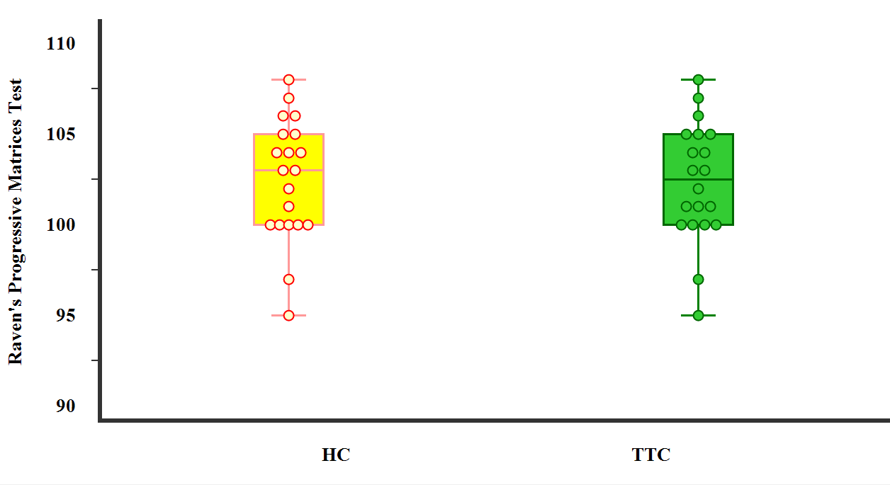
B | 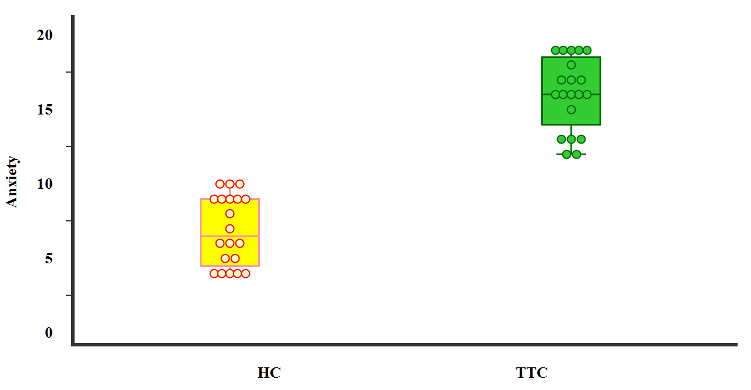
C | 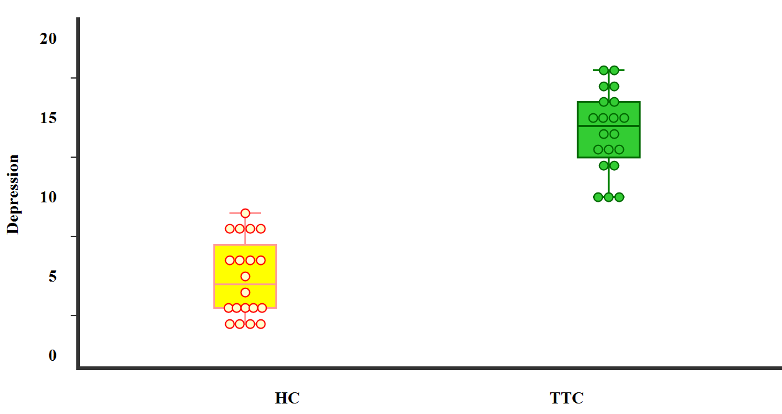
Figure 1. Box plots for comparisons between TTS and HC groups regarding (A) Raven's Progressive Matrices Test, (B) anxiety scale, and (C) depression scale.
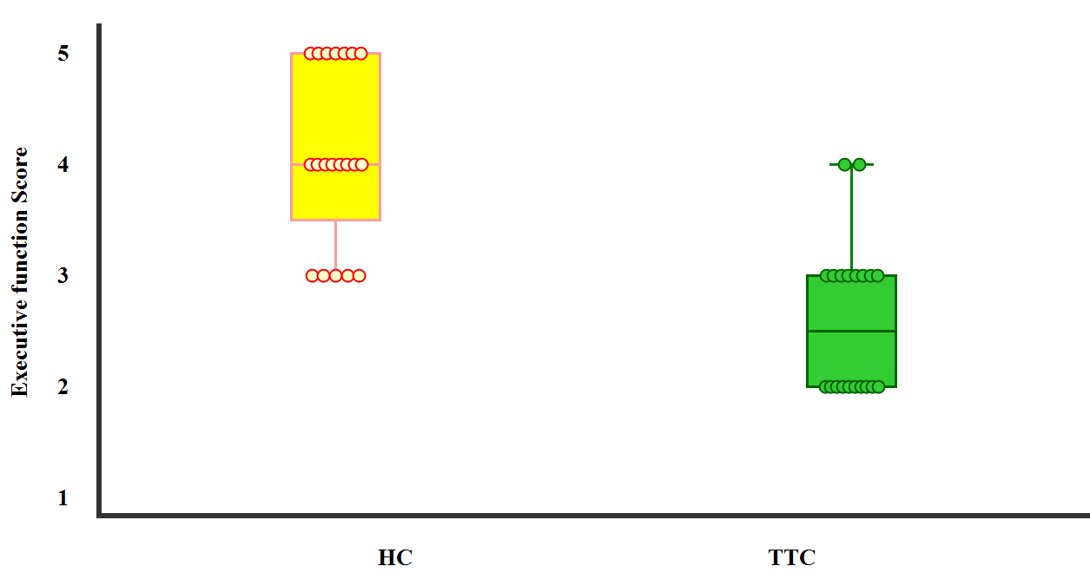 | 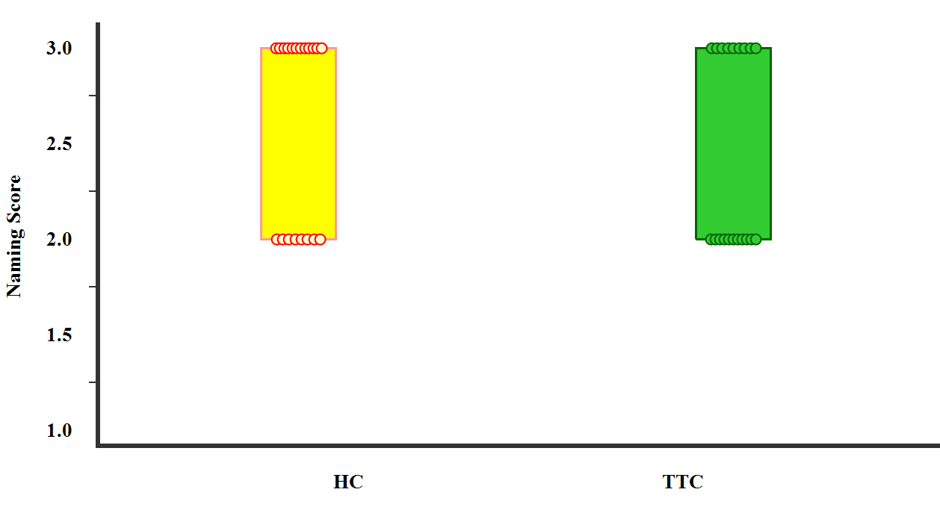
A | B
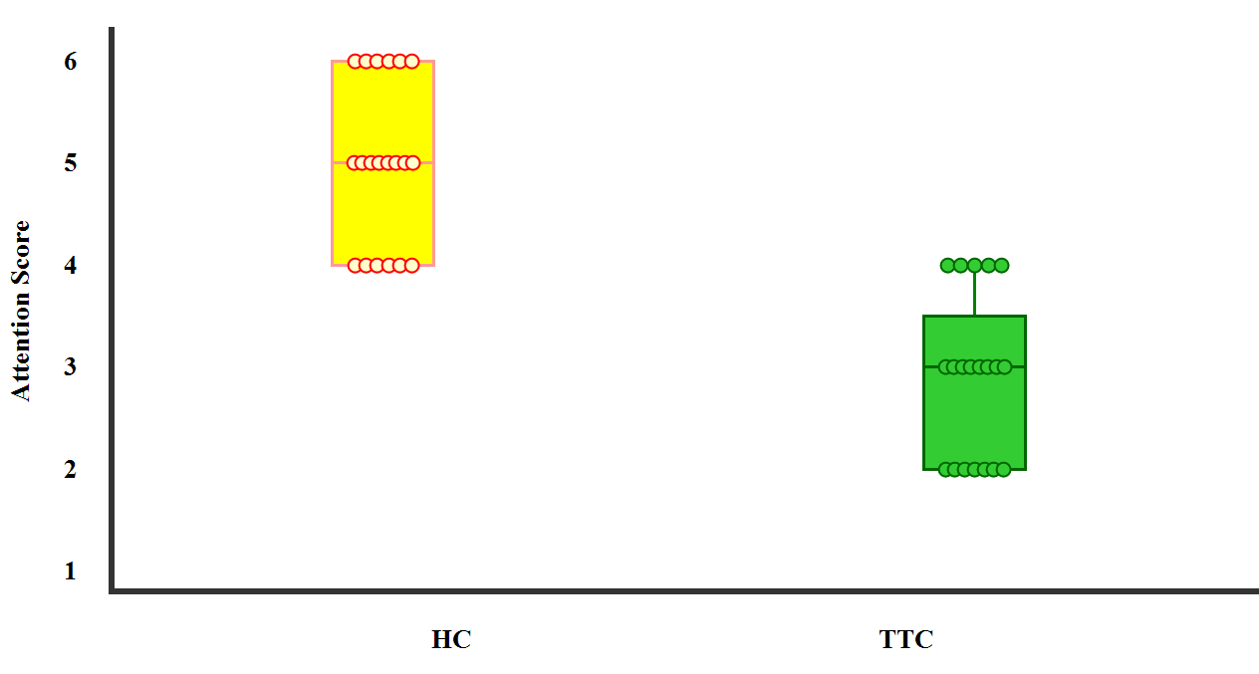 | 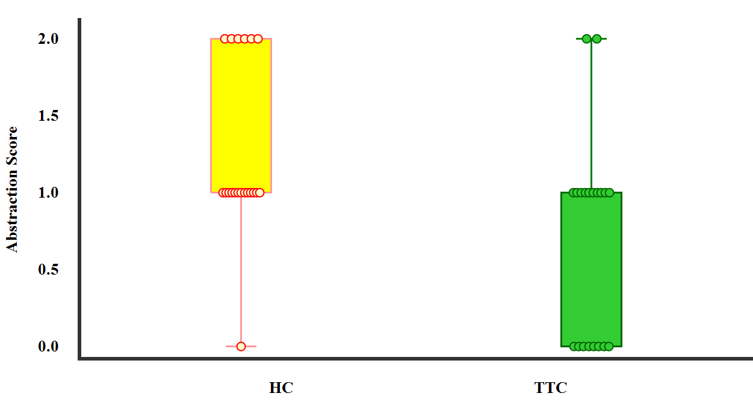
C | D
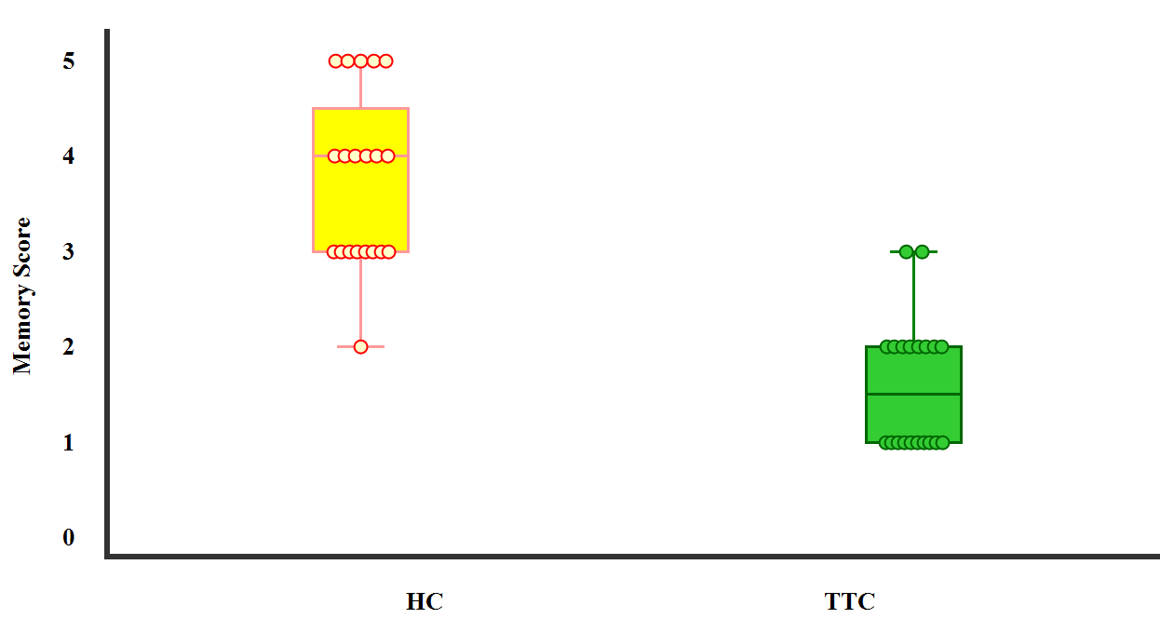 | 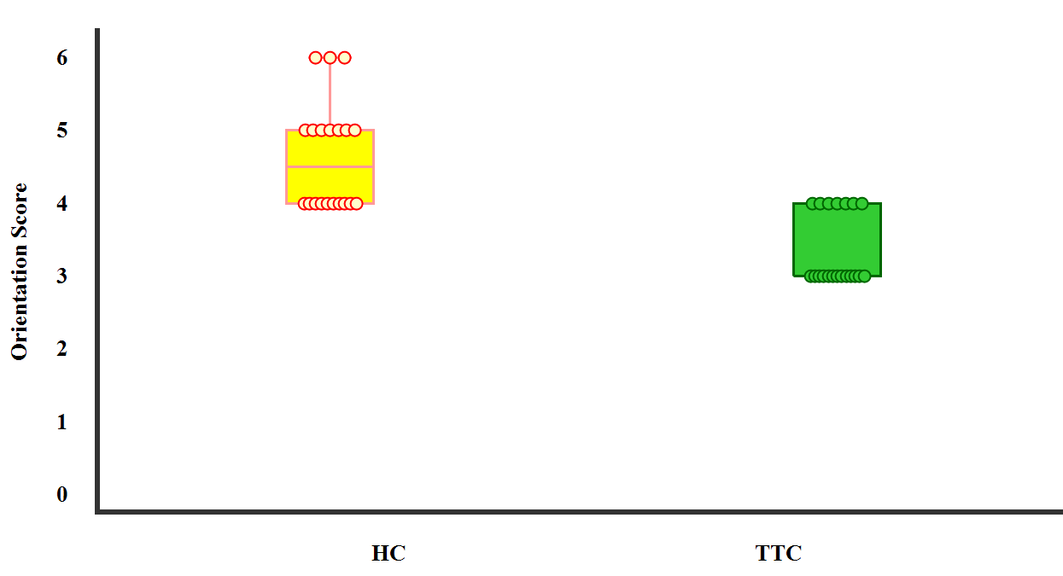
E | F
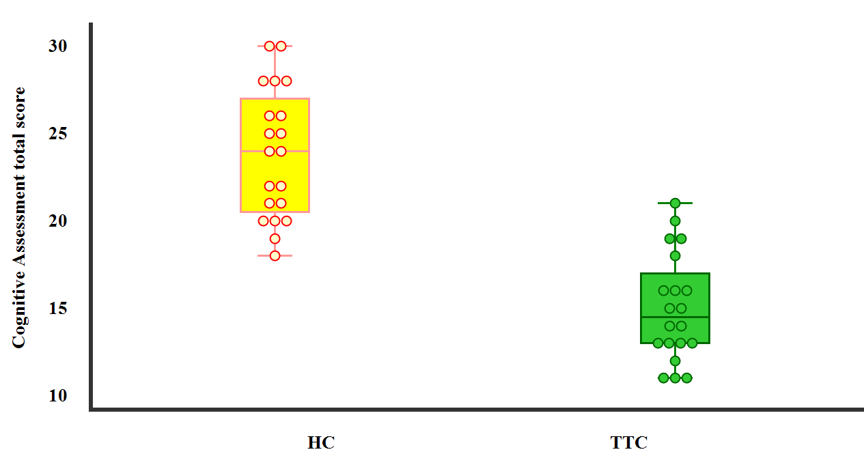
G
Figure 2. Box plots for comparisons between TTS and HC groups regrading (A) Executive function Score, (B) naming, (C) attention, (D) abstraction, (E) memory, (F) orientation, and (G) Cognitive Assessment total score.

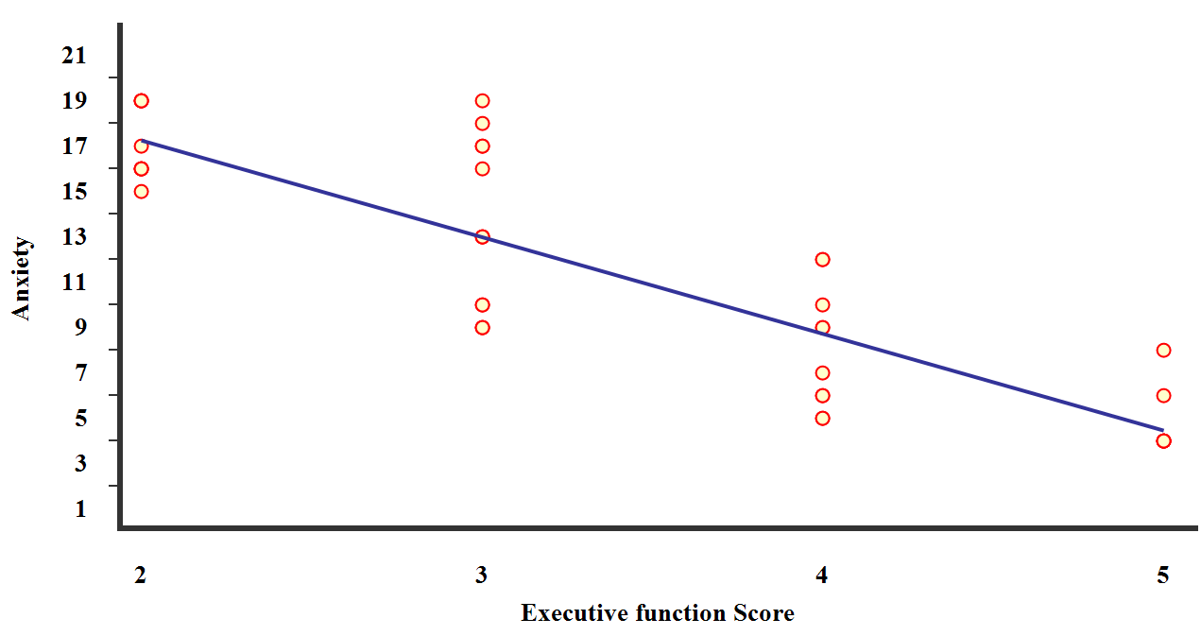 | 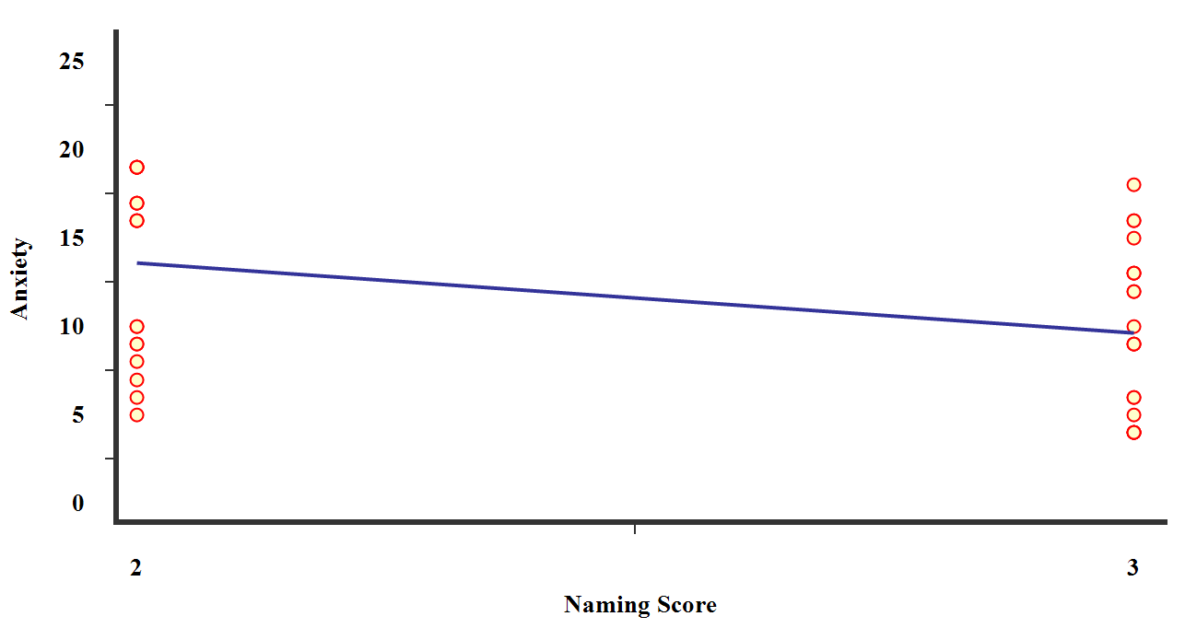
A | B
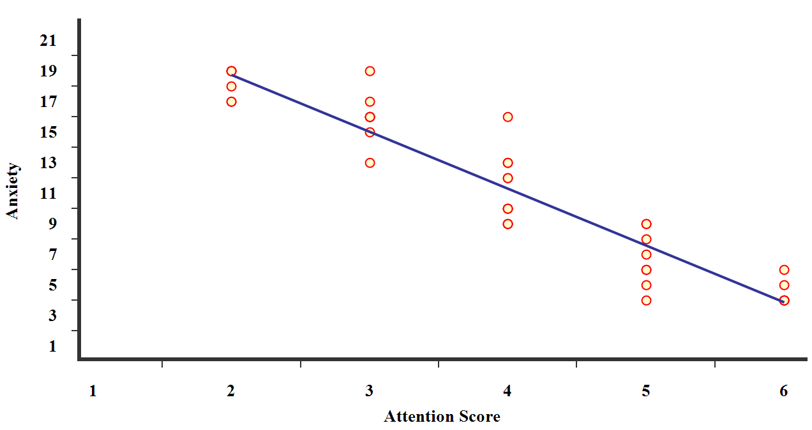 | 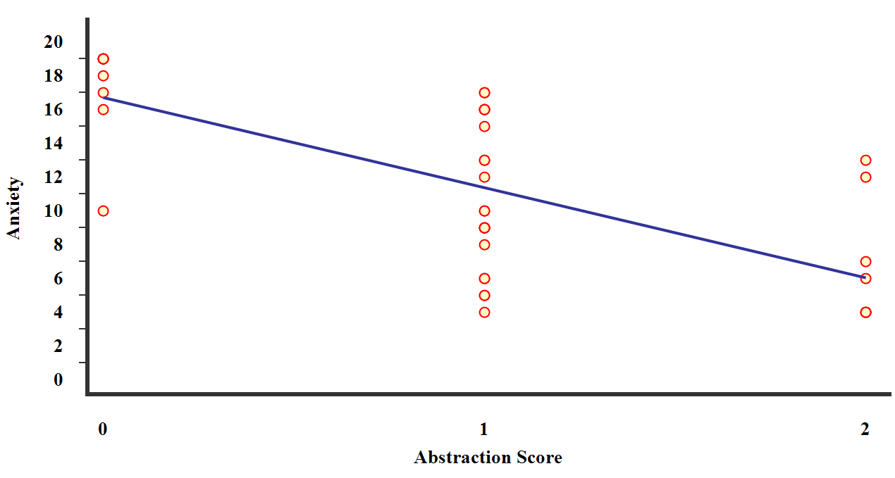
C | D
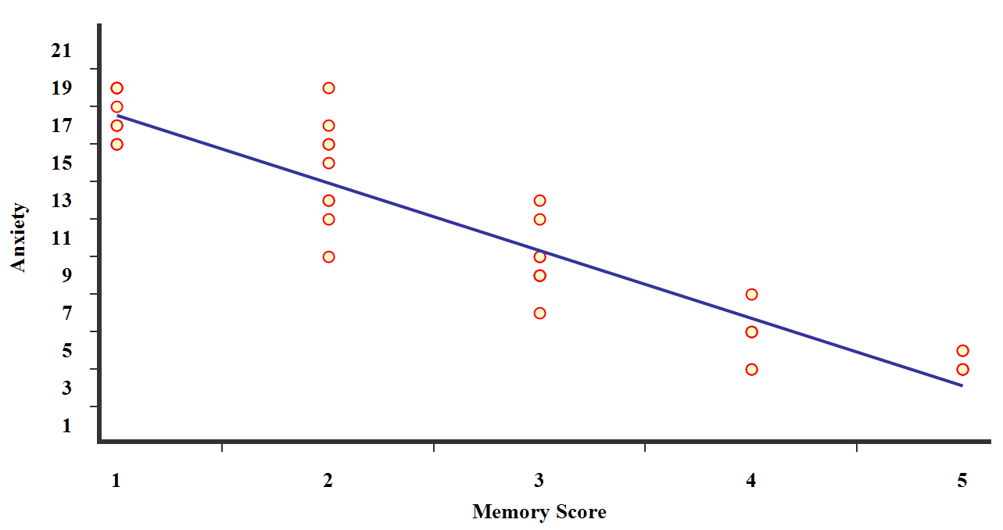 | 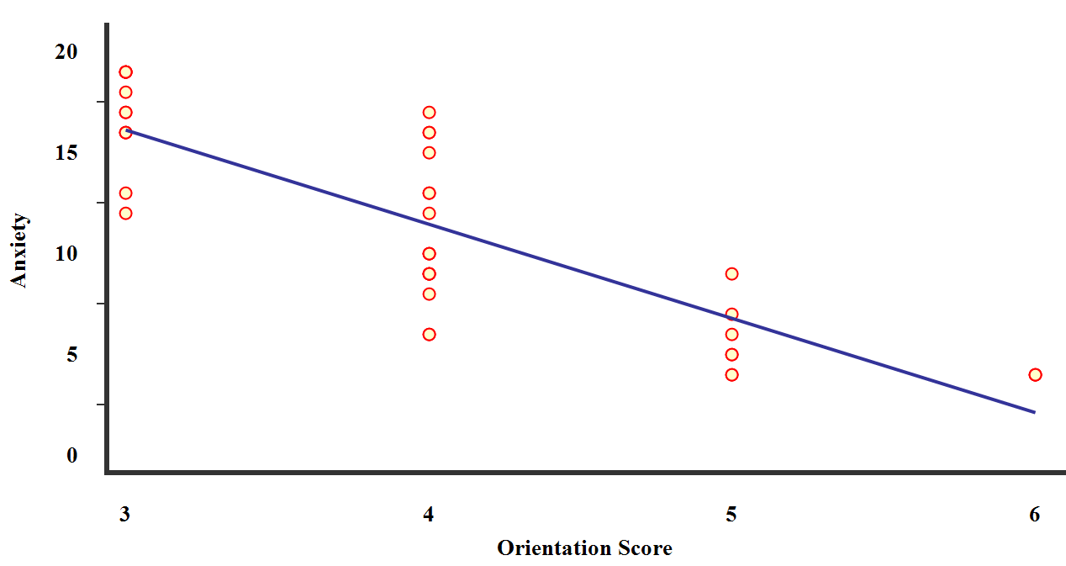
E | F
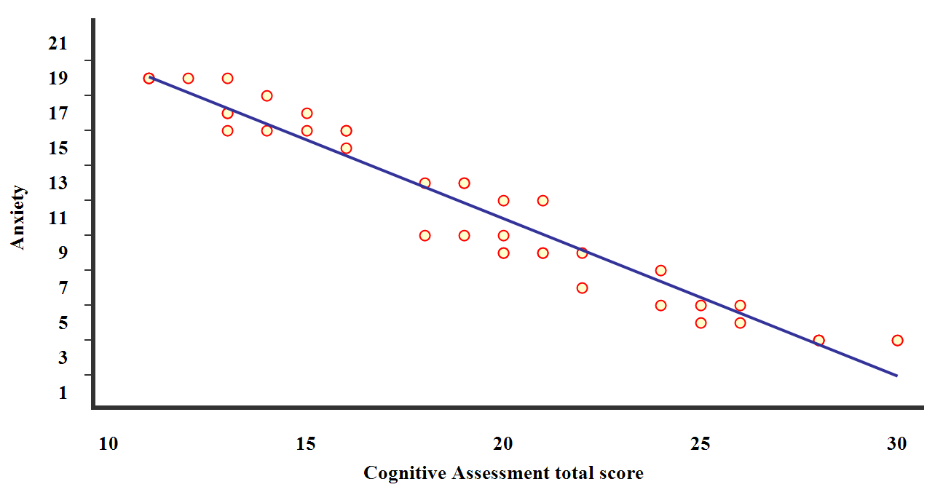
G
Figure 3. Scatter dot plots for correlations among all studied subjects, between anxiety scale with (A) Executive function Score, (B) naming, (C) attention, (D) abstraction, (E) memory, (F) orientation, and (G) Cognitive Assessment total score.
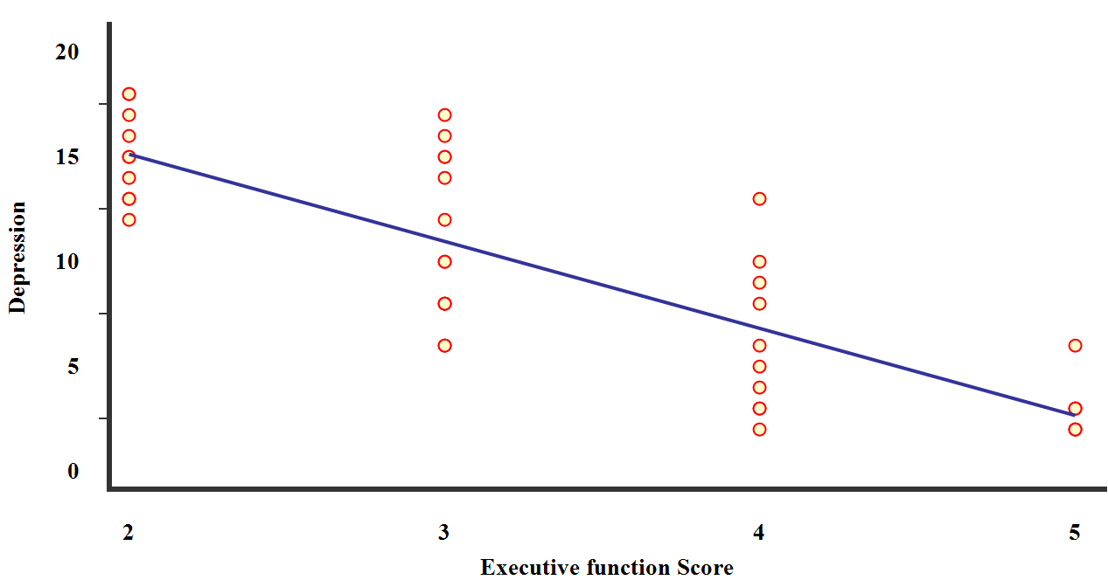 | 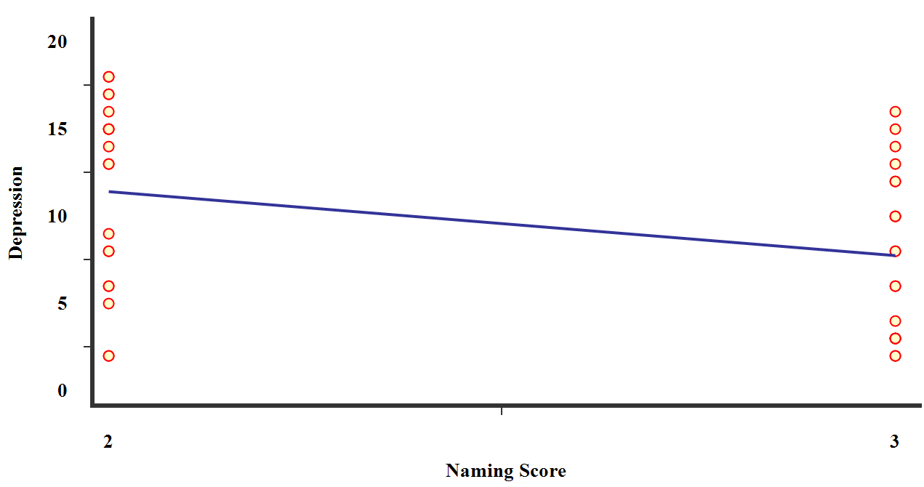
A | B
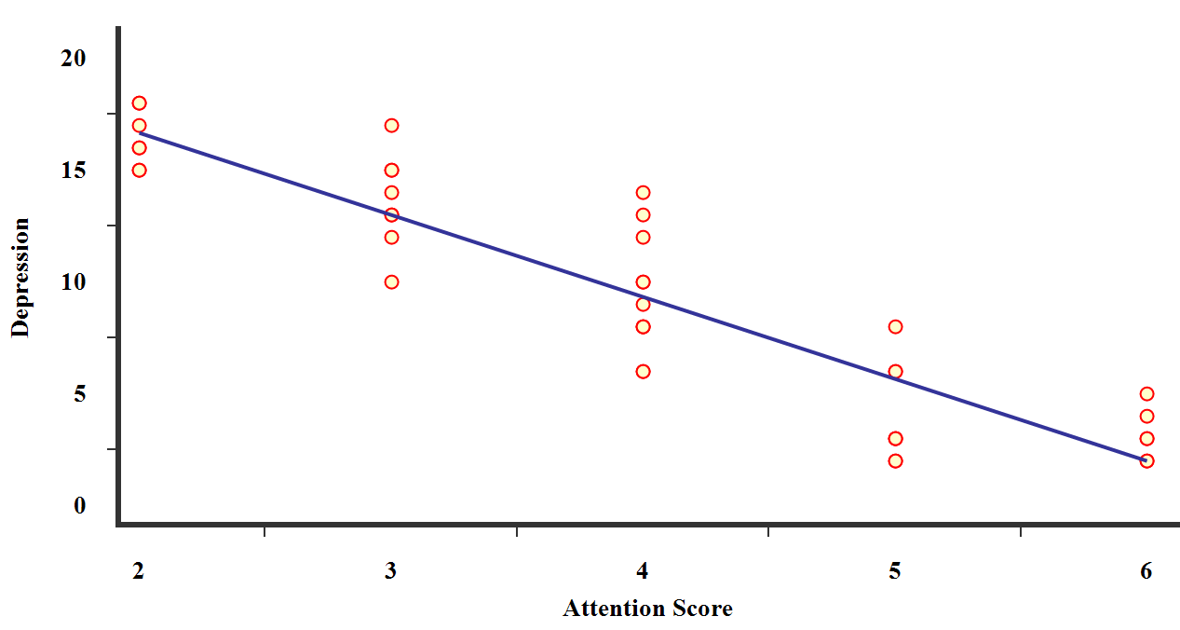 | 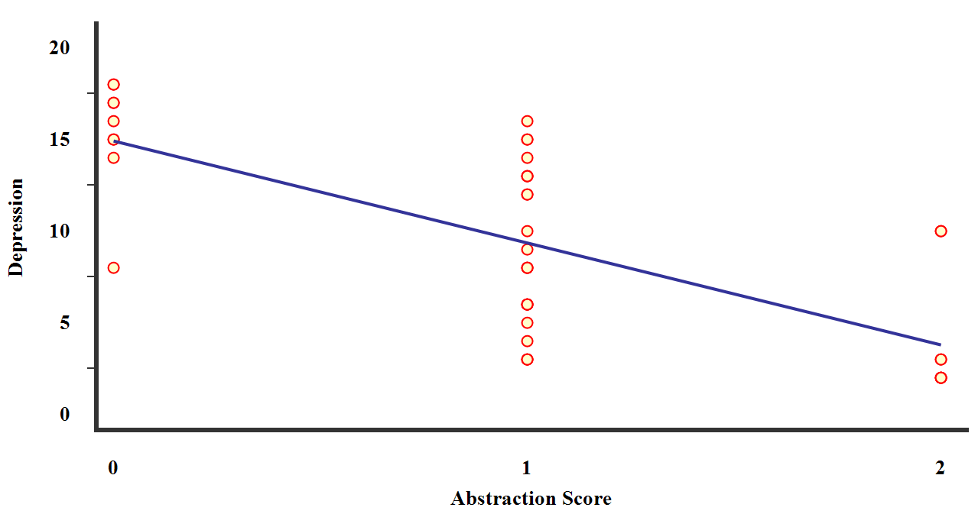
C | D
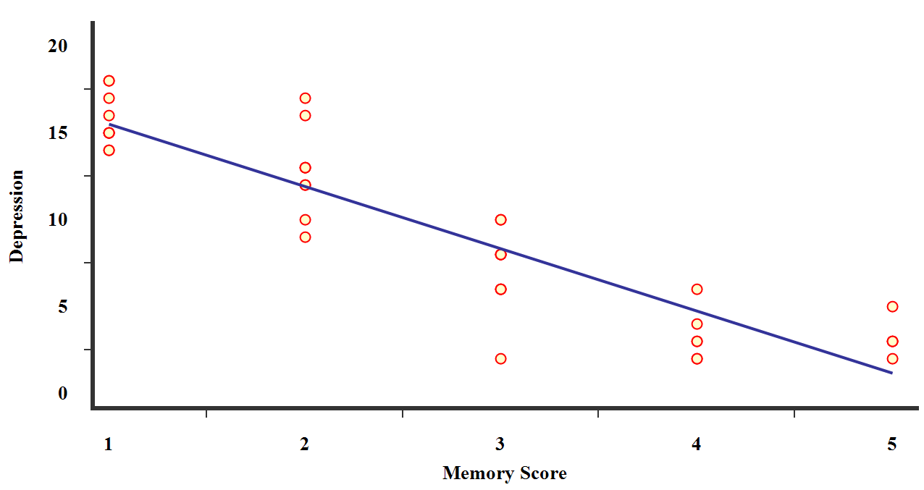 | 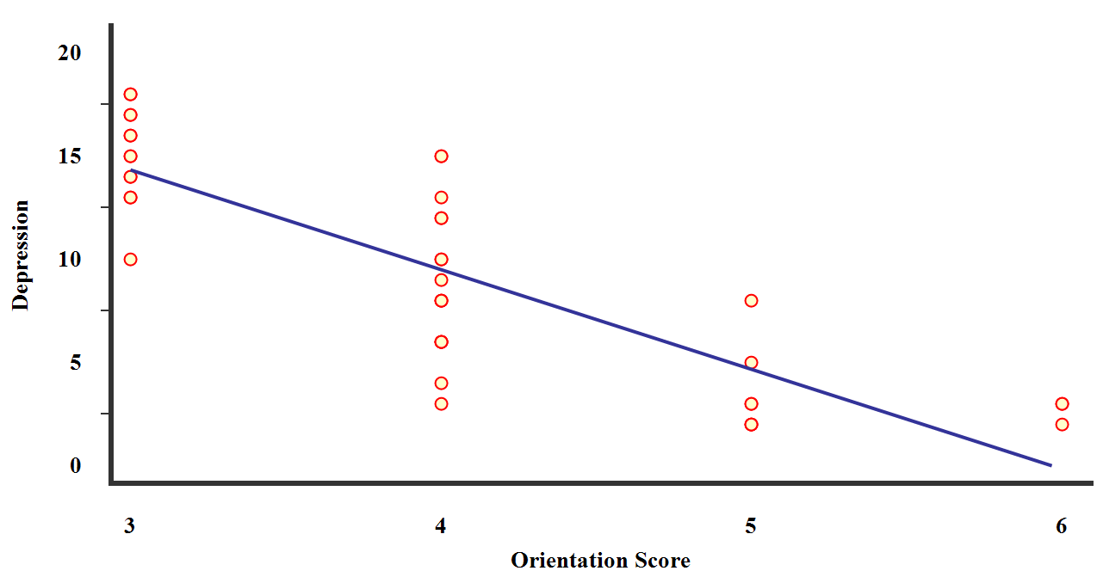
E | F
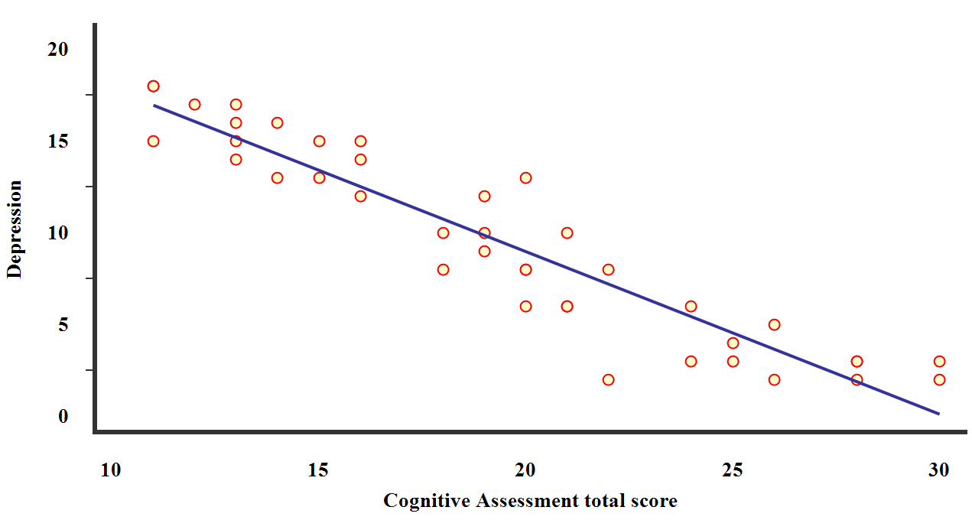
G
Figure 4. Scatter dot plots for correlations among all studied subjects, between the depression scale with (A) Executive function Score, (B) naming, (C) attention, (D) abstraction, (E) memory, (F) orientation, and (G) Cognitive Assessment total score.
A | 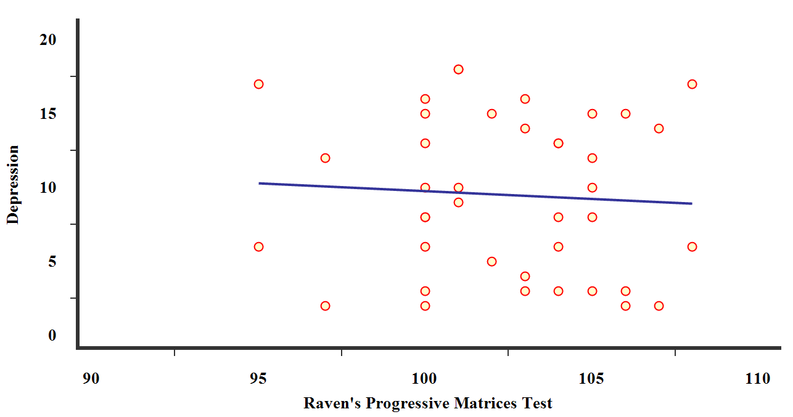
B | 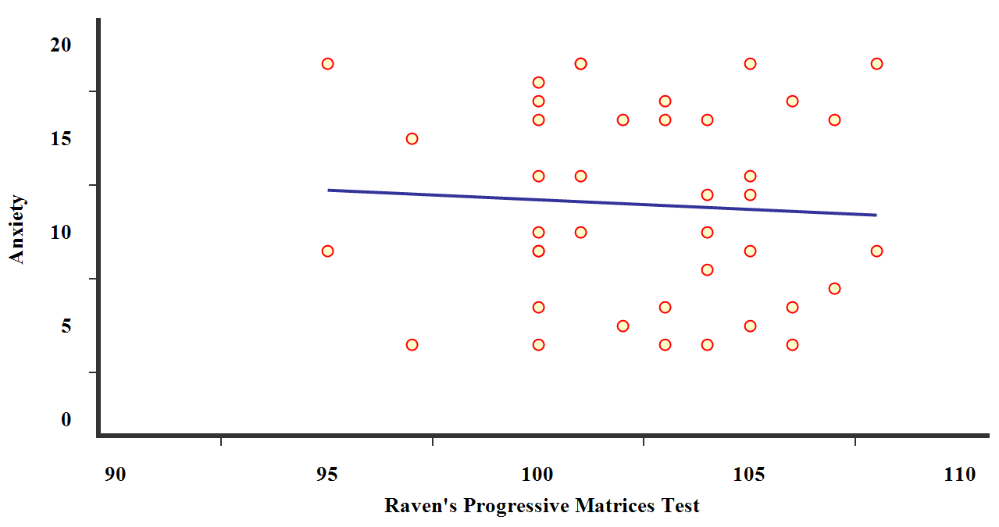
Figure 5. Scatter dot plots for correlations among all studied subjects, between Raven's Progressive Matrices Test with (A) anxiety and (B) depression scales.
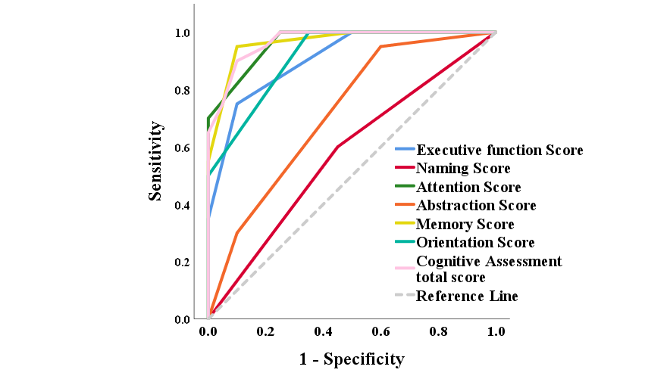
Figure 6. ROC curve of neuro-cognitive features for discrimination between TTS and HC groups.

DISCUSSION
The results of the study revealed a statistically significant increase in anxiety and depression levels among patients with TTS compared to healthy controls. The mean scores for anxiety and depression in the patient group fell within the moderate to severe diagnostic categories. This finding is consistent with previous studies indicating a strong association between anxiety, depression, and the syndrome, suggesting that these psychological indicators play a central role in the onset and exacerbation of symptoms, either as pre-existing conditions or as emotional triggers (Scuppa et al.,2025; Sultana et al.,2023; Weihs et al.,2022;Ghadri, et al., 2018; Summers et al., 2010).
Evidence further indicates that the prevalence of anxiety among TTS patients is approximately 13%, while mood disorders account for about 9%. In addition, nearly 60% of patients exhibit high trait anxiety (Sabisz et al.,2016; Vergel et al.,2017). Consistently, Mayer et al.(2016) reported that the prevalence of depressive mood reached 69.2% in their study sample.
Kim et al. (2018) found that two-thirds of patients had a prior history of anxiety or depression. In addition, nearly 80% of the TTS Group reported experiencing chronic psychological stress, which may have contributed to their vulnerability to both cardiovascular diseases and psychiatric disorders compared with healthy individuals(Akashi et al.,2007; Bao et al.,2008; Rosengren et al.,2004).
In light of these findings, both anxiety and depression are major risk factors, predisposing individuals to TTS when exposed to psychological stress. They also induce sympathetic nervous system hyperactivation, leading to elevated catecholamine release that affects β2-adrenergic receptors and activation of the hypothalamic-pituitary-adrenal (HPA) axis, resulting in increased cortisol levels. These changes are further associated with dysregulation of mood-related neurotransmitters such as serotonin, heightened secretion of inflammatory cytokines, tachycardia, vascular alterations, multi-organ dysfunction, and impaired myocardial function—all of which are implicated in the pathophysiology of TTS (Fu et al.,2019; Vergel et al.,2017; Jesulola et al.,2018; Gabarre et al.,2022).
These findings support previous studies linking anxiety, depression, and Type D personality, the most prevalent personality profile among TTS patients (Klein et al., 2020). The results also support neuroimaging studies showing abnormal activity in brain regions such as the amygdala and prefrontal cortex, along with structural changes in response to stress (Bozzi et al.,2022; Radvar et al.,2021). Notably, amygdala hyperactivity has been shown to predict cardiovascular dysfunction (Tawakol et al.,2017).
In addition, findings highlight increased expression of specific microRNAs, particularly MIRNA-16 and MIRNA-26a, among TTS patients. These molecules are also elevated in the brains of individuals with anxiety and depression, supporting the concept of a brain-heart axis that may underlie heightened sensitivity to psychological stress and the subsequent occurrence of functional myocardial infarction (Khan et al.,2021).
Taken together, the present findings underscore the role of psychological indicators as a critical link between emotional stressors and cardiac manifestations in the development of TTS.
The findings of the present study indicate a marked impairment in cognitive functions among patients with TTS compared to healthy controls. These differences are particularly evident in executive functions, memory, and attention. This aligns with certain qualitative findings, which demonstrated that patients with TTS tend to exhibit more pronounced cognitive decline, reflected in lower MMSE/MoCA scores, poorer performance in cognitive tasks, reduced brain activity in the SMA and SFGmed regions associated with executive dysfunction (EF), and diminished suppression of the default mode network (DMN) linked to elevated low-density lipoprotein cholesterol (LDL-C). Additionally, decreased ReHo and ALFF values, alongside reduced functional connectivity (FC), have been reported (Humayra et al.,2024). These findings can be explained by several interrelated factors, most notably:
Cerebral hypoperfusion resulting from impaired cardiac function, as reduced ventricular pumping efficiency limits cerebral blood supply, leading to compromised cognitive performance (Lopez Gomez et al.,2024).
Excessive adrenergic stimulation associated with the syndrome, manifested in a neurohormonal catecholamine surge. This surge impacts not only the heart but also the brain, particularly in patients with pre-existing vascular vulnerability, and may manifest as cognitive disturbances (Norcliffe-Kaufmann,2023; Scuppa et al.,2025).
Furthermore, evidence suggests the involvement of neurobiological mechanisms, characterized by altered neural responses, heightened autonomic nervous system activation following emotional stimuli, and dysfunction of the limbic system, which is responsible for regulating autonomic balance (Kakinuma et al.,2021; Madias, 2018; Pozzi et al.,2022).
Neuroimaging (fMRI) studies have also revealed reduced functional connectivity, in addition to structural and functional alterations in key brain regions associated with executive and cognitive functions, such as the supplementary motor area, central sulcus, lenticular nucleus, hippocampus, precentral cortex, cingulate cortex, prefrontal cortex, precuneus, medial temporal gyrus, amygdala, angular gyrus, and insula. These neural changes contribute to impaired processes of planning, decision-making, goal-directed behavior regulation, and emotional control (Borodzicz et al.,2019; Suzuki et al.,2021).
Moreover, neurochemical transmitter imbalances linked to fundamental cognitive functions—such as attention and memory—have been highlighted. Catecholamines (norepinephrine, epinephrine, dopamine), neuropeptide Y (NPY), serotonin, and acetylcholine have been implicated in these dysfunctions (Kakinuma et al.,2021; Pelliccia et al.,2014). In addition, cortisol and copeptin play further roles in the neurohormonal changes associated with the syndrome (Rallidis et al.,2024; Ruiz et al.,2022).
Taken together, these findings suggest that cognitive impairment in patients with TTS is multifactorial in nature, arising from the interplay of cerebral hypoperfusion, neurohormonal alterations, and dysfunction within cognitive and emotional brain networks. This explains the statistically significant differences revealed by the study’s results.

RECOMMENDATIONS
The study used questionnaires to measure psychological and cognitive indicators. These questionnaires rely on self-reporting, which is prone to measurement error, and therefore need to be integrated with other techniques less susceptible to measurement error.
STUDY LIMITATIONS
This study included a relatively small number of patients selected from the Health Insurance Hospital in Zagazig, Al-Sharqia Governorate. To generalize the results of the study, a larger number of patients in health insurance hospitals in Egypt should be considered.

Acknowledgements: Not applicable
Funding: This research received no external funding.
Conflict of interest: The authors acknowledge and declare that there are no potential conflicts of interest related to the authorship and publication of the current study.
Generative AI Statement: The authors declare that generative AI or AI-assisted technologies were not used in any way to prepare, write, or complete this manuscript.
Authors' contributions: All authors wrote the original draft, reviewed and edited the manuscript; supervised, analyzed data, performed statistical treatments, interpreted results and discussed, and finalized and approved the manuscript
Declarations
Consent to publish declaration: We agree to publish.
Ethical approval: The research, application of instruments, and all informed consent forms were approved by the Institutional Review Board of the Faculty of Arts, Benha University. The study adheres strictly to ethical standards regarding privacy, confidentiality, informed consent, dignity, protection, and voluntary participation. All processes and procedures followed in this research are consistent with the ethical principles set forth in the Declaration of Helsinki (1964). This approval covers all aspects of the study, such as participant recruitment, data collection and analysis, informed consent procedures, and confidentiality measures, as specified in the approved protocol.
Consent to participate: All participants were informed that participation in this study was voluntary and that they could decide to withdraw at any time. Furthermore, participants were informed that their responses would only be used for a research study and that their identities would not be revealed. All participants consented to the study, and participants were over 18 years old.
The data availability statement: The data that support the findings of this study are available from the corresponding author upon reasonable request.
REFERENCE
Akashi, Y. J., Barbaro, G., Sakurai, T., Nakazawa, K., & Miyake, F. (2007). Cardiac autonomic imbalance in patients with reversible ventricular dysfunction takotsubo cardiomyopathy. Journal of the Association of Physicians, 100(6), 335-343.‏ https://doi.org/10.1093/qjmed/hcm028
Algaralleh A, Altwalbeh D, &Alzayyat A.(2019) Preliminary psychometric properties of the Arabic version of Sheu and colleagues Perceived Stress Scale among nursing students at Jordanian universities. J. Multidiscip Healthc, 18(12),777-787. https://doi.org/10.2147/JMDH.S214456
Ali, I. (2016). Progressive Matrices Test. Cairo: Anglo Egyptian Bookshop. https://www.anglo-egyptian.com/ar/book.php?id=12820
Almadi, T., Cathers, I., Hamdan Mansour, A.M., &Chow, C.M. (2012). An Arabic version of the perceived stress scale: translation and validation study. Int J Nurs Stud.;49(1):84-90. https://doi.org/10.1016/j.ijnurstu.2011.07.012
Bao, M., Meynen, G., & Swaab, F. (2008). The stress system in depression and neurodegeneration: focus on the human hypothalamus. Brain research reviews, 57(2), 531-553.‏ https://doi.org/10.1016/j.brainresrev.2007.04.005
Beck, T., Epstein, N., Brown, G., & Steer, A. (1988). An inventory for measuring clinical anxiety: Psychometric properties. Journal of Consulting and Clinical Psychology, 56, 893-897. https://doi.org/10.1037/t02025-000
Borodzicz, S., Czarzasta, K., Opolski, G., & Cudnoch-Jędrzejewska, A. (2019). Authors’ response to the letter: Takotsubo syndrome: a neurocardiac syndrome inside the autonomic nervous system. Heart Failure Reviews, 24(5),831.‏ https://doi.org/10.1007/s10741-019-09789-y
Boyd, B., & Solh, T. (2020). Takotsubo cardiomyopathy: review of broken heart syndrome. Jaapa, 33(3), 24-29.‏ https://doi.org/10.1097/01.JAA.000065 4368.35241.fc
Casagrande, M., et al. (2024). The brain‐heart connection in Takotsubo syndrome: A review. Cardiovascular Medicine, 24(1), 4150291. https://doi.org/10.1155/2020/4150291
Chaaya, M., Osman, H., Naassan, G., & Mahfoud, Z. (2010). Validation of the Arabic version of the Cohen Perceived Stress Scale (PSS-10) among pregnant and postpartum women. BMC psychiatry, 10(1), https://doi.org/111.‏ 10.1186/1471-244X-10-111
ElKholy, N. (2019). Defining cut-off scores for MMSE in an educated and illiterate Arabic speaking Egyptian elderly population. The Egyptian Journal of Geriatrics and Gerontology, 6(1), 1-3.‏ https://doi.org/10.21608/ejgg.2019.30899
Fu K., Ng B., &Chua M. (2019). A unique case of acute brain haemorrhage with left ventricular systolic failure requiring ECMO. BMC Pediatrics, 19(1). https://doi.org/10.1186/s12887-019-1658-5
Gabarre, P., Ruiz, P., Chenevier-Gobeaux, C., Charpentier, E., Soulat-Dufour, L., Cohen, A., Monnier-Cholley, L., Chemali, L., François, H., Kerneis, M., Lefèvre, G., &Boissan, M. (2022). Inverted Takotsubo Syndrome With HELLP Syndrome: A Case Report. Frontiers in Cardiovascular Medicine, 9, 832098. https://doi.org/10.3389/fcvm.2022.832098
Ghadri, R., Wittstein, S., Prasad, A., Sharkey, S., Dote, K., Akashi, J., Cammann, L., Crea, F., Galiuto, L., Desmet, W., Yoshida, T., Manfredini, R., Eitel, I., Kosuge, M., Nef, M., Deshmukh, A., Lerman, A., Bossone, E., Citro, R., Ueyama, T., Corrado, D., Kurisu, S., Ruschitzka, F., Winchester, D., Lyon, AR., Omerovic, E., Bax, J.J., Meimoun, P., Tarantini, G., Rihal, C., Y-Hassan, S., Migliore, F., Horowitz, J.D., Shimokawa, H., Lüscher, T.F., &Templin, C. (2018).International Expert Consensus Document on Takotsubo Syndrome (Part I): Clinical Characteristics, Diagnostic Criteria, and Pathophysiology. Eur. Heart J.;39: 2032–2046. https://doi.org/1093/eurheartj/ehy076
Ghareeb, F. (2015). Beck Depression Inventory (Arabic version). Cairo, Anglo Egyptian Bookshop. https://www.anglo-egyptian.com
Gorini, A., Galli, F., Giuliani, M., Pierobon, A., Werba, J.P., Adriano, E.P., &Trabattoni, D. (2022).Psychological Characteristics of Patients with Takotsubo Syndrome and Patients with Acute Coronary Syndrome: An Explorative Study toward a Better Personalized Care. J Pers Med. 2022 Jan 4;12(1):38. doi: 10.3390/jpm12010038
Humayra, S., Yahya, N., Ning, C. J., Mir, I. A., Mohamed, A. L., & Manan, H. A. (2024). Brain functional alteration and cognitive performance in cardiovascular diseases: a systematic review of fMRI studies. Frontiers in Neurology, 15, 1425399. https://doi.org/10.3389/fneur.2024.1425399
Jesulola, E., Micalos, P., &Baguley, I. (2018). Understanding the pathophysiology of depression: From monoamines to the neurogenesis hypothesis model - are we there yet?. Behavioural Brain Research, 341, 79-90. https://doi.org/10.1016/j.bbr.2017.12.025
Kakinuma, Y., Kimura, T., Sakae, Y., Kubota, S., Ono, K.,& Kinno, R. (2021). Takotsubo syndrome associated with autoimmune limbic encephalitis: a case report. BMC Cardiovascular Disorders, 21(1), 86. https://doi.org/10.1186/s12872-020-01789-3
Khalid, N. (2024). Pathophysiology of Takotsubo Syndrome. In StatPearls. StatPearls Publishing. https://www.ncbi.nlm.nih.gov/books/NBK538160
Khan, H., Gamble, D., Mezincescu, A., Abbas, H., Rudd, A., &Dawson, D. (2021). A systematic review of biomarkers in Takotsubo syndrome: A focus on better understanding the pathophysiology. IJC Heart & Vasculature, 34, 100795. https://doi.org/10.1016/j.ijcha.2021.100795
Kim, H., Senecal, C., Lewis, B., Prasad, A., Rajiv, G., Lerman, L., &Lerman, A. (2018). Natural history and predictors of mortality of patients with Takotsubo syndrome. International Journal of Cardiology, 267(15),22-27. https://doi.org/10.1016/j.ijcard.2018.04.139
Klein, C., Leipold, S., Ghadri, J., Jurisic, S., Hiestand, T., Hänggi, J., Lüscher, T., Jäncke, L., &Templin, C. (2020). Takotsubo syndrome: How the broken heart deals with negative emotions. NeuroImage: Clinical, 25, 102124. https://doi.org/10.1016/j.nicl.2019.102124
Kosek-Nikołajczuk, M., Borowiak, E., Piatkowski, R., Grabowski, M., & Budnik, M. (2025). Long-Term Prognosis, Risk Assessment, and Management of Patients Diagnosed with Takotsubo Syndrome: A Narrative Review. Journal of Personalized Medicine, 15(9), 425.‏ https://doi.org/10.3390/jpm15090425
Lathouwers, E., Radwan, A., Blommaert, J. et al. (2023).A cross-sectional case–control study on the structural connectome in recovered hospitalized COVID-19 patients. Sci Rep 13, 15668. https://doi.org/10.1038/s41598-023-42429-y
Lopez Gomez, J., Garcia Tercero, E., Avellana Zaragoza, J., Belenguer Varea, A., Villalón Rubio, D., Trigo Suarez, R., Cunha-Pérez, C., &Tarazona-Santabalbina, F. (2024). Delirium as a geriatric syndrome in the initial presentation of Takotsubo syndrome. Revista Española de Geriatría y Gerontología, 59(3), 101482. https://doi.org/10.1016/j.regg.2024.101482
Lovallo, R. (2005). Cardiovascular reactivity: mechanisms and pathways to cardiovascular disease. International Journal of Psychophysiology, 58(2-3), 119-132.‏ https://doi.org/10.1016/j.ijpsycho
Madias, J. (2018). Diabetes mellitus prevalence in patients with takotsubo syndrome: the case of the brain-heart disconnect. Heart & Lung, 47(3), 222-225. https://doi.org/10.1016/j.hrtlng.2018.02.007
Mounjid, C., M’rabti, H., Sossé, L. A., Laraqui, A., Chajès, V., El Khannoussi, B., Bakr, Y. & Errihani, H. (2022). Validation of the Moroccan version of the Cohen perceived stress scale (PSS-10) among women with Breast cancer. Annals of Cancer Research and Therapy, 30(2), 100-105.‏ https://doi.org/10.4993/acrt.30.100
Nasreddine, S., Phillips, A., Bédirian, V., Charbonneau, S., Whitehead, V., Collin, I., Cummings,L., & Chertkow, H. (2005). The Montreal Cognitive Assessment, MoCA: a brief screening tool for mild cognitive impairment. Journal of the American Geriatrics Society, 53(4), 695-699.‏ https://doi.org/10.1111/j.1532-5415.2005.53221.x
Norcliffe-Kaufmann, L. (2023). Myocardial stunning and takotsubo cardiomyopathy. Primer on the Autonomic Nervous System, 489-494. https://doi.org/10.1016/B978-0-323-85492-4.00054-5
Pelliccia, F., &Camici, P. (2021). Acute neurological dysfunction: The missing link in the pathophysiology of takotsubo syndrome. International Journal of Cardiology, 345, 26-28. https://doi.org/10.1016/j.ijcard.2021.10.147
Pozzi, G., D'Amario, D., Princi, G., Ciliberti, G., Irano, A., Simone, V., Crea, F., & Galiuto, L. (2022). Pre-existing psychiatric morbidity Is strongly associated to Takotsubo syndrome: A case-control study. Frontiers in Cardiovascular Medicine, 12,9, 925459.‏ https://doi.org/10.3389/fcvm.2022.925459
Radfar, A., Abohashem, S., Osborne, T., Wang, Y., Dar, T., Hassan, O., Ghoneem, A., Naddaf, N., Patrich, T., Abbasi, T., Zureigat, H., Jaffer, J., Ghazi, P., Scott, A., Shin, M., Pitman, K., Neilan, G., Wood, J., &Tawakol, A.(2021). Stress-associated neurobiological activity associates with the risk for and timing of subsequent Takotsubo syndrome. European Heart Journal, 42(19), 1898-1908. https://doi.org/10.1093/eurheartj/ehab029
Rallidis, L., Papathanasiou ,K., Kosmas, N., Iordanidis, D., Rallidis, S., &Simitsis ,P. (2024). Is premorbid stress assessed by hair cortisol concentration linked to Takotsubo syndrome? Results from a pilot study. International Journal of Cardiology, 410, 132241. https://doi.org/10.1016/j.ijcard.2024.132241
Rosengren, A., Hawken, S., Ôunpuu, S., Sliwa, K., Zubaid, M., Almahmeed, W. A., ... & Yusuf, S. (2004). Association of psychosocial risk factors with risk of acute myocardial infarction in 11 119 cases and 13 648 controls from 52 countries (the INTERHEART study): case-control study. The Lancet, 364(9438), 953-962.‏ https://doi.org/10.1016%2FS0140-6736%2804%2917019
Ruiz, P., Gabarre, P., Chenevier-Gobeaux, C., François, H., Kerneis, M., Cidlowski, J., Oakley, R., Lefèvre, G., &Boissan, M. (2022). Case report: Changes in the levels of stress hormones during Takotsubo syndrome. Frontiers in Cardiovascular Medicine, 9, 931054. https://doi.org/10.3389/fcvm.2022.931054
Sabisz, A., Treder, N., Fijałkowska, M., Sieminski, M., Fijałkowska, J., Naumczyk, P., Nowak, R., Jaguszewski, M., Cwalina, N., Gruchała, M., Szurowska, E., &Fijałkowski, M. (2016). Brain resting state functional magnetic resonance imaging in patients with takotsubo cardiomyopathy an inseparable pair of brain and heart. International Journal of Cardiology, 224. https://doi.org/10.1016/j.ijcard.2016.09.067
Scuppa, D., Colaceci, F., Sciandrone, M., Arcari, L., Mariano, E., Musumeci, B., Barbato, E., &Galiuto, L. (2025). Predicting takotsubo syndrome subtypes: An interpretable machine learning model for differentiating emotional versus physical aetiologies. International Journal of Cardiology, 437, 376-381. https://doi.org/10.1016/j.ijcard.2025.133509
Scuppa, D., Colaceci, F., Sciandrone, M., Arcari, L., Mariano, E., Musumeci, B., Barbato, E., & Galiuto, L. (2025). Predicting takotsubo syndrome subtypes: An interpretable machine learning model for differentiating emotional versus physical aetiologies. International Journal of Cardiology, 437(15), 133509. https://doi.org/10.1016/j.ijcard.2025.133509
Shadmand, M., Lautze, J., & Md, M.(2024). Takotsubo pathophysiology and complications: what we know and what we do not know. Heart Fail Rev.29(2),497-510. https://doi.org/10.1007/s10741-023-10381-8
Sultana, S., Nisar, S., Kumar, F., Khan, H., Saeed, H., Ahmed, G., & Malik, J. (2023). Role of Positive Emotions in Takotsubo Cardiomyopathy. Current Problems in Cardiology, 48(12), 101997.‏ https://doi.org/10.1016/j.cpcardiol.2023.101997
Summers, R., Lennon, J., & Prasad, A. (2010). Pre-morbid psychiatric and cardiovascular diseases in apical ballooning syndrome (tako-tsubo/stress-induced cardiomyopathy): potential pre-disposing factors?. Journal of the American College of Cardiology, 55(7):700-1. https://doi.org/10.1016/j.jacc.2009.10.031
Suzuki, H., Takanami, K., Takase, K., Shimokawa, H., &Yasuda, S. (2021). Reversible increase in stress-associated neurobiological activity in the acute phase of Takotsubo syndrome; a brain 18 F-FDG-PET study. International Journal of Cardiology, 344 , 31-33. https://doi.org/10.1016/j.ijcard.2021.09.057
Tawakol, A, Ishai, A., Takx, A., Figueroa, L., Ali, A., Kaiser, Y.,& et al. (2017). Relation between resting amygdalar activity and cardiovascular events: a longitudinal and cohort study. Lancet, 389,834–45. https://doi.org/10.1016/S0140-6736(16)31714-7
Templin, C., Ghadri, R., Diekmann, J., Napp, C., Bataiosu, R., Jaguszewski, M., Cammann, L., Sarcon, A., Geyer, V., &Neumann, A., et al.(2015). Clinical Features and Outcomes of Takotsubo (Stress) Cardiomyopathy. N. Engl. J. Med.;373:929–938. https://doi.org/10.1056/NEJMoa1406761
Vergel J., Tamayo-Orozco S., Vallejo-Gómez A., Posada M., &Restrepo D. (2017). Acute stress and broken heart syndrome. A case report. Revista Colombiana de Psiquiatría (English ed.), 46. https://doi.org/10.1016/j.rcpeng.2017.09.007
Vergel, J., Tamayo-Orozco, S., Vallejo-Gómez, A., Posada, M., &Restrepo, D. (2017). Acute stress and broken heart syndrome. A case report. Revista Colombiana de Psiquiatría (English ed.), 46(4), 257-262. https://doi.org/10.1016/j.rcpeng.2017.09.007
Weihs, V., Pogran, E., Kunschitz, E., Weihs, W., Prinz, E., Eichenberg, C., Fiegl, J., Friedrich, O. & Huber, K.(2022). Psychocardiological assessment in the acute phase of the takotsubo syndrome: Somatic and depressive disorders, resilience and illness perception. Wiener Klinische Wochenschrift, 134(7), 269-275. https://doi.org/10.1007/s00508-021-01957-1
Weihs, V., Pogran, E., Kunschitz, E., Weihs, W., Prinz, E., Eichenberg, C., ... & Huber, K. (2022). Psychocardiological assessment in the acute phase of the takotsubo syndrome: Somatic and depressive disorders, resilience and illness perception. Wiener Klinische Wochenschrift, 134(7), 269-275. https://doi.org/10.1007/s00508-021-01957-
Wittstein, S., Thiemann, R., Lima, A., Baughman, L., Schulman, P., Gerstenblith, G., Wu, C., Rade, J., Bivalacqua, J., & Champion, C. (2005). Neurohumoral features of myocardial stunning due to sudden emotional stress. New England journal of medicine, 352(6), 539-548.‏ https://doi.org/10.1056/NEJMoa043046
Y-Hassan, S., & Falhammar, H.(2020). Clinical features, complications, and outcomes of exogenous and endogenous catecholamine-triggered Takotsubo syndrome: A systematic review and meta-analysis of 156 published cases. Clin Cardiol.43(5),459-467. https://doi.org/10.1002/clc.23352
Zigmond, S., & Snaith, P. (1983). The hospital anxiety and depression scale. Acta psychiatrica scandinavica, 67(6), 361-370.‏ https://doi.org/10.1111/j.1600-0447.1983.tb09716.x

