Priming And Prejudice: The Kuranta-Bothata Study

Luiz C. Victorino
Universidade de Brasília
Ronaldo Pilati
Universidade de Brasília
Alexandre Linhares
Fundação Getulio Vargas

2017

Authors Note
Luiz C. Victorino, Institute of Psychology, Universidade de Brasília.
Ronaldo Pilati, Institute of Psychology, Universidade de Brasília.
Alexandre Linhares, Fundação Getulio Vargas.
Some of the data used in this manuscript was presented before as a master’s thesis from the authors and as a poster in ICPS 2015.
Correspondence concerning this article should be addressed to Luiz C. Victorino, SQSW 100 Bl. D/303, Brasília, DF, 70670-014, Brazil. E-mail: luiz.victorino1@gmail.com

Abstract
Recent discussions of evaluation biases have highlighted the importance of priming effects in the process. We conducted two experiments with evaluation tasks (a scientific article evaluation and a chocolate tasting) in which participants were exposed to a footnote acknowledging financial support from a fictional agency. In one condition, the agency's name was associated with the African continent, while in another condition, it was associated with the European continent. There were statistically significant differences in judgments on both tests, with individuals on the European condition giving better evaluations of the article and the chocolate, even though the stimuli were subtle enough not to be remembered by 92.5% of all the participants. We also found evidence of a moderating effect of academic experience on the priming process.

Keywords: priming; cognitive bias; judgment.

Resumo
Discussões recentes sobre os vieses de avaliação enfatizaram a importância dos efeitos de priming neste processo. Dois experimentos foram realizados com tarefas de avaliação (uma avaliação de artigos científicos e uma degustação de chocolate) em que os participantes foram expostos a uma nota de rodapé indicando apoio financeiro de uma agência fictícia. Em uma condição, o nome da agência foi associado com o continente africano, enquanto em outra condição, com o continente europeu. Houve diferenças estatisticamente significativas nos julgamentos em ambos os testes, com indivíduos na condição europeia dando melhores avaliações ao artigo e ao chocolate, embora os estímulos fossem suficientemente sutis para não serem lembrados por 92,5% dos participantes. Também encontramos evidências de um efeito moderador da experiência acadêmica no processo de priming.
Keywords: priming; cognitive bias; judgment.

Introduction
Priming is recurrent phenomenon in social cognition, and recently, interest in how it can influence evaluation and judgment has been increasing (Chaxel, Russo, & Wiggins, 2016; Doyen, Klein, Simons, & Cleeremans, 2014; Mohr, Koutrakis, & Kuhn, 2015). Beyond the examination of priming effects, recent advances are trending towards the possible mediators and moderators (Pickering, McLean, & Krayeva, 2015; Poehlman, Dhar, & Bargh, 2016), including attributions related to the origin of primed information (Loersch & Payne, 2014).
The influence of priming on complex processes can be explained through cognitive biases, which can arise from different sources (Hilbert, 2012; Pleggenkuhle-Miles, Khoury, Deeds, & Markoczy, 2013), including culture, hence the need to investigate and replicate effects of priming on judgment in different cultural groups, such as Brazilian academics.
In the present study, we focus on two different types of evaluation, one presumably more technical (a scientific paper) and the other more subjective and personal (a chocolate tasting), and how the stereotype of origin can affect evaluation and judgment. Our objective is to investigate if, through a priming effect, subjects will show a bias in evaluation and judgment on both tasks. Also, to contribute to the growing body of evidence on the role of moderator variables in priming effects, the moderating effect of academic experience will be investigated.

General Method
The present work is based on two studies using the same stimuli, words on a footnote that imply European or African origins. There is consensus in the literature that European and African origins are related, respectively, to positive and negative representations, leading to stereotyping effects in many domains (Rubinstein & Brenner, 2014). Based on a pre-test, the words chosen were Welgesteld-Tijdschrift (“wealthy magazine” in Dutch), and Kuranta-Bothata (“problematic magazine” in Setswana, a Southern African language).

Experiment 1 – Chocolate Testing
Participants
For this experiment, 113 mostly (81.4%) male graduate students (M = 24.78 years, SD = 7.02) were given an unmarked chocolate, and after tasting, asked to evaluate it using a questionnaire.
The variable manipulated was the information presented in a footnote placed on the informed consent, regarding the institution which funded that research. The institution’s names were Welgesteld-Tijdschrift (WT Condition) and Kuranta-Bothata (KB Condition) with the control group lacking a footnote.

Instruments
The chocolate evaluation questionnaire (Valdeci, Bastos, Pereira, Basílio, & Leite, 2012) was answered on a Likert scale, from 1(very poor) to 5 (excellent) and one question asking if any information on the institution funding the research was remembered.

Results
The evaluation scores were summed and the average was considered the General Tasting Score (GTS). A one-way ANOVA indicated that the difference was significant, F (2, 112) = 5.641, MSE = .28, p = .005, ŋ² = .06, with participants in KB Condition showing a tendency to evaluate the chocolate more negatively (M = 3.61, SD = 0.61), whereas in WT condition the evaluation was more positive (M = 4.02, SD = 0.54). The mean for the CG condition was very similar to KB condition, (M = 3.78, SD = 0.43) with no significant difference.
Paired comparisons and the confidence intervals support the initial findings (95% CIs, WT [3.84, 4.19], KB [3.40, 3.82] and CG [3.63, 3.93]), confirming that the difference between KB (M = 3.61, SD = 0.61) and CG (M = 3.78, SD = 0.43) was not significant t (70) = 1.37, p = .173). Contrarily, the difference between KB (M = 3.61, SD = 0.61) and WT (M = 4.02, SD = 0.54) was significant t (75) = 3.10, p = .003.
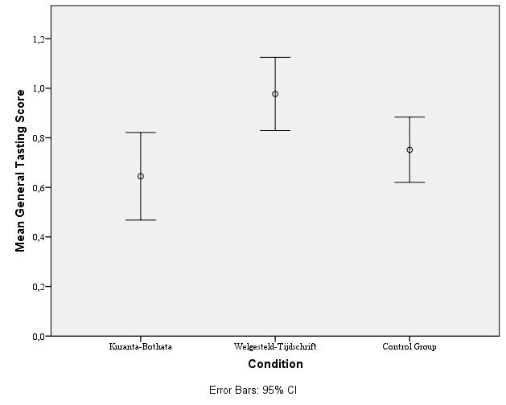
Figure 1- Error Bars

Discussion
The stimuli changed the evaluation of the chocolate and even though the differences between the control group and the others were not significant, the trends were in the expected direction. Furthermore, most of the participants did not remember any information concerning the institutions (92.7%), which strengthens the assumption that the stimuli were subtle enough.
Since the CG had no effect, for the second experiment, there were two conditions, WT and KB. In addition to replicating the priming effect in a different context, the aim of Experiment 2 was to investigate a moderator - academic experience. Presumably, more experienced academics would less prone to biases, hence less affected by the stimulus.
Experiment 2 - Article Evaluation Task
Participants
During an academic conference in Brazil, 80 participants, mostly doctorate students (63%) and PhDs (28.4%), were randomly selected and averaged 5.44 years of academic experience (SD = 4.51), with no significant difference in gender (50.6% male).

Procedures
Participants were asked to evaluate a scientific paper lacking any identification, except for a footnote regarding the funding institution - Welgesteld-Tijdschrift (WT Condition) and Kuranta-Bothata (KB Condition). After returning the article, they completed an evaluation questionnaire.

Measures
The questionnaire evaluated different aspects of the paper, such as Originality, Methodology and Conclusions. In the first part of the questionnaire, respondents evaluated based on their opinion, and on the second part, how they thought other scientists would evaluate it. The last part asked if they remembered any information on the funding institution.
The scores for each question were averaged, and named General Acceptance Index (GAI) and General Acceptance Index – Others (GAI-O). Scores ranged from -2 to +2, with -2 being the worst possible evaluation.

Results
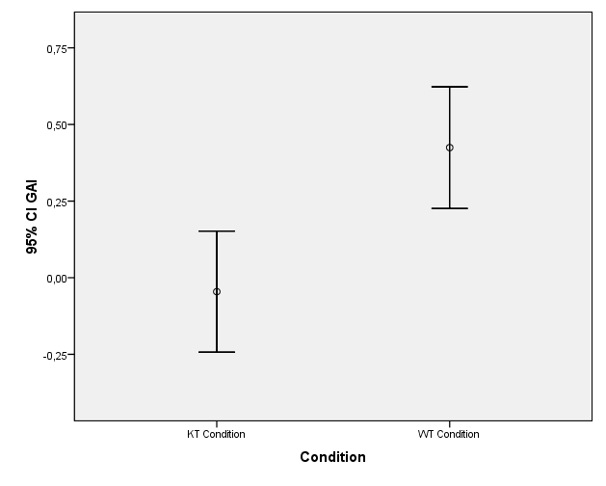
Concerning the GAI, participants in the WT condition evaluated the article more positively than in KB condition (m’s=_.42 and -.05, respectively). A one-way ANOVA confirmed that this difference was significant, F (1, 79) = 11.55, MSE = .39, p = .001, ŋ² = .13.
Figure 2 -Error Bars
For the GAI-O, the same pattern was found, with WT condition (M=.29) being significantly different from KB (M=-.14); F (1, 79) = 4.49, MSE = .14, p = .037, ŋ² = .05.
Academic experience was measured in years, self-reported in the questionnaire, and regression analysis was used to examine it as a moderator of the relation between priming and the GAI. Presumptively, as the academic experience increases, a confirmatory bias gets stronger, repeating the well-known discriminatory behavior towards European and African origin (de Bruin, Treccani, & Della Sala, 2015; Rubinstein & Brenner, 2014).
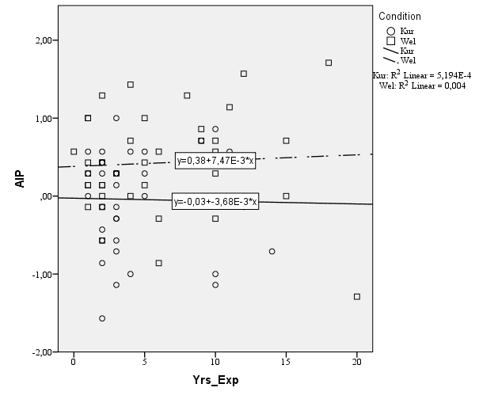
The slope of the regression lines is consistent with academic experience being a moderator, with the regression line for the WT showing a positive slope, while the line for KT showed a negative slope. The regression was significant F(3, 76) = 3,71, p < .05, indicating that the model was a good predictor of the GAI, even though the total variance explained was relatively low R²=0.12.
Figure 3 - Regression Lines

Discussion
Results indicated a consistent difference in evaluation and judgment between the conditions; the footnote appeared to have operated as a prime, and triggered a biased evaluation in both groups, even though it was subtle enough not to be remembered.
As for the moderating effect of academic experience, the total variance explained was small, but the slope lines confirmed a trend that as the years of academic experience grew, the evaluation given to the article was higher. Relatively small effects of priming have often been reported, indicating that the effect itself is subtle enough to make it hard to detect (Cesario, 2014).

Summary and Concluding Discussion
On both experiments the priming stimuli were sufficient to affect evaluation and judgment, especially considering that more than 90% of the participants were unable to remember it. The chocolate evaluation (subjective and non-technical) and the article evaluation (more technical) were similarly affected, which strengthens the case for the reliability of this effect.
Individual variables could have affected both experiments, such as personal taste in experiment 1 and experience as a reviewer in experiment 2. Both limitations should be addressed in future work. Nonetheless, the change of a mere two words, if these words resemble the origin of the entity being judged, had an effect.
The study of how moderators are related to the effects found would certainly provide important evidence regarding how priming works. Further work must address those issues, with different and perhaps larger populations, in an effort to understand the priming effects and its mechanisms, and how those effects could influence our behavior.

References
Cesario, J. (2014). Priming, replication, and the hardest science. Perspectives on Psychological Science, 9(1), 40–48. http://doi.org/10.1177/1745691613513470
Chaxel, A. S., Russo, J. E., & Wiggins, C. (2016). A Goal-Priming Approach to Cognitive Consistency: Applications to Judgment. Journal of Behavioral Decision Making, 29(1), 37–51. http://doi.org/10.1002/bdm.1874
Cokely, E. T., & Feltz, A. (2009). Individual differences, judgment biases, and theory-of-mind: Deconstructing the intentional action side effect asymmetry. Journal of Research in Personality, 43(1), 18–24. http://doi.org/10.1016/j.jrp.2008.10.007
de Bruin, A., Treccani, B., & Della Sala, S. (2015). Cognitive advantage in bilingualism: an example of publication bias? Psychological Science, 26(1), 99–107. http://doi.org/10.1177/0956797614557866
Doyen, S., Klein, O., Simons, D. J., & Cleeremans, A. (2014). On the other side of the mirror: Priming and social psychology. Social Cognition, 32, 12–32.
Hilbert, M. (2012). Toward a synthesis of cognitive biases: How noisy information processing can bias human decision making. Psychological Bulletin, 138(2), 211–237. http://doi.org/10.1037/a0025940
Loersch, C., & Payne, B. K. (2014). Situated Inferences and the What, Who, and Where of Priming. Social Cognition, 32(Supplement), 137–151. http://doi.org/10.1521/soco.2014.32.supp.137
Mohr, C., Koutrakis, N., & Kuhn, G. (2015). Priming psychic and conjuring abilities of a magic demonstration influences event interpretation and random number generation biases. Frontiers in Psychology, 6(JAN), 1–8. http://doi.org/10.3389/fpsyg.2015.00542
Pashler, H., & Harris, C. (2012). Is the replicability crisis overblown? Three arguments examined. Perspectives on Psychological Science, 7(6), 531–536. http://doi.org/10.1177/1745691612463401
Pickering, M. J., McLean, J. F., & Krayeva, M. (2015). Nonconscious priming of communication. Journal of Experimental Social Psychology, 58, 77–81. http://doi.org/10.1016/j.jesp.2014.12.007
Pleggenkuhle-Miles, E. a., Khoury, T. a. B., Deeds, D. L. C., & Markoczy, L. D. (2013). Exploring cognitive bias: Expert ratings of business schools. Management Decision, 51(9), 1905–1927. http://doi.org/10.1108/MD-12-2012-0877
Poehlman, T. A., Dhar, R., & Bargh, J. A. (2016). Sophisticated by Design: the Nonconscious Influence of Primed Concepts and Atmospheric Variables on Consumer Preferences. Customer Needs and Solutions, 3(1), 48–61. http://doi.org/10.1007/s40547-015-0051-2
Rubinstein, Y., & Brenner, D. (2014). Pride and Prejudice: Using ethnic-sounding names and inter-ethnic marriages to identify labour market discrimination. Review of Economic Studies, 81(1), 389–425. http://doi.org/10.1093/restud/rdt031
Valdeci, A., Bastos, S., Pereira, N. A. B. M., Basílio, J., & Leite, V. (2012). Avaliação Sensorial de Chocolate Amargo Formulado com Blend de Diferentes Variedades Clonais. III Congresso Brasileiro do Cacau.
Verlegh, P. W. J. (1999). A review and meta-analysis of country-of-origin research. Journal of Economic Psychology, 20, 521–546. http://doi.org/10.1016/S0167-4870(99)00023-9
Wall, M., Liefeld, J., & Heslop, L. A. (1991). Impact of country-of-origin cues on consumer judgments in multi-cue situations: a covariance analysis. Journal of the Academy of Marketing Science, 19(2), 105–113. http://doi.org/10.1007/BF02726002

