Assessment of muscle activity during muscular contraction using change-point analysis: A
pilot study.

Abstract
Surface electromyography (SEMG) can objectively evaluate the electrical activity of muscles under a variety of functional conditions. The aim of this study was to use change-point analysis to assess variations in muscle activation levels in the shoulder region during maximal voluntary isometric contraction. Using SEMG, the muscle activity of the right and left upper trapezius of 30 healthy participants was recorded. Significant changes characterized by a decreased electromyographic amplitude during the muscle contraction were observed in 27 subjects. Varied time location of detected changes indicated that there was not a common onset of muscular activity reduction. The change-point method can be a useful tool for the measurement of changes during muscle contractions. However, further research is necessary.
Keywords: surface electromyography, change-point analysis, isometric contraction.

Resumen
La electromiografía de superficie (EMGs) permite evaluar objetivamente la actividad eléctrica de los músculos en diferentes condiciones. El objetivo de este estudio fue usar el análisis de punto de cambio para evaluar las variaciones en la actividad muscular de los hombros durante contracción isométrica máxima voluntaria. Se registró con EMGs la actividad de los músculos trapecios superiores derecho e izquierdo de 30 participantes sanos. Se observaron cambios significativos caracterizados por disminución de la amplitud electromiográfica en 27 participantes. La ubicación distinta de los cambios detectados indica que no hay un inicio común de disminución de la actividad muscular. El método de punto de cambio puede ser una herramienta útil para la detección de cambios durante contracciones musculares. Sin embargo, es necesario realizar investigaciones adicionales.
Keywords: electromiografía de superficie, análisis de punto de cambio, contracción isométrica.

Introduction

Surface electromyography (SEMG) is a safe, noninvasive method for objectively evaluating the electrical activity of the muscles under different functional conditions and the relationship of this activity to force generation and movement (Plamondon, Djioua & Mathieu, 2013) and the presence of musculoskeletal disorders (Huysmans, Blatter & van der Beek, 2012). The SEMG signal amplitude is typically used to quantify the level of both isometric and isotonic muscle contractions (Rau, Schulte & Disselhorst-Klug, 2004), it is recommended that the root mean square be extracted and analyzed because this is a more sensitive and reliable method of analysis (Kollmitzer, Ebenbichler & Kopf, 1999).

When dynamic SEMG evaluation is used to make comparisons between bilateral muscles, between measurements from the same muscle on different days or between different subjects, it is necessary to perform a normalization, whereby the activity measured in microvolts is expressed as the ratio between basic muscle activity and a baseline contraction of the same muscle (Hodder & Keir, 2013; Lehman & Stuart, 1999; Marras & Davis, 2001). There are many normalization methods, the most common involve isometric contractions with maximal voluntary contraction or sub-maximal voluntary contraction (e.g., 50% of the maximum capacity). However, there is a lack of consensus about normalization techniques, though it is most common to use maximal voluntary contractions (Ng, McNee, Kieser & Farella, 2014).

The analysis of variance (ANOVA) is often used to statistically analyze the data derived from the dynamic SEMG evaluation (Burden, 2010). However, this type of analysis is insensitive to discrete changes and to time-limited events that occur at some point in a longitudinal psychophysiological data series (Rosenfield, Zhou, Wilhelm, Conrad, Roth & Meuret, 2010). Because statistical inference tests are not designed to identify the specific time at which changes occur in a time series (Chen & Gupta, 2012), an alternative statistical analysis is needed to detect such changes.

One alternative method is change-point analysis (CPA), change-point detection focus on identify where there is a change in the probabilistic distribution (mean or variance) of time series (Mei, 2006). A method for detecting sustained changes are cumulative sum charts (Hawkins & Qiu, 2003), which consider all of the information in the sequence of sample values and are therefore effective in detecting small changes in the process and samples of size n=1 (Montgomery, 2009). Taylor (2000) proposed a version of CPA that involves the integration of cumulative sums and resampling using the bootstrap technique. Using this method, it is possible to detect subtle changes and, for each detected change, assign a level of confidence indicating the probability that the change was not random.

The aim of this study was to evaluate the activity of a single muscle over time whose position remained constant and to use CPA to compare variations of the muscle activation levels. Specifically, the characteristics of the SEMG amplitude of the right and left upper trapezius were analyzed during maximal voluntary isometric contraction.

Methods
Participants
Thirty healthy right-handed volunteers participated in this study (16 women aged 24.7 ± 5.7 years with a body mass index of 22 ± 1; 14 men aged 24.8 ± 4.6 years with a body mass index of 22 ± 2). None of the participants reported medical or psychiatric problems. The exclusion criteria included presence of pain in the neck and back, degenerative disc disease or spinal column problems. All participants were provided with information about the procedure and subsequently signed a letter of informed consent.

Procedure
SEMG was used to simultaneously record the activity of the right and left upper trapezius muscles during a maximal voluntary isotonic contraction task. Electrode placement was bipolar; each electrode was placed in the midline between the spine of the scapula and the spinous process of vertebra C7, an interelectrode distance of 2 cm, as recommended by SENIAM (Hermens, Freriks, Disselhorst-Klug & Rau, 2000).

Muscle contraction was induced by elevating the scapula to raise the shoulders to the maximal contraction and consisted of five steps. 1) Baseline: sit motionless in a backless chair with arms relaxed and look forward for 10 seconds. 2) Movement: make upward shoulder movement in 3 seconds to reach the maximal contraction. 3) Isometric contraction: maintain muscle contraction without making other movements for 30 seconds. 4) Relaxation: gradually return to baseline position. 5) Repose: sit motionless for 10 seconds without back support with arms relaxed and look forward. Following the measurements, participants were asked if they had experienced pain during the task and whether they had difficulty reaching the maximal contraction and holding it constant.

Equipment
The PROCOMP equipment made by the Thought Technology company was used. A bandpass filter was set at 20-500 Hz and the raw data were rectified using the root mean square method.

Data analysis
Only the 30-second period of isometric contraction was used in the data analysis, considering one second bin, which was performed using the Change-Point Analyzer 2.3 shareware (Taylor Enterprises, Libertyville, IL, USA, 2009).

Change point analysis
The CPA procedure is described in detail in Taylor (2000). For each localized change, we determined whether the change type increased or decreased based on the levels of pre- and post-activity. By comparing the difference between these levels of activity, the magnitude of the decrease or increase was determined.

Results

None of the subjects participating in the experiment experienced pain or discomfort during the tasks and none reported difficulties in completing and maintaining maximal voluntary contraction. For the data analysis, only changes with a confidence level >95% were considered. Some participants showed just one change-point associated with decrease amplitude of EMGS (Figure 1A) or increase amplitude (Figure 1C), some participants showed more than one change-point (Figure 1B), in three participants analysis failed to detect change-points (Figure 1D). Of total change-points 52% were in the right muscle and 48% in the left muscle. The 95% of total detected change-points decrease in SEMG amplitude. One participant showed increased amplitude in the right muscle and two participants in the left muscle.

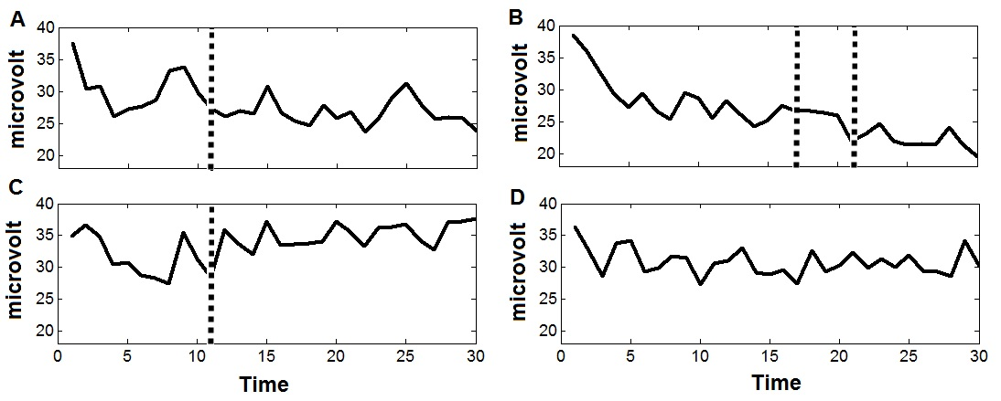
Figure 1. Examples of change points detected in EMGS data over sustained contraction. Dashed line indicated localization of change point.

To represent change-points associated with decreases in amplitude and its location over time, frequency distributions were calculated. As shown in Figure 2, the frequency distribution of SEMG in the right muscle started after 6 s and mainly gathered between 6 to 21 s of total contraction duration. In the left muscle (Figure 3) frequency distribution started 4s after the initiation of the muscle contraction and mainly gathered between 9 to 20 s of total contraction duration. Finally, considering the first change-point occurred in both muscles, the change-point was introduced first in the right muscle 10 times, in the left muscle 8 times and simultaneously in both muscles 1 time.

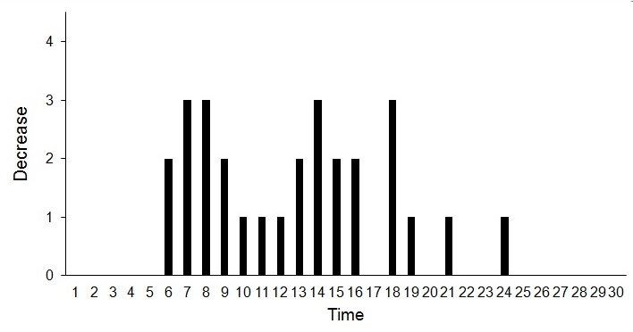
Fig 2. Frequency distribution of SEMG amplitude decreases during right muscle elevation

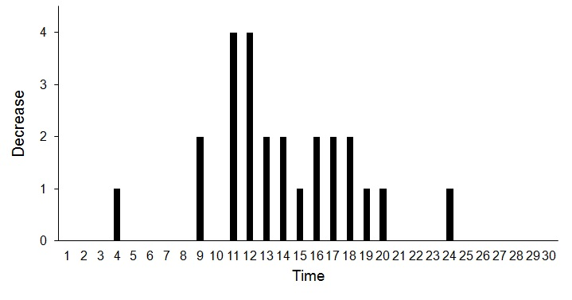
Fig 3. Frequency distribution of SEMG amplitude decreases during left muscle elevation

Discussion
In this research, to address factors related to the displacement of the recording electrode and the change in the length of the muscle fiber segment, only a sustained contraction was analyzed. To increase homogeneity and reduce the influence of certain factors modulating the amplitude of the SEMG without the use of normalization (Rau, Schulte & Disselhorst-Klug, 2004) we assessed every muscle against itself at different times but at a constant position. The task of lifting the shoulders to the maximal contraction mainly activated the levator of the scapulae and upper trapezius muscles (Kingston, 2005), and participants reported no difficulty in achieving and maintaining maximal voluntary contraction. We believe that the muscles under investigation were activated to the same degree, which according to Burden (2010) is a requirement when analyzing isometric muscle contractions.

With CPA we found that 90% of the participants exhibited change-points, with the right muscle presenting more changes than the left muscle. The main type of change-point was decreased range; the three detected increases could be due to slight alterations made to maintain the muscle contraction. Previous studies using group averages and statistical inference analysis have found that during sustained maximal isometric contraction, there is a progressive decline in SEMG amplitude soon after the onset of contraction (Gandevia, 2001; Kamen & Gabriel, 2010; Merletti, Lo Conte & Orizio, 1991). With CPA we found some reductions during the first 6 seconds of muscle contraction and that most of the decreases occurred before 20 seconds had elapsed. Time location of detected changes indicated that there was not a common onset of decline in SEMG amplitude.

These muscular decreases can be related with muscle fatigue, it is established that changes in SEMG amplitude can be considered myoelectric manifestations of muscle fatigue depending on the type of muscle contraction, activity and task duration (Enoka, 2012; Kay, Gibson, Mitchell, Lambert & Noakes, 2000). According to Merletti, Rainoldi and Farina (2004), fatigue indicators are defined based on the evolution over time of the SEMG signal characteristics during muscle contraction. If the decrease in SEMG amplitude is considered a manifestation of myoelectric muscle fatigue, location decreases found using CPA indicate that the fatigue process begins in different moments.

When changes occurred in both muscles, mild asymmetries appeared: the right muscle was faster than the left muscle. Asymmetries in the analysis of muscle activity generally indicate a difference in amplitude level between homologous muscles (Donaldson, S. & Donaldson, M, 1990). Asymmetries may be associated with the presence of joint problems and pain (Lin, Wu, Wang & Chen, 2005). Thus, when evaluating asymmetries, it could be beneficial to determine the moment in time at which they occur.

We believe that CPA should be integrated into SEMG analysis of muscular sustained contractions. However, additional research should be performed to determine CPA’s scope and limitations. When samples include participants with musculoskeletal disorders, CPA offers an advantage by allowing the analysis of a single case.

References
Burden, A. (2010). How should we normalize electromyograms obtained from healthy participants? What we have learned from over 25 years of research. Journal of Electromyography and Kinesiology, 20(6), 1023-1035. doi:10.1016/j.jelekin.2010.07.004
Chen, J. & Gupta, A.J. (2012). Parametric statistical change point analysis. USA: Boston: Birkhäuser.
Donaldson, S. & Donaldson, M, (1990). Multichannel EMG assessment and treatment techniques. In J.R. Cram (Ed.), Clinical EMG for surface recordings (pp. 143-173). Nevada City, CA: Clinical Resources.
Enoka, R.M. (2012). Muscle fatigue - from motor units to clinical symptoms. Journal of Biomechanics, 45(3), 427-433. doi: 10.1016/j.jbiomech.2011.11.047
Gandevia, S.C. (2001). Spinal and supraspinal factors in humand muscle fatigue. Physiological Reviews, 81(4), 1725-1789.
Hawkins, D.M. & Qiu, P. (2003). The changepoint model for statistical process control. Journal of Quality Technology, 35(4), 355-366.
Hermens, H.J., Freriks, B., Disselhorst-Klug, C. & Rau, G. (2000). Development of recommendations for SEMG sensors and sensor placement procedures. Electromyography and Kinesiology, 10(5), 361-374. doi:10.1016/S1050-6411(00)00027-4
Hodder, J.N. & Keir, P.J. (2013). Obtaining maximum muscle excitation for normalizing shoulder electromyography in dynamic contractions. Journal of Electromyography and Kinesiology, 23(5), 1166-1173. doi:10.1016/j.jelekin.2013.06.012
Huysmans, M.A., Blatter, B.M. & van der Beek, A.J. (2012). Perceived muscular tension predicts future neck-shoulder and arm-wrist-hand symptoms. Occupational and Environmental Medicine, 69(4), 261-267. doi:10.1136/oemed-2011-100279
Lin, J.J., Wu, Y.T., Wang, S.F & Chen, S.Y. (2005). Trapezius muscle imbalance in individuals suffering from frozen shoulder syndrome. Clin. Rheumatol., 24(6), 569-575. doi: 10.1007/s10067-005-1105-x
Kamen, G. & Gabriel, D.A. (2010). Essentials of electromyography. USA: Human Kinetics.
Kay, D., Gibson, A.S.C., Mitchell, M.J., Lambert, M.I., & Noakes, T.D. (2000). Different neuromuscular recruitment patterns during eccentric, concentric and isometric contractions. Journal of Electromyography and Kinesiology, 10(6), 425-431. doi:10.1016/S1050-6411(00)00031-6
Kingston, B. (2005). Understanding muscles. A practical guide to muscle function. United Kingdom: Cengage Learning EMEA.
Kollmitzer, J., Ebenbichler, G.R. & Kopf, A. (1999). Reliability of surface electromyographic measurements. Clinical Neurophysiology, 110(4), 725-734. doi:10.1016/S1388-2457(98)00050-9
Lehman, G.J. & Stuart, M. (1999). The importance of normalization in the interpretation of surface electromyography: a proof of principle. Journal of Manipulative and Physiological Therapeutics, 22(7), 444-446. doi:10.1016/S0161-4754(99)70032-1
Marras, W.S. & Davis, K.G. (2001). A non-MVC EMG normalization technique for the trunk musculature: Part 1. Method development. Journal of Electromyography and Kinesiology, 11(1), 1-9. doi:10.1016/S1050-6411(00)00039-0
Mei, Y. (2006). Sequential change-point detection when unknown parameters are present in the pre-change distribution. The Annals of Statistics, 34(1), 92-122. doi:10.1214/009053605000000859
Merletti, R., Rainoldi, A. & Farina, D. (2004). Myoelectric manifestations of muscle fatigue. In R. Merletti & P. Parker (Eds.), Electromyography. Physiology, engineering and noninvasive applications (pp. 233-258). USA: John Wiley & Sons.
Merletti, R., Lo Conte, L.R. & Orizio, C. (1991). Indices of muscle fatigue. Journal of Electromyography and Kinesiology, 1(1), 20-33. doi: 10.1016/1050-6411(91)90023-X
Montgomery, D.C. (2009). Introduction to statistical quality control. USA: John Wiley & Sons.
Ng, D, McNee, C. Kieser, J. & Farella, M. (2014). Neck and shoulder muscle activity during standardized work-related postural tasks. Applied Ergonomics, 45(3), 556-563. doi:10.1016/j.apergo.2013.07.012
Plamondon, R., Djioua, M. & Mathieu, P. (2013). Time-dependent between upper arm muscles activity during rapid movements: Observation of the proportionality effects predicted by the kinematic theory. Human Movement Science, 32(5), 1026-1039. doi:10.1016/j.humov.2012.07.006
Rau, G., Schulte, E. & Disselhorst-Klug, C. (2004). From cell to movement: to what answers does EMG really contribute? Journal of Electromyography and Kinesiology, 14(5), 611-617. doi:10.1016/j.jelekin.2004.02.001
Rosenfield, D., Zhou, E., Wilhelm, F.H., Conrad, A., Roth, W.T. & Meuret, A.E. (2010). Change point analysis for longitudinal physiological data: Detection of cardio-respiratory changes preceding attacks. Biological Psychology, 84(1), 112-120. doi:10.1016/j.biopsycho.2010.01.020
Taylor, W.A. (2000). Change-Point analysis: a powerful new tool for detecting changes. http://www.variation.com/cpa/index.html

