Abstract: Implicit memory tasks involve an increase in performance for previously seen items when compared with new items, independent of whether or not participants correctly classify the item as old. In this study we evaluated the effect of sex differences on word fragment (WFC) word stem completion (WSC) tasks, under the hypothesis that they would show no differences between tasks, and that women would overall perform better than men. 24 undergraduate students participated in this study, which consisted of a shallow encoding task, followed by a fragmented word completion task. Results did not reveal differences in performance between men and women on overall word completion rates. However, we found differences between WSC and WFC in men and women. Contrary to our hypothesis, women did not perform better than men.
Keywords: Implicit memory, Word stem completion, Word Fragment completion

Resumen
Las tareas de memoria implícita involucran una mejora en el desempeño para ítems previamente vistos comparados con ítems nuevos, independiente de si los participantes correctamente clasifican el ítem como antiguo. En este estudio evaluamos el efecto de las diferencias de sexo en tareas de completar fragmentos (WFC) y raíces (WSC), bajo la hipótesis de que no habría diferencias entre las tareas, y que las mujeres tendrían un rendimiento superior a los hombres. 24 alumnos de licenciatura participaron en este estudio, que consistió de una tarea de codificación superficial, seguida de una tarea de completar palabras fragmentadas. Los resultados no revelaron diferencias entre el desempeño de hombres y mujeres en el la taza de palabras completadas. Sin embargo, encontramos diferencias entre WSC y WFC en hombres y mujeres. Contrario a nuestra hipótesis, las mujeres no tuvieron un desempeño mayor a los hombres.
Palabras clave: Memoria implícita, Tarea de completar fragmentos, Tarea de completar Raíces

Scientists have considered memory as a process that consists of different systems, including long and short term memory, with long term memory being divided into explicit and implicit memory (Voss & Paller, 2009). Explicit memory, also known as declarative memory, can be further divided into episodic and semantic memory, and it includes information and events that are accessed intentionally and can be described verbally (Tulving & Schachter, 1990). On the other hand, implicit memory deals with memories that have an effect on an individual’s behavior without an intention made by the subject to retrieve such memories. Implicit memory has been postulated to include many types of learning, such as non-associative learning, conceptual and repetition priming, classical conditioning and procedural learning among others (Goldstein, 2008; Razumiejczyk, Macbeth & López Alonzo, 2008; Sweatt, 2009).
Dissociations between implicit and explicit memory were first observed in patients with lesions in the medial-temporal lobe, which includes structures known to be essential for explicit memory. These patients exhibit anterograde amnesia, that is, an apparent inability to learn novel information, as their performance in explicit memory tests revealed. Conversely, in indirect tests of memory like word fragment completion (WFC) and word stem completion (WSC), patients with amnesia exhibit little to no deficit when compared with controls (Warrington & Weiskrantz, 1974). Dissociations have also been observed in normal participants, and separate neural correlates have been found for each type of memory (Badgayian & Posner, 1997; Graf & Schacter, 1985; Meng & Guo, 2007; Rugg, Mark, Walla, Schloerscheidt, Birch & Allan, 1998; see Voss & Paller (2004) for a literature review).
Indirect tests of memory are used to study implicit memory. These tests measure priming, defined as the effect that prior exposure of a stimulus has on subsequent processing of the same or a similar stimulus (Razumiejczyk, et al., 2008), and given its indirect nature can only be inferred based on performance (Lorenzi, Giunta & Stefano, 2006), such that prior exposure to words increases the probability of giving a correct answer when compared with baseline words (Rajaram & Roediger, 1993).
Different types of indirect tests of memory exist, and they can be divided into perceptual and conceptual tests, with perceptual tests being the most frequently used in priming. In perceptual tests, including WFC and WSC, participants are primed by the physical characteristics of stimuli as opposed to conceptual tests, though it has been argued that both conceptual and perceptual priming are always present to some degree (Schacter & Buckner, 1998). In the case of WFC tests, participants are asked to complete fragmented words, such as _L_CE_A instead of the word ALACENA (Cupboard in Spanish), usually with the first word that comes to mind. WSC involves the completion of stems, which are fragmented words that provide the first few letter as clues, such as AMA_ _ _ instead of the word AMANTE (Lover in Spanish). Although there are many consistencies found between WSC and WFC tests, (Roediger, Weldon, Stadler & Rigler, 1992; Rajaram & Roediger, 1993), and theoretically report the same cognitive process, some differences between these tests have been established. Fey. Insingrini & Clarys (2005) observed that depth of processing has an effect on priming rates obtained in WSC but not on WFC tasks, where a deeper processing was correlated with higher priming rates only for WSC. These authors argue that lexical encoding may be important for only for WSC tasks, where the given stem cues participants to retrieve words from their lexicon to complete the item, in contrast to WFC, where the fragments do not give enough clues for lexical retrieval.
Gender differences in memory are usually not studied directly, in either implicit or explicit memory measures (Burton, Rabin, Bernstein, Frohlich, Wyatt, Dimitri, Constante & Guterman, 2004). Such differences can be rooted in both biological and social processes (Feingold, 1994), as has been shown in autobiographical memory task by Davis (1999) and a word stem completion task by (Lorenzi et al., 2006). Of the relatively few studies that study gender differences, Lorenzi et al. (2006) used a WSC task and found that women are better at completing word stems than men in an implicit memory test. However, Hertliz, Nisson & Bäckman (1997), in a study with a very large sample size found the differences in priming WSC rates between men and women to be non-significant, ie. low effect size, although they did not report women’s menstrual phase. Estrogen levels vary in women depending on their menstrual phase (which can be divided into a follicular and luteal phase) in women and have been suggested to have an impact on priming performance, as higher estrogen levels during the follicular phase appear to facilitate implicit memory retrieval that results in higher priming rates in object completion tasks (Maki, Rich & Rosenbaum, 2001). This interaction with different tasks emphasizes the need to control for women’s menstrual cycle. Since many implicit memory studies use both male and female participants, it would be helpful to know the differences elicited by the women’s menstrual cycle.
Concentration levels of estradiol in women also have an effect on cognitive activity, including memory (Hertliz et al., 1997). It is important to note that the effect of estradiol and other hormones may differ for memory types and tasks, where estradiol levels have been shown to negatively correlate with certain implicit memory tasks including fragmented object recognition (Hampson, Finestone & Levy., 2004). On the other hand, Maki et al. (2001) found that priming rates were improved in a fragmented object identification test during the luteal phase, which is characterized by high estrogen and progesterone. Thus it is necessary to control for these levels whenever implicit memory is studied in women.
We hypothesized that completion rates in two implicit memory tasks would not show any differences. As women typically perform better on tasks with verbal stimuli, including memory tasks we expected this to hold true for both implicit memory measures and overall completion rates. Therefore, the aim of this study was to evaluate the effects of sex on priming on two implicit memory tasks

METHOD
Participants
24 right-handed subjects (12 men and 12 women) participated in this study. Participants were Mexican middle-class undergraduate volunteers from the faculty of psychology of the Universidad Veracruzana, in Xalapa, Veracruz, Mexico. Participants’ age ranged from 18 to 25 years (mean = 21.5 + 2.1 years) and Spanish was their maternal language. All participants gave their written consent before participating in this study. In addition, women participated two weeks after the beginning of their menstrual period (after day 14), which corresponds to their luteal phase (Maki et al., 2002; Poromaa & Gingell, 2014). Open invitations were held for a whole semester, and the participants included in the sample were the ones who met the inclusion criteria.

Materials
240 infrequent words were obtained from a free lexical evocation task performed by 100 undergraduate students. Infrequent words were counted as those that were evoked by only one subject out of the hundred. 240 infrequent nouns, of word length between 6 and 12 letters were selected for this study.
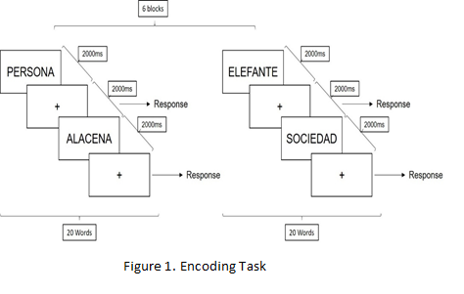
These words were sorted into two 120 word lists, list A and list B, such that the words in list A were all matched by their first letter to the words of list B. List AB was then created, which consisted of fragments and stems from list A and B. Fragments were created by randomly deleting between 40 and 50% of the letters belonging to each word. Stems were created by deleting all but the first three letters of the word. Half of list AB consisted of fragmented words from each list (i.e. 60 words total) and half of stems. Words were separated into 6 blocks of 20 words for each list. We used a STIM 2 stimulus presentation system, located in a stimulus free room, for both the encoding and retrieval tasks. Stimuli were displayed on a 19 by 10.5 inch screen located 60 cm from the subject.

Procedure
Encoding task
Participants were seated and asked to read the following instructions which appeared on screen. The instructions were presented in Spanish:
“Count the number of syllables for each word that appears onscreen. Do not tell me your answer until the word disappears and a cross appears onscreen. Do not blink and do not move while the words appear. When words stop appearing and a white screen appears, you can move and blink if you desire. We will begin with a brief example.”
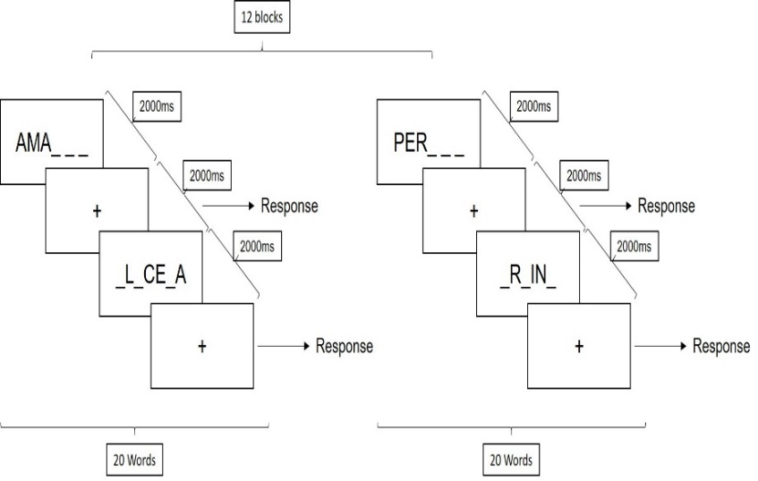
Afterwards, participants were exposed to three sample stimuli, in which they demonstrated an understanding of the instructions shown. Once they successfully completed the sample stimuli, participants were presented with the words from list A, one word at a time. Each word appeared for 1000 milliseconds (ms), and was followed by a fixation point that lasted for 1500 ms. Participants were asked to count the number of syllables in each word as soon as the word came onscreen, but to wait until the fixation point to answer how many syllables they counted. Between each block of 20 words, participants were given a small break that was cued by a white screen with no words. This sequence was repeated until the end of each block (Figure 1).
Figure 2. Retrieval Task

Retrieval Task
The retrieval task was similar to the online recognition method used by Richardson-Klavehn & Gardiner (1995) which permits the evaluation of both recognized and implicitly completed items. The task was done after a 20 minute break. Participants were first presented with the instructions for the procedure:
“Complete in silence and as fast as possible the word fragments that appear onscreen. Try to complete it with the first word that comes to mind. Some of the fragments can be completed with words that appeared on the previous list. If the word you used to complete the fragment was a word you saw before, press button one. If it is a new word, press button two. Once the cross has appeared onscreen, say your answer, if any.”
Participants were presented with one fragment or stem at a time. Each stimulus was displayed on screen for 2 seconds, after which a fixation cross appeared. Participants were asked to mentally solve the incomplete word as soon as it appeared on screen, but to

wait until the fixation cross to give their answer, if any. After giving an answer, participants were asked to press one of two buttons on the Stim pad: Button one if they felt they had seen the word before and button 2 if they considered the word to be new. Since the fragmented words were presented for only a few second, participants were asked to maintain their gaze on the screen for as long as the fragmented words of each block were presented, so that they would not miss any words. Similar to the encoding task, participants were allowed to rest for a few seconds. A diagram for this procedure can be seen in Figure 2.

Behavioral results were analyzed by categorizing correctly completed fragments and stems into primed and unprimed items, according to prior exposure. Primed words were counted as words from list A that participants used during the retrieval task to solve stems and fragments but that they did not recognize as having seen before, that is they pressed button 1. Priming rate was calculated by subtracting the number of correctly completed baseline words from the number of correctly completed primed words. All statistical analyses were done using Sigmastat software, while graphs were made in Statistica 7. Post-hoc sensitivity power analysis were calculated using the program G*Power 3 (Faul, Erdfelder, Lang, & Buchner, 2007).

RESULTS
All participants completed more fragmented words belonging to list A than baseline words, revealing a significant difference (t(23)= 15.01, p<.01) of word completion rates between baseline and primed items, with primed items (M=35.3, S.D.= 5.6)

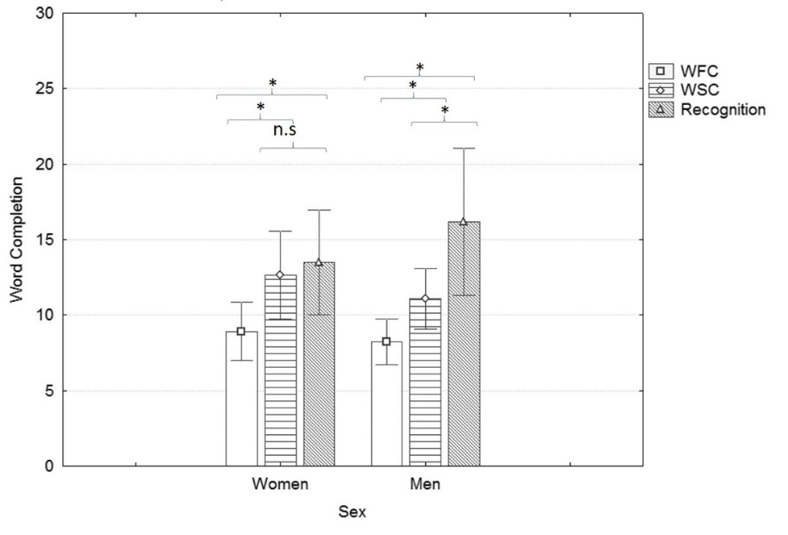
Figure 3. Number of correctly completed words for women and men depending on memory response type (WFC and WSC for implicitly recovered items, Recognition for correctly completed items that were recognized). Bars represent the mean number of correctly completed words. Error bars represent + 95% C.I. *= p<.05
having higher completion rates than baseline words (M=17.96, S.D.=3.7) This remained true when men (t(11)=9.3, p<.01) and women ((t(11)=11.9, p<.01) were analyzed separately. Between men and women, no significant differences were found in either baseline performance (t=.18, p=.85, Cohen’s d=.2), with an average of 18 words completed for both men and women (S.D. + 4.4 and 3.1 words respectively)), or in priming completion rates (t(22)=.436, p=.67, Cohen’s d=.18) with an average of 35 words (SD + 5.6) completed by women and 36 words (S.D. + 5.9) completed by men.
Analyses between memory response types for men and women showed a different trend. Items that were correctly completed but not recognized (WSC and WFC) had higher completion rates than items that were completed with recognition (t(23)=-3.3, p=.003, Cohen’s d=.87). Using Friedman repeated measures analysis on ranks we found significant differences for both men (X²₍₂₎=9.7, p<.05) and for women (X²₍₂₎=7.19, p<.05) between WFC, WSC and recognition items. A Post-hoc Tukey test revealed statistically significant differences between WSC and WFC completion rates in women (q=3.3, p<.05) and in men (q=3.4,
p<.05), but only between WFC and recognition completion rates (q=4.43, p<.05) in men. No differences were found between WSC and recognition completion rates in either men (q=.87, n.s.) or women (q=.144, n.s.). Individual comparisons for response types between men and women revealed no statistically significant differences (Figure 3).
Sensitivity analysis performed for within-subject differences by setting α=.05, 1-β=.8 and the current sample size for a two tailed t-test revealed the minimum detectable effect size to be 1.2, considered to be a large effect size.

DISCUSSION
The aim of this study was to find the effect of sex on WSC and WFC tasks. Overall completion rates for implicit and explicit measures were similar to those found by Paller (1990), even though free recall was used in that experiment. We did not find enough evidence for differences between men and women in general priming rates. Although the statistical power of this study is low, our results are similar to those found by Herlitz et al. (1997), who in a study with a larger sample size found no differences between sexes, albeit only using a word stem fragment task instead of both the word fragment and stem completion tasks used in this study. On the other hand, Lorenzi et al. (2006) found that women performed better than in WSC and a free recall task. The task we used to measure explicit memory comparison was word recognition, which might explain this inconsistency. Further studies with higher statistical power should be realized to explore this issue.
Even though the main priming effects did not favor either sex, differences within memory responses varied. Men and women showed differences when contrasting WFC with WSC, but only men showed differences between WSC and recognition memory. This could be interpreted as evidence for explicit contamination in WSC but not on WFC, which has been argued before (Roediger et al., 1992), though our data shows that this could be only for men and not for women. Indeed, previous studies have shown higher scores in word stem cued recall compared with priming rates (Paller, 1990). If this is the case, further studies should investigate why this did not happen for WFC.
We found within subject differences between WSC and WFC for men and women, which we did not expect given that both tasks theoretically report the same process, that is, implicit memory. One explanation would be that an unknown variable affected WSF and WSC, more so in men than in women. These results could also be the result word stems are easier to complete than word fragments. Having future studies use infrequent stem completion responses as primes is one solution. On the other hand, WSC may depend on different processes including lexical retrieval. In Spanish however, lexical retrieval as measured in a free lexical evocation task did not show differences between men and women (Author, 2012), and thus lexical retrieval by itself cannot explain the different trends for each gender found in this study.
A different possibility could lie in the stage of the menstrual cycle women were evaluated in. As has been well stated by Hampson et al. (2005), estrogen effects on memory are probably complex. Maki et al. (2002) found an interaction between Study-Test completion rates and estrogen levels. Although cycle variability would suggest the need for future studies involving a comparison between different periods of the menstrual cycle, if one is interested only in controlling for behavioral overall priming rates between men and women, our study shows that evaluating women in their luteal phase is adequate for such purposes. If however in the differences between the processes involved in these tasks is of interest, then a comparison between men and women at different stages would be necessary.
The fact that word stems and word fragments were used simultaneously must also be taken into account for future studies in order to further understand the results obtained. Randomly switching between fragmented incomplete word types, that is between word fragments and word stems, might have impeded performance in one of the tasks. Thus, task switching might have a differential effect on the processes involved in WSC and WFC, which could explain the lower word fragment completion rates found in men. Weiss, Ragland, Brensinger, Bilker, Deisenhammer & Delazer (2006), obtained results showing a clear advantage for women over men in a verbal fluency task, results they attributed to a more efficient task switching strategy used by women. A future study could make use of reaction times to measure the effects of said task switching on performance, using both mixed word fragment and word stem lists as well as separate word lists. Even if using both tasks may come at a cost, there are some benefits that could be explored in these studies, such as the integration of an ERP or another neurophysiological paradigm to the simultaneous study of both tasks.

Acknowledgements
We would like to thank CONACYT for the scholarship used in the financing of this study.

References:
Badgaiyan, R. D., & Posner, M. I. (1997). Time course of cortical activations in implicit and explicit recall. The Journal of Neuroscience, 17(12), 4904-4913.
Burton, L. A., Rabin, L., Vardy, S. B., Frohlich, J., Wyatt, G., Dimitri, D., & Guterman, E. (2004). Gender differences in implicit and explicit memory for affective passages. Brain and Cognition, 54(3), 218-224.
Davis, P. J. (1999). Gender differences in autobiographical memory for childhood emotional experiences. Journal of personality and social psychology, 76(3), 498.
Faul, F., Erdfelder, E., Lang, A.-G., & Buchner, A. (2007). G*Power 3: A flexible statistical power analysis program for the social, behavioral, and biomedical sciences. Behavior Research Methods, 39, 175-191.
Fay, S., Isingrini, M., & Clarys, D. (2005). Effects of depth-of-processing and ageing on word-stem and word-fragment implicit memory tasks: Test of the lexical-processing hypothesis. European Journal of Cognitive Psychology, 17(6), 785-802
Feingold, A. (1994). Gender differences in personality: a meta-analysis. Psychological bulletin, 116(3), 429.
Goldstein, E. B. (2008). Cognitive Psychology: Connecting Mind, Research, and Everyday Experience. Supplement. Cengage Learning.
Hampson, E., Finestone, J. M., & Levy, N. A. (2005). Menstrual cycle effects on perceptual closure mediate changes in performance on a fragmented objects test of implicit memory. Brain and cognition, 57(2), 107-110.
Herlitz, A., Nilsson, L. G., & Bäckman, L. (1997). Gender differences in episodic memory. Memory & cognition, 25(6), 801-811.
Lorenzi, I., Giunta, F., & Di Stefano, M. (2006). Implicit and explicit memory formation: influence of gender and cultural habits. Archives italiennes de biologie, 144(1), 25-31.
Maki, P. M., Rich, J. B., & Rosenbaum, R. S. (2002). Implicit memory varies across the menstrual cycle: estrogen effects in young women. Neuropsychologia, 40(5), 518-529.
Meng, Y., & Guo, C. (2007). ERP dissociation and connection between implicit and explicit memory. Chinese Science Bulletin, 52(21), 2945-2953.
Mitchell, D. B. (2006). Nonconscious Priming After 17 Years Invulnerable Implicit Memory?. Psychological Science, 17(11), 925-929.
Paller, K. A. (1990). Recall and stem-completion priming have different electrophysiological correlates and are modified differentially by directed forgetting. Journal of Experimental Psychology: Learning, Memory, and Cognition, 16(6), 1021.
Poromaa, I. S., & Gingnell, M. (2014). Menstrual cycle influence on cognitive function and emotion processing—from a reproductive perspective. Frontiers in neuroscience, 8.
Rajaram, S., & Roediger, H. L. (1993). Direct comparison of four implicit memory tests. Journal of Experimental Psychology: Learning, Memory, and Cognition, 19(4), 765.
Razumiejczyk, E., Macbeth, G., & López Alonso, A. O. (2008). Evidencia de priming gustativo y su disociación con la memoria explícita. Revista Universitas Psychologica, 7(2), 549-556.
Richardson-Klavehn, A., & Gardiner, J. M. (1995). Retrieval volition and memorial awareness in stem completion: An empirical analysis. Psychological research, 57(3), 166-178.
Roediger, H. L., Weldon, M. S., Stadler, M. L., & Riegler, G. L. (1992). Direct comparison of two implicit memory tests: Word fragment and word stem completion. Journal of Experimental Psychology: Learning, Memory, and Cognition, 18(6), 1251
Rugg, M. D., Mark, R. E., Walla, P., Schloerscheidt, A. M., Birch, C. S., & Allan, K. (1998). Dissociation of the neural correlates of implicit and explicit memory. Nature, 392(6676), 595-598.
Sherwin, B. B. (2012). Estrogen and cognitive functioning in women: Lessons we have learned. Behavioral neuroscience, 126(1), 123.
Soler, M. J., Ruiz, J. C., Vargas, M., Dasí, C., & Fuentes, I. (2011). Perceptual priming in schizophrenia evaluated by word fragment and word stem completion. Psychiatry research, 190(2), 167-171.
Sweatt, J. D. (2009). Mechanisms of memory. Academic Press.
Tulving, E. (1972). Episodic and semantic memory 1. Organization of Memory. London: Academic, 381, 402.
Tulving, E., & Schacter, D. L. (1990). Priming and human memory systems. Science, 247(4940), 301-306.
Voss, J. L., & Paller, K. A. (2008). Brain substrates of implicit and explicit memory: The importance of concurrently acquired neural signals of both memory types. Neuropsychologia, 46(13), 3021-3029.
Warrington, E. K., & Weiskrantz, L. (1968). A study of learning and retention in amnesic patients. Neuropsychologia, 6(3), 283-291.
Warrington, E. K., & Weiskrantz, L. (1974). The effect of prior learning on subsequent retention in amnesic patients. Neuropsychologia, 12(4), 419-428.
Weiss, E., Ragland, D., Brensinger, C., Bilker, W., Deisenhammer, E., M., Delazer. (2006) Sex differences in clustering and switching in verbal fluency tasks. Journal of the International Neuropsychological Society. 12, 502–509.

