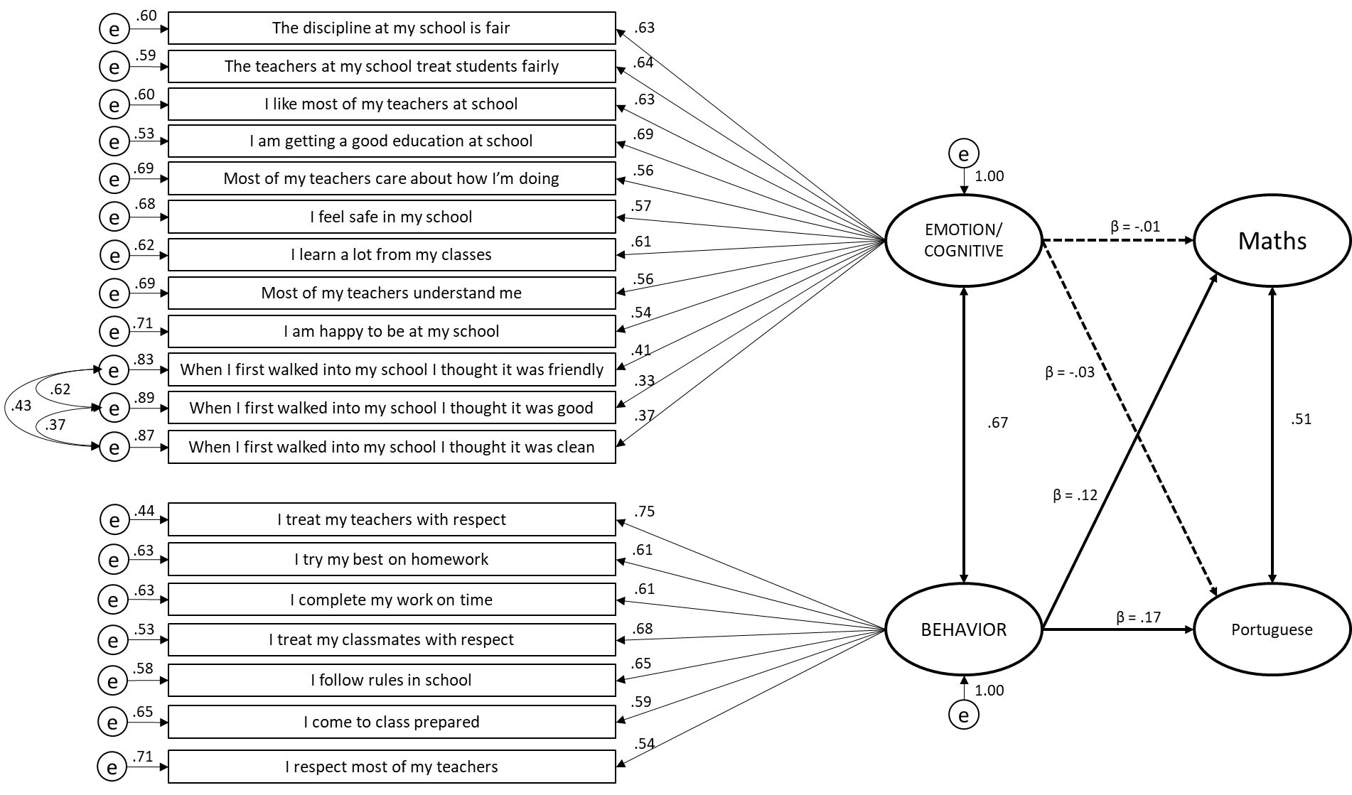
Figure 1. Final structural equation modelling (SEM)-model for the predictive effect of student engagement on maths and portuguese grades. Β = standardized regression weight.

