Trends in the scientific publication on retirement: a brief report

Abstract
This study aimed to synthesize the scientific publication on retirement between 1991 and 2015. Analysis were done using the software Iramuteq to systematize papers extracted from Scopus database that included the word retirement (N = 18,362). Results have shown that North American and European countries are among the most productive. Health and economics are the most researched fields and are interconnected by a common interest in public policy. Relevant topics, such as retirement education, were absent from the main results. It is discussed that the number of publications is associated with national investment in research and development and has little relationship with the proportion of elderly individuals. A broader and interdisciplinary research agenda is recommended.
Key words: retirement; literature review; public policy; bibliometrics; semantic analysis.

Resumo
Este estudo teve por objetivo sintetizar a produção científica sobre aposentadoria entre 1991 e 2015. Análises foram realizadas utilizando-se o software Iramuteq para sistematizar artigos extraídos da base de dados Scopus que incluíram a palavra aposentadoria (N = 18,362). Resultados mostraram que países norte americanos e europeus são os mais produtivos. Saúde e economia são os campos de pesquisa mais pesquisados e estão interconectados por um interesse comum em política pública. Tópicos relevantes, tal como educação para aposentadoria, estão ausentes dos resultados principais. Discute-se que o número de publicações é associado com o investimento nacional em pesquisa e desenvolvimento e tem pouca relação com a proporção de indivíduos idosos. É recomendada uma agenda de pesquisa mais ampla e interdisciplinar.
Palavras-chave: aposentadoria; revisão de literatura; política pública; bibliometria; análise semântica.

Professional life used to last as long as did workers' physical capacity (Thane, 2006). During the second half of the 19th century, Europe witnessed the first large-scale changes in this context, with a growing population of poor and frail elderly individuals unable to work. Starting in England, the first modern retirement modalities spread out to Western Europe, Oceania and North America. In the first half of the 20th century, Latin American countries adopted social security systems containing large discrepancies between contributions and benefits, which would prove to be unsustainable due a fastly aging population (Tuesta, 2011). Social security in Africa is still very limited, excluding mainly women and informal workers (Darkwa & Mazibuko, 2002).
The situations that led to the emergence of retirement – old age and poverty – coexist with new demands that make social security governmental systems unsustainable: between 2008 and 2013, social security was reformulated in 54% of the countries (United Nations; UN, 2015). Quality of life during retirement is threatened by factors such as chronic disease, comorbidities, and impairment (World Health Organization a; WHO, 2015). In addition to financial and health issues, lack of attention to other adjustment predictors, such as leisure and social support, may increase the risks posed to one’s quality of life during retirement (Barbosa, Monteiro, & Murta, 2016).
The continued growth of life expectancy around the world indicates a social reconfiguration in which people live longer but not necessarily better (WHO a, 2015). For this reason, WHO developed a plan of action to promote “a world in which everyone can live a long and healthy life” (WHO, 2015, p. 9) and ensure that the next decade be the Decade of Healthy Aging. It aims to establish evidence and implement evidence-based practices that enable everyone to do the things they value. More specifically, one of the strategic objectives is to conduct research to synthesize evidence on healthy aging. In this context, this study’s objective was to synthesize the publication of scientific papers on retirement between 1991 and 2015. This investigation can facilitate the implementation of evidence-based strategies that favor a long and healthy life during retirement.

Method

Data Collection
All publications were extracted from the electronic database Scopus. The search included the following criteria: (1) papers or reviews; (2) published between 1991 and 2015; (3) containing the term retirement in the title, abstract or keywords fields. The initial planning also included data from Web of Science; however, differences in type of information provided and database formatting prevented a joint analysis. Scopus was chosen because it contained around half more publications than Web of Science.

Software General Description
Keywords were analyzed using Iramuteq, version 0.7 alpha 2. Its functioning is based on a linguistic model in which the meaning of words results from their organization and distribution throughout a text (Smallman, 2015). Relevant words are identified using grammatical and statistical filters while referring to an internal dictionary. In comparison to traditional content analysis, computer methods analyze more data in less time, reducing sampling and researcher biases. On the other hand, results generated by algorithms can distort the original textual context, overestimate differences between word classes or ignore classes with lower representativeness. To minimize these effects, results should be interpreted according to its original context.

Data Analysis Process
Data analysis followed the method developed by Lahlou and described by Smallman (2015). It was divided into three stages: data collection, modeling and analysis. The text database was prepared for analysis during data collection. During the modeling, filters were chosen to select among active forms (substantives, adjectives, verbs and adverbs) or complementary forms (e.g., pronouns and prepositions), indicating the frequency and significance of words to be extracted. In the analysis step, the automatic categorization performed by the program generated classes of words to be interpreted.
The main categorization is the Descending Hierarchical Classification (DHC), which groups text segments with lexical similarities into a large class. The algorithm compares expected and observed frequencies of words and divides this set into two classes. It repeats this process until establishing two classes that present the largest possible difference between each other. Each class ranks its words based on the strength of the association between the word and the class. CHD was interpreted by assigning meaning to classes or subgroups of words in each class.
Specificity and similarity analyses were also performed. Specificity analysis organizes the text according to variables chosen by the researcher – in this study, year of publication, first author’s country, author and journal. Similarity analysis organizes words correlated in the text and produces groups formed by terms that repeat together. To enable a visual representation of results, this analysis considered only the 50 most common words.

Results
Data extraction identified 18,362 records. Only 47% out of this total contained keywords assigned by the authors, while 66% contained indexed keywords, which are assigned by the database. For this reason, indexed keywords were chosen for analysis.
The frequency of publications on retirement in 2015 was 3.9 times higher than in 1991 (Figure 1). This number is higher than the 3.5 times growth recorded in the Scopus’ annual publication for the same period, which went from 479,480 to 1,657,210.
Figure 1
Table 1 ranks publication frequency per country, author, and journal. United States ranked first, with 4.6 times more papers than United Kingdom, which ranked second. Among journals, Journal of Gerontology, Series B (interdisciplinary papers) ranked first. According to information provided by the journals’ websites, the most common topics are interdisciplinary subjects (n = 9; especially public health, social sciences and psychology) and economic issues (n = 8). Additionally, journals from both fields publish papers addressing public policies. The most productive author was Kenneth Langa, an american physician from the University of Michigan. He researches epidemiology and the impact of chronic diseases on the elderly, especially Alzheimer and other forms of dementia. According to information provided by the authors’ or their institutions’ websites, impact of epidemiological and psychosocial factors on health (n ≥ 9) and retirement’s economic aspects (n ≥ 8) are the most common research topics. Authors in the health field, however, report interest mainly on aging, and not on retirement. It suggests that research on health during retirement results from an overlap between retirement and aging.
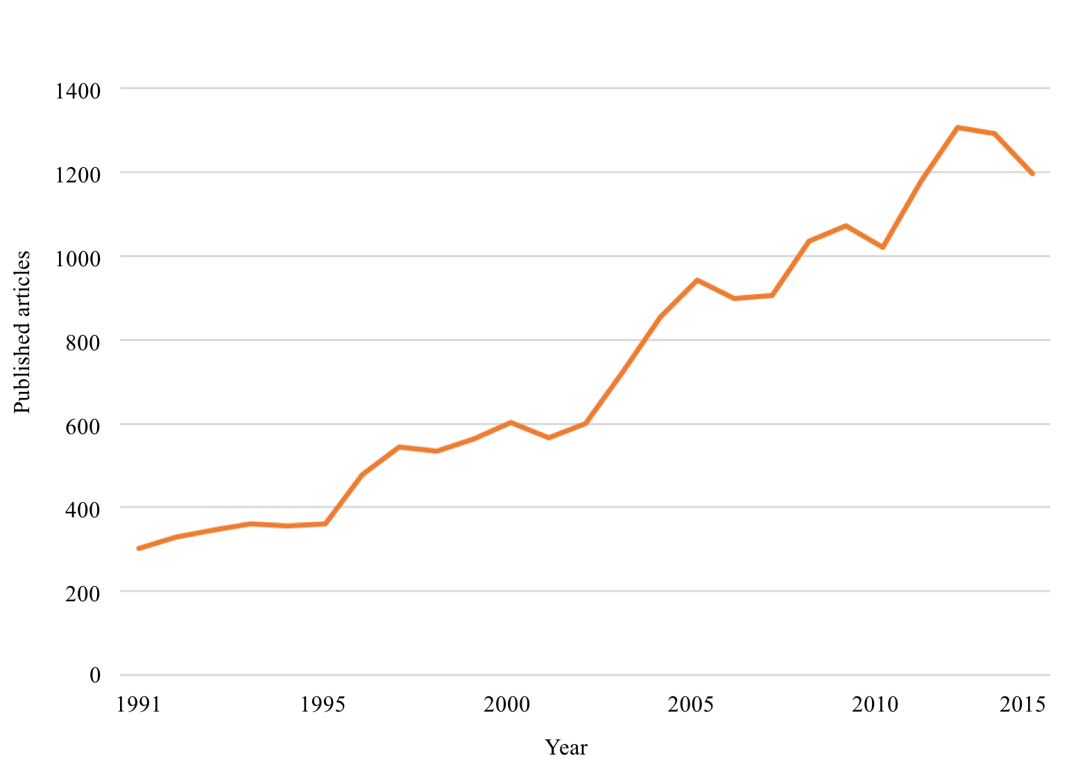
Figure 1. Number of papers and reviews containing the term retirement recorded yearly in the Scopus database between 1991 and 2015.

Table 2 presents the 20 most frequent keywords at the first and last years analized. In 1991, a set of words related to the economic aspects of retirement stood out, such as economics, pension, employment, organization and management, financial management, investment and health insurance. In 2015, however, only three terms were related to this group: economics, employment and income. On the other hand, a group of terms related to health and health research stood out. It was composed of major clinical study, controlled study, psychology, depression, and health status. Aged 80 and over also appeared as a common expression, referring to an age group that was absent in the previous classification.

Table 1
Distribution of 20 countries, authors and journals with the highest number of publications on retirement between 1991 and 2015.
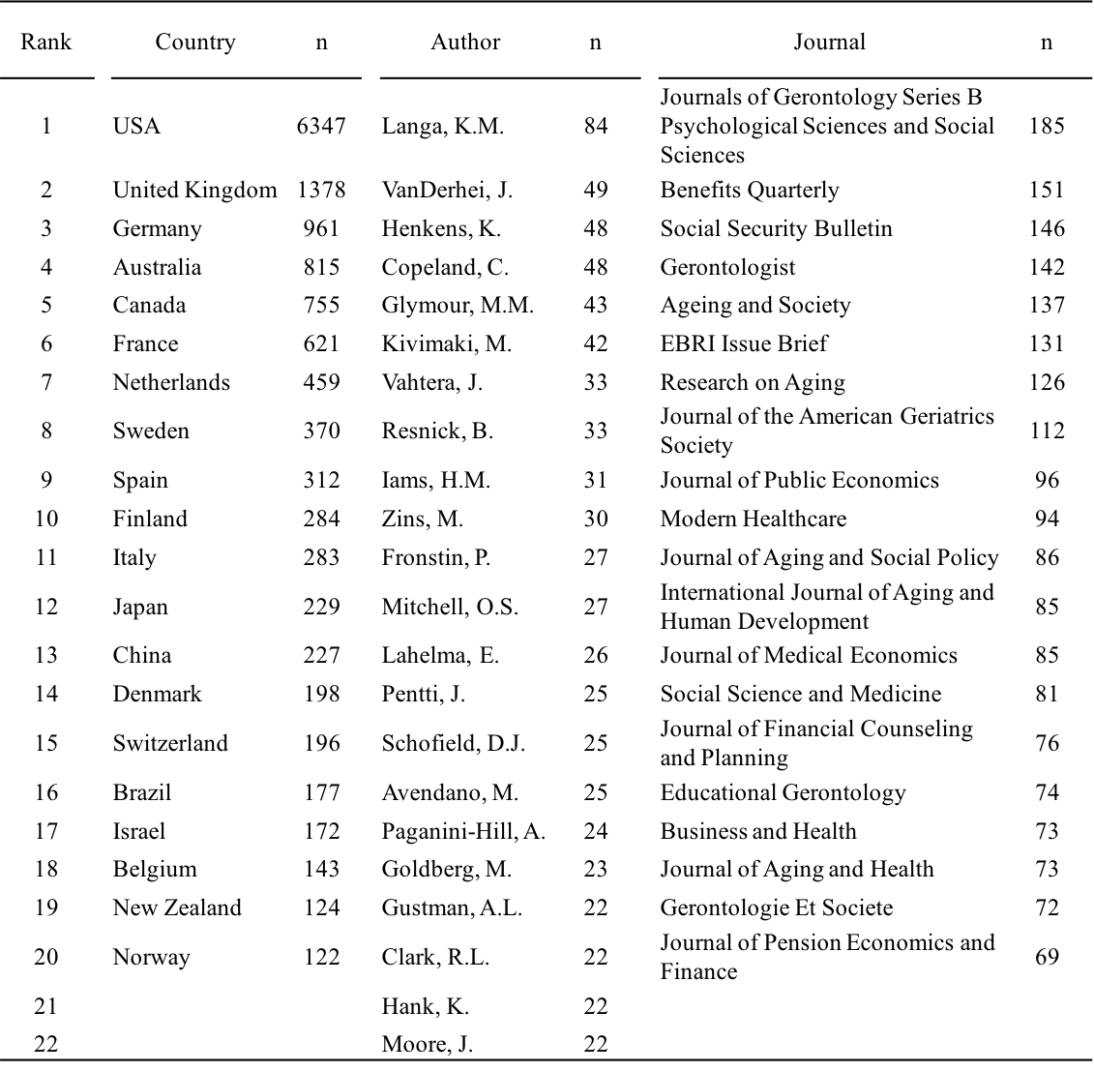
Table 2
Figure 2 presents the results concerning the DHC of keywords. A semantic overlap between words of different classes is expected because this classification is based on an algorithm. Seven thematic fields emerged: Class 1 – comprises 11.7% of the words and refers to economics and legal aspects including terms such as legal aspects, employee retirement; Class 2 – comprises 15.4% of the words and refers to biomedical psychosocial determinants including terms such as smoke, hypertension and obesity; Class 3 – comprises 13.6% of the words and refers to occupational health, with the following terms absenteeism, occupational diseases and cost of illness; Class 4 – encompasses 15.4% of the words and refers to sociodemographic determinants, including terms such as socioeconomics, income and age; Class 5 – encompasses 16.2% of the words and refers to psychological/psychosocial determinants, including psychological, adaptation and personal satisfaction; Class 6 – encompasses 16.1% of the words and refers to health systems, including terms such as physician, nurse and medical education; and Class 7 – encompasses 11.7% of the words and refers to demographic aspects, including terms such as pension system, eurasia, and aging population.

Table 2
Comparison between the most common keywords in publications on retirement published in 1991 and in 2015.
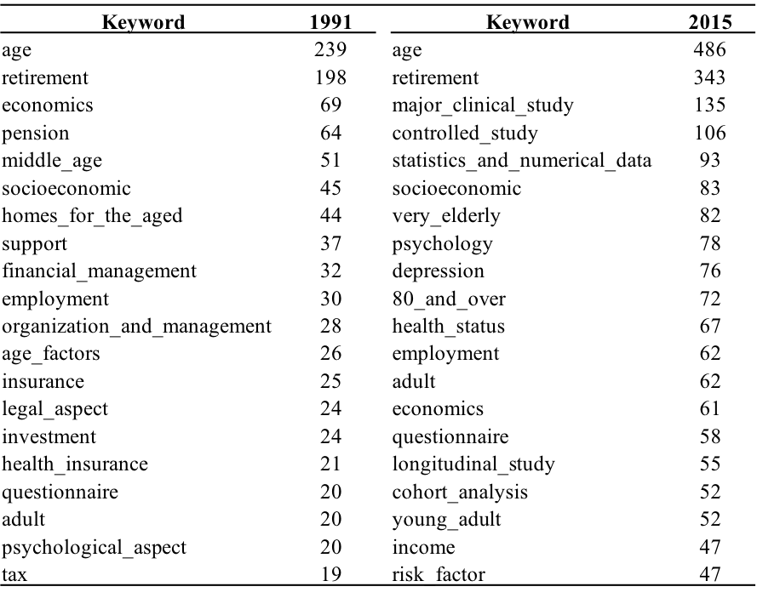

Figure 3 presents similarity analysis. Two large groups of words clustered around the terms retirement and age. The group associated with retirement refers to economic aspects, such as economics, employment, pension and income. The group associated with age refers to health aspects and its determinants, such as major clinical study, health status, psychological and risk factors.
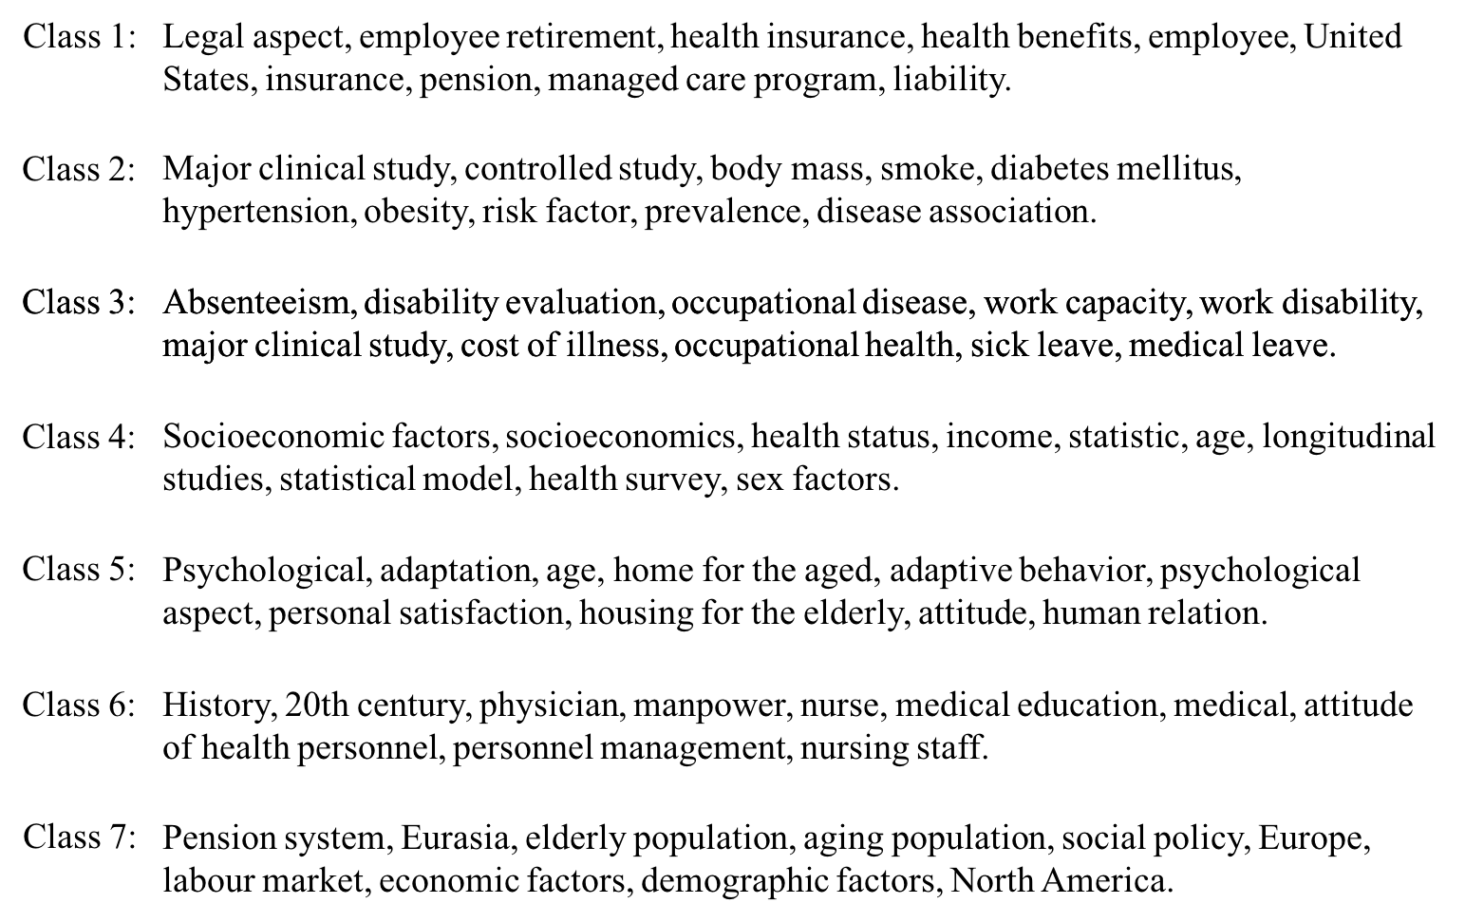
Figure 2. Thematic classes resulting from the Descending Hierarchical Classification of the indexed keywords.
Note: To facilitate visualization, only the 10 most frequent words in each class are presented.

It is also relevant to identify topics the analysis did not indicate. For instance, research on retirement education – preparing workers to cope with retirement – is socially relevant and highly applicable, but scarce. The expressions program development, educational programs, and intervention studies had a total of only 115 occurrences.

Discussion
The objective of this study was to synthesize the scientific publication on retirement between 1991 and 2015. For that, the publications included in Scopus were selected. The analysis of indexed keywords showed how publications addressing retirement are organized and indicated the main research topics in the field.
The scientific publication of papers on retirement grew at a pace similar to the growth of the general scientific publication. Among the most prolific countries, 14 are located in North America and Europe; only one is located in Latin America (Brazil), while none is located in Africa. This geographical distribution may not be random: there is a correlation of 0.84 between studies addressing retirement and national investment in research and development (UNESCO, 2013). On the other hand, there is a correlation of -0.06 between studies addressing retirement and the relative elderly population (WHO b, 2015). Apparently, studies on retirement reflect the national investment in research rather than the country’s social demands. Regions with lower scientific production are vulnerable to the risks of importing knowledge, such as inappropriate cultural adaptations, and its consequences, such as implementing interventions with low cultural sensitivity (Castro, Barrera Jr., & Steiker, 2010). Attending the social demands on retirement and aging with sensitivity will depend on regional scientific policies encouraging the production of knowledge focused on contextual specificities.
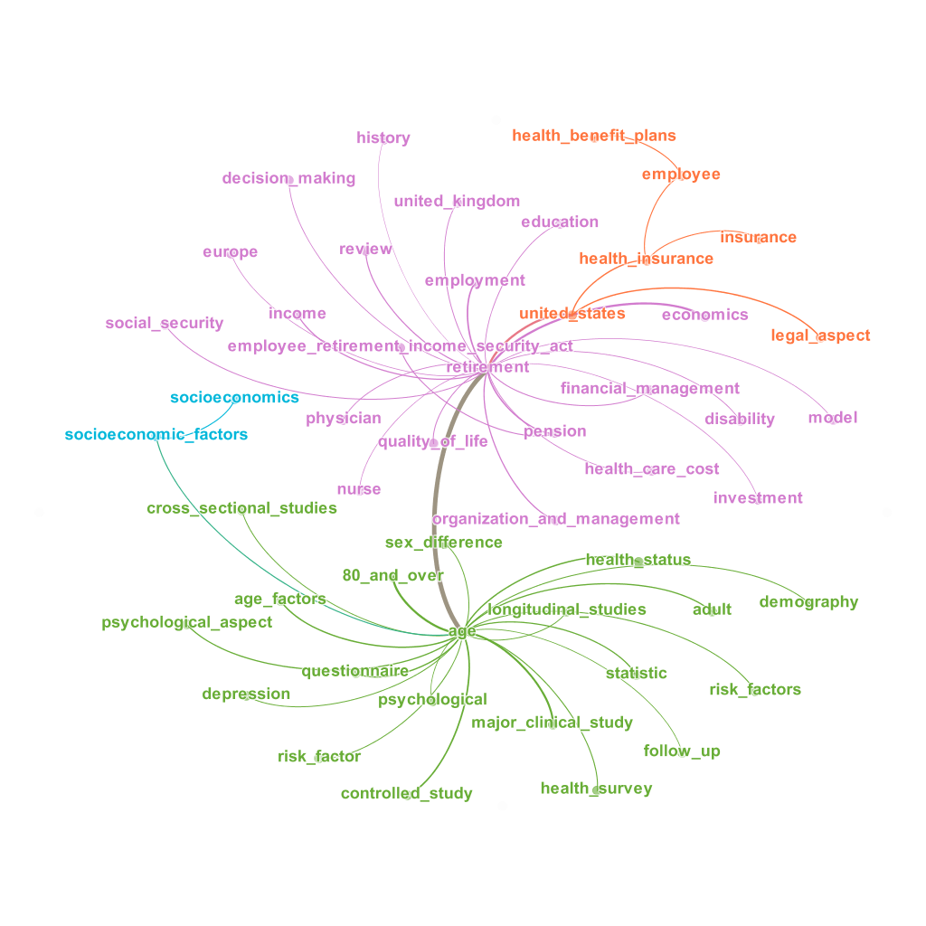
Figure 3. Groups of correlated words identified in the similarity analysis.

In a broader level, the research field on retirement is divided into two large thematic fields: health and economics. After a century and a half, retirement research still focus the same two aspects that led to its emergence in the first place. If one of the goals of WHO’s global strategy is helping people “to be able to continue to do the things they value” (WHOa, 2015, p. 12), health and money are important conditions, but not enough (Barbosa et al., 2016). This is the reason why retirement research should be expanded. For instance, preparing workers for retirement is a long existing demand (Lawton, 1941) and can be effective (Leandro-França et al., 2016) but little has been produced about it. Similarly, factors such as leisure and social support, among others, can improve quality of life during retirement (Barbosa et al., 2016), indicating distinct and promising research fields.
This study contributes to the body of studies addressing retirement by organizing knowledge production. Such systematization may ease its use in applied situations and support researchers planning new studies. Research regarding public policies can foster integration between health and studies in economics, optimizing the application of knowledge from each field in order to meet social demands. Having a map of the knowledge available in the field may promote the development of scientific development tailored strategies.

References
Barbosa, L. M., Monteiro, B., & Murta, S. G. (2016). Retirement Adjustment Predictors – A Systematic Review. Work, Aging and Retirement, 2(2), waw008. http://doi.org/10.1093/workar/waw008
Castro, F. G., Barrera Jr., M., & Steiker, L. K. H. (2010). Issues and challenges in the design of culturally adapted evidence-based interventions. Annual Review of Clinical Psychology, 6, 213–39.
Darkwa, O. K., & Mazibuko, F. N. M. (2002). Population aging and its impact on elderly welfare in Africa. International Journal of Aging & Human Development, 54(2), 107–23. http://doi.org/10.2190/XTQG-6DXD-9XWE-9X85
HelpAge (2013). Global Age Watch Index 2013: Insight report. London: HelpAge International.
Lawton, G. (1941). After sixty-five? Mental Hygiene, 25, 414-419.
Leandro-França, C., Murta, S. G., Hershey, D. A., & Barbosa, L. M. (2016). Evaluation of retirement planning programs: A qualitative analysis of methodologies and efficacy. Educational Gerontology, 1–16. doi: 10.1080/03601277.2016.1156380.
Smallman, M. (2015). What has been the impact of public dialogue in science and technology on UK policymaking? (Doctoral dissertation). Available at http://discovery.ucl.ac.uk/1473234/
United Nations Educational Scientific and Cultural Organization. (2013). World social science report 2013, Changing Global Environments. Paris. doi: 10.1787/9789264203419-en
Thane, P. (2006). The history of retirement. In G. L. Clark, A. H. Munnell, & J. M. Orszag (Eds.), The Oxford Handbook of Pensions and Retirement Income (p. 33–51). Oxford University Press.
Tuesta, D. (2011). A review of the pension systems in Latin America. BBVA Research, (11/15).
United Nations (2015). World population ageing 2015. New York: United Nations.
World Health Organization, a. (2015). World Report on Ageing and Health. Luxembourg.
World Health Organization, b. (2015). WHO Statistics 2015. Luxembourg.

